Reflective Project report
Group Project

Jamie Leung

Contents
Introduction 2
What is Renishaw? 3
Department 3
What is Quad Fusion? 3
Design Brief/Specification 4
Stakeholder Influence 5
Project Schedule 0
Project Management Tools 0
Gantt Chart 0
Critical Path Analysis 0
SWOT Analysis 3
Kanban 4
Feasibility Study 5
Design 6
System Description 6
Drawings 6
6
General Safety 7
Safety Strategy 7
Assembly 7
Electrical Safety 7
Final Idea & Outcome 0
0
Risk Assessment 1
FMEA 0
Change 0
Improvements 1
Communication 1
3
Conclusion 4
References 5

Introduction

One year after the project's completion, this report will talk about and consider how the cleaning tank project was managed and how successful it was. Research on change management and the implementation of different methods of management will be the key areas of attention. This report's goal is to examine the management of the project as a whole and any improvements the project could benefit from.
The safeguarding of the cleaning tank was introduced into production on April 10th 2022. Due to it being put into production, the standard procedures changed and management overseen it. The report will look at how management behaved and how change got implemented.
Key management tools such as SWOT, Critical Path Analysis, Gantt and Kanban will be looked at in detail. With further information on a feasibility study and analysis tools like FMEA and Risk assessment were carried out. Later in the report, you can see a questionnaire asked to Renishaw Quad Fusion employees about the project.

What is Renishaw?
Renishaw is a British company with headquarters in Gloucestershire. Recently, Renishaw marked 50 years of innovation. The touch trigger probe was the first product David McMurtry and John Deer produced when they started their company in 1973. Renishaw focuses on production, measurement, and high precision metrology. The primary production facilities for the business are currently located in the UK's Woodchester, Stonehouse, and Miskin.
The Miskin South Wales factory will be the centre of attention. Several different items, including encoder readheads, probes, scales, and various components are produced in the Miskin South Wales facility using CNC milling and turning equipment. Additionally, France, Germany, India, Ireland, and the USA all have production facilities for Renishaw. Furthermore, Renishaw is a market leader in the area of additive manufacturing (metal 3D printers).
With more than 5,000 people worldwide and 77 offices spread over 36 nations. In the UK, where Renishaw carry out the bulk of research, development, and production, over 3,000 people are employed. (Renishaw plc, 2020)

Department
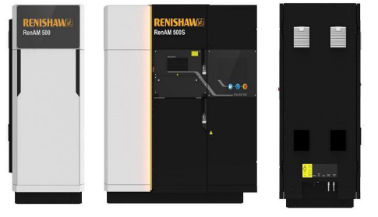
Figure 1 - AM Machine
Additive Manufacturing (AM) – There are two types of AM machines which are RenAM500Q and the flex. Additive manufacturing is also called 3D printing where thin layers of material is used to produce complex shapes which cannot be created by normal techniques such as machining. At Miskin, we currently build from start to finish and commission these machines

What is Quad Fusion?

Quad Fusion is a sub assembly on the Additive Manufacturing (AM) line. Each module is built up and installed into the AM machines. The quads modules are the most important component of an AM machine as it dictates where the lasers go. Within the cell, it must be clean as any kind of dust or dirt can affect the lasers which is potentially very dangerous. All components must be cleaned beforehand in the cleaning tank. Whilst handling any parts, gloves, ESD coat and hairnets must be worn to avoid any contamination.
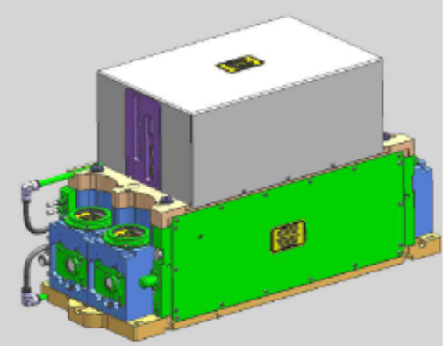
The improvement of safety was this project's primary goal. The objective was to create a safety mechanism for the AM cleaning tank to defend against any potential harm to employees. In 2021, there was an unfortunate event where the lack of a protecting mechanism caused the baskets in the cleaning tank to fly out and land on an employee foot.

Pictured on the right-hand side is a fully built-up module that will be fitted into an AM machine.

Figure 2 - Quad Module

Design Brief/Specification

The safeguarding project's requirements and goals are described in full in the project summary below. To make sure the project is on track to achieve the design brief, this brief was referenced frequently during the project.

Company Name: Renishaw
Project Name: Safeguarding of Cleaning Tank
Due Date: April 2022
Problem: Renishaw AM's cleaning tank contains a solvent that is used to clean the components after they are placed into the baskets. Currently, assemblers manually hoist the baskets onto the rollers within the cleaning tank before the cleaning process begins, and they would carry the baskets back off after the cleaning process was complete. Following a risk analysis, two key dangers—the potential harm caused by manual handling accidents while raising the baskets and dropping them—were discovered. Manual handling problems can range from back injuries to chronic problems.
Scope: This project will involve designing a safe transportation system to transfer baskets back and forth.
Purpose/Function: For parts to be conveniently delivered to the appropriate areas, the concept must feature a movable transportation system to move the baskets about the cell. The area where the transportation concept will be placed should also have a permanent guarding and an interlock mechanism to assure stability before moving anything. Without any parts put upon them, the baskets weigh 15.5 Kg now. Tests were carried out and run with the baskets filled to their maximum weight of 18.9 kg. The transportation system must be capable of withstanding 18.9 kg.
The project will be split into two sections - one section for the trolley and one section for the safeguarding of where the trolley will sit. Both products will have to follow the correct guidelines and the key objectives of the following;
Key Requirements:
The trolley;
The safeguarding;
● Interlock system to keep the trolley in place to avoid potential movement.
● No sharp edges (that can potentially harm others)
● Must conform to CE
● Ergonomic fit for use
● The correct materials should be used.
● Must be fixed to the floor or wall

● No sharp edges (that can potentially harm others)
● Aesthetically Pleasing
● Ergonomic fit for use
● Meet all rules and regulations
● Must move smoothly without damaging anything (such as the floor)

Stakeholder Influence

It is crucial to take into account the needs of the project stakeholders at the design specification stage. In the case that this is not done, it is quite possible that the project will not satisfy the demands of the stakeholder, ultimately leading to the project's failure. The stakeholders will influence the project and explain exactly what the project needs to achieve and by when.
For this project there were several different stakeholders. CPEG (Current Products Engineering Group) was a significant stakeholder in this project. Once the guarding system is in use, this team oversees maintaining it. They are also in charge of ensuring that production goes off without any problems, and if there is a problem, CPEG oversees fixing it.
Another Stakeholder within this project was the senior management. Meetings were carried out every week with senior management to discuss the project and to keep track of what has been carried out and what needs to be done etc. The senior management set a deadline of April 2022 with a £1000 budget for this project.

Project Schedule

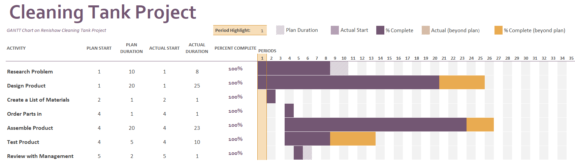
Figure 3 shows the project Gantt char
Figure 3 - Project GANTT Chart

Project Management Tools

Techniques used in project management assist a team in optimising activities and ensuring project success (pnaybour, 2022). Project management tools is a way to breakdown a project into different sections and help keep track on a project’s timeline. Throughout this project the main project management tools used were Gantt Chart and Critical Path Analysis.

Gantt Chart

A project management tool in the form of a bar chart is called a GANTT Chart. This will cover the many activities you'll undertake as well as the beginning and ending dates for each distinct activity. The GANTT chart was used throughout this project and the chart is shown in figure 3. Utilising this has the advantage that you can visibly see each action and when it must be finished (Atlassian, 2023).
It was an outstanding way for my project to graphically organise work, establish due dates, and monitor progress. The Gantt Chart allowed me to immediately identify which activities were accomplished and which ones were still outstanding, which was beneficial for tracking progress. This helped me keep organised and make sure I was moving in the right direction. Overall, I thought the Gantt Chart was a useful tool for project management. Setting deadlines, monitoring development, and maintaining organisation were all helped by it. If I was to complete another project, I would hundred percentage use this tool. If there was one thing I could have done differently when utilising the Gantt Chart, it would be to utilise one with dates. Figure 3 displays a Gantt chart with only numerical durations; it would be more useful if each activity included a start and finish date.

Critical Path Analysis

Similar to a GANTT chart, critical path analysis aids in the planning of the entire activity. With this approach, you must outline each action you'll carry out along with an estimate of how long it will take, as well as any dependencies there may be between the tasks. Depending on the route you take, if any activity is delayed, the project will also be delayed (Kenton, 2020). One of the benefits of working with CPM is that it promotes carefully evaluating the needs of each activity in a project and it shows the quickest timeframe for project completion.
I used Critical Path Analysis (CPA) in this project, and it was very effective as it allowed me to find the most critical activities. It gave a visual feeling to see which path the most feasible and which activities are depended on each other. I was able to plan my project with the help of the tool, which helped me keep on track and finish it on time.
A downside of using CPA is that it may lack flexibility. CPA is easy to carryout when the activities have obvious completion times. However, the accuracy of the estimations and assumptions used heavily influences the end result (tutor2u, 2017).
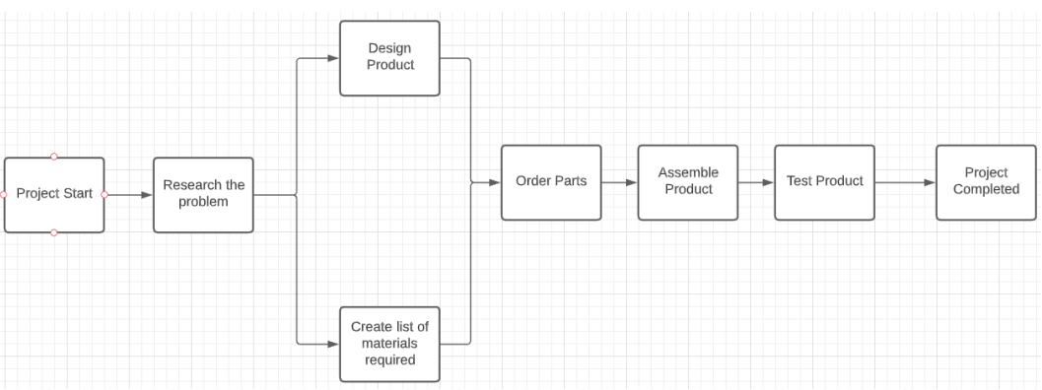
Shown below in Figure 4 shows a basic CPA that was undertook throughout this project without the different paths, floats and timings.
Figure 4 - CPA

Next time I would use CPA again but make it more complex with duration times shown below in Figure 5.

Task | Activity | Order | Duration (days)
A | Project Start | Starting Activity | 1
B | Research problem | Begin when A is complete | 10
C | Create list of materials | Begin when B is complete | 4
D | Design Product | Begin when B is complete | 10
E | Order parts | Begin when C is complete | 1
F | Assemble product | Begin when E is complete | 15
G | Test Product | Begin when F is complete | 10
H | Review with management | Begin when G is complete | 1
I | Project Finish | Begin when G H is complete | 1

From looking at figure 4 There are 2 possible paths –
Path 1 – A>B>C>D>E>F>G>H>I Path 2 – A>B>D>E>F>G>I
We can add up the duration times of each path to see which path will be the quickest completion time for this project.
Path 1 = 51 Days Path 2 = 46 Days
I could have saved an enormous amount of time if I had introduced this kind of management tool with durations times from the beginning of the project. This management tool can also been seen as Activity-on-node (AON) diagram.

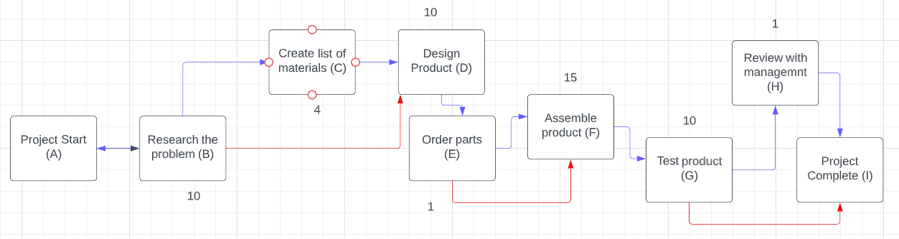
Figure 5 - CPA

SWOT Analysis

The acronym SWOT, which stands for Strengths, Weaknesses, Opportunities, and Threats, refers to a strategic planning technique. SWOT is a crucial technique to employ while working on any project since it provides detailed information on the advantages and potential drawbacks of the project. SWOT “could claim to being the most widely used strategy tool in modern times” (Sarsby 2016, p.3). A The internal and external elements, or what's happening inside and outside of your project, are both included in the SWOT analysis. As a result, although some of these variables will be under your control, others won't. The optimal course of action will become more obvious once you've found, recorded, and examined as many factors as you can in either case.

SWOT Analysis was carried out for this project shown in figure *****
Strengths | Weaknesses
- Safety feature added within the Fusion cell to protect the health and safety of any employees that may work in the cell.  - Reduces the number of potential manual handling injuries. | - There will be less room within the cell.  - It will take up time and resources.  - The cost of the whole project
Opportunities | Threats
- New market explored - the potential to sell to other companies that use the same cleaning tank.  - Chance to improve project management skills. | - The deadline not being met.

A Swot analysis was conducted at the project's beginning and was a useful tool for understanding the project's present viewpoints, including its advantages and disadvantages. The benefit of this table is that it allowed me to quickly summarise the major points of the project's benefits and drawbacks for my management.
The analysis is only as reliable as the data I enter, which is a drawback of utilising this tool for analysis. The analysis may be inaccurate if any of the input data used in it are inaccurate.

Kanban

A workflow management approach called kanban is used to define, regulate, and optimise knowledge work services. Its objective is to help you see your work and maximise productivity (Halton, 2019).
Throughout this project, I used a similar type of board on Devops which required the team to have a meeting every day. The meetings were called sprints and it allowed team members to see the state of every piece of work at any team. It helped keep track of all work activities and was separated into “To do” “In Progress” and “Done” boxes. Using this type of tool was good as it made all team members collaborate together and were able to see exactly what stage the activity is at. By utilising the kanban project management method, the project team were able to visualise workflow, set priorities, and identify co-workers who aren't doing what they're supposed to be doing. Due to everyone's efforts being directed towards the right tasks at the right times, the team's performance rose as a result.
A disadvantage of using a Kanban board over other management tools is that it won't tell you how long it will take to accomplish each task. They just go from one section to the next across the board; there are no deadlines placed on when they must be completed (Kanbanchi, 2021).

Feasibility Study
Project Feasibility is a type of analysis that reviews all of the project's factors (Bridges, 2021). It is split into different topics which consist of Technical, Economic, Legal, Operational and Scheduling. With the different topics, people can see whether the project is feasible or not by looking at things like project costs and returns.
Technical
All work was carried out in Miskin Renishaw, and any materials required for the project was ordered from Renishaw approved sellers. A technical feasibility study is crucial because it may help in developing a plan for the project process. The desired outcome from this project will be to complete a safe transportation system for the cleaning tank to minimise any potential problems. There will be engineering teams supporting this project to make this project technically feasible.
Economic
Before the project gets started, all costs and budgets were calculated by senior management. All budgets will have to be approved and justified so that the project is spent correctly, and no money is wasted. Once the budget has been approved, the project will automatically generate a ‘CEA’ number where all transactions/purchases will be recorded under that CEA number. The budget for this project has been set at £1000. Although the project won't have a direct financial impact on the business, it will assist prevent future health and safety accidents.
Legal
Legal Feasibility consists of checking the proposed project with any conflicts such as legal requirements like zoning laws, data protection acts, or social media laws. The senior management of Renishaw will be carrying out several different checks to ensure that the project is compliant with all laws and regulations. Since there are corporate policies and paperwork that must be finalised before this product can be used for manufacturing, this project is technically feasible.
Operational
This project will not directly improve the efficiency of the production line but however will improve the safety level whilst handling the baskets. The working environment will not be majorly affected however there will be less room within the cell as the guarding will take up some space. The actual process of the production line will not change but the project will make it easier to transport parts back and forth ready for the production line.
Scheduling
The estimated completion date for the project was April/May 2022. To help with any scheduling issues that may arise during the project, a GANTT chart and critical path analysis was carried out to help keep track of any activities. The project will fail if the schedule is improper, making this one of the most crucial aspects for its success.

Design

System Description

The safeguarding system is a simple design incorporating an electromagnetic interlock switch, a push button and a light bar. The body of the safeguarding is made from Aluminium extrusion and the electrical connections are housed in an ABS box. The magnetic lock is situated at the rear of the corral as is the control box. There is a piece of acrylic sheet across the rear of the corral to reduce the risk of access to the corral from the rear and to protect the lock and control box. The power supply for the Corral is 24vDC brick power supply. This then connects to the control box via a Dc socket. The connections between the magnetic release solenoid and switch contacts is housed inside the ABS control box.

Drawings
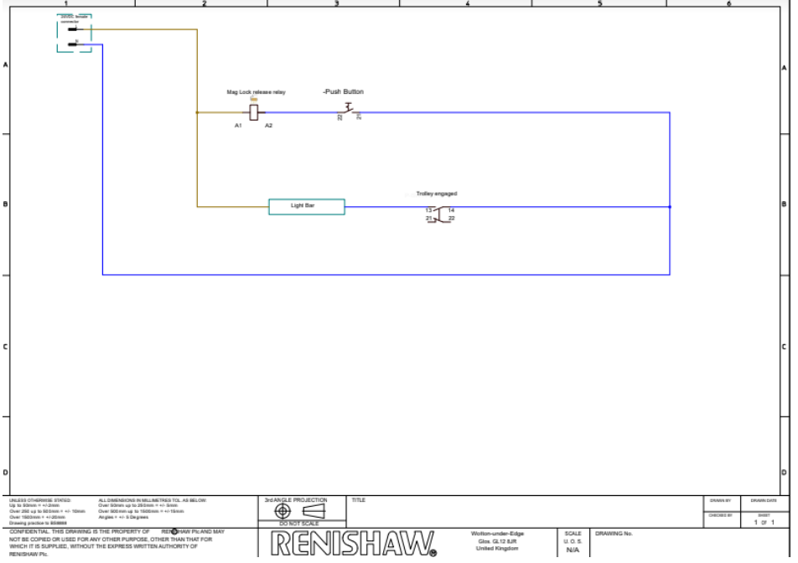
Figure 6 - Electrical Schematic

General Safety

- This equipment weighs >25Kg.
- The equipment is designed to be fixed into position and not be portable
- PPE must be worn while using this equipment, especially safety shoes.
- As the equipment will be subjected to the point of use workplace risk assessment and therefore no safety issues are foreseen.

Safety Strategy

This equipment has the requirement for 24vDC. This is recognised as a safe working voltage. A risk assessment will be undertaken as part of the assembly, prove out process on the tooling as well as a workplace risk assessment at its working location.

Assembly

This equipment has been assembled by a competent Technician to the specifications recommended by the manufacturers of the individual components and following sound engineering practices.

Electrical Safety

Electrical Ratings / Specification Input Supply Rated Voltage 24vDC Maximum Rated Input Current 1.2A Fuse Rating & Type 2A

Final Idea & Outcome

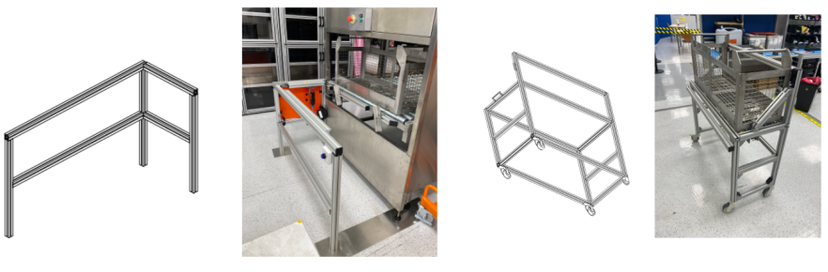

Risk Assessment
Risking Rating out of 5
Column 1 = Likelihood
Column 2 = Severity

What are the hazards? | Who might be harmed and how? | Risk Rating |  |  | How to control the risk? | Further actions or improvements
Hands getting jammed | Making contact with the trolley in between the fixed guard and trolley | 2 | 2 | 4 | Implementation of several different safety features such as light curtains. | Full training should be provided on how the trolley engages with the interlock.
Electric Shocks | Anyone touching the equipment. | 2 | 3 | 6 | All equipment must be earthed, and all control panels must remain shut. | N/A
Slips and Trips | Anyone entering the Quad Cell. | 3 | 1 | 3 | Ensure all wires are tucked away in trunking and to implement a safe area to put bags away. | Daily checks on housekeeping and to clean up any mess as soon as possible.
Trolley Collapsing | Anyone near the trolley | 1 | 1 | 1 | Buddy checks all trolleys built with supervisors/engineers | Weekly/Monthly maintenance on the trolley to ensure it runs smoothly.
Before the guarding system is put into production, it is essential to do a risk assessment. Finding any other safety issues falls under this category as well. The goal of this risk assessment is to guarantee that any potential problems with the guarding system are identified and addressed to reduce the likelihood of workplace accidents. An organisation must comply with legal requirements and conduct a risk assessment (Health and Safety Executive, 2020).

FMEA
Process Step/Input | Potential Failure Mode | Potential Failure Effects | SEVERITY (1 - 10) | Potential Causes | OCCURRENCE (1 - 10) | Current Controls | DETECTION (1 - 10) | RPN | Action Recommended | Actions Taken | SEVERITY (1 - 10) | OCCURRENCE (1 - 10) | DETECTION (1 - 10) | RPN
Fixed Guarding | Push Button not working | Interlock system failure - can't disengage the interlock to release the trolley. | 4 | Wired up  incorrectly /  Faulty wires | 2 | Wired up by Engineers and checked by supervisors | 10 | 80 | Implement a reset switch | No action carried out just yet. | 1 | 1 | 1 | 1
Trolley | Wheels falling off | Trolleys will be unbalanced and will not move smoothly. | 3 | Incorrect assembling | 2 | Wheels are installed by Engineers and checked by supervisors | 10 | 60 | Regular Maintenance | No action carried out just yet. | 1 | 1 | 1 | 1
Trolley | Basket exceeded the weight limit | Trolley collapsing | 5 | Basket too heavy | 3 | Measure the weight of basket | 5 | 75 | Increase trolley weight capacity | No action carried out just yet. | 1 | 1 | 1 | 1

Above is a FMEA Table I’ve carried out after the project has been completed. FMEA stands for Failure Mode Effect Analysis and It is an effective way of risk management that may pinpoint current and potential failures, rate possible risks according to their importance, provide alternative solutions, and enable a pro-active strategy for issue prevention (Wilhelmsen and Ostrom, 2019, p.7). If I implemented this type of analysis tool before the project was completed, I could had seen actions such as implement a reset switch for the interlock, carry out regular maintenance and to increase weight capacity to make the project more successful.

Change

In project management, adopting organisational changes without affecting current procedures and tactics is known as change management. This entails switching to a new strategy to deal with unforeseen developments. Due to improper change management in this project, production came to stop while the project was being carried out. Due to potential health and safety concerns, the cleaning tank was not in use while the project of the safeguarding was in progress. As a result, no components could be cleaned through the tank, which put a stop to manufacturing. To be able to afford to pause production for a few weeks, the management or engineers should have put measures in place, such as cleaning the bulk of the parts before beginning the project or creating a safety stock of modules. This shows the importance of having good change management.

One of the most vital tasks throughout the change-implementation process is "effectively communicating change to employees" (Duncan, 2021). If the change is not disclosed to the employees, they will be shocked and maybe unhappy at work. In addition to this, "Seek employee feedback" was one of Indeed's recommendations. One of the most important things to do is to ask employees for their opinions. This is one of the most essential things to do because it "gives leaders the information they need to lead for a change and it makes employees feel more involved when projects are going on (Elzinga, 2021). Employee input hadn't been asked throughout this project. According to a blog post on Culture Amp, "Employee feedback is a way to monitor your progress and take everyone on that journey with you" (Elzinga, 2021). Employee input motivates individuals to speak out and share their thoughts on the change whether its good or bad.

However, certain people may be resistant to change, so it's not always advantageous. Individual and organisational resistance to change is a common occurrence, “Change is often resisted at both the individual and the organisational level” (Mullins, 2010, p.791). Habits may be a source of comfort and stability at work, and many people are wary of new technology, which may lead to individual reluctance to change at Renishaw.

Improvements

I want to integrate monthly trolley maintenance as a way to enhance my project. Even if the trolley typically won't need routine maintenance, it's still a good idea to perform it to make sure it is operating effectively and securely. Regular maintenance can assist in increasing the life of the trolley by recognising any possible problems and treating them before they become more expensive to fix. It can also help to spot any faults before they become critical. It's also critical to do routine maintenance to maintain the trolley's functionality for efficient and safe shipment of the parts (Balachandran, 2023).
Another enhancement would be to add a reset switch to disengage the trolley in the event of any electrical or mechanical problems, preventing the trolley from being trapped. A reset switch gives more control over the safeguarding system and increases safety because it can stop serious harm from occurring.
Sticking to one management approach and one analytical technique, such as Gantt and Swot, would have been another the improvement. When many management strategies are used simultaneously, it becomes complicated and certain activities begin to overlap. Gantt and Swot look so straightforward and basic, but I discovered they were the most useful since they provide you a project timetable and Swot provides you with the project's advantages and disadvantages.

Communication

This project's communication was superb throughout. I often used email, Microsoft Teams, or face-to-face conversation to communicate with the stakeholders. Microsoft Teams, in my opinion, was the most efficient method of communication since it allows for quick and easy texting and keeps track of chats so that, if I forget about something, I can always go back and check. Emails was also effective when it came to contacting the stakeholders if there was a more formal approach required. With email you can include text, images and documents like Microsoft teams.
The fastest method of communication may have been face-to-face interactions, which have several advantages like being casual and direct and offering instant feedback. Confusions and misunderstandings are cleared up on the spot, and it's confidential. The disadvantages of this, nevertheless, are the low legal and reference value that results from the lack of written records and the possibility that it won't work for some people who have difficulty speaking confidently. Additionally, a communicator may occasionally speak too quickly, leaving important information out (Articles Junction Blog, 2013).

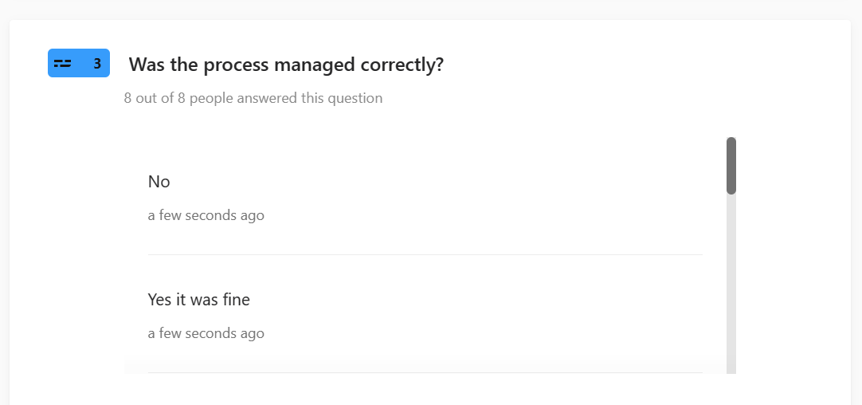
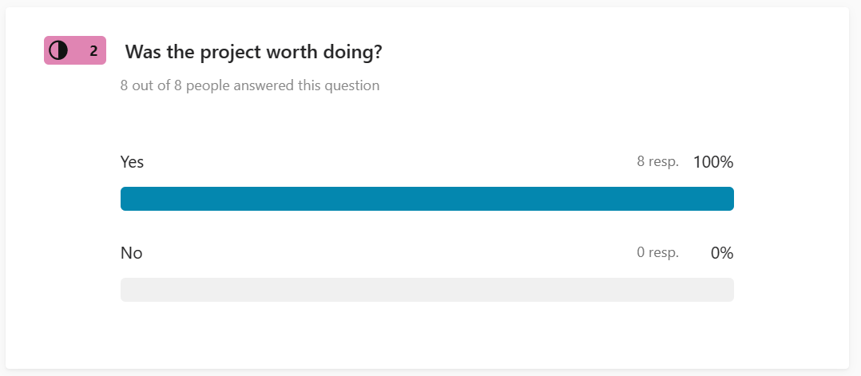
I asked employees that worked in the Quad Fusion cell a couple questions about the project and their results are shown below.
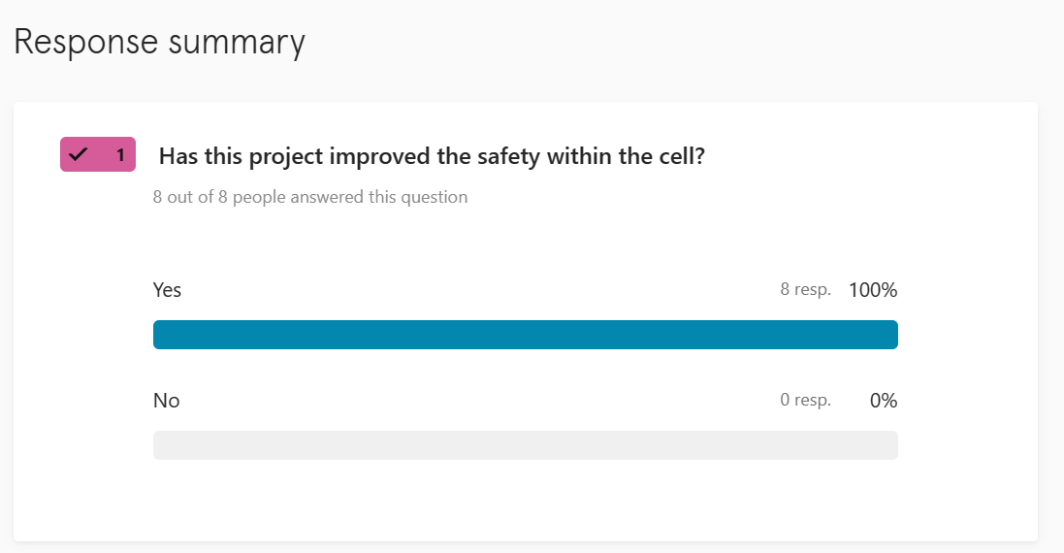

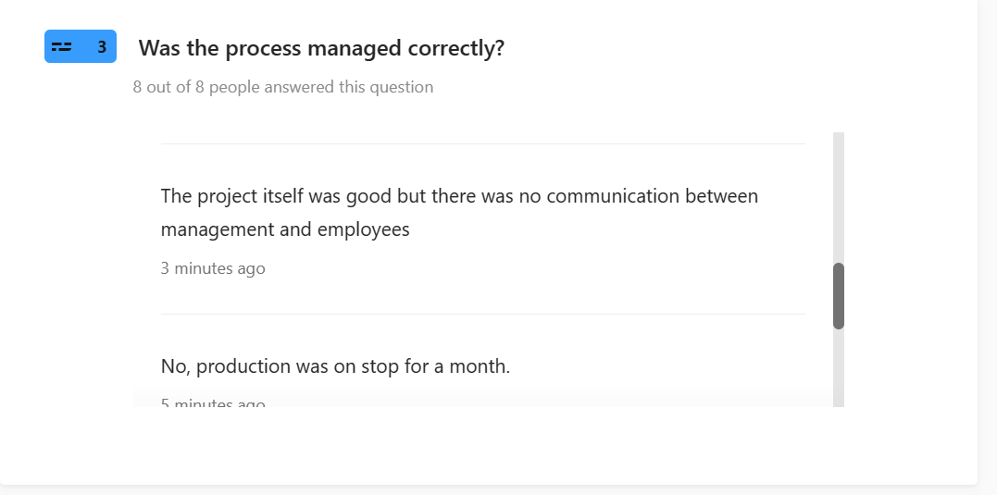
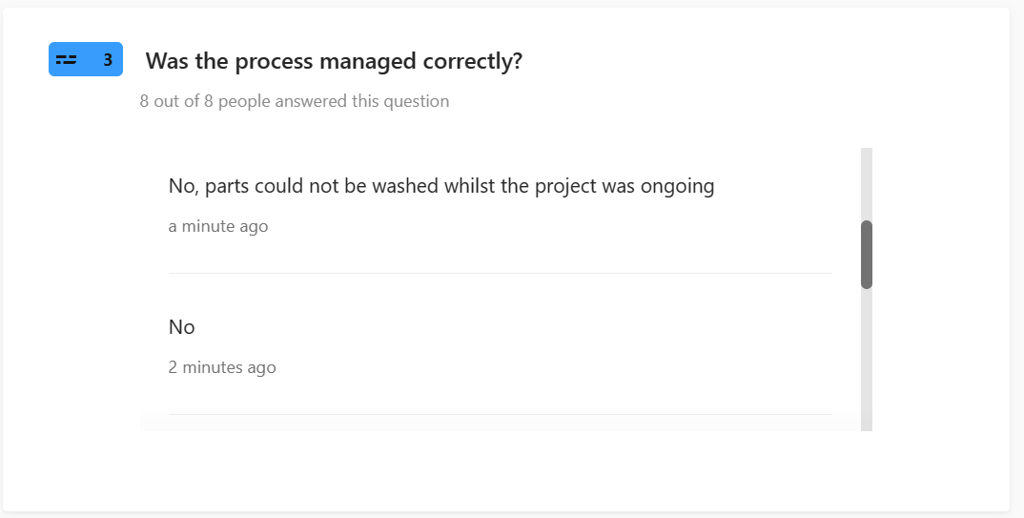
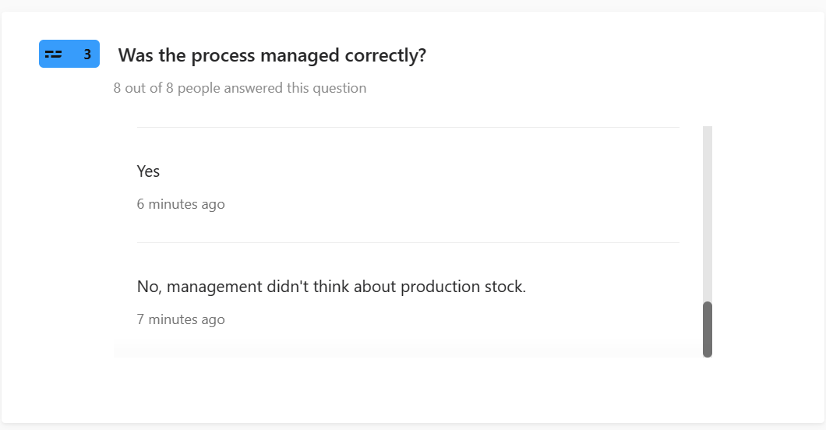

Conclusion

Overall, the project went well, and all targets were met. The original brief was to Design a safe transportation system to transfer baskets back and forth. The idea needs to have a portable transportation system to move the baskets around the cell so that parts can be easily transported to the correct locations. Also, there should be a fixed guarding where the transportation idea will sit, including an interlock system to ensure stability before moving anything. The whole point of this project was to tackle a health and safety issue and I believe that has been met. All these objectives were met, and the project is fully functioning even after a year on. The project has helped me develop my designing skills on ITEM24 and I have gained valuable experience building the project with using different materials and tools such as metal extrusion which I have never used before.
The fact that all deadlines were met was another benefit of this project. The project ran more smoothly as a result of the use of several project management technologies, such as GANTT charts and CPA. Another advantage of the project is that it was satisfying to see it through to completion and that it helped to address the safety issue in the department where I really work. The fact that the entire budget for this project was not surpassed is another plus, which is always positive for the stakeholders. It was also beneficial to do research and utilise several analytical techniques, including risk assessment, SWOT analysis, and FMEA.
I believe that at the beginning of the project, I was a little undermotivated, and as time went on, I began to get lazy. But as soon as my engineer and I spoke about a prospective project concept, my desire returned, and I began to look forward to working on the project and trying out various ideas. Finding something you are enthusiastic about so you can focus on it as a method to increase motivation and reduce laziness.
In conclusion, the project was kept quite simple and achieved all of its goals. Some modifications, like adding a reset switch, might have been implemented if I had more time and money, but the project functions as it should. Judging from the questionnaire I carried out, it looks like the project was a success however, it could have been managed better.

References

Articles Junction Blog (2013). Advantages and Disadvantages of Face to Face Communication. [online] Blogspot.com. Available at: http://articles-junction.blogspot.com/2013/08/advantages-and-disadvantages-of-face-to.html [Accessed 22 May 2023].
Atlassian (2023). Gantt Charts. [online] Atlassian. Available at: https://www.atlassian.com/agile/project-management/gantt-chart#:~:text=a%20Gantt%20chart%3F- [Accessed 14 May 2023].
Balachandran, J. (2023). Maintenance Matters. How to Create an Effective Monthly Maintenance Plan. [online] www.linkedin.com. Available at: https://www.linkedin.com/pulse/maintenance-matters-how-create-effective-monthly-plan-balachandran [Accessed 17 May 2023].
Bridges, J. (2021). How to Conduct a Feasibility Study - ProjectManager.com. [online] ProjectManager.com. Available at: https://www.projectmanager.com/training/how-to-conduct-a-feasibility-study [Accessed 14 May 2023].
Duncan, C. (2021). Communicating Change To Employees: 9 Key Strategies To Succeed. [online] www.alert-software.com. Available at: https://www.alert-software.com/blog/communicating-change-to-employees [Accessed 23 May 2023].
Elzinga, D. (2021). Why you need to collect employee feedback during change. [online] Culture Amp. Available at: https://www.cultureamp.com/blog/collect-employee-feedback [Accessed 26 Apr. 2023].
Halton, C. (2019). Kanban Definition. [online] Investopedia. Available at: https://www.investopedia.com/terms/k/kanban.asp [Accessed 17 May 2023].
Health and Safety Executive (2020). Health and safety risk assessment and management. YouTube. Available at: https://www.youtube.com/watch?v=xyANahuhGs0 [Accessed 22 May 2023].
kanbanchi (2021). Kanban Style Work Boards: Pros and Cons. [online] Kanbanchi. Available at: https://www.kanbanchi.com/kanban-style-work-boards [Accessed 23 May 2023].
Kenton, W. (2020). Understanding Critical Path Analysis. [online] Investopedia. Available at: https://www.investopedia.com/terms/c/critical-path-analysis.asp#:~:text=Critical%20path%20analysis%20(CPA)%20is [Accessed 14 May 2023].
pnaybour (2022). Project Planning Techniques. [online] Parallel Project Training. Available at: https://www.parallelprojecttraining.com/blog/project-planning-techniques/#:~:text=It%20is%20still%20useful%20to [Accessed 14 May 2023].
Renishaw plc (2020). Renishaw: About Renishaw. [online] Renishaw. Available at: https://www.renishaw.com/en/about-renishaw--6432 [Accessed 14 May 2023].
Sarsby, A. (2016). SWOT Analysis. [online] Google Books. Lulu.com. Available at: https://books.google.co.uk/books?hl=en&lr=&id=Yrp3DQAAQBAJ&oi=fnd&pg=PA1&dq=swot+analysis&ots=ODrcYtC0ZE&sig=l_KLmRQGFdsrI2lQVOotkPXmZFU&redir_esc=y#v=onepage&q=swot%20analysis&f=false [Accessed 14 Apr. 2023].
tutor2u (2017). tutor2u. [online] tutor2u. Available at: https://www.tutor2u.net/business/reference/critical-path-analysis [Accessed 17 May 2023].
Wilhelmsen, C.A. and Ostrom, L.T. (2019). Risk Assessment: Tools, Techniques, and Their Applications. [online] Google Books. John Wiley & Sons. Available at: https://www.google.co.uk/books/edition/Risk_Assessment/Ca-hDwAAQBAJ?hl=en&gbpv=1&pg=PP1 [Accessed 22 May 2023].

