Student name: Fruzsina Valoczki
Student number: 2223630
Programme: Master of Business Administration
Module: Managing Marketing Change (BMMB7026D)
Lecturer: Navdeep Randhawa
Word count: 3173
Submission date: 01 June 2026
Marketing in the Digital Era:
A Critical Evaluation of Premier Inn

I confirm that I have not used any AI tools in the research and creation of this assignment. I confirm that I have not presented any AI generated materials as my own work. I confirm I have copies of my draft, notes, and other resources I used, which I may be asked to provide in evidence.

Executive Summary
The purpose of this report is to assess the marketing function of Premier Inn within a hospitality industry shaped by technological change and evolving consumer trends. The company remains one of the leading businesses in the UK budget hotel market due to its reliable service model and value-for-money approach. At the same time, technological developments are encouraging hospitality businesses to improve customer experience and strengthen their online services.
The report looks at the company’s current marketing approach and the factors shaping change within the hospitality sector. It discusses the growing importance of digital technology, sustainability and changing customer booking behaviour. The business benefits from consistent operations, strong corporate backing and a well-recognised brand position within the market. Even so, strong dependence on the UK market and increasing competition could affect future development.
The discussion suggests that Premier Inn’s marketing approach has generally responded to market developments rather than proactively leading innovation. Although the company managed the post-pandemic transition effectively, digital developments continue to alter customer expectations across the sector. At the same time, sustainability expectations and data protection requirements are increasing pressure on hospitality companies.
Long-term competitiveness will increasingly depend on the extent to which the business can develop a data-driven, digitally integrated and customer-focused marketing approach. To support this objective, the report proposes several short-, medium- and long-term recommendations, including the development of zero-party data systems, the improvement of data competencies and the testing of adaptive smart room technologies.
Table of Contents
1. Introduction 4
2. Key Findings 4
2.1 Critical evaluation of current marketing activities 4
2.1.1 SWOT Analysis 4
2.1.2 STP Analysis 5
2.1.3 7Ps Marketing Mix Analysis 6
2.1.4 Evaluation of Marketing Efficiency 7
2.1.5 Ethical, Cultural and Sustainability Considerations 8
2.2 Analysis of Internal and External Drivers of Change 9
2.2.1 Influence of Disruptive Technologies 9
2.2.2 Regulatory and Sustainability Pressures 10
2.2.3 Shifting Consumer Behaviour in the Digital Age 11
2.3 Future Developments in Marketing 11
3. Conclusion 12
4. Recommendations 13
Short-term recommendation 13
Medium-term recommendation 13
Long-term recommendation 14
References 15
Appendices 20
Appendix A: SWOT Analysis 20
Appendix B: PESTEL Analysis 21
Appendix C: STP Analysis 21
Appendix D: 7Ps Marketing Mix 22

1. Introduction
This report examines the strategic position of Premier Inn within the UK hospitality industry. The brand operates under Whitbread PLC, one of the major organisations within the sector. Across the United Kingdom, the business operates over 850 hotels containing approximately 86,000 rooms, which corresponds to nearly 12% of the domestic hotel market (Whitbread PLC, 2025a; Baker, 2026).
Consumers now have access to large amounts of hotel information through digital booking platforms, allowing them to compare prices and reviews within a short period of time. Alongside this, economic pressures linked to inflation have influenced spending behaviour across the travel sector. This environment forces businesses to replace traditional promotional activities with data-led digital marketing strategies to effectively co-create value with modern consumers (Kotler, Keller and Chernev, 2022). Premier Inn responded to these market conditions by adapting its operations and marketing activities after the pandemic.
The report provides a critical discussion of Premier Inn’s marketing function in relation to digital transformation within the hospitality sector. It evaluates existing marketing practices, investigates the factors contributing to marketing change and assesses how future trends may influence the organisation. The discussion additionally applies SWOT, STP and 7Ps frameworks to strengthen the analysis.

2. Key Findings

2.1 Critical evaluation of current marketing activities

2.1.1 SWOT Analysis
In terms of strengths, Premier Inn enjoys a high level of brand awareness in the United Kingdom, where the concept of budget accommodation is often associated with the brand itself. The standardised service model supports a consistent customer experience and contributes to operational efficiency, although a high degree of standardisation may limit opportunities for differentiation (Dev, 2024). As competition within the market continues to intensify, this may gradually increase the brand’s vulnerability. Nevertheless, Whitbread’s financial resources continue to provide Premier Inn with significant investment and expansion opportunities (Whitbread PLC, 2026). At the same time, operating within a large and established organisation may sometimes limit flexibility and slow responses to rapid market developments.
A significant weakness for Premier Inn is the relatively limited scale of its international operations. Compared with Accor Ibis and IHG Holiday Inn Express, the company operates on a far smaller international scale (Accor, 2026; IHG, 2026). Most of the company’s operations are still concentrated within the UK hospitality market, which increases dependence on domestic demand. The brand may appear less attractive than midscale and upscale hotel competitors, which makes it difficult to justify higher prices. At the same time, it is questionable whether this is truly a weakness in the economy segment, or rather the result of a deliberate positioning decision.
Regarding opportunities, upgrading the loyalty programme with exclusive benefits could strengthen guest retention and improve the availability of customer data (Gubiniova et al., 2023). Additional opportunities also emerge from Whitbread’s restaurant brands, including Brewers Fayre and Beefeater, which remain closely linked to Premier Inn’s hospitality operations. Targeting new market segments also offers growth potential, however, entry costs and the potential loss of a clear brand position could create significant risks.
From the perspective of threats, increasing competition within the budget hotel segment poses the greatest challenge. High substitutability in the discount segment can lead to aggressive price wars (Angelini, Costa and Guizzardi, 2025). In this environment, the higher quality standards of Premier Inn could result in a cost disadvantage. Alternative accommodation platforms such as Airbnb continue to attract customers away from traditional hotels, particularly groups of friends travelling together (Lin et al., 2024). The growing market power and commission demands of OTAs could reduce the share of direct bookings (O’Connor, Assaker and Haddad, 2025). This may not only reduce profitability, but also hinder the development of direct guest relationships.

2.1.2 STP Analysis
Within the segmentation stage, Premier Inn operates in both urban and coastal markets. Its customer base is demographically diverse, consisting of a relatively even balance between business and leisure travellers. From a psychographic perspective, the brand is particularly popular among travellers looking for simple, reliable and affordable accommodation. Research by Strudley (2022) suggests that interest in the brand generally increases with age and is strongest among the 50 to 59 age group, although younger, price-conscious travellers still form an important part of the customer base. Nevertheless, appealing to a wide audience of this kind may reduce the clarity of the brand’s positioning.
Targeting within the organisation follows a differentiated marketing logic. Service expectations among business travellers are generally linked to efficiency and speed, while leisure guests tend to place greater importance on comfort and family-friendly surroundings (Perez-Ricardo and Garcia-Mestanza, 2025). Even so, these differences are communicated more through marketing than through major variations in the actual hotel experience.
In terms of positioning, Premier Inn builds its market presence on value for money and predictability (Strudley, 2022). The Good Night Guaranteed programme strengthens this promise by making the brand proposition more concrete for consumers. Although customer expectations are increasingly moving toward flexibility and experience-centred services, this stable brand identity can still offer a significant competitive advantage.

2.1.3 7Ps Marketing Mix Analysis
In terms of product, the core offering of Premier Inn centres on overnight accommodation, providing standardised, family and accessible rooms. The brand’s reputation for reliability is supported through consistent room layouts and predictable sleep quality. Alongside its traditional hotels, the company also operates Hub by Premier Inn properties located in major urban centres (Whitbread PLC, 2021).
Regarding price, the business applies a differentiated system separating flexible and fixed rates. This setup is managed by Premier Inn’s own commercial trading model, which controls pricing centrally and optimises revenue based on real-time market demand (Stephenson, 2023). The brand’s strong value-for-money market position is further proven by its leading spot in the YouGov Value index (Fernandes, 2025). However, this dynamic pricing system is not always fully transparent to consumers, which may occasionally result in customer dissatisfaction.
From a place perspective, the company utilises a mixed distribution model. Its internal reservation platforms include the main website, a mobile application and dedicated call centres, while rooms remain available through external partners as well. Prioritising these direct booking channels reduces third-party intermediary fees and allows the business to gather valuable guest data. However, the commercial practice where hotels cannot offer different rates across alternative platforms can trigger competition law concerns (Ennis, Ivaldi and Lagos, 2023). This can also create ongoing operational tension between hotel brands and online booking sites due to high commission structures.
For promotion, television advertising has been heavily supported by the company, with Lenny Henry serving as the brand’s face for many years. Maintaining this level of long-term consistency is relatively unusual within hospitality and helps reinforce brand recognition across established customer segments. At the same time, the business supports this traditional strategy through targeted digital campaigns and direct email marketing designed to increase direct bookings.
Concerning people, receptionists and housekeeping teams remain central to service delivery across the business. Standardised workflows support a consistent guest experience between hotel locations, although staff retention continues to present difficulties within the hospitality industry because of high turnover rates (Kilson, 2025).
Within processes, the entire customer journey from initial booking to departure shapes the overall user experience. The integrated booking system provides real-time capacity updates and automated electronic invoicing, both of which improve operational efficiency. On the other hand, heavy digitalisation can present challenges for some consumer segments. Certain guests prefer traditional service and tend to value personal interaction over fully automated check-in systems.
Finally, for physical evidence, the consistent application of purple styling and corporate branding supports strong brand recognition (Strudley, 2022). The room design, branded bedding and standardised bathroom amenities reinforce a predictable guest experience. However, younger travellers may not value this level of uniformity to the same extent over time.

2.1.4 Evaluation of Marketing Efficiency
Beyond promotional communication, the marketing function also affects occupancy performance, direct booking activity and overall brand value. These operations additionally remain closely connected to revenue management systems and digital distribution structures.
Based on guest satisfaction metrics, Premier Inn displays a mixed performance. According to a consumer survey by Which?, the company’s 73% customer satisfaction score places it in the middle tier among UK hotel chains, proving that service quality meets basic sector expectations (Hobbs, 2025). At the same time, this score fails to provide a distinct competitive advantage over immediate rivals in the same class.
The development of brand equity is illustrated by YouGov Brand Index data, which shows that Premier Inn remains one of the strongest players in the UK hotel market regarding consideration and purchase intent (Bansal, 2024). According to Whitbread’s annual report, the financial value of the brand increased during the previous three years (Whitbread PLC, 2025a). Even so, growth within the economy hotel segment appears less pronounced than among upscale hospitality brands.
Hospitality performance indicators suggest a generally positive but limited confirmation of these marketing results. In 2025/26, RevPAR increased by 1%, while occupancy remained stable at 79.1% and ADR rose by 3% to £81.95 (Whitbread PLC, 2026). This performance also placed Whitbread above the market average in terms of RevPAR growth. However, profitability remains affected by inflation, which limits the extent to which revenue increases can be interpreted as improved marketing performance.
The growing complexity of the multi-channel customer journey also creates challenges in identifying the exact contribution of individual campaigns to final conversions. This is a widely recognised challenge of attribution modelling within digital marketing (BenMrad and Hnich, 2024). For Premier Inn, this creates a need for marketing budgets to be allocated in a more efficient and data-oriented manner.

2.1.5 Ethical, Cultural and Sustainability Considerations
Premier Inn advertising activities are required to operate in line with Advertising Standards Authority expectations regarding misleading promotions and accurate communication. Promotional images within the hotel industry can sometimes present accommodation differently from the experience received by guests in reality (Khan et al., 2024). This makes realistic representation important for maintaining customer confidence.
In the cultural domain, the company faces increasing pressure to recognise regional differences in customer behaviour and operational expectations during international expansion. Customer expectations may vary across regional markets, making flexibility within communication and hotel services increasingly important. Whitbread additionally funds programmes supporting disabled and underrepresented communities (Whitbread PLC, 2025b). Nevertheless, maintaining standardisation alongside local responsiveness may create operational tensions.
Regarding sustainability, local supply partnerships and environmentally responsible sourcing form part of the company’s operational priorities. Corporate social responsibility goals are further supported through contributions to the Great Ormond Street Hospital Charity. While environmental initiatives including energy-saving systems and waste-reduction measures contribute to operational sustainability, their value within marketing communication remains debatable. Nevertheless, the marketing value of environmental certifications remains uncertain, as research by Assaker and O’Connor (2023) shows that they are rarely a primary factor in accommodation choice.

2.2 Analysis of Internal and External Drivers of Change

2.2.1 Influence of Disruptive Technologies
IoT systems and smart-room technologies are becoming more visible within hotel operations across the hospitality sector (Gajic et al., 2024). Automated room controls may personalise temperature and lighting settings, while mobile-key access can improve the efficiency of check-in procedures. These technological advancements demand substantial corporate investment, making the timing of implementation a strategic question for Premier Inn, since the financial return on such innovations remains uncertain within the economy segment.
The practical application of artificial intelligence primarily involves predictive algorithms and automated chatbots. The operational benefits of chatbot systems include reduced pressure on customer support staff, although the accuracy of these technologies depends largely on reliable data sources (Al-Hyari, Al-Smadi and Weshah, 2023).
The use of big data analytics allows hospitality businesses to improve demand forecasting and strengthen revenue management activities (Carneiro, Picoto and Pinto, 2023). Within Premier Inn, these functions may improve occupancy coordination and adaptive pricing practices.
Online customer reviews and guest-shared visual content continue to gain importance within hospitality marketing and booking behaviour. At the same time, negative experiences may spread rapidly across digital platforms and create reputational concerns (Kumar and Maidullah, 2022). Standardised operational structures may sometimes limit response flexibility.
The evolution of online booking environments through metasearch engines like Trivago and Kayak enables real-time price comparison across brands. This environment intensifies price competition, as consumers can easily evaluate multi-channel offers within a single search. The popularity of mobile technology has contributed to rising expectations for simple and rapid payment solutions within hotel operations.

2.2.2 Regulatory and Sustainability Pressures
GDPR legislation establishes strict expectations regarding the management of personal guest information within hospitality marketing (ICO, 2023). Increasing privacy restrictions may limit the effectiveness of personalised advertising activities. In addition, hospitality businesses must clearly present pricing details and cancellation policies within digital booking systems.
Sustainability reporting practices are receiving greater attention within hospitality management. Under the EU Corporate Sustainability Reporting Directive, organisations are expected to strengthen environmental disclosure activities (Sustainable Hospitality Alliance, 2023). This development may increase operational complexity and place additional pressure on environmental marketing activities.
Misleading sustainability communication remains a concern across the hospitality sector because it may reduce brand credibility and customer confidence (Persakis et al., 2025). Environmental claims without sufficient evidence may also result in regulatory criticism. The issue of greenhushing highlights how businesses may reduce public sustainability communication in order to avoid accusations linked to misleading environmental messaging (Hilton, 2025). This creates additional communication difficulties for organisations.

2.2.3 Shifting Consumer Behaviour in the Digital Age
The expansion of online travel information has increased the complexity of accommodation booking decisions in recent years. Due to widespread multi-device behaviour, consumers frequently initiate their initial research on a mobile device but finish the actual transaction on a desktop computer (Zarezadeh, Benckendorff and Gretzel, 2023). This habit makes the accurate tracking of marketing channels increasingly difficult for analysts.
The demand for flexible cancellation terms has remained permanently high following the global pandemic. Hotel brands operating with inflexible cancellation policies may become less attractive to contemporary consumers (Fan, Qian and Ji, 2026). Offering more adaptable booking conditions could therefore strengthen competitiveness among cautious travellers.
Visual travel content shared through platforms such as TikTok and Instagram has become increasingly influential within accommodation selection behaviour and hospitality marketing. This trend increases the relevance of guest-created promotional communication.

2.3 Future Developments in Marketing
Generative artificial intelligence supports the real-time production of personalised marketing materials and enables advertising content to adapt according to individual consumer behaviour (McKinsey & Company, 2025). This development may improve campaign relevance while reducing content creation costs. Even with technological improvements, automated outputs may occasionally include inaccuracies or quality issues that could negatively affect brand credibility.
Context-aware personalisation refers to adaptive hospitality solutions that utilise guest profile information to tailor elements of the hotel experience throughout the customer journey (Hassan and Eassa, 2025). However, gathering the extensive data required for these systems triggers serious privacy concerns among consumers. Furthermore, given Premier Inn’s established position as an economy provider, it remains questionable whether the business can justify investing in such cost-intensive technologies.
Metaverse technology offers opportunities for virtual hotel tours and immersive experiences before a guest even begins their journey (Konar and Weimei, 2026). This function allows customers to gain a realistic view of the accommodation prior to arrival, which can successfully minimise post-booking uncertainty. For Premier Inn, however, the financial return on metaverse investments inside the budget hospitality tier remains highly uncertain. The high price sensitivity of the core target audience might heavily limit the actual market value of these digital tools.
The concept of regenerative marketing moves beyond standard harm-reduction messages, shifting the corporate focus toward the positive social and environmental impacts of the business (Salonen, Ritala and Bocken, 2025). This modern approach requires marketing communications to demonstrate exactly how the company contributes to the development of local communities and the natural environment. This shift may provide additional strategic possibilities for the company, although maintaining credibility could demand continuous organisational attention.
Finally, the zero-party data model relies entirely on information that guests share voluntarily with the business, which can directly ease ethical concerns regarding corporate surveillance. This consumer-led approach is gaining rapid traction across modern digital marketing networks as data tracking restrictions tighten.

3. Conclusion
The assessment of Premier Inn’s marketing function demonstrates that the company operates within a well-established market environment experiencing substantial change. The existing strategy continues to support operational stability, although technological developments are increasing expectations for innovation across the business.
The findings demonstrate that the company’s marketing approach mainly reacts to market developments instead of actively shaping changing consumer expectations. The current model may continue functioning effectively in the short term, although competitors investing more heavily in personalised marketing and analytical decision making may improve their future position.
The report further highlights Premier Inn’s strong market recognition, consistent operational structure and financial support from Whitbread. Together, these strengths continue to support the company’s position within hospitality. However, broader developments across the industry continue to create changing market conditions for hotel businesses.
The hospitality sector continues to experience increasing sustainability expectations and ethical pressures. Consumer behaviour and regulatory conditions are also changing rapidly. For Premier Inn, the ability to maintain its strong economy market position while responding to technological and environmental change will remain increasingly important.
Future market competitiveness will increasingly depend on the organisation’s ability to combine operational efficiency with technological adaptation and personalised communication strategies. The following chapter therefore provides practical recommendations for future development.

4. Recommendations

Short-term recommendation
Zero-party data programme
Developing an incentive scheme where guests actively and transparently share their preferences and travel habits represents a key priority. As part of this programme, extra discounts and personalised offers become accessible to individuals who voluntarily provide their travel choices. This model effectively reduces ethical concerns regarding data collection and strengthens the consumer’s sense of control over personal information (Fakfare et al., 2024). Implementation can be completed within 6 to 8 months through minor expansions of the existing IT infrastructure.

Medium-term recommendation
Data competency development
Launching a data competency development initiative for the marketing team that focuses heavily on data interpretation, and analytics skills will prove highly beneficial. Research by Nguanson and Jarumaneerat (2024) indicates that hotel marketing professionals often show significant skill gaps in data analysis and search engine marketing. McKinsey & Company (2021) suggests that businesses implementing data-driven marketing approaches may achieve improvements of between 10 and 20 percent in marketing efficiency. The training programme would be structured around quarterly workshops where participants work directly with real corporate data sets. Execution would require approximately 12 months, with costs mainly tied to educational fees.

Long-term recommendation
Environment-adaptive room experience
Initiating a limited pilot project where selected hotel rooms are equipped with environmental sensors and automated control systems offers a strong long-term opportunity. The network would personalise the room experience based entirely on data voluntarily shared by the guests. Hilton and Marriott Connected Room initiatives demonstrate that adaptive room technologies can improve customer experience and contribute to competitive advantage within hospitality (Gajic, Vukolic and Veljovic, 2026). Nevertheless, managing concerns related to privacy requires continuous organisational attention. For this reason, the first implementation phase should involve only 20 or 30 rooms. The pilot programme may require approximately 18 to 24 months to become fully operational and could involve allocating 4 to 6 percent of the official marketing budget.

References
Accor (2026). Overview. [online] Available at: https://assets.group.accor.com/yrj0orc8tx24/1gfnIc7BnVhT7xnnVrKMYj/99650016e507edc1b240b040b1c0ded4/Accor_Overview.pdf (Accessed 26 May 2026).
Al-Hyari, H.S., Al-Smadi, H.M. and Weshah, S.R. (2023). The Impact of Artificial Intelligence (AI) on Guest Satisfaction in Hotel management: an Empirical Study of Luxury Hotels. GeoJournal of Tourism and Geosites, [online] 48(2 supplement), pp.810–819. doi: https://doi.org/10.30892/gtg.482spl15-1081.
Angelini, G., Costa, M. and Guizzardi, A. (2025). Agglomeration and competition dynamic effects on hotels pricing strategies in Venice. International Journal of Hospitality Management, [online] 131, p.104298. doi: https://doi.org/10.1016/j.ijhm.2025.104298.
Assaker, G. and O’Connor, P. (2023). The Importance of Green Certification Labels/Badges in Online Hotel Booking Choice: A Conjoint Investigation of Consumers’ Preferences Pre- and Post-COVID-19. Cornell Hospitality Quarterly, 64(4). doi: https://doi.org/10.1177/19389655231184474.
Baker, T. (2026). Whitbread outlines five-year plan, proposes selling £1.5 billion of freehold hotels. [online] Costar. Available at: https://www.costar.com/article/443951614/whitbread-outlines-five-year-plan-proposes-selling-1-5-billion-of-freehold-hotels (Accessed 17 May 2026).
Bansal, B. (2024). UK: Premier Inn records the highest Ad Awareness score amongst all hotel brands in 2024. [online] YouGov. Available at: https://yougov.com/en-gb/articles/49806-uk-premier-inn-records-the-highest-ad-awareness-score-amongst-all-hotel-brands-in-2024 (Accessed 12 May 2026).
BenMrad, A. and Hnich, B. (2024). Intelligent attribution modeling for enhanced digital marketing performance. Intelligent systems with applications, 21, pp.200337–200337. doi: https://doi.org/10.1016/j.iswa.2024.200337.
Carneiro, T., Picoto, W.N. and Pinto, I. (2023). Big Data Analytics and Firm Performance in the Hotel Sector. Tourism and Hospitality, 4(2), pp.244–256. doi: https://doi.org/10.3390/tourhosp4020015.
Dev, C.S. (2024). Hotel Brand Overload: The Coming Shakeout. [online] Available at: https://ecommons.cornell.edu/server/api/core/bitstreams/cc4cf073-6309-4959-9447-e79ba6456386/content (Accessed 20 May 2026).
Ennis, S., Ivaldi, M. and Lagos, V. (2023). Price-Parity Clauses for Hotel Room Booking: Empirical Evidence from Regulatory Change. The Journal of Law and Economics, 66(2), pp.309–331. doi: https://doi.org/10.1086/723456.
Fakfare, P., Manosuthi, N., Lee, J.-S., Jin, M., Han, H. and Kim, J.J. (2024). Data vulnerability and privacy risk among hotel guests who share personal data. Journal Of Vacation Marketing, 32(2). doi: https://doi.org/10.1177/13567667241276213.
Fan, J., Qian, W. and Ji, C. (2026). Strategic Interaction of Online Travel Platforms: Cancellation Policies Under Heterogeneous Reputation Sensitivity. Sustainability, 18(5), p.2651. doi: https://doi.org/10.3390/su18052651.
Fernandes, J. (2025). Booking.com Leads UK in Ad Awareness, but Premier Inn Wins on Brand Value in 2024. [online] Yougov. Available at: https://yougov.com/en-gb/articles/51632-bookingcom-leads-uk-in-ad-awareness-but-premier-inn-wins-on-brand-value-in-2024 (Accessed 22 May 2026).
Gajic, T., Petrovic, M.D., Pesic, A.M., Conic, M. and Gligorijevic, N. (2024). Innovative Approaches in Hotel Management: Integrating Artificial Intelligence (AI) and the Internet of Things (IoT) to Enhance Operational Efficiency and Sustainability. Sustainability, 16(17), pp.7279–7279. doi: https://doi.org/10.3390/su16177279.
Gajic, T., Vukolic, D. and Veljovic, S. (2026). Can hotels benefit from connected rooms technology, and are tourists ready to embrace it? An analysis of business performance and user perception. International Journal of Hospitality Management, [online] 133, p.104480. doi: https://doi.org/10.1016/j.ijhm.2025.104480.
Gubiniova, K., Moller, T.R., Treľova, S. and Jarossova, M.A. (2023). Loyalty Programmes and Their Specifics in the Chinese Hospitality Industry-Qualitative Study. Administrative Sciences, [online] 13(6), p.152. doi: https://doi.org/10.3390/admsci13060152.
Hassan, S.A.Z. and Eassa, A.M. (2025). SHMIS: An integrated IoT context awareness framework for hotel management to enhance guest experience and operational efficiency. Information Technology & Tourism, 27, pp.579–612. doi: https://doi.org/10.1007/s40558-025-00316-4.
Hilton, J. (2025). An integrated analysis of greenhush. Innovation and Green Development, 4(2), p.100222. doi: https://doi.org/10.1016/j.igd.2025.100222.
Hobbs, G. (2025). Best UK Hotel Chains - and the Ones to Swerve in 2026. [online] Which? Available at: https://www.which.co.uk/reviews/uk-hotel-chains/article/best-and-worst-uk-hotel-chains-aaVVF4u1jZpe (Accessed 18 May 2026).
ICO (2023). UK GDPR Guidance and Resources. [online] Information Commissioner’s Office. Available at: https://ico.org.uk/for-organisations/uk-gdpr-guidance-and-resources/ (Accessed 23 May 2026).
IHG (2026). Full Year Results for the year to 31 December 2025. [online] InterContinental Hotels Group PLC. Available at: https://www.ihgplc.com/en/news-and-media/news-releases/2026/full-year-results-for-the-year-to-31-dec-2025 (Accessed 14 May 2026).
Khan, K.A., Ali, F., Khan, U., Sun, D. and Alotaibi, S. (2024). Seeing isn’t always believing: Exploring the influence of misleading photos on consumer responses in hotel industry. International Journal of Hospitality Management, 123, p.103934. doi: https://doi.org/10.1016/j.ijhm.2024.103934.
Kilson, G.A. (2025). Optimizing Employee Attraction and Retention in Hospitality and Tourism: A Systematic Review of Employer Branding Research. Administrative Sciences, 15(5), pp.153–153. doi: https://doi.org/10.3390/admsci15050153.
Konar, R. and Weimei, C. (2026). AI and Metaverse-Powered Immersive Hotel Experiences for Smart Tourism Transformation. Advances in Computational Intelligence and Robotics, pp.271–300. doi: https://doi.org/10.4018/979-8-3373-6541-1.ch011.
Kotler, P., Keller, K.L. and Chernev, A. (2022). Marketing management. 16th ed. Hoboken, Nj: Pearson Education.
Kumar, J. and Maidullah, S. (2022). THE IMPACT OF HOTEL RESPONSES TO ONLINE NEGATIVE REVIEWS ON CONSUMERS’ PURCHASE INTENTION. ENLIGHTENING TOURISM. A PATHMAKING JOURNAL, 12(1), pp.213–242. doi: https://doi.org/10.33776/et.v12i1.6916.
Lin, G., Chen, J.L., Li, G. and Song, H. (2024). Substitution between sharing accommodation and hotels: A behavioral economic demand curve analysis. Annals of Tourism Research, [online] 104, p.103716. doi: https://doi.org/10.1016/j.annals.2023.103716.
McKinsey & Company (2021). The new marketing model for growth: How CPGs can crack the code. [online] McKinsey & Company. Available at: https://www.mckinsey.com/capabilities/growth-marketing-and-sales/our-insights/the-new-marketing-model-for-growth-how-cpgs-can-crack-the-code#/ (Accessed 18 May 2026).
McKinsey & Company (2025). Unlocking the next frontier of personalized marketing. [online] McKinsey & Company. Available at: https://www.mckinsey.com/capabilities/growth-marketing-and-sales/our-insights/unlocking-the-next-frontier-of-personalized-marketing#/ (Accessed 26 May 2026).
Nguanson, S. and Jarumaneerat, T. (2024). The Impact of Facebook on Jordanian Consumers’ Decision Process in the Hotel Selection. Journal of International Studies, Prince of Songkla University, [online] 14(1), pp.1–16. Available at: https://so03.tci-thaijo.org/index.php/jis/article/view/267693 (Accessed 15 May 2026).
O’Connor, P., Assaker, G. and Haddad, R.E. (2025). Online Travel Agency Participation: An Empirical Investigation of Its Financial Contribution to U.S. Hotel Profitability. Cornell Hospitality Quarterly, 66(4). doi: https://doi.org/10.1177/19389655251318185.
Perez-Ricardo, E. del C. and Garcia-Mestanza, J. (2025). Exploring booking intentions through price elasticity of demand in tourism accommodations using large-scale data analytics. European Research on Management and Business Economics, [online] 31(1), p.100271. doi: https://doi.org/10.1016/j.iedeen.2025.100271.
Persakis, A., Nikolopoulos, T., Negkakis, I.C. and Pavlopoulos, A. (2025). Greenwashing in marketing: a systematic literature review and bibliometric analysis. International Review on Public and Nonprofit Marketing, 22, pp.957–992. doi: https://doi.org/10.1007/s12208-025-00452-x.
Salonen, K., Ritala, P. and Bocken, N. (2025). Emerging Regenerative Business Paradigm: Narrative Review, Synthesis, and Research Agenda. Journal of Circular Economy, 3(3). doi: https://doi.org/10.55845/dozq3944.
Stephenson, J. (2023). Premier Inn owner hails brand marketing a ‘powerful tool’. [online] Marketing Week. Available at: https://www.marketingweek.com/premier-inn-marketing-powerful-tool/ (Accessed 20 May 2026).
Strudley, C. (2022). Premier Inn: true love is knowing what you’re getting BrandVue’s Most Loved Travel & Transport Brands 2022. [online] Savanta. Available at: https://savanta.com/knowledge-centre/view/premier-inn-true-love-is-knowing-what-youre-getting/ (Accessed 11 May 2026).
Sustainable Hospitality Alliance (2023). Reporting in line with the EU Corporate Sustainability Reporting Directive (CSRD). [online] Sustainable Hospitality Alliance. Available at: https://sustainablehospitalityalliance.org/wp-content/uploads/2023/10/Reporting-in-line-with-the-EU-CSRD.pdf (Accessed 17 May 2026).
Whitbread PLC (2021). Introducing: hub by Premier Inn. [online] Available at: https://cdn.whitbread.co.uk/media/2021/02/26121153/Introducing-hub-by-Premier-Inn_March-2021.pdf (Accessed 22 May 2026).
Whitbread PLC (2025a). Investing Investing in growth Annual Report and Accounts 2024/25. [online] Available at: https://cdn.whitbread.co.uk/media/2025/05/Whitbread-PLC-Annual-Report-and-Accounts-2024-25.pdf (Accessed 22 May 2026).
Whitbread PLC (2025b). Whitbread scoop trio of awards in dominating night - Whitbread PLC. [online] Whitbread PLC. Available at: https://www.whitbread.co.uk/whitbread-scoop-trio-of-awards-in-dominating-night/ (Accessed 22 May 2026).
Whitbread PLC (2026). Year in review. [online] Whitbread PLC. Available at: https://www.whitbread.co.uk/investors/annual-report/ (Accessed 21 May 2026).
Zarezadeh, Z., Benckendorff, P. and Gretzel, U. (2023). Explicating affordances in travel information search: investigating device use in relation to goals and personal characteristics. Information Technology & Tourism, 25, pp.235–257. doi: https://doi.org/10.1007/s40558-023-00250-3 (Accessed 23 May 2026).

Appendices

Appendix A: SWOT Analysis
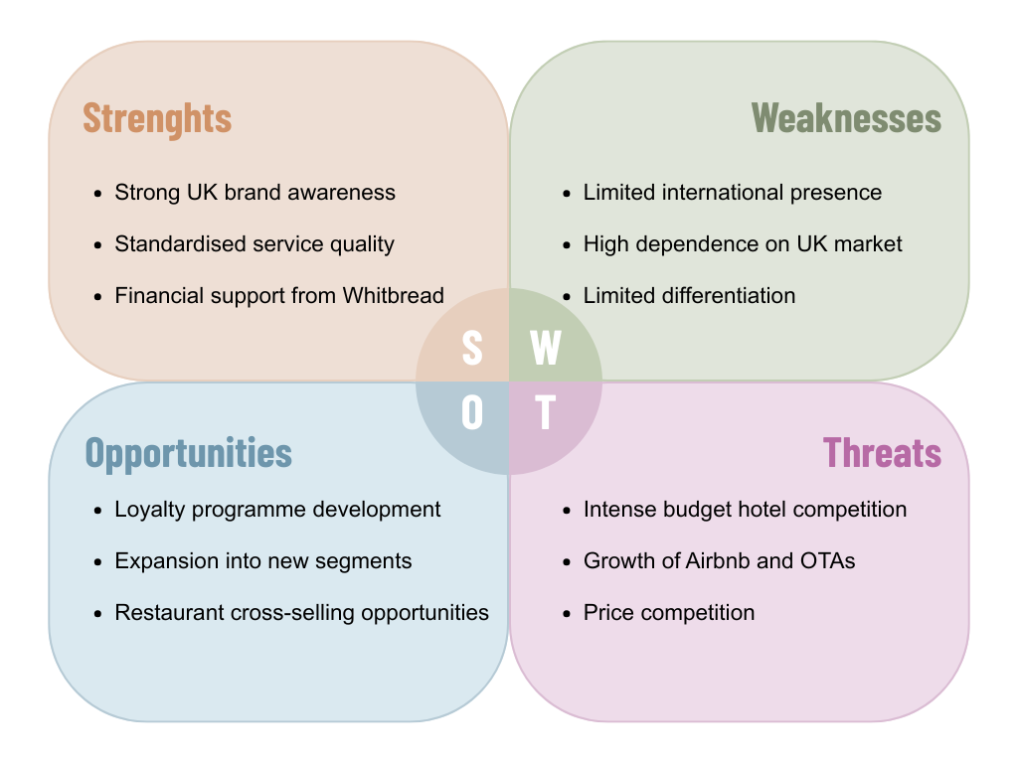

Appendix B: PESTEL Analysis
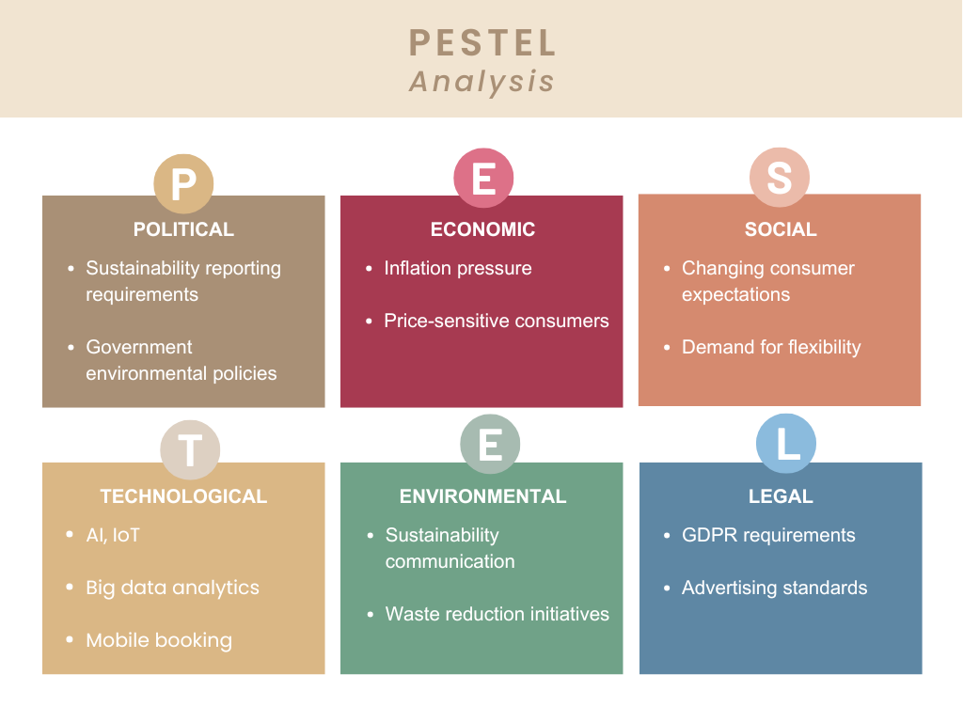

Appendix C: STP Analysis
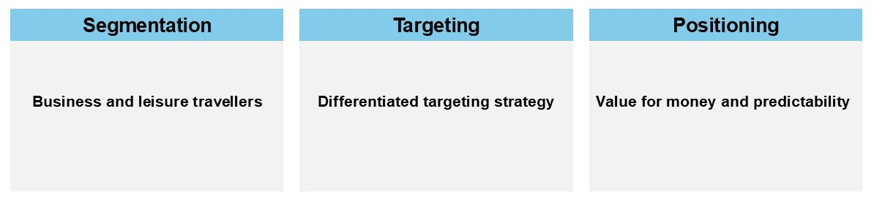

Appendix D: 7Ps Marketing Mix


