University of Wales Trinity Saint David

Community Engagement

LCBB4002

Reflective Evaluation
Role Play:Human Resource Manager
Lecturer’s Name:Dr. Navami Leena

Student Name:Neli Atanasova
Student Number: 1813125
Table of contents:
1. Introduction to Gibbs Reflective Cycle………………….…………..……...3
2. Role Play explained…………………………...………………….………....4
3. Reflection on the Role Play………………………………………..……..... 4
3.1. Description, Feelings & Evaluation….……………………….…..............4
3.2. Feedback ………………….………...……..………………….………….6
3.3 Analysis and Action plan ….…………………………………………... 6
4. Conclusion………………………………………………………………….7
References…………………………………………………. . . . .. . . . . .. . . 8
Appendix…………………………………………………………………….. 9

The purpose of this record is to evaluate the process of given business role play: the case of Human Resource Manager in Asda interviewing a prospective employee. The analysis will be made in the frame of Gibbs Reflective Cycle and on the basis of the feedback received by fellow students.
1. Introduction to Gibbs Reflection Cycle
Each process that occurs in the surrounding environment tends and is meant to be evaluated and explored by people in order to understand it and to improve it. Especially, when there is a simulation-learning process it needs to be addressed by appropriate steps and measures for the purpose of learning enhancement. In an article in Harvard Business Review is mentioned that “Research by Giada Di Stefano, Francesca Gino, Gary Pisano, and Bradley Staats in call centers demonstrated that employees who spent 15 minutes at the end of the day reflecting about lessons learned performed 23% better after 10 days than those who did not reflect” (Porter, J., 2017).
The paper in HBR is focused more on personal reflection in each micro daily task. Hence, for the purpose of this report, the Gibbs Reflective Cycle is going to be used, as it is a well-established form of evaluation in business environment. Below is a graphic representation of the reflective principle developed by Graham Gibbs.
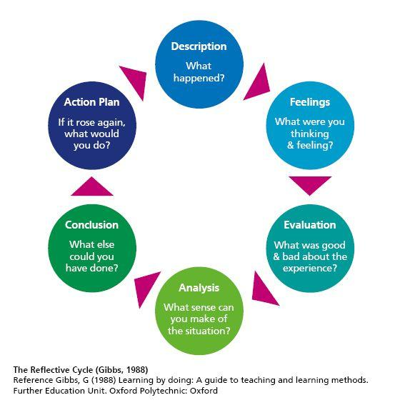
The model was introduced by Graham Gibbs in 1998 to structurize the learning outcome and experience. It suggests a cycle of steps or framework to critically evaluate an experience and to allow a future action plan. The reflection cycle contains six stages: presentation of the experience, feelings and thoughts on the process, evaluation with both good and bad parts of the experience, analysis to reflect on the experience, conclusion and action plan on what has to be improved or done in a different and better way (The University of Edinburgh, 2019).
2. The Role Play explained
During the education session, a role play was emulated for the purpose of understanding the concept of transferable skills and their adoption in the business field. Further, the notion of community and personal development and their revival was the second outcome of the exercise.
In the particular case, I was in the role of human resource manager, representing Asda company. I was responsible for the effective recruitment and was interviewing Niya Petkova, a prospective candidate for a store assistant in one of London’s Asda Stores.
My role play was following the principles described in the book “Human Resource Management” which states that “In relation to recruitment, job analysis has traditionally sought to identify the key tasks and responsibilities which constitute a particular role and the knowledge, skills and abilities required to conduct those tasks and responsibilities.” (Torrington, D. et. al, 2014).
3. Reflection on the Role Play
This section will follow the six stages of the Gibb’s Reflective cycle divided into two main paragraphs, but not compromising on the full analysis. The report will reveal the relationship between relevant theory and the experienced simulation.
3.1 Description, Feelings & Evaluation
The interview started with a warm greeting from me towards Niya Petkova and a cheerful prompt asking her to take a seat. Almost immediately after that, I presented myself and the process that is going to take place. After the candidate responded, I offered her to bring her a glass of water. During these first moments of encounter, I was calm and polite. The kind gesture of offering the glass of water is very important, as the person being interviewed needs to feel welcomed and relaxed. As an article by Derek Doeing suggests, the interview process most probably includes certain level of anxiety, no matter which site of the table the person is sitting at (Doeing, D., 2019).
In the next phase, I started the interview with the first question which is quite broad, as it needs to open the topic, and is related to the most relevant job experience that the candidate possess. I had prepared printed the application documents of the candidate and in the beginning I made sure that she knows the documents have been read,understood and that I show a certain level of interest about the experience shown in the them. After the positive answer, a clarifying question follows up and Niya Petkova reveals the specific sides of experience that she was asked about. Shortly afterwards, I had a question that goes in more depth, about the way the candidate had perceived the customers in her previous position. The question is perceived by the candidate as an ad hoc towards her personal experience and psychological point of view. The feeling is backed by the next topic about the positive and negative sides of the personality of the candidate, according her personal beliefs.
Next, I have a question about experience on specific software system that is going to be used in Asda company. There is a positive answer again and I encourage the candidate, listen carefully to her answers and avoid any interruption. Finally, I had a question to understand the knowledge of the candidate on the company, the job offer and what was she attracted by. The answer leads me to the last question about team working and how she finds it. Because the candidate shared a positive feedback from her friend, an employee of the company, I was able to easily switch to the topic of team work and what it means to Niya Petkova. Lastly, as every Human Resource Manager must do, I ask if the candidate has any questions or claims on the interview and the position and we both said goodbye.
As for the first time on this side of the table during an interview process, I felt worried and my diction was revealing that. I was making some pauses and not pronouncing each word correctly. Critically, I need to be more serious and not so promising - as the candidate might felt that she already has been granted the job offer. The good part was the constant eye-contact and it was important and beneficial to me as I had to follow and understand the emotions of the candidate when a question was raised. Additionally, I made the candidate feel comfortable from the beginning and she was answering my questions without worries and with reliance.
3.2 Feedback
The feedback from the three people in charge was positive with predominantly high grades.

Petar Lambev rates the role play as short, sound, clear, realistic and interesting. In the end, he writes he got the impression that I have already done a dozen of interviews. This relates to certain level of expertise, which even that I did not have for the certain position, I succeed to “hide” and overcome my anxiety according to the listeners.
Penka Petrova has evaluated the performance as excellent and considers the discussion had a professional outlook.
Todor Dimitrov has also wrote positive feedback: “Very good introduction, very good questions… She was calm and concentrate which is very important.”
3.3 Analysis and Action Plan
The detailed analysis of the experiment role play shows affirmative results that I have performed very satisfactory in my role. Key factors are that I was aware of the mood I had to introduce the candidate to and to make her predisposed for a meaningful conversation. The structure of the interview was also outlined following universal guidelines. However, due to the fact I was feeling a bit nervous, I missed to ask follow-up questions at the end of the interview. A possible course of the interview might end with a question about specific situation that Asda’s employees encounter often, for example a missing click-and-collect order, and how would the candidate react to that. This would be beneficial to both sides, as I would understand how much the candidate has envision herself in the position she applies for and on the other hand, the candidate will eventually experience a tiny part of the routine or extraordinary situations in the company. In the future I need to continue to be so careful and considerate with the prospective candidates but also make sure I make the most out of the interview process, by asking even more explanatory questions.

4. Conclusion
In conclusion, the reflective evaluation cycle is a commonly used tool to understand better a given process, especially in a business environment. In the particular case, the interview tracking revealed very good practice from my side as the human resource manager with very short lacks in the explanatory questions due to anxiety. The overall experience was good and there is no purpose on emphasizing on small missing parts as practitioners tends to be easily focused only on things that did not go well (Oxford Brookes University).

References:

1. Doeing, D., (2019) 7 Interview Process Steps to Implement and Expect [online]. Available at: https://learn.g2crowd.com/interview-process-steps Assessed: 4th May, 2019
2. Porter, J., (2017) Why you should make time for self-reflection(Even if you hate doing it), Harvard Business Review, [online]. Available at: https://hbr.org/2017/03/why-you-should-make-time-for-self-reflection-even-if-you-hate-doing-it Assessed: 4th May, 2019
3. The University of Edinburgh (2019) Gibbs’ reflective cycle [online]. Available at: https://www.ed.ac.uk/reflection/reflectors-toolkit/reflecting-on-experience/gibbs-reflective-cycle Assessed: 4th May, 2019

4. Torrington, D., Taylor S. and Hall L.(2011) Human Resource Management, 8/E, Financial Times Prentice Hall, [online].Assessed: 4th May, 2019
5. Oxford Brookes University (2019) Reflective Writing: About Gibbs’ Reflective Cycle [online]. Available at: https://www.brookes.ac.uk/students/upgrade/study-skills/reflective-writing-gibbs/ Assessed: 4th May, 2019

Appendix


