LAURENTIU-COSTEL POPA
2126893
FOOD & BEVERAGE OPERATIONS (BMIH4002)
TRISTAN HAWKINS

REFERENCE LIST

Hotel Alexandra ah_wine_list.pdf (hotelalexandra.co.uk) (Aceesed 17/11/2022)

Cardiff Christmas Party Venues | Marriott UK Celebrations (memoriesmademarriott.co.uk) (Accessed 14/11/2022)

Christmas_Brochure_2022_NEWDESIGN_v3_email_spreads.pdf

Six cracking Welsh recipes for Christmas dinner Six cracking Welsh recipes for Christmas dinner where you can ditch the turkey - North Wales Live (dailypost.co.uk) (Accessed 12/11/2022)

The Best Value Michelin Star Menus in the UK - Hospitality & Catering News (hospitalityandcateringnews.com) (Accessed 15/11/2022)

THE OLD SHIP HACKNEY Christmas 2022 (oldshiphackney.com) (Accessed 13/11/2022)

Traditional Welsh winter celebrations Christmas and New Year breaks in Wales | Visit Wales (Accessed 12/11/2022)

Wales Ales launches 12 Beers of Christmas to showcase the best Welsh festive ales | InYourArea News (Accessed 16/11/2022)

Welcome to the Glen-Yr-Afon Wedding Venue & Hotel South Wales Wedding Venue & Hotel | Monmouthshire (glen-yr-afon.co.uk) (Accessed 13/11/2022)

THU SAT
19PM 02AM


20% DISCOUNT FOR BOOKING IN ADVANCE
FREE PARKING AVAILABLE

53 ARMTHORPE ROAD, DONCASTER
RESERVATIONS: 07764434486
www.triniti-hotel.co.uk

HO-HO-HO
Merry Christmas
2022

LIVE MUSIC & PIANO
CABARET SHOW
3-COURSE MEAL DEAL
BEVERAGES INCLUDED
A red Tie code is required
Limited seats: 150 Seated
Prebook and Deposit Required: 40£/pers, 20£/child, Infants FREE
Sad-Wed prices: 125£/adult, 90£/child (aged 2-16), Infants FREE
Thu-Sat prices: 135£/adult, 100£/child (aged 2-16), Infants FREE

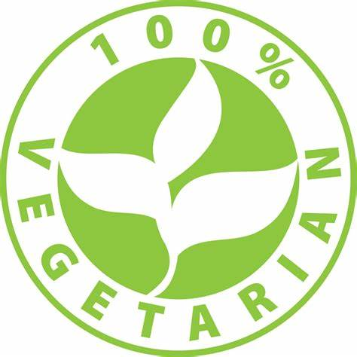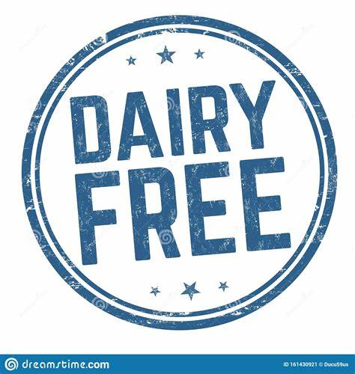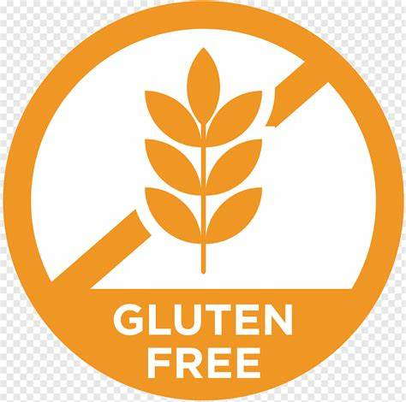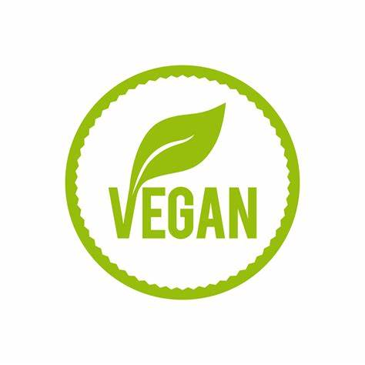
SUN WED
17PM 00AM
Beverages Included
From the House: Prosecco, Wine (Rose, White, Red)
Beers & Lager: Stella, Glamorgan, Purple Moose, Heineken, Amstel Ber, Fosters, Strongbow
Soft drinks: Coca-Cola, Coca-Cola Diet, Sprite, Fanta, Red Bull, Mineral Water
Cocktails: Bourbon Old Fashioned, Porn Star Martini, Long Island Iced Tea, Margarita,
Natural Drinks: Fresh Orange, Fresh Lemonade
Others: Expresso, Coffee, Tea, Water

Extras
Moët & Chandon Imperial Brut - 60£
Mumm Cordon Rouge Brut Champagne - 55£
Lyme Bay Chardonnay (Red & White) - 55£
Chateau Soussans – Margaux - 90£

Christmas Menu
- (V) Vegetarian, (VE) Vegan, (GF) Gluten-free
- For any dietary or food allergies, please call us upon your arrival, and our assistants will help you to choose the ingredients from the Menu
- Arrival at 16PM (SUN-WED), 18PM (THU-SAT)
- Dinner is served at 18PM (SUN-WED), 20PM (THU-SAT)

Deserts
- Croutons & Creamy Squash Soup with a Taste of Parmesan (V)
- Soft-boiled Broccoli & Cauliflower Dressed in Chickpea Salad and Mild Chili Dressing (V), (VE)
- Pink Salmon & Mix Prawn on a Crispy Tart
- Duck Liver Parfait Mixed with Truffle Butter on a Bruschetta

- Sweet Potato Roulade with a rich Cajun taste (V), (VE), (GF)
- Glazed beetroot with baby spinach and a mix of dates and apples with pesto sauce (V)
- Maturated sirloin steak served with sautéed mushrooms and smoothly dried tomatoes, in peppercorn sauce
- Tasty lamb with herbs cooked with gin and cranberry sauce

- Chocolate truffle tart and grilled orange and passion fruit (V)
- Apple crumble pie juicy raisins (GF), (VE)
- Profiterole filled with chocolate liquor and bailey’s cream
- Christmas tree macaroons served with mango ice cream

Starters
Main Course

