Tyler Bate (2304031)

UniSport Platform
Assignment 2: Practical & Professional Development
Student Name: Tyler Bate
Student ID: 2304031
Programme: Computing
Module: Changemakers: Creativity and Value Creation
Module Code: ACCA5033
Lecturer: James MG Williams
Submission Date: 7th May 2026

Contents
1. Introduction 1
2. Task 1 – Practical Development / Implementation 2
2.1 Initial Feedback 2
2.2 Practical Implementation 3
2.3 Troubleshooting and Problem Solving 4
3. Task 2 – Enterprise & Innovation 5
3.1 Tech Start-up Overview 5
3.2 Business Strategy 6
3.3 PEST Analysis 6
3.4 Legal and Ethical Considerations 7
4. Task 3 – Project Feedback & Reflection 8
4.1 Practical Feedback 8
4.2 Project Progress Reflection 8
4.3 Knowledge and Skills Development 9
4.4 Positive Social Impact (PSI) 9
5. Conclusion 10
6. References 10
7. Appendices 11

1. Introduction
The purpose of this project was to design and develop a secure digital platform called UniSport that enables university students to discover sports clubs, join activities, register for events, and engage with sports communities through a centralised online system. The project was developed in response to the growing use of digital technologies within education, fitness, and student engagement environments. Many universities rely on disconnected communication systems such as social media groups, posters, and messaging applications, which can make it difficult for students to discover opportunities and remain engaged with sports communities.
The UniSport platform was designed as a web-based system using PHP, MySQL, HTML, CSS, and XAMPP. The project includes features such as user registration, club browsing, event management, RSVP functionality, and an administration dashboard. Throughout the development process, project management techniques, database design principles, user feedback methods, and software development practices were applied to support the implementation of the system.
This report documents the practical development of the project, enterprise considerations, user feedback, reflections on project management and technical skills, and the wider social impact the system could have within university communities.

2. Task 1 – Practical Development / Implementation

2.1 Initial Feedback
To gather initial feedback on the proposed UniSport platform, a questionnaire-based data collection method was designed using Google Forms. The questionnaire was distributed to four university students who regularly participate in sports activities or university societies. Participants were shown the early Base44 prototype, initial design work, and screenshots of the implementation process before being asked to provide feedback on usability, functionality, and visual design.
The questionnaire included both open and closed questions focusing on navigation, usability, design quality, and future improvements.
The feedback received was mostly positive. All participants agreed that the platform would be useful for university students and that a centralised sports management system could improve engagement with clubs and events. Participants particularly liked the ability to browse clubs, view events, and manage participation through a single platform. Several users stated that the design looked modern and easy to understand.
Some improvements were also suggested. One participant recommended implementing filtering and search functionality to help users locate clubs more quickly. Another suggested adding notification and reminder features to improve communication regarding upcoming events. Additional feedback highlighted the importance of mobile responsiveness.
Based on the feedback received, several changes were planned for the system. Search and filtering functionality was added to the club browsing page, and improvements were made to the navigation layout to make the interface more intuitive. Future development considerations included push notifications and mobile optimisation to improve accessibility and user engagement.
User feedback is an important part of software development because it helps developers identify usability issues and improve the system before deployment [1]. Collecting early feedback also supports user-centred design principles by ensuring that the final platform aligns with the needs and expectations of the intended audience.

2.2 Practical Implementation
The practical implementation of the UniSport platform involved the development of a database-driven web application using PHP, MySQL, HTML, CSS, and JavaScript. XAMPP was used as the local development environment because it provides Apache, PHP, and MySQL services within a single package, making it suitable for academic web development projects.
Before implementation began, a prototype was created using the Base44 design platform. The prototype helped visualise the layout and user interface of the final system and identify improvements before implementation. Research has shown that user interface design and usability significantly influence user engagement and retention within digital platforms [2].
The first stage of implementation involved configuring the development environment. XAMPP and phpMyAdmin were installed to manage the MySQL database, while Notepad++ was used as the primary code editor for PHP, HTML, CSS, and JavaScript development.
The next stage involved creating the database schema using phpMyAdmin. Several relational tables were developed, including users, clubs, memberships, events, announcements, and event RSVP records. Foreign keys and primary keys were implemented to maintain referential integrity between the tables. An Entity Relationship Diagram (ERD) was also created during the design phase to visually represent the relationships between the database entities. Relational database design principles such as entity relationships, normalisation, and structured querying were important considerations throughout the implementation process [10].
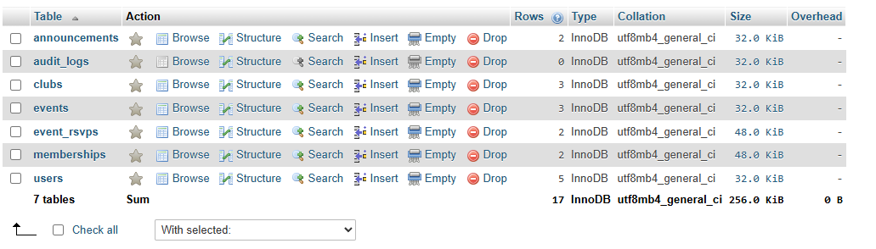
Figure 1: Database structure and relationships.
The front-end implementation began with the development of the homepage (index.php), which acts as the dashboard for the platform. The page includes navigation links, club statistics, event information, and featured sports clubs. Additional pages were then developed, including clubs.php, events.php, club.php, login.php, register.php, and an administration dashboard.
The administration dashboard allows administrators to create clubs, manage sporting events, and review membership requests.
User authentication was implemented using PHP sessions and password hashing techniques. Passwords are securely stored using PHP’s password_hash() function, which improves system security and reduces the risk of unauthorised access [3]. Input validation and prepared statements were also implemented to reduce the risk of SQL injection attacks.
Several screenshots will be included within the final submission to demonstrate:
- Homepage implementation
- User registration and login pages
- Club management functionality
- Event management system
- Admin dashboard
- Database tables within phpMyAdmin
- RSVP functionality
- My Activity page
The implementation process demonstrated how database-driven web systems can be designed and developed using established software development tools and techniques.

2.3 Troubleshooting and Problem Solving
During the implementation process, several technical problems and development challenges were encountered. One issue involved database connectivity within PHP. Initially, the system displayed a connection error because the incorrect MySQL port number was being used. This was resolved by modifying the PDO database connection string to use the correct XAMPP port configuration.
Another issue involved page routing and navigation. The admin dashboard initially returned a “Page Not Found” error because the admin.php file was not saved in the correct project directory. The issue was resolved by ensuring the file was stored within the root UniSport project folder.
Additional challenges involved ensuring relationships between database tables functioned correctly. Foreign key constraints occasionally prevented records from being inserted because related records did not yet exist. These issues were resolved by reviewing the database structure and ensuring the correct order of data insertion.
Testing and debugging are essential parts of software development because they help developers identify faults before systems are deployed [4]. The Horizon Post Office scandal demonstrates the consequences of poor testing and weak system validation.
To reduce the risk of similar issues, the UniSport project implemented several software engineering practices, including:
- Use of prepared statements
- Structured database relationships
- Password hashing
- Incremental testing
- User feedback collection
- Local environment testing using XAMPP
Development tools such as version control systems, automated testing tools, and monitoring software could further improve the reliability of the system if developed at a larger scale [5].

3. Task 2 – Enterprise & Innovation

3.1 Tech Start-up Overview
The proposed technology start-up developed for this project is called UniSport. The platform is designed to provide a secure digital environment where university students can discover sports clubs, register for events, communicate with communities, and remain engaged with fitness activities.
The proposed business model would operate as a Software as a Service (SaaS) platform for educational institutions.
The business would initially operate as a private limited company because this legal structure provides limited liability protection while also supporting future expansion opportunities.

Figure 2: UniSport logo.

3.2 Business Strategy
Mission Statement
To connect university students through sport by providing a secure, user-friendly digital platform that makes it easy to discover clubs, join events, and stay active within a supportive community.
Objectives
- Develop a functional platform that enables students to browse sports clubs, register for events, and manage participation.
- Increase student engagement in university sports through a centralised digital platform.
- Ensure platform security and reliability through secure authentication and database protection methods.
- Enhance usability by developing a modern, responsive, and intuitive user interface.
Business Values
- Accessibility
- Community
- Innovation
- Security
- Wellbeing
A strong business strategy is important because it helps organisations align their technical solutions with user needs and long-term goals [6].

3.3 PEST Analysis
Political Factors
Universities operate within regulated educational environments that require compliance with data protection and safeguarding policies. GDPR regulations require organisations to protect personal data and process information securely. Educational institutions also increasingly promote student wellbeing and participation in extracurricular activities, which supports systems such as UniSport.
Economic Factors
Universities may seek cost-effective digital solutions that improve student engagement while reducing administrative workload.
Social Factors
There is increasing awareness of the importance of physical activity and mental wellbeing among university students. Sports participation has been linked to improved physical health, reduced stress, and stronger social connections [7]. A platform such as UniSport could encourage greater participation in university sports communities.
Technological Factors
Advances in web technologies and mobile platforms make digital sports management systems more accessible and scalable.

3.4 Legal and Ethical Considerations
Several legal and ethical considerations were identified during the development of the project. The system stores user account information, meaning data protection and privacy are important considerations. Password hashing and secure authentication methods were implemented to improve security and reduce risks associated with unauthorised access.
The project also considered ethical responsibilities regarding inclusivity and accessibility. The interface was designed to remain simple and easy to navigate so that users with varying technical abilities could access the platform.
If deployed within a real university environment, additional legal considerations would include:
- GDPR compliance
- Data retention policies
- Accessibility standards
- Cybersecurity monitoring
- Terms of service agreements
Secure software development practices are essential because weak security controls can expose organisations and users to significant risks [8].

4. Task 3 – Project Feedback & Reflection

4.1 Practical Feedback
Following the completion of the main implementation stage, a second feedback questionnaire was created to evaluate the practical implementation of the UniSport platform. Participants were asked questions relating to functionality, usability, design, reliability, and future improvements.
Overall feedback was positive. Most users stated that the platform was easy to navigate and visually clear. Features such as browsing clubs, joining events, and using the dashboard were identified as particularly useful. Participants also believed that the technologies used, including PHP, MySQL, and XAMPP, were suitable for this type of system.
Some participants suggested additional features such as mobile notifications and event reminders.
Based on the feedback received, future development could include:
- Push notifications
- Mobile application support
- Enhanced filtering systems
- Social interaction features
- Integration with fitness tracking technologies
User testing demonstrated the importance of collecting feedback throughout the software development lifecycle [9].

4.2 Project Progress Reflection
Throughout the project, weekly project progress sheets were completed to help monitor development stages and maintain project organisation. The progress sheets documented implementation activities, actions for the following week, and areas requiring improvement.
Using the progress sheets improved time management and helped ensure the project remained aligned with the original objectives. The use of a Gantt chart and weekly reviews also helped break the project into manageable stages, including design, implementation, testing, and documentation.
If the project were undertaken again, additional time would be allocated to interface design and advanced functionality. Earlier implementation of user testing could also help identify usability improvements sooner.

4.3 Knowledge and Skills Development
Throughout the development of the UniSport platform project, significant project management and technical skills were developed.
One of the key project management skills gained was the ability to plan and manage software development tasks using timelines, progress sheets, and structured requirements documentation. Creating requirements specifications and managing development phases improved organisational skills and helped reduce scope creep.
The project also improved technical skills in:
- PHP web development
- MySQL database design
- XAMPP server configuration
- User authentication systems
- ERD creation
- User interface design
- Security implementation
The use of Base44 for prototyping improved understanding of UI/UX design principles and helped visualise the final system before implementation.
Overall, the project provided valuable practical experience for future software development projects.

4.4 Positive Social Impact (PSI)
The UniSport platform could have several positive social impacts within university communities. One major benefit is encouraging increased participation in sports and fitness activities. Physical activity has been linked to improved physical health, reduced stress, and better mental wellbeing among students [7].
The platform could also help reduce social isolation by making it easier for students to discover clubs, events, and communities that match their interests. This is particularly important for first-year students and international students who may find it difficult to connect with others.
In addition, the project demonstrates how digital technologies can be used to support community engagement and wellbeing rather than focusing solely on commercial outcomes. The technical and project management skills developed throughout the project could also support future employability opportunities within software development and digital industries.

5. Conclusion
In conclusion, the UniSport project successfully demonstrated the design and development of a secure digital platform for university sports clubs and event management. The project combined database design, web development, user feedback, and project management techniques to create a functional prototype system.
The implementation process provided valuable experience in PHP development, database management, user-centred design, and software security. Feedback collected throughout the project helped improve usability and highlighted areas for future development.
Overall, the project demonstrated how digital platforms can support student engagement, community participation, and wellbeing within university environments while also developing practical technical and professional skills.

6. References
[1] Interaction Design Foundation, “User Experience (UX) Design and Why It Matters.” Available: https://www.interaction-design.org/literature/topics/ux-design. Accessed: Mar. 9, 2026.
[2] Interaction Design Foundation, “User Experience (UX) Design and Why It Matters.” Available: https://www.interaction-design.org/literature/topics/ux-design. Accessed: Mar. 9, 2026.
[3] OWASP Foundation, “Password Storage Cheat Sheet.” Available: https://cheatsheetseries.owasp.org/cheatsheets/Password_Storage_Cheat_Sheet.html. Accessed: Mar. 9, 2026.
[4] I. Sommerville, Software Engineering, 10th ed. Harlow, U.K.: Pearson, 2016.
[5] R. Hanslo and M. Tanner, “Critical Success Factors for Agile Software Development,” 2026. Available: https://arxiv.org/abs/2602.04467. Accessed: Mar. 9, 2026.
[6] M. Porter, Competitive Strategy: Techniques for Analyzing Industries and Competitors. New York, NY, USA: Free Press, 2008.
[7] World Health Organization, “Physical Activity.” Available: https://www.who.int/news-room/fact-sheets/detail/physical-activity. Accessed: Mar. 9, 2026.
[8] LinkedIn Learning, Cybersecurity Foundations, 2024. Available: https://www.linkedin.com/learning/cybersecurity-foundations-22006082?u=77966930. Accessed: Mar. 9, 2026.
[9] K. Schwaber and J. Sutherland, The Scrum Guide, 2020. Available: https://scrumguides.org/docs/scrumguide/v2020/2020-Scrum-Guide-US.pdf. Accessed: Mar. 9, 2026.
[10] T. Connolly and C. Begg, Database Systems: A Practical Approach to Design, Implementation and Management, 6th ed. Harlow, U.K.: Pearson, 2015.

7. Appendices
Appendix A – Weekly Project Progress Sheets
Weekly Project Review Forms
Name: Tyler Bate (2304031)
Programme: Computing
Project Aim:
To design and develop a secure digital platform (UniSport) that enables university students to discover sports clubs, join events, and manage participation within a centralised system.
Project Objectives:
- Design a database structure to support users, clubs, and events.
- Develop a functional web-based platform using PHP and MySQL.
- Test the system with users and improve usability and functionality.
WEEK 1 — Design Phase
Date: 25/02/2026
Progress:
• Began the design phase of the UniSport platform.
• Created the initial system requirements specification, including functional and non-functional requirements.
• Designed the Entity Relationship Diagram (ERD) to define database tables such as users, clubs, memberships, and events.
• Selected the Agile development methodology to guide project development.
Actions:
- Review and refine the system design documentation.
- Prepare database structure for implementation.
- Install and configure development tools (XAMPP and Notepad++).
Next review date: 04/03/2026
WEEK 2 — Prototype Development / Implementation Start
Date: 04/03/2026
Progress:
• Began the implementation stage of the UniSport platform.
• Installed and configured XAMPP to support local web server and database development.
• Created the initial project folder structure and index.php file.
• Developed a basic homepage layout for the system.
Actions:
- Create database tables in MySQL using phpMyAdmin.
- Develop basic navigation and user interface layout.
- Test system functionality in the local development environment.
Next review date: 11/03/2026
WEEK 3 — Continued Development
Date: 11/03/2026
Progress:
• Continued development of the UniSport platform interface.
• Designed pages for browsing clubs and viewing events.
• Connected the website to the MySQL database.
• Began implementing basic user interface styling and layout.
Actions:
- Develop club and event management features.
- Improve user interface design and navigation.
- Continue testing system functionality.
Next review date: 18/03/2026
WEEK 4 — Core Feature Development
Date: 18/03/2026
Progress:
• Implemented additional system functionality, including club listings and event display features.
• Tested database connectivity and page functionality.
• Reviewed system design to ensure alignment with project requirements.
Actions:
- Finalise core system features.
- Identify and fix any errors or bugs in the system.
- Prepare system for user testing stage.
Next review date: 25/03/2026
WEEK 5 — User Testing & Feedback
Date: 25/03/2026
Progress:
• Began user testing of the UniSport platform.
• Created and distributed feedback questionnaires to participants.
• Collected feedback on system usability, design, and functionality.
Actions:
- Analyse feedback results from participants.
- Identify areas for system improvement.
- Plan updates to improve usability and performance.
Next review date: 01/04/2026
WEEK 6 — System Improvements
Date: 01/04/2026
Progress:
• Reviewed feedback received from user testing.
• Identified improvements to system navigation and layout.
• Updated system features based on user suggestions.
Actions:
- Implement system improvements.
- Conduct additional testing to ensure reliability.
- Prepare system for final development completion.
Next review date: 08/04/2026
WEEK 7 — Finish Development Work
Date: 08/04/2026
Progress:
• Completed final system development tasks.
• Tested system functionality and performance.
• Ensured system features met project requirements.
Actions:
- Finalise system documentation.
- Prepare deployment planning.
- Review system readiness for submission.
Next review date: 15/04/2026
WEEK 8 — Deployment Planning
Date: 22/04/2026
Progress:
• Planned system deployment and final project submission.
• Reviewed system files and ensured all components were functioning correctly.
• Prepared final screenshots and supporting documentation.
Actions:
- Finalise project report.
- Review all system documentation.
- Prepare for final submission.
Next review date: 29/04/2026
WEEK 9 — Reflection & Report Writing
Date: 29/04/2026
Progress:
• Completed final reflection and documentation sections.
• Reviewed project outcomes and learning experiences.
• Prepared final submission materials.
Actions:
- Proofread and finalise project report.
- Ensure all evidence and documentation are included.
- Submit completed project.

25/03/2026
Appendix B – Feedback Questionnaires
Google Forms questionnaire responses:
https://docs.google.com/spreadsheets/d/16oP-IG-mgUF3CrOLztk7CirlJAGjUJY6aF1V7bZvBww/edit?usp=sharing
Appendix C – Screenshots of Practical Implementation
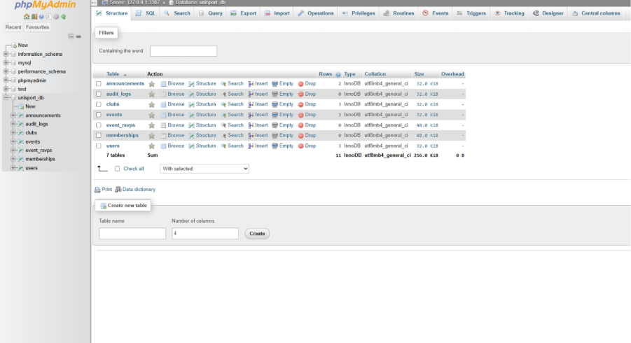
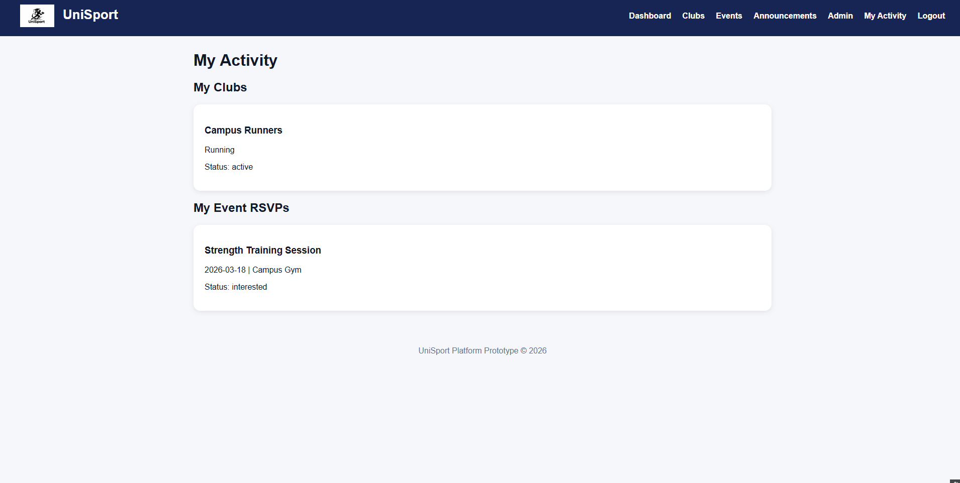
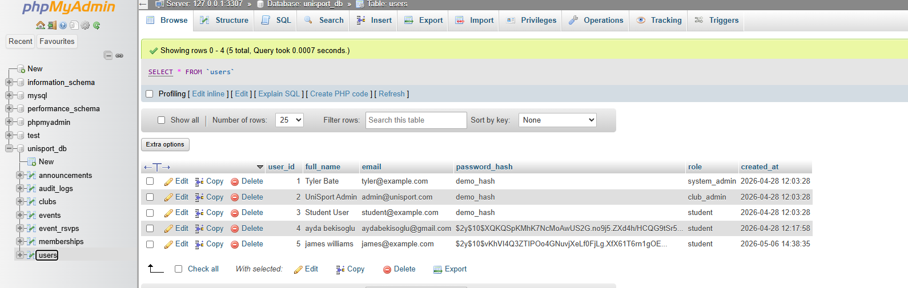
The screenshots and demonstration video show the relationship between user account creation and database integration within phpMyAdmin.. Account for James created in the video, James is now in users. Password hashing also visible here. Use of platform is documented in the video attached via link.
https://youtu.be/upupn8OdMmA

Appendix D – ERD Diagram
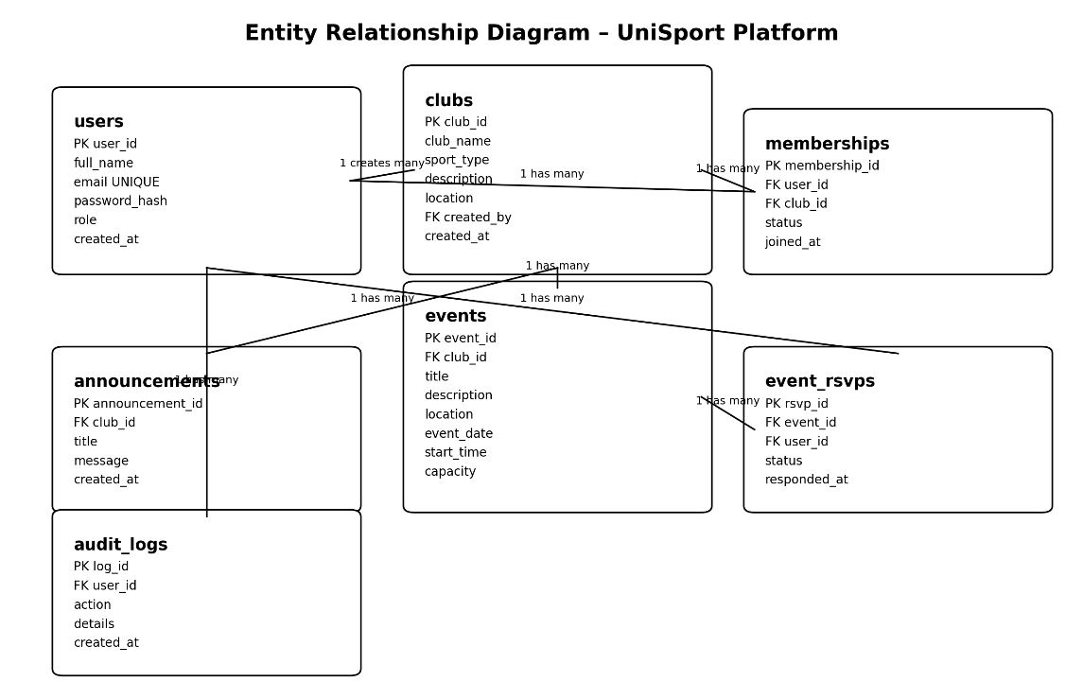
Admin system test credentials:
Username: admin
Password: admin123

