4/30/2026
Jolanta Pacek (2413830)
University of wales trinity saint david london
Computing Portfolio
Data Security and Compliance ACCA5034 Lecturer Dr Ayman Al Hajjar

Table of Contents
Introduction 3
Task 1 4
Securing the Hybrid Workforce: Protecting data beyond the corporate perimeter (ZTNA, SASE, DLP). 4
** Abstract-** 4
Introduction 1
Task 2 2
Case Scenario 2
Summary 13
References 14

Introduction

The contemporary digital landscape is increasingly defined by hybrid work models, cloud computing and extensive organisational connectivity. While these developments have improved flexibility, productivity and operational resilience, they have simultaneously introduced complex cybersecurity challenges. Traditional perimeter-based security models are no longer effective where employees, devices and data operate across multiple locations, networks and cloud platforms. Consequently, organisations must adopt more adaptive approaches to protect information beyond the corporate perimeter. Hybrid work has expanded the attack surface, reduced visibility and increased exposure to phishing, ransomware, credential theft and leakage. This research evaluates the effectiveness of Zero Trust Network Access, Secure Service Edge and Data Loss Prevention. It argues that while each framework offers important benefits, none is sufficient alone. Effective protection requires an integrated, layered and continuously evolving security strategy capable of securing data regardless of location.

Task 1

Securing the Hybrid Workforce: Protecting data beyond the corporate perimeter (ZTNA, SASE, DLP).

** Abstract-** The emergence of hybrid work has transformed organisational operations by increasing flexibility and productivity while introducing significant cybersecurity challenges. Traditional perimeter-based security models are no longer sufficient in distributed environments where users, devices and data operate across multiple networks and cloud platforms. This shift has expanded the attack surface, reduced visibility and increased exposure to identity-based threats, misconfigurations and human error. This task critically analyses the security risks associated with hybrid work and evaluated the effectiveness of Zero Trust Network Access, Secure Access Service Edge and Data Loss Prevention. The study finds that while each framework addresses specific security concerns, none is sufficient in isolation. An integrated, layered security in hybrid environments depends on the combination of advanced technologies, strategic implementation and continuous adaptation to evolving threats.
**Keywords-**hybrid work, cybersecurity, zero trust, SASE, Data Loss Prevention, network security
The emergence of the hybrid work model has fundamentally transformed organisational operations, introducing both significant strategic advantages and complex cybersecurity challenges. While hybrid work enhances flexibility, employee satisfaction and operational resilience, it simultaneously disrupts traditional security paradigms that were built around clearly defined network perimeters. As employees increasingly access corporate systems from diverse locations, devices and networks, the long-standing assumption of a trusted internal network is no longer valid [1].
Traditional cybersecurity frameworks relied heavily on perimeter base controls, such as firewalls and virtual private networks (VPNs), which were designed to protect centralised infrastructures. However, this model fails to address the realities of modern distributed environments, where sensitive data traverses’ multiple networks, endpoints, and cloud platforms. VPNs, for instance, often provide overly broad access once authentication is achieved, increasing the risk of lateral movement within systems. Accordingly, organisations must adopt security strategies that prioritise identity verification, contextual awareness and data protection rather than relying solely on network boundaries [2].
This paradigm shift has led to the adoption of advanced security frameworks, including Zero Trust Network Access (ZTNA), Secure Access Service Edge (SASE) and Data Loss Prevention (DLP). While these technologies offer significant benefits individually, their true value lies in their integration within a comprehensive security architecture.
This assignment critically evaluates the challenges associated with hybrid work and assesses the effectiveness of ZTNA, SASE and DLP in mitigating these risks. It argues that only a layered, integrated approach can provide sufficient protection in contemporary digital environments.
Critical Analysis of Security Challenges in Hybrid Work
Expanding Attack Surface and Reducing Visibility
Hybrid work significantly expands the organisational attacks surface, introducing new vulnerabilities that are difficult to monitor and control. Unlike traditional environments, where security teams maintain direct oversight of infrastructure, hybrid models rely on decentralised access points, including personal devices, home networks and public
Wi-Fi connections [2].
This shift reduces organisational visibility, creating bind spots that attackers can exploit. For instance, unmanaged or poorly secured devices may lack updated security patches, making them attractive entry points for attackers. Additionally, the use of multiple endpoints complicates asset management, making it difficult for organisations to maintain an accurate inventory of devices accessing corporate resources.
From risk management perspective, decentralisation increases both the likelihood and potential impact of cyberattacks. The attack surface is no longer confined to a single network but distributed across numerous environments, each with varying levels of security. Furthermore, the lack of standardisation across devices and networks complicates the enforcement of consistent security policies.
Critically, traditional monitoring tool are often insufficient in this context, as they are designed for centralised infrastructures. This highlights the need for cloud native and identity-driven security solutions capable of operating effectively across distributed environments. Without such solutions, organisations risk losing control over their security posture.

Cloud Dependency and Structural Vulnerabilities
Cloud computing is a cornerstone of hybrid work, enabling seamless access to applications and data regardless of location. However, its adoption introduces structural vulnerabilities, particularly in relation to misconfigurations and inadequate access controls. Misconfiguration is consistently identified as a leading cause of data breaches, often resulting from human error or insufficient governance [3].
Moreover, multi-cloud strategies, while beneficial for resilience and scalability, further complicate security management. Each cloud platform has its own configuration requirements, security models, and compliance frameworks. This diversity increases the risk of inconsistencies, creating gaps that attackers can exploit.
Another critical issue is the shared responsibility model in cloud environments. While cloud providers are responsible for securing the underlying infrastructure, organisations remain responsible for securing their data, applications and access controls. Misunderstanding this division of responsibility can lead to critical security gaps.
From a critical standpoint, the issue is not inherent to cloud technology itself, but rather to how organisations implement and manage it. Effective cloud security therefore requires not only technical solutions but also robust governance frameworks, continuous monitoring and organisational discipline.

Identity as the New Perimeter
One of the most significant shifts in cybersecurity is the transition from network based to identity-based threats. Attackers increasingly target user credentials through phishing, credential stuffing and social engineering attacks. Once authenticated, malicious actors can operate within systems with minimal resistance, effectively bypassing traditional security controls [3].
This evolution necessitates a fundamental rethinking of security strategies. Identity must be treated as the primary security boundary, with continuous verification mechanisms replacing static authentication models. Multi-factor authentication (MFA), behavioural analytics and risk-based authentication are critical components of this approach.
However, reliance on identity-based security also introduces new risks. For example, attackers may exploit weaknesses in authentication mechanisms, such as SIM swapping or MFA fatigue attacks. Additionally, poorly implemented identity
management systems can lead to privilege escalation and excessive access rights.
Therefore, identify- centric security must be complemented by contextual and behavioural analysis, ensuring that access decisions are based not only on credentials but also on user behaviour, device posture and environmental factors.
Human Error and Organisational Culture
Human factors remain a persistent and complex challenge in cybersecurity. In hybrid environments, employees often operate outside controlled settings, increasing the likelihood of errors such as using insecure Wi-Fi networks, reusing passwords, or mishandling sensitive data [4].
Importantly, cybersecurity is not solely a technical issue but also a cultural one. Organisational that fail to promote security awareness and accountability are more likely to experience breaches. Employees may prioritise convenience over security, particularly when security controls are perceived as obstacles to productivity.
However, relying exclusively on user behaviour is insufficient as human error cannot be eliminated. Even well-trained employees may fall victim to sophisticated attacks.
Therefore, effective security strategies must combine user education with automated enforcement mechanisms. Security controls should be designed to minimise reliance on human judgement, ensuring consistent protection regardless of individual actions.
Evaluation of Zero Trust Network Access (ZTNA)
ZTNA represents a fundamental departure from traditional security models,
emphasising continuous verification and privilege access [1][5]. Its primary strength lies in its ability to address identity- based threats, which are increasingly prevalent in hybrid environments [1].
ZTNA significantly reduces the risk of lateral movement within networks by limiting user access to specific applications rather than entire networks. This granular approach ensures that even if credentials are compromised, the potential damage is contained.
additionally, ZTNA’s context aware authentication enhance security by incorporating factors such as device health, location and user be behaviour. This dynamic approach allows organisations to adapt access policies in real time, improving resilience against evolving threats.
Another advantage is improved visibility. ZTNA solutions provide detailed insights into user activity, enabling organisations to detect anomalies and respond more effectively to incidents.
Despite its advantages, ZTNA is not a comprehensive solution. It primarily focuses on access control not does not address all aspects of cybersecurity, such as data protection or network performance optimisation.
Furthermore, its implementation can be complex, requiring significant changes to existing infrastructure and process. Legacy systems may not be easily compatibles with ZTNA, creating additional challenges.
Critically, ZTNA should be viewed as a foundational component rather than a standalone solution. Without integration with other security technologies, its effectiveness remains limited.
Evaluation of Secure Access Service Edge (SASE)
SASE extends the capabilities of ZTNA by integrating networking and security into a unified cloud- based architecture, a concept originally defined and popularised by Gartner [6][7].
SASE provides a holistic approach to security, combining technologies such as secure web gateways, cloud access security brokers and firewall as a service within a single framework. The integration enables consistent policy enforcement across all users and devices.
Moreover, SASE improves performance by processing traffic closer to the user, reducing latency and enhancing user experiences. This is particularly important in hybrid environments, where performance issues can impact productivity.
Its scalability also makes it suitable for organisations undergoing digital transformation. As businesses grow and adopt new technologies, SASE can adopt to changing requirements.
However, SASE implementation requires significant organisational change. Transitioning from traditional network architectures to a cloud- based model redesigning infrastructure, retaining staff and integrating multiple technologies.
Additionally, reliance on a cloud-based infrastructure introduces concerns related to vendor dependency, data sovereignty and regulatory compliance. Organisations must carefully evaluate providers to ensure alignment with the security and compliance requirements.
From a critical perspective, while SASE offers a comprehensive framework, its effectiveness depends heavily on proper implementation and governance. Despite widespread industry promotion, Zero Trust is often misunderstood as a complete solution rather than a strategic approach. In practice, organisations frequently implement partial Zero Trust models, which may create a false sense of security. Similarly, SASE is sometimes adopted as a trend driven solution without fully addressing organisational readiness, leading to fragmented or ineffective implementations.
Evaluations of Data Loss Prevention (DLP)
DLP focuses on protecting sensitive data, Addressing a critical gap in many security strategies. In hybrid, environments, where data is frequently shared across multiple platforms, DLP plays a vital role in preventing data breaches [8].
DLP provides granular control over data usage, enabling organisations to monitor, detect and prevent unauthorised data transfer [8]. Its ability to classify data ensures that sensitive information receives appropriate protection [8].
The integration of artificial intelligence enhances DLP capabilities, enabling the detection of anomalous behaviour and potential data exfiltration attempts. Theis allows organisations to identify threats that may not be visible though traditional monitoring tools [9].
However, DLP solutions can generate false positives, potentially disrupting legitimate business activities. Overly restrictive policies may hinder productivity, leading to user frustration and potential workarounds.
Additionally, DLP effectiveness depends on accurate data classification, which can be difficult to achieve in complex environments with large volumes of unstructured data. Critically, DLP should not be viewed as a standalone solution but as part of a broader security strategy.
Comparative Analysis and Integration
While ZTNA, SASE and DLP each address specific aspects of cybersecurity, their individual limitations highlight the need for integration.
- ZTNA focuses on access control
- SASE ensures secure connectivity and visibility
- DLP protects data itself
Individually, these technologies provide partial solutions. However, when integrated, they create a layered security model that addresses threats at multiple levels. This aligns with the principle of defence in depth, widely recognised as a best practice in cybersecurity [1]. For example, if an attacker gains access to user credentials:
- ZTNA limits access to specific resources
- SASE detects anomalous behaviour
- DLP prevents sensitive data exfiltration
This Layered approach significantly reduces both the likelihood and impact of breaches. While integrated security models offer significant advantages, they also introduce inherent trade-offs between security, usability and cost. Highly restrictive Zero Trust policies may negatively impact user experience and productivity leading employees to seek workarounds. Similarly, SASE centralisation can create performance bottlenecks or over-reliance on single vendors. This highlights a fundamental tension between security and operational efficiency, which organisations must continuously balance.
One important consideration that further strengthens the argument for an integrated security model is the issue of interoperability and architectural complexity. While ZTNA, SASE and DLP collectively enhance security, integrating these technologies across hybrid environments is not inherently seamless. Organisations often rely on multiple vendors, each offering distinct capabilities and proprietary frameworks. This can result in fragmented security architectures, where tools operate in silos rather than as a unified system. Consequently, gaps in communication between systems may reduce overall effectiveness, particularly in incident detection and response.
Moreover, the success of integration depends heavily on organisational maturity. Companies with limited cybersecurity expertise may struggle to configure and maintain these solutions effectively, leading to misconfigurations like those observed in cloud environments. This reinforces the argument that technology alone is insufficient without appropriate governance, skilled personnel and continuous monitoring.
Another critical issue is the balance between automation and human oversight. While AI- driven security solutions enhance threat detection, over-reliance on automation may introduce new risks, such as incorrect threat classifications or delayed human intervention in complex incidents. Therefore, organisations must adopt a hybrid approach that combines automated processes with expert analysis.
From a strategic perspective, integration should not be viewed as a one-time implementation but as an ongoing process of optimisation. As threats evolve, organisations must continuously reassess how ZTNA, SASE and DLP interact within their security ecosystem. This highlights that cybersecurity in hybrid environments is not a static goal but a dynamic capability requiring continuous adaptation.
A practical example can be observed in organisations that transitioned to hybrid work during the COVID-19 pandemic. Initially, many relied on VPN based access, which quickly proved insufficient due to scalability and security limitations.
A real-world example of this approach can be seen in Google’s BeyondCorp model, which eliminates reliance on traditional VPNs by implementing Zero Trust principles across all access requests. Similarly, Microsoft has adopted a comprehensive Zero Trust architecture integrating identity, device compliance and data protection through its cloud ecosystem. These examples demonstrate how large organisations operationalise ZTNA, SASE, like architectures and DLP in a cohesive security strategy
[4][6].
Subsequently, organisations adopted Zero Trust architecture combined with cloud-based frameworks. ZTNA reduced reliance on VPNs, SASE improved performance and consistency and DLP ensured compliance with data protection regulations.
While these changes improved security posture and user experience, they required significant investment and organisational change, highlighting the complexity of modern cybersecurity transformation.
The future of cybersecurity in hybrid environments will be shaped by technological advancement and evolving threats. Artificial intelligence and automation will play a central role in enabling faster threat detection and response [9].
Organisations will increasingly adopt data centric security models, focusing on protecting information rather than infrastructure. Zero Trust Principles will continue to evolve, incorporating more advanced identity and behavioural analytics.
However, economic and organisational challenges remain significant. Smaller organisations may struggle to implement advanced solutions due to limited resources. Therefore, a phased and strategic approach is essential to ensure successful adoption.
Hybrid work has fundamentally redefined the cybersecurity landscape, necessitating a shift away from traditional perimeter-based models. The distributed nature of modern environments introduces risks that cannot be addressed through conventional approaches [1].
ZNTA, SASE, DLP provide a strong foundation for securing hybrid workforces. However, the effectiveness depends on integration within a comprehensive, layered strategy.
Ultimately, securing data beyond the corporate perimeter requires not only advanced technologies but also strategic alignment, organisational commitment and continuous adaptation to evolving threats.
Therefore, it can be argued that no single framework is sufficient in isolation.
Instead, cybersecurity effectiveness in hybrid environments depends on the orchestration of multiple integrated technologies, rather than reliance on individual solutions. The ability of organisations to strategically align, manage and continuously adapt these frameworks is ultimately more critical than the specific technologies themselves.

Introduction

MediTrust Analysis Ltd is an expanding HealthTech organisation that delivering artificial intelligence (AI)- powered clinical support systems through a complex multi-cloud infrastructure. The organisation processes highly sensitive data, including electronic patient records, diagnostic imaging and IoT monitoring data. As it expands into the Europe, MediTrust must comply with strict regulations such as GDPR, DORA and the NIS2 Directive. The healthcare sector is particularly vulnerable due to the criticality of services and sensitive data.
The finding of Task 1 is directly relevant to this case. Earlier research demonstrated that hybrid work, cloud dependency and the erosion of the traditional network perimeter have made static, perimeter-based security models increasingly ineffective. They also showed that Zero Trust Network Access (ZTNA), Secure Access Service Edge (SASE) and Data Loss Prevention (DLP) work bets as part of an integrated security architecture.
this report proposes a Zero Trust security programme for MediTrust, combining governance, identity security, secure cloud design, compliance, risk management and continuous monitoring.

Task 2

Case Scenario

MediTrust Analytics Ltd is a rapidly evolving HealthTech organisation delivering artificial intelligence (AI)-driven clinical support systems through a complex multi-cloud infrastructure. The organisation processes highly sensitive healthcare data, including electronic patient records, diagnostic imaging and real-time data streams from Internet of Things (IoT) medical devices. As MediTrust expands its operations into the European Union, it becomes subject to stringent regulatory frameworks, including the General Data Protection Regulation [10], the Digital Operational Resilience Act [11] and the NIS2 Directive [12].
The hybrid workforce model and reliance on third-party services introduce significant cybersecurity risks, particularly in relation to data confidentiality, system integrity and operational resilience. Traditional perimeter- based security approaches are no longer
sufficient in distributed environments. Therefore, a Zero Trust architecture where trust is never assumed and verification is continuously enforced, provides a suitable strategic response. This report proposes a comprehensive, forward-looking security programme aligned with Zero Trust principles as defined by the National Institute of Standards and Technology [13], integrating governance, compliance risk management and advanced protection mechanisms.
In addition to the regulatory and technological challenges identified the increasing reliance on artificial intelligence introduces a new category of systemic risks beyond traditional cybersecurity concerns.AI systems not only process sensitive data but also generate outputs that may directly affect clinical outcomes. A compromised AI model could result in incorrect diagnoses, delayed treatments or biased outcomes, creating both ethical and legal implications [14]. Furthermore, the distributed nature of MediTrust’s infrastructure, spanning multiple cloud providers and third-party integrations, significantly increases the attack surface. This complexity necessitates a transition from reactive security approaches towards proactive and adaptive strategies. Zero Trust therefore should be understood not only as a technical framework but also as an organisational philosophy embedded across governance, processes and culture.
The effectiveness of a Zero Trust programme depends on a well-defined organisational structure that supports cross-functional integration and clear accountability. MediTrust should adopt a security structure built around strategic leadership and operational specialisation. At the executive level, the Chief Information Security Officer (CISO) is responsible for aligning cybersecurity strategy with organisational objectives and regulatory requirements. Supporting this role, the Cloud Security Architect ensures that all cloud environments are designed according to secure-by-design and Zero Trust principles, incorporating guidance from the Cloud Security Alliance [15]. The DevSecOps Lead plays a critical role in embedding security controls throughout the software development lifecycle [16], ensuring that vulnerabilities are identified and mitigated early.
Operational support is provided by the Security Operations Centre (SOC), which enables continuous monitoring and incident response, while the Risk and Compliance Officer ensure adherence to regulatory frameworks such as DORA [17] and NIS2 [18].
The inclusion of a Data Protection Officer (DPO) ensures compliance with GDPR requirements concerning personal data processing [19].
In a Zero Trust environment, rapid coordination between teams is essential, particularly during incident response scenarios. Collaboration between the Cloud Security Architect and DevSecOps Lead ensures that security controls are consistently applied across both infrastructure and application layers.
Additionally, integration of governance and operational roles enables MediTrust to bridge the gap between regulatory requirements and technical implementation. This is particularly important in the context of DORA and NIS2, where accountability, auditability and resilience must be demonstrable.

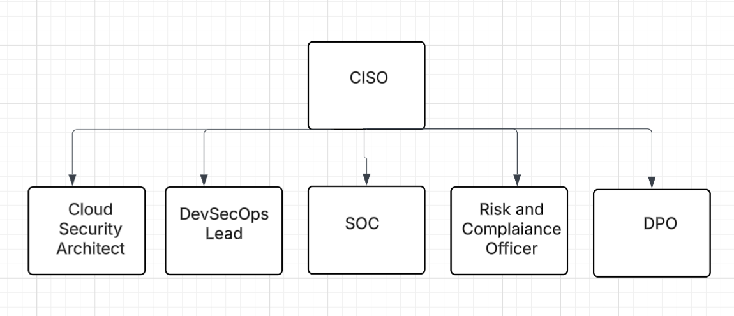

Figure 1 Organisational Structure
The structure facilitates a holistic approach to cybersecurity by integrating governance, engineering and operational capabilities.
Policies and Procedures
The implementation of formalised policies is essential to translate Zero Trust principles into operational practice. The AI Usage Policy must address the unique risks associated with machine learning systems, particularly data poisoning and adversarial manipulation. Additional risks include model theft, unauthorised extraction of proprietary algorithms and prompt injection attacks in AI-enabled applications. According to the European Union Agency for Cybersecurity [20], AI systems require continuous validation and monitoring to ensure data integrity and model reliability. Consequently, access to training datasets should be strictly controlled and all data must undergo validation processes.
The secure SaaS Configuration Policy must ensure that all cloud services are configured securely. This includes enforcing multifactor authentication, implementing role-based access control and continuously monitoring configurations using Cloud Security Posture Management tools. These measures align with best practices outlined by the Cloud Security Alliance [21].
AI security controls remain less mature than traditional cybersecurity controls.
As a result, MediTrust should review AI risks continuously and adapt governance as threats evolve.
In a hybrid working environment, the Bring Your Own Device (BYOD) Policy must ensure that personal devices do not compromise organisational security. Devices should be subject to compliance checks and Endpoint Detection and Response solutions must be deployed to monitor activity. Encryption of sensitive data on endpoints is essential.
By fostering a culture of security awareness, the organisation can reduce risks associated with insider threats, phishing and accidental data exposure. From a Zero Trust perspective, policies should be dynamically enforced through identity-aware and context-based access controls, ensuring that access decisions adapt to changing risk conditions.
Nevertheless, strict BYOD enforcement may create resistance from employees if security controls are perceived as intrusive. Therefore, security usability and clear communication are essential. For instance, a remote employee using an unpatched personal laptop on public Wi-Fi could expose credentials or sensitive patient data if device compliance controls are absent.
Regulatory Compliance: DORA and NIS2
Compliance with EU regulatory frameworks is central to MediTrust’s operational expansion. The Digital Operational Resilience Act [22] requires organisations to ensure resilience against ICT-related disruptions by implementing robust incident capabilities, conducting regular resilience testing and managing third-party risks. Similarly, the NIS2 Directive [23] imposes stricter cybersecurity requirements, including mandatory incident reporting within 24 hours and enhanced governance responsibilities. Notably, NIS2 emphasises supply chain security, requiring organisations to assess and manage risks associated with third-party dependencies. The integration of these regulatory requirements into a unified Zero Trust framework enables MediTrust to achieve both compliance and operational resilience, thereby reducing legal and reputational risks. This requires MediTrust to prioritise security investments based on the potential impact of risks on critical healthcare services.
DORA’ s focus on operational resilience encourages organisations to conduct regular stress testing and scenario-based exercises to ensure service continuity under adverse conditions. Similarly, NIS2 strengthens governance accountability by requiring senior management to actively oversee cybersecurity. This shift highlights the importance of integrating cybersecurity into overall business strategy rather than treating it as a purely technical function.
However, while these frameworks improve accountability and resilience, compliance may also create financial and governance pressures for expanding organisations such as MediTrust, particularly where specialist resources are limited. A prolonged outage affecting MediTrust’s cloud-hosted clinical platform could disrupt hospital access to decision-support services, making operational resilience a business-critical requirement.
MediTrust should introduce supplier assurance reviews, contractual security clauses and annual audits for critical third-party vendors.
Governance and Strategic Alignment (NIST CSF 2.0)
The proposed governance model is based on the Cybersecurity Framework developed by the National Institute of Standards and Technology [24]. This framework provides a structured approach to managing cybersecurity risks through five core functions: Identify, Protect, Detect, Respond, and Recover.

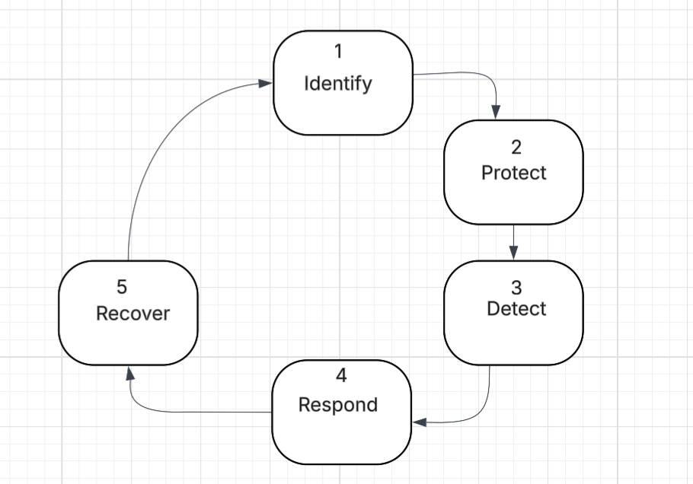
Figure 2 NIST CSF 2.0 Model
The Identify function focuses on asset management, including AI datasets and cloud resources. The Protect function involves implementing Zero Trust controls, encryption and identity management. The Detect function relies on advanced monitoring systems such as SIEM to identify anomalies. The Respond function ensures effective incident management, while the Recover function focuses on restoring operations through backup and recovery mechanisms. This framework aligns cybersecurity strategy with organisational objectives, such as ensuring patient trust, maintaining regulatory compliance and delivering reliable healthcare services.
All high-risk AI models should be subject to explainability testing, bias review and documented human oversight before production deployment.
Risk Management
MediTrust faces a range of cybersecurity risks, as particularly in relation to its software supply chain and cloud infrastructure. Supply chain attacks represent a significant threat, as malicious code may be introduced through third party dependencies. Additionally, AI systems are vulnerable to data poisoning, where adversaries manipulate training data to influence model outputs. Cloud misconfigurations further increased risk, as improperly configured storage or access controls can expose sensitive healthcare data.
To mitigate these risks, MediTrust should implement a Software Bill of Materials (SBOM) to maintain visibility over software components. Automated dependency scanning tools recommended by OWASP [25], should be integrated into the development pipeline. Furthermore, CSPM tools should provide continuous cloud monitoring.
An additional layer of risk arises from the interdependencies between cloud infrastructure and AI systems. A vulnerability in one component may propagate across the system, leading to cascading failures. For example, exposure of training datasets could compromise model integrity and impact clinical decision-making. To mitigate this, MediTrust should adopt a holistic risk management approach incorporating continuous risk assessment, real-time monitoring and threat intelligence. Zero Trust principles further reduces risk by limiting lateral movement and enforcing strict access controls across all systems.
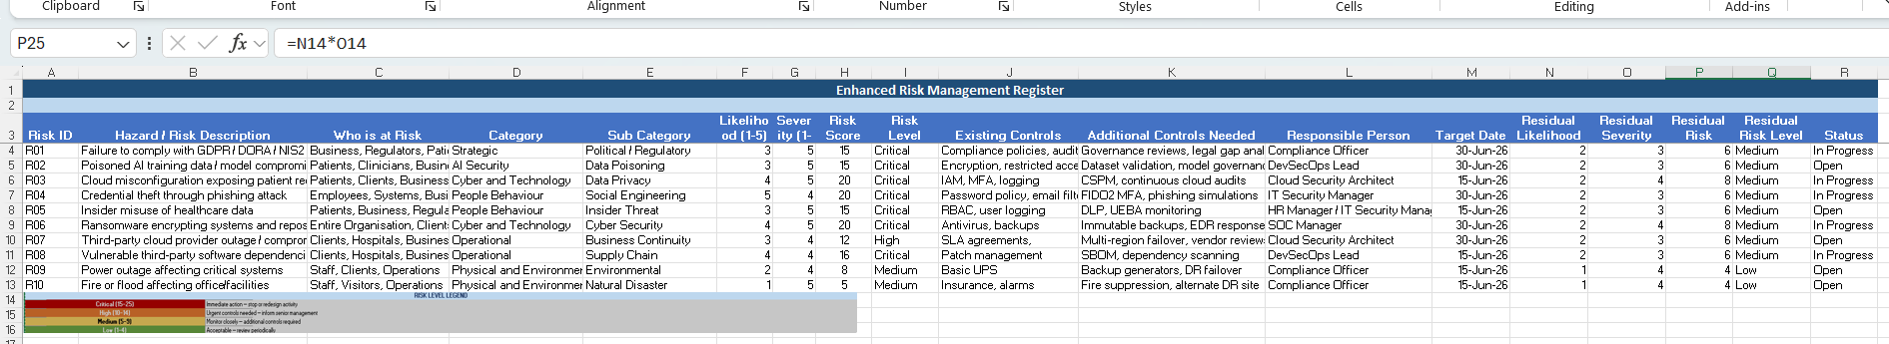
Figure 3. Risk Management Register
Risk Management Register.xlsx

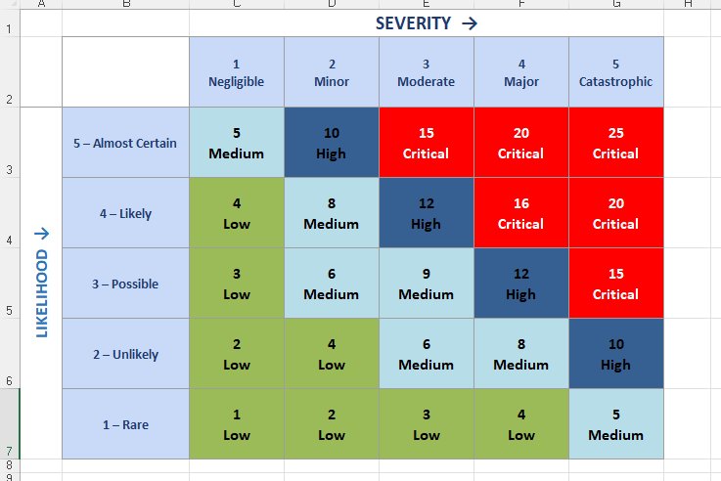
Figure 4. Risk Heatmap
Risk_Heatmap .xlsx
Unlike traditional systems, AI models may deteriorate over time due to data drift, unauthorised retraining or manipulation of model inputs. Security must therefore extend beyond infrastructure protection to include trust in outputs and decision quality.

Contingency Planning: Ransomware Scenario:
In a scenario where AI training data and source code repositories are encrypted, the organisation must be able to respond rapidly and effectively. Detection should be achieved through SIEM systems capable of identifying abnormal activity patterns. Once an attack is confirmed, affected systems must be isolated to prevent further spread. Recovery should involve restoring data from immutable backups, while ensuring that backup integrity is maintained. In compliance with NIS2 requirements, the incident must be reported within mandated timeframe [26].
In addition, to technical recovery measures, effective contingency planning must also address organisational coordination and communication. Clearly defined roles and escalation procedures ensure that response efforts are efficient and well-coordinated. Regular testing of disaster recovery plans, including simulated ransomware scenarios, enables MediTrust to evaluate and improve its response capabilities. Integrating Zero
Protection Mechanisms
The implementation of modern security controls is critical to supporting the Zero Trust architecture. Cloud Security Posture Management tools provide continuous visibility into cloud environments, while SIEM systems enable real-time threat detection. Endpoint Detection and Response solutions enhance the organisation’s ability to respond to threats through automation.
Phishing-resistant multifactor authentication mechanisms, such as FIDO2, significantly reduce the risk of credential compromise. Additionally, Zero Trust Network Access ensures that access decisions are based on identity and contextual factors rather than network location [27].
Zero Trust in AI Healthcare Platform
The practical application of the proposed framework can be demonstrated through an AI- based MRI analysis platform deployed across a multi-cloud environment. In this scenario, access to the system is mediated by the identity provider that enforces strict authentication requirements. A policy engine evaluated each request based on user identity, device posture and contextual risk factors. For example, if clinical analyst attempts to access patient imaging records from an unknown device, access should be blocked or limited until additional verification is completed.

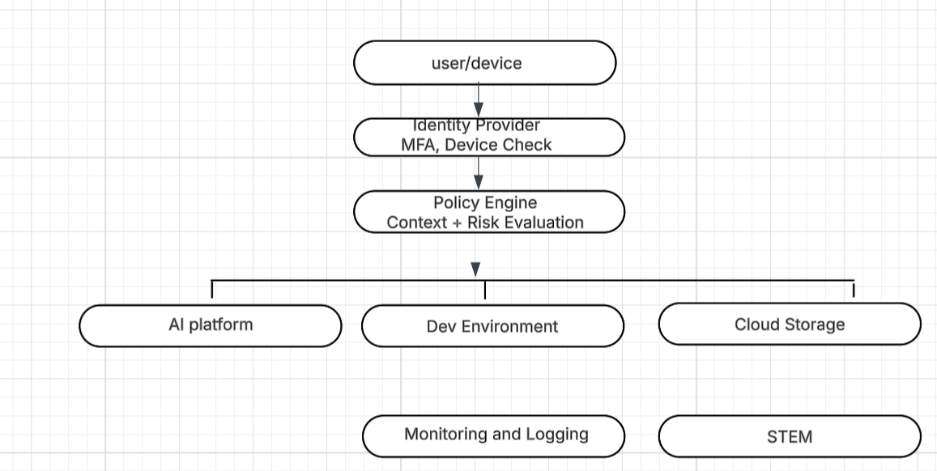
Figure 5 : Zero Trust Architecture
Workloads are segmented to prevent lateral movement, and all data is encrypted both at rest and in transit. Security controls are integrated into the DevSecOps pipeline, ensuring continuous assessment of vulnerabilities. This architecture demonstrates how Zero Trust principles can be effectively operationalised in a healthcare context.
Despite its advantages, the implementation of a Zero Trust model presents challenges. These include integrating security controls across multi-cloud environments, organisational change and continuous investment in security technologies and training. A phased implementation strategy is therefore recommended, prioritising critical systems and gradually extending Zero Trust principles across the organisation. This approach minimises disruption while enabling continuous improvement. In the long term, Zero Trust enhances not only security but also organisational agility, enabling MediTrust to innovate securely within a regulated healthcare environment.
The proposed Zero Trust aligned security programme provides MediTrust Analytics Ltd with a strategic approach to addressing cybersecurity challenges associated with AI systems, cloud environments and regulatory compliance. By integrating governance frameworks, advanced technologies and risk management practices the organisation can enhance resilience and maintain compliance with DORA and NIS2. Ultimately, this approach enables MediTrust to build trust with patients, partners and regulators while ensuring long-term sustainability.
Implementation Roadmap
To reduce disruption and manage cost, MediTrust should adopt a phased approach. Phase one should prioritise critical assets such as patient data repositories, identity systems and privileged accounts. Phase two should extend Zero Trust controls across cloud workloads, SaaS platforms and third-party access channels. Phase three should focus on optimisation through security automation, assurance testing and AI governance reviews.
This staged model enables measurable progress while maintaining business continuity. Key success indicators should include reduced privileged access accounts, faster incident detection times, improved patching compliance, successful backup recovery tests and lower phishing click rates. From strategic perspective, successful implementation will depend not only on technology deployment but also on organisational maturity. MediTrust should establish regular reviews, policy compliance checks and executive reporting cycles to ensure that Zero Trust controls remain effective over time. This is particularly important in healthcare where cybersecurity failures may affect not only information security, service continuity, patient trust and regulatory confidence. Continuous improvement should therefore be treated as a core principle of the programme rather than a final stage.

Summary
In conclusion, MediTrust Analytics Ltd requires a strategic cybersecurity programme capable of protecting sensitive healthcare data, AI systems and cloud infrastructure within a hybrid, regulated environment. Traditional perimeter security is no longer sufficient. A Zero Trust aligned model provides stronger protection through continuous verification, least privilege access and resilience by design.
By implementing an effective organisational structure, clear policies, compliance with GDPR, DORA and NIS2, formal risk management, tested disaster recovery plans and controls such as CSPM, SIEM, EDR and phishing-resistant MFA, MediTrust can reduce cyber risk.
Although implementation requires investment, governance maturity and organisational change, the long-term benefits include stronger resilience, regulatory confidence, patient trust and secure growth across the European healthcare market.

References

[1] "National Institute of Standards and Technology (NIST), “Zero Trust Architecture,”," pp.SP 800–207, 2020
[2] "Cybersecurity and Infrastructure Security Agency (CISA), Hybrid Identity Solutions Guidance," 2024
[3] "Cybersecurity and Infrastructure Security Agency (CISA), “Zero Trust Maturity Model," 2023
[4] "Microsoft, Security for Hybrid Workforce," 2025
[5] J. Kindervag, "No More Chewy Centres: Introducing the Zero Trust Model,” Forrester Research," 2010
[6] Gartner, "Secure Access Service Edge (SASE) Overview," 2026
[7] Gartner, "What is SASE?" 2026
[8] Microsoft, Data Loss Prevention (DLP) Overview," 2026
[9] Microsoft, “Endpoint DLP and AI Security," 2025
[10] European Union (2016) General Data Protection Regulation (GDPR)
[11] European Union (2022) Digital Operational Resilience Act (DORA)
[12] European Commission (2022) NIS2 Directive.
[13] National Institute of Standards and Technology (2020) Zero Trust Architecture. SP 800-207.
[14] European Union Agency for Cybersecurity (ENISA) (2021) Securing Machine Learning Algorithms.
[15] Cloud Security Alliance (2023) Cloud Controls Matrix.
[16] National Institute of Standards and Technology (2022) Secure Software Development Framework (SSDF). SP 800-218.
[17] European Union (2022) Digital Operational Resilience Act (DORA).
[18] European Commission (2022) NIS2 Directive.
[19] European Union (2016) General Data Protection Regulation (GDPR).

[20] European Union Agency for Cybersecurity (ENISA) (2021) Guidance on AI and Machine Learning Security.
[21] Cloud Security Alliance (2023) Security Guidance for Critical Areas of Cloud Computing.
[22] European Union (2022) Digital Operational Resilience Act (DORA).
[23] European Commission (2022) NIS2 Directive.
[24] National Institute of Standards and Technology (2024) Cybersecurity Framework (CSF) 2.0.
[25] OWASP (2023) Software Supply Chain Security Guidance.
[26] European Commission (2022) NIS2 Incident Reporting Requirements.
[27] National Institute of Standards and Technology (2020) Zero Trust Architecture. SP 800-207.

