26/08/2019
ACADEMIC AND EMPLOYABILITY SKILLS. BMSW4001_LON
ASSIGNMENT
LECTURER: TIM HOPKINS

GILBERTO LOURENCO-ID. 1816188

UNIVERSITY OF WALES TRINITY SAINT DAVID

MODULE: BMSW 4001

ACADEMIC AND EMPLOYABILITY SKILLS:

OBJECT OF THIS ESSAY: EMPLOYABILITY SKILLS

LECTURER: TIM HOPKINS
STUDENT: GILBERTO LOURENCO
ID N. 1816188
LONDON 26th, AUGUST 2019

This is an Essay focusing on analyzing and evaluating of the Employability Skills Theory, showing a little progress since I have started attending the classes taught here at this University and also having contact with Module. The understand or decision to express in this essay the reflection, vision, the soaked teachings and retained for the future life, as well as a better understanding of what this skill is about.
Nowadays deciding for what kind of job we need finding in this busy job market is a tough task as high education is always requested. In fact, knowledge is a big requirement and works as a gemstone. And acquiring knowledge has become an important task for those looking to find the job that most fulfills their desires and last long. Spending time at university, in libraries, in media will be sources of learning as long as one’s can subtract from them what is essential for acquiring skills and or improve the innates one for everyday life, which will be reflected in working life.
On my reflective opinion, we verify that not everyone has the ability to study or graduate from an university, (although it is a government concern to prepare workers to face this busy labour market (Cullen, 2008) nor are all jobs likely to require an university degree (although the former Prime Minister of the UK, Tony Blair at that time tried to work in order to supply more workers with better qualifications (cited in DfEE, 1998). However there are Jobs that professional experiences become very important (Brown and Hesketh, 2004; Lafer, 2004) in a specific or different area of labour activity as well as academically acquired knowledge. And if there are professionals experience in such fields, surely there are innates and acquired skills to perform such functions

SOFT OR TRANFORABLE SKILLS: Are the employability skills that are transferrable in many job ,(Flynn, and Thomasson, 2006) like cleaner, communication, speaking, problem solving, even assertiveness, etc., etc., and in my understanding don’t require necessary an academic degree as they cannot be acquired for being innates skills (Moss and Tilly, 1996: 253). Therefore, they can be improved.
However, it becomes necessary to define what type of employment is required, what kind of job is most wanted, and must analyze it in relation to the job market. Analyzing whether ones has such skills to fill a hypothetical job vacancy in a company that is quite demanding is an exercise in intelligence as well as honesty. And intellectual honesty too. Businesses are looking for resourceful employees with soft skills at all levels (“Employers Value Communication,” 2004; John, 2009) with interpersonal qualities (Rodas, 2007) who is able to arouse interest of, understand emotionally job mates (Klaus, 2010). “We want somebody who shows up on time, somebody who works hard and someone who’s trainable” (Arkansas Department of Education, 2007, p. 13)-
All the job search pushes us into the labor market and for that it is necessary to have and developing all the skills, including adapting to the different types of jobs we may encounter. This is also called of Employability Skill.
EMPLOYABILITY OR TRANSFERABLE SKILL: Being a multi-faceted skills person his more likely able to find job first and quicker. The capacity and ability to work in several areas and having a good performing, motivated, confident, a leader, someone who can add value, etc. is what employers are also looking for when they interview people on job searching. So, all that ability makes ones employable. (MORGAN, 2017 p.24)
According to Robinson (2000), Employability Skills is defined as basic skills necessary for getting, keeping and doing well on a job.
Considered by Dest (2002), Employability Skills include communication, teamwork, problem solving, self-management, technology, enterprise skills, life-long, learning, planning and organization.
Employability Skills is the term preferred by the industries rather than many others like key skills, core skills, life skills, essential skills, key competencies, generic skills, 21st century skills, necessary skills and transferable skills. (The Allen Consulting Group, 2006

Research done permit me to consider that depending on a kind of job, each employer requires different skills that meet their needs. Then, it is difficult to fully define which qualities and skills employers want because the labour market is large, extensive and diverse.
RECRUITMENT AND SELECTION: “The highlight on the possibility of getting a job masks fact that corporate recruitment and selection practice tend to be discriminatory. The emphasis on transferable skills enhances applicants’ social origins and families’ early culture investments. In other words, well-red and well-spoken applicants are more likely to be successful and one's skills and one's personal quality are source of innovation and productivity for the economy (Brown et al., 2004)”
“Employers in the United Kingdom are keen recruiters of graduates from apparently ill-suited subjects: For examples, many large accountancy and management consultancy firms seek history, classic, social science or physics graduates rather than accountants” (Harvey, 2000, p.7)
Given all considerations of employability skills and taking into account my interest in becoming a Jurist/ Lawyer in the future, a man of the Law as it is a dream of a lifetime, different skills are required. Committing to something of this grandeur and nature becomes a similarly huge challenge.

SKILL NEEDED TO BE A JURIST/LAWYER:

ACADEMIC SKILLS
ORAL COMMMUNICATION SKILLS
WRITING COMUNICATION SKILLS
TECHNICAL WRITING SKILLS
ANALYTICAL AND LOGICAL REASONING SKILLS
KNOWLEDGE OF SUBSTANTIVE LAW AND LEGAL PROCEDURE SKILLS
IDENTIFYING AND SOLVING PROBLEMS SKILLS
TIME MANAGEMENT SKILLS

ACAMEMIC SKILLS: I have enrolled at University of Wales Trinity Saint David for in the future to be ready to start studying Law as it is one of my passions. That means that all my effort will be done towards accomplishment the task and to go through. Law is an academic course and whoever has not degree in this area is unable to work as Lawyer, Attorney, Barrister, etc. Being a jurist require
Qualifications Needed to Become a Lawyer-(https://work.chron.com/qualifications-needed-become-Lawyer-8804.html, on 07/08/2019
According to this site:
PRE-LAW- the first qualification to become a Lawyer is bachelor’s degree.
LAW SCHOOL- being succeed at bachelor’s degree, the lucky one completes Law School to qualify him to practice. To get in, it is necessary for student to pass the LSAT-(Law School Admission Test) which assesses student’s potential for study of Law.
To study Law other subject is needed like Sociology, political science, psychology, and history. Science and math classes enhance analytical thinking.-(https://work.chron.com/want-Lawyer-com-high-school-make-happen-10462.html/, on 07/08/2019

SKILLS THAT I DO HAVE:

TIME MANAGEMENT: is one of the essential skills to whom wants to study, whatever is the subject or course.
In all my life I have been able to reconcile time so that I can carry forward what I propose to do. Prove of that is my full attendance at this class as well as other classes, as easily can be checked in Myday (Attendance Section) of Moodle section. As stated, (Morgan, 2017) we can control our lives but not the time.
On third week we studied Eisenhower’s Method of Time Management and according him, his matrix has four quadrants that help us to consider or define what is urgent and what is important as well as consider that something may be urgent and important at the same time. (Appendix 3).
Using this method, I come across the possibility to take my task in writing this assignment and place it in quadrant one which means that it is urgent and important as deadline is approaching. To do that, I have defined some other duties in many different positions in the quadrant. For example, I have placed in quadrant number two the addressing a card of congratulations of birthday or a goodbye letter is important but had no any urgency.
Following the same structure, in quadrant three I placed an appointment to meet the doctor as it is urgent but not important. For the last quadrant number four, I have intended to postpone the scheduled football game with friends giving the highest relief to the finish of the assignment. This is called of Prioritization, (Morgan, 2017, p.52)
IDENTIFYING AND SOLVING PROBLEMS: Identifying and solving problems is part of my duty as employee. Every day I face guests who complain about different situations in my workplace, and although not being the manager, I have the task of first, trying to solve it if eventually it falls within my area of action and / or if it is of my competence.
As stated by Williams, important decisions can shape our lives and we must consider different options, use our creatively and analyze the problems, weighing evidence objectively and looking every angle of the problems as well as think critically to solve them out. Thinking critically does not mean that the good decisions are always made or that we never make mistakes, or yet that our conclusion is every time right.
Of point of view of (Amabile, 1988), that creativity that we have to reach out to help us solve a particular situation results in new ideas, and it is nothing less than the ability to do things differently, to be unique, original, innovative, etc.
TASTE FOR READING: This is what I have been doing for long time ago. It is a great pleasure to cultivate, to be and feel constantly inform and keep abreast of what is going on in this universe; and nothing better than reading to keep us in the loop.
ORAL COMMUNICATION: One of the good things about youth associations and youth groups are the meetings where we discussed various topics of various kinds. And each of us had his precious time to give his point of view and to demonstrate or present solutions for settling a dispute, to spell out his ideas or arguments. And that made us young with confidence and with the power of speaking, oratory, and quite argumentative.
Although getting some oral communication skills, the practice will help me to add more experience, improving it and getting better.
KNOWLEDGE OF SUBSTANTIVE LAW AND LEGAL PROCEDURE: I have got some of this skill acquired as student at Law University in Portugal where previously I was studying this course although I have not finished degree.

SKILLS THAT I NEED TO DEVELOP:

ACADEMIC SKILLS: Being an academic student is a tremendous opportunity to develop your knowledges, to improve skills and help us to get rid of the ignorance that sometimes accompanies us. Not only in this, academic skills will help law students how to process law information, how to be organized, how to think critically, how to analyze logically, etc.
PARAPHRASING: as Lawyer/jurist paraphrasing will take place in my life as there will have necessity and moment that part or phrase of the text of an author will be or should be mentioned in an order, decision, sentence or any other legal expedient as a means of clarifying such decisions.
The use of paraphrasing is still a big issue as became evident on the paraphrasing test made on 18/07/2019. (Appendix 1)
To develop it and solving out, this difficulty will be properly overcome with constant exercises and practices, following the advising of my lecturer.
SUMMARISING: The capacity and ability of taking from a big text the main idea and make it shorter giving an overview. I have to performing in this skill because according to exercise made in the class my performance is low than expected. (Appendix 2)
SWOT ANALYSIS: is a strategic planning technique used to help a person or organization identify strengths, weaknesses, opportunities, and threats related to business competition or project planning.
https://www.mindtools.com › pages › article › newTMC_05
Applying that definition to my daily life, on 04/07/2019 I was taught by lecturer on how to make a Personal Development Plan for the coming times. (Appendix 4)
DIGITAL SKILLS: the new technology is not that field where I feel comfortable. This skill is being improved every week in the classes with an expert in this subject, my Digital lecturer. This is an ongoing process of learning.
Agents of justice must face the challenge of news technologies since the elaboration of texts and legal decisions do not match the delay that typewriters used in the old days. But these new technologies of digital age are not only exhausted in the use of computers and software of the elaboration of legal texts, but also in the use of all the other advantages they can provide such as the use of video-calling, the use of media like Facebook, Instagram, Twitter and many others.
In the technological and digital age, institutional agents must be prepared to deal with constantly emerging technologies, and to take advantage of them to improve their particular and professional life in general. And the agents of justice are no exception. The use of the new technologies by jurists will allow progress and greater speed for the realization of justice itself.
To improve and develop this skill, I have attended the class every week and interacting to my laptop every day, trying to find how to have a better performance in this field.
ADAPTIVE SKILLS: Sometimes our attitudes and body language get confused with bad manners from the point of view of those with whom we interact. Knowing how to control certain emotions is often a daunting task as we have been used to it for a long time. Thus, adaptive skills help us to deal, to shape our attitudes, govern our interpersonal interactions and teaches us how to control or manage ourselves. This is an important skill for those who intend to deal with legal problems because the reason must prevail over emotion, contributing to fairness in decisions so as not to harm others.
In my point of view a good listening, relaxing, patience, etc. represent a valid way which we can apply to control our emotions.
LISTENING SKILLS: This skill has been a big challenge for me because I am still facing a big issue and struggling to understand properly when someone speak to me.
To tackle this problem, I am in ongoing process of learning and, being a student of this University and listening my lecturers every week will help me to cope this it.
Another thing that I have been doing to deal with less capacity of listening (English understanding) is reading newspapers and listening LBC Radio every day.
According to Haas and Arnold (1995) “growing body of research suggests that listening ability, or the perception of effective listening, is inextricably linked to effective individual performance in organizations”.
GOOD UNDERSTANDING/MANAGMENT UNDERSTANDING: English is not my first language and as a result there is some lack of a good understanding of the essence of the language itself. This should not serve, however, as a barrier or impediment for me to always promote some improvement and put it into practice in my daily life.
Undone this lack of good understanding and gaining confidence in the handling of the language, it is necessary to manage this understanding in order to know how to profit from what is read and heard.
BE PATIENT: Patience is a virtue that everyone misses. And much more do jurists need it to make decisions that do not undermine fairness and the realization of justice.
KNOWLEDGE OF SUBSTANTIVE LAW AND LEGAL PROCEDURE:
Although I have some of these skills, obviously I will need to improve them as I have studied it long time ago and, this will be possible when I start studying the Law academically again.
The constant updating of procedures and rules should be part of the legal action of the lawyers, as a discussion may lead to a decision that could indelibly harm any client and negatively mark the career of a jurist/lawyer.

C O N C L U S I O N

From June 17, 2019, when university classes begin to date, I have noticed progress in learning and improving skills that would otherwise be impossible or difficult.
However, this small progress is not yet a great cause for joy, as I still have a long way to go and the commitment to increasingly improve will be one way that, when finishing university studies makes me more capable, able and confident to face this labor market that is increasingly becoming a fratricidal competition.
As can be seen from the body of this essay, the term employability skills have no standard definition since, depending on countries and authors, each one adopts his own definition and what they consider to be the reason for these skills.
From my point of view this does not constitute any contradiction between the authors but only the vision of each of them and the meaning that the employer gives to the skills they consider indispensable in an applicant to hire him and bring him to his company.
Therefore, it is easy to conclude that employers are currently struggling to find the right person who has different skills in himself and who may be able to help the company progressively.

R E F E R E N C E S:

Maund, A., Schriek, M. and Tinkler Paul K. (2017). Certificate in Higher Education: kills for the Workplace. London: Sage Publications Ltd. pp. 13, 89,181-183,463, 517.
Brown, P., Hesketh, A. (2004); William, S. (2003) The Mismanagement of Talent. Oxford: Oxford University Press. Oxford.
Morgan, P. (2017). The Business Student’s Guide to Study and Employability. London: Sage Publications Ltd. p. 24.
Guzman, A.B and Choi, K. O. (2013). The Relations of Employability Skills to Career Adaptability Among Technical School Student. Journal of Vocational Behavior, Volume 82, Issue 3, p. 200.
Available at: http//dx.doi.Org/10.1016/j.jvb.2013.01.009. [20. 08.2019].
Johnson, S. Qualifications Needed to Become a Lawyer.
https://work.chron.com/qualifications-needed-become-Lawyer-8804.html [07/08/2019]
https://work.chron.com/want-Lawyer-com-high-school-make-happen-10462.html/ [07/08/2019]
Mind Tools Content Team. MindTools, Swot Analysis. Available at: https://www.mindtools.com › pages › article › newTMC_05. [22.08.2019]

A P P E N D I X:

APP. 1----Paraphrasing.
APP. 2----Summarizing.
APP. 3----Time Management Exercise.
APP. 4----Personal Development Plan Exercise.

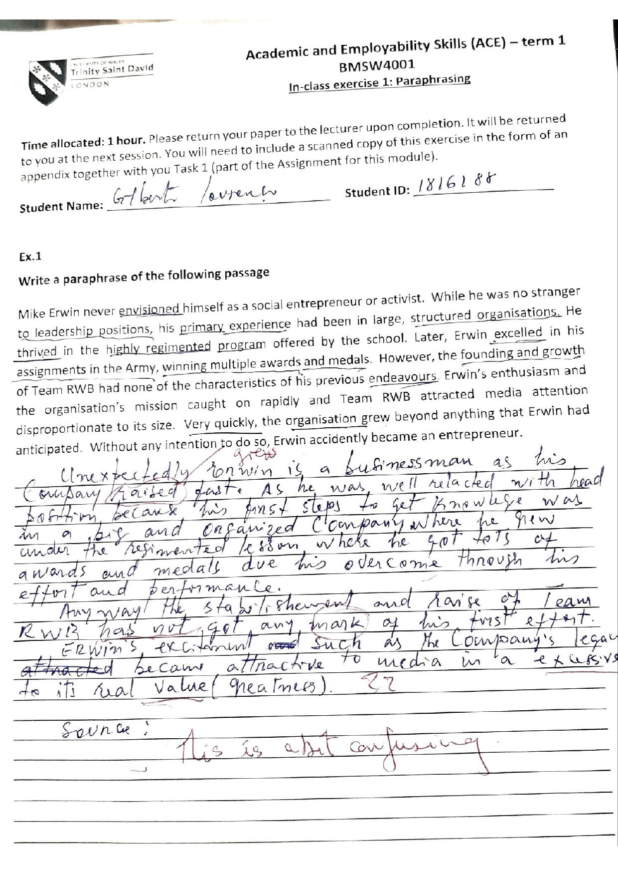

AP. 1----Paraphrasing-
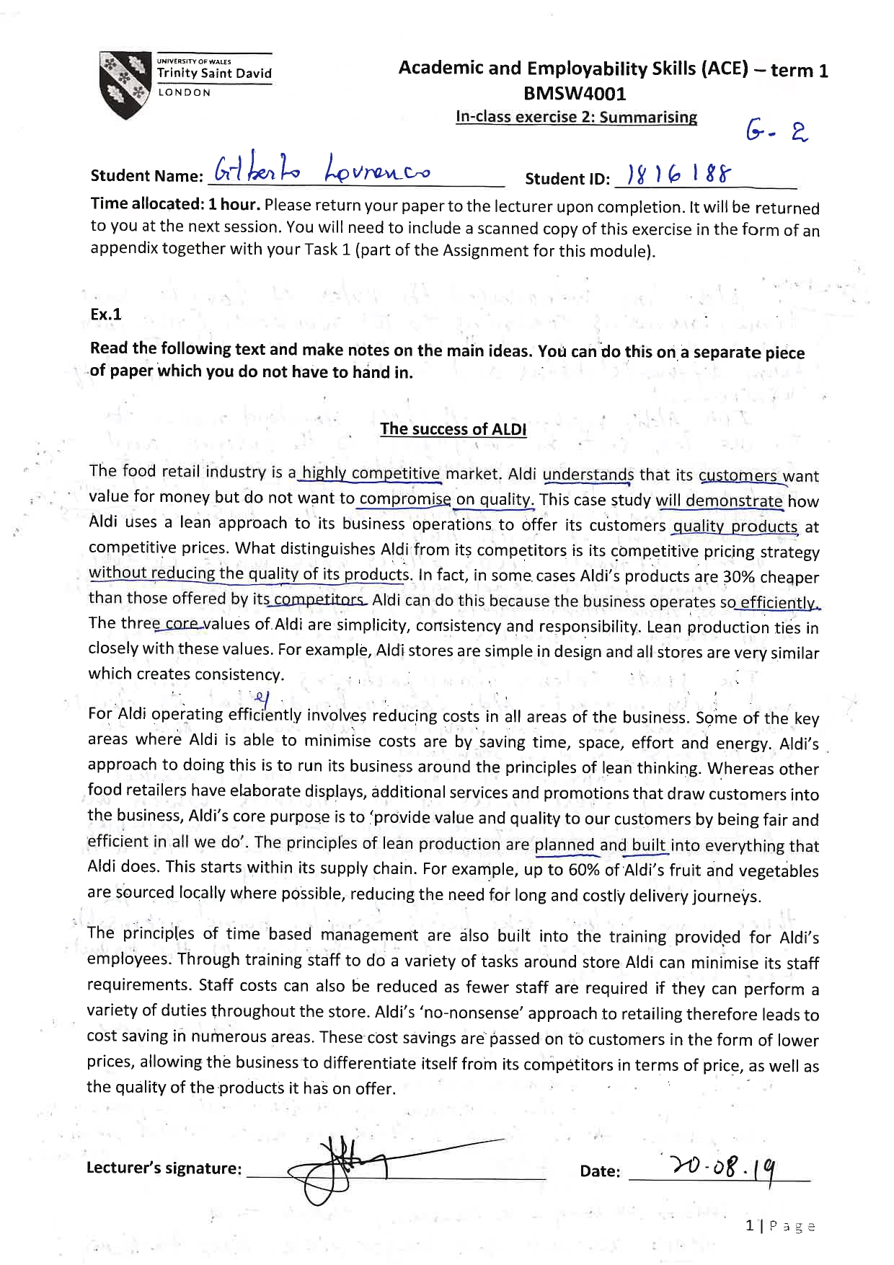

AP. 2----Summarizing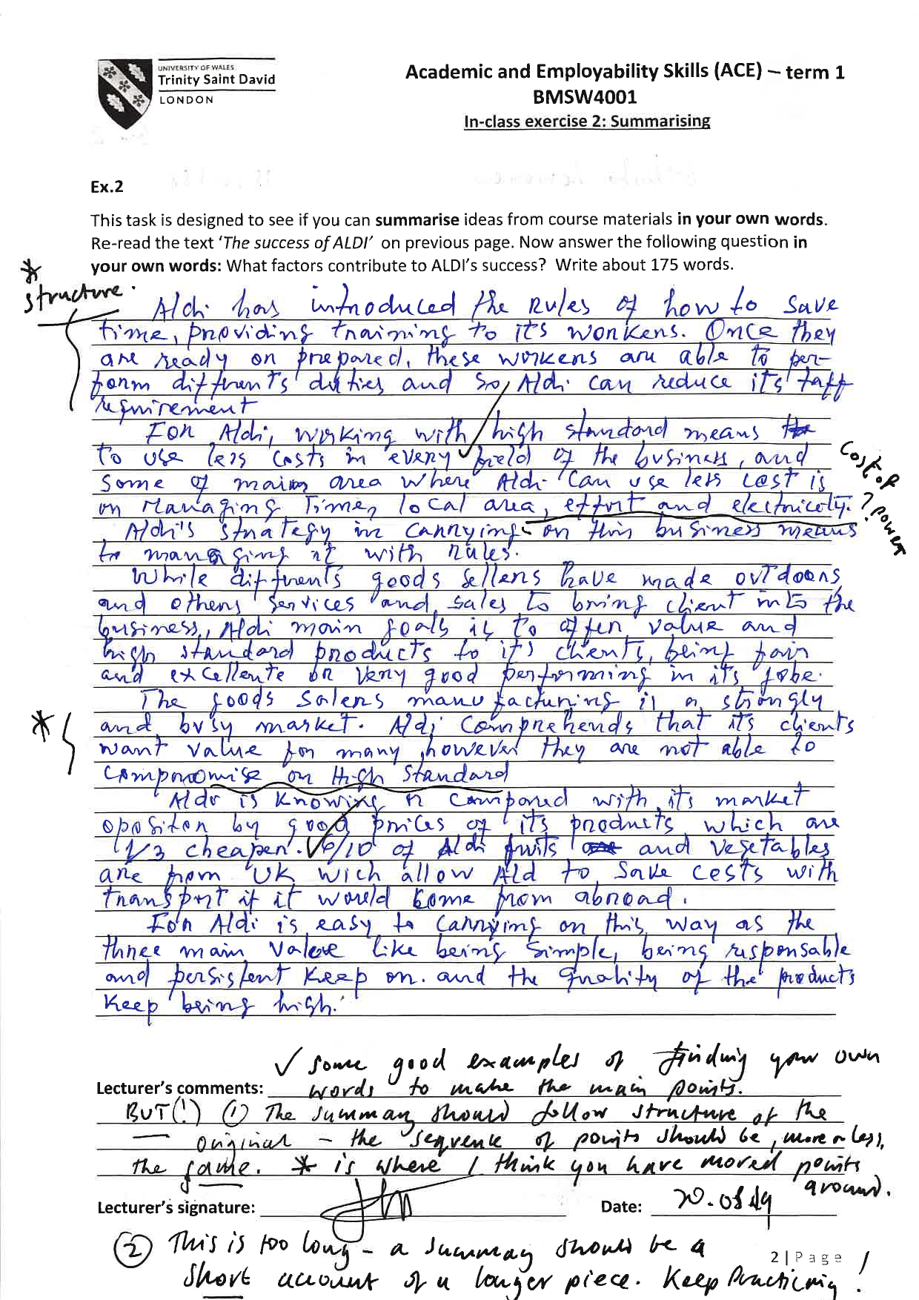
AP. 3----Time Management Exercise
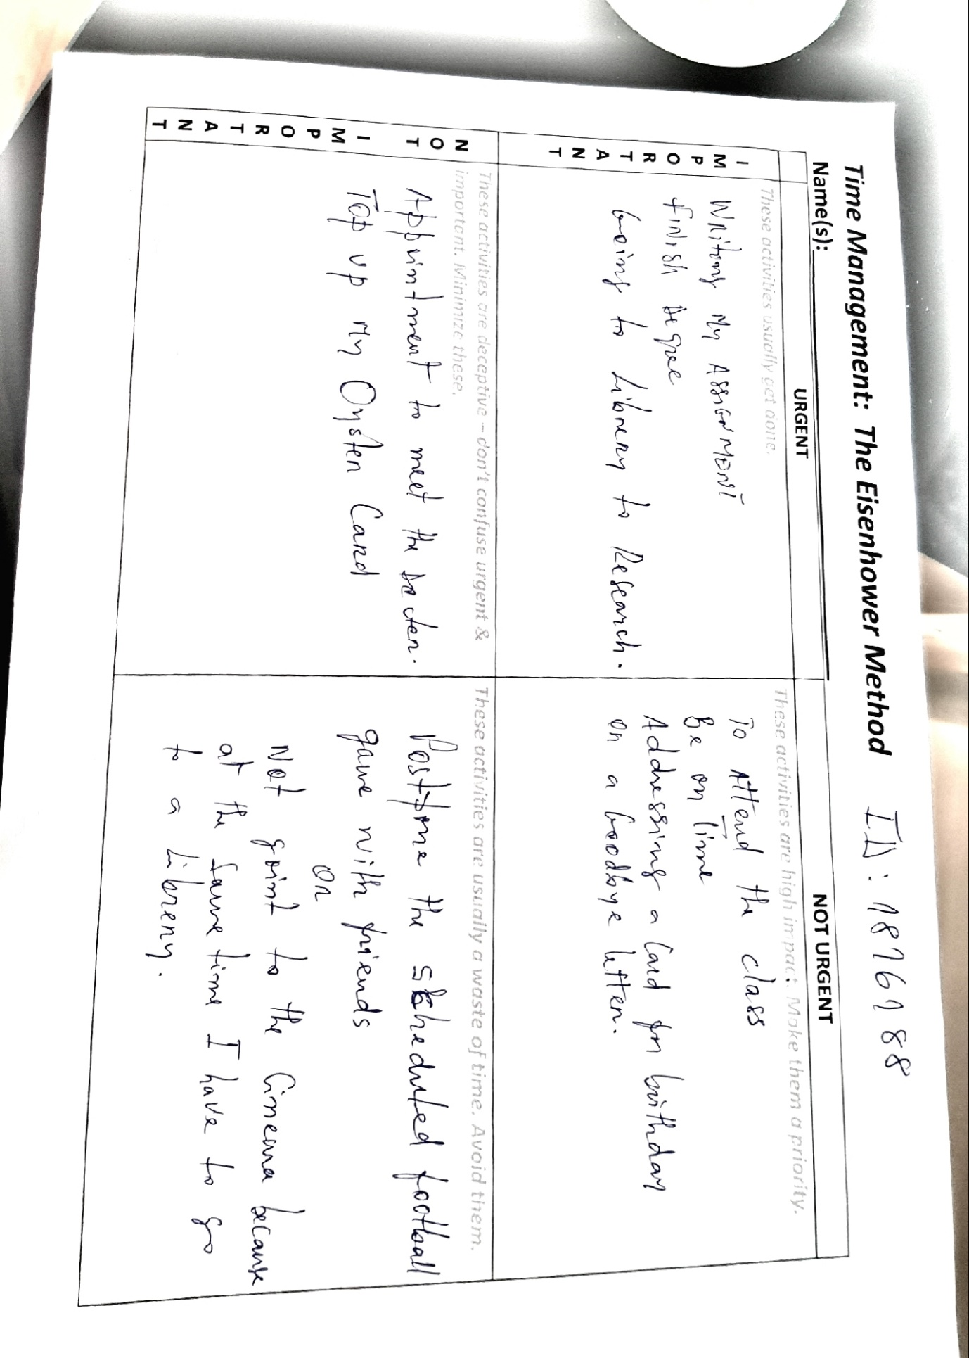

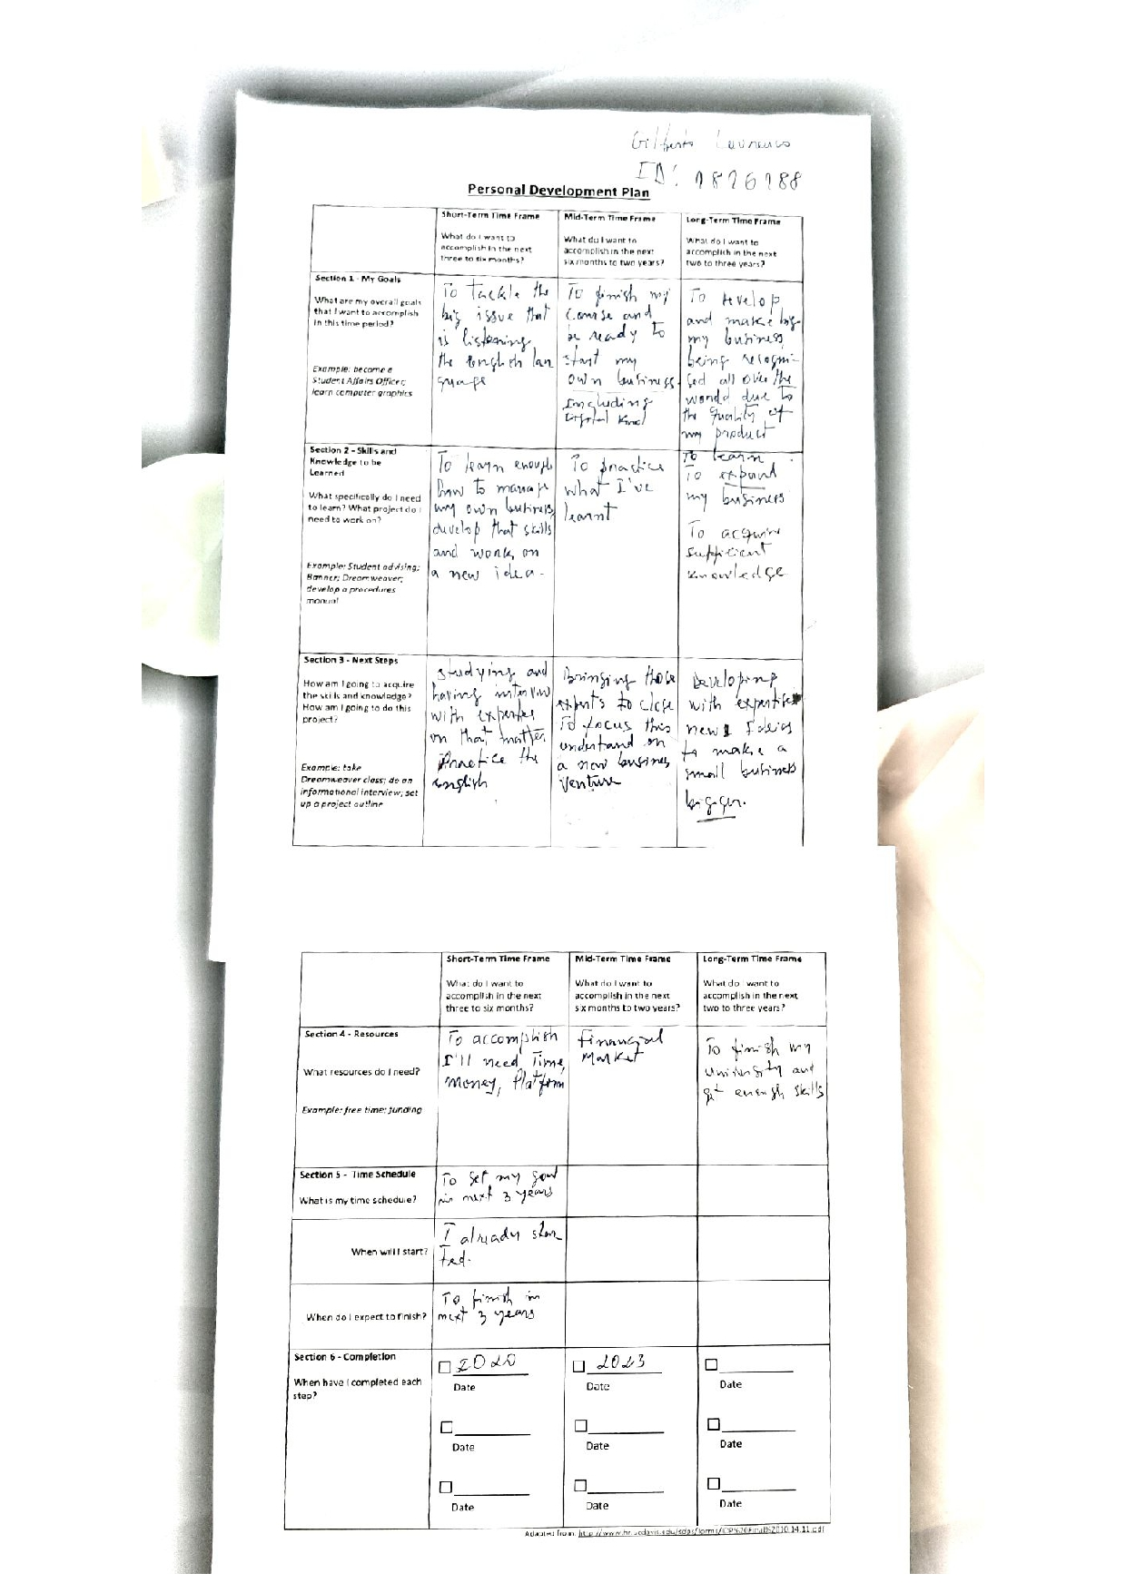

TOPIC RESEARCH JOURNAL ARTICLES:

- MDRC- The Power of Career.

- Learn the Skills that Employers Are Looking For.

- Preparing for a Career Engineer.

- AEI- Improving Skills.

5- Journal of Vocational Behavior.



