6/12/2022
Stanciu Mihai Radu
Student ID:211825
Portfolio of Work Task 2
Professional and Career development BMSW 4005
Contents:
Curriculum Vitae …………………………………………………………………………………Page 02
Cover Letter ………………………………………………………………………………………..Page 03
Job Advertise ………………………………………………………………………………………Page 04
References ………………………………………………………………………………………….Page 05

Stanciu Mihai Radu_________________________________
Business Advisor specialist current in stage of development with strong communication skills, experienced to work in a dynamic place and with experience of business background. Also well experienced with MS office program and with a flexible scheduler.
_________________________________________________________
Languages:
Romania-Maternal Language
English- Level 2
Italian - Level 2
Contact Details:
Address:
Phone number: 07384555921
Email: stanciu.radu22@gmail.com
LinkedIn:

Skills Highlights: ______________________________________
Analytic Skills Leadership and management Skills
Interpersonal skills Marketing Analysis Skills
Business Administration skills
Professional Credibility skills
Experience:_______________________________________________
Active Business Advisor Company (2010-2013)
Street: 52a Anton Pann ;City Bucharest, Romania
Role of Business consultant Apprenticeship
Daily duties: Analyse financial records and preparing budgets, to evaluate and improve sales, and branding strategies, to prepare project and productivity reports and ensuring compliance with quality and safety requirements, to develop and maintain internal and external communication channels, to Analyse and advise on employee, labour, vendor, and supplier contracts, and Perform risk analysis to mitigate and manage risks.
Education :________________________________________________
University of Wales Trinity Saint David -Certificate of higher education skills for workplace and health and social care (2021-2023) United Kingdom
Jun, 12 2022
Address: 307-308 High Holborn,
London WC1V 7LL
To: Pertemps, HR Department

Respected Recruitment Team,
As an high skilled Business consultant I am written you regarding the job advertise on the business website regarding T24 Business Consultant role available, with interest in this position, my skills, experience and qualification fit in place for this position which I am with certain become a valuable member for the organization. My experience of 3 years of apprentice and my skills of problem solving, interpersonal skills, Decision Making Skills, Team skills finance and computing skills and leadership skills I can drive to grow this business. In addition my qualifications of skills for workplace are fitting like a glove for the position, as a solid educational foundation and passion for the business process improvements.
Further please review my attached document for further understanding in my experience and skills, and also qualification and career achievements. I will wait to hear from you soon to discuss how my experience and background fits your needs, and what are my set up plans for further to help in growing and developing the business.
My Sirncerely,
Stanciu Mihai Radu

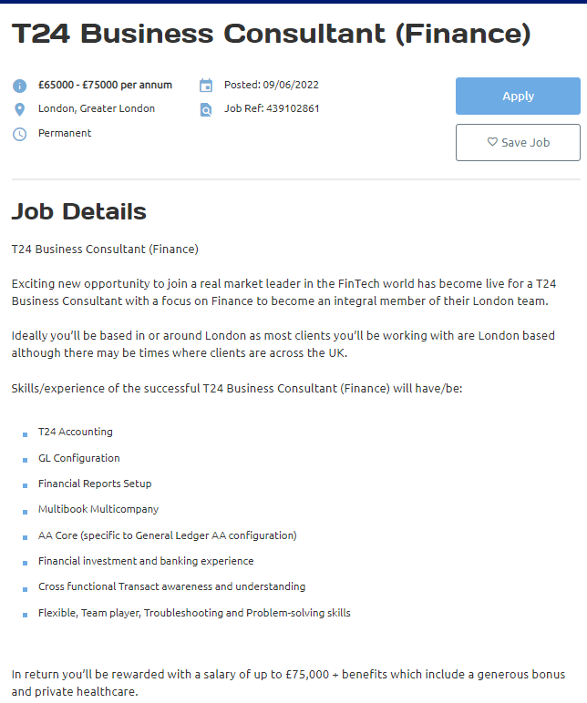
(Pertemps, 2022)

References
Pertemps, 2022. T24 Business Consultant (Finance). [Online]
Available at:
https://www.pertemps.co.uk/job/439102861/T24-Business-Consultant-Finance--job-in-London-Greater-London?utm_campaign=google_jobs_apply&utm_source=google_jobs_apply&utm_medium=organic
[Accessed 12 06 2022].

