AN EVALUATION OF MARKETING
A definition of marketing is:
‘Marketing is the activity, set of institutions, and processes’ for creating, communicating, delivering, and exchanging offerings that have value for customers, clients, partners, and society at large’.
Source AMA (2017)
The purpose of this essay is to evaluate marketing and the concepts of the macro-environment using the PESTLE method and how it helps companies achieve their wider organisational goals, there has been a lot more companies dealing with online ways of selling through the market. In this essay we will also be looking at the marketing mix and what has changed to help companies in these circumstances. We will also be looking at types of markets that’s out there and discuss why each one is important to the organisation.
Marketing is important in the organisations as without marketing organisations won’t be able to market their products or services to the public or to other organisations. Marketing is an effective way of engaging with customers, it helps boosts sales it also helps build relationships between business and its customers. Marketing helps to build and maintain the company’s reputation; marketing also creates revenue options. Marketing is widely in organisations it has changed over the years even more through the covid pandemic where organisations have had to deal through online sales by marketing their business a different way then what they are used to.
Types of markets
- Consumer- people. You and me, individuals, or groups, but public
- Business – B2B sales. Provide product or service for business users machinery or outsourcing, marketing, or HR E.G
- Not For Profit – charities
- Government – Public Health
- Public Sector – same as government but on a more local scale for E.G councils
- Global Markets – increasingly a globalised world. Covid is an example of this.

Marketing in the digital age, many marketing professionals are unsure of their future and believe that digital marketing will be critical to their organisations over the next two years, with new media that will generate the information technology sector that will achieve customer power.
There are two forms of marketing they are traditional, and contemporary, Traditional forms includes shopping malls and in magazine, television, and direct-mail advertisements in the contemporary forms, markets have assembled a host of new marketing approaches-websites, mobile phone apps, blogs, and social media. Evolution of marketing started in 1930 with production orientation “This is what we make and sell”, then in 1960 came consumer orientation “This is the target customer get them to buy”, then in 2010- consumer as driver “This is what we believe join us”.

The Marketing mix (the 7P’s)
The 7 Ps of the marketing mix are:
- Product
- Price
- Place
- Promotion
- People
- Process
- Physical evidence

There are three levels of product core customer values, the actual product, and the augmented product.
Price is the second in the marketing mix, pricing is an extremely important it determines profit and costing in the business of the organisation, pricing also helps consumers to determine the perception of your product.
Place, make sure you know where you are going to place your product or services and be easily available E.G online store, a high street shop, email order, or even door stop delivery.
Promotion, it is the way the company communicates what it offers to the customer, good promotion is not one-way communication it paves the way for a dialogue with the customers. The promotion is the benefits that a customer receives from the product, not just it’s features, other channels of promotion are website, brochures.
People. When marketing to People you must decide what type of people you are going to market your product at for example will it be for the older generation (50+) or the middle generation (20+) or the much younger generation. When marketing for your customers you must make sure that the product is ideal for them.
“Consumer Buying behaviour refers to the buying behaviour of individuals and households that buy goods and services for personal consumption”. (Kotler,et al.,2005)
Process. The process in getting a product or delivering a service has to be looked at when buying so that the customer or the consumer will be able to get or have it delivered to you on time so planning has to be in place and the process has to be quick and efficient to both organisations and customer.
Physical evidence. In a company or organisation physical evidence is vital they have to make sure everything is covered by insurance and its policies, that is a must in businesses if they don’t have that they can be sued, or companies will close down.
When looking at consumer behaviour- psychological one person we look at is ‘Maslow’s hierarchy of needs”. These include physiological needs e.g., hunger and thirst, safety needs, which include security, protection, social needs which is self-belonging, love, esteem needs, self-esteem, recognition, status and the final one in the hierarchy is self-actualization needs, self-development, and realization.
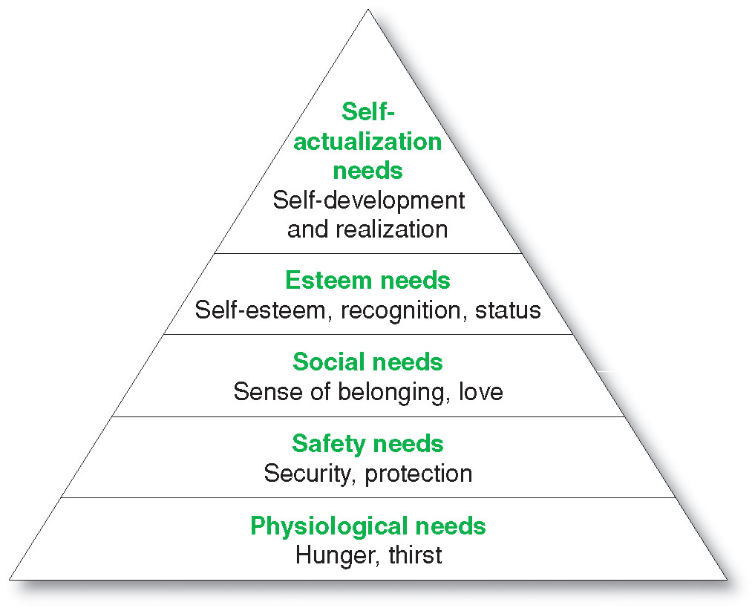 Pic 1 Maslow’s hierarchy of needs

Definition of macro-environment
“A macro-environment refers to the set of conditions that exist in the economy as a whole, rather than in a particular sector or region”.
Source https://www.investopedia.com/terms/m/macro-environment.asp

The organisations environment, there are three layers they are internal, micro, and macro, we will be looking at the macro-environment.
They are as follows:
- Demographic factors
- Economic factors
- Political factors
- Legal factors
- Socio-culture factors
- Ecological and geographical
- Technological factors
- Macro-environmental publics
With the change in the government and leaving the EU companies have had to restrict and change their policies who they can deal with, that has had an impact on the organisations, with the environmental regulations changing and making companies change to using less plastic like with local deliveries not using plastic bags to pack peoples online shopping. Tax has also affected companies and organisations, by the rise of inflation on food, heating, electric with some electric companies folding and going into administration due to the increase in the tax of oil. Marketing is a crucial part of every business, as well within the macro-environment exchange rates have fluctuated daily, which affect businesses that deal with overseas, so they have competition with other foreign countries, the price climate also affects organisations. The macro-environment includes the major forces that act not only on the firm itself, but on its competitors and on elements in the micro-environment.
The Macro-Environment is as follows.
- Political Environment
- Economic Environment
- Social and Cultural Environment
- Technological Environment
- Legal Environment
- Environmental/ecological Environment
A crucial economic issue is that of foreign exchange availability. If the target country does not have a sustainable export market for its own products, it will not be able to import foreign products because potential importers will not be able to pay for the goods in the appropriate currency. This has been a problem for most third world countries and also in some communist countries. The demographic environment includes such factors as family size, degree to which the country has a rural as apposed to an urban population, and the migration patterns that shape the population. Most migration patterns can be marked changes to structure of countries consumption like Indonesian food in the Netherlands, of Thai food in Australia, of Indian food in the united Kingdom, and of Algerian food in France are all much greater than can be accounted for by the respective ethnic minorities in those countries (Paulson-Box 1994).marketers have played a part in this culture-swapping process to the extent that segmentation by ethnicity is no longer possible for many products (Jamal 2003).
Operational flexibility working hours refers to flexibility in the ways in which work is carried out. The term is sometimes extended to include financial flexibility. The three forms of operational flexibility are:
- Functional flexibility so that employees can be redeployed quickly and smoothly between activities and tasks. It may require multi-skilling-workers who possess and can apply a number of skills: for example, both mechanical and electrical engineering, or multi-tasking-workers who carry out a number of different tasks in a work team.
- Structural flexibility in a ‘flexible firm’, where the core of permanent employees is supplemented by a peripheral group of part-time employees, employees on short-or fixed-term contracts or subcontracted workers.
- Numerical flexibility, which is associated with structural flexibility and means that the number of employees can be quickly and easily increased or decreased in line with even short-term changes in the level of demand for labour.
Most companies that use the flexibility short-term contracts pay the minimum wage for long working hours, Organisations intend to take advantage of their employees because of being on a flexible contract and intend to get them to work long hours over so many days then it is to give fixed contracted employees the overtime, so they cut back on paying full-time staff and rather pay the flexible contract staff. Unemployment across local and national countries have fluctuated over the last few years with cuts being made due to the covid-19 pandemic some even being paid Furlough, which was only being paid 80% of wages that was paid by the government to help businesses through the pandemic. This did not help families due to the cost of living rising with food prices going up and household bills like gas, and electricity rising also, many families have suffered they have had to choose either to pay their .bills or feed their families to survive. The autumn budget 2021, the chancellor has announced the following on NMW and wages.
- NMW increases on 1 April 2022 to £9.50 for those over 23 years of age, £9.18 for those age 21-22, £6.83 for those aged 18-20, and £4.81 for those under 18.
- Apprentice rate increases to on 1 April 2022 to £4.81,
- The government will continue to meet 95% of the apprenticeship training cost for employers who do nt pay the apprenticeship levy, and will extend the £3,000 apprentice hiring incentive for employers until 31 January 2022: and
- Increased funding for the national skills fund to expand the lifetime skills guarantee so more adults in England can access funding for in-demand level 3 courses and skills bootcamps will be scaled up.
The changes to legislation impacting employment with distribution many wholesalers, like general-merchandise wholesalers they carry out a wide range of mix product, but with little depth, they mainly deal with small grocery shops and general stores, as for limited-line wholesalers they offer a limited range of products, but stock them in depth. They are often found in industrial markets, selling specialist equipment (such as materials handing equipment) and offering expertise in the field.
Communication has been defined as a transactional process between two or more parties whereby meaning is exchanged through international use of symbols (Engel et al,1994).
Communication in marketing is always expensive according to Stewart (2017).
Foreign law (non-UK jurisdictions) in many foreign primary sources of law may be categorised in a similar way to those of the UK jurisdictions, as legislation and case law. Legislation from other countries may be revoked or amended and judicially interpreted. In common law jurisdictions (such as USA, Canada, or Australia) systems of precedent operate in relation to case law. Some countries contain more than one jurisdiction- for example, in the USA individual states have their own legislatures and courts but federal laws apply across all states. (Gareth ryan,2017).
The crucial task for marketers is to monitor and environmental factors that may impact on their organisations, largely so that they can look for ways to adapt the marketing mix to address any changes (Jackson & Wood 2013).
Selling is probably the most powerful marketing tool the firm has. A salesperson sitting in front of a prospect, discussing the customers needs and explaining directly how the product will benefit him or her, is more likely to get the business than any advertising, PR or sales. In marketing many organisations prefer a face-to-face sale then over the internet with online sales, but theses are increasing as the years go on. Marketing has come a long way since the pandemic started as lot of organisations have had to deal with the changes and legislation that has changed over time.
The marketing organisations have had to deal with a lot of changes in the years and have had to adapt to new restrictions and rules that had been set out by the countries local governments to deal with laws and buying through other countries as we have come out of the EU it has given us a lot to look at also with price increase over many products and services with people loosing jobs or taking pay cuts, marketing will have to adapt and look at what changes they will continue to need to change as the market changes to be in line with laws and policies. With changes to wages and with prices still increasing we all have to adapt and try to get a plan in place. Organisations will have to structure more to be able to deal up coming demand for online ordering as that is going to increase in the coming years. Marketing is going to have to look at how they promote their products and market then in line with demand. Business will need to get plans in place so if this happens again, they will know what to do to employ more staff to deal with the increase in demand of online orders e.g., like Tesco Morrisons and Sainsburys. With the EU placing restrictions on foreign countries marketing is going to have to deal with policies and work with the countries to make a deal on what they buy and sell to one another. Within the laws of each country, Companies will have to market more so that they won’t end up closing down like companies have ended up doing over the last couple of months and with inflation with gas and electric increasing many suppliers have gone into administration due to the rise in oil prices. The government needs to look at what they are changing due to people’s income as even though wages and benefits are increasing so is the cost of living so people are in the same situation. Marketers need to look at saving costs and try and not increase prices they will need to look at their buying market for a better deal which is not always the best option. As in the Maslow’s hierarchy of needs marketing in businesses needs to look at what should come first and that is to make sure employees have a wage that will make sure all the essentials are accounted for like rent food etc. An evaluation of marketing has given people and businesses a way of looking at what they can or need to change in the future and prepare them for any situation that may arise that will or can affect businesses and people’s lives. Organisations is gong to slowly but surly be using more digital way of life in ways people market their businesses and business get employees to work and train in the future, marketing as a whole has been affected but now its time to change.

REFERENCES
AMA (2017)
ARMSTRONG’S HANDBOOK 3RD EDITION OF MANAGEMENT AND LEADERSHIP
CLASS NOTES WEEK3 LECTURE (7-12-21)
ESSENTIALS OF MARKETING SEVENTH EDITION
BLYTHE, J AND MARTIN, J
(ENGEL ET AL,1994)
https://www.investopedis.com/terms/m/macro-environment.asp
www.cipd.co.uk
https://www.burges-salmon.com/news-and-insight/legal-updates/employmeny-law-updates.
https://www.bbc.co.uk/bitesize/guides/z8m36yc/revision/5
computer misuse act (1990) date accessed (7-12-21)
https://guides.lib.strath.ac.uk/non-uk_law/foreign
Author Gareth Ryan (2017). Date accessed (8-12-21)
(Jamal 2003)
(Jackson & Wood 2013)
Kotler,et al,(2005)
Marketing and the 7p’s CIM (2015)
(Paulson-box 1994)

