Student name: Shaikh mohd mohasin mohd nishar
Student id: 2207962
Subject: Marketing Management

A business report on the marketing strategies of Nike

Table of Contents
1 Introduction 3
1.1 Background of the company 3
1.2 Aims of the study 3
1.3 Vision and Mission of the company 3
2 Communication model 4
3 Brand equity model 5
3.1 The advantages of brand equity 6
4 Customer journey map and touchpoints of the Nike 7
5 Total Engagement Model 9
6 Conclusion 10
References 12

1 Introduction
A confidently recognized organization, Nike emphases typically on the sport apparel and footwear sector. The company creates, manufactures, and sells substances for sporty clothing, footwear, accessories, and gear (Sahami et al., 2019). Nike is led by President Philip Knight and CEO (Sahami et al., 2019). In 1962, Mr. Knight facilitated start Blue Band Athletics, which also 1978 transformed its designation to Nike. To commence a corporate assessment of Nike and its fully owned companies, financial data, news releases, marketing info, corporate background, and existing creativities were gathered from the corporate (Sahami et al., 2019). After the information was gathered, it was inspected, and an evaluation was done on Nike to recognize the firm's weaknesses, strengths, threats, and opportunities (Sahami et al., 2019). The formation, manufacturing, and worldwide advertising of premium footwear, clothing, technology, and ancillary goods is Nike's main business model (Sahami et al., 2019).

1.1 Background of the company
In the United States and over 110 other nations, Nike distributes their goods to nearly 20,000 department stores (Sahami et al., 2019). The majority of Nike's merchandise is finished by sovereign subcontractors. While many clothing commodities are finished both nationally and internationally, the popular of shoes or footwear merchandise is made overseas in the United States (Sahami et al., 2019). Earnings were $8.9 billion for the financial year that ended on May 31, 2000, down from $9.5 billion the immediately prior year (Sahami et al., 2019). Nike sneaker is manufactured with a concentration on creative appearance and premium materials and is envisioned principally for athletic purpose. However, an important helping of the stock is worn informally or for recreation. Footwear for basketball, fractious training, kids, and women are just a limited of the belongings that Nike proposes and distributes (Sahami et al., 2019).
In adding to present clothes in all of the above-mentioned divisions as well as accessory items and sporty bags, Nike ongoing selling energetic athletic clothing in 1979 (Sahami et al., 2019). The athletic footwear substances from Nike are supplemented by accessories and clothes that share identical copyrights and go finished the same marketing and distribution channels (Sahami et al., 2019). The commercial regularly sells footwear, clothing, and collectibles in archives with a comparable aesthetic or for convinced uses (Sahami et al., 2019). Furthermore, Nike trades footwear finished for recreational sports like cheerleading, bicycling, tennis, soccer, golf, baseball, football, volleyball, aquatic sports, auto motorsport, and various recreational and athletic pursuits (Sahami et al., 2019).
Currently, the company is known for the premium brand segment in the sports apparel market and creates a long relationship with its consumer base (Elisa et al., 2020). Currently, the Jordan air shoes are the recent success of the company (Elisa et al., 2020). The main focus of the company is innovation and research about new technologies. The company leads the global smartphone market and innovation in this field after that innovation other companies followed Nike (Elisa et al., 2020).

1.2 Aims of the study
The main aim and objective of this study are to find the key successor of Nike which is the global consumer sports apparel company in terms of financial aspects and number of users. The company is working in the field of sports apparel for years and creates a better experience for users with its capabilities to innovate new and upgrade products understanding these kinds of techniques is the objective component of this study.

1.3 Vision and Mission of the company
According to Nike's goal declaration, the company is dedicated to preserving the ecosystem, maximizing value for its clients, stockholders, and company associates, as well as ensuring multigenerational life quality. The vision of the company is to long-term sustainability in consumer sports apparel and provide better facilities and services through their products and services. The company always focuses on innovating new things rather than copying things from its peers, and this is the main strength of the company. The major goal of the company is to lead the global sport and apparel market to dominate the industry through its innovations and R&D.

2 Communication model
The business's position on particular components of the commercial statement mix, counting media and print advertising, sales campaigns, events and experiences, public relations, direct marketing, and direct marketing, is described in the Nike commercial communications mix (Elisa et al., 2020). The major objective of Nike's promotional messaging mix is to convey the brand's commercial statement to the intended market category through the use of the aspects mentioned previously (Elisa et al., 2020). Nike is good at integrating components of the brand communication mix to maintain the coherence of the advertising message (Elisa et al., 2020). Nike has utilized media and print promotion aggressively to marketplace the business in universal and fresh foodstuffs in specific since its establishment and over years earlier (Elisa et al., 2020). The biggest noteworthy media and print advertising campaigns for Nike are listed below:
- Nike bravely introduced a range of designed T-Shirts with Nike phrases like "Get High" "Ride Pipe" and "Dope" throughout its 6.0 promotion, which was meant to be athletic slang rather than phrases endorsing drug usage (Sahami et al., 2019).
- In June 2015, the company Nike and the NBA announced an eight-year partnership that would see Nike serve as the team's official provider beginning in 2017 to 18 (Sahami et al., 2019). The agreement ended the NBA's lengthy partnership company Adidas, which jerseys players had worn before 2006 (Sahami et al., 2019).
Additionally, Nike makes great use of superstar sponsorships in media and print advertising (Sahami et al., 2019). Previously, Nike's 'Imagine Different' media and print advertising campaigns comprised pictures of innovators and trailblazers from a variety of arenas, including Jimi Hendrix, Charlie Chaplin, Alfred Hitchcock, and Albert Einstein (Sahami et al., 2019). Drake, Aubrey Plaza, Taylor Swift, Neil Patrick Harris, and other celebrities have recently endorsed Nike products (Sahami et al., 2019).
The IT behemoth also frequently and successfully employs the merchandise placement advertising approach (Elisa et al., 2020). TV and Film programs including Mission: Impossible, Gossip Girls, twenty-four, Toy Story 3, Tron: Legacy, The Social Network, and others are among the greatest noteworthy examples of Nike brand placement (Elisa et al., 2020). It's been revealed that perhaps the iPhone manufacturer forbids antagonists from using their gadgets in motion pictures and television programmers (Elisa et al., 2020).
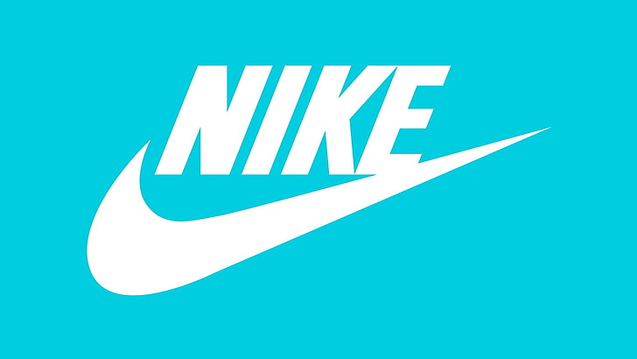
Figure 1: The brand logo of Nike
Source: (Elisa et al., 2020)
This image shows that in how Nike company changed its brand image and public image. Initially, the company has a logo that is a little bit complex to understand but currently, the company has a logo that is very simple and easy to understand for everybody (Elisa et al., 2020). The main motto of the company for their communication strategies like their logo is to justify in the premium segment and look different from the other brands (Elisa et al., 2020). People are very exiting about that kind of thing which is launched by Nike (Elisa et al., 2020).

3 Brand equity model
In this assignment, the brand equity model which is getting used is called Aaker’s brand equity model. Whenever compared to a comparable alternative, a corporation can command a higher price for a commodity with a well-known brand (Hoffman, Gold and Curtin, 2019). This is known as brand ownership. Making items unique, instantly recognizable, exceptional in quality, and dependable help businesses build a brand image for particular goods (Hoffman, Gold and Curtin, 2019). A corporation must be able to set itself apart from the opposition by providing outstanding goods and services together with top-notch user support. On the one extreme, that results in devoted followers (Hoffman, Gold and Curtin, 2019). Additionally, it enables the business to demand a surcharge from its clients for the use of the trademark and the goods. Customers have higher expectations of the companies they choose (74%) (Hoffman, Gold and Curtin, 2019). In other words, barely about 20% of the companies have a meaningful brand image (Hoffman, Gold and Curtin, 2019).
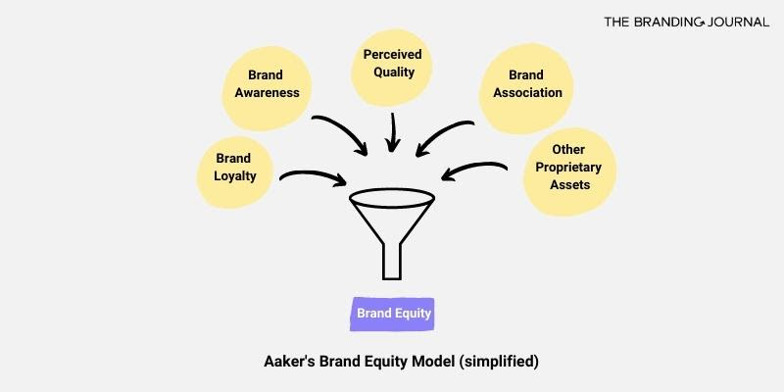
Figure 2: Aaker’s Brand Equity Model
Source: (Elisa et al., 2020)
Brand image has a lot of value. The very identical set of characteristics is available from numerous brands for less money (Elisa et al., 2020). Nevertheless, Nike's brand ownership also incorporates a reputation for high quality, first-rate customer support, and a sense of camaraderie among Nike’s Jordan air consumers. This indicates that numerous customers are prepared to spend extra for identical functionality (Elisa et al., 2020). Brand equity differs from the value of the brand of the company (Elisa et al., 2020). The most significant commodity of a corporation is brand image, which is not listed on the income statement. An ephemeral asset, that is. A business that has strong brand ownership has 3 distinct economic advantages (Elisa et al., 2020).
- Perception: Customer perspective refers to how they perceive company goods and offerings. Therefore, a company's impression is owned by and driven by its customers (Elisa et al., 2020).
- Net Effect: The firm's bottom and top lines are impacted by the customer's impression. The net result would be good if clients respond favorably to a corporation's product (Elisa et al., 2020). A bad reputation will also damage marketing and profits for the business (Elisa et al., 2020).
- Value: The entire impact has a bearing on the significance of product equity. Positive effects result in measurable benefits for profitability and sales (Elisa et al., 2020). Additionally, it generates qualitative worth through increased brand recognition and satisfaction (Elisa et al., 2020).

3.1 The advantages of brand equity
Increment in revenues: A corporation's corporate reputation helps it improvement awareness in the market and within its goal market. Rather than buying less luxurious alternates from other companies, customers regularly spend additional cash on the trademark (Hoffman, Gold and Curtin, 2019). A strong brand can upsurge brand gratitude and contribution a firm's marketing creativities, follow-on in increased sales statistics (Hoffman, Gold and Curtin, 2019). Productions with countless reputation equity normally control respective particular marketplaces. Brand reputation foodstuffs a substantial, enthusiastic client group that is ready to pay more for excellent services and goods. Furthermore, it allows a business to perform very well from its competitors in terms of income (Hoffman, Gold and Curtin, 2019).
Profitability aspects: Productions with robust product owners have robust bottom and top lines. Buyers will purchase additional for the company brand if people trust it to be greater to the opposition. Since of this, the product perform very well with its adversaries in terms of profitability and sales. Equivalent products from rival companies cost less than those made by Nike (Hoffman, Gold and Curtin, 2019). However, no matter how expensive the newest Jordan air is, people wait all evening in line outside of Nike storefronts to be between the earliest to get it (Hoffman, Gold and Curtin, 2019). Instances of profitable premium brands with strong brand ownership are Ferrari and Rolex. Even though they may never sell as numerous products as companies like Toyota or Timex, they have more than sufficient brand equity to continue to exist and innovate (Hoffman, Gold and Curtin, 2019).
Lower cost advantage: lower cost is the other advantage that comes through after the achievement of brand equity among the consumer base (Hoffman, Gold and Curtin, 2019). If the company has strong brand equity, then it will get a higher number of consumers and it will trigger a higher number of growth and profitability prospects for the company (Hoffman, Gold and Curtin, 2019). Companies with noteworthy justice have additional thump in discussions with consumers, manufacturers, and contractors. Since employed with businesses offers them a standing, producers and distributors want to cooperate through Nike and regularly do so at inexpensive costs (Hoffman, Gold and Curtin, 2019). Because Nike has a enthusiastic subsequent of consumers willing to give more for its items, vendors would like to offer them. Because the company doesn’t need to expend as considerably on advertising and marketing, businesses with strong brand reputations do so (Hoffman, Gold and Curtin, 2019). The product and its advantages are currently well to consumers. Facebook, Coca-Cola, and Apple are not among the top 10 firms having the greatest ad expenditure, based on a current Statista analysis, which suggests that brand recognition alone is sufficient to generate sales (Hoffman, Gold and Curtin, 2019).
Launching of new products: Because the company's customers trust their brand, it is simpler to offer new items and offerings if Nike's business has strong brand ownership (Elisa et al., 2020). Once more, Nike is the best illustration, with people gladly upgrading their shoes whenever Nike releases revolutionary Jordan air shoes each pair of year (Elisa et al., 2020). Good brand value enables any company to invest extra in developing new items while spending less on marketing. Nike brand will be having more influence over the characteristics that will include in its new products if the company has a concentrated marketplace (Elisa et al., 2020).
The above advantages are the points that mansions that brand equity’s importance in the corporate world (Elisa et al., 2020). A company like Nike’s business model is completely dependent on the brand equity model and if the company wants to adopt different approaches for its business strategies, then it will be trouble for its exitance in long term (Elisa et al., 2020).

4 Customer journey map and touchpoints of the Nike
An image that shows each of the connections at Nike company that a client interacts with it as they strive to accomplish an objective, as well as the sentiments they encounter throughout that experience, is the foundation of consumer journey mapping (Elisa et al., 2020). However, creating the mapping isn't a straightforward procedure (Elisa et al., 2020). The mapping approach necessitates precise client insight and in-depth research. Cutting corners is impossible if the company wants the map to accurately represent what the consumer encounters on a psychological level (Elisa et al., 2020). No 2 mappings will be completely alike, with the layout shifting depending on the business, service, product, and customer mapped out, which further complicates issues (Elisa et al., 2020).
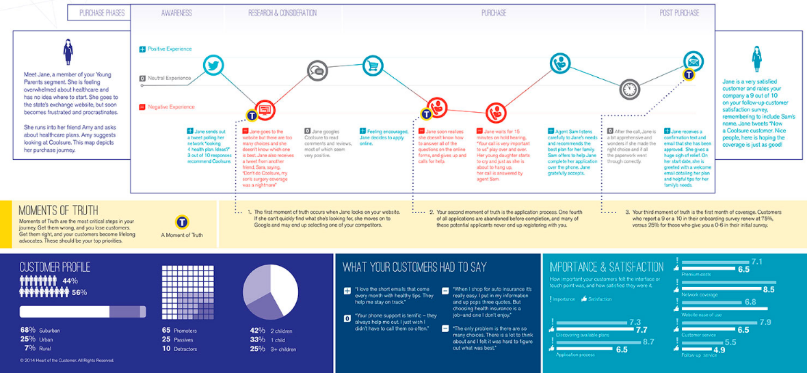
Figure 3: Customer journey map
Source: (Sahami et al., 2019)
After doing the research, a company ought to have a good understanding of the steps that every one of the company personas takes to reach the point of beyond and purchase (Elisa et al., 2020). Whenever creating a map, it's crucial to organize it according to milestones that correspond to the main objectives that the customer is aiming to accomplish rather than according to sections that correspond to the company’s internal procedures (Elisa et al., 2020). Consider each customer's goals at each stage and base their decisions on the information that have from their consumer interviews (Elisa et al., 2020).
The roadmap should attempt to explain more particular considerations and goals that the client may have throughout the path, in addition to documenting the broad goals that comprise the segments of the map (Sahami et al., 2019). These could include things like the desire to know more about the possible options, making sure the pricing is reasonable or needing confirmation that they have all the necessary knowledge on the journey at hand (Sahami et al., 2019). The company may evaluate how well they are achieving these objectives and find the answers to any concerns by writing down these objectives and thoughts at each phase of the process (Sahami et al., 2019).
The company can now mark its identified pain areas on the route map after users have recorded all the interactions (Sahami et al., 2019). They will be aware of these pain areas because consumers interviewed teams that operate on connections and employees who interact with customers (Sahami et al., 2019). When people are searching for things to do after the mapping procedure, this will be helpful. Similarly, visitors may draw attention to areas where they excel. This user-testing illustration uses color coding to show both negative and positive experiences (Sahami et al., 2019). The challenges (and triumphs) might also represent the feelings of business customers. While part of this could be determined by the caliber of providing company, other sentiments may well be brought on by the circumstance the client discovers themselves in (Sahami et al., 2019).

5 Total Engagement Model
A company can significantly improve service quality, including growth and sales, if it goes above simply persuading clients to make one-time transactions and alternatively tries to cultivate committed customers (Sahami et al., 2019). Recognizing the value of engaged clients is simpler than actually earning them, though. The subject in their prior paper, Customers Involvement, Developing and Integrating Key Competitive Components to Achieve Development, is expanded upon in this section (Sahami et al., 2019). Since this earlier publication, 5 more years have passed in which it has worked with businesses that use the Complete Engagement Model to increase client participation (Sahami et al., 2019). As a result, our trust in the framework has increased, and it now have new observations to offer (Sahami et al., 2019).
The foundation of the concept is the idea that to develop interested customers, major strategic components of a business must be planned and synchronized (Faggiano and Colao, 2021). These components are found in the majority of organizations, and it is generally known that each of them has personal advantages. As follows:
- Simply said, their customer value proposition is the benefits the business provides to their clients. In another respect, there is a justification for why clients ought to choose business over potential rivals (Faggiano and Colao, 2021).
- Not only the company name or logo, but the entirety of who the company is and what it stands for makes up the company brand (Faggiano and Colao, 2021). Their brand, which is how effectively communicate about company's brand to customers, must include their value proposition prominently in both company branding (Faggiano and Colao, 2021).
- The phrase "the way they do business around here" relates to an organization’s intrinsic characteristics, including its objectives, aims, and internal behaviours (Faggiano and Colao, 2021). This needs to be managed to develop a workplace where employees can consistently provide the brand's business model and intended user experience (Faggiano and Colao, 2021).
- Users connect with brands and organizations, which results in a mixture of emotional and physical factors that make up the shopper experiences.
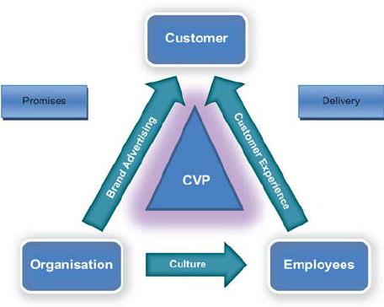
Figure 4: Total engagement model
Source: (Faggiano and Colao, 2021)
The total engagement model covers all the aspects of company marketing strategies like brand awareness, customer experience, and many more aspects (Faggiano and Colao, 2021). In this image, the total engagement model for Nike shows the total business aspect of the company. Employee connection is crucial for providing excellent customer situations, particularly through the transmission of critical positive feelings from consumer workers to clients (Faggiano and Colao, 2021). It is, in our opinion, a crucial differentiation within businesses that excel at providing excellent client interactions and those that fall short. Employee involvement is a concept that is simple to talk about but challenging to implement in hierarchical organizations. It merits attention because it is frequently the main obstacle (Faggiano and Colao, 2021). Engaged Marketers performed a countrywide poll to better comprehend what is genuinely occurring with workplace participation today through the perspectives of the workforce because is how it should be evaluated (Faggiano and Colao, 2021).

6 Conclusion
The accompanying observations have been made after a full study of Nike's structure, operations, and market positioning. Nike presently concentrates the majority of its marketing efforts on its sports shoe products. They could extend this to encompass their collection of casual shoes as well to increase sales. Nike must maintain its position at the forefront of athletic sneaker technology because uniqueness is the company's main marketing approach. By adopting this, they will be able to create new styles of shoes and other sports apparel, expanding their product line-up.
The company needs to spend its money more effectively. Since there is no longer a clear distinction between sports and entertainment, this may be done by broadening their campaigns to include such and additional non-sports locations. The utilization of the Web to interact with customers has emerged to be among the most crucial facets of Nike's company. They are working on a brand-new innovation that will let their clients create personalized shoes digitally. They must improve their webpage to make it more consumer to achieve this. The website now takes excessively long to upload, and the simple layout says nothing about the goods.

References
Ali, M. (2022). Fake-News Network Model: A Conceptual Framework for Strategic Communication to Deal with Fake News. International Journal of Strategic Communication, pp.1–17. doi:10.1080/1553118x.2021.1988616.
Aluru, S.S. and Sathvika, J. (2020). Study role of technology (App) in millennial engagement by masstige shoe brand Nike. repository.iimb.ac.in. [online] Available at: https://repository.iimb.ac.in/handle/2074/19614 [Accessed 26 Dec. 2022].
Bahrainwala, L. and O’Connor, E. (2019). Nike unveils Muslim women athletes. Feminist Media Studies, pp.1–16. doi:10.1080/14680777.2019.1620822.
Davey, N. (2016). Nine sample customer journey maps – and what we can learn from them. [online] MyCustomer. Available at: https://www.mycustomer.com/customer-experience/engagement/nine-sample-customer-journey-maps-and-what-we-can-learn-from-them.
Elisa, P., Alessandro, P., Andrea, A., Silvia, B., Mathis, P., Dominik, P., Manuela, R., Francesca, T., Voglar, G.E., Tine, G., Nike, K. and Thomas, S. (2020). Environmental and climate change impacts of eighteen biomass-based plants in the alpine region: A comparative analysis. Journal of Cleaner Production, [online] 242, p.118449. doi:10.1016/j.jclepro.2019.118449.
Faggiano, A. and Colao, A. (2021). Editorial—Special Issue: Foreword to the Special Issue on NIKE: Neuroendocrine Tumors, Innovation in Knowledge and Education. Frontiers in Endocrinology, 12. doi:10.3389/fendo.2021.722145.
Hoffman, A., Gold, N. and Curtin, C. (2019). Nike, Inc.: Late Arrival to the ‘Athleisure-wear’ Trend. [online] SAGE Knowledge. London. Available at: http://sk.sagepub.com/cases/nike-inc-late-arrival-to-the-athleisure-wear-trend.
Jiang, W. (2019). Sustainable Development of Supply Chain in Footwear Industry – Take Nike as the Case. Asian Business Research, 4(3), p.86. doi:10.20849/abr.v4i3.690.
Kim, M. (2020). How Phil Knight made Nike a leader in the sport industry: examining the success factors. Sport in Society, 23(9), pp.1–12. doi:10.1080/17430437.2020.1734329.
Mingxiao, M. (2022). THE IMPACT OF MULTINATIONAL TRADING COMPANIES ON CHINA-U.S. ECONOMIC RELATIONS: THE HISTORY AND SUCCESS OF THE NIKE COMPANY. The European Journal of Humanities and Social Sciences, (4), pp.62–66. doi:10.29013/ejhss-22-4-62-66.
Sahami, F.M., Kepel, R.C., Olii, A.H. and Pratasik, S.B. (2019). What species make up the Nike fish assemblages at the macrotidal estuary in Gorontalo Bay, Indonesia? [online] f1000research.com. Available at: https://f1000research.com/articles/8-1654 [Accessed 26 Dec. 2022].
Sharma, H. (n.d.). (PDF) Using of KPIs and Dashboard in the analysis of Nike company’s performance management. [online] ResearchGate. Available at: https://www.researchgate.net/profile/Ionut-Nica-2/publication/351123152_Using_of_KPIs_and_Dashboard_in_the_analysis_of_Nike_company.
Sharma, H. (n.d.). C A P P A P E R N O . 2 7 2. [online] Available at: https://centralasiaprogram.org/wp-content/uploads/2021/12/cap-paper-no.-272-by-tomiris-mashan.pdf.
Tian¹, Lin², H. and Peng³, Q. (2019). Research Report on Profit Maximization of Sports Shoes (Nike)--Modeling and Finding Solution. The Frontiers of Society, Science and Technology, [online] 1(6). doi:10.25236/FSST.2019.010605.
Wiggins, B.E. (2019). Memes and the media narrative. Internet Pragmatics. doi:10.1075/ip.00032.wig.

