  LOCATION Swansea | LLEOLIAD abertawe
LEVEL 5 | LEFEL 5
EXAMINATION PERIOD | CYFNOD ARHOLIADAU
Jan 2022 | Ionawr 2022

MODULE CODE: ACDA5002
Electronics 1

Marking Scheme

ANSWER ALL QUESTIONS

QUESTION ONE (20 marks total)
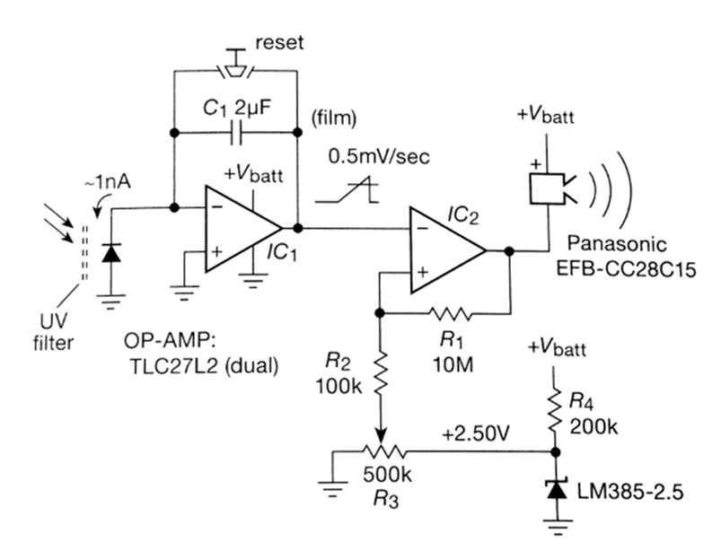

The Circuit above shows a purely analogue implementation of a simple ‘suntan timer’ where the light falling on a photodiode causes the sounder to operate after a time period that can be adjusted by the 500K potentiometer.
It is based around two op-amps configured in different ways.

- Identify and name how IC1 is configured. Explain its method of operation, specifically on the use of C1 and how the ‘reset’ button works?
Ans:
IC1 = integrator. Charge builds up across C1 due to current flowing via the photodetector causing op amp output to rise in voltage. Reset button simply shorts out and discharges the capacitor thus resetting the ramp. 5 marks
- Identify and name how IC2 is configured. Explain its method of operation, including a description of all the associated resistors and their function in this particular circuit, as well as the purpose of the LM385 device.
Ans:
The voltage is presented to IC2 which is configured as a comparator.
When the comparator input crosses a threshold set by the reference voltage produced by the precision voltage reference (and made variable by the pot R3 which forms a potential divider), the output switches and drives the buzzer. R1 provides hysteresis – 5 marks
- What is the diode type device on the far left of the circuit? How does it operate in this context, what is the UV filter for?
Ans:
Photodiode used in reverse bias configuration (i.e. leakage current increases with photon impingement)
Device responds to many wavelengths of light, therefore optical filter is used to specifically target the UV portion of the spectrum. – 5 marks
- Describe any potential disadvantages of using this simple analogue implementation? How might these be overcome?
Ans:
e.g.
The time constant of charging the capacitor is very large, therefore either the capacitor needs to be large (with subsequent leakage issues) or the filter needs to be very strong (potential light leaks).
Can be overcome with a more complex design which counts multiple ‘charges’ of the capacitor during the overall duration of sun exposure.
5 marks

QUESTION TWO (30 marks total)

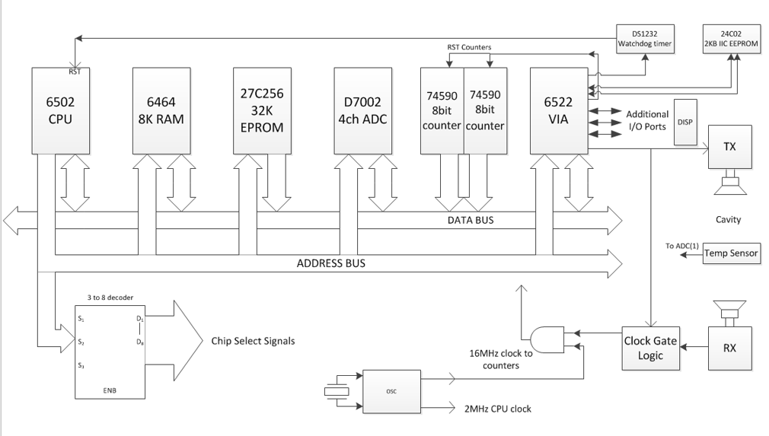

The system diagram above depicts the use of a 6502 microprocessor used as the controller for a CO2 detection system that utilises ultrasonic transducers (labelled RX and TX)
You are told that:
The speed of sound in air varies with the concentration of Carbon Dioxide as well as the air temperature. If an accurate determination of these parameters can be made, a complex, floating point mathematical function can be performed to calculate the CO2 level. An alarm can then be triggered. Potentially a fairly trivial task for an embedded system, but there are a few problematic aspects:
The mathematical function is non-trivial and will require floating point functions.
The accuracy of the speed of sound measurement requires a minimum of a 16MHz clock to drive a measurement circuit when a distance of around 30cm is used.
The temperature measurement needs at least 10 bits of accuracy over a 0-40c range.
Each system will need initial calibration which needs storing in NVM

- For each block/component in the diagram, explain what it is and what is its function in the context of the given circuit.
Ans:
Approx 10 major items on the diagram, therefore 2 marks per adequately described item. (20 marks)
- What is the width of the Data bus? Ans 8 bits (2 marks)
- How many pins are used on the 8K RAM chip when connecting to the address bus? Ans 13 bits (2^13 = 8k) (2 marks)
- Produce a flowchart or pseudocode that could be used to describe the fundamental software operation of the detector (10 marks)
- If one was to re-design the given circuit around a microcontroller to reduce component count and overall cost, what are the main issues a designer would need to take into account when choosing a micro? (list what you consider to be the three most important factors)
Ans:
e.g.
16MHz clock needed to directly clock counters – problematic for the majority of micros due to internal pre-scaling
Sufficient program space needed
Compiler needed for floating point arithmetic
Sufficient pins for I/O
Need for built in ADC with sufficient resolution
etc
2 marks per sensible comment- 6 marks total

QUESTION THREE (20 marks total)

- Explain the principle of phase angle control when using a thyristor for AC power modulation. Include diagram(s) to assist your answer
Ans to include diagram similar to:
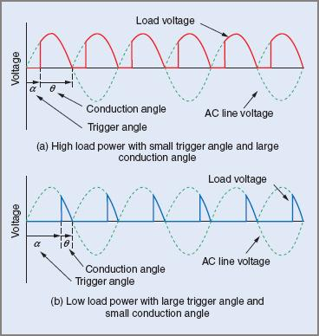
(3 marks for description, 3 marks for diagram = 6 marks total )
- What is meant by the ‘zero crossing point’. Include a diagram to assist your answer. (4 marks)
Ans to include diagram similar to:
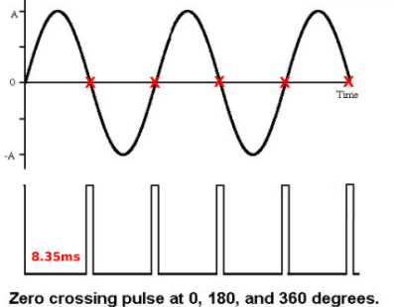
(2 marks for description, 2 marks for diagram = 4 marks total )
- A typical domestic lighting dimmer circuit is shown below. Identify and name the two semiconductor components and then describe the general principle of how the circuit operates. (5 marks)

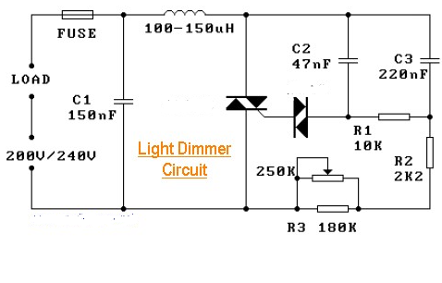
Ans:
Device controlling the load is a Triac (1 mark)
Device connected to C2 and R1 is a Diac (1 mark)
Operation:
the 250K resistor controls the time constant of capacitor charging
Once C2 reaches a certain threshold, the diac switches on into avalanche conduction, providing a clean pulse of current to switch on the triac
Triac conducts for the duration of the AC waveform until the next zero voltage cross point event.
C1 and inductor are used as transient suppression devices.
(3 marks)

- A conventional op-amp can be configured as a zero crossing point detector. Sketch this circuit and briefly explain its operation (5 marks)

Ans:
2 marks for diagram
3 marks for description


