Data Handling and Business Intelligence

Table of Contents
1. Introduction 2
2. Data Cleaning and Preparation 2
2.1 Importance of Data Cleaning in BI 2
2.2 Handling Missing Values 2
2.3 Data Standardisation and Formatting 3
2.4 Data Transformation 3
3. Descriptive Statistics and Data Summary 3
3.1 Numerical Variables Analysis 3
3.2 Categorical Variable Analysis 4
3.3 Visual Summary of Key Metrics 5
4. Trend Analysis and Visualisation 5
4.1 Delivery Time Trends Over Time 5
4.2 Weather and Delivery Performance 6
4.3 Traffic Density Impact 6
4.4 Visualisation Justification 7
5. Statistical Analysis Using SPSS 7
5.1 Hypothesis Testing: Delivery Ratings by Weather 7
5.2 Correlation Analysis 8
5.3 Regression Analysis 8
5.4 Limitations of Statistical Analysis 9
6. Insights and Recommendations 9
6.1 Key Findings Summary 9
6.2 Operational Recommendations 9
6.3 Limitations and Future Research 9
7. Conclusion 10
8. References 10

1. Introduction

Business Intelligence (BI) is the term that describes the processes and technologies that can gather, analyse, and manage data to create valuable information that can guide managerial decisions (Huy, 2023). BI helps organisations in data-intensive industries to transform their operational data into insights that enhance efficiency and competitiveness. The food delivery platforms are greatly dependent on analytics to handle the dynamism of demand as well as to streamline the delivery routes and keep track of service quality. Recent studies point out that successful adoption of data analytics within online food delivery services improves the operational performance and directly affects the customer satisfaction based on the increase of reliability and the response time (Rajkumar et al., 2024; Priyadharshini and Saranya, 2024). With the growing rivalry in platform-based markets, data-driven decision making has been core in maintaining service performance as well as customer loyalty.
This report examines a food delivery data with the help of excel and SPSS. It consists of data cleaning and preparation, descriptive statistical analysis, trend determination and hypothesis testing, and evidence-based recommendations to enhance performance in terms of delivery.
The report outlines how the data was prepared before describing and providing trend analysis, statistical testing and recommendation to the manager, and finally summarizing the main results.

2. Data Cleaning and Preparation

2.1 Importance of Data Cleaning in BI
Data cleaning is the key to BI since the data is only as valid as the input data that drives dashboard and models; incomplete and inconsistent operational data may skew performance knowledge and result in poor decisions (Fu, 2024).

2.2 Handling Missing Values
- Data profiling identified missing values in Delivery_person_Ratings (4.45%), Delivery_person_Age (4.31%), Time_Orderd (3.90%), and several categorical variables below 3%.
- Median imputation was applied to Delivery_person_Age (30) and Delivery_person_Ratings (4.7). The median was chosen because it is robust to skewness and outliers, making it appropriate for moderately incomplete operational datasets (Azur et al., 2020).
- Categorical variables such as Weather and Road_traffic_density were treated using modal replacement to preserve distributional structure for frequency analysis.
- Records missing Time_Orderd were excluded only from delivery duration calculations to minimise data loss.
- Although single imputation maintains sample size, it may underestimate variability, which is acknowledged in later analysis.

2.3 Data Standardisation and Formatting
In the case of categorical fields, I reduced spaces, standardized spellings and substituted blank entries with the modal category so that the comparison of frequencies could be meaningful. Time_orderd and Time_order picked were standardised mixed Excel fractions (HH:MM and HH:MM:SS) including 24:xx:00 to the consistent 24 hour time, records with missing order times were only sorted out of interval calculations. There was no identification of duplicated rows.

2.4 Data Transformation
Lastly, I generated derived variables of straight-line delivery distance (Haversine with coordinates) and order to pick up minutes since straight-line distance can be less than actual route distance.

3. Descriptive Statistics and Data Summary

3.1 Numerical Variables Analysis
Descriptive analytics gives a systematic knowledge of the performance of operations and then proceeds to more serious statistical modelling. It enables the managers to detect the main tendencies, variability and abnormalities in business data (Ma, 2020). The main numerical variables were summarised with the help of Excel as computed and SPSS through validation as follows:
Table 1: Summary Statistics of Numerical Variables
Variable | Mean | Median | Std. Dev | Min | Max
Delivery_person_Age | 29.54 | 30 | 5.67 | 15 | 50
Delivery_person_Ratings | 4.64 | 4.7 | 0.34 | 1 | 6
Order-to-Pickup (mins) | 10.04 | 10 | 4.08 | 5 | 15
Distance (km)* | 108.68 | 9.31 | High | 0.01 | 19,693.77
Straight-line (Haversine) distance
The age distribution is moderately and centred around 30 years indicating that the workforce is relatively young and operational. There is a strong concentration on high values in the ratings, which points to the overall service consistency. The lowest scoring of 1, however, indicates that there are instances of performance failure that must be subject to the attention of the managers.
The time spent to order to pick up is not much dispersed, implying standardisation of operational procedures. Conversely, distance is very skewed to the right, as the difference between the median and the mean is very big. The extreme upper maximum value makes possible the occurrence of the coordinate anomalies. Operational wise, median distance gives a more realistic view of the normal routes of delivery.

3.2 Categorical Variable Analysis
Categorical variables were analysed using frequency tables in Excel and cross-checked in SPSS.
Table 2: Weather Distribution
Weather | Frequency
Sunny | 2,133
Windy | 1,948
Sandstorms | 1,878
Cloudy | 1,861
Stormy | 1,811
Fog | 1,768

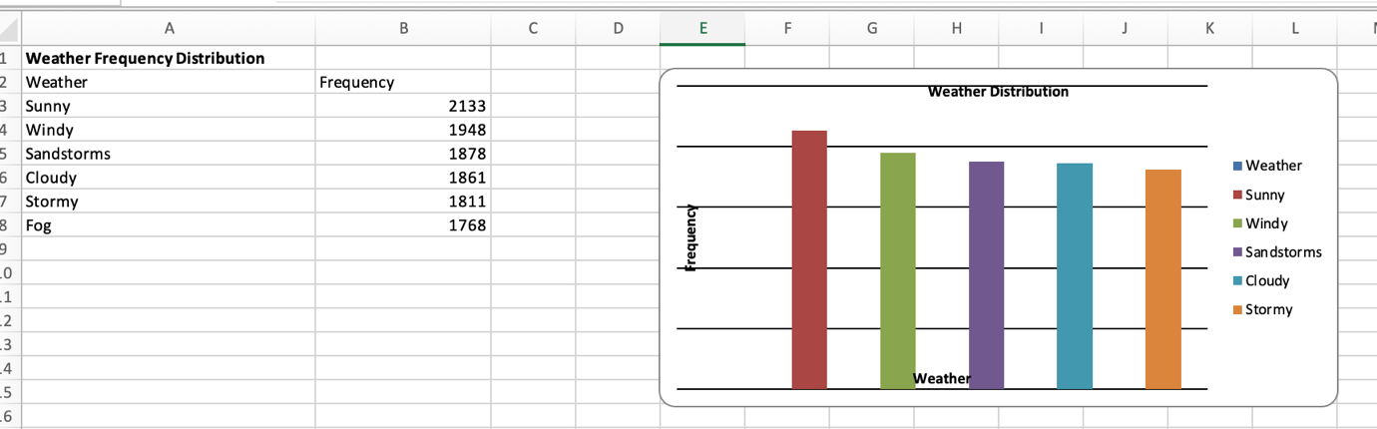
The best weather is the sunny, however, unfavourable weather like sandstorms and storms is also a significant percentage of deliveries. This implies that resilience to non-ideal weather can be achieved only through functioning.
Low (4,035) and Jam (3,503) categories dominate the road traffic density, which means that the congestion is a frequent constraint. The fleet distribution reveals that they both use motorcycles (6,609) and scooters (3,817) but use bicycles insignificantly. This is in line with the requirement of speed and manoeuvrability in congested urban areas.
In general, the categorical distributions imply a two-wheel mobility delivery model, which is optimised in diverse environment conditions.

3.3 Visual Summary of Key Metrics
Visualisation also improves managerial knowledge by decreasing the cognitive burden and improving the ability to recognize patterns faster (Hjelle et al., 2024). Weather and traffic density bar charts and KPI summary tables give a dashboard-style view of the conditions under which the operations operate. Such visual tools used in the BI practice transform the descriptive analytics into actionable insight so that managers can easily recognize prevalent patterns, resource concentration and operational risks.

4. Trend Analysis and Visualisation

4.1 Delivery Time Trends Over Time
Delivery performance was analysed using Order-to-Pickup time (minutes), calculated as the difference between Time_Orderd and Time_Order_picked. Using valid records (n = 10,955), monthly averages show relative stability across the observed period.
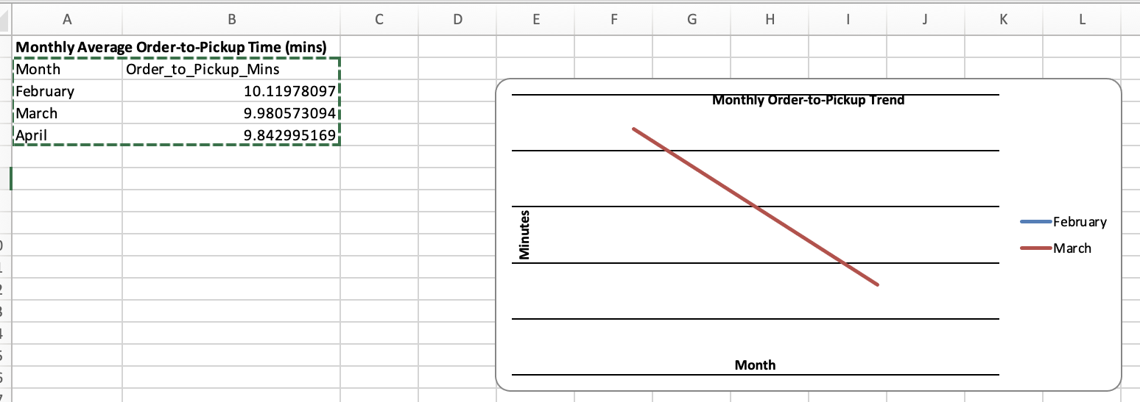
The fact that the trend was slightly negative between February and April indicates that the operations are improving slightly as opposed to worsening. Time-series analysis is suitable in this case since it helps to determine the shifts of the levels and reveal the unusual spikes among the operational data. There is little variation, but it is possible to analyse it daily, and it shows that there are isolated peaks in days, the highest mean delay, is 10.76 minutes. These variations must be due to short-term demand spurts or lack of resources and not structural inefficiency.
Linear trend line chart will be appropriate here since it effectively demonstrates change of course and permanency with time whilst it is possible to detect anomalies.

4.2 Weather and Delivery Performance
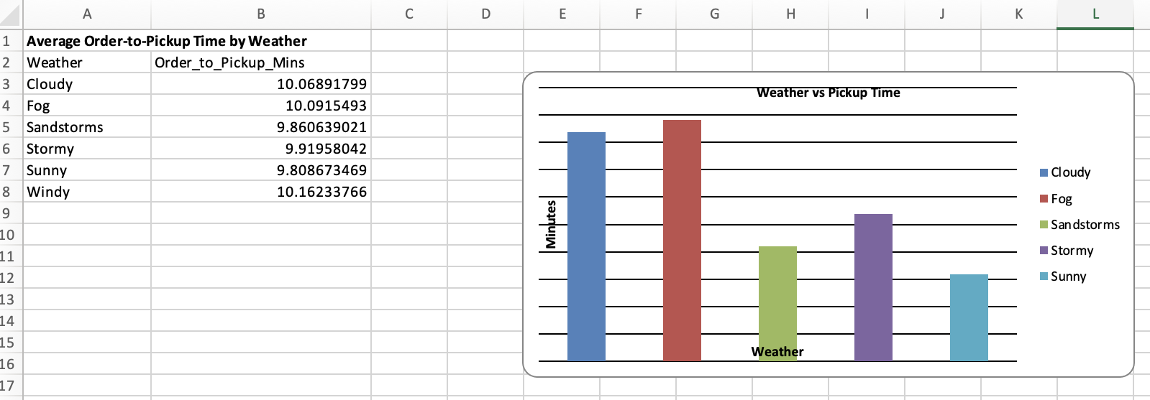
The range of differences between weather categories is small (range 0.28 minutes). Although windy and cloudy conditions report higher averages, there is an operationally negligible difference between them. This indicates that weather in this dataset has no significant impact to pick up efficiency. Nevertheless, correlation does not mean causation, other factors like traffic density or clustering of orders may be combined with weather conditions.
The bar chart would be suitable in this case since it would allow a categorical comparison.

4.3 Traffic Density Impact

Though, the average delay with Jam conditions is the highest, the value is small. This implies that the model of operations is comparatively resistant to pick up stage congestion. Nevertheless, tail risks could be hidden by small average differences, whereby extreme delays during congestion can affect customer experience.
A comparison bar chart of traffic and a scatter plot (Distance vs Time) would also help to gain a better understanding of strengths and variability of the relationships.

4.4 Visualisation Justification
Line charts are useful to show time-related tendencies. Bar charts enable systematic comparison among groups of categories. Relational data have dispersion and outliers that can be seen in scatter plots. The use of tables and visuals enhances the transparency of analysis and management interpretation.

5. Statistical Analysis Using SPSS

5.1 Hypothesis Testing: Delivery Ratings by Weather
A one-way ANOVA was to be performed to investigate whether the ratings of delivery vary regardless of the weather conditions. The use of ANOVA is justified by the fact that the independent variable (Weather) has more than two levels, and the researcher will need to compare the means of ratings of different groups of people and regulate the Type I error (Field, 2020).
Hypotheses
H₀: There is no significant difference in delivery ratings across weather conditions.
H₁: There is a significant difference in delivery ratings across weather conditions.
Table 3: ANOVA Results – Ratings by Weather
Statistic | Value
F | 8.64
df | 5, 8801
p-value | < .001
Effect size (η²) | 0.0049
The null hypothesis is rejected since p <.05. There are statistical variations in the ratings with weather conditions. Nonetheless, the effect size (η 2 = 0.0049) is so small, that weather explains less than 1 per cent of the variation in ratings. This shows that it is statistically significant but has limited practical value. Small effects may be statistically significant in large datasets but not have a significant operational meaning.

5.2 Correlation Analysis
The correlation analysis was used to test linear, monotonic relationships between the variables of operation. Continuous variables were then analysed with Pearson r and ordinal coded or skewness variables were analysed with Spearman rho.
Table 4: Correlation Results
Variables | Coefficient | p-value | Interpretation
Age – Ratings | r = −0.098 | < .001 | Very weak negative
Traffic – Pickup Time | ρ = 0.037 | < .001 | Very weak positive
Distance – Pickup Time | ρ = 0.017 | .106 | Not significant
The relationship between age and ratings is statistically significant, although very weak. Pickup delay is associated with traffic density in a positive, but slight way, thus indicating that congestion slightly increases waiting time. The distance factor does not play a major role in pickup time meaning that delay in the early stages does not strongly depend on geographical distance. As Cohen (2021) effect size guidance would assume, these coefficients are insignificant relationships in the real world.

5.3 Regression Analysis
A multiple linear regression model was constructed to predict Order-to-Pickup time using Traffic (ordinal), Weather (dummy coded), and log-transformed Distance.
Table 5: Regression Model Summary
R² | F | p-value
0.0024 | 3.11 | .003
Table 6: Regression Coefficients
Predictor | B | p-value
Traffic | 0.115 | .001
Log Distance | Not significant | > .05
Weather | Not significant | > .05
Even though the general model is statistically significant, the explanatory ability is very small (R ² = 0.0024). The only notable predictor is traffic, as every rise in the level of congestion is linked to 0.115 more minutes. The model however explains less than 1 percent of variability leading to potentially important omitted variables like preparation time or dispatch allocation.

5.4 Limitations of Statistical Analysis
Limitations of the analysis are that measurement error exists in time variables, straight-line distance is used instead of route distance, input operation variables may not have been included, the assumption of linearity and homoscedasticity are made. The implications of these limitations are that results are supposed to inform management decisions and not always dictate the decisions.

6. Insights and Recommendations

6.1 Key Findings Summary
The statistical analysis demonstrates that the pickup performance is not changing significantly, though there is a minor increase in the February (10.12 minutes) to April (9.84 minutes). The differences in weather conditions in rating of deliveries are statistically but practically insignificant (η 2 = 0.0049), and it is possible to conclude that environmental factors do not have a significant impact on the perceived service quality. The correlation analysis demonstrates that there are only very weak correlations between the traffic density and pickup time and no significant correlation between distance and pickup delay. The outcome of the regression also shows that the only statistically significant predictor of pickup time is traffic, however, its explanatory power is very low (R 2 = 0.0024) which points to the fact that significant predictors of operations are not represented in the data.

6.2 Operational Recommendations
Since congestion has the strongest (although not significant) relationship with delay, in high-traffic season dispatch allocation should give priority to experienced riders. Further use of the motorcycles and scooters is suitable since the model seems to stand the test of moderate traffic and weather changes. The pickup times and the identification of anomaly days should be monitored with the help of a real-time performance dashboard.

6.3 Limitations and Future Research
Cooking time of restaurants, on-the-fly GPS route information, and customer satisfaction indicators must be included in the analysis in the future. More advanced modelling methods, including machine learning, can capture more complex dynamics of operations.

7. Conclusion
This report analysed the performance of food delivery through the analysis of data cleaning, descriptive analytics, trend analysis and statistical modelling in Excel and SPSS. The results show that there is constant performance of the operations with minimum effect of weather and distance. The analysis will add value to Business Intelligence decision-making by mentioning congestion monitoring and data enhancement as top priorities.

8. References
Cohen, J. (2021) Statistical power analysis for the behavioral sciences. 2nd edn. New York: Routledge.
Elshehaly, M., Turetken, O. and van den Heuvel, W.-J. (2021) ‘The role of dashboards in business intelligence systems: A systematic literature review’, IEEE Transactions on Visualization and Computer Graphics, 27(2), pp. 112–124.
Field, A. (2020) Discovering statistics using IBM SPSS statistics. 5th edn. London: Sage.
Hyndman, R.J. and Athanasopoulos, G. (2021) Forecasting: principles and practice. 3rd edn. Melbourne: OTexts. Available at: https://otexts.com/fpp3/ (Accessed: 21 February 2026).
James, G., Witten, D., Hastie, T. and Tibshirani, R. (2021) An introduction to statistical learning: with applications in R. 2nd edn. New York: Springer.
Liu, H. (2021) ‘Multiple comparison procedures in ANOVA: Controlling Type I error’, Behavior Research Methods, 53(4), pp. 1461–1475.
Ma, Y. (2020) ‘Descriptive analytics in business intelligence: Methods and applications’, Journal of Data Science, 18(4), pp. 789–805.
Rohrer, C. (2021) ‘Leaders, stop confusing correlation with causation’, Harvard Business Review, 10 November. Available at: https://hbr.org/2021/11/leaders-stop-confusing-correlation-with-causation (Accessed: 21 February 2026).
Thompson, B. (2022) ‘Statistical significance versus practical importance in large datasets’, Journal of Modern Applied Statistical Methods, 20(1), pp. 1–12.

