

Title Page

Programme of Study: CertHE Business Skills for the Workplace

Module Name & Code: LCLM4006 Enterprise & Entrepreneurship

Assignment Title: Youths United Ltd

Lecturer’s Name: Fouziya Farheen

Student Name: Monique Joyti Kiran

Student ID: 2520247

Executive Summary

Youths United Ltd provide a platform for 16-24-year-olds with little to no experience and/or lower grades.
It has become difficult for youth between the ages of 16-24-year-olds to apply for jobs. This is because most organisations want to recruit people with experience or high educational grades.
Youth unemployment for 16-24-year-olds is currently around three times the national average (Jober Editorial Team, 2026).
Youth United will be a UK job website built for 16-24-year-olds:
All roles are open to candidates with no experience or low grades, as we match people based on their potential rather than their past jobs or academic results. Every employer provides full training to help people get started, and each position includes a paid trial that gives young people valuable, hands-on experience they can proudly add to their CV.

Our unique selling point is that this will be the only platform removing experience/grade rules for this age group.
Youths United is funded through a combination of a £22,500 Start Up Loan, local grant support, and personal funds. Launching initially in the West Midlands, the platform will expand across the UK within 12 months, with targets of securing over 500 job opportunities and growing to more than 2,000 registered users within the first six months. Committed to sustainable practice, the business will operate fully as a paperless, eco-friendly organisation.


AI (DOLA, 2026)

Table Of Content
Title Page 1
Executive Summary 2
Table Of Content 3
Business Overview 4
Market Research 6
Marketing Communications 9
Financial 11
Reference List 14

Business Overview

Youths United Ltd is an online job platform built exclusively for 16–24-year-olds with little to no work experience and/or lower grades. It will connect them to entry-level roles where employers promise training from day one where no experience is required and we will also give them the opportunity to take part in a paid trial shift where they can gain some experience. They will create an online profile that will focus on attitude and potential rather than past jobs or grades.
UPS
Our UPS (unique selling point) is that this will be the only platform removing experience/grade rules for this age group.
Other job sites list everything. Youths United lists roles open to beginners. There is no other platform available that remove experience and grade barriers for this age group. The website fills a clear gap in the market where young people will get fair chances and small businesses get motivated, reliable new staff.

Management Structure
This would require a team of individuals to come together to help set up and run this organisation.
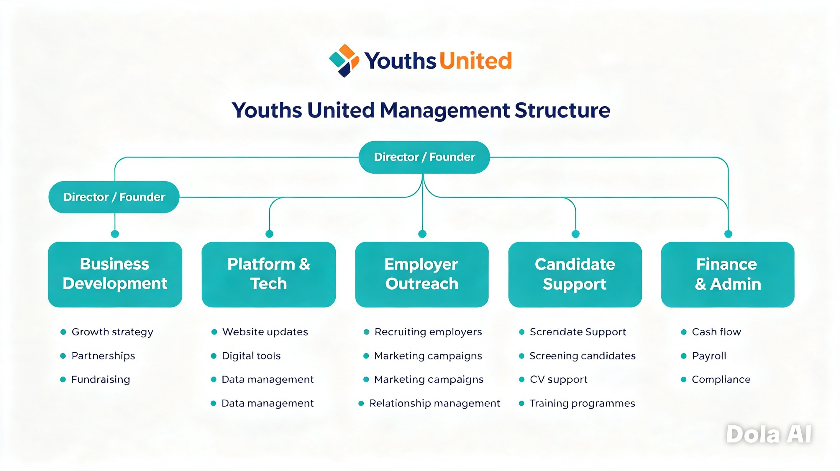
AI (DOLA, 2026

Legal Format
Youths United will be established as a Private Limited Company (Ltd), which is one of the most popular and trusted business structures chosen by entrepreneurs across the UK (NatWest, 2025). This legal form is particularly well suited to the platform’s ambitions, as it creates a clear separation between personal and business finances. Crunch (2025) explains that operating as a limited company provides important safeguards, including full protection of personal assets such as your home and savings, meaning they cannot be used to settle business debts in most circumstances. It also delivers significant tax efficiencies, allowing you to structure your income more effectively and potentially keep more of what you earn. Furthermore, being a limited company enhances your professional reputation, inspiring confidence in employers, partners, investors, and funding bodies alike, which in turn makes securing loans, grants, and support much easier. On top of these benefits, incorporating legally protects your business name, ensuring that no other organisation can trade as Youths United and preserving your brand identity across the marketplace
Environmental Sustainability
Youths United is fully paperless and will work digitally to cut carbon footprint. Going paperless not only reduces the environmental impact of letters and packages, but it can also help businesses reduce their costs and carbon footprint. (WWF, n.d.).
The below picture shows the environmental and operational benefits of moving to paperless systems (Water Delivery Solutions, 2022).

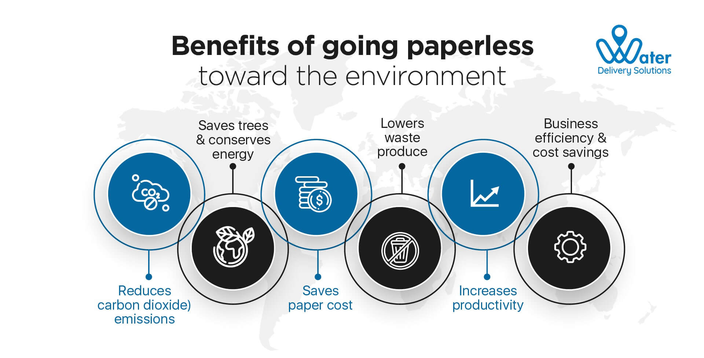

Market Research

PESTEL Analysis

Political | Government supports youth employment.  We have designed the Scheme to be open and accessible, ensuring eligible employers and young people can easily take part in the Scheme and benefit from the grant. (Department for Work and Pensions, 2026)
Economic | Cheaper to hire young people - the National Minimum Wage is lower for under-21s. This makes it more affordable for small businesses to take on someone new, so they’re more likely to list roles with you. The National Minimum Wage for under-21s is lower than the National Living Wage for workers aged 21 and over. (Hand, 2026).  When you recruit an experienced employee, they bring valuable knowledge, but they also bring habits and ways of working from previous organisations. A young person offers something different. They learn your processes, your systems, and your culture from day one. Rather than adapting existing habits from previous employers, you've the opportunity to shape skills and behaviours from the ground up, creating employees who are aligned to business needs, ways of doing things and future goals. (Cross-Webber, 2026).
Social | Youth United designed to help the community make a living and build a career by giving them opportunities. We will start off by advertising on all major social media platform such as TikTok, Facebook, LinkedIn and Instagram.  Social platforms are no longer just places to post updates. For many UK businesses, they are one of the most controllable and measurable ways to reach new customers, drive enquiries, and build demand (Bird, 2026).
Technological | Youths are tech savvy.  They have grown up in a world where digital connectivity has always existed. Information has always been available at their fingertips. Communication has always been instant. Entertainment has always been on demand. Because technology has been present throughout their formative years, they interact with digital tools with a level of comfort and familiarity that feels almost instinctive. Instead of attending formal training sessions to understand new technologies, they often learn through exploration, experimentation, and observation. Their ability to intuitively navigate digital environments is one of the key factors that makes them exceptionally tech-savvy (Cogent Infotech, 2026).
Environmental | Our paperless setup appeals to eco-conscious employers & funders.  Transforming paper processes to digital isn’t a way to create more work, but rather reduce it along with reduced cost, better security and less waste (Xenith, n.d.).
Legal | In the UK, data protection is governed by the UK General Data Protection Regulation (UK GDPR) and the Data Protection Act 2018.  Organisations must ensure personal data is used fairly, accurately, and only kept for as long as necessary (UK Government, 2025).

Competition
Indeed, LinkedIn and reed - They are direct competitors as they are based online and may offer some of the job roles that will be provided on Youths United’s site. Their site is catered to people from the age 16+, there is not particular age group.
Youths United will also face competition with job board in shops, newspapers and job centres. They are indirect competitors as they are not online and will have a different process in place for applying for jobs. This is also catered to people from the age 16+, there is not particular age group.

Competition | Strengths | Weaknesses | Our Advantage
Indeed / Reed | Huge reach | Still ask for experience/grades | Every role is beginner-friendly
Apprenticeship sites | Government-backed | Most need good Maths/English grades | No grade minimums
Local council sites | Trusted | Slow, outdated websites | Fast, modern, easy to use

Indeed (2018) claim on their website that they are the UK’s no Job site.
They use AI alongside extensive hiring data. Indeed state that they connect millions of people with opportunities every day while helping employers find the right talent.

Job Centre Guide. (2022) explain that the Jobcentre Plus, part of the Department for Work and Pensions, is a government-funded agency that help people who are looking for work from the working age. They source employers from across the UK. It provides job searching tools, training information, and administers benefit support to assist those seeking work.

Marketing Communications

Marketing Plan
Market segmentation means splitting customers into smaller groups based on shared traits such as age, location, spending habits, or values. This lets businesses target people more effectively, spend wisely, and offer products and messages that suit their specific needs, leading to better results and happier customers (Investopedia, 2026).

The image below shows how market segmentation works to group customers by shared characteristics (Investopedia, 2026).
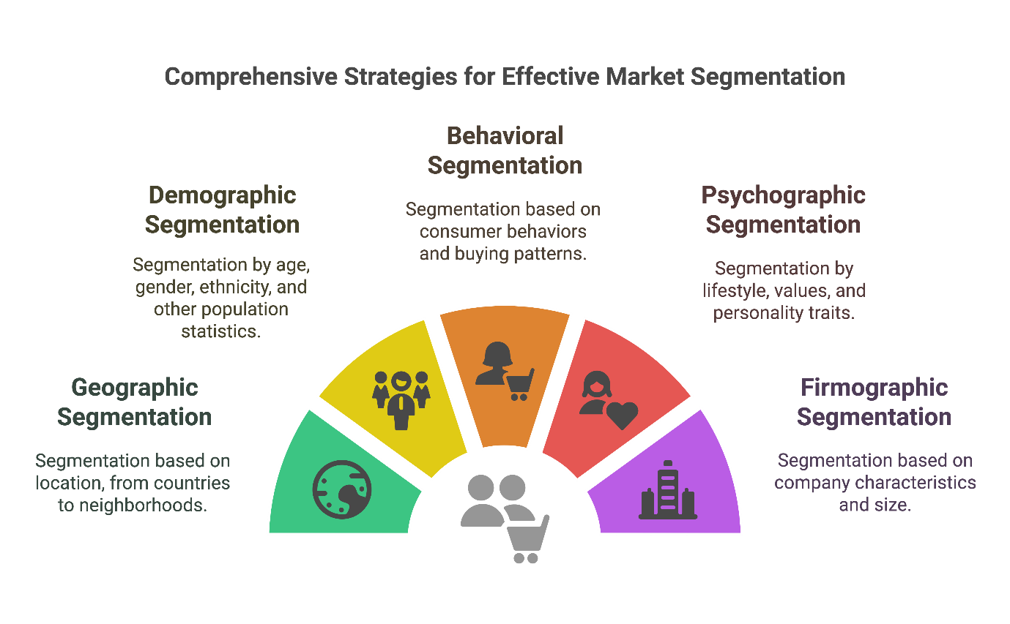

Demographic segmentation is ideal because it will focus specifically on 18 - 24-year-olds, which is what this website is designed to do. Psychographic segmentation means this will appeal to customers in search of the same thing which is finding a job with little or no experience or/and low educational grades.

The website Metaintro explains that 18–24 year olds are increasingly using social media to find work, as traditional application methods become more competitive and harder to stand out in. (Garach, 2026).

Typing simple phrases such as “jobs with no experience” in the search engine will suggest my website as a result.

An example of a short reel story on a social media platform:
Title: I got a job with no experience!
(hashtag) #jobwithnoexperience
A 30 second video of a young lady using the Youth United website browsing for a job opportunity using the key words “no experience” in the search engine. The second scene will show the young lady receiving an email response asking them to meet for a paid trial shift which she accepts. The third scene shows her on the trial shift and getting paid at the end of her shift. The final scene that she has been offered the job based on the potential they showed during their trial shift resulting in them signing a full-time contract.
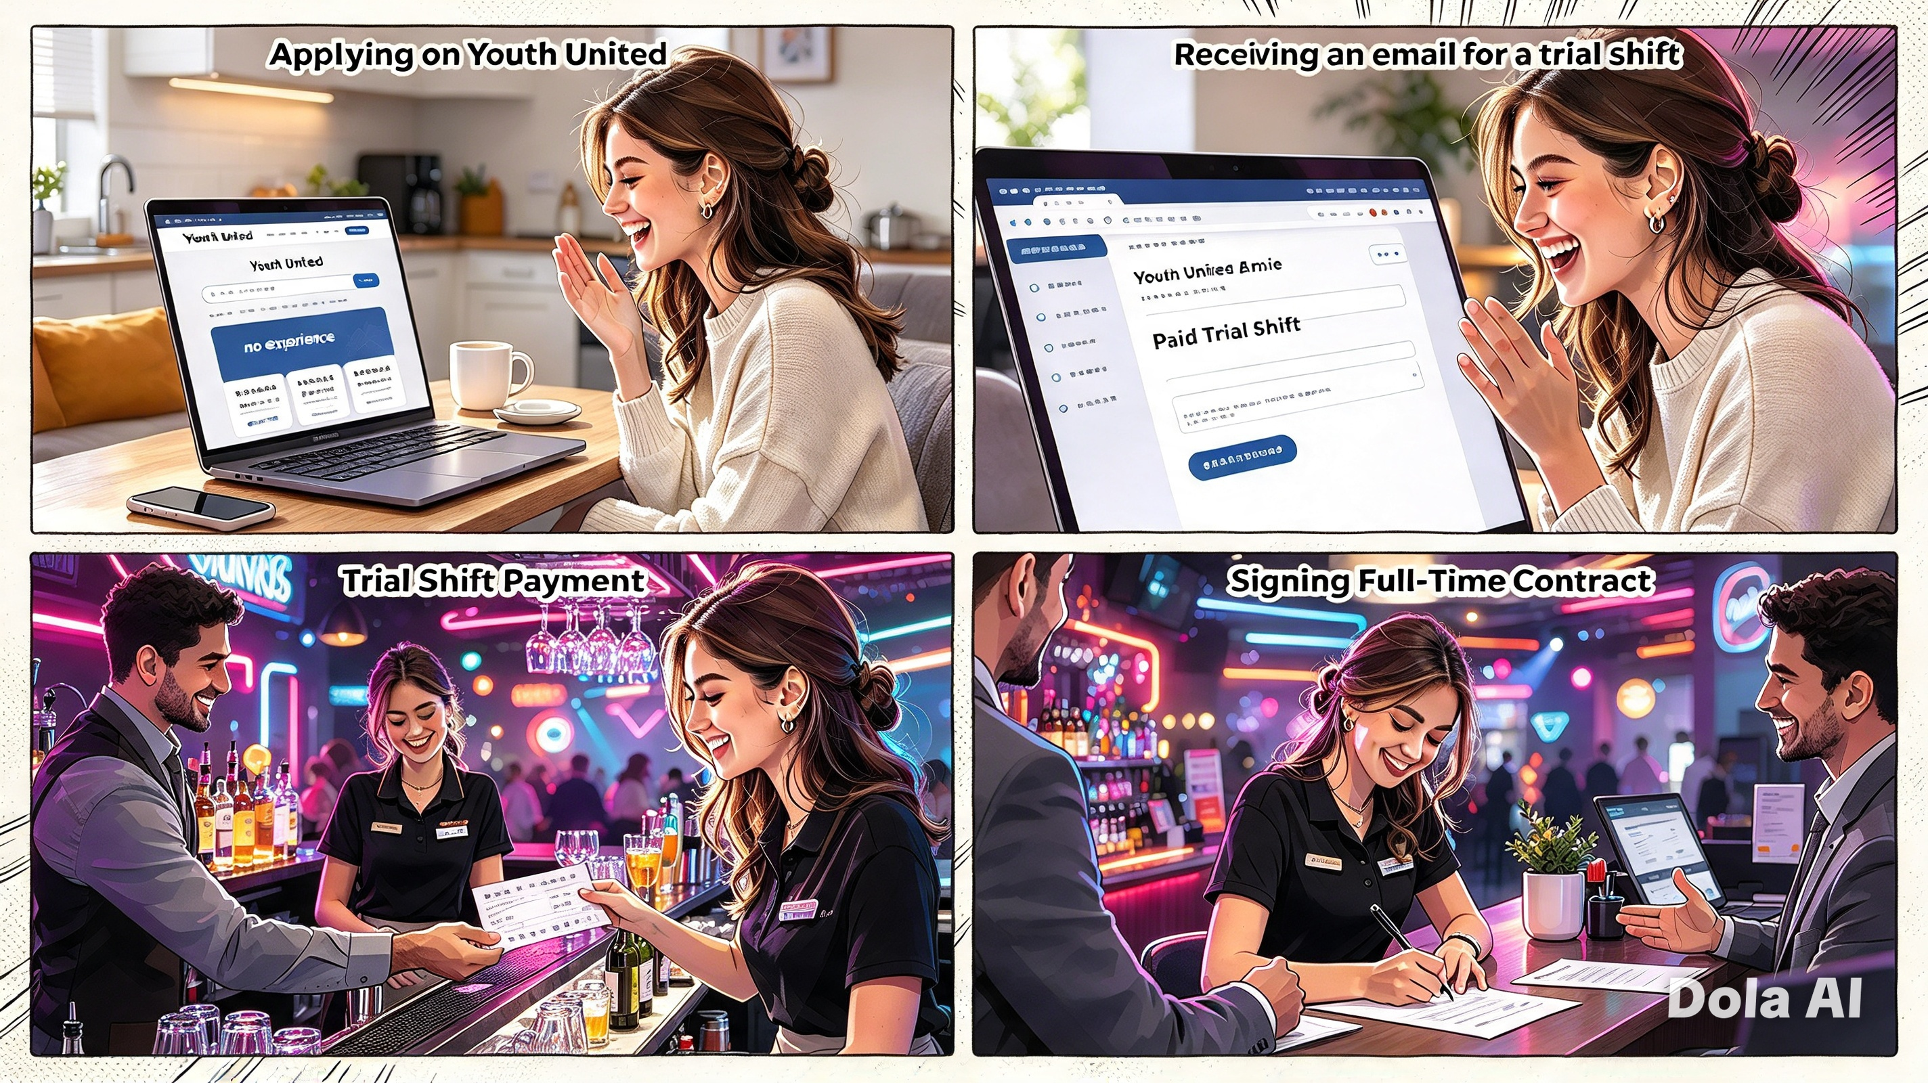
AI (DOLA, 2026)

Financial

Amount of Funding Required
Youth United would require £22,500 in start-up funding to establish and launch successfully.
The amount is calculated to cover all necessary setup costs and first-month operating expenses.
Employers will pay a subscription to list roles and browse candidates.
Community: 5% of annual profits fund free job-skills workshops in schools and youth centres in high-NEET areas (Not in Education, Employment, or Training).

Chosen Funding Source: Government Start-Up Loan
The Government Start Up Loan is available for new entrepreneurs. This funding source protects your personal assets and has a fixed 7.5% interest rate which means repayments stay predictable. This funding also has flexible terms of 1-5 years and provides extra support such as free. (Start Up Loans, 2025).
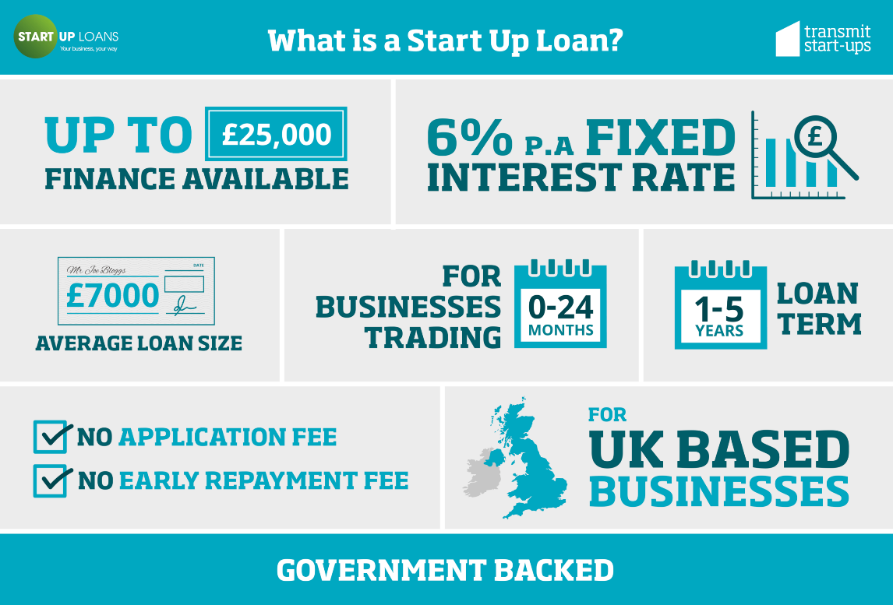
(Cizmeci, 2020).

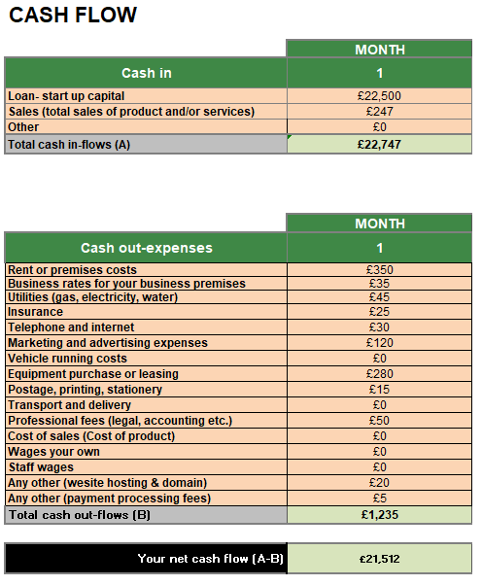
The above cash flow shows Youths United starting with a £22,500 start-up loan and earning £247 in sales, giving total incoming funds of £22,747. Total running costs come to £1,235, covering rent, equipment, marketing, and all essential overheads, with no wages drawn in the first month. This leaves a healthy positive net cash flow of £21,512, meaning the business begins with strong funds in reserve to support ongoing operations as revenue grows.

Reference List
Bird, J. (2026) Advantages of Social Media Advertising for UK Businesses in 2026. [online] Delivered Social. Available at: https://deliveredsocial.com/advantages-of-social-media-advertising-for-uk-businesses-in-2026/ [Accessed 7 Oct. 2026].
Cizmeci, D. (2020) The pros and cons of using government business loans for your startup [image]. [online] Daglar Cizmeci. Available at: https://daglar-cizmeci.com/government-business-loans/ [Accessed 24 Oct. 2026].
https://Cogentinfo.com . (2026). Cogent | Blog | Why Gen Z Is the Most Tech-Savvy Generation. [online] Available at: https://cogentinfo.com/resources/why-genz-is-the-most-tech-savvy-generation [Accessed 7 Oct. 2026].
Cross-Webber, A. (2026). Why Employing a Young Person Could Be One of the Best Decisions Your Business Makes. [online] https://Realisetraining.com . Available at: https://realisetraining.com/news-and-events/news/why-employing-a-young-person-could-be-one-of-the-best-decisions-your-business-makes [Accessed 3 Oct. 2026].
www.crunch.co.uk. (n.d.). What are the main advantages of a limited company? | Crunch. [online] Available at: https://www.crunch.co.uk/knowledge/article/what-are-the-main-advantages-of-a-limited-company [Accessed 24 Oct. 2026].
Department for Work and Pensions (2026). Youth Jobs Grant: Grant guidance. [online] https://GOV.UK . Available at: https://www.gov.uk/government/publications/youth-jobs-grant/youth-jobs-grant-grant-guidance [Accessed 3 Oct. 2026].
DOLA (2026) Youth United branded office workspace [AI-generated image]. Available at: [paste the link or note where the image is held] [Accessed 24 Oct. 2026].
DOLA AI (2026) Youths United management structure diagram [AI-generated image]. Available from: Business plan materials [Accessed 24 Oct. 2026].
Drashti Garach (2026). Why gen Z is using social media to get hired in 2026. [online] Metaintro. Available at: https://www.metaintro.com/blog/why-gen-z-is-using-social-media-to-get-hired-in-2026 [Accessed 24 Oct. 2026].
FinanceBox. (2026). FinanceBox. [online] Available at: https://financebox.co.uk/articles/2026-03-19-lower-costs-higher-potential-why-under-21-employees-make-business-sense [Accessed 3 Oct. 2026].
Hoenig, H. (2025). Understanding market segmentation: A comprehensive guide. [online] Investopedia. Available at: https://www.investopedia.com/terms/m/marketsegmentation.asp [Accessed 24 Oct. 2026].

Indeed (2018). About indeed. [online] Indeed.com. Available at: https://www.indeed.com/about [Accessed 25 Oct. 2026].
Job Centre Guide. (2022). What is the jobcentre plus? [online] Available at: https://www.jobcentreguide.co.uk/what-is-the-jobcentre-plus [Accessed 25 Oct. 2026].
Jober Editorial Team (2026). Youth Unemployment UK 2026: Why Finding Work Is Hard. [online] Jober. Available at: https://www.jober.uk/articles/young-people-struggling-to-find-work-uk-2026-24 [Accessed 7 Oct. 2026].
Keleshian, C. (n.d.). 5 Simple ways to assess your market segmentation. [online] www.sapbwconsulting.com. Available at: https://www.sapbwconsulting.com/blog/inbound-marketing/5-simple-ways-to-assess-your-market-segmentation [Accessed 24 Oct. 2026].
Microsoft excel (2026) Cash flow projection — Youths United, Month 1 [Excel spreadsheet image]. Available from: Business plan materials [Accessed 24 Oct. 2026].
Sharma, M. (2022). Go aperless: Practise sustainability in your bottled water business. [online] Water Delivery Solutions. Available at: https://www.waterdeliverysolutions.com/blog/go-paperless-practice-sustainability-in-your-bottled-water-business/ [Accessed 24 Oct. 2026].
Start Up Loans. (2025). Comparing a business loan and a start up loan for a new business. [online] Available at: https://www.startuploans.co.uk/support-and-guidance/business-guidance/finance/business-loan-versus-start-up-loan [Accessed 24 Oct. 2026].
UK Government (2025). Data Protection Act. [online] https://Gov.uk . Available at: https://www.gov.uk/data-protection [Accessed 7 Oct. 2026].
WWF. (2023). Go paperless. [online] Available at: https://www.wwf.org.uk/challenges/go-paperless [Accessed 24 Oct. 2026].
www.xenith.co.uk . (n.d.). 8 Reasons to switch paper to digital alternatives. [online] Available at: https://www.xenith.co.uk/blog/8-reasons-to-switch-paper-to-digital-alternatives [Accessed 7 Oct. 2026].

