

Professional Career Development in Health and Social Care
LCHS4009

Assignment 2 – Practical Portfolio

Name of Student: | Fatemeh Kazeminojehdeh
Student ID: | 2442621
Module Code: | LCHS4009
Tutor: | Dr Christopher Mafuva
Date: | April 2026

Acknowledgement of AI Use:

"I confirm that I have not used AI to complete my work. I used Grammarly as a proofreading and spell-checking tool to support the accuracy of my writing."

Table of Contents

Introduction 3

Job Advertisement 4

Task 1 of 4: Curriculum Vitae 5

Task 2 of 4: Personal Statement 7

Task 3 of 4: SWOT Analysis & Personal Development Plan 9

Task 4 of 4: Critical Reflection (Gibbs) 12

References 15

Introduction
A professional portfolio is a structured collection of evidence demonstrating an individual’s skills, knowledge, experience, and readiness for employment. Within health and social care, portfolios are essential for evidencing competence, reflective practice, and commitment to continuous professional development (Skills for Care, 2023a). Cottrell (2019) highlights that employers increasingly expect candidates not only to possess knowledge but also the ability to critically evaluate their own skills and apply them in real-world practice.

This portfolio is tailored to a Team Leader role in domiciliary care, focusing on leadership, person-centred care, and regulatory compliance – all areas that are fundamental to delivering safe, effective, and high-quality services (Care Quality Commission [CQC], 2023). The portfolio includes: a professional CV; a personal statement; a SWOT analysis with a Personal Development Plan (PDP); and a critical reflection on my Assessment 1 presentation, structured using Gibbs’ (1988) Reflective Cycle.

Job Advertisement (Evidence)
The following role was identified as the target position for this portfolio. All tasks have been tailored to demonstrate suitability for this specific job.

Role: Team Leader – Domiciliary Care
Employer: Evergreen Care(UK)
Location: London
Key Responsibilities:
- Supervise and support care staff
- Ensure person-centred care delivery
- Maintain compliance with CQC standards
- Monitor and improve care quality

Essential Requirements:
- Experience in care or leadership
- Knowledge of safeguarding and regulations
- Strong communication skills

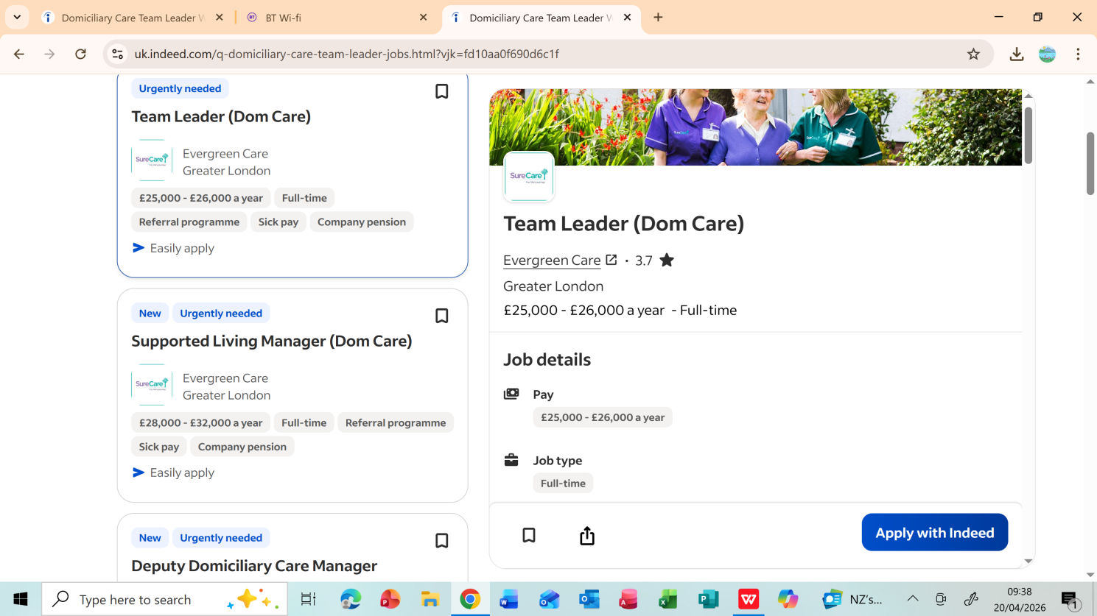
Reference: Indeed (2026) Team Leader – Domiciliary Care (London). Available at: https://uk.indeed.com/q-domiciliary-care-team-leader-jobs.html?vjk=fd10aa0f690d6c1f (Accessed: 23 April 2026).

Task 1 of 4: Curriculum Vitae
Fatemeh Kazeminojehdeh
London, NW4 1QW • 07738 622 616 • daria_kazemi@yahoo.com

Personal Profile
Results-driven professional with over fifteen years of senior leadership, quality management, and business operations experience across international environments. Currently completing a Level 4 Diploma in Health and Social Care at UWTSD, combining strategic management expertise with developing person-centred care knowledge. Seeking a Team Leader role in domiciliary care to apply proven leadership capabilities within a regulated, service-user-focused environment, in line with CQC (2023) standards.

Key Skills
- Leadership, supervision and team management  - Quality assurance and ISO 9001 compliance  - Person-centred communication and empathy  - Safeguarding awareness | - Staff development and performance management  - Problem-solving and decision-making under pressure  - Organisation, planning and prioritisation  - IT proficiency (Microsoft Office, management systems)

Education & Professional Development
Level 4 Diploma in Health and Social Care – UWTSD | 2025–2026
Modules: Safeguarding, Person-Centred Care, Leadership in Health and Social Care, Professional Development
ISO 9001 Quality Management Systems – Consultant Level Certification | 2009–2011

Work Experience
Director – Starley Ltd, London | 2021- present
- Led and managed a multidisciplinary team, overseeing daily operations and maintaining high performance standards
- Designed and implemented quality assurance frameworks, ensuring sustained regulatory compliance
- Conducted regular staff supervisions, mentoring sessions, and performance reviews
- Managed complex stakeholder relationships and resolved operational challenges under pressure
- Maintained accurate organisational documentation and reporting systems

ISO 9001 Quality Management Consultant | 2009–2011
- Advised organisations on implementing ISO 9001 quality management systems, directly relevant to CQC compliance
- Conducted regulatory audits, identified non-compliances, and led corrective action planning
- Delivered staff training on quality standards, documentation, and regulatory requirements

Director / Manager – Industrial Companies (Iran) | 2006–2009
- Directed operations across industrial organisations, managing large teams and complex operational environments
- Developed strong foundations in leadership, compliance, and multi-stakeholder management

Interests & Volunteering
I am passionate about supporting others and committed to continuous professional development. I regularly engage with Skills for Care resources and health and social care literature to deepen my sector knowledge. I enjoy volunteering in community initiatives that support vulnerable or isolated individuals, which reinforces my person-centred values and my belief that every person deserves dignity and compassionate care. I also maintain my wellbeing through regular walking and mindfulness practices, which I find essential for resilience in demanding professional roles.

References
Available upon request.

Task 2 of 4: Personal Statement
I am applying for the position of Team Leader in domiciliary care because I am committed to improving the quality of care experienced by vulnerable individuals, while building a purposeful second career in health and social care. With over fifteen years of senior leadership and quality management experience, and a current Level 4 Health and Social Care qualification, I bring a distinctive and directly relevant skills set to this role.

My professional background as a Director at Starley Ltd and as an ISO 9001 Quality Consultant has given me extensive, demonstrable experience in team supervision, regulatory compliance, performance management, and quality assurance. These are skills that transfer directly into domiciliary care team leadership, where supervising staff, ensuring CQC (2023) compliance, and sustaining high care quality are the central responsibilities of the role. My ISO experience in particular has given me a disciplined understanding of how to implement standards, conduct internal audits, and lead staff to maintain compliance in regulated environments – skills that are immediately applicable to a CQC-regulated care setting.

However, I recognise that leadership in care requires more than operational management. A pivotal moment in my Level 4 studies was studying person-centred care and encountering the principle that effective care begins with genuinely listening to the individual. Reading about how service users’ outcomes improve when their preferences, values, and identities are placed at the centre of every decision made me reflect on how different this approach is from the output-focused environments I had previously led. It deepened my motivation to develop as a care leader who truly understands the human impact of every decision made on behalf of a service user (Skills for Care, 2023a).

I openly acknowledge that direct, hands-on care experience is an area I am actively building. I view this honestly as a development priority, not a barrier. Skills for Care (2023b) emphasises that continuous professional development and reflective practice are professional expectations in the care sector, not optional extras, and I am committed to fulfilling them through placements, training, and mentored experience.

My commitment to equality, diversity, and inclusion, developed through both my studies and my international professional background, also prepares me well for the diverse environments of domiciliary care in London. I understand that every service user and every care worker brings their own background, needs, and perspectives, and that inclusive leadership is essential for building effective, trusted teams (NHS Careers, 2024).

In summary, I offer proven leadership, quality compliance expertise, a growing understanding of person-centred care, and a genuine commitment to the values of the sector. I am motivated to develop, open to learning, and dedicated to making a meaningful difference to the individuals I would support and the teams I would lead.

Task 3 of 4: SWOT Analysis & Personal Development Plan

SWOT Analysis
A SWOT (Strengths, Weaknesses, Opportunities, Threats) analysis is a structured evaluative tool used to assess internal capabilities and external factors relevant to a professional goal (Gürel & Tat, 2017). The following analysis is completed in relation to the Team Leader role in domiciliary care.

STRENGTHS | WEAKNESSES
- Over 15 years of senior leadership and management experience  - ISO 9001 compliance expertise directly transferable to CQC standards  - Proven track record in staff supervision, mentoring and team development  - Strong communication, organisation and problem-solving skills  - Level 4 Health and Social Care theoretical knowledge base | - Limited direct, hands-on experience in care delivery settings  - Limited knowledge of domiciliary care-specific software and systems  - Building confidence in clinical and care-specific environments  - No prior experience conducting formal care staff supervisions
OPPORTUNITIES | THREATS
- Growing national demand for qualified care team leaders  - Access to Skills for Care CPD frameworks and funded training  - Opportunity to gain supervised care experience through placements  - Fresh perspective and disciplined quality mindset as a sector newcomer  - Clear progression pathway from Team Leader to Registered Manager | - Competition from candidates with direct care experience  - High emotional and physical demands of care leadership roles  - Rapidly evolving CQC regulatory requirements  - Staff shortages in domiciliary care creating high-pressure environments

Critical Analysis
This SWOT analysis reveals a profile with substantial leadership strengths alongside clear, manageable development needs. My most significant strength is my extensive experience in regulated quality systems. As an ISO consultant, I developed the ability to implement compliance frameworks, audit performance against standards, and lead corrective actions – competencies that translate directly to CQC-regulated care environments. Skills for Care (2023b) notes that effective care leaders must be able to drive quality improvement, which aligns precisely with this background.

My principal weakness is the absence of direct care experience. This matters because care credibility is built through practice, not just management expertise (Cottrell, 2019). However, I also recognise that entering the sector without prior care habits means I bring fresh eyes and a rigorous, disciplined approach to standards that can be an asset rather than simply a gap. Where experienced care workers may become habituated to existing routines, my quality management background equips me to question practice constructively and identify improvements systematically.

The opportunities in the sector are meaningful. The strong demand for team leaders, combined with accessible training resources, creates a clear development pathway. Critically, my position as a new entrant who brings transferable discipline and quality rigour is itself an opportunity to contribute something distinctive to a team. The threats – particularly competition and sector pressures – reinforce that my development must be active and urgent, with particular focus on gaining direct care experience as quickly as possible.

Personal Development Plan (PDP)
A Personal Development Plan supports structured, goal-directed professional growth through reflection and planning (Cottrell, 2019). The following PDP targets three areas critical to my development as a Team Leader in domiciliary care over the next two years.

GOAL | SMART TARGET | IMPORTANCE | DEVELOPMENT & EVALUATION
1. Gain direct domiciliary care experience | Secure a placement or care worker role within 6 months. Complete 40+ hours of supervised care practice by month 12. | Builds confidence, practical competence, and credibility with care staff and service users. | Apply for placements and entry-level care roles. Seek supervisor feedback regularly. Maintain reflective journal. Review progress at 6 and 12 months.
2. Deepen knowledge of CQC standards and domiciliary care legislation | Complete a CQC awareness course and read the Fundamental Standards in full within 6 months. | Regulatory knowledge is essential for leading a compliant, safe care service. | Study CQC guidance and Skills for Care resources. Apply learning to practice scenarios. Review quarterly with tutor or mentor.
3. Develop care-specific supervision and staff coaching skills | Attend a supervision skills workshop within 12 months and conduct 3 practice supervisions with peers. | Staff supervision is a core Team Leader function, directly linked to care quality and staff wellbeing. | Attend training. Shadow experienced managers. Seek feedback from peers. Reflect on outcomes and adapt. Review progress at 12 and 24 months.

This PDP targets the three areas most likely to determine my early effectiveness as a Team Leader. Progress will be monitored through self-reflection, supervisor feedback, and periodic review against the SMART targets set above.

Task 4 of 4: Critical Reflection Using Gibbs’ Reflective Cycle
This reflection critically analyses my experience of delivering the Component 1 presentation for LCHS4009, using Gibbs’ Reflective Cycle (1988) as a structural framework. Gibbs’ model is widely used in health and social care because it guides practitioners through six structured stages – description, feelings, evaluation, analysis, conclusion, and action plan – moving beyond surface description toward genuine, analytical learning from experience (Cottrell, 2019).

Description
For my Assessment 1 presentation, I chose to explore how Gibbs’ Reflective Cycle can be understood and applied as a practical tool within a healthcare setting. My presentation provided a clear explanation of each of the six stages of the model, a discussion of why structured reflection is important for care professionals, and a real-life case scenario that illustrated how a healthcare worker might use Gibbs’ model to reflect on and improve their practice after a challenging patient interaction. I prepared detailed slides in advance, structured the content carefully to build logically from theory to application, and rehearsed the delivery before the session. The presentation was delivered to my tutor, Dr Christopher Mafuva, and my fellow students.

Feelings
In the days before the presentation I felt considerable anxiety. Despite my extensive experience presenting and leading meetings in professional business contexts, presenting in an academic setting – in English as a second language, on a subject area I am still developing expertise in – felt meaningfully different and more pressured. On the day itself I was physically tense before I began. As I moved through the content, particularly when I introduced the case scenario, I grew noticeably calmer and more engaged with the material. After finishing I felt genuine relief, but also a strong wish to understand clearly how my work had been received.

Evaluation
The written feedback I received from Dr Mafuva was very positive. He described the presentation as excellent and specifically noted that Gibbs’ Reflective Cycle had been clearly explained. He highlighted that there was a clear outline of how reflection can be used in a healthcare setting, and he praised the inclusion of the case scenario as a particular strength, noting it as a well-done element of the work. This feedback was highly meaningful because it confirmed that the three areas I had invested the most preparation in – clarity of explanation, practical application to healthcare, and the use of a real-world scenario – had all been delivered successfully and were recognised by my assessor.

Reflecting critically alongside this positive feedback, I also identified areas I felt could be stronger in my own performance. I was aware during delivery that I relied on my slides more than I would have liked, and that I could have spoken with greater spontaneity and confidence at certain points. I also felt that, while the case scenario was well received, I could have drawn out its connection to each individual stage of Gibbs’ model even more explicitly in my verbal delivery, rather than leaving some of those links implicit.

Analysis
The specific elements highlighted in Dr Mafuva’s feedback carry real significance for my professional development. The confirmation that Gibbs’ model was clearly explained demonstrates that I have developed a solid academic understanding of reflective practice – a foundation that is essential for a career in health and social care leadership. Gibbs (1988) himself argues that reflection is only transformative when it is genuinely understood and consistently applied; being able to explain it clearly and accurately to others suggests that this understanding is developing meaningfully.

The recognition of the case scenario is equally important. In health and social care, the ability to connect theoretical frameworks to real-world practice situations is a core professional competency (Skills for Care, 2023a). My lecturer’s specific praise for this element suggests I am developing the analytical skill of bridging academic knowledge and practical application – a capacity that will be central to my effectiveness as a Team Leader (NHS Careers, 2024). The areas I identified myself – slide reliance and the explicitness of stage-by-stage analysis in verbal delivery – reflect the continued challenge of presenting with full fluency and spontaneity in a second-language academic context, and represent my clearest next development focus.

Conclusion
Overall, this was a successful and encouraging experience. My lecturer’s written feedback confirmed that I had achieved the key learning outcomes: explaining Gibbs’ model clearly, demonstrating its application within a healthcare context, and grounding the theory in a concrete and well-received case scenario. My own critical reflection has identified specific refinements to carry forward. Together, the external feedback and honest self-analysis give me a clear and balanced picture of where I am and what to develop next.

Action Plan
Building on the strengths confirmed by my lecturer’s feedback, I will continue to invest in clear, logically structured slide preparation and the use of case scenarios to bridge theory and practice. To address the areas I identified myself, I will practise presenting with minimal slide reliance – working from key prompt words rather than full slide text – to develop more natural and confident verbal delivery. I will also deliberately practise making the connections between each stage of a theoretical model and its practical application explicit in my spoken delivery, not only in the slide content itself. I will use Gibbs’ Reflective Cycle as an ongoing self-assessment tool after each future presentation, and will seek formative feedback from my tutor and peers before assessed submissions to allow for informed improvements in advance.

References
References
Care Quality Commission (CQC) (2023) Fundamental standards. Available at: https://www.cqc.org.uk/what-we-do/how-we-do-our-job/fundamental-standards (Accessed: 20 April 2026).
Cottrell, S. (2019) The study skills handbook. 5th edn. London: Red Globe Press.
Gibbs, G. (1988) Learning by doing: A guide to teaching and learning methods. Oxford: Oxford Polytechnic.
Gürel, E. and Tat, M. (2017) ‘SWOT analysis: A theoretical review’, Journal of International Social Research, 10(51), pp. 994–1006.
NHS Careers (2024) Healthcare skills. Available at: https://www.healthcareers.nhs.uk/explore-roles (Accessed: 18 April 2026).
Skills for Care (2023a) Communication in care. Available at: https://www.skillsforcare.org.uk/learning-development/communication (Accessed: 15 April 2026).
Skills for Care (2023b) Leadership in care. Available at: https://www.skillsforcare.org.uk/learning-development/leadership (Accessed: 15 April 2026).

