

Smart Campus and Internet of Things (IoT)

Nabil Ouzahra – P147535

BSc Computer Networks and Cybersecurity
Research Methods: M5X01051

Dr Nik Whitehead

Project Proposal

Research Methods – M5X01051
University of Wales Trinity Saint David, Swansea
Email: nouzahra.147535@student.uwtsd.ac.uk
Table of Contents
List of Figures 2
Keywords: 2
I. INTRODUCTION & BACKGROUND SUDY 3
II. IDENTIFYING PROBLEMS 5
III. LITERATURE REVIEW 6
LITERATURE REVIEW… 7
Works related to the project proposal 7
1st Paper: Smart Campus System using IoT 7
LITERATURE REVIEW… 8
2nd Paper: Smart System, loT for University [8] 8
LITERATURE REVIEW… 9
3rd Paper: Teaching Management System with Applications of RFID and IoT Technology [11] 9
LITERATURE REVIEW… 10
IV. RESEARCH METHODOLOGY 11
V. AIMS AND OBJECTIVES 12
VI. DATA EVALUATION & RISKS 13
VII. PROJECT PLANNING 14
PHYSICAL AND HUMAN RESOURCES 16
VIII. Conclusion: 17
REFERENCES 18

List of Figures
Figure 1: IoT topology layers of an IoT application 7
Figure 2: Sketch of the project proposed by Dr K. Sharma and Dr T. Suryakanthi 9
Figure 3: Research onion by Saunders 12
Figure 4: Project Planning 15
Figure 5: Project Gantt chart 16

Keywords:
WSN: Wireless Sensor Network
IoT: Internet of Things
MCU: Micro control unit
ZigBee: technology used to create Wireless Personal Area Network using IEEE 802.15 standards.
Wi-Fi: wireless communication system used in Wireless Local Area Networks using 802.11 standards.
LowPAN: IPv6 over Low Power Wireless Personal Area Network, also known as “6LowPAN”
QR code: Quick Response Code
RFID: Radio Frequency Identification

INTRODUCTION & BACKGROUND SUDY

Technology has evolved so fast in the last two decades, thanks to advanced computing capabilities and the improvement of all communication systems, especially wireless communications, that Internet of things (IoT) [1] has emerged as one of the leading features when it comes to designing and developing projects with “things” interacting and communicating in the hope of enhancing systems and services. The fact that Kevin Ashton, pioneer of IoT, [2] has called his famous power point presentation back in 1999 “Internet of things” has proven that his words were well chosen. “Things” could mean absolutely anything: object, animal, humans, etc.
IoT consists of four main elements: things, individuals, process and data. As more and more devices get connected to the internet, it is predicted to reach 75 billion devices by 2025 [3] and over 212 billion sensors connected [4]. In the near future we will see more autonomous devices in our daily life, for example e-wallets, smart jackets, smart glasses, fridges etc. More sensors will also be planted in our cities and buildings, gathering useful data to ensure our security, health, wellbeing and to protect the environment. As the world internet traffic is entering the Zettabyte era (ZB), it is predicted that the IoT market growth worldwide will reach $7.1 trillion by 2020 [4].
In relation to this project proposal, the main objective would be to implement Wireless Sensor Networks (WSN) within the UWTSD to manage and control classroom environment such as automated heating, light and window control, temperature management and control, carbon dioxide, humidity and attendance monitoring in the rooms. Thanks to the data coming from all the sensors, we would be able to build an entire smart system aimed at managing and controlling all the aforementioned elements.
The project proposal would consist of two parts. The first part would be simulation using a software to design and run a simulation and then analyse the results. The second part would be to create a live system in one of the computer rooms to control the windows and the heating and to monitor the lights, carbon dioxide and humidity. Student attendance would also be monitored using a RFID system. All would be managed with the help of a management device using Raspberry Pi interface. This system could be implemented in any building or campus and could be configured depending on the user objective. In our scenario, it could be implemented all around the new UWTSD campus. Many benefits could arise from this project: it would allow substantial savings in terms of energy usage, reduce carbon emissions and protect the environment. It would also reduce the costs associated with energy bills. The project would also help to generate data to produce attendance sheets for lecturers, putting an end to the daily printing of signing sheets.
WSNs are used more and more in smart monitoring and control applications. This increase is driven by advanced industrial improvement such as the use of Micro Control Unit (MCU) within the sensors which has improved them in terms of cost and low power consumption [5], as well as the demand for smart systems, smart homes and smart businesses in the last few years. The innovative idea of IoT has created a great buzz in the early 2000 before reaching its pick in 2014 [6].
However, the lack of security when using these types of networks is one of the drawbacks and there is room for future system improvement. Data integrity is vital and can be costly indeed.
The author has found that this part of networks skills intersects with the world of electronics, making it even more interesting not only due to his background in electronics but also because of the experience he previously gained using and maintaining similar smart systems.

IDENTIFYING PROBLEMS

Due to the lack of access to the new university campus, it is not possible to identify the most suitable lab-room where this project could be implemented. However, as stated earlier, it could be implemented anywhere in the new university campus.
From initial research on how much smart technology is implemented in this part of the current university building and some of the services, we could see that there is some level of smart IoT technology that has already been implemented. For example, some of the rooms and labs have an RFID system to collect access data; the control access system for the university carpark also uses RFID; there is a smart system within the library to borrow and return books; the printing system uses student cards. However, when it comes to energy efficiency and its direct impact on the environment, the university seems to have failed this part.
There is no system in place to monitor and manage elements such as heat, light and air-conditioning, which is mainly due to the building age and the state of all management systems but also to the fact that renewing these systems would be very costly.
This project will be based on collecting different data using Wireless Sensor Network, such as light, movement, Carbone dioxide, temperature, access entries, etc. All the data generated could be configured to initiate certain electromagnetic switches to power ON or OFF an element depending on the design (heat, light, air-con, vent, etc.).
Implementing a project like this within UWTSD would make our new campus a smarter campus and could mean building a one and only system that would manage almost everything and help to detect threats like water leaks, fire and intrusions.

LITERATURE REVIEW

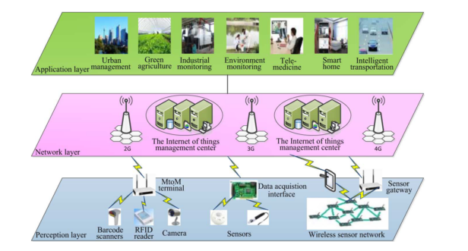
The research in this subject shows that there is great quantity and quality of academic research that has been carried out in the field of smart buildings (home/campus/factory) using IoT. Many published papers explain different approaches to build and manage an IoT system for “Smart Campus”. It has become clear that using a WSN is key and that the general topology for these types of smart systems does not change. It consists of three major layers: Application layer, Network layer and Sensor or Perception layer, as illustrated below in figure -1 [7].
Figure 1: IoT topology layers of an IoT application
After studying and analysing some of the finest papers, many key elements have been found, that could define the design of this project proposal.
The first element was the type of IoT gateway that should be used between the WSN and the management device. Many IoT gateways support different connection protocols and standards like Bluetooth, Wi-Fi, ZigBee, Z- wave, 6LowPAN, etc. [8].
The second element was the sensor characteristics such as power efficiency, its size and mode of connectivity. Many aspects should be verified before choosing the appropriate sensor like cost, energy, adaptability, data processing speed and security.
The third element was the appropriate way to store, visualise and manipulate the data transmitted. Different solutions and techniques could be used. Some are Web based GUI display like “dweet” or “freeboard” [9]; others are more professional like IBM Watson IoT Platform or Microsoft azure web App [10].

LITERATURE REVIEW…

In general, the rapid advance and development of sensors manufacturing have been driven by the huge progress of nanotechnology in the last decade. Many (IoT) applications have been developed in different fields such as healthcare, manufacturing and the environment, and the use of these advanced WSNs has brought great results [5]. The positive impact of some major projects like “Ocean quality monitoring”, “urban cities air quality monitoring”, “energy efficiency” or “tracking and alert for patients” can only encourage researchers to work even harder.

Works related to the project proposal

During the research of “Smart class and campus using IoT”, many interesting academic papers were found. Some of these papers were more environmentally oriented; some focused on the effectiveness of the system while others dealt with the interaction of humans with this intelligent design. The following three papers will now be reviewed and studied to help find the best possible design for this project proposal:

- Smart Campus System using IoT [11]

- Smart System, loT for University [8]

- Teaching Management System with Applications of RFID and IoT Technology [12].

1st Paper: Smart Campus System using IoT

The authors in this paper highlighted the importance of IoT in its impact on humans’ everyday lives and the possibility to upgrade our manual systems to smarter systems where autonomy could be added, and artificial intelligence could be built in.
The smart campus system proposed by the authors consists of a complete environmental system built to monitor the temperature, light, current use and motion in the rooms to detect if they are vacant or not. Every sensor in each room should be connected to a synch node. In this scenario, they proposed Mini Wi-Fi enabled board “ESP8266 Wemos D1” compatible with Wi-Fi standard so the data could be transmitted wirelessly to the “Raspberry Pi” processing unit. The

LITERATURE REVIEW…

beauty of this project was its simplicity and efficiency. The project went to make good use of the data collected in the local server and developed a way to display and manipulate the data on GUI interface. All that showed that the entire system was fully functioning and that this project could save energy. It was fully automated and could improve our environment.
However, this research paper lacked a few key elements, such as the importance of using a WSN in IoT applications. This proposed project may have seemed to harvest some results. However, it was lacking evidence and results from simulation. Finally, this could prove inefficient if implemented at a high scale in a big campus like UWTSD. Wireless sensors and a good gateway link would have a great impact on the overall system.

2nd Paper: Smart System, loT for University [8]

This fine paper published by Dr K. Sharma and Dr T. Suryakanthi explains in detail the idea of monitoring and controlling the consumption of energy by all the different equipment existing inside the campus. This paper may fall under what is called “Green IT” as the environmental impact that it could have is very important, looking at the energy wasted every year by human habits.
Figure 2: Sketch of the project proposed by Dr K. Sharma and Dr T. Suryakanthi

LITERATURE REVIEW…
The project proposed is designed as seen in figure -2, using ZigBee sensors to monitor the current used by the electric devices and send this data to the cloud. The sensors also monitor room temperature, humidity and light. The system should be linked to a database where a predefined time table would automatically initiate the power down, for example when on holidays or there is no class.
It also offers the use of a hub that can accommodate all major protocols like ZigBee, Z-Wave, Wi-Fi and Bluetooth that most universities use, capable of creating alert messages to notify the user. This project focuses on the use of a cloud-based server and designing a GUI application to visualise all the data, manually switching ON and OFF the equipment when needed.
This project would undoubtedly have a great impact on the environment and would be very beneficial for the university in terms of energy saving and cost. However, the project focuses only on one element, “power consumption”, and the authors did not make good use of the Wireless Sensor Network spread throughout the university to collect different types of data like carbon dioxide, temperature and door entries, for example. It is always important to utilise the resources in an efficient way to maximise the benefits of any project.
The authors did not choose either an appropriate simulation technique to draw useful results that could support the outcome of this project. Their approach only focuses on mathematical modelling to calculate some figures though this type of project should use a more appropriate technique, such as sample testbed over a period of time or the use of some advanced software to generate a good quantity of data [13].

3rd Paper: Teaching Management System with Applications of RFID and IoT Technology [12]

In this paper, the project proposed aimed at creating a cloud-based teaching management system using Internet of Things. The authors proposed a multi-function system to improve and boost this IoT teaching model. This project had four primary objectives:
- Accessing course video using QR [14]code technology.
- Creating an attendance record using RFID [15]and android app.
- Real-time interactive response.
- Creating classroom behaviour database.

LITERATURE REVIEW…

The authors explained the functionality of each part of this system separately without explaining in detail the entire system topology. Some entities like the cloud database and its link with hardware transmitting the data and the app configuration seemed to be missing, which
appeared to have some negative effects on the reader’s understanding. However, some strong positive statistical outcomes gave this project very strong credibility. After running an experimental comparison on one real classroom, the results showed that students’ attendance had increased from 85% to 98%, and that 96% of students and teachers had started to believe that using this IoT teaching system would promote the curriculum learning.
The authors explained the functionality of each part of this system separately without explaining in detail the entire system topology, some entities like could data base and its link with hardware transmitting the data and the app configuration seems to be missing, this appear to have some negative effect on the reader understanding. However, some strong positive
statistical outcomes gave this project very strong credibility after running an experimental comparison on one-real classroom, the results show that attendance of student has increase from 85% to 98%, and that 96% of students and teachers start to believe that use of this IoT teaching system will promote the curriculum learning.

RESEARCH METHODOLOGY

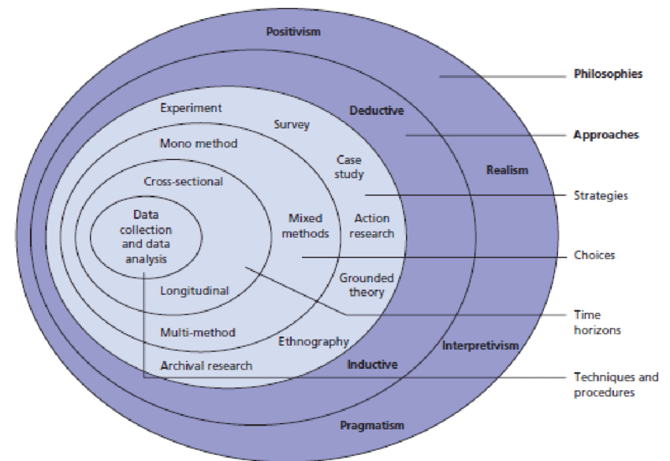
It is very important to conduct good research about the correct philosophy to be chosen. Mark Saunders has developed a good break down structure to show all linked philosophies, approaches and strategies on what is called the “Research Onion”, as seen on figure -3 [16].
Figure 3: Research onion by Saunders

Research methodology is the primary technique used to resolve research problems. It is considered as the logical way that research process goes through [17]. In this project proposal, the methodologies used are as follows: positivism, deductive, experimental and cross section.
In term of positivism, this philosophy suits the nature of this project well because it focuses mainly on data experiments [18]. The deductive approach or deductive reasoning would be the appropriate one simply because we would be deducting conclusions after putting theories into tests [19]. The experimental strategy would also go well with our project because of the data that need to be generated from the experiments, so it can be analysed.
Due to budget and time limitations, it would not be possible to apply this project throughout the campus, which is why it is believed that creating sample test bed is the ideal approach.

AIMS AND OBJECTIVES

The primary aim of this project proposal is to create a Management system for Smart Classroom using Wireless Sensor Network.
This project is set to have five objectives:
- Conduct a literature review about Smart Campus based on IoT using WSN.
- Create a simulation experiment using Packet tracer or QualNet.
- Create a live system for this project proposal.
- Run two different simulations using one band and dual band channel.
- Create a management system using Raspberry Pi [20].
This project will help to evaluate the use of a wireless sensor network in an IoT management service, its effectiveness and suitability. It will also allow the comparison of one band and dual band channel performance. The major point that could be studied further would be the security aspect of the entire system, as failing to secure such a system could have disastrous outcomes.
Security itself in IoT was and still is a major threats and issues. Many research and critics are still focusing on the vulnerability of this area [21], covering this topic would need full research into this sensitive and critical area.
The expected outcomes of this project would be to develop a smart system that could help save the environment; to make the new university campus a smarter campus; and finally, to lay the foundation for further works to enhance the security aspect of it and possibly implement it across the entire campus.

DATA EVALUATION & RISKS

Data Evaluation:
After building the live system and simulation replicate of this project, the next step would be to run all the necessary tests and simulation to gather all possible data in order to start the analysis and evaluation phase of this project, and also to evaluate and analyse the data generated by the two comparison experiments using one band and dual band channel.
The analysis of all these experiments should help identify the most efficient system in terms of network performance, power consumption, life time of the batteries used within the sensors, and give a good comparison of all key features such as data transmitted, packets collided, packet errors and overhead packets.
The main method used to evaluate this project would be “Comparison”: comparing the results from all the experiments set could help identify the strengths and weaknesses and improve the design to achieve better performance.
Creating a management device using a Raspberry Pi interface will help to learn new skills and programming languages. It would also boost the project effectiveness and add more features to the way the various elements could be controlled.

Risks:
Any good project proposal should have an extensive risk analysis to help identify all possible threats that could delay its completion or defect its efficiency. In this project, a few risks could have some negative effect on the run of the project:
- Access restriction to the lab resources during weekends and out of hours.
- Licence Software limitation, as some software like NetSim are only for university use.
- A limited budget could become an issue when purchasing wireless sensors and network adaptors to transmit the data to the local server.
- Data back-up failure: this could be a fatal error for any experimental project. A daily backup would therefore be a good approach to save all progress achieved.
- Power failures and IT maintenance schedule within the campus could delay the progress of the project.
- Time management is key to complete the project successfully, especially during exam periods.

PROJECT PLANNING

Good project planning is key to successfully complete any project. It is inevitable that issues and problems will arise when running any type of project, small or big. Creating goals and objectives and setting deadlines for every phase of the project help to complete the project successfully within the timeframe set.
This project has been divided into three parts: literature review, design and implementation, and report writing. The project planning and Gantt chart (see figures -4 and -5) show all sub-sections of the first two main parts or phases of this project. Appropriate time was allocated for the completion of each step. The 3rd phase of writing the report is set to start before the total completion of the first and second phases. This is to gain time and be more efficient to be able to break down the writing 15,000-word report at the end. It would be wise if the project leader could start writing the parts related to literature research as early as possible.
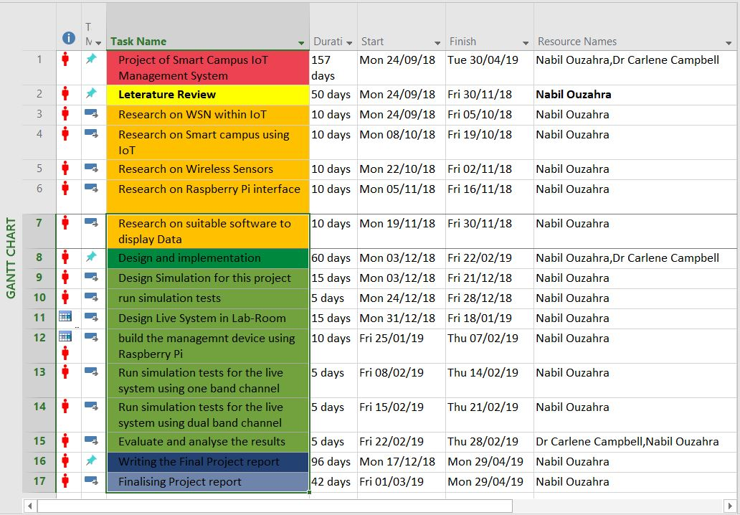
Figure 4: Project Planning
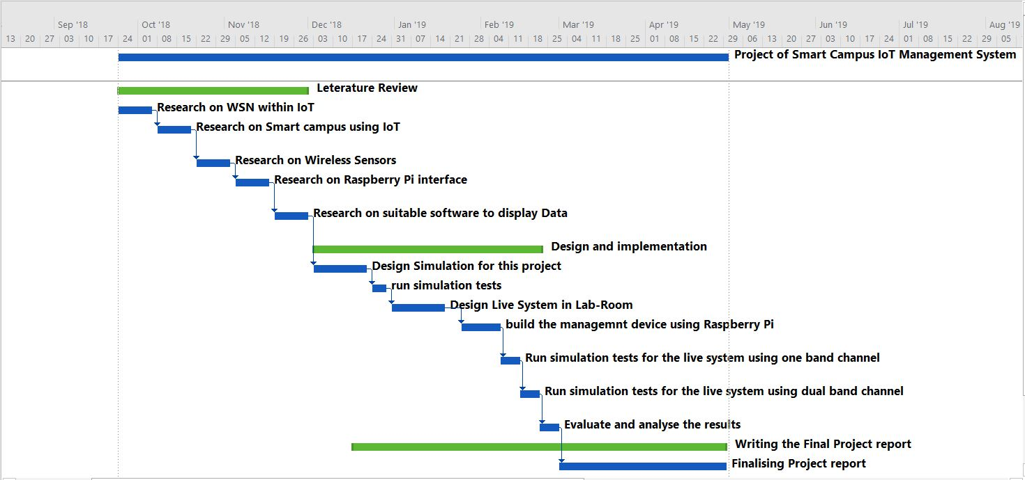
Figure 5: Project Gantt chart

PHYSICAL AND HUMAN RESOURCES

At the heart of every project are tools and resources that should be considered. This could vary from the chosen software to the personal computers used to the people involved in the making of the project at all stages. Identifying all the resources that the project will need and ensuring their availability will help to avoid any threats of delays and interruptions.
Some of the simple actions that could have a positive impact on the running of this project are as follows: for example, making sure that software licences are in place for the durability of the project, good time management with the help of Project Supervisor Dr Carlene Campbell, checking the possibility of re-using some of the sensors used by previous students and ensuring their functionality at an early stage to avoid any disappointment and delays.
The resources needed for the completion of this project are:
- Software resources:
The use of software like Words, Excel, Access, Microsoft project, QualNet, Packet tracer, Microsoft Azure, MatLab, Visio, Tableau and NetSim.

- Hardware resources:
The use of hardware like Lab PC, private laptop, Wi-Fi router, RFID, sample cards and sensor gateway.

- Library material:
UWTSD online library, books and magazines from the main library.

- Human resources:
Project Leader Student Nabil Ouzahra and Project Supervisor Dr Carlene Campbell.

Conclusion:

This project is about building a smart IoT management system to monitor a few elements and manipulate the data generated by the Wireless Sensor Networks. The literature review of this project has helped the author identify relevant aspect that could be implemented and formulate ideas to resolve potential issues. Implementing such a project that could have a great impact on the environment could only be considered as a good practical example. The use of big data to monitor and control “things” around us in recent years has seen a huge increase. Most of these big environmental projects are using Wireless Sensors Networks, thanks to their efficiency, scalability and cost. The impact of using IoT to build smart systems is not only environmental but can also positively affect the daily life of all humans.

REFERENCES

[1] S. Madakam, R. Ramaswamy, and S. Tripathi, “Internet of Things (IoT): A Literature Review,” J. Comput. Commun., vol. 3, no. 3, pp. 164–173, 2015.
[2] J. Bainbridge, “Meet Kevin Ashton, the man behind the internet of things,” Campaign, 2014.
[3] Statista.com, “Internet of Things (IoT) connected devices installed base worldwide from 2015 to 2025 (in billions),” 2018. [Online]. Available: https://www.statista.com/statistics/471264/iot-number-of-connected-devices-worldwide/. [Accessed: 19-Apr-2018].
[4] A. Bowen, “IoT is eating the world: Future of IoT – Alexandra – Medium,” Medium.com, 2016. [Online]. Available: https://medium.com/@AlexandraBowen/iot-is-eating-the-world-future-of-iot-a001dc263f08. [Accessed: 19-Apr-2018].
[5] Q. Chi, H. Yan, C. Zhang, Z. Pang, and L. Da Xu, “A reconfigurable smart sensor interface for industrial WSN in IoT environment,” IEEE Trans. Ind. Informatics, vol. 10, no. 2, pp. 1417–1425, 2014.
[6] postscapes.com, “History of IoT | Background Information and Timeline of the Trending Topic,” 2018. [Online]. Available: https://www.postscapes.com/internet-of-things-history/. [Accessed: 16-Apr-2018].
[7] Q. Chi, H. Yan, C. Zhang, Z. Pang, L. Da Xu, and S. Member, “A Reconfigurable Smart Sensor Interface for Industrial WSN in IoT Environment.”
[8] D. K. Sharma, “Smart System : loT for University,” pp. 1586–1593.
[9] I. Bug Labs, “freeboard - Dashboards For the Internet Of Things,” 2018. [Online]. Available: https://freeboard.io/. [Accessed: 03-May-2018].
[10] Microsoft Azure, “Real-time data visualization of sensor data from your Azure IoT hub – Web Apps | Microsoft Docs,” 2018. [Online]. Available: https://docs.microsoft.com/en-us/azure/iot-hub/iot-hub-live-data-visualization-in-web-apps. [Accessed: 19-Apr-2018].
[11] S. K. Dixit and S. M. Kulkarni, “Smart Campus System using IoT.”
[12] P. Tan, H. Wu, P. Li, and H. Xu, “Teaching Management System with Applications of RFID and IoT Technology,” Educ. Sci., vol. 8, no. 1, p. 26, 2018.
[13] K. Tan, D. Wu, A. Chan, and P. Mohapatra, “Comparing Simulation Tools and Experimental Testbeds for Wireless Mesh Networks.”
[14] T. Marktscheffel et al., “QR code based mutual authentication protocol for Internet of Things,” 2016 IEEE 17th Int. Symp. A World Wireless, Mob. Multimed. Networks, pp. 1–6, 2016.
[15] S. Park, R. Media, S. K. Telecom, and A. S. R. Reader, “An IoT Application Service Using Mobile RFID Technology FOR SMART PHONE,” pp. 2–5.
[16] K. Hinkelmann and H. F. Witschel, “How to choose a research methodology?,” 2010.
[17] A. S. Lee, R. Briggs, and A. R. Dennis, “Crafting Theory to Satisfy Requirements of Explanation,” 47th Hawaii Int. Conf. Syst. Sci., pp. 4599–4608, 2014.
[18] F. Herbert, “Positivism Philosophy,” 2018. [Online]. Available: https://www.britannica.com/topic/positivism. [Accessed: 25-Apr-2018].
[19] L. K. Soiferman, “Compare and Contrast Inductive and Deductive Research Approaches,” 2010.
[20] A. Kaur and A. Jasuja, “Health monitoring based on IoT using Raspberry PI,” 2017 Int. Conf. Comput. Commun. Autom., pp. 1335–1340, 2017.
[21] M. FRUSTACI, P. PACE, G. ALOI, and G. FORTINO, “Evaluating critical security issues of the IoT world: Present and Future challenges,” IEEE Internet Things J., vol. 4662, no. c, 2017.

