Student Name: Justin Wella
Student Number: 2412967
Module: PROJECT MANAGEMENT
Lecturer: SAMSON OLADEJO

PART A

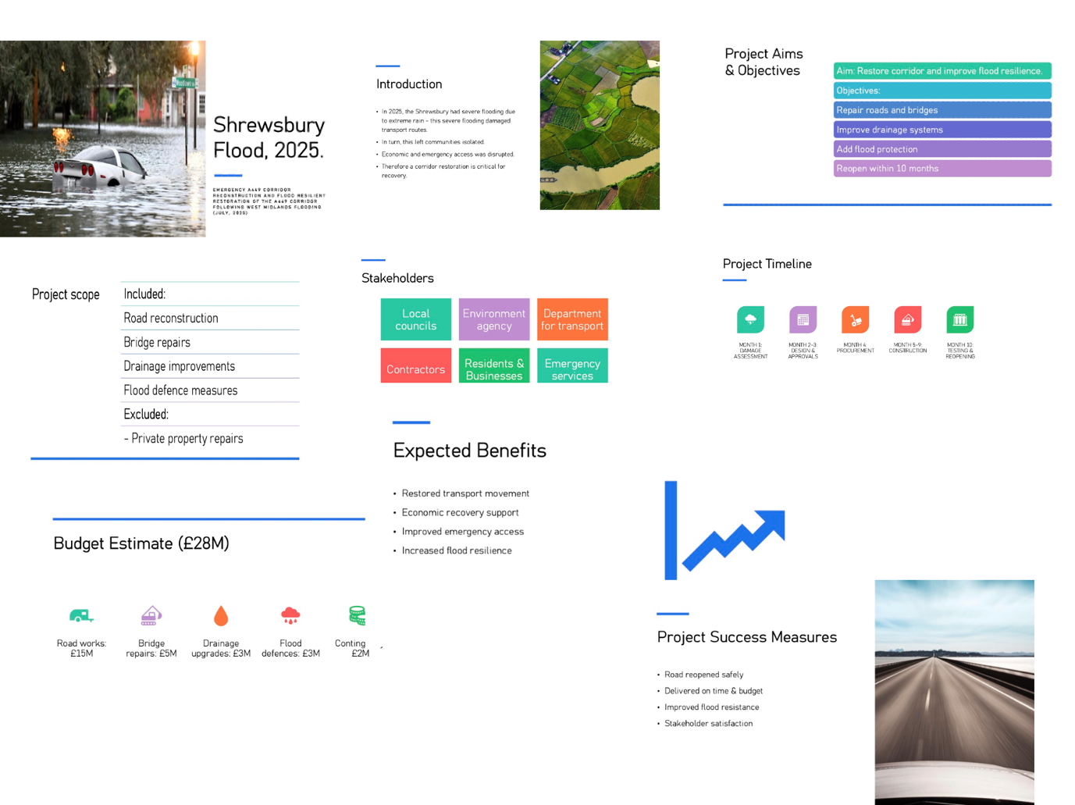

PART B

The feedback I received during my poster presentation played a major role in shaping and improving the final project management plan. My original proposal focused on the emergency reopening and flood-resilient reconstruction of a key highway corridor in the West Midlands after the severe flooding in July 2025. Overall, the poster was well-received because it addressed a realistic, high-impact infrastructure issue without trying to tackle every aspect of the wider flooding event. This clarity of scope was recognised as a strength, as effective project management relies on well-defined problems and achievable objectives.
One of the key positives highlighted by both the tutor and peers was the strong and clear project rationale. The poster successfully demonstrated why transport infrastructure is essential following a disaster, making clear links between road disruption, emergency access, economic activity, and community resilience. This helped show that the project was not just a technical repair effort but a strategic recovery initiative with broader social and economic implications. The tutor noted that this strategic framing aligned well with what was expected for a project management assignment.

The objectives were also praised for being specific, measurable, and realistic. The phased reopening plan, the timeline for full restoration, and the focus on resilience improvements were considered practical and well-thought-out. This showed a good understanding of project planning principles, especially the need to convert broad recovery goals into concrete deliverables. In this sense, the poster communicated the project’s intended outcomes effectively.

However, the feedback also pointed out areas where the proposal needed more depth and stronger use of project management techniques. One important critique was that the poster did not clearly separate short-term emergency actions from longer-term reconstruction activities. This distinction is crucial in real-world practice because these phases involve different governance structures, timelines, and resource requirements. In response, the final plan now includes a clearer phased approach that differentiates immediate reopening work from permanent reconstruction and resilience measures.

Another area for development was the stakeholder analysis. Although the poster listed the key stakeholders, it lacked deeper insight into their varying levels of influence, interests, and potential impact on the project. This feedback was particularly valuable given the complexity of post-disaster infrastructure projects, where political, environmental, community, and operational interests often intersect. The final report now incorporates a more comprehensive stakeholder management strategy with attention to engagement methods and interdependencies.

My tutor also suggested making better use of project management tools to show methodological rigour. This included strengthening the Work Breakdown Structure, Gantt Chart, resource planning, and risk analysis. These recommendations were directly integrated into the final submission, resulting in a more organised and credible implementation framework.

In summary, the feedback process was highly beneficial and significantly improved the final project plan. While the poster provided a solid foundation with a relevant and feasible project concept, the final version is much stronger due to clearer project phasing, enhanced stakeholder analysis, and more robust use of project management tools. These improvements have increased both the academic quality and the practical realism of the work.

PART C
In July 2025 the West Midlands experienced one of the most disruptive flooding events recorded in the region for many years. Several weeks of intense rainfall placed mounting pressure on natural and man‑made drainage systems, and communities along the River Severn began to experience the consequences as water levels rose to dangerous heights. Worcester, Shrewsbury and Kidderminster were among the most severely affected areas. As the river breached its defences, entire neighbourhoods were submerged, and local councils and emergency services struggled to respond to the scale of the disruption. Roads became impassable, electricity networks failed and families were forced to evacuate their homes with limited time to prepare. The damage extended far beyond residential zones and affected essential transport corridors that support daily movement across the region. This highlighted the vulnerability of an ageing infrastructure network at a time when extreme weather events are becoming more frequent.
Among the transport links affected by the flooding, the A449 corridor emerged as one of the most critical. The route connects Worcester, Kidderminster and Wolverhampton, and plays an important role for residents, businesses, emergency services and freight operators. When the floods damaged sections of this corridor, the consequences were immediate. Emergency vehicles struggled to reach isolated communities. Businesses faced delays in receiving supplies and transporting goods. Commuters experienced long detours that created further pressure on alternative roads. In addition, the closure of the A449 increased the workload for local councils who were already under strain. For these reasons, the restoration of the A449 became a priority action within the broader flood recovery effort.
This Project Management Plan presents a structured and practical approach to restoring the A449. It builds on recognised project management methods and aims to demonstrate responsible planning, coordination and delivery. It also shows how the project integrates resilience measures to reduce the impact of future severe weather events. The plan has been developed to support communication with stakeholders and provide clarity on how the project will be governed, delivered and monitored. By setting out the project description, scope, work breakdown structure, schedule, stakeholder involvement and risk analysis, the plan functions not only as a technical response but also as a framework for ensuring accountability.
2. Project Description
2.1 Project Title
Emergency Reopening and Flood Resilient Reconstruction of the A449 Highway Corridor.
2.2 Background
The A449 is a major transport route that supports daily travel and economic activity across the West Midlands. It carries commuters, freight vehicles and access traffic to local services. During the July 2025 floods, the corridor suffered significant damage. Large areas of the road were submerged, and this caused the breakdown of surface layers. Embankments eroded under the force of moving floodwater, while drainage systems became blocked with debris. Several bridges required urgent inspection because it was unclear whether their structural integrity had been compromised. This combination of damage made it unsafe to keep the route open, which led to an immediate closure at a time when emergency services needed clear access to many areas that had been cut off.
According to the Environment Agency (2025), the scale of flooding along the River Severn placed extraordinary strain on transport infrastructure, and the combined authority later described the event as one of the most damaging in recent decades (West Midlands Combined Authority 2025). The condition of the A449 after the floods made it clear that the corridor required more than minor repair. A comprehensive reconstruction effort would be needed to restore the road safely and to strengthen its resilience for future events. This project management plan sets out how that work will be organised and delivered.
2.3 Aim
The aim of the project is to restore safe and reliable transport along the A449 and to rebuild the corridor in a way that improves its ability to withstand future flooding. This includes designing and implementing resilience measures that reduce the likelihood of similar levels of damage occurring again.
2.4 Objectives
The project has several objectives that will guide planning and delivery.
The first objective is to reopen the A449 for controlled emergency traffic within four weeks. This is essential for allowing emergency services and utility providers to access flood‑affected areas quickly.
The second objective is to complete full reconstruction and resilience upgrades within twelve months.
Further objectives include repairing damaged road surfaces, drainage networks, bridges and embankments, and integrating sustainable flood mitigation measures into the upgraded design. These measures will help the road cope with future periods of heavy rainfall.
The project also aims to work closely with stakeholders in order to coordinate recovery activities and share information effectively.
Finally, the project must remain within agreed time, quality and budget constraints so that public funds are used responsibly.
3. Scope
A clear scope helps define what is included in the project and what is outside the project’s responsibility. For the A449 reconstruction, the in‑scope activities include emergency clearance of debris left behind by the floods. This will make it possible to carry out structural inspections and assessments of the road, drainage systems and bridges. The project will also redesign the road foundations and drainage systems to improve their strength and capacity. Repairing and strengthening bridges is another important part of the scope since structural weaknesses would pose major risks. Stabilising embankments is necessary to prevent future erosion, and a range of flood resilience improvements will be incorporated into the final design. These may include improved drainage layouts, the use of stronger construction materials and more effective control of water flow close to the road. Procurement and contractor management, stakeholder communication and the final inspection and handover process are also part of the project’s scope.
There are also aspects that fall outside the scope of the project. Repairs to private properties are excluded because the project focuses on public infrastructure. Flood defence projects that do not affect the A449 are also beyond the project’s boundaries. Broader water utility upgrades and public transport projects not directly linked to the reconstruction are out of scope as well.
The main deliverables for the project include a route that is accessible for emergency vehicles, a fully reconstructed and resilient highway, updated engineering documentation and a final project evaluation report which will summarise the work completed and the lessons learned.
The project must also work within certain constraints. These include predicted heavy rainfall at specific times of the year, which could slow down construction progress. The availability of specialist contractors may be limited, and environmental regulations will need to be followed when working close to riverbanks. The project team must also work within budget constraints set by funding authorities. At the same time, it is assumed that funding will be approved for each phase of the work, that key materials will be available and that local communities will support temporary diversions when needed.
4. Work Breakdown Structure
A work breakdown structure is useful for organising the project into manageable sections. The structure for this project begins with Project Initiation, which includes setting up governance arrangements, securing funding, appointing the project team and holding an initial stakeholder briefing.
The next section focuses on emergency works and assessment. This involves completing a detailed inspection of the damage, carrying out surveys and modelling, clearing debris, installing temporary barriers and reopening sections of the road for emergency traffic.
The third part of the work breakdown structure is the design phase. This includes developing a new roadway design, redesigning the drainage system, undertaking bridge engineering design and completing an environmental impact review. Procurement planning is also completed during this stage.
The fourth section covers the construction phase. This includes earthworks and embankment stabilisation, installing drainage, reconstructing road surfaces, carrying out bridge repairs, adding resilience measures, relocating utilities if required and installing road safety features.
The monitoring and control phase runs throughout the project. It includes quality checks, progress reporting, budget tracking and health, safety and environmental compliance inspections. The final section of the structure is project closure, which includes final testing, handover to local councils, a lessons learned workshop and the completion of a final evaluation report.
5. Quad Chart
The quad chart summarises the project in a clear format for stakeholders. The overview highlights that the project involves restoring the A449 and improving its resilience. The objectives show the importance of reopening the road quickly and completing full restoration within twelve months, with a strong emphasis on improving drainage and structural resilience. The key risks include weather delays, cost increases, environmental restrictions and shortages in skilled labour. The stakeholders include the Combined Authority, local councils, the Environment Agency, emergency services, local residents, businesses and contractors.
Area | Summary
Overview | Restoration and resilience-focused reconstruction of the A449.
Objectives | Emergency reopening in four weeks. Full restoration within twelve months. Improved drainage, road surfaces and structural resilience.
Key Risks | Weather delays, cost increases, environmental restrictions and shortages in skilled labour.
Stakeholders | Combined Authority, local councils, Environment Agency, emergency services, residents, businesses and contractors.

6. Gantt Chart
A simple schedule outlines how the work will progress across the twelve‑month programme. In the first month the initiation phase begins and emergency works are carried out. Temporary reopening and design activities take place during the second and third months. Procurement overlaps with the later design phase and early construction planning. Construction is expected to take place across months four to twelve. Monitoring runs continuously to ensure safety, quality and progress are maintained. Closure activities take place at the end of the project, mainly in the twelfth month.
Months 1–12
Project Phase | Month 1 | Month 2 | Month 3 | Months 4–6 | Months 7–9 | Months 10–12
Initiation | X
Emergency Works | X | X
Temporary Reopening | X | X
Design Phase |  | X | X
Procurement |  |  | X | X
Construction |  |  |  | X | X | X
Monitoring and Control | X | X | X | X | X | X
Closure |  |  |  |  |  | X

7. Stakeholder Involvement
Stakeholder involvement is central to effective project delivery. The West Midlands Combined Authority oversees the project and provides funding. Local councils coordinate local services and permissions. The Environment Agency ensures that the work complies with environmental and flood‑related regulations. Emergency services need safe access throughout the project period. Local residents use the route daily and rely on clear communication, especially when diversion routes are in place. Businesses and freight operators require reliable transport links for commercial activity. Contractors and engineers carry out the technical work, while utility providers manage services that intersect with the corridor.
The project team will adopt several approaches to stakeholder engagement. Weekly meetings will be held with local authorities and the Environment Agency to coordinate progress and address concerns early. The public will receive monthly updates through meetings and online communication channels. A dedicated contact line will be created to allow residents to raise questions or report issues. Emergency services will be involved in regular coordination activities to ensure that their access requirements are met. Formal progress reports will be prepared for funding bodies to maintain transparency.

8. Allocation of Resources
Human resources for the project include a project manager, civil engineers, drainage specialists, structural engineers, environmental specialists, safety officers, construction teams and procurement and finance staff. The materials required include aggregates, asphalt, reinforced concrete, drainage pipes, geotextiles, barriers, signage and heavy machinery.
The financial resources for the project amount to an estimated total of £38 million. This includes £2 million for emergency works, £3 million for design, £15 million for road reconstruction, £8 million for drainage and resilience measures, £6 million for bridge repairs, £2 million for environmental compliance and a £4 million contingency budget.
Time resources include a one‑month emergency phase, a three‑month design and procurement period and an eight‑month construction phase.
9. Risk Analysis
The risk register identifies several potential risks. Weather delays are considered highly likely and may have a significant impact. Cost increases are possible and could affect the budget if value engineering and careful financial monitoring are not applied. Contractor shortages could slow the project, although framework contracts may help reduce this risk. Environmental restrictions are another potential issue, so early engagement with the Environment Agency will be essential. Other risks include community dissatisfaction, supply chain delays and safety incidents, which can be managed through communication, planning and compliance with safety regulations such as CDM 2015 (HM Government 2020).
10. Conclusion
This project management plan offers a comprehensive and practical framework for restoring the A449 following the severe flooding that affected the West Midlands in 2025. The plan demonstrates how structured project management approaches can guide recovery efforts in a way that remains transparent, accountable and aligned with the needs of the communities most affected. By outlining clear objectives, defining scope, identifying stakeholders and establishing a detailed schedule, the plan provides a foundation for organised and coordinated action during what is a challenging period for the region.
The plan also emphasises the importance of combining immediate emergency actions with well-considered long-term reconstruction. Emergency works will make the route accessible as soon as possible, which is essential for supporting residents, businesses and emergency responders. The longer-term design and resilience measures provide an opportunity to address underlying weaknesses within the corridor so that the road can better endure future periods of heavy rainfall. This integrated approach recognises that recovery is not only about returning infrastructure to its previous condition but about improving its durability and reliability.
The success of the project will depend on effective collaboration between a wide range of stakeholders. Local councils bring knowledge of community needs, while the Combined Authority plays a vital coordinating role. The Environment Agency guides environmental standards, and emergency services rely on the route for essential operations. Continued communication with residents and businesses will also help maintain trust and minimise disruption during the construction period.
With careful planning, consistent monitoring and open communication, the restoration of the A449 has the potential to support a wider regional recovery. The project will not only repair critical infrastructure but also enhance the resilience of the corridor, helping to reduce the impact of future severe weather events and contributing to a safer, more connected West Midlands.

Reference List
CIRIA (2015) The SuDS Manual (C753). London: CIRIA.
[nao.org.uk]
Chartered Institution of Highways and Transportation (CIHT) (2024) Delivering a Resilient Transport Network: Maintaining and Future Proofing Highway Infrastructure from Extreme Weather. CIHT.
[gov.uk]
Environment Agency (2025) Further flooding impacts expected in England following Storm Claudia. Department for Environment, Food & Rural Affairs.
[wmca.org.uk]
Health and Safety Executive (HSE) (2015) Managing health and safety in construction: Construction (Design and Management) Regulations 2015. Guidance on Regulations (L153). London: HSE Books.
[wmca.org.uk]
National Audit Office (NAO) (2024) The Condition and Maintenance of Local Roads in England. Department for Transport.

