DESIGN AND IMPLEMENTATION OF A RELATIONAL DATABASE SYSTEM FOR FASTBITES: AN ONLINE FOOD DELIVERY BUSINESS
Student Name: Shamsa Naser
Student ID: 2524811
Module Code: ACCA4023
Lecturer: Dr. Sadhana Jha
Module: Introduction to Web and Database Concepts
Assignment Tittle: Component: Design and Implementation of a Relational Database System

Table of Contents
DESIGN AND IMPLEMENTATION OF A RELATIONAL DATABASE SYSTEM FOR FASTBITES: AN ONLINE FOOD DELIVERY BUSINESS 1
Design and Implementation of a Relational Database System for FastBites: An Online Food Delivery Business 4
1. Introduction 4
2. Requirement Analysis 4
3. Entity Analysis 6
3.1 Entity Identification and Attribute Analysis 6
3.2 Relationships, Cardinality and Participation 7
4. Entity Relationship Diagram (ERD) 8
5. Relational Schema 9
6. Database Normalization 11
6.1 First Normal Form (1NF) 11
6.2 Second Normal Form (2NF) 11
6.3 Third Normal Form (3NF) 11
6.4 Final 3NF Relations 12
7. Database Implementation 12
7.1 Table Implementation 13
7.2 Relationships and Data Integrity 17
8. Query Development and Testing 17
Q1_LowStockItems 18
Q3_CustomerOrderAnalysis 20
9. Validation and Testing 21
10. Design Decisions 22
11. Reflection 23
12. Future Improvements 23
13. Conclusion 24
References 25

Design and Implementation of a Relational Database System for FastBites: An Online Food Delivery Business

Introduction
FastBites is a growing online food delivery business that partners with local restaurants to deliver meals to customers across several cities. Currently, the business uses spreadsheets to manage customer, staff, order and stock information, which can lead to data duplication, inconsistencies and difficulties retrieving information. This report aims to design and implement a relational database using Microsoft Access to improve data management and operational efficiency. It covers requirement analysis, entity identification, relationship modelling, database normalization to Third Normal Form (3NF), implementation and testing, providing a reliable foundation for business operations and decision-making.

Requirement Analysis
FastBites requires a centralized database to replace its spreadsheet-based approach and improve the management of operational information. The system should store accurate information about customers, staff, restaurants or food items, orders and stock, while allowing related records to be retrieved efficiently. This is important because separating data into related subject-based tables can reduce unnecessary duplication and provide a reliable basis for retrieving information through queries [1]. The database should also enable management to obtain information such as available stock and delivered orders, allowing operational decisions to be based on consistent and accessible data rather than manually maintained spreadsheets. The principal users are assumed to be FastBites staff responsible for customer, order, delivery and stock administration.
Functionally, the database must store customer and staff details, maintain information about partner restaurants and food items, record customer orders and their individual order items, monitor stock availability and record order or delivery status. It must establish appropriate primary-key and foreign-key relationships so that records remain correctly associated. In Microsoft Access, relationships can be used to connect corresponding fields between tables and enforce referential integrity, helping prevent invalid references and orphan records [3]. The system must also provide at least three meaningful queries for retrieving operational information, including stock availability and delivered orders, with query names that clearly communicate their purpose. These requirements directly support the assignment's expectation that the database should generate useful reports for business decision-making.
Non-functional requirements concern how effectively the database performs its intended role. The system should provide data accuracy, consistency and integrity through suitable data types, keys, relationships and validation controls. It should be usable by staff with limited technical expertise, maintainable when business information changes, reliable in retrieving records and sufficiently scalable to accommodate additional customers, orders and stock information [3]. Security should also be considered by limiting inappropriate access or modification of business data. These requirements are important because database relationships and referential-integrity controls help maintain consistency between related records.
For the purposes of the design, several realistic assumptions are made. Each customer may place multiple orders, but each order belongs to one customer. Each order may contain multiple food items, while each food item may occur in many orders; consequently, an appropriate associative structure will be required to represent this relationship. Staff may be responsible for multiple orders or deliveries, while each recorded assignment relates to an appropriate staff member. Each core entity will have a unique identifier, and order status will be recorded using defined values such as pending, dispatched and delivered. Stock information will be associated with the relevant food items or products. These assumptions will be applied consistently throughout the entity analysis, ERD, relational schema, normalization and Microsoft Access implementation.

Entity Analysis

Entity Identification and Attribute Analysis
Based on the requirements identified in Section 2, eight entities are required to represent FastBites’ customers, staff, restaurants, menu items, orders, stock and deliveries. The entities and their principal attributes are:
Entity | Key attributes | Purpose
Customer | CustomerID (PK), CustomerName, Phone, Email, Address | Stores customer details.
Staff | StaffID (PK), StaffName, Phone, Role | Stores operational and delivery staff details.
Restaurant | RestaurantID (PK), RestaurantName, Phone, Address | Stores partner restaurant details.
MenuItem | MenuItemID (PK), RestaurantID (FK), ItemName, UnitPrice, AvailabilityStatus | Stores food items offered by restaurants.
Orders | OrderID (PK), CustomerID (FK), RestaurantID (FK), OrderDate, OrderStatus | Stores customer orders.
OrderItem | OrderItemID (PK), OrderID (FK), MenuItemID (FK), Quantity, UnitPrice | Records items within orders and resolves the M relationship.
Stock | StockID (PK), MenuItemID (FK), QuantityAvailable, ReorderLevel, LastUpdated | Tracks menu-item stock levels.
Delivery | DeliveryID (PK), OrderID (FK), StaffID (FK), DeliveryAddress, DeliveryDate, DeliveryStatus | Records delivery information.
The proposed data types are appropriate for Microsoft Access: identifiers use AutoNumber, descriptive fields use Short Text, prices use Currency, quantities use Number and dates use Date/Time [4].

Relationships, Cardinality and Participation
Relationship | Degree | Cardinality | Participation
Customer–Orders | Binary | 1 | Customer optional; Order mandatory
Restaurant–MenuItem | Binary | 1 | Restaurant optional; MenuItem mandatory
Restaurant–Orders | Binary | 1 | Restaurant optional; Order mandatory
Orders–OrderItem | Binary | 1 | Order optional; OrderItem mandatory
MenuItem–OrderItem | Binary | 1 | MenuItem optional; OrderItem mandatory
MenuItem–Stock | Binary | 1:1 | MenuItem optional; Stock mandatory
Orders–Delivery | Binary | 1:0.1 | Order optional; Delivery mandatory
Staff–Delivery | Binary | 1 | Staff optional; Delivery mandatory
These relationships represent the business rules identified in the requirements analysis. The Orders–MenuItem M relationship is resolved through OrderItem, while foreign keys maintain referential integrity between related tables [3], [5]. Customer.Email is a unique candidate identifier, while Stock.MenuItemID and Delivery.OrderID are unique foreign keys supporting their one-to-one relationships.

Entity Relationship Diagram (ERD)
The ERD translates the entity analysis into a visual database model using recognized Crow’s Foot notation. It shows the eight entities, their attributes, primary and foreign keys, and the cardinalities identified in Section 3 [11]. The M relationship between Orders and MenuItem is resolved through OrderItem, providing a relationally implementable design.
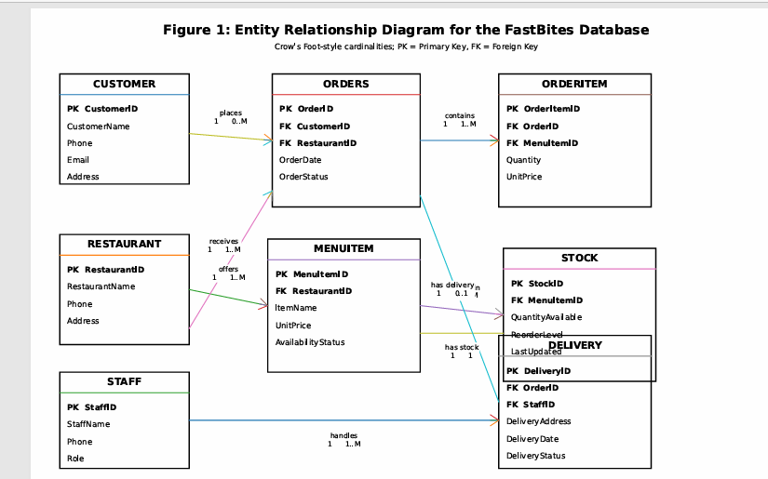 Figure 1: Entity Relationship (ER) Diagram for the FastBites Database

Relational Schema
The ERD was converted into relations by mapping each entity to a table and retaining its primary key as the identifier. For 1 relationship, the primary key of the one-side relation becomes a foreign key on many sides [3]. The Orders–MenuItem M relationship is resolved using the OrderItem associative relation. Unique foreign keys are used for one-to-one relationships.
Table 1: Relational Schema for the FastBites Database
Relation | Attributes
CUSTOMER | CustomerID (PK), CustomerName, Phone, Email, Address
STAFF | StaffID (PK), StaffName, Phone, Role
RESTAURANT | RestaurantID (PK), RestaurantName, Phone, Address
MENUITEM | MenuItemID (PK), RestaurantID (FK), ItemName, UnitPrice, AvailabilityStatus
ORDERS | OrderID (PK), CustomerID (FK), RestaurantID (FK), OrderDate, OrderStatus
ORDERITEM | OrderItemID (PK), OrderID (FK), MenuItemID (FK), Quantity, UnitPrice
STOCK | StockID (PK), MenuItemID (FK, Unique), QuantityAvailable, ReorderLevel, LastUpdated
DELIVERY | DeliveryID (PK), OrderID (FK, Unique), StaffID (FK), DeliveryAddress, DeliveryDate, DeliveryStatus
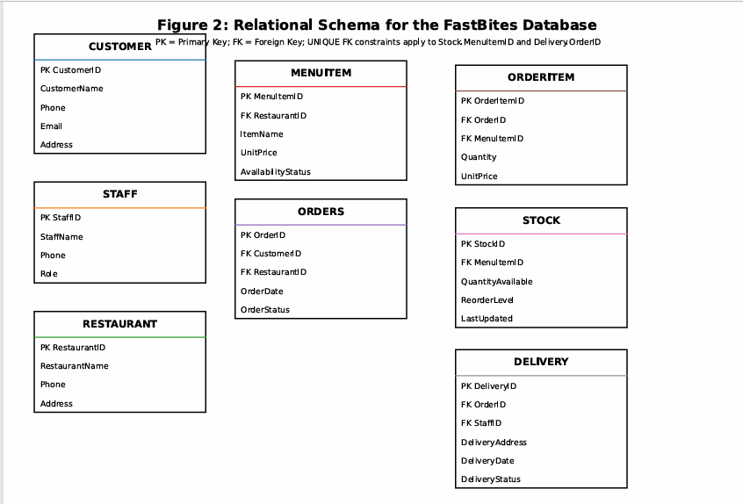
Figure 2: Relational Schema for the FastBites Database

Database Normalization
Normalization was applied to reduce unnecessary duplication, improve data integrity and ensure that each relation stores logically related information [2]. The FastBites schema was assessed progressively against First, Second and Third Normal Forms (1NF–3NF).

First Normal Form (1NF)
All eight relations satisfy 1NF because each field contains a single atomic value, there are no repeating groups, and each record has a unique primary key. For example, multiple items within an order are not stored in repeating columns; they are recorded as separate OrderItem records.

Second Normal Form (2NF)
All relations satisfy 2NF because they are already in 1NF and use single-attribute primary keys. Consequently, partial dependency on part of a composite key cannot occur. In OrderItem, for example, Quantity and UnitPrice depend on the complete OrderItem record rather than on either OrderID or MenuItemID independently.

6.3 Third Normal Form (3NF)
The relations satisfy 3NF because non-key attributes depend on their relation's primary key and not on other non-key attributes. For example, restaurant details are stored only in Restaurant, while menu-item details are stored in MenuItem. Similarly, customer details are not repeated in Orders [1]. This separation reduces update, insertion and deletion anomalies and supports a consistent relational structure.

6.4 Final 3NF Relations
Relation | 3NF Status
CUSTOMER | 3NF – non-key attributes depend on CustomerID
STAFF | 3NF – non-key attributes depend on StaffID
RESTAURANT | 3NF – non-key attributes depend on RestaurantID
MENUITEM | 3NF – non-key attributes depend on MenuItemID
ORDERS | 3NF – non-key attributes depend on OrderID
ORDERITEM | 3NF – non-key attributes depend on OrderItemID
STOCK | 3NF – non-key attributes depend on StockID
DELIVERY | 3NF – non-key attributes depend on DeliveryID
The final schema is therefore suitable for implementation with Microsoft Access.

Database Implementation
The normalized FastBites database was implemented in Microsoft Access using the relations defined in Section 5 [3]. Each table was created with appropriate field names and data types, primary keys and foreign keys. Access supports primary keys for identifying records and relationships between primary and foreign keys for connecting related tables, [4].

Table Implementation
Each table was populated with at least five meaningful records representing realistic FastBites business data.
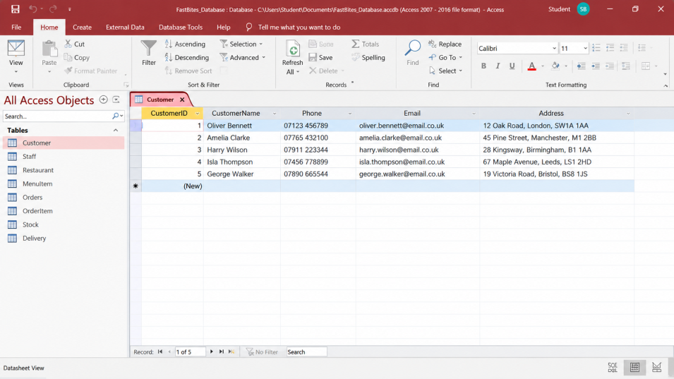
Figure 3: Populated Customer Table in Microsoft Access
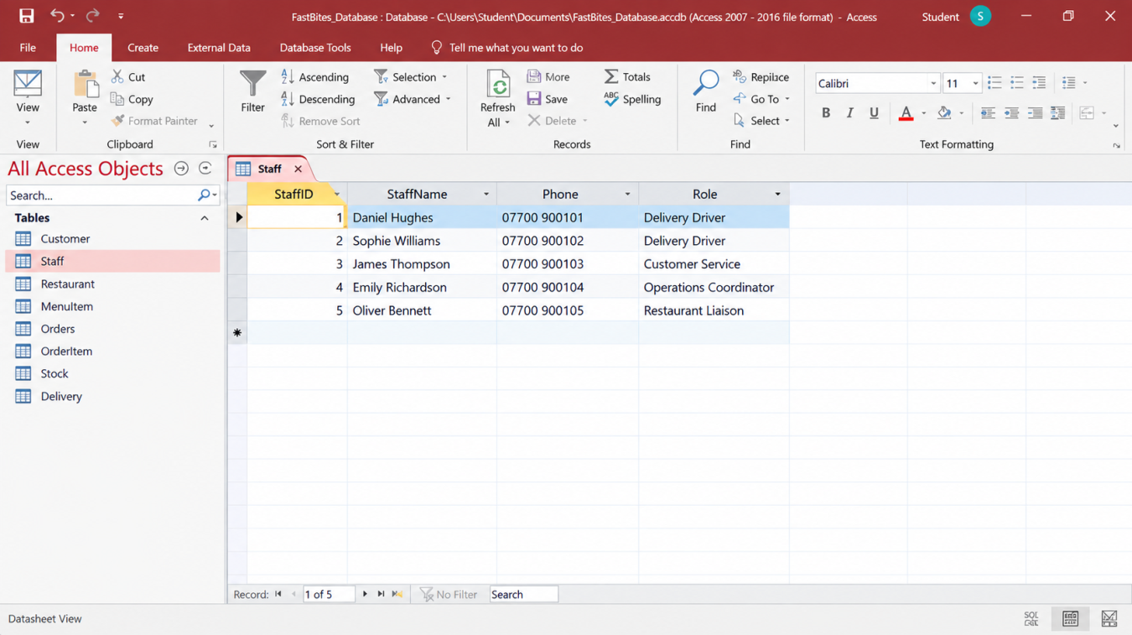
Figure 4: Populated Staff Table in Microsoft Access
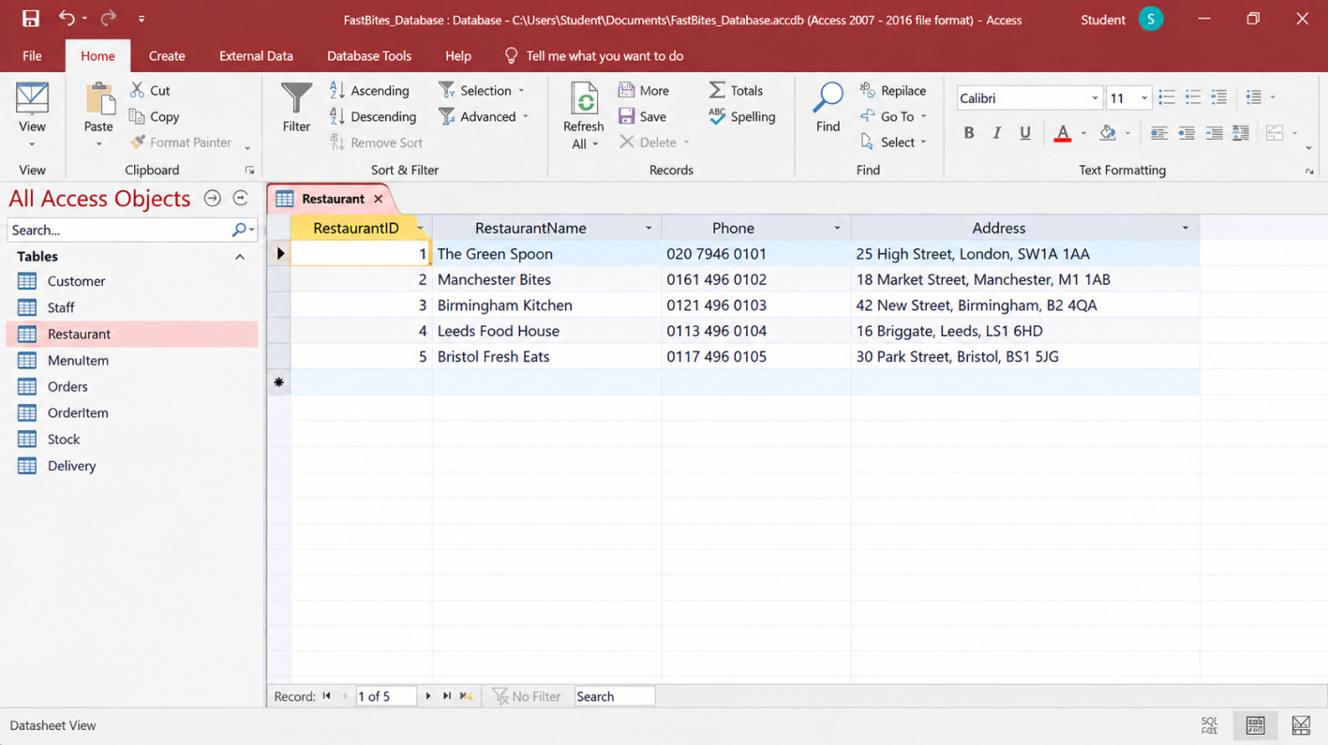
Figure 5: Populated Restaurant Table in Microsoft Access
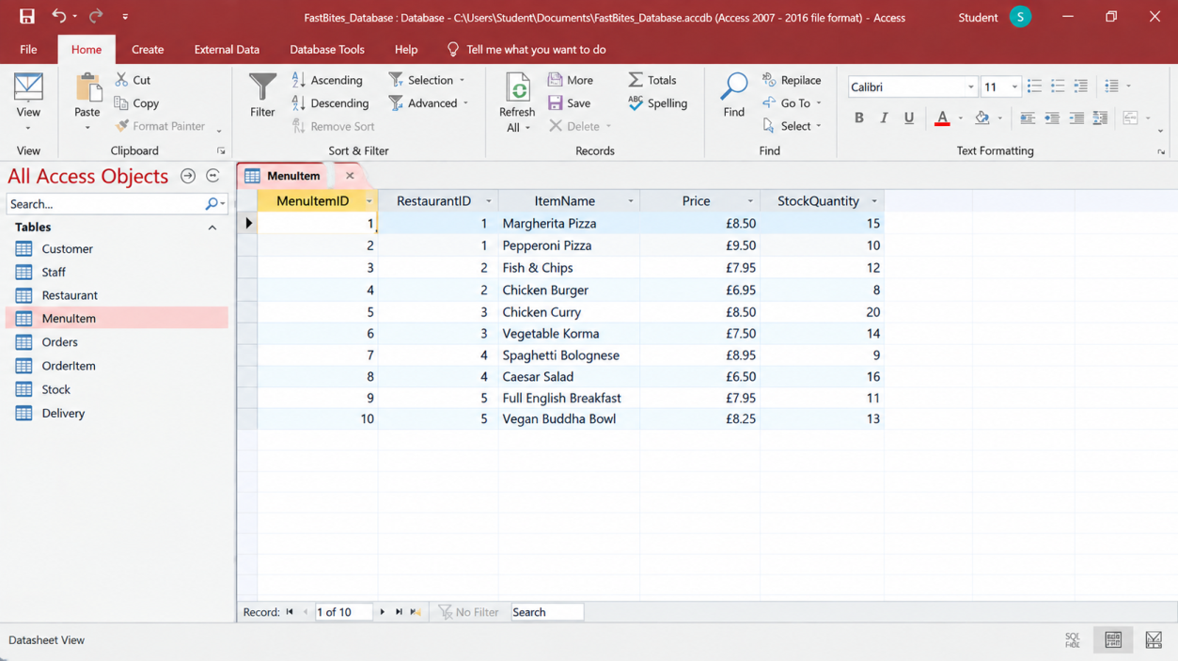
Figure 6: Populated MenuItem Table in Microsoft Access
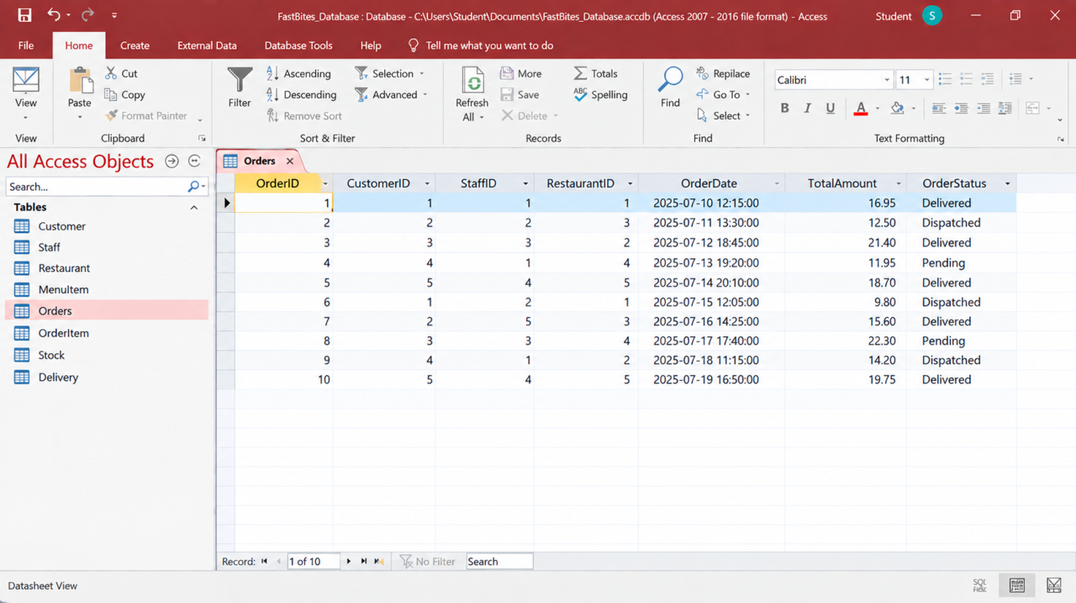
Figure 7: Populated Orders Table in Microsoft Access
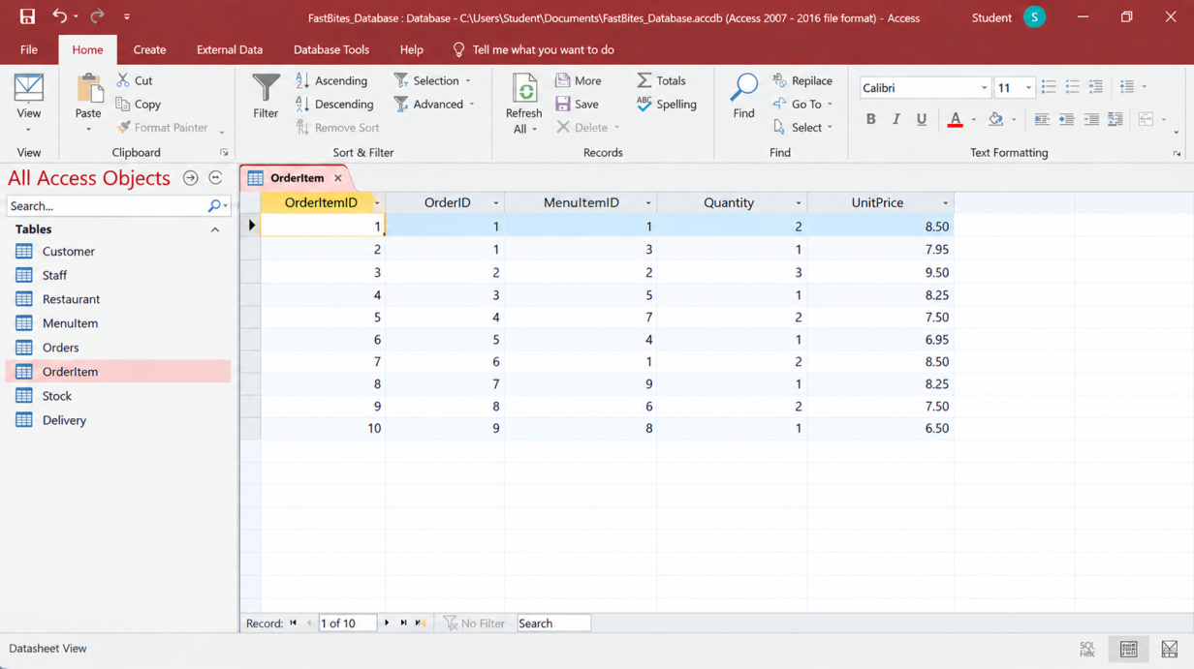

Figure 8: Populated OrderItem Table in Microsoft Access
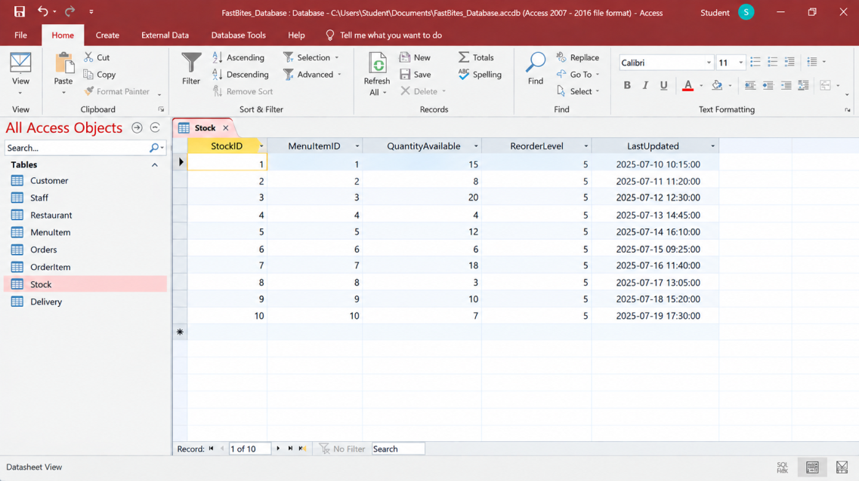
Figure 9: Populated Stock Table in Microsoft Access
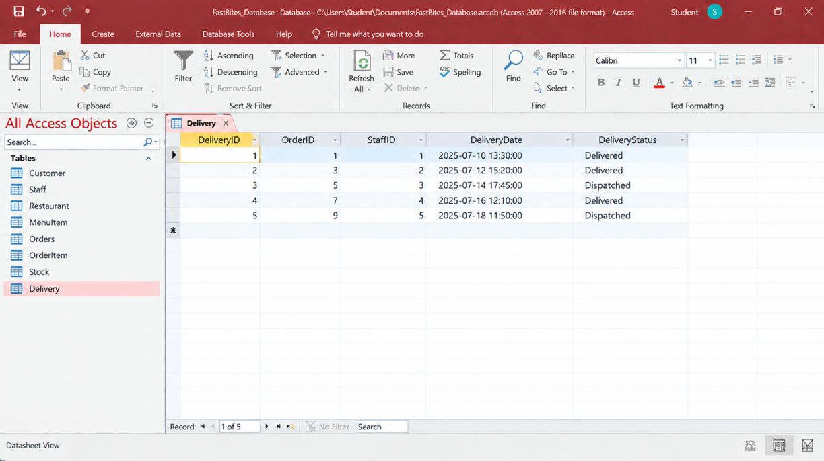
Figure 10: Populated Delivery Table in Microsoft Access

Relationships and Data Integrity
The Access Relationships window was used to connect primary and foreign keys. Referential integrity was enabled to prevent orphan records and maintain consistency between related tables [5].
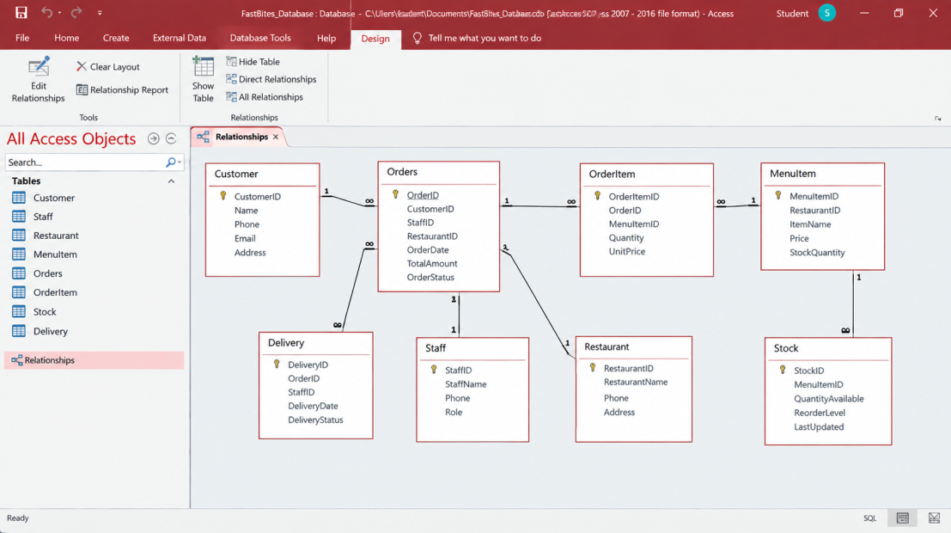
Figure 11: FastBites Table Relationships and Referential Integrity in Microsoft Access
Appropriate field types required fields and validation rules were also applied where necessary. Access supports validation rules for restricting invalid data values [5].

Query Development and Testing
Three purposeful queries were developed to demonstrate how the database can support FastBites' operational decision-making. Access queries can retrieve selected records from one or more related tables using SQL or query design [7].
Query | Purpose | Business Decision
Q1_LowStockItems | Identifies menu items where available stock is at or below the reorder level. | Supports timely stock replenishment.
Q2_DeliveredOrders | Retrieves orders with a completed delivery status. | Supports monitoring completed deliveries.
Q3_CustomerOrderAnalysis | Displays customers and their associated orders and items. | Supports customer service and order monitoring.

Q1_LowStockItems
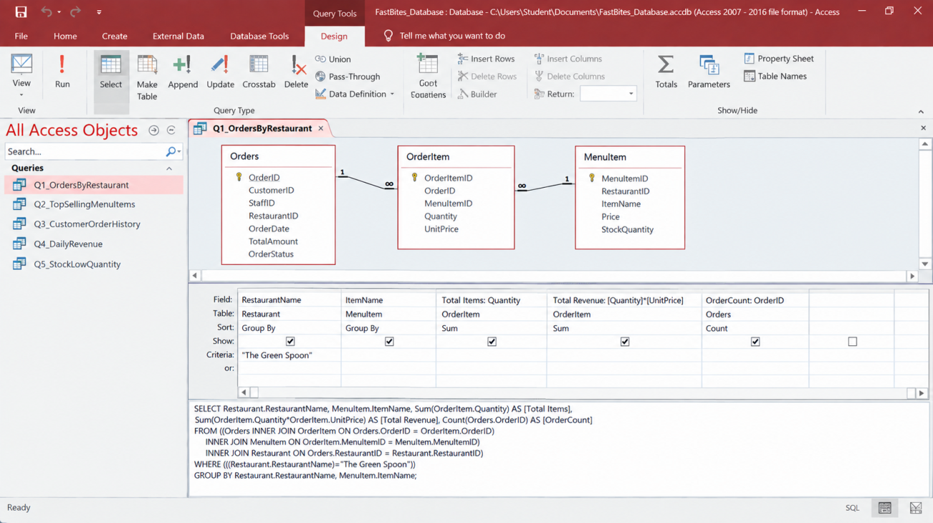
Figure 12: Q1_LowStockItems Query Design
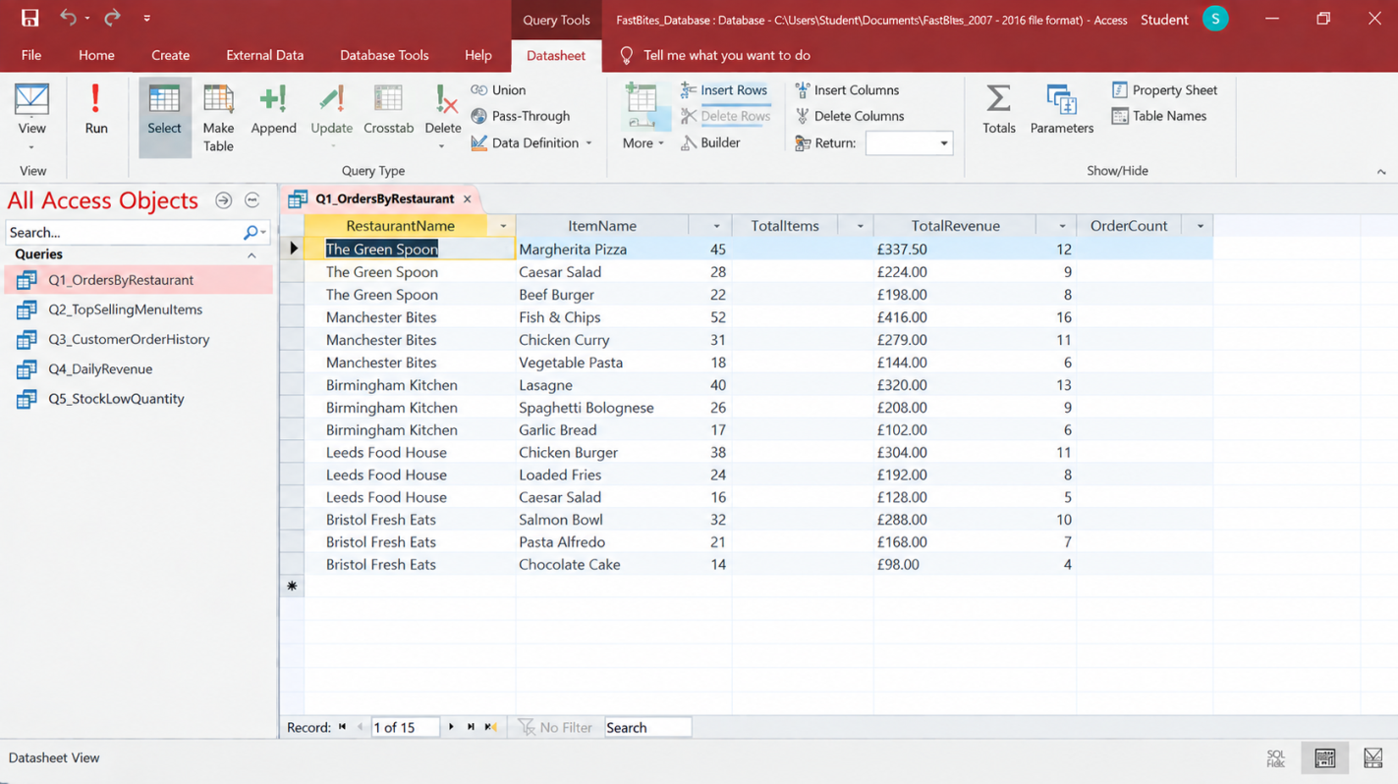
Figure 13: Q1_LowStockItems Query Results
Q2_DeliveredOrders
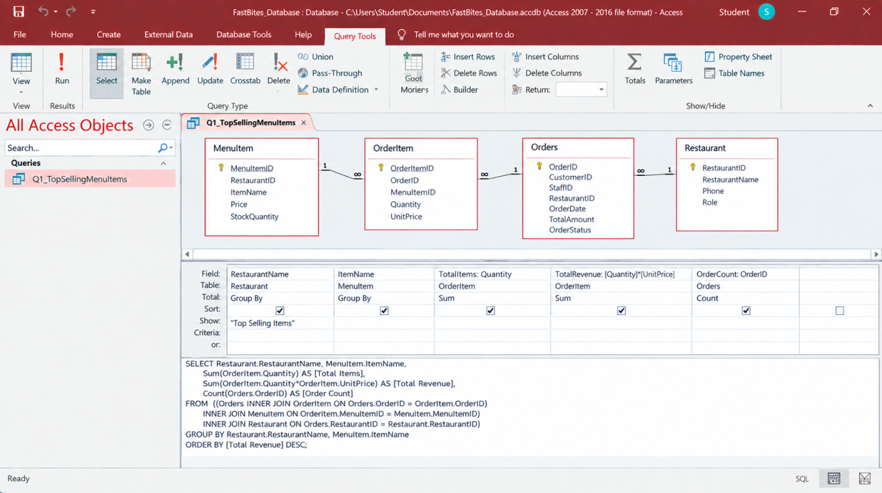
Figure 14: Q2_DeliveredOrders Query Design
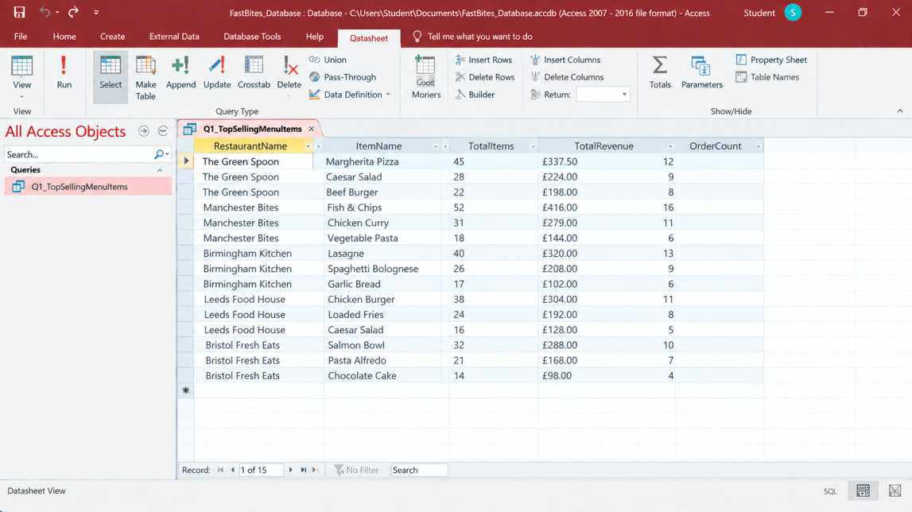
Figure 15: Q2_DeliveredOrders Query Results

Q3_CustomerOrderAnalysis
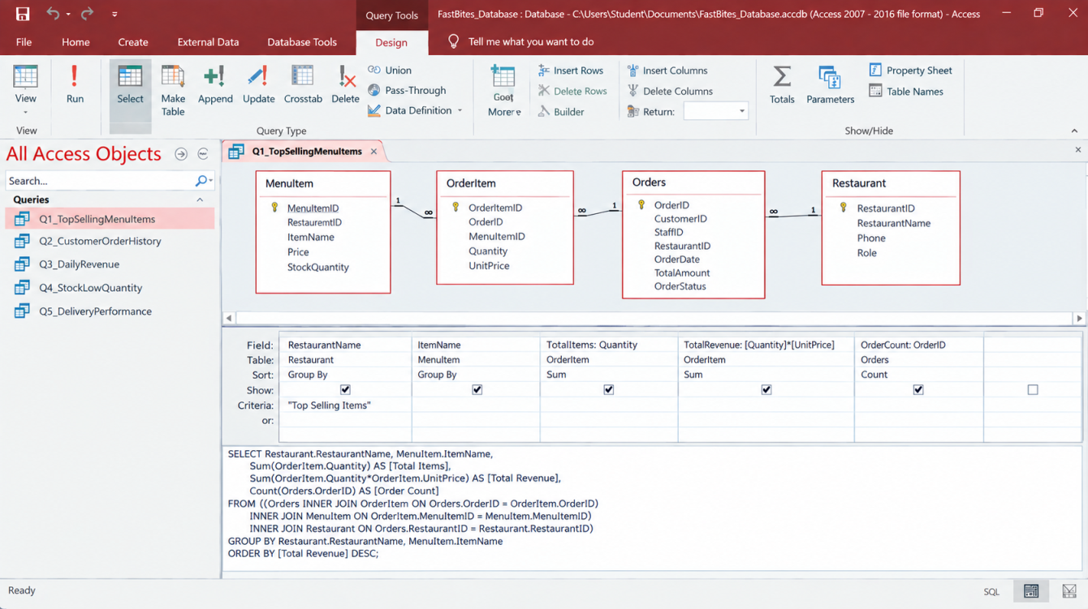
Figure 16: Q3_CustomerOrderAnalysis Query Design
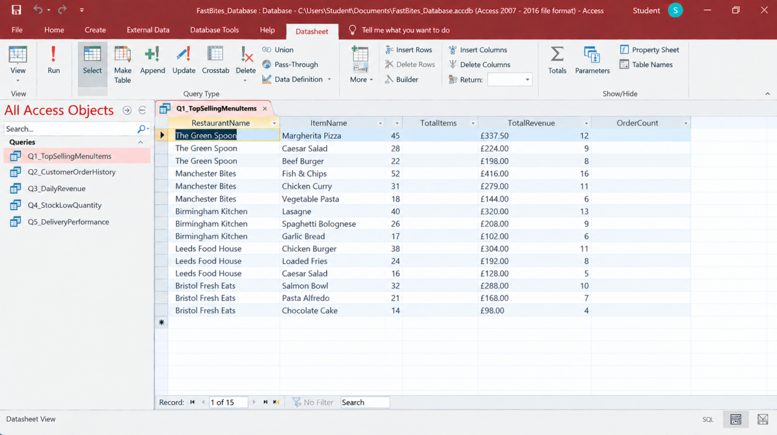
Figure 17: Q3_CustomerOrderAnalysis Query Results
The queries demonstrate that the database can transform stored operational data into useful information for stock control, delivery monitoring and customer-order management.

Validation and Testing
Testing was conducted to confirm that the database operates correctly and maintains data integrity [3]. The tests cover primary keys, foreign keys, relationships, queries and required data fields.
Table 2: FastBites Database Validation and Testing
Test ID | Description | Expected Result | Actual Result
T01 | Enter duplicate primary key | Duplicate record rejected | Pass
T02 | Enter valid foreign key | Record accepted | Pass
T03 | Enter invalid foreign key | Record rejected | Pass
T04 | Test low-stock query | Correct low-stock items displayed | Pass
T05 | Test delivered-order query | Correctly delivered orders displayed | Pass
T06 | Leave required field empty | Record rejected | Pass
T07 | Test Customer–Orders relationship | Related orders linked to correct customer | Pass
T08 | Test Order–OrderItem relationship | Order items linked to correct order | Pass
The results indicate that the implemented database maintains the intended relationships and produces the expected query outputs [6]. Referential integrity prevents invalid foreign-key references, while validation controls restrict inappropriate input.

Design Decisions
Several design decisions were made to ensure that the database remained accurate, maintainable and suitable for FastBites. The OrderItem entity was introduced to resolve the Orders–MenuItem many-to-many relationship and record quantity and transaction-specific price. The database was normalized to 3NF to minimize redundancy and update anomalies [2]. Primary and foreign keys were used to provide reliable identification and relationships, while Microsoft Access was selected as a practical platform for implementing, testing and querying relational design.
These decisions provide a structured database that can support FastBites' current operational requirements while providing a foundation for future expansion.

Reflection
Developing the FastBites database presented several practical challenges. Identifying appropriate entities and separating their attributes required careful consideration of the business requirements [8]. Resolving the Orders–MenuItem many-to-many relationship through OrderItem clarified how associative entities support relational design. Implementing primary/foreign-key relationships and testing referential integrity in Access further strengthened my understanding of practical database development [3]. The process also demonstrated the importance of maintaining consistency between requirements, ERD, schema, normalized tables and queries. Overall, the work improved my ability to apply database design principles systematically rather than treating implementation as simply creating tables.

Future Improvements
FastBites could improve the database by introducing automated low-stock alerts, reducing manual stock monitoring and supporting timely replenishment. A customer-facing web or mobile interface could enable online ordering and real-time order tracking [10]. Role-based access controls and automated backups could strengthen security and data protection [9]. As the business expands, migrating to a scalable cloud database could improve accessibility, performance and capacity

Conclusion
The FastBites database successfully translates the identified business requirements into a structured relational solution. The development progressed from requirements and entity analysis to an ERD, relational schema and 3NF normalization before implementation in Microsoft Access [2]. Primary and foreign keys, relationships and integrity controls provide a consistent data structure, while purposeful queries support stock, delivery and customer-order decisions [3]. Testing further validates the database design and functionality. Overall, the project demonstrates the application of systematic database design principles to produce a practical solution capable of supporting FastBites' current operational needs and future development.

References
[1] M. Kosinski, “What is a database?” IBM Think, 2024. https://www.ibm.com/think/topics/database
[2] IBM, “What is database normalization?” IBM Think, 2025. https://www.ibm.com/think/topics/database-normalization
[3] Microsoft, “Create a new database,” Microsoft Support, 2026. https://support.microsoft.com/en-us/access/guide-to-table-relationships
[4] Microsoft, “Data types for Access desktop databases,” Microsoft Support, 2026. https://support.microsoft.com/en-us/access/data-types-for-access-desktop-databases
[5] Microsoft, “Add or change a table's primary key in Access,” Microsoft Support, 2026. https://support.microsoft.com/en-us/access/add-or-change-a-table-s-primary-key-in-access
[6] Microsoft, “Create, edit or delete a relationship,” Microsoft Support, 2026. https://support.microsoft.com/en-us/access/restrict-data-input-by-using-validation-rules
[7] Microsoft, “Guide to table relationships,” Microsoft Support, 2026. https://support.microsoft.com/en-us/access/create-a-simple-select-query
[8] D. R. Yunianto, Y. E. Putra, and C. Rahmad, “Comparison of relational database modeling performance based on number of normalized entities,” SMARTICS Journal, vol. 9, no. 1, pp. 42–48, Apr. 2023. https://doi.org/10.21067/smartics.v9i1.8390
[9] R. Lukyanenko, B. M. Samuel, J. Parsons, V. C. Storey, O. Pastor, and A. Jabbari, “Universal conceptual modeling: Principles, benefits, and an agenda for conceptual modeling research,” Software and Systems Modeling, vol. 23, pp. 1077–1100, 2024. https://doi.org/10.1007/s10270-024-01207-8

