Introduction to Web and Database Concepts (ACCA4023)

HTML and CSS Web Development

Stephen Protheroe-Hewitt – 2112883

Data and Information Systems

Contents

Introduction 3
Requirements 4
Implementation 10
Validation 17
Homepage/Index HTML Validation 17
CSS Validation 19
Evaluation 20
Research 20
Usability 20
Accessibility 23
Search Engine Optimisation (SEO) 25
Completed Website 27
Usability 27
Accessibility 31
Search Engine Optimisation (SEO) 34
References 38
Appendices 41
CSS 41
HTML – Index 45
HTML – About Us 48
HTML – Products 52
HTML – Product One (Yarn Pumpkins) 56
HTML – Product Two (Coffee) 59
HTML – Product Three (Dustbin) 62
HTML – Frequently Asked Questions (FAQ) 65
HTML – Contact Us 70
HTML – Login/Register 74

Introduction

When we create new websites and webpages, Hyper Text Markup Language (HTML) provides the fundamentals of creating websites since the web existed [1] and provides the general content for webpages and websites on the internet. HTML5 is currently the latest version and provides functionality such as more element choices (for example, <div> has an option for <section> among other options) and support for multimedia content via application programming interfaces (APIs) [1].

While HTML provides the content of webpages, Cascading Style Sheets (CSS) provide us with the ability to create the webpage style by specifying how certain content should appear, such as the colour of backgrounds on webpages, how paragraphs should appear using different colours and fonts, or have certain headings (for example) in green and bold [2]. An advantage of CSS within web design is that one CSS file can be used for a website, as it allows the content style to be applied throughout and when required. CCS3 is currently the latest version and provides functionality such as text effects and layout (for example, allowing us to change the whitespace and how text is laid out) and multi-column layouts, which allows web designers to show content in multiple columns [3].

As part of creating the website, this report will detail the following.

- The requirements of the website, such as what the website being created is (for example, information about a city, educational content, banking etc.), what the purpose of the website is, the intended target audience the website is trying to reach, the information required and how that information will be presented. This will include the site and wireframe diagrams.
- The implementation of the website, which will show screenshots of all the webpages from the completed website and the validation of the HTML and CSS codes used. If any errors are received from the validation, this will either be corrected or where unable to be corrected, what could be causing the error.
- An evaluation of the website to analyse, judge and conclude whether the website is well designed or requires improvement. This will involve the usability of the website (if the website and webpages look appealing and can be easily navigated by users), the website’s accessibility (if the website can be accessed by users with visual or audio impairments) and the on-page search optimisation engine techniques used to make the website stand out on search engines such as Google.

Requirements

The website will be an online shopping website like Amazon and ASOS and will consist of the following web pages.

- The main page (or ‘Index’ in HTML), which will introduce the company and have links to the other areas of the website.
- ‘About Us’, which will describe the company in more detail and provide links to the other areas of the website.
- ‘Products’, which are the products the company provides and will show each product available. When selected, each product will have its own webpage and will allow the user to confirm any product requirements (for example, if someone orders a t-shirt, whether the size should be small, medium, or large).
- ‘Contact Us’, which will provide details of how to contact the company (such as a telephone number or e-mail address) and submit different queries via customer forms.
- ‘Login/Register’, which will allow users to log in or register on the website.

Before creating the website, it is important to create a website diagram as it allows us to plan the purpose and usability of a website while allowing us to test new navigation paths and new layouts [4]. It can also show how the web pages will interact with each other.

The website diagram created for the website is as follows.

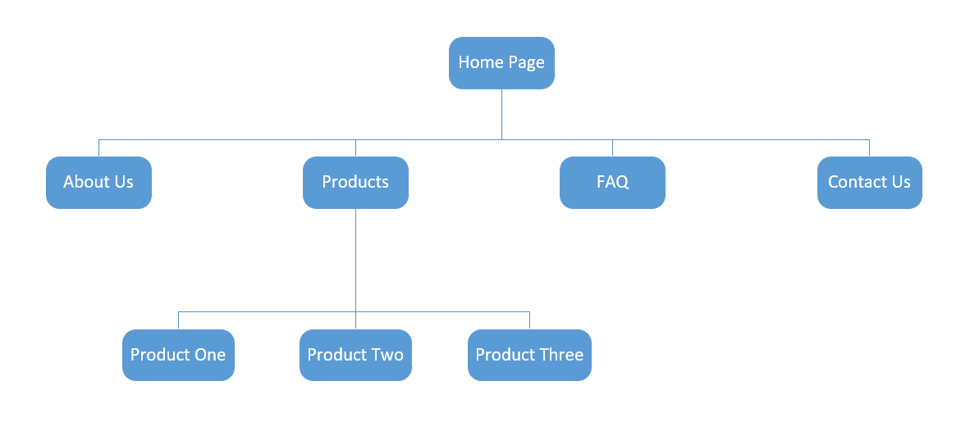
Fig. 1 Website Diagram
It is also important that wireframe diagrams are created before the website is created, as they allow a blueprint to be created for how webpages are structured, content is laid out and if ideas would work [5]. Wireframe diagrams can also show how website designers may want users to interact with a website (for example, where buttons are located or finding menus on different web pages), as users unable to find these buttons or menus on a wireframe diagram would mean that they need to be clearer, allowing for improved user interface design [6].

The wireframe diagrams for each webpage of the website are as follows.

  - Homepage/Index

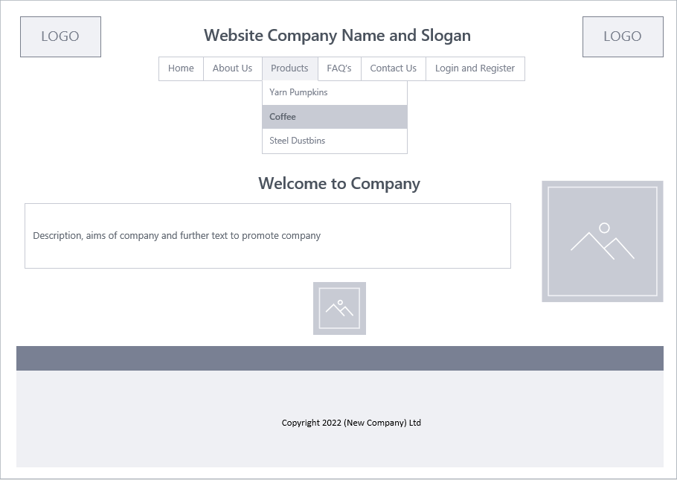
Fig. 2 Wireframe Diagram Homepage

  - About Us

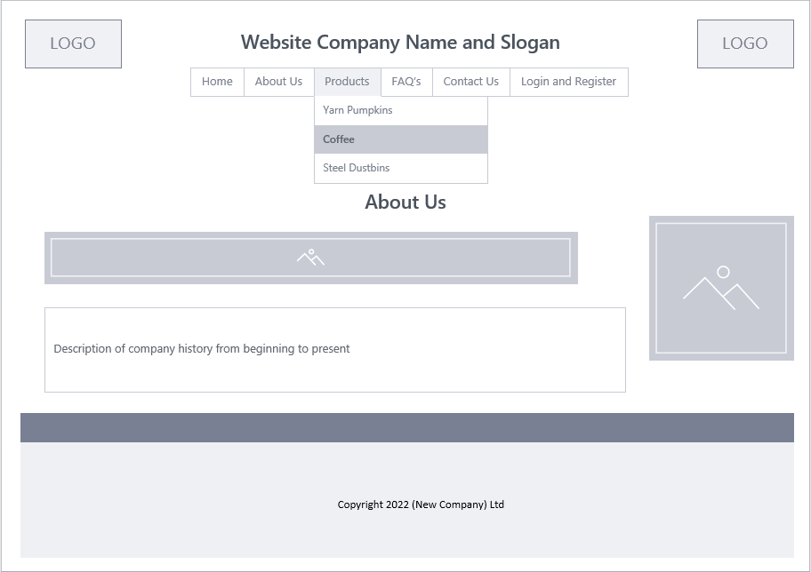
Fig. 3 Wireframe Diagram About Us

  - Products

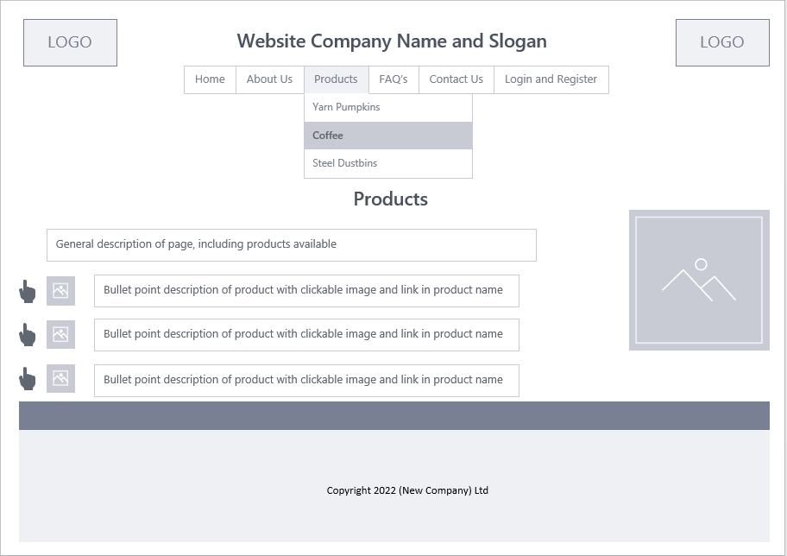
Fig. 4 Wireframe Diagram Products

  - Products 1, 2 and 3

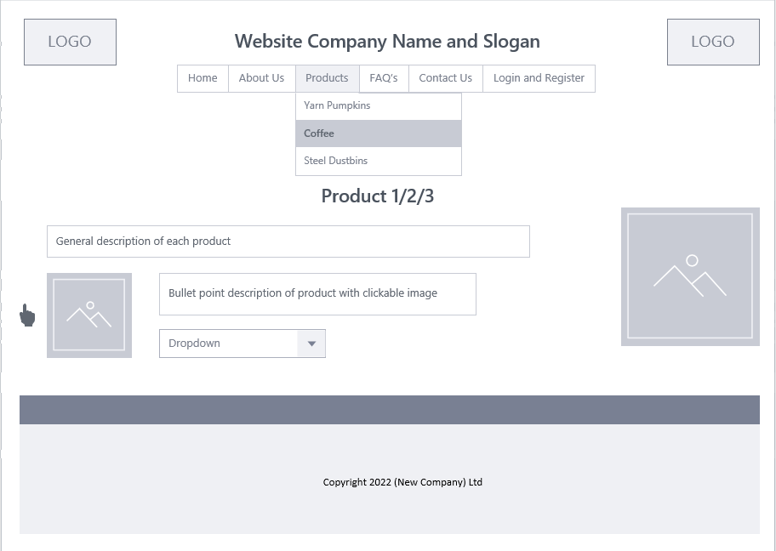
Fig. 5 Wireframe Diagram Products 1/2/3

  - Frequently Asked Questions (FAQ’s)

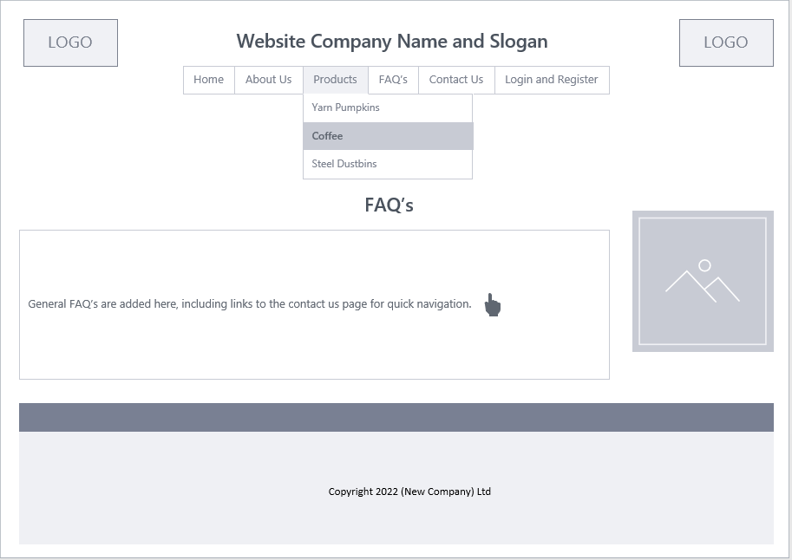
Fig. 6 Wireframe Diagram Frequently Asked Questions (FAQ’s)
  - Contact Us

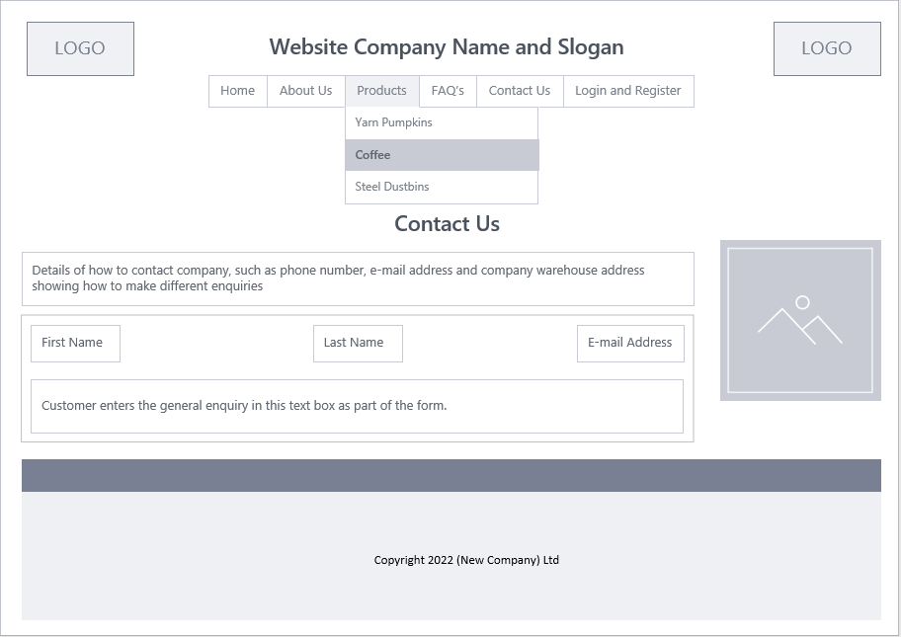
Fig. 7 Wireframe Diagram Contact Us

  - Login/Register

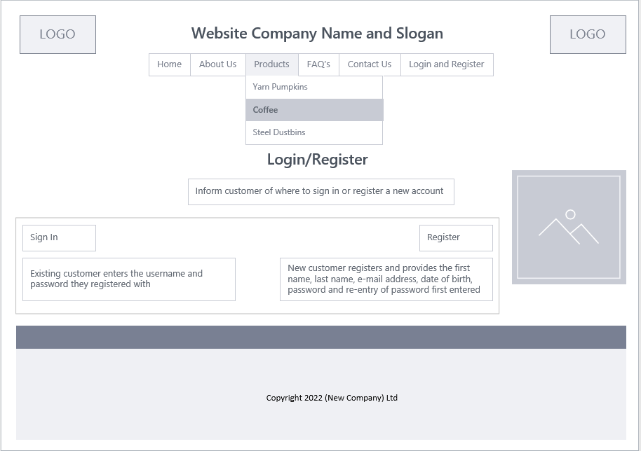
Fig. 8 Wireframe Diagram Login/Register

The main purpose of the website would be to promote and sell products to customers. This would be achieved by making the website well organised, fast, and easy to navigate for customers to use, while making it attractive for prospective customers to view. This would allow potential customers to find information easily, choose the specifics of the product they would like (for example, a small, medium, or large dress) and purchase the product with ease to improve the prospect of customer retention.

The intended target audience would be aimed at younger adults as they would be more likely to browse the website as potential customers and make purchases. However, the website would also be catered to older adults and would be configured to ensure they can access and use the website if they are not ‘tech savvy’. This is evidenced by an article from The Guardian [7], which mentions that 54% of people over the age of 65 say that they shop online.

Implementation

The website was created with consistency, quickness, and usability in mind. As a result, all web pages look similar, with the main links shown within the navigation bar at the top of each page and a footer at the bottom of every webpage.

The website and each webpage were created as follows.

  - Homepage/Index

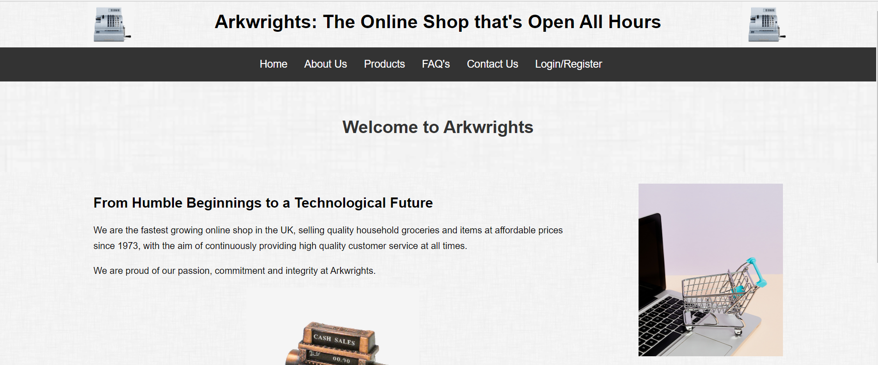
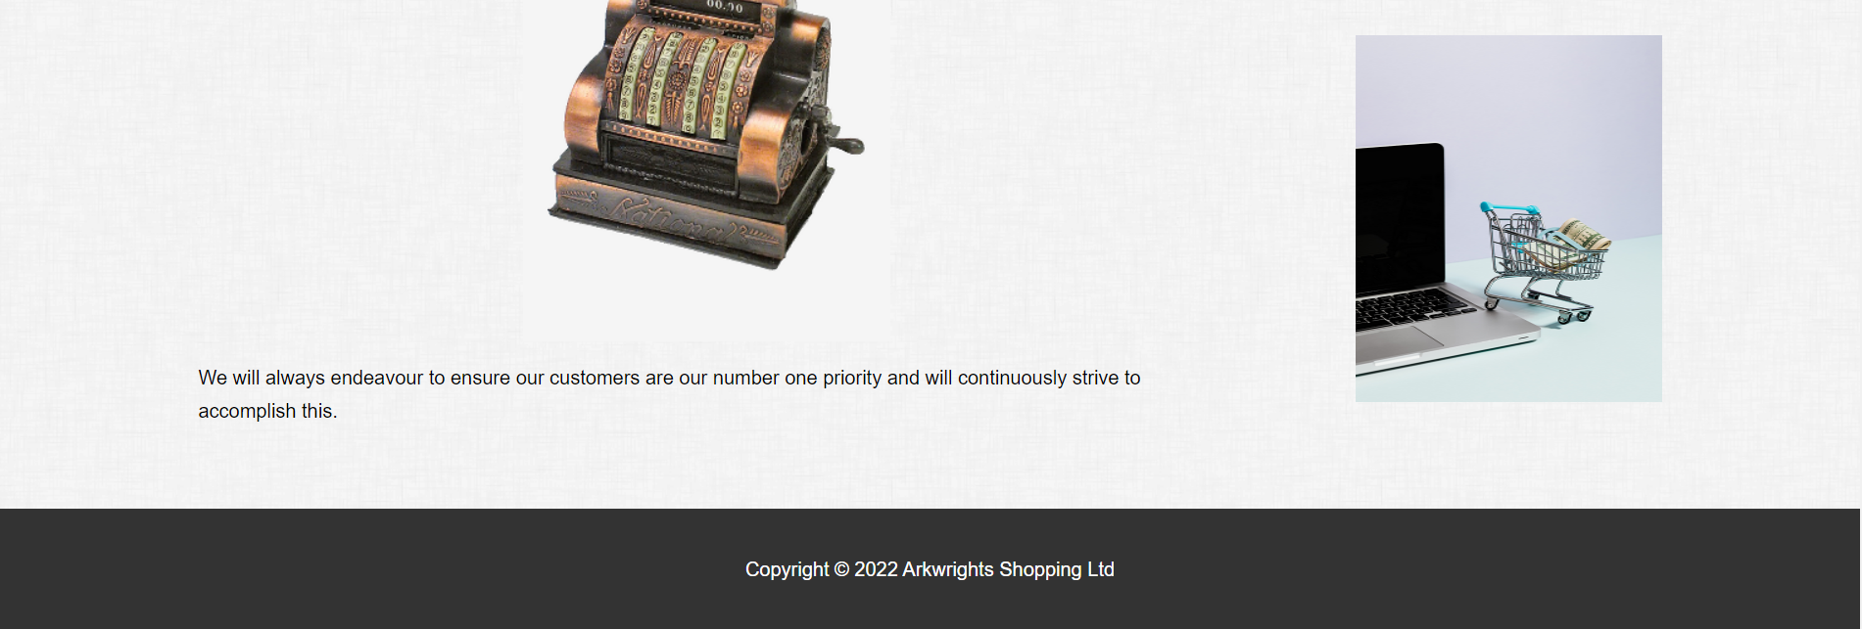
Fig. 9 Website Homepage

  - The image of the two cash registers in the header was used from Unsplash [8], while the main image of the antique cash register was used from Free Images [9]. The two images of the trolley next to the laptop used in the sidebar throughout the website were photos taken by K. Grabowska on Pexels [10], [11].
  - About Us

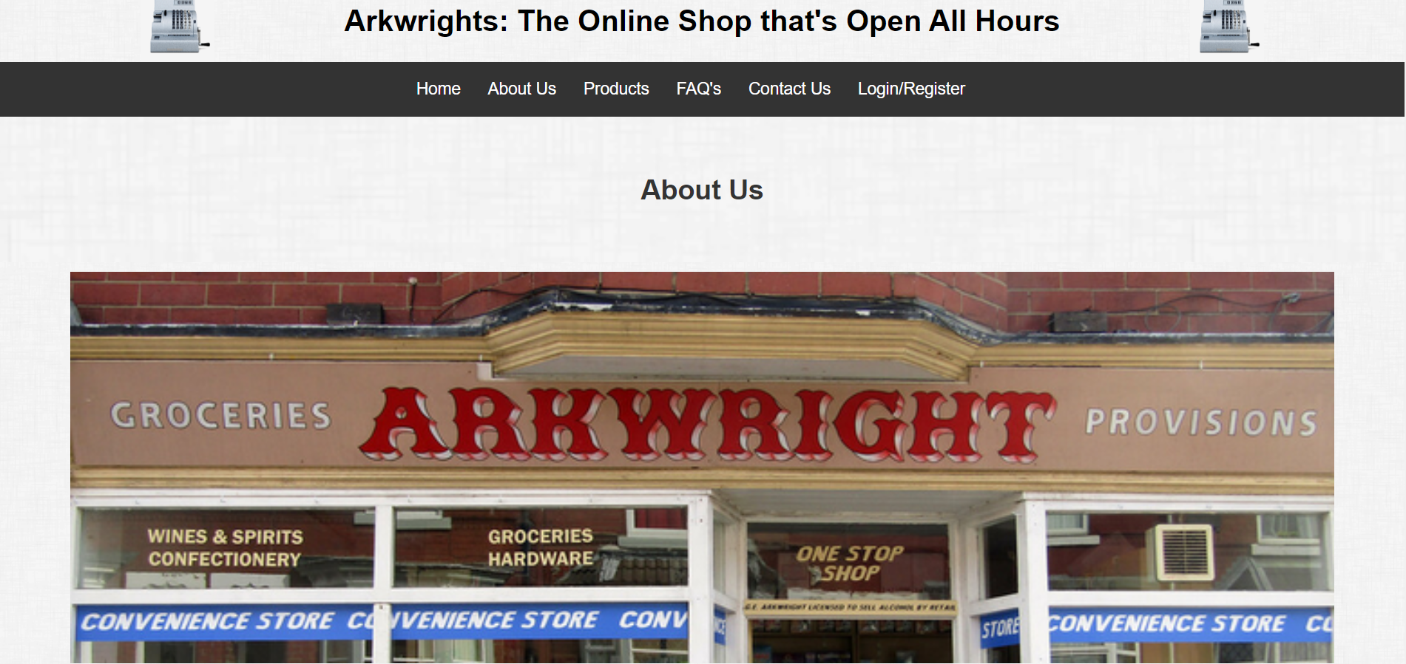
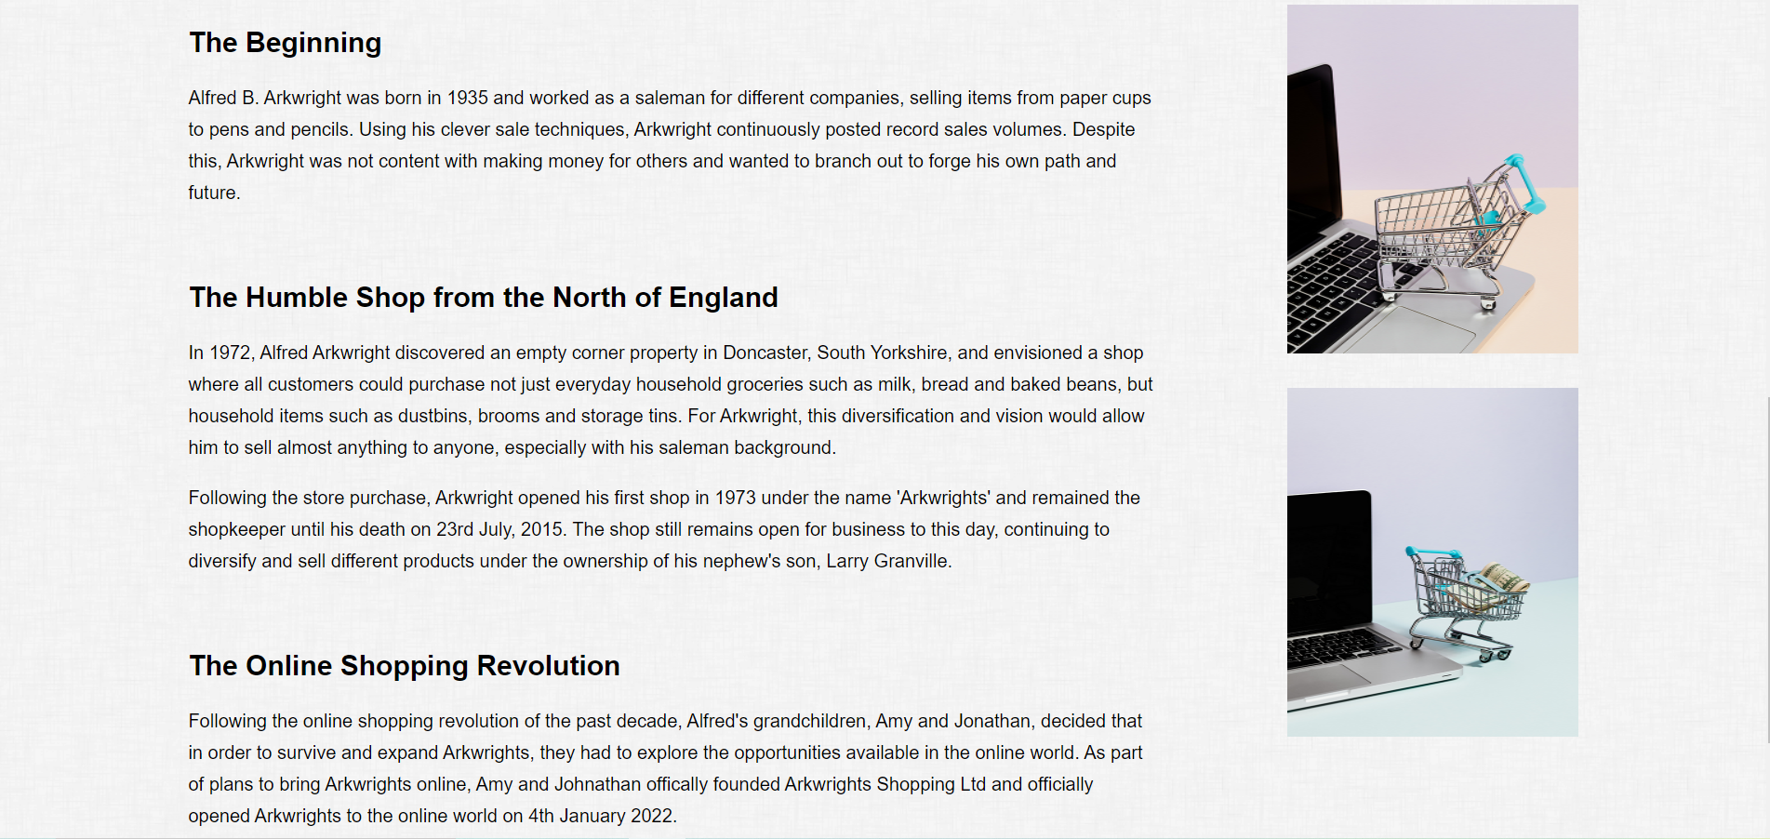
Fig. 10 Website – About Us

The image of the Arkwright old shop was a photo taken by D. Johnson on Flickr [12].

  - Products

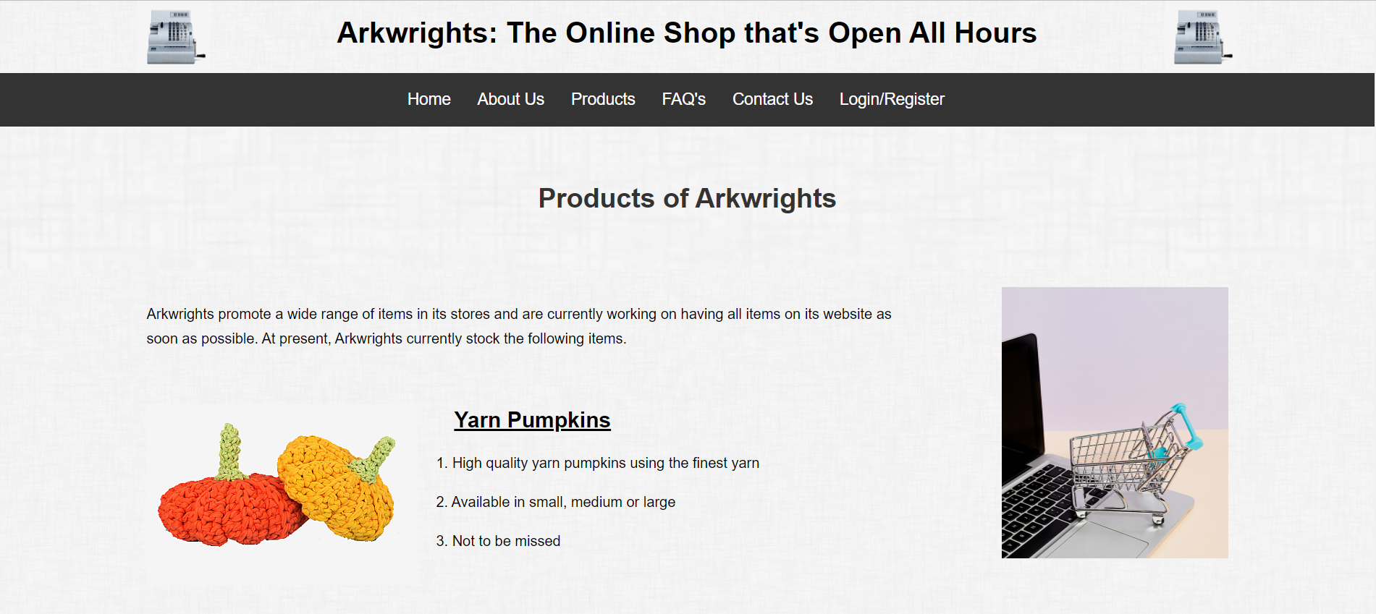
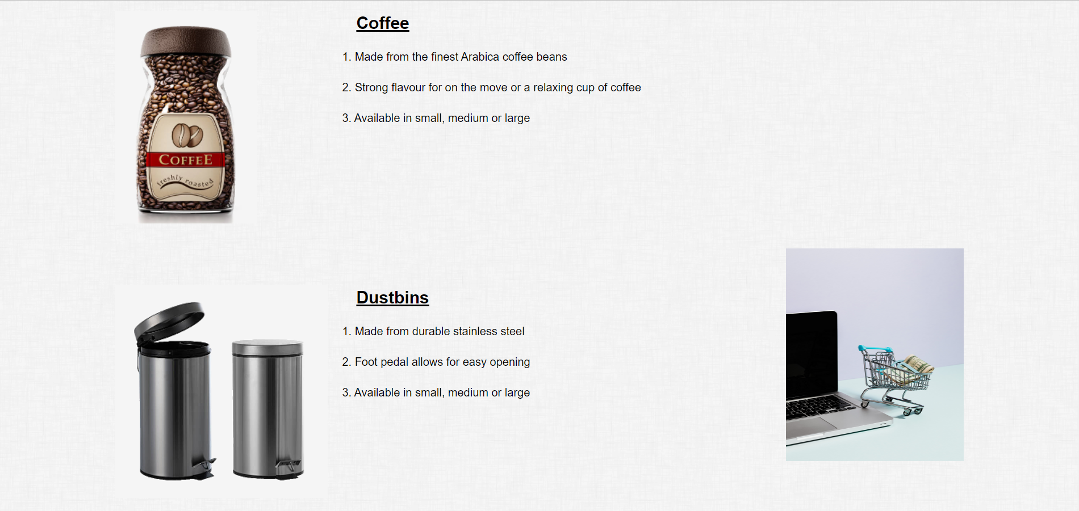
Fig. 11 Website - Products

The image of the yarn pumpkins, coffee jar and dustbins were used from Unsplash [8].

Product One – Yarn Pumpkins

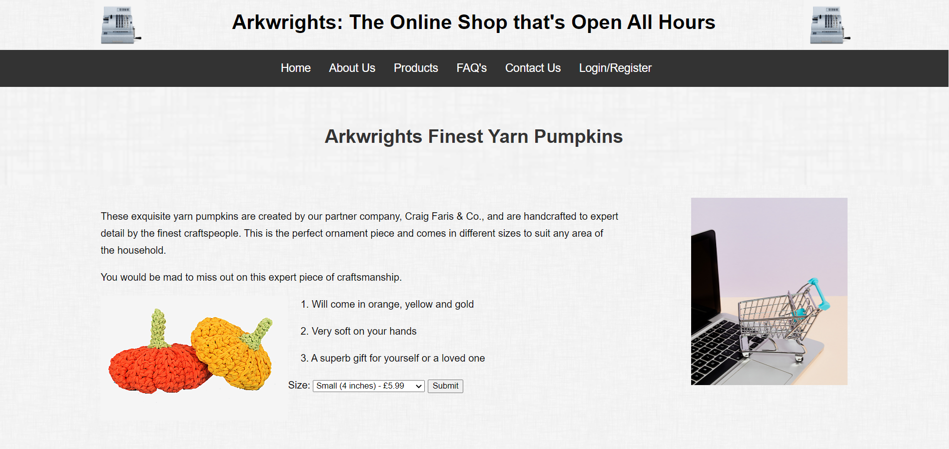
Fig. 12 Website – Product One (Yarn Pumpkins)
Product Two – Coffee

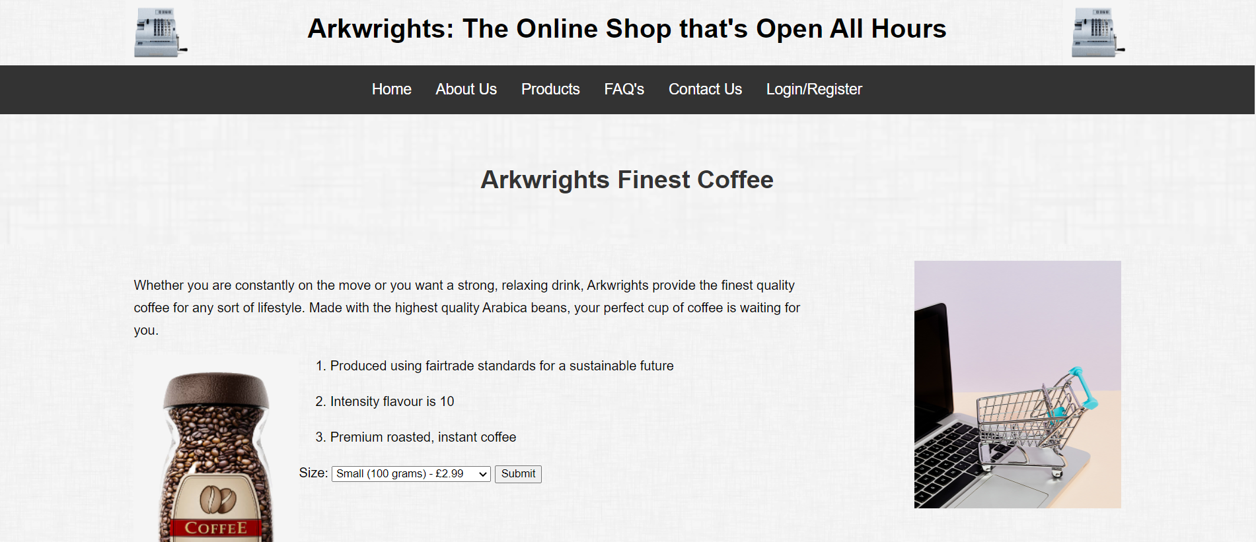
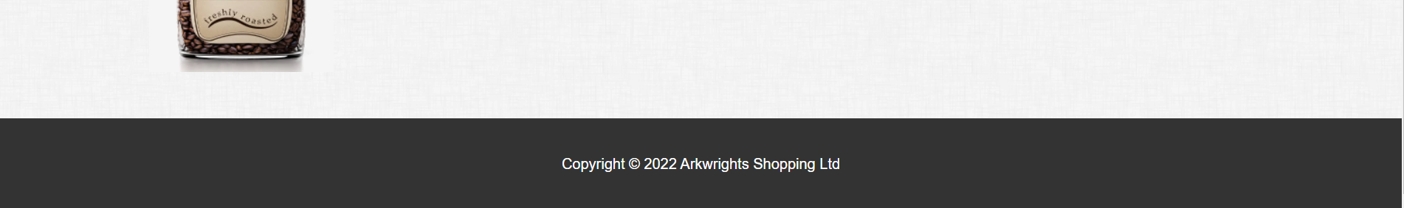
Fig. 13 Website – Product Two (Coffee)

Product Three – Dustbins

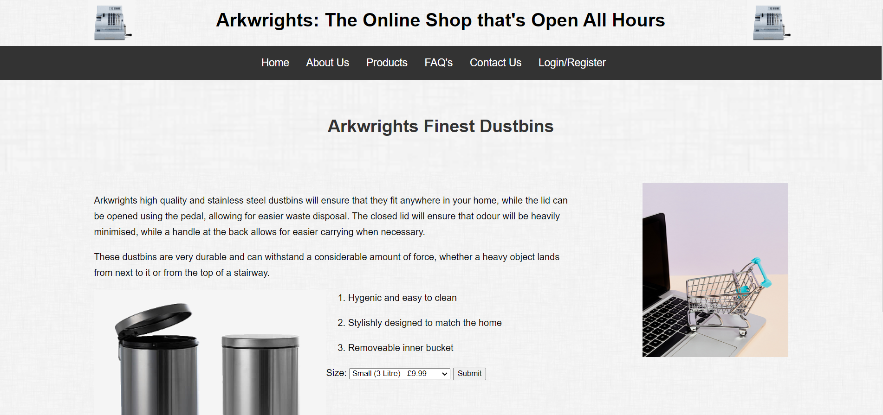
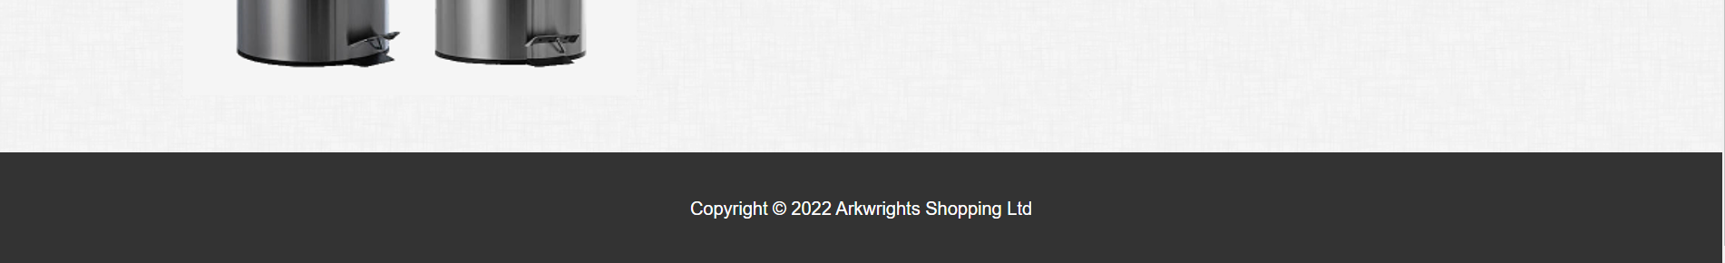
Fig. 14 Website – Product Three (Dustbins)

Frequently Asked Questions (FAQ’s)

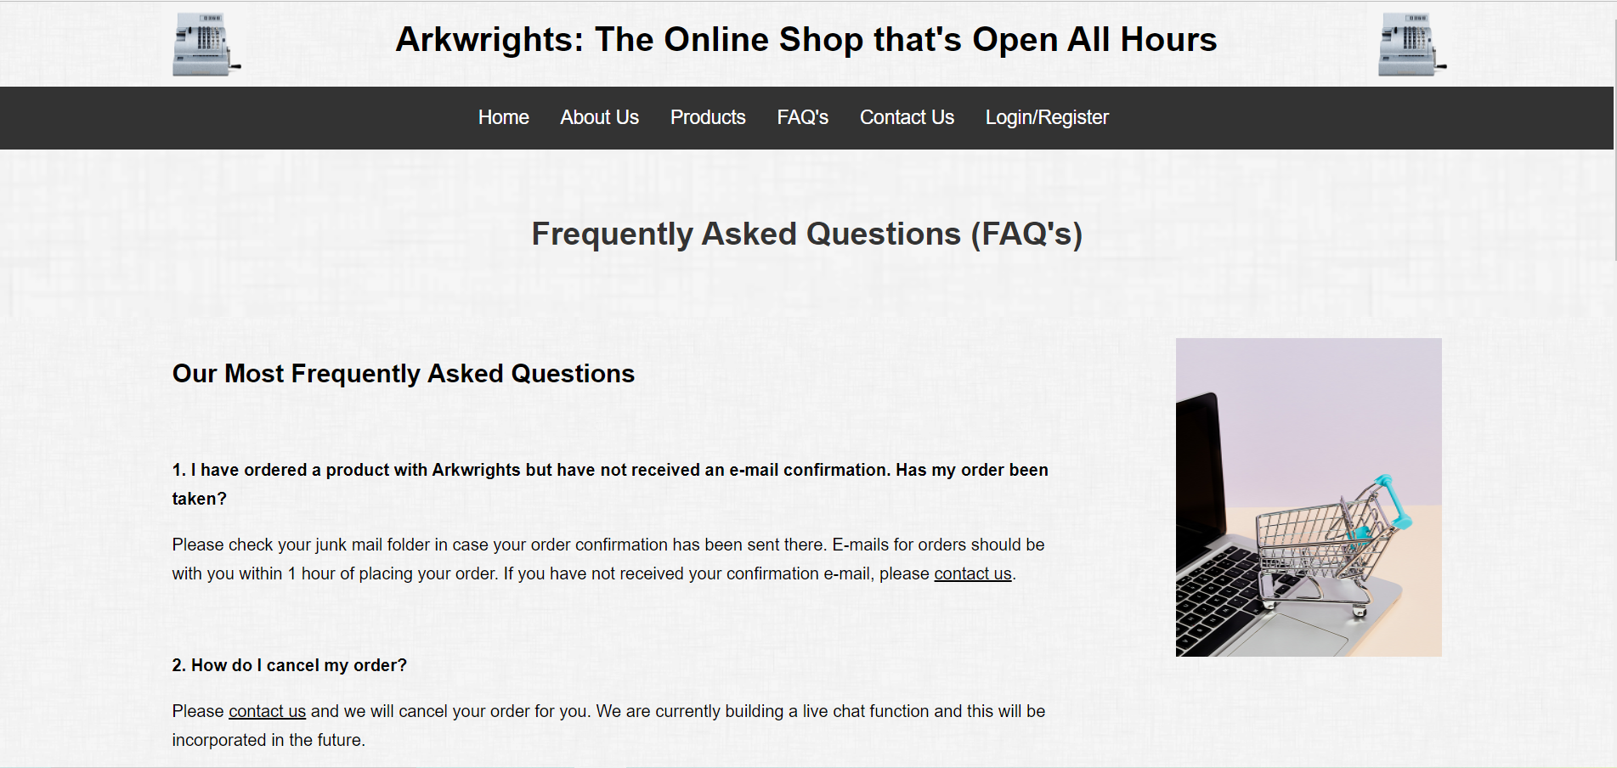
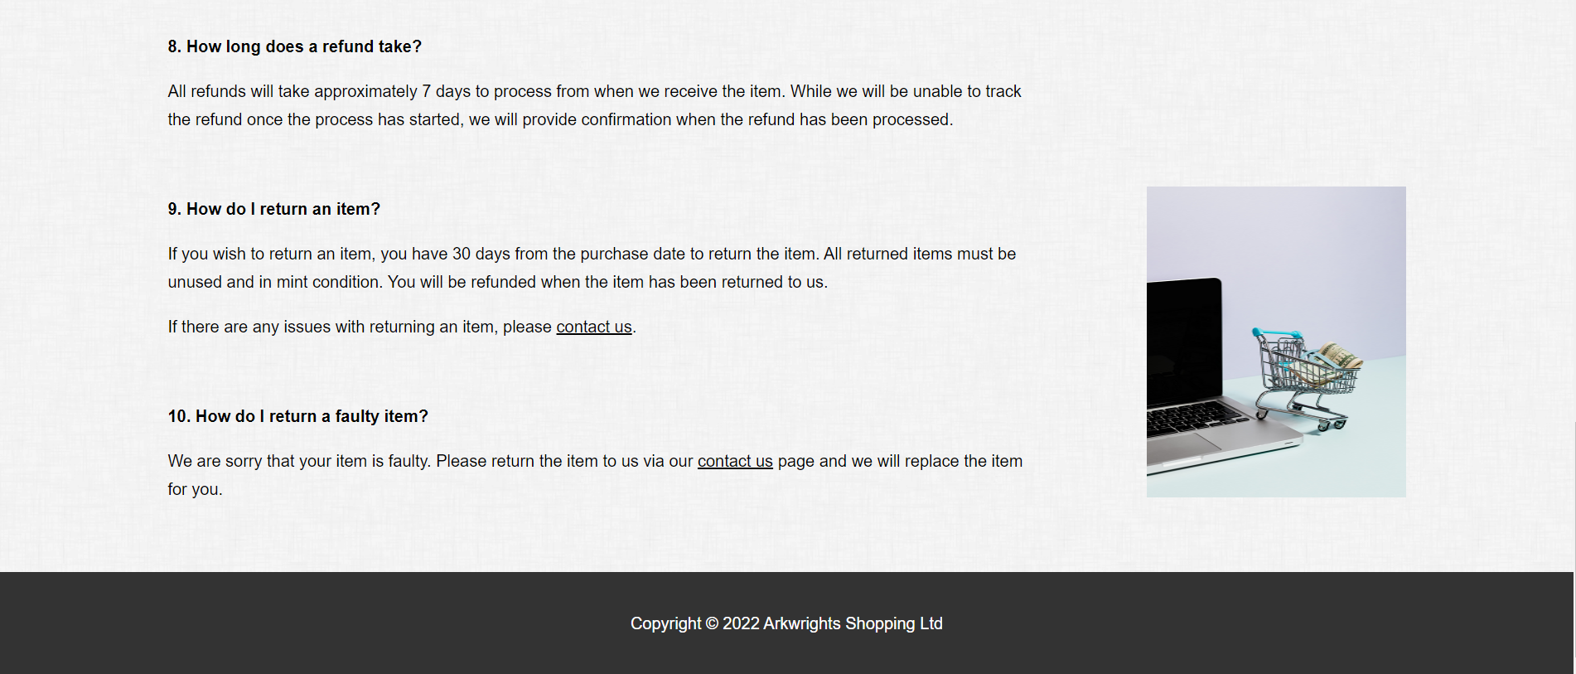
Fig. 15 Website – Frequently Asked Questions (FAQ’s)

Contact Us

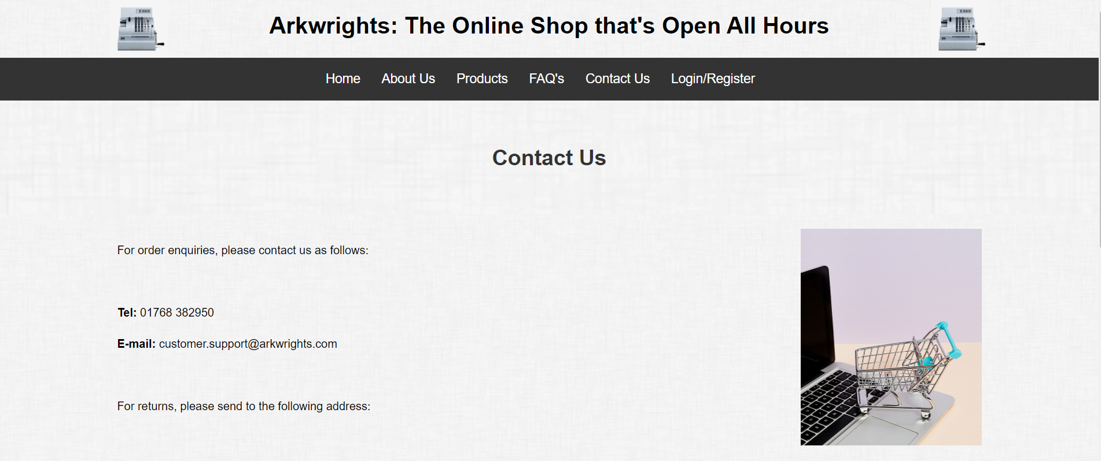
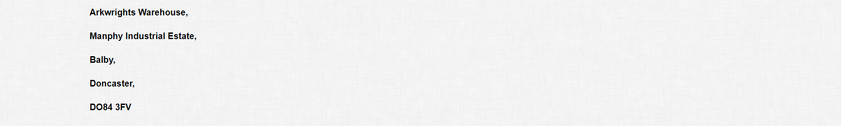

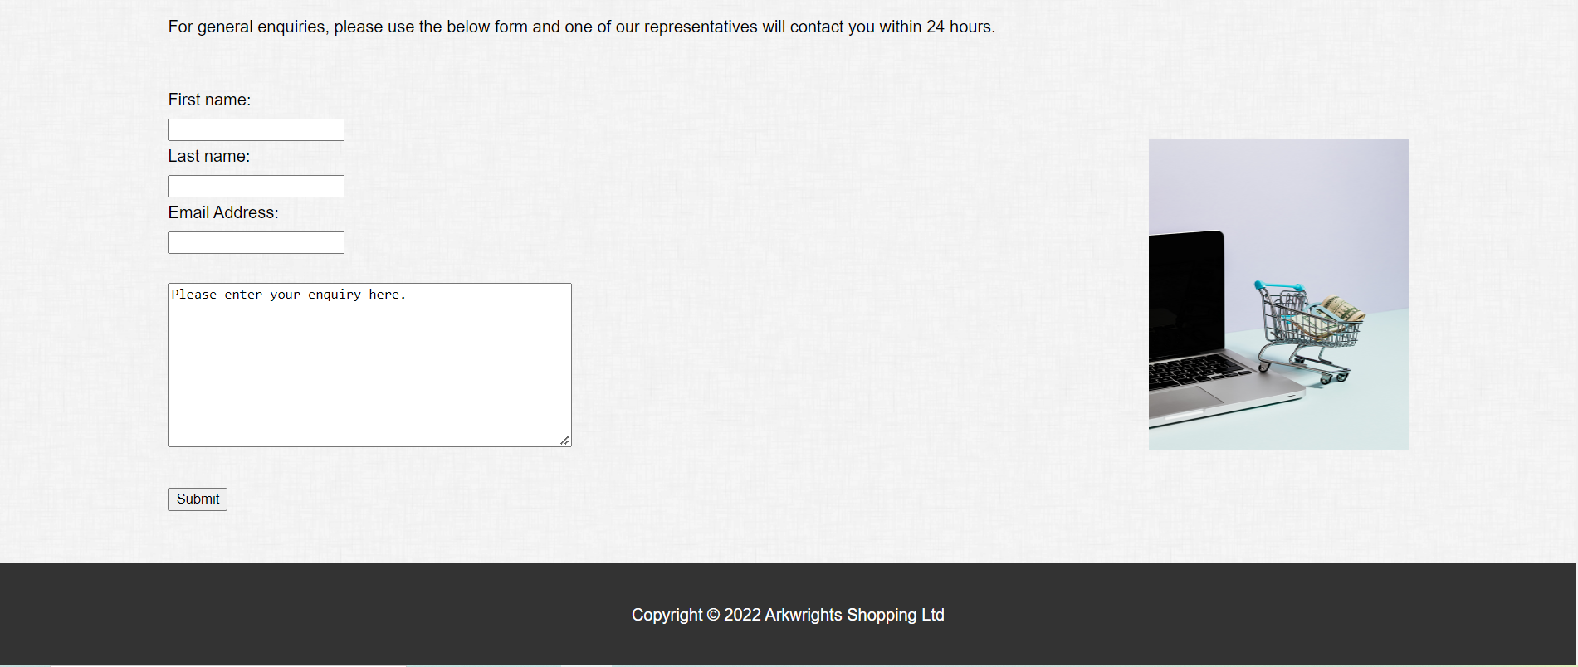
Fig. 16 Website – Contact Us

Login/Register

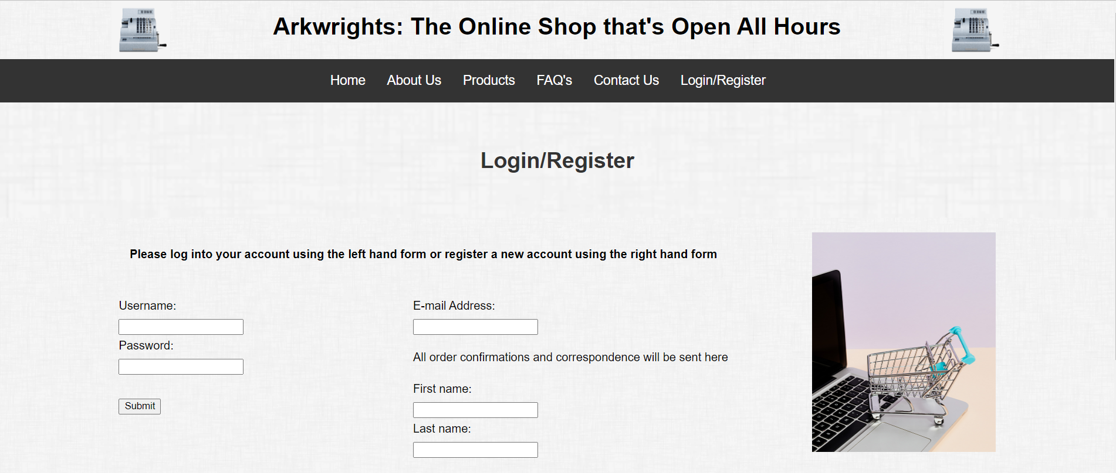

Fig. 17 Website – Login/Register

Validation

It is important to validate the HTML and CSS codes used for websites and webpages as validation can be crucial in finding and correcting any errors found, with some of the benefits of validation being that it:

- can teach good practices for those starting in HTML and CSS coding by assisting in spotting mistakes and quality assurances such as accessibility.
- can protect against errors that may not be shown consistently on different browsers currently and in the future.
- shows excellent quality and if the code is laid out well [13].

The HTML and CSS code layout used for the website was based on a template by Gareth Jones at the University of Wales, Trinity St. David’s for the homepage of the ‘Umbrella Corporation’ [14], which provided a strong layout and could be adapted as a template for the website.

Homepage/Index HTML Validation

The HTML homepage/index webpage was validated via the website http://validator.w3.org/ and while there were thirty errors in total, the following types of errors were received and repeated throughout the validation.

The first error was due to spaces within the CSS filename. This was corrected on the CSS and all HTML files to show with an underscore (‘_’) and for any errors corresponding to images as well for consistency.

Fig. 18 CSS Illegal Characters in Filename

The second error was due to a missing equal sign within the alternative text (‘alt’) attribute. This was corrected on all HTML files to show an equal sign for all ‘alt’ attributes, while any spaces within the attribute were amended to show an underscore between each word. This was to ensure consistency throughout all HTML files.

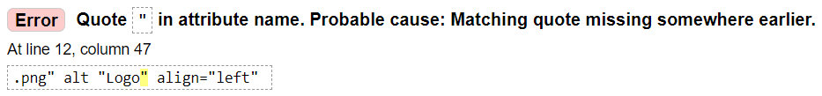
Fig. 19 HTML Missing Equal Sign

The third error was like above with a missing equal sign in the alternative text (‘alt’) attribute. This was corrected on all HTML files as mentioned above, with any gaps in words amended to show with an underscore instead of spacing between words for consistency.

Fig. 20 HTML Unexpected Whitespace

The fourth error is due to how the logos for each webpage have been created. Instead of using CSS to insert and align the two images left and right throughout the website, this was performed individually within each HTML file. While it has worked as expected for the Arkwright website, this can be cumbersome if there are a lot of web pages for a website. Unfortunately, I have been unable to perform this correctly via CSS.

Fig. 21 HTML Logo Not Using CSS

The final error is due to the file path used for the ‘Products’ link on the website, as the main product HTML file, the yarn pumpkins, coffee and dustbin HTML files and any corresponding images are in a separate folder. While this can be amended by moving the files up one directory where all the other HTML files, CSS file and other images are, this would make the file path directory for the website cluttered. Because of this, the file path has not been amended.

Fig. 22 HTML Unexpected Backslash

CSS Validation

The CSS file was validated via the website http://jigsaw.w3.org/css-validator/ and there were no errors found at all within the CSS file for the website, as the below screenshot shows.

Fig. 23 CSS Validator

Evaluation

When creating a website, it is important that usability, accessibility, and search engine optimisations are analysed to ensure that the website is fit for its target audience, maximises the benefits of the website’s creation, adheres to any required legislation, ensures the website can easily be found by the target audience on the internet and overall, achieve the aims of what the website was created for (for example, selling products or providing information).

The following are detailed descriptions and research elements around usability, accessibility, and search engine optimisation on websites.

Research

Usability

According to Belanche, Casaló and Guinalíu [15], website usability can be considered as follows.

- How to understand the website structure, its interface, the content of the website and how it works by the user.
- How easy it is to use the website.
- How quick users can find what they require.
- How easy it is to navigate the website to perform what is required and the time taken to do said action.
- How the user can control what they do and where they are as required.

It was stated by Belanche, Casaló and Guinalíu [15] that consumer satisfaction is a vital aspect for further purchases and usage of a company’s product or services, which would influence consumers to use the company’s website. It became apparent that website usability was crucial in improving and maintaining user satisfaction, most notably around the user interface, the content provided and the website’s ease of use (especially around searching and selecting products, as well as making payments). If a website is not user friendly, the purchasing process is too long or content is not updated or irrelevant, this would negatively impact user satisfaction towards that company and influence future purchases with them.

However, according to Krug [16], the most important rule of website usability is to ensure the user does not have to think when looking at a webpage, about what the user sees, what the user wants and how to navigate there is very clear and self-explanatory (for example, if you want to purchase a specific video game, you can see where the product section and categories are, the ‘video games’ area in the list of categories and finally, the video game console it is for). If webpages are clear and self-explanatory, everything will feel comfortable to the user and effortless in terms of navigation and ease of use, while webpages that make users think about, for example, how to navigate the webpage, where sections are, the wording on webpages and links or buttons that do not appear to be clickable will waste a user’s time and effort, potentially losing a customer for e-commerce websites.

Krug’s most important rule could link to further importance of website usability in older adults. In a study by Romano Bergstrom, Olmsted-Hawala and Jans [17], it was noted that older adults had difficulty with some navigational elements of websites as they tend to look more at the central part more often than younger adults, while looking at the left peripheral of the screen less often and taking longer to look first at the top peripheral. As website designers can place navigational elements in periphery areas rather than the centre of the screen, this can make the peripheral areas less clear, more cluttered and usability for all users (especially older adults) worse.

For the study, Romano Bergstrom, Olmsted-Hawala and Jans [17] were focused on two eye-tracking results, which were the number of fixations per area of interest on the main website page, and the time taken before the first fixation on each area of interest. Of the five studies performed, the results were as follows.

- The fixation on the central area of interest was greater in older than younger adults for the first and fifth studies.
- The fixation on the peripheral left area of interest was greater in younger than older adults for the first study.
- The time to view the top peripheral was longer in older than younger adults in the fifth study.
- The accuracy was better in younger adults for the third and fifth studies, while efficiency was better in younger adults for the first study.

Following the study, it was concluded that website designers should create websites and webpages for younger and older users, with repeated important content moved into the centre and periphery, having a clear and uncluttered layout, and reducing unwanted distractions that could draw older adults’ eyes to a different part that does not provide the information they require.

Different web developer roles focus on the usability of a website, such as user experience (UX) designers that focus on the initial design, functionality, and layout of the website, while user interface (UI) designers focus on the visual presentation to give the website identity, using different fonts, logos and colours (as well as tools like buttons, links and menus) to create an effective and attractive website for users [18], [19]. All web developers and designers work together to ensure that websites and web pages are created to meet all user usability needs.

Those performing website user experience (UX) roles would usually have a good understanding of the C.R.A.P. principles, which allow designers to create effective designs that attract users and keep them engaged with the website [20].

The four principles are as follows.

- Contrast – Having good contrast can make colours, images and designs stand out that are easy on the users’ eyes (for example, if certain colours stand out too much or certain text becomes unreadable).
- Repetition – This allows for consistency in a design and assists users to feel familiar with how the content is being presented to them (for example, having the same font type or using the same types of images).
- Alignment – Having images and text aligned with each other allows for better cohesion in a website design. If they are not aligned, it can cause web pages to look messy and make them difficult to read and view.
- Proximity – Having certain elements that are linked with each other (for example, an address) closer together can provide an improved user experience. It can also allow for gaps between different areas (such as different articles and advertising space for a news website) and whitespace to improve the website usability [20].

If the four principles are used well, they can change the quality of a website’s design, allowing for improved user experiences, engagement and, for e-commerce websites, customer retention.

Accessibility

Website accessibility is important to ensure that all people can view and navigate a website, taking into consideration those with different disabilities. According to a study by Hanson and Richards [21], the World Health Organisation (WHO) classes disability as three distinct factors; impairment, activity limitation and societal participation. Disabilities around using the web come in the form of different impairments and as a result, the Web Accessibility Initiative (WAI) was created by the World Wide Web Consortium (W3C) to create guidelines around, for example, visual impairments that require webpages to be zoomed in and other visual presentations and those with auditory impairments that require any audio content to be displayed visually.

The study by Hanson and Richards [21] looked at two areas around website accessibility. The first part focused on the findings of accessibility improvements over the fourteen-year period that was studied and whether there were fewer issues in areas such as providing appropriate alternative text for images or indicating the language webpages. The second part focused on the possible reasons that websites made changes in accessibility, as well as the underlying reasons that can assist web developers to be more effective with their content, tools, and standards.

The study concluded that in the fourteen years, the websites in question had consistently poor conformance with web accessibility, though there was evidence of improvements in some of the success criteria. At the same time, the study did question whether web accessibility improvements were due to awareness and adherence to the Web Content Accessibility Guidelines (WCAG), as some noted improvements appeared to be due to good coding practices, improving web page designs and website visibility in search results, meaning that accessibility may have been improved because of general improvements to code and website changes rather than focusing on accessibility itself.

There appear to be considerable hurdles to overcome for web accessibility. A different study by Conway, Brown, Hollier and Nicholl [22] on the Australian National and State/Territory Library websites mentions that in 2010, the Australian Government Information Management Office created the Web Accessibility National Transition Strategy and all Government offices had to work toward meeting WCAG 2.0 to Level AA standard (whereby the website is usable and understandable for most people, regardless of whether they have a disability or not. This can include using ‘alt’ text, consistent navigation and headings being in a logical order [23]). As libraries provide information to users, it is vital that all people have equal access to the information available and the study assessed the accessibility compliance with WCAG 2.0 to see whether the National Library of Australia and the State/Territory Libraries setting the required example.

The study by Conway, Brown, Hollier and Nicholl [22] concluded that at the time, none of the websites met WCAG 2.0 level A requirements (whereby the website would simply be inaccessible or exceedingly difficult for those with disabilities. This includes being navigational by keyboard and having non-text alternatives [23]). This is concerning as the study mentions that one in five people have a disability, meaning that they may have considerable difficulty in reading and viewing the website. All websites in the study had the same errors, including the following.

- A lack of text alternatives for non-textual content
- A lack of information and structure (for example, form labels, tables, and some form of sequence)
- The lack of purpose with links in context (for example, providing a link that has no meaning to the sentence or paragraph on the website)
- A lack of headings and labels (which would provide some structure and navigational assistance, with labels providing users instructions on how to complete certain tasks)

Web developers need to adhere to the WAI as much as possible to ensure that all users can read and view websites, especially as this will also assist in adherence to legislation such as the Equality Act 2010. According to W3C [24], some of the ways websites can be more accessible are as follows.

- Provide text alternatives for non-text content, such as images and buttons
- Making content easier to see and hear
- Allow time for users to read and use content
- Navigation for users to find content and where it is should be easy
- Any text can be read, is clear and understandable
- Users can avoid and correct any mistakes made

Search Engine Optimisation (SEO)

When a website has been created, the website must be optimised for search engines on the internet. This is because when people view search results, most will only look at some of the pages and those ranked low will very rarely be viewed, so it is important that website rankings are improved to ensure people will find the website and increase the volume of traffic to the website [25].

The term ‘Search Engine Optimisation’ (SEO) is considered as a type of technique that optimises the website and looks at the webpage code and content, to which they learn how search engines retrieve a webpage and make an index while understanding the ranking for keywords in search results. As a result, the search engine can find the webpage and raise the ranking in search results so that users can find the website easier and allow for improved marketing of the website [25].

There are two types of SEO to assist with optimising websites. They are on-page optimisations that the website owner can control and allows search engines to view and understand the content you are presenting, and off-page optimisations that relate to how the website is marketed to earn social media attention, to which the website can improve its standing and result in improved ranking and traffic [26].

According to Xu, Yin and Zhao [27], a 2012 survey showed that 78.3% of users will search for different terms and websites more than once daily, but users would not pay attention to search results that are not at the top. Because of this, websites must improve search engine rankings with the focus of designing and optimising websites using search engine principles.

The study by Xu, Yin, and Zhao [27] examined the methods of search engines and the main parts that improve the ranking, followed by analysing areas such as the structure, keywords and link optimisation to provide an SEO strategy. This SEO strategy includes the website structure optimisation (where the latest content should be placed, the site map of the website and creating a tree structure for the search engine to view more clearly), the site content optimisation (where the content should be original and of high quality, the content of the website matches the title and the website is updated regularly), website links optimisation (creating internal links on the website, having quality inbound links from popular websites and ensuring outbound links are of good quality and quantity) and keyword optimisation (such as choosing keywords to cater to user search habits, keyword density by using certain keywords often that relate to a website and keyword distribution that correspond to specific parts of the content in certain sections.

The study concluded that while there are many different SEO technologies that should be used depending on the scenario, it is recommended to review the structure, content, keywords, titles, and website links. This will allow websites to plan and evaluate how to improve the ranking for users to find the website.

This conclusion has been backed up by a study from Feng, Wen and Kong [28], whereby relevant SEO tools were used to assess the official website of Hainan College of Software Technology, with optimisation suggestions made to improve the ranking and traffic of the website in search engines. When the website was analysed and evaluated for search engine optimisation, it was discovered that the website required improvement as it was not very friendly for search engines, there is no ranking information, the response speed was too slow, there are too few webpage tags (for example, there are no ‘alt’ tags for images), certain webpages are updated rarely and some webpages are in a different style to the home page, causing a detriment to the user experience.

The suggestions provided for improved SEO included further content optimisation (such as creating regular and quality articles, while linking with other websites to improve traffic flow), keyword optimisation (using words such as ‘Hainan Software’ and Hainan Software College’ which can be placed in different tags and at different areas of webpages), link optimisation (such as internal links within the website and external links that are from recognised websites) and structural optimisation (for example, the page setup should be clear and allow for easy navigation between each webpage, while the style of each webpage should be consistent in terms of colour and layout).

The study concluded similarly to Xu, Yin and Zhao in that the website had to conform to how search engines work, while being optimised to improve the content of the website with original, high quality and regularly updated content, with certain keywords, structure, tags and using recognised external to increase the ranking of the website and overall, provide an increase in traffic.

Completed Website

Following the creation of the website, the website can be analysed and evaluated for usability, accessibility and search engine optimisation as follows.

Usability

When evaluating the functionality of the website, it was initially planned to be quick and responsive when browsing through different webpages via the links within the header of all the webpages, the ‘product’ links, and clickable images within the webpage, and the ‘contact us’ links within the FAQ webpage. To this extent, the website functions as expected, with the webpages being very responsive, navigation speed is consistent throughout the website and all the links (both in the navigation bar and within webpages) function as expected.

One minor concession had to be made to improve the functionality of the website, which was to lower the resolution of the images used. This was due to the original file size of the images making the webpages load noticeably slower, which would make the website a little unresponsive when loading webpages. Because of this, an image editing software called Faststone Image Viewer was used to lower the resolution and sharpen the images without losing too much of the image quality. This was a good compromise as the website could be responsive while the images still look attractive, despite the resolution drop.

When evaluating the usability of the website, it was initially planned for the design to be consistent across all web pages, with the header always showing the cash register logo’s either side of the website title and links to all areas of the website available in the navigation bar (and correctly aligned) throughout the website. The images used were correct in terms of context and aligned as required in the centre (to show Arkwright’s historical banner for its first shop), to the left (to show the products more clearly and with the required information alongside) and the trolley images within the sidebar (to add more visual appeal to the website). The website is easy to navigate, with users being able to recognise where they would need to go for certain things and how to order a product. All the main text within the body is aligned to the left to ensure that it is more readable for users, with any headers and the main title in bold to make them stand out more and separate certain text areas. This was made consistent throughout the website for ease of use to users and to ensure there is no unnecessary clutter on the website.
However, there are a couple of recommended future improvements to the usability of the website. One recommendation would be as a drop-down box in the navigation bar to show the various products the website sells at present, users must click on the ‘Products’ and then the product they wish to view, rather than being able to directly view the product.

Another recommendation would be amending the background colour scheme. While the intention is to make the website more accessible to those with visual impairments, the colours used are quite bland and make the website not attractive. The website would look more attractive if a colour such as light blue or light yellow was used as it would make the website more vibrant and, with the black text on a bright background, the text should still be readable for everyone.

One more potential recommendation is the font used. While the website uses Helvetica (sans-serif) as a CSS and HTML safe font, the website text looks bland and a little amateurish as while it is readable, it does not look attractive. A different font like Times New Roman (serif) or Garamond (serif) may make the text on the website more attractive without losing some of its readability, though Helvetica is considered one of the main fonts web designers like and has been used for different businesses [29], which is why the font was the only font used for the website.

When evaluating the content of the website, it was initially planned for the information to be clear and precise for users to view, while being in the main body of each webpage and aligned to the left for the content to be viewed in a logical format, without the webpages being too cluttered. The website shows the content correctly in most aspects (such as the general text layout describing the company and the history) and the line spacing has been made wide enough for people to read. The images have been laid out as expected and provide some form of attractiveness to the website, while the ‘Product’ images were configured to remove the backgrounds in the image to match the colour scheme of the website.

However, there are some recommended future improvements to the content of the website. One recommendation is to improve the image quality of the Arkwright banner in the ‘About Us’. While the image resolution was dropped to reduce the file size and make the webpage more responsive, with the image being sharpened a little to make it stand out more, there is still a little bit of fuzziness around parts of the image (namely the wording on the shop window). The images within the ‘Products’ page, while sharpened, lost a minor amount of the outer parts of the image when the background colour was removed, despite continuous attempts to minimise the amount lost.
Another recommendation would be how the sign in and register forms have been laid out on the ‘Login/Register’ webpage. While the forms for both parts show the required information, are laid out logically with the correct type of structure (the ‘sign in’ part has been aligned to the left, with the ‘register’ part aligned to the right and both forms starting in line with each other) and has an instruction at the top of the page, the form layouts could have been improved as it looks basic and not appealing to the user. This could have been done by either combining them to create one form with two tabs (one tab for signing up and the other for registering), which would reduce the clutter a little bit, show a link within the header that could have been removed the need for having the login/register link in the navigation bar (though could have caused potential accessibility issues if the link was too small to read), show the sign-in page first with the option to create a new account as per the below screenshot.

Fig. 24 Wireframe Login Page Container [30]

The above recommendation can also be applied similarly to the ‘contact us’ webpage, as while the text and information are aligned to the left, the information provided is precise and the form for general enquiries is in a logical structure, it looks bland and not appealing to users. Some of these areas could have been combined or alongside each other to remove the extra little bit of navigation required.

Another recommendation is how the text was used on the main ‘products’ page. While it was intended to use a bullet point list to highlight the selling points of the three products, the actual bullet points would overlap the images and would not look professional to users. This was similar for the alignment, as the bullet point lists would not align as a single column for all products, meaning users could not read the text in a straight line. While it does show as intended to an extent, it is not as expected and would need further formatting to show the list correctly.

One other recommendation is to improve the FAQ section as while the required information is within the webpage, there is a lot of text within one webpage and can look overwhelming to users when viewing the questions and answers. The main improvement would be to categorise each area (for example, for deliveries, payments, returns etc) and have different web pages and/or links for each one to split them out, making it more condensed and viewable for users.

Accessibility

When evaluating the accessibility of the website, it was planned to be as accessible to all users, regardless of whether they have a disability or not, and adhere to the C.R.A.P. principles of web design [20]. Per WCAG 2.1 [31], the implemented website has the following areas to assist with accessibility for all users.

- All images have an ‘alt’ tag to describe the image for those with visual impairments and can be viewed using visual reading assisted technologies.
- All webpages have been created with a consistent layout and structure for text, using the same font of Helvetica and consistent line spacing of 1.7 to read the content easier, while headings are larger in font size and are more distinguishable compared to other text.
- All webpages use the same colour design and template throughout, which ensures consistency for familiarity for users of the website. Though the colour scheme is not the most attractive, it was designed to be more accessible for visually impaired users.
- All links within the navigation bar are clear and self-explanatory while being available on all web pages for ease of navigation and consistency for all users. The links on the ‘Products’ and ‘FAQ’ webpages are clear and show an underline underneath to indicate that the text is clickable and will direct users to that specific product or webpage.
- All webpages use the same type of contrast, with black text standing out on a white with a faint grey design background. This was done to make it easier on all user’s eyes for all content on web pages to be easier to view. When checking the website contrast on an online contrast checking tool [32], the results confirmed that the website contrast and colour selection were compliant.

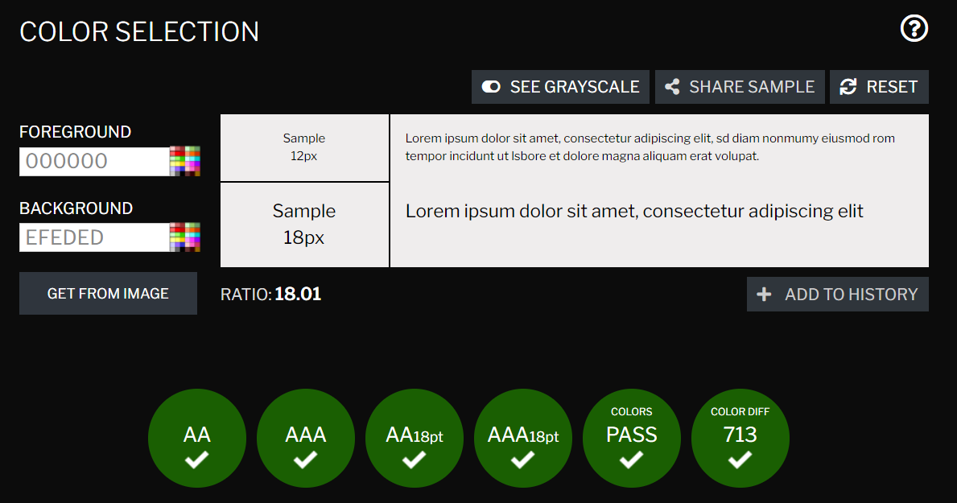
Fig. 25 Contrast Checker [32]
This is the same when using another contrast checking tool [33].

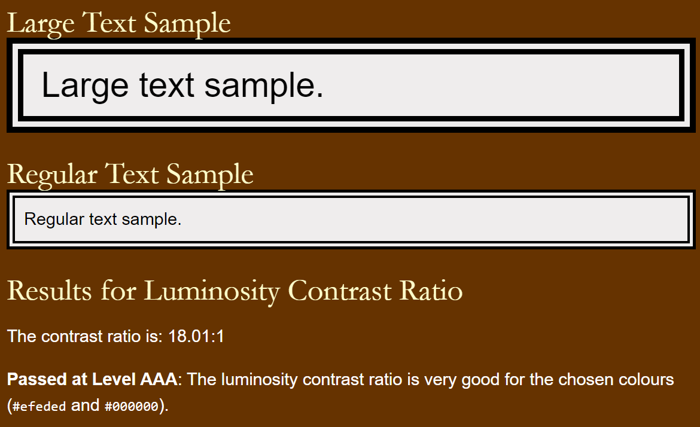
Fig. 26 Luminosity Contrast Ratio [33]

- All text and images on the website have been aligned logically (the text has been padded on all webpages to be more central, with images aligned centrally on the home and about us webpages, to the left for all product webpages and in the sidebar) for ease of reading for all users. This helped to ensure that the design was logical and coherent, without being cluttered with images and/or text to make web pages unreadable.
- For the ‘Contact Us’ webpage, there are instructions for users on how to contact Arkwright by phone, e-mail, post or via an online form that users could submit, while the ‘Login/Register’ webpage instructs users on how to either register new users or sign up with a new account. The instructions inform users of what they need to do when user input is required on the website.
- All webpages have been created so that distinct types of text and images are not too close to each other while allowing for necessary whitespace between them. This will ensure that the web pages are spaced out, while correct areas of text (such as addresses) can be closer together as needed. This improves the experience users would have to interact with the content and viewing the website.

Overall, with what has been described above, the website has been configured as much as possible to ensure that all users can access, view, and navigate the website with ease, creating a website that is accessible to all users, including those with disabilities. This is evident when evaluating the ‘Products’ webpage on the (MAUVE++) website [34].

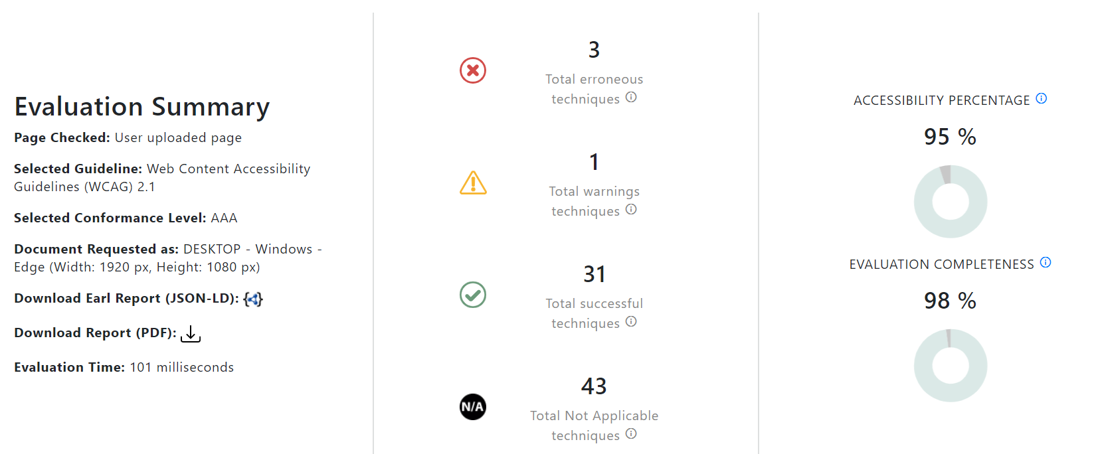
Fig. 27 MAUVE++ ‘Products’ Webpage Accessibility Evaluation [34]

Search Engine Optimisation (SEO)

The following on-page search engine optimisations have been applied as part of the website creation.

- All HTML documents have a <title> element within the <head> aspect of the file, with each one showing the keyword of ‘Arkwright’. This would help with targeting the keyword and linking it with the products (for example, ‘Arkwright’s Yarn Pumpkins’ and ‘Arkwright’s Dustbins’). An example of a <title> element from the ‘Arkwright’s Yarn Pumpkins’ webpage is as follows.

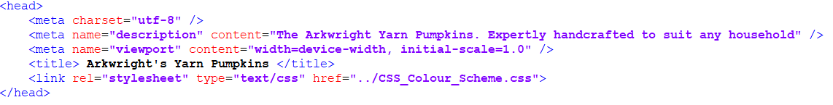
Fig. 28 Title Element

- All HTML documents have heading sections to highlight different headers. The website name is displayed at the top of each webpage and the section header is shown as <h1> elements as part of keywords, while any subheadings within the HTML document are shown as <h2> elements and are not keywords. An example of a <h1> and <h2> element from the ‘About Us’ webpage is as follows.

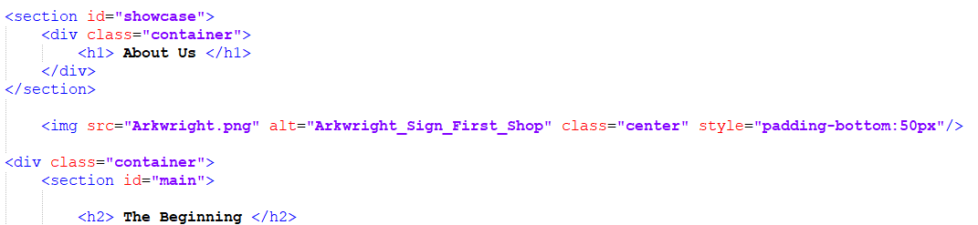
Fig. 29 Different Headers

- All HTML documents have the navigation bar at the top and each link can be clicked to take users to the requested webpage. This allows users to navigate the website and to each webpage with ease to create a natural linking flow. An example of the navigation bar and HTML code from the ‘Contact Us’ webpage is as follows.

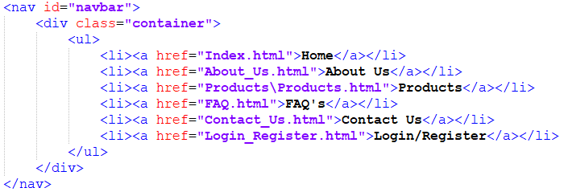

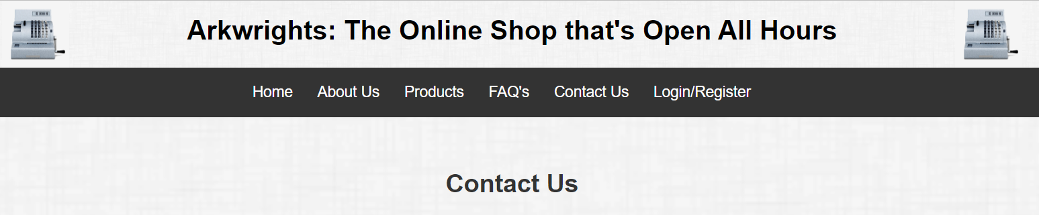
Fig. 30 Navigation Bar

- All HTML documents have an ‘alt’ tag for every image on the website. This ensures that search engines can identify these images, while those with visual impairments will be able to understand the image, making the website more accessible. An example of the alt tag from the ‘Products’ webpage is as follows.

Fig. 31 Alt Tag

- The ‘Products’ and ‘FAQ’ HTML documents have links that direct users to other pages. For the ‘Products’ webpage, the product name is a link that takes you to each product, while the ‘FAQ’ webpage has four links to the ‘Contact Us’ webpage. An example from the ‘Product’ webpage is as follows.

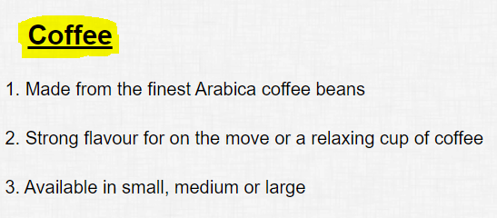
Fig. 32 Website Link

- All HTML documents contain two cash register logos in the main header (please see point three for an example) and two general images in the sidebar, while further images are on the homepage, ‘About Us’, ‘Products’ and individual product pages. While the resolution has been lowered for the images, they have been sharpened to ensure that the images are of high quality to attract users to the website. An example of images from the ‘Products’ webpage is as follows.

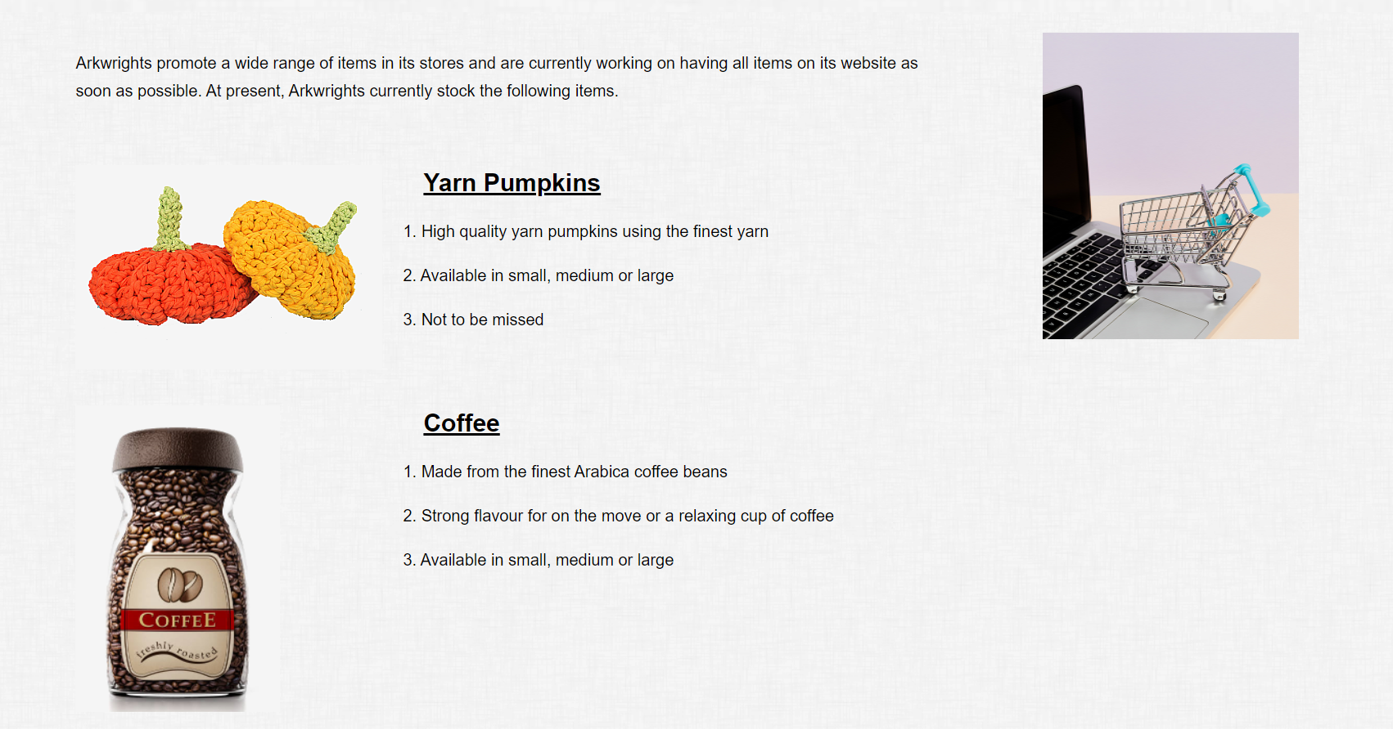
Fig. 33 Images and Consistency

- All images used on the website have been adjusted to lower the resolution while sharpening the images where necessary to improve the quality. This is to ensure that the file size is lowered to an acceptable amount, which in turn improves the overall speed and responsiveness of the website. The total file size for all images is around 2.5MB, allowing for webpages to be very quick to load.

- All HTML documents have been designed to ensure that content is current, relevant, and appealing to users by ensuring that the content has appropriate headers for webpages while being organised and easy to follow. An example from the ‘About Us’ webpage is as follows.

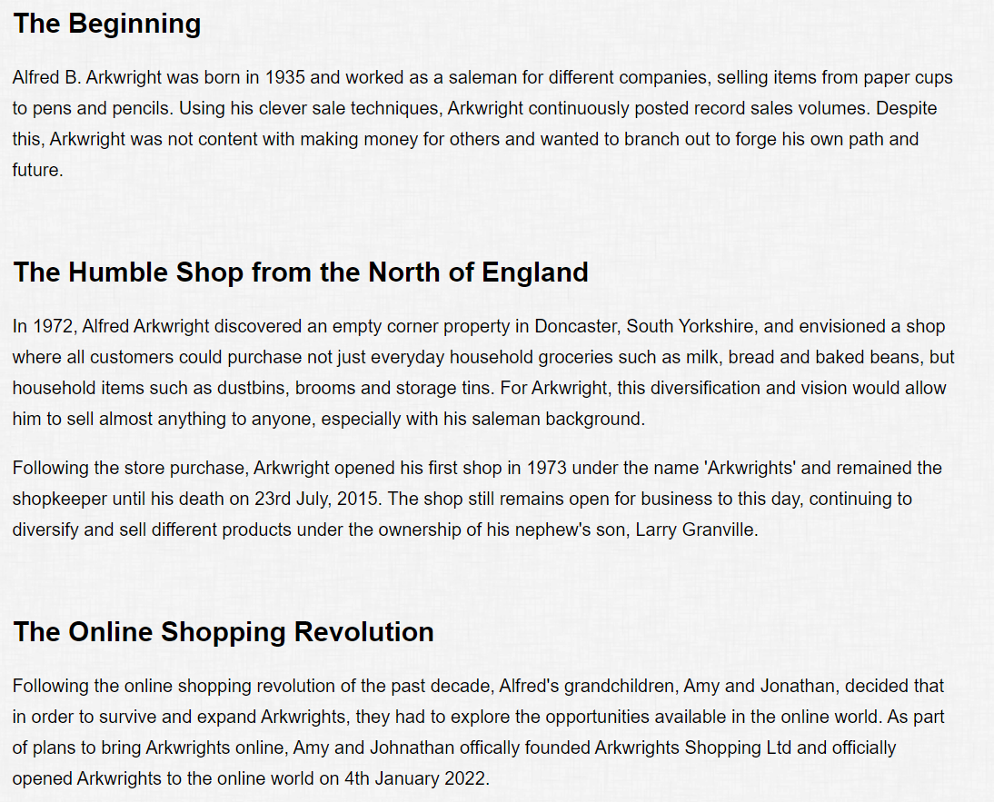
Fig. 34 Partial Content from About Us Webpage

- All HTML documents have a short <meta> description of each webpage within the <header> area. This is because a meta description tag can inform search engines what each webpage is about and can provide users with a better understanding of what they are viewing on the Search Engine Results Page (SERP) [35]. An example from the ‘FAQ’ webpage is as follows.
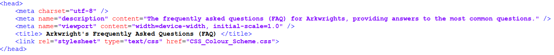
Fig. 34 Meta Description Tag

References

[1] | S. C. Baker, “Making It Work for Everyone: HTML5 and CSS Level 3 for Responsive, Accessible Design on Your Library’s Web Site,” Journal of library & information services in distance learning, vol. 8, no. 3-4, pp. 118-136, October 2014. [Online] Available: 10.1080/1533290X.2014.945825. [Accessed April 5, 2022].
[2] | J. Duckett, HTML & CSS : design and build websites, 1st ed., Indianapolis, Indiana: Wiley, 2011. [E-book]
[3] | J. Kyrnin, “What Is CSS3?,” ThoughCo. Mar. 9, 2020. [Online]. Available: https://www.thoughtco.com/what-is-css3-3466973. [Accessed Apr. 6, 2022].
[4] | WriteMaps, “Make your Website Diagram,” WriteMaps [Online]. Available: https://writemaps.com/website-diagram/#:~:text=A%20website%20structure%20diagram%20helps,architecture%2C%20and%20try%20new%20layouts. [Accessed Apr. 7, 2022].
[5] | Gliffy, “Examples of Wireframes and How to Create a Wireframe,” Perforce Software, Oct. 26, 2020. [Online]. Available: https://www.gliffy.com/blog/how-to-create-a-wireframe. [Accessed Apr. 13, 2022].
[6] | R. Allabarton, “The Definitive Guide: How To Make Your First Wireframe,” Career Foundry, Aug. 6, 2021. [Online]. Available: https://careerfoundry.com/en/blog/ux-design/how-to-create-your-first-wireframe/#what-is-a-wireframe. [Accessed Apr. 13, 2022].
[7] | M. Sweney, “More than half of people aged 65 and over now shop online – ONS,” The Guardian, Aug. 12, 2019. [Online]. Available: https://www.theguardian.com/money/2019/aug/12/more-than-half-of-people-aged-65-and-over-now-shop-online-ons. [Accessed Apr. 7, 2022].
[8] | Unsplash, “Unsplash Homepage,” Unsplash [Online]. Available: https://unsplash.com/. [Accessed Apr. 11, 2022].
[9] | Free Images, “Free Antique Cash Register Stock Photo,” Free Images [Online]. Available: https://www.freeimages.com/photo/antique-cash-register-1552352. [Accessed Apr. 11, 2022].
[10] | K. Grabowska, “Photo - Shopping Cart on a Macbook,” Pexels, Oct. 12, 2020. [Online]. Available: https://www.pexels.com/photo/shopping-cart-on-a-macbook-5632382/. [Accessed Apr. 11, 2022].
[11] | K. Grabowska, “Photo - Shopping Cart with Money on Top of a Laptop,” Pexels, Oct. 12, 2020. [Online]. Available: https://www.pexels.com/photo/shopping-cart-with-money-on-top-of-a-laptop-5632379/. [Accessed Apr. 11, 2022].
[12] | D. Johnson, “Arkwright's Shop, Still Open All Hours 2016,” Flickr, Sept. 23, 2016. [Online]. Available: https://www.flickr.com/photos/doctor_dave/29896431985. [Accessed Apr. 12, 2022].
[13] | T. Park, B. Dorn and A. Forte, “An Analysis of HTML and CSS Syntax Errors in a Web Development Course,” ACM transactions on computing education, vol. 15, no. 1, pp. 1-21, March 2015. [Online]/ Available: https://doi-org.ezproxy.uwtsd.ac.uk/10.1145/2700514. [Accessed April 14, 2022].
[14] | G. Jones, Umbrella Corporation HTML and CSS Code, University of Wales, Trinity St. Davids, 2022.
[15] | D. Belanche, L. V. Casalo and M. Guinaliu, “Website usability, consumer satisfaction and the intention to use a website: The moderating effect of perceived risk,” Journal of retailing and consumer services, vol. 19, no. 1, pp. 124-132, January 2012. [Online] Available: 10.1016/j.jretconser.2011.11.001. [Accessed April 15, 2022].
[16] | S. Krug, Don’t make me think, revisited : a common sense approach to web usability, 3rd ed., Berkeley, California: New Riders, 2014. [E-book].
[17] | J. C. Romano Bergstrom, E. L. Olmsted-Hawala and M. E. Jans, “Age-Related Differences in Eye Tracking and Usability Performance: Website Usability for Older Adults,” International journal of human-computer interaction, vol. 29, no. 8, pp. 541-548, August 2013. [Online] Available: 10.1080/10447318.2012.728493 [Accessed April 15, 2022].
[18] | Room 34 Creative Services, “Roles + Responsibilities,” Room 34 Creative Services [Online]. Available: https://room34.com/philosophy/roles/. [Accessed Apr. 15, 2022].
[19] | Codecademy, “What does a web developer do?,” Codecademy, May 24, 2021. [Online]. Available: https://www.codecademy.com/resources/blog/what-does-a-web-developer-do/. [Accessed Apr. 15, 2022].
[20] | N. Deshdeep, “How to Use C.R.A.P. Design links with Principles for Better UX?,” VWO, Feb. 2, 2022. [Online]. Available: https://vwo.com/blog/crap-design-principles/. [Accessed Mar. 21, 2022].
[21] | V. L. Hanson and J. T. Richards, “Progress on Website Accessibility?,” ACM transactions on the web, vol. 7, no. 1, pp. 1-30, March 2013. [Online] Available: 10.1145/2435215.2435217 [Accessed April 15, 2022].
[22] | V. Conway, J. Brown, S. Hollier and C. Nicholl, “Website Accessibility: a Comparative Analysis of Australian National and State/Territory Library Websites,” The Australian library journal, vol. 61, no. 3, pp. 170-188, August 2012. [Online] Available: 10.1080/00049670.2012.10736059 [Accessed April 15, 2022].
[23] | Accessible Metrics, “What are the Levels of WCAG Compliance?," Accessible Metrics, Nov. 5, 2019. [Online]. Available: https://www.accessiblemetrics.com/blog/what-are-the-levels-of-wcag-compliance/. [Accessed Apr. 16, 2022].
[24] | W3C, “Accessibility Principles,” W3C, May 10, 2019. [Online]. Available: https://www.w3.org/WAI/fundamentals/accessibility-principles/. [Accessed Mar. 21, 2022].
[25] | Z. Hui, Q. Shigang, L. Jinhua and C. Jianli, “Study on Website Search Engine Optimization,” in 2012 International Conference on Computer Science and Service System, Nanjing, 2012. [Online] Available: 10.1109/CSSS.2012.236 [Accessed Apr. 15, 2022].
[26] | Team Linchpin, “How To Design An SEO Friendly Website That Ranks Well In Google,” Linchpin SEO, Jan. 13, 2022. [Online]. Available: https://linchpinseo.com/how-to-design-an-seo-friendly-website/#:~:text=SEO%20web%20design%20is%20a,index%20it%20in%20their%20database. [Accessed Apr. 8, 2022].
[27] | J. G. Xu, X. J. Yin and X. F. Zhao, “For Search Engine Optimization Strategy Analysis of Website Design,” Applied Mechanics and Materials, Vols. 519-520, pp. 383-386, February 2014. [Online] Available: 10.4028/www.scientific.net/AMM.519-520.383 [Accessed April 15, 2022].
[28] | S. Feng, C. Wen and L. Kong, “Application of Search Engine Optimization in the College’s Official Website from the Perspective of Website Diagnosis,” Journal of physics. Conference series, vol. 1992, no. 4, p. 42059, August 2021. [Online] Available: 10.1088/1742-6596/1992/4/042059 [Accessed April 15, 2022].
[29] | W3 Schools, “CSS Web Safe Fonts,” W3 Schools [Online]. Available: https://www.w3schools.com/cssref/css_websafe_fonts.asp. [Accessed Apr. 18, 2022].
[30] | Microsoft, Microsoft Visio, 2021.
[31] | W3C, “Web Content Accessibility Guidelines (WCAG) 2.1,” W3C, Jun. 5, 2018. [Online]. Available: https://www.w3.org/TR/WCAG21/#requirements-for-wcag-2-1. [Accessed March 21, 2022].
[32] | Contrast Checker, “Contrast Checker,” Contrast Checker, 2017. [Online]. Available: https://contrastchecker.com/. [Accessed Apr. 21, 2022].
[33] | Juicy Studio, “Luminosity Colour Contrast Ratio Analyser,” Juicy Studio, 2000-2022. [Online]. Available: https://juicystudio.com/services/luminositycontrastratio.php. [Accessed Apr. 21, 2022].
[34] | Multiguideline Accessibility and Usability Validation Environment, “MAUVE++,” HIIS Lab, 2012 - 2022. [Online]. Available: https://mauve.isti.cnr.it/. [Accessed Apr. 21, 2022].
[35] | Google Search Central, “Beginner SEO,” Google, Apr. 14, 2022. [Online]. Available: https://developers.google.com/search/docs/beginner/seo-starter-guide#descriptionmeta. [Accessed Apr. 19, 2022].

Appendices

CSS

body{
background-image:url("https://www.toptal.com/designers/subtlepatterns/uploads/dust_scratches.png");
color:black;
font-family: Helvetica, Sans-serif;
font-size:16px;
line-height:1.7em;
margin:0;
}

.container{
width:80%;
margin:auto;
overflow:hidden;
}

#main-header{
background-image:url("https://www.toptal.com/designers/subtlepatterns/uploads/dust_scratches.png");
text-align:center;
color:#000000;
}

#navbar{
text-align:center;
background-color:#333;
color:#fff;
}

#navbar ul{
padding:0;
list-style:none;
}

#navbar li{
display:inline;
}

#navbar a{
font-size:18px;
padding-right:25px;
}

a{
color:white;
text-decoration:none;
}

a:hover{
color:green;
}

#main-footer{
background-color:#333;
color:#fff;
text-align:center;
padding:20px;
margin-top:40px;
}

#main{
float:left;
width:70%;
padding:10px;
box-sizing:border-box;
}

.center {
display: block;
margin-left: auto;
margin-right: auto;
width: 90%;
}

#main a{
color:black;
}

#main a:link{
color:blue;
text-decoration:underline;
}

#sidebar{
float:right;
width:20%;
/* color:#fff; */
padding:10px;
box-sizing:border-box;
}

#showcase{
background-image:url("https://www.toptal.com/designers/subtlepatterns/uploads/dust_scratches.png");
background-size:1280px;
opacity:1.0;
background-position:center right;
min-height:60px;
margin-bottom:10px;
text-align:center;
}

#showcase h1{
color:#333;
font-size:30px;
line-height:1.6;
padding:30px;
}

@media (max-width:600px) {
#main {
width:100%;
float:none;
}

#sidebar{
width:100%;
float:none;
}

#navbar li{
display:block;
}
}

HTML – Index

<!DOCTYPE html>
<html>
<head>
<meta charset="utf-8" />
<meta name="description" content="Arkwrights provide affordable high quality products for the modern household." />
<meta name="viewport" content="width=device-width, initial-scale=1.0" />
<title> Arkwrights: The Online Shop that's Open All Hours </title>
<link rel="stylesheet" type="text/css" href="CSS_Colour_Scheme.css">
</head>

<body>
<header id="main-header">
<div class="container">
<img src="Cash_Register_Logo.png" alt="Logo" align="left" style="width:80px;height:80px;" />
<img src="Cash_Register_Logo.png" alt="Logo" align="right" style="width:80px;height:80px;" />
<h1> Arkwrights: The Online Shop that's Open All Hours </h1>
</div>
</header>

<nav id="navbar">
<div class="container">
<ul>
<li><a href="Index.html">Home</a></li>
<li><a href="About_Us.html">About Us</a></li>
<li><a href="Products\Products.html">Products</a></li>
<li><a href="FAQ.html">FAQ's</a></li>
<li><a href="Contact_Us.html">Contact Us</a></li>
<li><a href="Login_Register.html">Login/Register</a></li>
</ul>
</div>
</nav>

<section id="showcase">
<div class="container">
<h1> Welcome to Arkwrights </h1>
</div>
</section>

<div class="container">
<section id="main">
<h2> From Humble Beginnings to a Technological Future </h2>

<p>We are the fastest growing online shop in the UK, selling quality household groceries and items at affordable prices since 1973, with the aim of continuously
providing high quality customer service at all times.
</p>

<p>We are proud of our passion, commitment and integrity at Arkwrights.</p>

<img src="Cash_Register_Index.png" alt="Old_Cash_Register" class="center" style="width:300px;height:400px;" />

<p>We will always endeavour to ensure our customers are our number one priority and will continuously strive to accomplish this.
</p>

</section>

<aside id="sidebar">
<img src="Online_Shopping_Top_Image.png" alt="Trolley_on_Laptop_Bottom_Right" align="right" style="width:250px;height:300px;" />
<img src="Online_Shopping_Bottom_Image.png" alt="Trolley_with_Money_Next_to_Laptop" align="right" style="width:250px;height:300px;padding-top:30px" />
</aside>

</div>

<footer id="main-footer">
<p> Copyright &copy; 2022 Arkwrights Shopping Ltd </p>
</footer>

</html>

HTML – About Us

<!DOCTYPE html>
<html>
<head>
<meta charset="utf-8" />
<meta name="description" content="A short history of Arkwrights, from one local shop to the digital era." />
<meta name="viewport" content="width=device-width, initial-scale=1.0" />
<title> About Arkwrights </title>
<link rel="stylesheet" type="text/css" href="CSS_Colour_Scheme.css">
</head>

<body>
<header id="main-header">
<div class="container">
<img src="Cash_Register_Logo.png" alt="Logo" align="left" style="width:80px;height:80px;" />
<img src="Cash_Register_Logo.png" alt="Logo" align="right" style="width:80px;height:80px;" />
<h1> Arkwrights: The Online Shop that's Open All Hours </h1>
</div>
</header>

<nav id="navbar">
<div class="container">
<ul>
<li><a href="Index.html">Home</a></li>
<li><a href="About_Us.html">About Us</a></li>
<li><a href="Products\Products.html">Products</a></li>
<li><a href="FAQ.html">FAQ's</a></li>
<li><a href="Contact_Us.html">Contact Us</a></li>
<li><a href="Login_Register.html">Login/Register</a></li>
</ul>
</div>
</nav>

<section id="showcase">
<div class="container">
<h1> About Us </h1>
</div>
</section>

<img src="Arkwright.png" alt="Arkwright_Sign_First_Shop" class="center" style="padding-bottom:50px"/>

<div class="container">
<section id="main">

<h2> The Beginning </h2>

<p>Alfred B. Arkwright was born in 1935 and worked as a salesman for different companies, selling items from paper cups to pens and pencils. Using his clever
sale techniques, Arkwright continuously posted record sales volumes. Despite this, Arkwright was not content with making money for others and wanted to branch out
to forge his own path and future.</p>

</br>

<h2> The Humble Shop from the North of England </h2>

<p>In 1972, Alfred Arkwright discovered an empty corner property in Doncaster, South Yorkshire, and envisioned a shop where all customers could purchase not just everyday
household groceries such as milk, bread and baked beans, but household items such as dustbins, brooms and storage tins. For Arkwright, this diversification and
vision would allow him to sell almost anything to anyone, especially with his salesman background.
</p>

<p>Following the store purchase, Arkwright opened his first shop in 1973 under the name 'Arkwright' and remained the shopkeeper until his death on 23rd July, 2015. The
shop still remains open for business to this day, continuing to diversify and sell different products under the ownership of his nephew's son, Larry Granville.
</p>

</br>

<h2> The Online Shopping Revolution </h2>

<p>Following the online shopping revolution of the past decade, Alfred's grandchildren, Amy and Jonathan, decided that in order to survive and expand Arkwright,
they had to explore the opportunities available in the online world. As part of plans to bring Arkwright online, Amy and Johnathan officially founded
Arkwrights Shopping Ltd and officially opened Arkwright to the online world on 4th January 2022.
</p>

</section>

<aside id="sidebar">
<img src="Online_Shopping_Top_Image.png" alt="Trolley_on_Laptop_Bottom_Right" align="right" style="width:250px;height:300px;" />
<img src="Online_Shopping_Bottom_Image.png" alt="Trolley_with_Money_Next_to_Laptop" align="right" style="width:250px;height:300px;padding-top:30px" />
</aside>

</div>

<footer id="main-footer">
<p> Copyright &copy; 2022 Arkwrights Shopping Ltd </p>
</footer>

</html>

HTML – Products

<!DOCTYPE html>
<html>
<head>
<meta charset="utf-8" />
<meta name="description" content="The Arkwright's products, all high quality and all at low prices." />
<meta name="viewport" content="width=device-width, initial-scale=1.0" />
<title> Products of Arkwrights </title>
<link rel="stylesheet" type="text/css" href="../CSS_Colour_Scheme.css">
</head>

<body>
<header id="main-header">
<div class="container">
<img src="../Cash_Register_Logo.png" alt="Logo" align="left" style="width:80px;height:80px;" />
<img src="../Cash_Register_Logo.png" alt="Logo" align="right" style="width:80px;height:80px;" />
<h1> Arkwrights: The Online Shop that's Open All Hours </h1>
</div>
</header>

<nav id="navbar">
<div class="container">
<ul>
<li><a href="../Index.html">Home</a></li>
<li><a href="../About_Us.html">About Us</a></li>
<li><a href="Products.html">Products</a></li>
<li><a href="../FAQ.html">FAQ's</a></li>
<li><a href="../Contact_Us.html">Contact Us</a></li>
<li><a href="../Login_Register.html">Login/Register</a></li>
</ul>
</div>
</nav>

<section id="showcase">
<div class="container">
<h1> Products of Arkwrights </h1>
</div>
</section>

<div class="container">
<section id="main">

<p> Arkwrights promote a wide range of items in its stores and are currently working on having all items on its website as soon as possible.
At present, Arkwrights currently stock the following items.
</p>

</br>

<p><a href="Product_One_Yarn_Pumpkins.html"><img src="Yarn_Pumpkin.png" alt="Yarn_Pumpkin" style="float:left;width:300px;height:200px;"/></a></p>

<p><h1><a href="Product_One_Yarn_Pumpkins.html" style="padding:40px">Yarn Pumpkins</a></h1></p>
<p style="text-indent:20px">1. High quality yarn pumpkins using the finest yarn</p>
<p style="text-indent:20px">2. Available in small, medium or large</p>
<p style="text-indent:20px">3. Not to be missed</li>

</br></br></br>

<p><a href="Product_Two_Coffee.html"><img src="Coffee.png" alt="Coffee" style="float:left;width:200px;height:300px;"/></a></p>

<p><h1><a href="Product_Two_Coffee.html" style="padding:140px">Coffee</a></h1></p>
<p style="text-indent:120px">1. Made from the finest Arabica coffee beans</p>
<p style="text-indent:120px">2. Strong flavour for on the move or a relaxing cup of coffee</p>
<p style="text-indent:120px">3. Available in small, medium or large</p>

</br></br></br></br></br></br></br>

<p><a href="Product_Three_Dustbin.html"><img src="Dustbin.png" alt="Dustbin" style="float:left;width:300px;height:300px;"/></a></p>

<p><h1><a href="Product_Three_Dustbin.html" style="padding:40px">Dustbins</a></h1></p>
<p style="text-indent:20px">1. Made from durable stainless steel</p>
<p style="text-indent:20px">2. Foot pedal allows for easy opening</p>
<p style="text-indent:20px">3. Available in small, medium or large</p>

</section>

<aside id="sidebar">
<img src="../Online_Shopping_Top_Image.png" alt="Trolley_on_Laptop_Bottom_Right" align="right" style="width:250px;height:300px;" />
<img src="../Online_Shopping_Bottom_Image.png" alt="Trolley_with_Money_Next_to_Laptop" align="right" style="width:250px;height:300px;padding-top:400px" />
</aside>

</div>

<footer id="main-footer">
<p> Copyright &copy; 2022 Arkwrights Shopping Ltd </p>
</footer>

</html>

HTML – Product One (Yarn Pumpkins)

<!DOCTYPE html>
<html>
<head>
<meta charset="utf-8" />
<meta name="description" content="The Arkwright Yarn Pumpkins. Expertly handcrafted to suit any household." />
<meta name="viewport" content="width=device-width, initial-scale=1.0" />
<title> Arkwright's Yarn Pumpkins </title>
<link rel="stylesheet" type="text/css" href="../CSS_Colour_Scheme.css">
</head>

<body>
<header id="main-header">
<div class="container">
<img src="../Cash_Register_Logo.png" alt="Logo" align="left" style="width:80px;height:80px;" />
<img src="../Cash_Register_Logo.png" alt="Logo" align="right" style="width:80px;height:80px;" />
<h1> Arkwrights: The Online Shop that's Open All Hours </h1>
</div>
</header>

<nav id="navbar">
<div class="container">
<ul>
<li><a href="../Index.html">Home</a></li>
<li><a href="../About_Us.html">About Us</a></li>
<li><a href="Products.html">Products</a></li>
<li><a href="../FAQ.html">FAQ's</a></li>
<li><a href="../Contact_Us.html">Contact Us</a></li>
<li><a href="../Login_Register.html">Login/Register</a></li>
</ul>
</div>
</nav>

<section id="showcase">
<div class="container">
<h1> Arkwrights Finest Yarn Pumpkins </h1>
</div>
</section>

<div class="container">
<section id="main">

<p>These exquisite yarn pumpkins are created by our partner company, Craig Faris & Co., and are handcrafted to expert detail by the finest craftspeople. This is the
perfect ornament piece and comes in different sizes to suit any area of the household.
</p>

<p>You would be mad to miss out on this expert piece of craftsmanship.</p>

<p><a href="Product_One_Yarn_Pumpkins.html"><img src="Yarn_Pumpkin.png" alt="Yarn_Pumpkin" style="float:left;width:300px;height:200px;"/></a></p>

<p style="text-indent:20px">1. Will come in orange, yellow and gold</p>
<p style="text-indent:20px">2. Very soft on your hands</p>
<p style="text-indent:20px">3. A superb gift for yourself or a loved one</li>

<form action="/checkout_page.php">
<label for="size">Size:</label>
<select id="size" name="size">
<option value="Small" selected>Small (4 inches) - £5.99</option>
<option value="Medium">Medium (7 inches) - £7.99</option>
<option value="Large">Large (10 inches) - £9.99</option>
</select>
<input type="submit">
</form>

</section>

<aside id="sidebar">
<img src="../Online_Shopping_Top_Image.png" alt="Trolley_on_Laptop_Bottom_Right" align="right" style="width:250px;height:300px;" />
</aside>

</div>

<footer id="main-footer">
<p> Copyright &copy; 2022 Arkwrights Shopping Ltd </p>
</footer>

</html>

HTML – Product Two (Coffee)

<!DOCTYPE html>
<html>
<head>
<meta charset="utf-8" />
<meta name="description" content="The Arkwright Coffee. A strong flavoured hit to suit any time of the day." />
<meta name="viewport" content="width=device-width, initial-scale=1.0" />
<title> Arkwright's Coffee </title>
<link rel="stylesheet" type="text/css" href="../CSS_Colour_Scheme.css">
</head>

<body>
<header id="main-header">
<div class="container">
<img src="../Cash_Register_Logo.png" alt="Logo" align="left" style="width:80px;height:80px;" />
<img src="../Cash_Register_Logo.png" alt="Logo" align="right" style="width:80px;height:80px;" />
<h1> Arkwrights: The Online Shop that's Open All Hours </h1>
</div>
</header>

<nav id="navbar">
<div class="container">
<ul>
<li><a href="../Index.html">Home</a></li>
<li><a href="../About_Us.html">About Us</a></li>
<li><a href="Products.html">Products</a></li>
<li><a href="../FAQ.html">FAQ's</a></li>
<li><a href="../Contact_Us.html">Contact Us</a></li>
<li><a href="../Login_Register.html">Login/Register</a></li>
</ul>
</div>
</nav>

<section id="showcase">
<div class="container">
<h1> Arkwrights Finest Coffee </h1>
</div>
</section>

<div class="container">
<section id="main">

<p> Whether you are constantly on the move or you want a strong, relaxing drink, Arkwrights provide the finest quality coffee for any sort of lifestyle. Made with the highest
quality Arabica beans, your perfect cup of coffee is waiting for you.
</p>

<p><a href="Product_Two_Coffee.html"><img src="Coffee.png" alt="Coffee" style="float:left;width:200px;height:300px;"/></a></p>

<p style="text-indent:20px">1. Produced using fairtrade standards for a sustainable future</p>
<p style="text-indent:20px">2. Intensity flavour is 10</p>
<p style="text-indent:20px">3. Premium roasted, instant coffee</p>

<form action="/checkout_page.php">
<label for="size">Size:</label>
<select id="size" name="size">
<option value="Small" selected>Small (100 grams) - £2.99</option>
<option value="Medium">Medium (200 grams) - £4.99</option>
<option value="Large">Large (300 grams) - £6.99</option>
</select>
<input type="submit">
</form>

</section>

<aside id="sidebar">
<img src="../Online_Shopping_Top_Image.png" alt="Trolley_on_Laptop_Bottom_Right" align="right" style="width:250px;height:300px;" />
</aside>

</div>

<footer id="main-footer">
<p> Copyright &copy; 2022 Arkwrights Shopping Ltd </p>
</footer>

</html>

HTML – Product Three (Dustbin)

<!DOCTYPE html>
<html>
<head>
<meta charset="utf-8" />
<meta name="description" content="The Arkwright Dustbins. Stainless steel quality and very durable for all household waste." />
<meta name="viewport" content="width=device-width, initial-scale=1.0" />
<title> Arkwright's Dustbins </title>
<link rel="stylesheet" type="text/css" href="../CSS_Colour_Scheme.css">
</head>

<body>
<header id="main-header">
<div class="container">
<img src="../Cash_Register_Logo.png" alt="Logo" align="left" style="width:80px;height:80px;" />
<img src="../Cash_Register_Logo.png" alt="Logo" align="right" style="width:80px;height:80px;" />
<h1> Arkwrights: The Online Shop that's Open All Hours </h1>
</div>
</header>

<nav id="navbar">
<div class="container">
<ul>
<li><a href="../Index.html">Home</a></li>
<li><a href="../About_Us.html">About Us</a></li>
<li><a href="Products.html">Products</a></li>
<li><a href="../FAQ.html">FAQ's</a></li>
<li><a href="../Contact_Us.html">Contact Us</a></li>
<li><a href="../Login_Register.html">Login/Register</a></li>
</ul>
</div>
</nav>

<section id="showcase">
<div class="container">
<h1> Arkwrights Finest Dustbins </h1>
</div>
</section>

<div class="container">
<section id="main">

<p>Arkwrights high quality and stainless steel dustbins will ensure that they fit anywhere in your home, while
the lid can be opened using the pedal, allowing for easier waste disposal. The closed lid will ensure that odour will
be heavily minimised, while a handle at the back allows for easier carrying when necessary.
</p>

<p>These dustbins are very durable and can withstand a considerable amount of force, whether a heavy object lands from next to it or from the top of a stairway.</p>

<p><a href="Product_Three_Dustbin.html"><img src="Dustbin.png" alt="Dustbin" style="float:left;width:400px;height:300px;"/></a></p>

<p style="text-indent:20px">1. Hygenic and easy to clean</p>
<p style="text-indent:20px">2. Stylishly designed to match the home</p>
<p style="text-indent:20px">3. Removeable inner bucket</p>

<form action="/checkout_page.php">
<label for="size">Size:</label>
<select id="size" name="size">
<option value="Small" selected>Small (3 Litre) - £9.99</option>
<option value="Medium">Medium (5 Litre) - £14.99</option>
<option value="Large">Large (7 Litre) - £19.99</option>
</select>
<input type="submit">
</form>

</section>

<aside id="sidebar">
<img src="../Online_Shopping_Top_Image.png" alt="Trolley_on_Laptop_Bottom_Right" align="right" style="width:250px;height:300px;" />
</aside>

</div>

<footer id="main-footer">
<p> Copyright &copy; 2022 Arkwrights Shopping Ltd </p>
</footer>

</html>

HTML – Frequently Asked Questions (FAQ)

<!DOCTYPE html>
<html>
<head>
<meta charset="utf-8" />
<meta name="description" content="The frequently asked questions (FAQ) for Arkwrights, providing answers to the most common questions." />
<meta name="viewport" content="width=device-width, initial-scale=1.0" />
<title> Arkwright's Frequently Asked Questions (FAQ) </title>
<link rel="stylesheet" type="text/css" href="CSS_Colour_Scheme.css">
</head>

<body>
<header id="main-header">
<div class="container">
<img src="Cash_Register_Logo.png" alt="Logo" align="left" style="width:80px;height:80px;" />
<img src="Cash_Register_Logo.png" alt="Logo" align="right" style="width:80px;height:80px;" />
<h1> Arkwrights: The Online Shop that's Open All Hours </h1>
</div>
</header>

<nav id="navbar">
<div class="container">
<ul>
<li><a href="Index.html">Home</a></li>
<li><a href="About_Us.html">About Us</a></li>
<li><a href="Products\Products.html">Products</a></li>
<li><a href="FAQ.html">FAQ's</a></li>
<li><a href="Contact_Us.html">Contact Us</a></li>
<li><a href="Login_Register.html">Login/Register</a></li>
</ul>
</div>
</nav>

<section id="showcase">
<div class="container">
<h1> Frequently Asked Questions (FAQ's) </h1>
</div>
</section>

<div class="container">
<section id="main">
<h2> Our Most Frequently Asked Questions </h2>

</br>

<p><b>1. I have ordered a product with Arkwrights but have not received an e-mail confirmation. Has my order been taken?</b></p>

<p>Please check your junk mail folder in case your order confirmation has been sent there.

E-mails for orders should be with you within 1 hour of placing your order. If you have not received your confirmation e-mail, please
<a href="Contact_Us.html">contact us</a>.</p>

</br>

<p><b>2. How do I cancel my order?</b></p>

<p>Please <a href="Contact_Us.html">contact us</a> and we will cancel your order for you. We are currently building a live chat function and this will be incorporated
in the future.</p>

</br>

<p><b>3. How can I check the item is in stock?</b></p>

<p>We strive to ensure that we always have stock for all items sold by Arkwrights whenever you need them. You will be able to see if the item is in stock when you
order your item.</p>
<p>If your item is out of stock, we will inform you with an estimated date of when the item will be back in stock.</p>

</br>

<p><b>4. How long will it take for my order to be dispatched? </b></p>

<p>Orders will be dispatched within 24 hours of the order being received. We will notify you with an explanation if the order takes longer to dispatch.</p>

</br>

<p><b>5. How long will it take for my order to be delivered? </b></p>

<p>We aim to deliver all orders within 3 to 5 days of dispatch.</p>

</br>

<p><b>6. Where do you deliver?</b></p>

<p>We deliver to all of mainland UK, Scottish Islands, Isle of Man, Isle of Wight and Isles of Scilly. We are currently not delivering to Northern Ireland or
internationally, but are looking to expand our delivery services in the future.</p>

</br>

<p><b>7. Why was my credit/debit card refused?</b></p>

<p>If your card has been refused, please try to pay again using a different card. It is recommended to contact your bank to see why your card was refused in
the first place.</p>

</br>

<p><b>8. How long does a refund take?</b></p>

<p>All refunds will take approximately 7 days to process from when we receive the item. While we will be unable to track the refund once the process has started, we
will provide confirmation when the refund has been processed.</p>

</br>

<p><b>9. How do I return an item?</b></p>

<p>If you wish to return an item, you have 30 days from the purchase date to return the item. All returned items must be unused and in mint condition. You will be
refunded when the item has been returned to us.</p>

<p>If there are any issues with returning an item, please <a href="Contact_Us.html">contact us</a>.</p>

</br>

<p><b>10. How do I return a faulty item?</b></p>

<p>We are sorry that your item is faulty. Please return the item to us via our <a href="Contact_Us.html">contact us</a> page and we will replace the item for you.<p>

</section>

<aside id="sidebar">
<img src="Online_Shopping_Top_Image.png" alt="Trolley_on_Laptop_Bottom_Right" align="right" style="width:250px;height:300px;" />
<img src="Online_Shopping_Bottom_Image.png" alt="Trolley_with_Money_Next_to_Laptop" align="right" style="width:250px;height:300px;padding-top:1100px" />
</aside>
</div>

<footer id="main-footer">
<p> Copyright &copy; 2022 Arkwrights Shopping Ltd </p>
</footer>

</html>

HTML – Contact Us

<!DOCTYPE html>
<html>
<head>
<meta charset="utf-8" />
<meta name="description" content="For all the different enquiries to Arkwright, this is how to contact us." />
<meta name="viewport" content="width=device-width, initial-scale=1.0" />
<title> Contact Arkwrights </title>
<link rel="stylesheet" type="text/css" href="CSS_Colour_Scheme.css">
</head>

<body>
<header id="main-header">
<div class="container">
<img src="Cash_Register_Logo.png" alt="Logo" align="left" style="width:80px;height:80px;" />
<img src="Cash_Register_Logo.png" alt="Logo" align="right" style="width:80px;height:80px;" />
<h1> Arkwrights: The Online Shop that's Open All Hours </h1>
</div>
</header>

<nav id="navbar">
<div class="container">
<ul>
<li><a href="Index.html">Home</a></li>
<li><a href="About_Us.html">About Us</a></li>
<li><a href="Products\Products.html">Products</a></li>
<li><a href="FAQ.html">FAQ's</a></li>
<li><a href="Contact_Us.html">Contact Us</a></li>
<li><a href="Login_Register.html">Login/Register</a></li>
</ul>
</div>
</nav>

<section id="showcase">
<div class="container">
<h1> Contact Us </h1>
</div>
</section>

<div class="container">
<section id="main">
<p>For order enquiries, please contact us as follows:</p>

</br>

<p><b>Tel:</b> 01768 382950</p>
<p><b>E-mail:</b> customer.support@arkwrights.com</p>

</br>

<p>For returns, please send to the following address:</p>

</br>

<p><b>Arkwrights Warehouse,</p>
<p>Manphy Industrial Estate,</p>
<p>Balby,</p>
<p>Doncaster,</p>
<p>DO84 3FV</b></p>

</br>

<p>For general enquiries, please use the below form and one of our representatives will contact you within 24 hours.</p>

</br>

<form action="/enquiry_page.php">
<label for="fname">First name:</label><br>
<input type="text" id="fname" name="fname"><br>
<label for="lname">Last name:</label><br>
<input type="text" id="lname" name="lname"><br>
<label for="email">Email Address:</label><br>
<input type="email" id="email" name="email"><br><br>
<textarea name="message" rows="10" cols="50">Please enter your enquiry here.</textarea><br><br>
<input type="submit" value="Submit">
</form>

</section>

<aside id="sidebar">
<img src="Online_Shopping_Top_Image.png" alt="Trolley_on_Laptop_Bottom_Right" align="right" style="width:250px;height:300px;" />
<img src="Online_Shopping_Bottom_Image.png" alt="Trolley_with_Money_Next_to_Laptop" align="right" style="width:250px;height:300px;padding-top:400px" />
</aside>

</div>

<footer id="main-footer">
<p> Copyright &copy; 2022 Arkwrights Shopping Ltd </p>
</footer>

</html>

HTML – Login/Register

<!DOCTYPE html>
<html>
<head>
<meta charset="utf-8" />
<meta name="description" content="This is the Arkwrights login and register webpage for new and existing customers to sign into their account." />
<meta name="viewport" content="width=device-width, initial-scale=1.0" />
<title> Arkwright's Sign In and Registration </title>
<link rel="stylesheet" type="text/css" href="CSS_Colour_Scheme.css">
</head>

<body>
<header id="main-header">
<div class="container">
<img src="Cash_Register_Logo.png" alt="Logo" align="left" style="width:80px;height:80px;" />
<img src="Cash_Register_Logo.png" alt="Logo" align="right" style="width:80px;height:80px;" />
<h1> Arkwrights: The Online Shop that's Open All Hours </h1>
</div>
</header>

<nav id="navbar">
<div class="container">
<ul>
<li><a href="Index.html">Home</a></li>
<li><a href="About_Us.html">About Us</a></li>
<li><a href="Products\Products.html">Products</a></li>
<li><a href="FAQ.html">FAQ's</a></li>
<li><a href="Contact_Us.html">Contact Us</a></li>
<li><a href="Login_Register.html">Login/Register</a></li>
</ul>
</div>
</nav>

<section id="showcase">
<div class="container">
<h1> Login/Register </h1>
</div>
</section>

<div class="container">
<section id="main">

<p align="center"><b>Please log into your account using the left hand form or register a new account using the right hand form</b></p>

</br>

<form action="/account_page.php" style="float:left">
<label for="username">Username:</label><br>
<input type="text" id="username" name="username"><br>
<label for="pwd">Password:</label><br>
<input type="password" id="pwd" name="pwd"><br><br>
<input type="submit" value="Submit">
</form>

<form action="/account_page.php" style="float:right">
<label for="email">E-mail Address:</label><br>
<input type="email" id="email" name="email"><br>
<p>All order confirmations and correspondence will be sent here</p>
<label for="fname">First name:</label><br>
<input type="text" id="fname" name="fname"><br>
<label for="lname">Last name:</label><br>
<input type="text" id="lname" name="lname"><br><br>
<label for="birthday">Birthday:</label><br>
<input type="date" id="birthday" name="birthday"><br><br>
<label for="pwd">Password:</label><br>
<input type="password" id="pwd" name="pwd"><br>
<label for="pwd">Re-Enter Password:</label><br>
<input type="password" id="pwd" name="pwd"><br><br>
<input type="submit" value="Submit">
</form>
</section>

<aside id="sidebar">
<img src="Online_Shopping_Top_Image.png" alt="Trolley_on_Laptop_Bottom_Right" align="right" style="width:250px;height:300px;" />
</aside>
</div>

<footer id="main-footer">
<p> Copyright &copy; 2022 Arkwrights Shopping Ltd </p>
</footer>

</html>

