
Designing a Human Capital Architecture for Strategic Renewal
A Strategic Human Capital Advisory Report for Helios Urban Mobility (HUM)
Assignment title | Individual Report – Assessment Component 1
Module | Human Capital Management (LCMB7023)
Programme | Master of Business Administration
Lecturer | Gladius Kulothungan / Eno Maycock
Student name | Dishaben nirav goyani
Student ID number | 2536657
Word count | 2500 words
Submission date | 17 July 2026

Table of Contents
1 Introduction 3
2 Task A: Socialisation, Identity and Business Activism 3
2.1 Traditional onboarding versus strategic organisational socialisation 3
2.2 A structured socialisation framework for Helios 5
2.3 Cultivating identification, ethical professionalism and the business-activist mindset 6
3 Task B: Innovative Job Design 7
3.1 An integrated job-design strategy 7
3.2 Stimulating intrinsic motivation and innovation 9
4 Task C: Reflective Report 10
4.1 Using AI as decision-support without eroding human judgement 10
4.2 Personal capability development plan 10
5 Conclusion 11
6 References 12

Introduction
Helios Urban Mobility (HUM) is a 450-employee European smart-transport start-up whose five years of rapid expansion have outpaced its people architecture. Three symptoms now threaten strategic renewal: prolonged newcomer ramp-up of eight months, employee engagement of 54%, and the loss of high-potential graduates. While 54% appears high against the 23% global benchmark reported by Gallup (2024), the comparison is misleading; Gallup measures a stricter definition of active engagement, and European engagement is the lowest of any world region, so Helios’s trajectory – not its absolute score, is the concern (Figure 2). This report, written from the position of an external Strategic Human Capital Advisor, designs an integrated human capital architecture across three linked domains: organisational socialisation and identity (Task A), innovative job design (Task B), and a reflective account of AI-augmented judgement and personal capability development (Task C).

Task A: Socialisation, Identity and Business Activism

Traditional onboarding versus strategic organisational socialisation
Onboarding and socialisation are often used interchangeably, but they have different goals and scope. Traditional onboarding is a transactional, administrative process (induction paperwork, access to systems, compliance training) which is usually completed in days. Strategic organisational socialisation, however, is a process that unfolds over time as new members learn attitudes, behaviours and knowledge that enable them to function effectively as members of an organisation (Van Maanen and Schein, 1979). Van Maanen and Schein (1979) identified six tactical dimensions ranging on an institutionalized, individualised continuum: collective, formal, sequential, fixed, serial and investiture tactics. Jones (1986) later found that institutionalised tactics (collective, formal, sequential, fixed, serial and investiture) are associated with lower role ambiguity and lower turnover intentions, while individualised tactics are associated with higher role innovativeness. Helios took eight months to get up and running, indicating a lack of any real institutional structure, and newcomers are left to ‘sink or swim’. It is now well documented: in a meta-study of 70 samples it was found that institutionalised tactics and proactive information-seeking contribute to newcomers' role clarity, self-efficacy and social acceptance, and that this has a positive effect on newcomer job satisfaction, commitment, job performance and retention – outcomes Helios will not achieve (Bauer et al., 2007).
Socialisation also takes place via the psychological contract, which is the new employee's set of beliefs concerning wagers of reciprocal obligations between the individual and the employer (Rousseau, 1989). Helios's graduate flight is likely due to unmet expectations set during the recruitment process that led to early turnover. The second lens is identity, based on social identity theory, Tajfel and Turner (1979) suggest that people have a self-concept that comes from being part of groups, and that socialisation which is geared toward internalising a positive organisational identity contributes to people’s commitment. Ashforth and Mael (1989) have done the same in the context of the workplace and conclude that organisational identification (a sense of oneness with the organisation) increases as the group becomes more distinctive and prestigious and leads to behaviour that is consistent with the goals of the organisation – an identity is a practical factor rather than an abstract one for Helios. Importantly, a field experiment by Cable, Gino and Staats (2013) has demonstrated that socialisation based on sincere expression of the newcomer’s true identity, as opposed to conforming to the organization, positively impacts retention and customer satisfaction, as reframing best practice to focus on assimilation.
However, the Van Maanen and Schein framework is not perfect for a company such as Helios. It was created in a time when jobs were fixed in one location, with little consideration to the multi-located workforce Helios has in London, Berlin and Singapore, in which socialisation needs to happen virtually, and across varying national norms. More recent scholarship focused on this, Saks and Gruman (2018) suggest that, rather than the tactics that an organisation uses, the entry socialisation resources that are provided (feedback, social support, role clarity, autonomy) better explain newcomer engagement. For Helios, it changes the focus of the design question from ‘which tactics?', to ‘which resources does a graduate require in month one to be productive by month three?', which is an attack on the eight-month ramp-up, directly. This framework is thus a combination of institutionalised structure and provision of resources, and not tactics.
Table 1: Traditional onboarding versus strategic socialisation
Dimension | Traditional onboarding | Strategic socialisation
Time horizon | Days to weeks | Pre-boarding to year one
Purpose | Compliance and administration | Identity, commitment and adjustment
Tactics | Individualised, informal (Van Maanen and Schein, 1979) | Institutionalised, sequential, serial
Psychological basis | Transactional contract | Relational contract (Rousseau, 1989)
Typical outcome | Role ambiguity, slow ramp-up | Faster adjustment, lower attrition (Jones, 1986)
Source: Maanen and Schein (1979), Jones (1986) and Rousseau (1989).

A structured socialisation framework for Helios
The suggested framework consists of three phases of institutionalisation (Figure 1). To narrow the psychological-contract gap, pre-boarding (offer to day one) is provided such as a digital welcome portal, buddy system and a pre-arranged IT access, which turns abstract expectations into concrete reciprocity (Rousseau, 1989). The first 90 days contain collective, sequential and fixed socialisation – structured induction curriculum, cohort-based learning, 30/60/90 day check-ins – to ‘ramp up' and minimise ambiguity, in line with institutionalised strategies proven by Jones (1986). The year-one phase uses identity and values logic of Cable, Gino and Staats (2013) to embed identity and values using a serial mentoring approach and stretch assignments and ‘authentic best-self’ reflection exercises. The rationale for this design is that it directly addresses Helios's three symptoms: cohort structure attacks the eight-month ramp-up, early relational contracting attacks graduate attrition and identity work attacks disengagement.

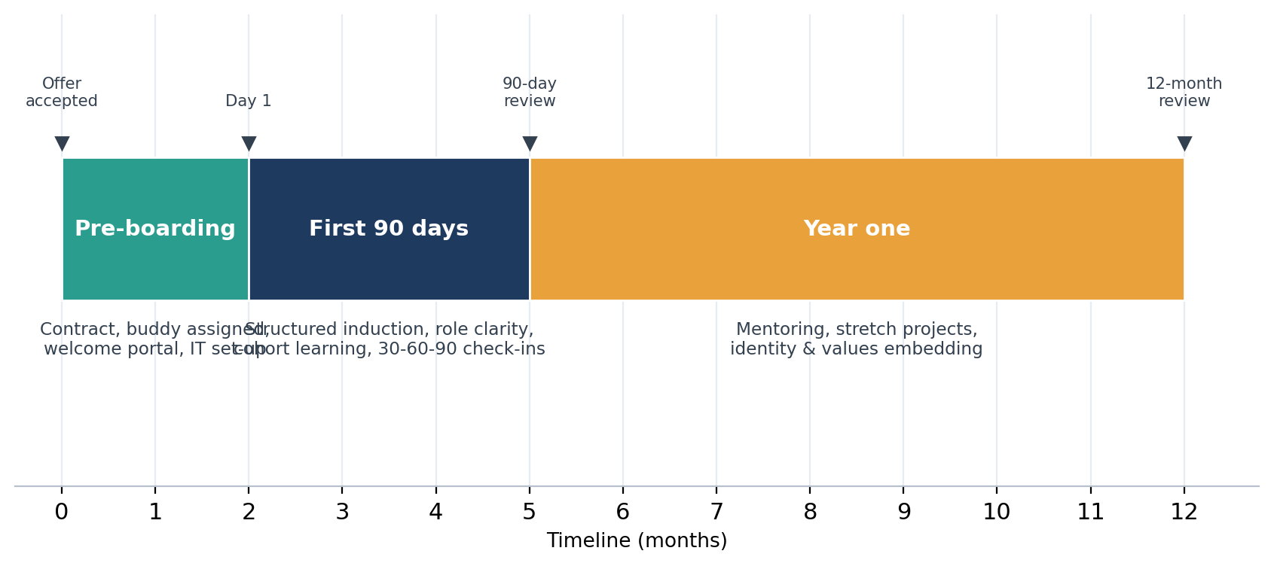
Figure 1. Structured three-phase socialisation framework for Helios (Van Maanen and Schein, 1979; Jones, 1986).
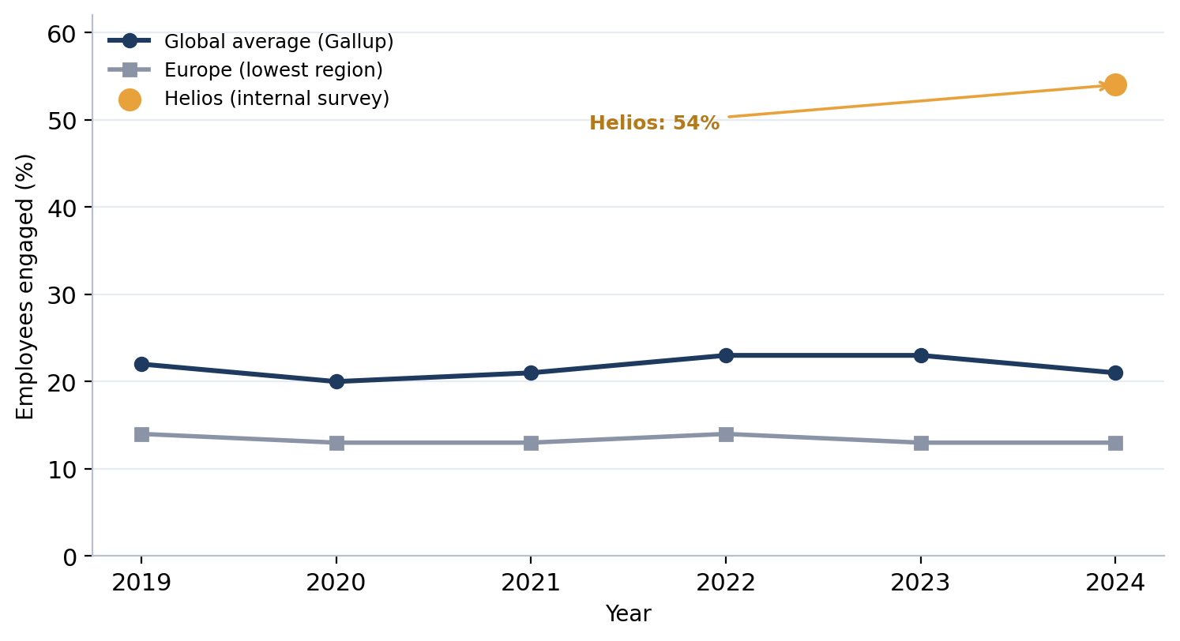
Figure 2. Employee engagement: Helios versus global and European benchmarks (Gallup, 2024).

Cultivating identification, ethical professionalism and the business-activist mindset
There are three mechanisms proposed. Cohort rituals, purpose linking (seeing the everyday work as part of the civic mission of cleaner cities) and storytelling provide an opportunity for building the group-membership dimension of self-concept (Tajfel and Turner, 1979; Ashforth and Mael, 1989) and enhancing affective commitment (Meyer and Allen, 1991). Embedded through a values-based code, ethics scenarios during induction and psychological safety to raise concerns – vital for an AI company to serve city governments. Psychological safety is not just a pleasant thing to have, it is a prerequisite for engagement: Meaningfulness, safety and availability are the three conditions that Kahn (1990) says are necessary for employees to be engaged in their work and relate it to Helios's engagement problem. The business-activist mindset is associated with the shift in HR's role from being an administrator to becoming a strategic partner and a HR change agent (Ulrich, 1997), and with a stakeholder-capitalism orientation, in which value is created for all stakeholders and not just shareholders (Freeman, 1984). This can be realised at Helios by providing employees with mandates to be active players in the sustainability and community outcomes, and not passive employees. There should be a balanced assessment which recognizes the risks. The model of authentic self-expression (Cable, Gino and Staats, 2013) is more appealing than assimilationist induction to an AI company because identity-driven socialisation can become assimilationist and stifle dissent and cognitive diversity. The same applies for an activist's role in the business: the mandate must be real, not performative, so that employees feel a sense of ownership when making decisions that have an impact on their civic life, but when that is not the case, cynicism sets in (Rousseau, 1989). The mechanisms above are then complemented by real decision rights and psychological safety, ensuring that identification, ethics and activism are complemented by an affective and normative commitment that is translated into a lasting bond that curtails the graduate attrition problem that is plaguing Helios, but doesn't simply make it go away with a rubber stamp.

Task B: Innovative Job Design

An integrated job-design strategy
The suggested framework is an integrated framework of three complementary frameworks. The key components of the Job Characteristics Model (JCM) of Hackman and Oldham (1976) are skill variety, task identity, task significance, autonomy and feedback, which create three psychological states – experienced meaningfulness, experienced responsibility and knowledge of results – that lead to increased intrinsic motivation and performance (Figure 3). The results of this study are backed by later research conducted by meta-analysis that shows autonomy and feedback are the most powerful motivating factors for knowledge workers at Helios.

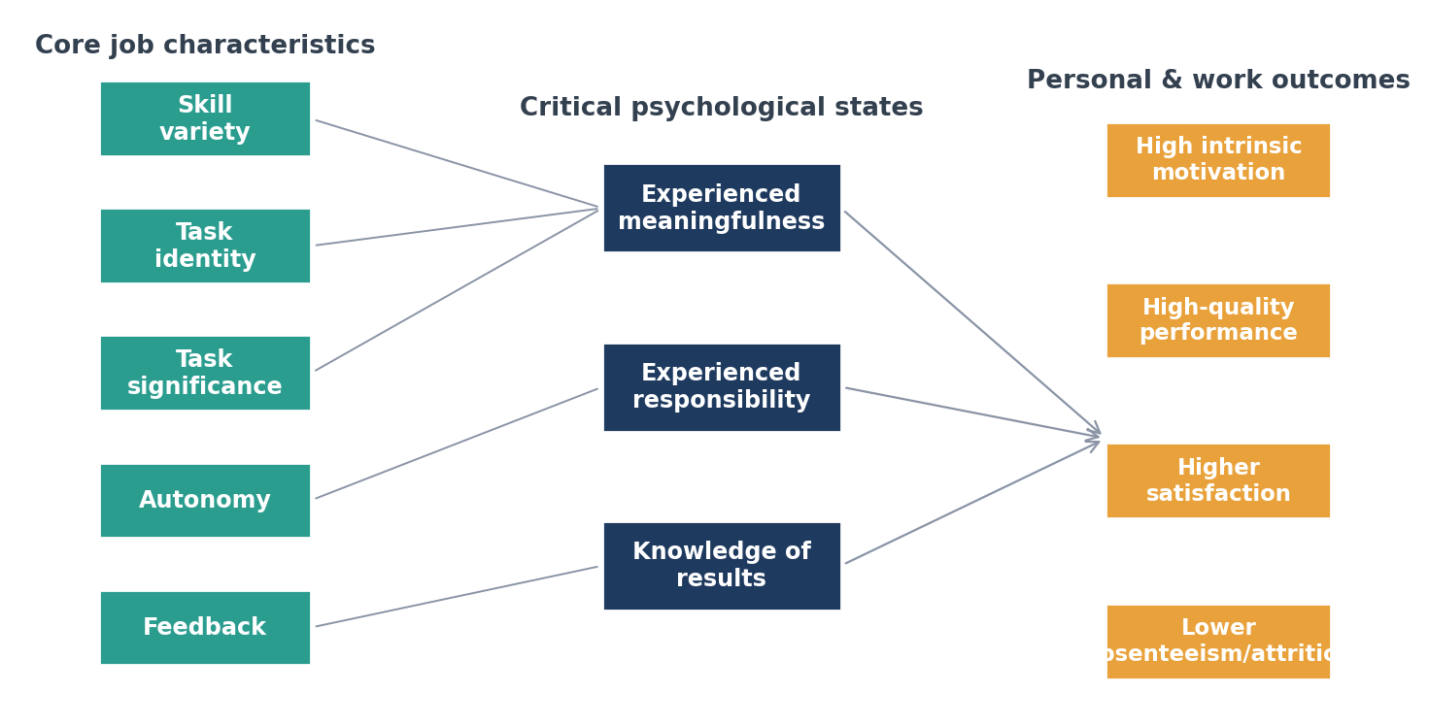
Figure 3. The Job Characteristics Model applied to Helios (Hackman and Oldham, 1976).
Job crafting is the second layer. Wrzesniewski and Dutton (2001) reframe employees as active creators who change the nature of their tasks, relational and cognitive frameworks of their work, and consequently the meaning and identity of their work. Tims and Bakker (2010) operationalise this in the job demands–resources model as employees' need to gain resources and to optimise challenges. Quarterly ‘craft your role' conversations should be used to legitimise bottom-up crafting, alongside the top-down JCM redesign. The third is a skills-based architecture and internal talent marketplace: roles are broken down into skills, and an internal platform connects employees to projects, gigs and mentoring at all three of the company's locations (London, Berlin and Singapore). The direct link to high-potential retention, because the World Economic Forum (2023) has found that internal mobility and continuous reskilling are key in keeping scarce analytical talent.
Table 2: Three-layer job-design strategy for Helios
Layer | Theoretical basis | Application at Helios
Structural redesign | Job Characteristics Model (Hackman and Oldham, 1976) | Enrich roles: raise autonomy and embed real-time feedback loops
Bottom-up crafting | Job crafting (Wrzesniewski and Dutton, 2001; Tims and Bakker, 2010) | Quarterly role-crafting conversations; resource-seeking encouraged
Skills architecture | Internal talent marketplace (World Economic Forum, 2023) | Skills-based profiles; cross-site gig and project matching

Stimulating intrinsic motivation and innovation
The design encourages intrinsic motivation by creating experienced responsibility through an increase of autonomy, and knowledge of results through an increase of feedback, which both lead to increases in internal work motivation (Hackman and Oldham, 1976). It is supported by self-determination theory, which Ryan and Deci (2000) demonstrate is a precondition for the flourishing of intrinsic motivation that when people's basic psychological needs for autonomy, competence, and relatedness are satisfied, their motivation is intrinsic. The proposed architecture is designed intentionally to address autonomy, competence, and relatedness – the autonomy is addressed through enrichment and crafting, competence is addressed through a skills marketplace, and relatedness is addressed through cohort socialisation. Increasingly, job crafting provides an opportunity for employees to contribute in ways that lead to meaningfulness on their own terms: employees who craft cognitively re-frame their contribution to Helios's civic mission (Wrzesniewski and Dutton, 2001). The structuring of innovation includes an internal talent marketplace for sharing information about a variety of problems, as well as cross-functional teams, and proactivity as part of the job demands-resources theory (Bakker and Demerouti, 2017) is linked to the quest for resources. The system, as a whole, transforms something that is just 54% engagement into a self-reinforcing motivational system rather than a compliance program. There are two caveats to this optimism. The reason is that the JCM makes the assumption that all employees are of high ‘growth-need strength' and not all of Helios' 450 staff will be affected equally by enrichment and the redesign should be offered flexibly, rather than imposed uniformly. Second, job crafting can have a double-sided effect: employees can craft jobs that are not aligned with organisations' priorities, hence, it is recommended to have bounded and supported job crafting conversations rather than giving employees a free rein (Tims and Bakker, 2010). Governance is also essential for a skills-based marketplace to ensure that managers don't control the limited skills available. These qualifications are not really a dilution of the strategy but discipline the delivery of it to ensure that the design remains evidence-based and not a fashionable overlay.

Task C: Reflective Report

Using AI as decision-support without eroding human judgement
As a practitioner, I believe that AI should be used to enhance human judgment rather than replace it. At Helios, I would say that most successful enterprise AI is ‘assisted’ and ‘augmented’ intelligence, it helps people make better decisions, it does not replace them. The specific risks in HR are well documented, Tambe et al. (2019) list four, which I would consider to be safeguards to include in any HR deployment: Complexity of HR phenomena; Small and unrepresentative data sets; Fairness and Accountability constraints; Adverse reactions from employees to algorithmic decision making. While I'm aware of the dangers of automation bias, hidden algorithms, and flawed algorithm training, I see the potential of AI to expose patterns of attrition or to pre-screen candidates based on patterns. The algorithmic output is in fact one of several inputs, so I should demand a good explanation of the output before I act on the recommendation, and for any people decisions: promotion, exit, discipline, I should withhold my final judgment until a human has considered the algorithm's output. This ensures that critical human judgment, empathy, and contextual ethics remain at the heart, while the use of AI extends the evidence base, not restrict responsibility.

Personal capability development plan
I have identified 4 priorities for my development as a person to increase my future employability; these are the skills which are on the rise as identified by the World Economic Forum (2023), and the professional standards as outlined by the CIPD (2023). These are summarised in Table 3.
Table 3: Personal capability development plan
Capability | Development action | Evidence of progress
Data literacy | Complete HR analytics course; practise dashboard interpretation | Portfolio of people-analytics analyses (6 months)
AI augmentation in HR | Pilot AI screening tool with bias audit; study responsible-AI guidance | Documented bias-audit protocol (9 months)
Strategic influencing | Practise board-level advisory writing; seek stakeholder feedback | Peer/mentor 360 feedback (ongoing)
Global mobility awareness | Study cross-cultural HRM across UK, Germany, Singapore | Comparative policy briefing (12 months)
Table 3. Personal capability development plan (Forum (2023) and CIPD (2023).
I'll use this reflection to review and measure progress against the evidence milestones that are listed above, and the influencing and data-literacy actions above are directly addressing my principal limitation: taking theoretical models and converting them into actions for the board in the face of uncertainty.

Conclusion
This report has developed integrated human capital architecture to support Helios' strategic renewal. In addition to a three-phase institutionalised socialisation process, a three-phase identity, ethics and business-activism process transform newcomers into committed citizens, and a three-layer job-design process – the JCM enrichment, job crafting and the skills-based talent marketplace – re-energises intrinsic motivation and innovation capacity, all of which address ramp-up time and graduate attrition. Reflective account places emphasis on AI as an Augmentation and establishes a personal development plan for employability in Postgraduate Studies. These interventions combine to view Helios's people as strategic assets, not operating expenses, and align human capital design with the organisation's civic mission.

References
Ashforth, B.E. and Mael, F. (1989) 'Social identity theory and the organization', Academy of Management Review, 14(1), pp. 20–39. https://journals.aom.org/doi/abs/10.5465/amr.1989.4278999
Bakker, A.B. and Demerouti, E. (2017) 'Job demands–resources theory: Taking stock and looking forward', Journal of Occupational Health Psychology, 22(3), pp. 273–285. https://psycnet.apa.org/fulltext/2016-48454-001.html
Bauer, T.N., Bodner, T., Erdogan, B., Truxillo, D.M. and Tucker, J.S. (2007) 'Newcomer adjustment during organizational socialization: A meta-analytic review of antecedents, outcomes, and methods', Journal of Applied Psychology, 92(3), pp. 707–721. https://psycnet.apa.org/fulltext/2007-06438-009.html
Cable, D.M., Gino, F. and Staats, B.R. (2013) 'Breaking them in or eliciting their best? Reframing socialization around newcomers’ authentic self-expression', Administrative Science Quarterly, 58(1), pp. 1–36. https://psycnet.apa.org/fulltext/2007-06438-009.html
Chartered Institute of Personnel and Development (CIPD) (2023) People Profession 2023: International Survey Report. London: CIPD. https://www.cipd.org/en/knowledge/reports/people-profession-survey-2023/
Davenport, T.H. and Ronanki, R. (2018) 'Artificial intelligence for the real world', Harvard Business Review, 96(1), pp. 108–116. https://academichelptoday.com/assets/documents/Artificial_Intelligence_for_the_Real_World_-_HBR.pdf
Freeman, R.E. (1984) Strategic Management: A Stakeholder Approach. Boston: Pitman. https://scholar.google.com/scholar?cluster=4470555682924659331&hl=en&as_sdt=2005&sciodt=0,5
Gallup (2024) State of the Global Workplace: 2024 Report. Washington, DC: Gallup, Inc. https://www.gallup.com/workplace/349484/state-of-the-global-workplace.aspx
Hackman, J.R. and Oldham, G.R. (1976) 'Motivation through the design of work: Test of a theory', Organizational Behavior and Human Performance, 16(2), pp. 250–279. https://www.sciencedirect.com/science/article/pii/0030507376900167

Jones, G.R. (1986) 'Socialization tactics, self-efficacy, and newcomers’ adjustments to organizations', Academy of Management Journal, 29(2), pp. 262–279. https://journals.aom.org/doi/abs/10.5465/256188
Kahn, W.A. (1990) 'Psychological conditions of personal engagement and disengagement at work', Academy of Management Journal, 33(4), pp. 692–724. https://journals.aom.org/doi/abs/10.5465/256287
Meyer, J.P. and Allen, N.J. (1991) 'A three-component conceptualization of organizational commitment', Human Resource Management Review, 1(1), pp. 61–89. https://www.sciencedirect.com/science/article/pii/105348229190011Z
Rousseau, D.M. (1989) 'Psychological and implied contracts in organizations', Employee Responsibilities and Rights Journal, 2(2), pp. 121–139. https://link.springer.com/article/10.1007/BF01384942
Ryan, R.M. and Deci, E.L. (2000) 'Self-determination theory and the facilitation of intrinsic motivation, social development, and well-being', American Psychologist, 55(1), pp. 68–78. https://psycnet.apa.org/journals/amp/55/1/68.html?uid=2000-13324-007
Saks, A.M. and Gruman, J.A. (2018) 'Socialization resources theory and newcomers’ work engagement: A new pathway to newcomer socialization', Career Development International, 23(1), pp. 12–32. https://www.emerald.com/cdi/article/23/1/12/46298
Tajfel, H. and Turner, J.C. (1979) 'An integrative theory of intergroup conflict', in Austin, W.G. and Worchel, S. (eds.) The Social Psychology of Intergroup Relations. Monterey, CA: Brooks/Cole, pp. 33–47. https://books.google.com/books?hl=en&lr=&id=uk8AFpo3BnYC&oi=fnd&pg=PA94&dq=Tajfel,+H.+and+Turner,+J.C.+(1979)+%27An+integrative+theory+of+intergroup+conflict%27,+in+Austin,+W.G.+and+Worchel,+S.+(eds.)+The+Social+Psychology+of+Intergroup+Relations.+Monterey,+CA:+Brooks/Cole,+pp.+33%E2%80%9347.&ots=qNL52Tbyza&sig=v0UPaQGabfsjb2yPNKLhj4F6b_U
Tambe, P., Cappelli, P. and Yakubovich, V. (2019) 'Artificial intelligence in human resources management: Challenges and a path forward', California Management Review, 61(4), pp. 15–42. https://journals.sagepub.com/doi/abs/10.1177/0008125619867910

Tims, M. and Bakker, A.B. (2010) 'Job crafting: Towards a new model of individual job redesign', SA Journal of Industrial Psychology, 36(2), pp. 1–9. https://journals.co.za/doi/abs/10.10520/EJC89228
Ulrich, D. (1997) Human Resource Champions: The Next Agenda for Adding Value and Delivering Results. Boston: Harvard Business School Press. https://books.google.com/books?hl=en&lr=&id=qTxz6I7tNSEC&oi=fnd&pg=PR7&dq=Ulrich,+D.+(1997)+Human+Resource+Champions:+The+Next+Agenda+for+Adding+Value+and+Delivering+Results.+Boston:+Harvard+Business+School+Press.&ots=Nr4rXgwpid&sig=iEMD5kIpzXJHreZ-X0ZF6Y9VSDM
Van Maanen, J. and Schein, E.H. (1979) 'Toward a theory of organizational socialization', Research in Organizational Behavior, 1, pp. 209–264. https://dspace.mit.edu/bitstream/handle/1721.1/1934/?sequence=1
World Economic Forum (2023) Future of Jobs Report 2023. Geneva: World Economic Forum. https://www.weforum.org/publications/the-future-of-jobs-report-2023/
Wrzesniewski, A. and Dutton, J.E. (2001) 'Crafting a job: Revisioning employees as active crafters of their work', Academy of Management Review, 26(2), pp. 179–201. https://journals.aom.org/doi/abs/10.5465/amr.2001.4378011

