Scott Burgess - 1350316
University of Wales Trinity Saint David
learning in the digital era
Assignment 1: E-Portfolio

Contents
E-Portfolio 2
Link to E-Portfolio 2
Screenshot of E-Portfolio Homepage 2
Task 1 3
Task 1a – Academic & Employability Skills 3
Task 1b – The use of AI 6
Task 1c – Reflection 6
Task 2 8
Mind Map 8
Academic Poster 9
Task 3 10
Automatic Referencing Tool 10
Task 4 13
Choice of Online Tool for E-Portfolio 13

E-Portfolio

Link to E-Portfolio
https://13503169.wixsite.com/life-is-a-team-sport

Screenshot of E-Portfolio Homepage
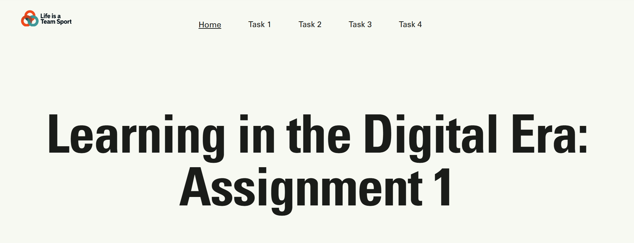
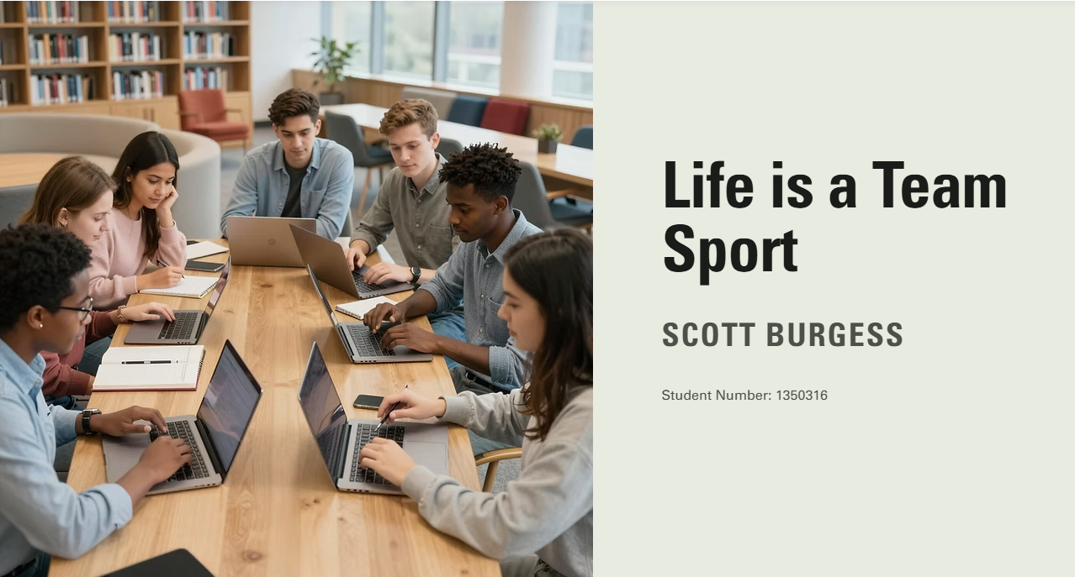
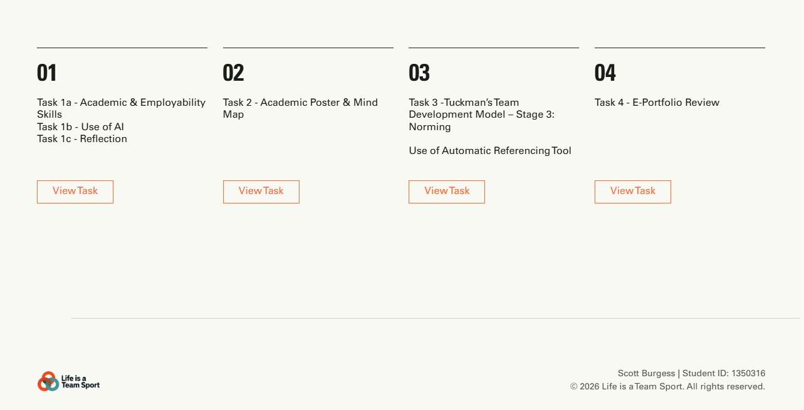

Task 1

Task 1a – Academic & Employability Skills
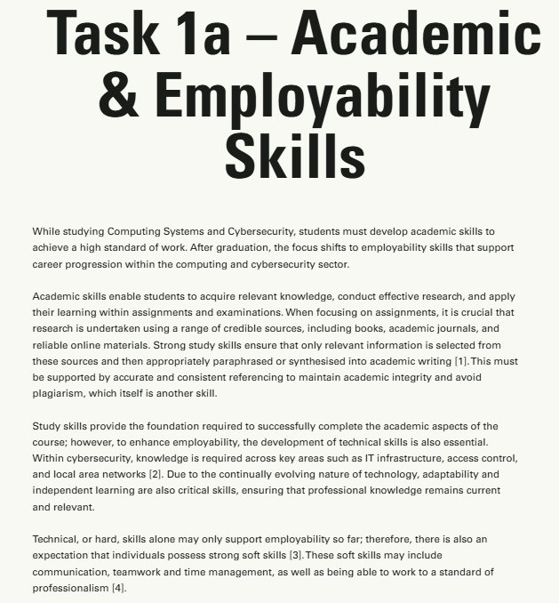
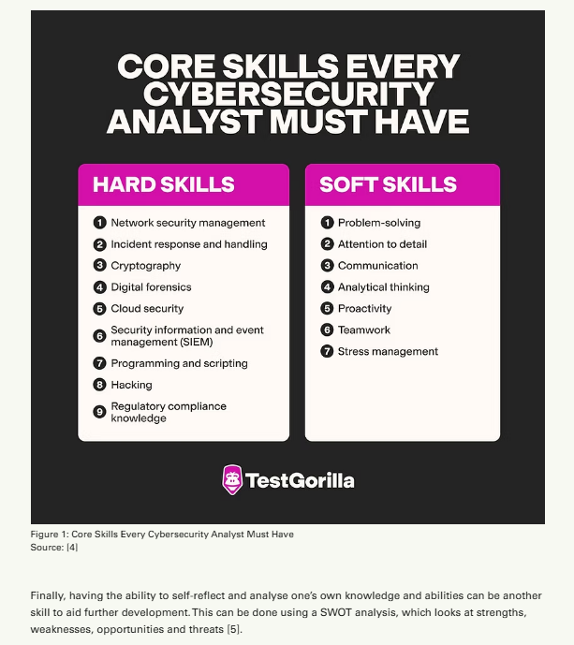
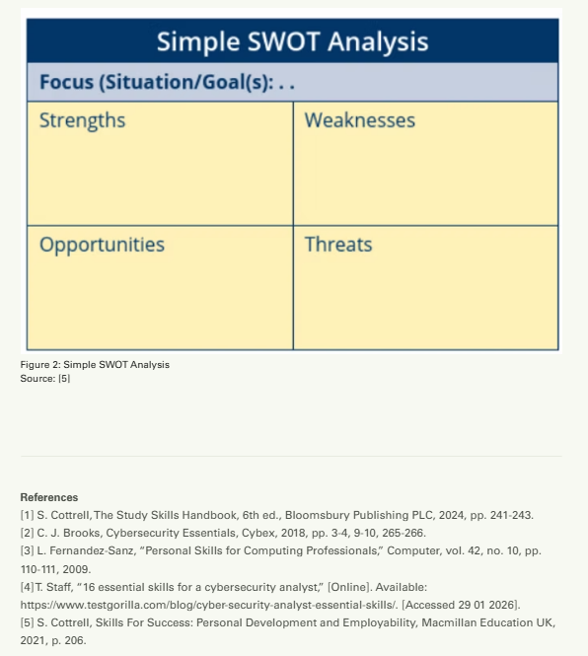

Task 1b – The use of AI
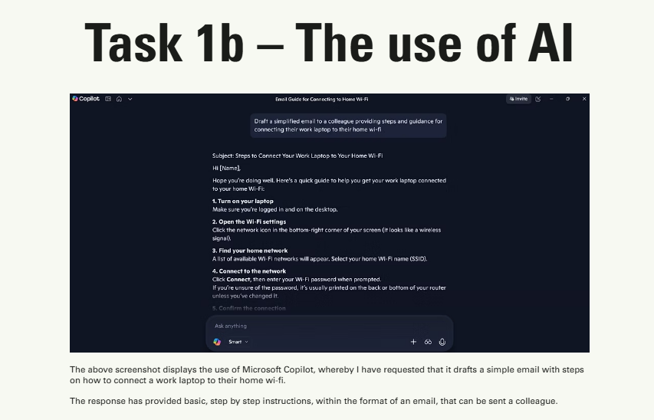

Task 1c – Reflection
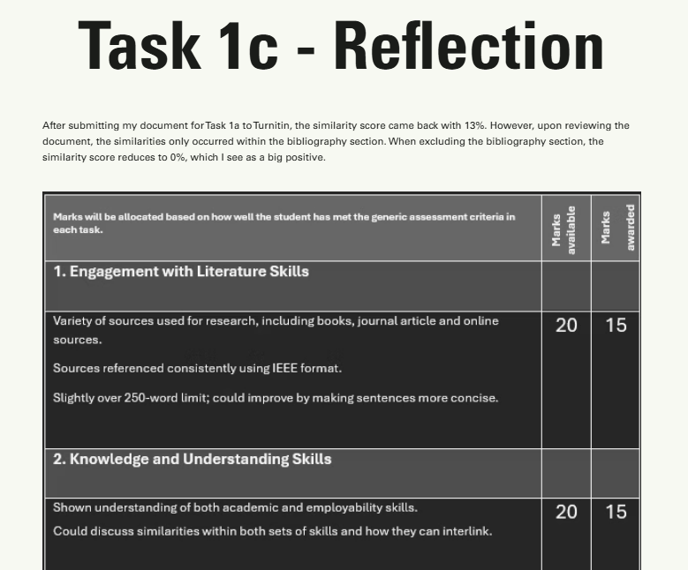
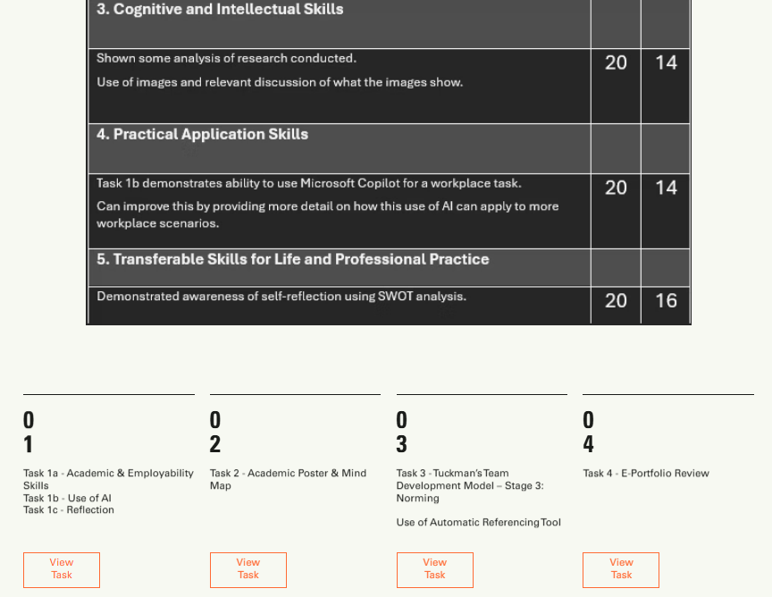

Task 2

Mind Map
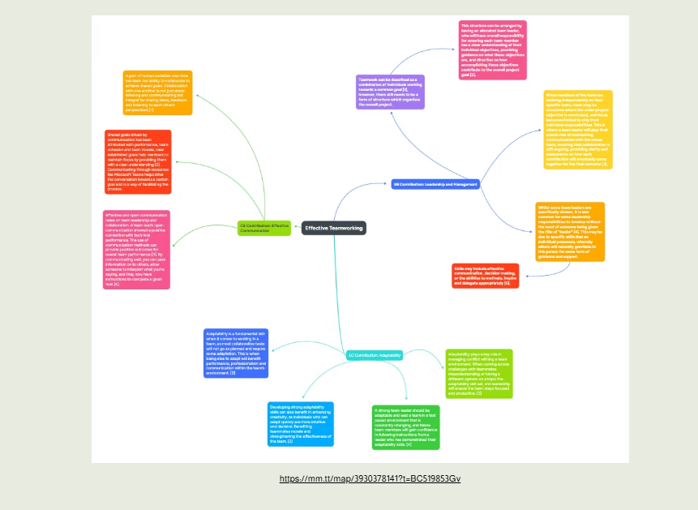
https://mm.tt/map/3930378141?t=BC519853Gv

Academic Poster
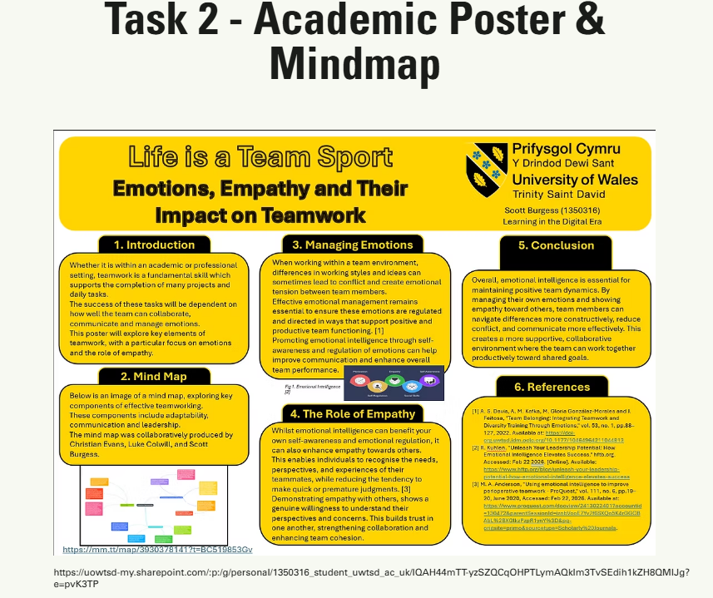
https://uowtsd-my.sharepoint.com/:p:/g/personal/1350316_student_uwtsd_ac_uk/IQAH44mTT-yzSZQCqOHPTLymAQklm3TvSEdih1kZH8QMlJg?e=pvK3TP

Task 3

Tuckman’s Team Development & Automatic Referencing Tool
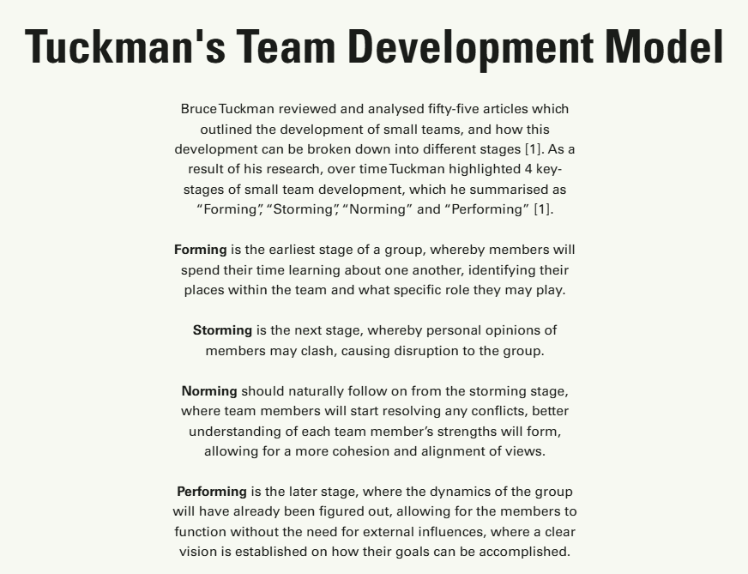
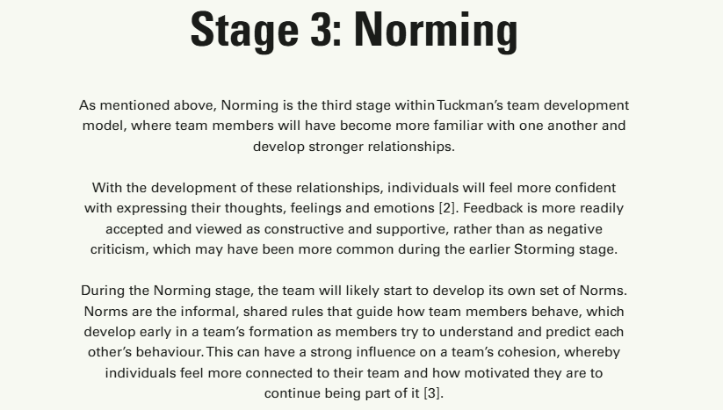
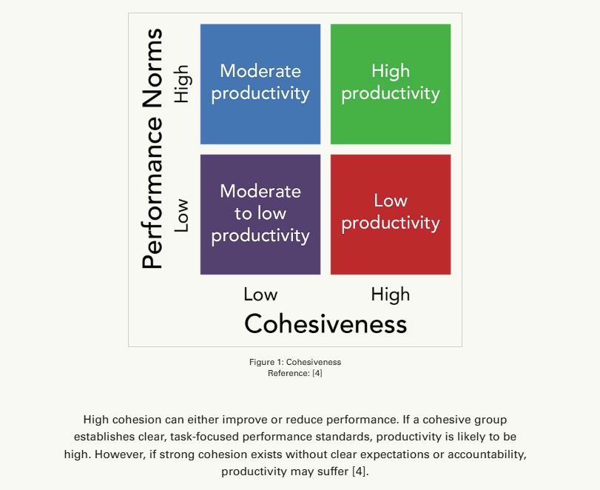
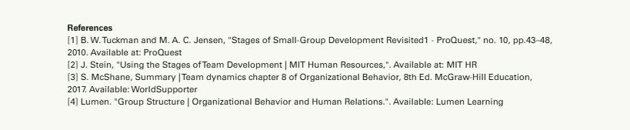
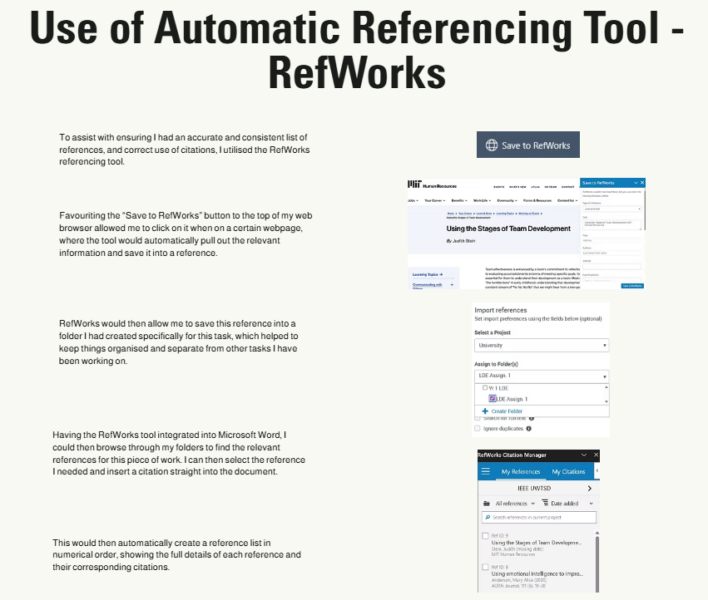

Task 4

Choice of Online Tool for E-Portfolio


