University of Wales Trinity Saint David

Apple & IKEA
Leadership & Comparison

Valentina Oana Vintila (1)
Valentin-Victor Zlate (2)
Barbabara Berto (3)
Mircea Octavian Olteanu (4)
Petrica Stefan (5)

(Numbers from brackets is who is first ,second …)

Introducing the Modern Workplace LCBB 4003

Uju Ugochukwu

APPLE

Table of Content
Introduction 3
Essential nature of managerial work in both functions and processes 4
Role of leadership and factors determining effective management and leadership; 5
A behavioral approach to management along with the factors affecting differences in employer bvehaviour 5
Conclusion 7

Valentina-Oana Vintila

Introduction
Apple Inc. Is an American multinational technology company, headquarted in Cupertino, California, that designs, develops and sells consumer electronics, computer software and online services.
It is considered one of the Big Five companies in the U.S. information technology, industry, along with Amazon, Google, Microsoft and Facebook. It’s hardware products include the iPhone smartphones, the iPad tablets computer, the Mac personal computer, the iPod portable media player, the Apple Watch smartwatch, the Apple TV digital media player, the AirPods wireless earbuds, the AirPods Max headphones and the HomePod smart speaker line.
Apple was founded by Steve Jobs, Steve Wozniak and Ronald Wayne in April 1976 to develop and sell Wozniak’s Apple I personal computer, though Wayne sold his share back to Jobs and Wozniak within 12 days. It was incorporated as Apple Computer, Inc., in January 1977, and sales of its computers, including the Apple II, grew quickly.
Jobs and Wozniak hired a staff of computer designers and had a production line starting in Jobs’ garage. Apple went public in 1980 to instant financial success. Over the next few years, Apple shipped new computers featuring innovative graphical user interfaces, such as the original Macintosh in 1984, and Apple’s marketing advertisements for its products received widespread critical acclaim. However, the high price of its products and limited application library caused problems, as did power struggles between executives.
In 1985, Wozniak departed Apple amicably and remained an honorary employee, while Jobs resigned to found NeXT, taking some Apple co-workers with him. As the market for personal computers expanded and evolved through the 1990s, Apple lost considerable market share to lower-priced duopoly of Microsoft Windows on Intel PC clones.
The board recruited CEO Gil Amelio to what would be a 500-day attempt to rehabilitate the financially troubled company-reshaping it with layoffs, executive restructuring, and product focus. He led Apple to buy NeXT in 1997, solving a failed operating system strategy and bringing Jobs back.
Jobs regained leadership status, becoming CEO in September 1977. Apple swiftly returned to profitability under the revitalizing “Think different” campaign, rebuilding Apple’s status by launching the iMac and iPod, opening a retail chain of Apple Stores in 2001, and acquiring numerous companies to broaden the software portfolio. The company was renamed to Apple Inc. in 2007, reflecting a focus toward consumer electronics, and launched the iPhone to critical acclaim and financial success. In August 2011, Jobs resigned as CEO due to health complications, and Tim Cook became the new CEO. Two months later, Jobs died, marking the end of an era for the company. In June 2019, Jony Ive, Apple’s CDO, left the company to start his own firm, but stated he would work with Apple as its primary client.
Apple is the world’s largest technology company by revenue and one of the world’s most valuable companies. Apple is the world’s 4th largest PC vendor by unit sales as of January2021. It is also the world’s 4th largest smartphone manufacturer. In August 2018, Apple became the first publicly traded U.S. company to be valued at over $1 trillion and just two years later, in August 2020 became the first $2 trillion U.S. company.

Apple employs 147,000 full-time employees and maintains 510 retail stores in 25 countries as of 2020. It operates the iTunes Store, which is the world’s largest music retailer. As of January 2020, more than 1.5 billion Apple products are actively in use worldwide. The company also has a high level of brand loyalty and is ranked as the world’s most valuable brand. However, Apple receives significant criticism regarding the labour practices of its contractors, its environmental practices, including anti-competitive behaviour, as well as the origins of source materials.

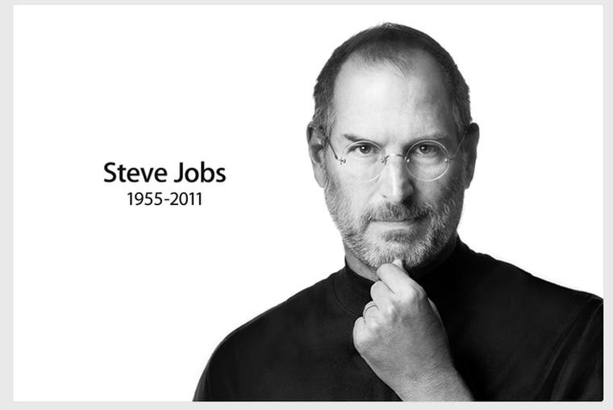

Valentin Victor Zlate

Relationship between structure, culture, people, and organizational performance

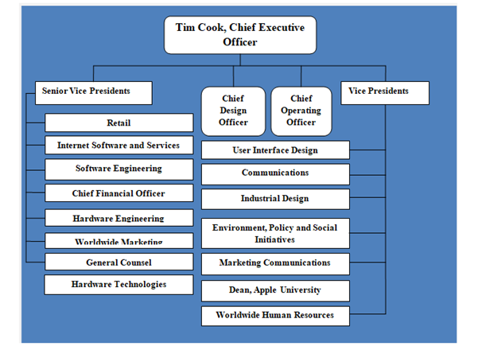
Figure 1: Organisational structure
Source: (statista.com, 2021)

Apple has a hierarchical organizational structure including many layers of management as elaborated in the above figure. The company is huge, comprising almost 147000 employees who operate globally adhering to the hierarchical structure (statista.com, 2021). It is advantageous in administering with a tight control with clear levels of authority and responsibility. However, it compromises the flexibility of the business reflecting on the changes in the global market as well as deeming it as less effective regarding the organizational communications across various departments. Furthermore, it has a product-based grouping arrangement dividing its operations according to the products like Mac, iPhone, iPad and other services.
Apple’s organizational culture is the key reason for its continuing success in the business market which focuses on innovation. As mentioned by Pathiranage (2019, p.265) the Apple culture is inclusive of producing simple, elegant as well as innovative products fostering an effective and productive culture. As mentioned by ANDIPARA et al., (2017, p.8) Apple’s organizational culture includes three significant characteristics as follows:
Spoke and wheel hierarchy: previously under (Steve Jobs), all the major decisions were taken. However, under the leadership of (Tim cook), less rigidness is observed.

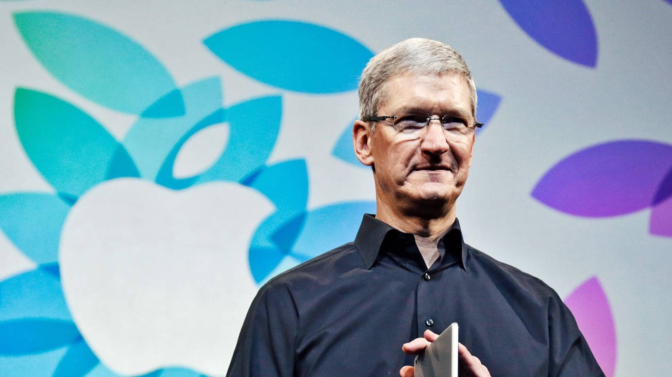
Function-based grouping: this aspect of the corporate structure is utilized for managing certain specific products and components which focus on the activities to deliver to its target customers. Each vice president of Apple reports to (Tim Cook) regarding their business functions.
Product based grouping: the lower part of the hierarchy is managed on product-based grouping which is mainly an arena of the divisional type regarding the organizational structure.

Essential nature of managerial work in both functions and processes
Apple has managed to devise a new strategy considering the senior vice president who is generally the most experienced in a specific field such as industrial design or marketing or management control. Apple’s top leaders are used to reporting the useful business needs in terms of vast functional areas. In the product based grouping, the senior vice presidents supervise the vice presidents for administering and monitoring the various outputs as well as designated products(ANDIPARA et al., 2017, p.8). As pointed out by Tasnim (2018, p.1) in her study Apple is one of the largest and most influential companies globally and was ranked in the third position in the Fortune 500 list. Apple is renowned for its innovative products as well as its unique strategies regarding design and marketing. The organization possesses a large number of loyal customers with a market share (in tablets) of 34.6% in the year 2019 (T4.ai, 2021). The overall performance is based on motivated teams working in coordination and responsibility following innovation and excellence. It maintains secrecy as well as attention to details. The culture is focused on “think different” which is the slogan for the company.

Role of leadership and factors determining effective management and leadership;
According to Warrick (2017, p.398) leaders can create a deep impact on culture through their values, practices, strategies and leadership styles. The influence of leaders is particularly impactful at the top levels. Warrick further pointed out that Tim Cook has reinforced certain positive aspects of Apple culture that have improved and brought more autonomy and flexibility in the system. Apple follows a transformational leadership style concerning the shared interests induced in the employees by indicating the importance of the company’s goals so that the employees are more focused on the common good rather than the personal interests (Rizki et al., 2019, p.230). This fosters innovative bvehaviour among the employees and increasing employee performance and employee loyalty. Further as explained by Kao (2018, p.16) Apple also involves disruptive leadership which is focused on finding better solutions and distinctive ways for establishing innovative processes with an intention to holistically improve and better the business management without disturbing the existing norms to obtain the necessary results.

A behavioral approach to management along with the factors affecting differences in employer behaviour

As stated by Merrick and Koprowski (2017, p.35), behaviour-management theory is gaining importance increasingly, within the modern-day workplace, with the rise in the awareness among the employees regarding their rights at the workplace as well as the increasing education levels among the employees, which renders them a degree of self-respect too. Behavioural Management Theory focuses on the establishment of human relations within the professional context and consideration of employee motivation, satisfaction and well-being, in order to enhance the productivity of the organization. Several Behavioral theorists also believed that the enhanced sympathy of the human behaviour management at work including conflict, motivation, and expectations, improved productivity rate and group dynamics management. Apple Inc. under the current leadership of Tim Cook, abides by the Behavioural Management Theory, for appropriate management of the human resources, as well as organizational productivity, through propagating employee motivation, well-being and appropriate conflict management. The main factors also influencing an individual’s approach in individual as well as in actual social life are related.
Abilities- the Abilities are actual traits that a person also gains knowledge from the surroundings around in addition to the personality an individual is actually gifted with people by birth.
Gender- Several Researches also proves that women and men both set equally in particular terms of accurate job presentation and basic mental abilities practice; nevertheless, society also emphasizes accurate differences connecting two genders.
Race and the culture- Nowadays, within the diverse organizational work culture, core management staff should accept and learn codes of dissimilar cultures, common values and protocols, to generate a more contented commercial culture (Gil et al., 2018, p. 535).
Attribution- The accurate Attribution practice is the highlight the course management of basic observing performance followed by formative its grounds actually based on the basic individual’s situation and personality.
Perception- Different perceptions of the employees as well as the management staff, owing to the difference in the cultures, within Apple Inc, results in different behaviours being meted out to the people within various departments.
Attitude- The Attitude management in this company is related to the conceptual learnt response or say reaction of a person’s complete cognitive procedure over the accurate time span (Merrick and Koprowski, 2017, p.35).

https://www.youtube.com/watch?v=f60dheI4ARg
(Steve Jobs) how he managing people

Conclusion
This present study is based on business and organizational analysis. The selected company is Apple Inc. in this study. This study includes the relationship structure, people, culture and organizational performance of this company. This study also focused on the essential nature of managerial work’s function and process, including the lead role as well and considers the aspect of behavioural approach of management, for exploring the ways in which the management at Apple Inc, functions efficiently, to uphold the organizational culture.

Barbara Berto

Leadership Style Analysis for IKEA

Introduction of the organisation

IKEA is founded by a Swedish young boy named Ingvar Kamprad in 1943 when he was only 17 years old.
IKEA has become the biggest home furniture retailer from Sweden since 2008 in the world and is internationally recognised.

In 2020 IKEA had 445 stores in 52 countries and regions around the world.
Which is mostly has been franchised round Europe and has the most stores based round Europe and is also well known in United States, Asia, Canada and Australia.

IKEA prints up to 100 million copies of catalogs every year, enclose 12,000 items and believe to be the largest book diffuse besides the Bible (IKEA 2018).

A famous Kamprad quote is:” A good leadership it is to provide a great example “ this is a clear explanation of his leadership morals.

Kamprad was know as a simple person, flying in economy class and using subway or public bus, this not just for ambition to figure up his billions, but more to be an example to thousands of IKEA staffs (Sylt,C., 2005 “Ingvar Kamprad: leader of the flat pack “).
Kamprad had as routine of personally send out Christmas presents every year to thousands of employees, receiving in return their appreciation and fidelity.

The organisational mission and vision

“Creating a better everyday life for most people” is the guideline that IKEA follow since its establishment.
IKEA has always been connected with developing people’s quality life and follow to the business foundation of “try to create market with lots of variety of furniture and other household goods, cheap but functional and well designed, in prices that everyone can afford”
In agreement to provide beautiful and practical household goods, IKEA try to create a model of business that wants to meet the interest of the customers (IKEA 2020).

Leadership style

The actual IKEA leadership system are placed on leadership ethic and life theory of his founder, also know for using transformational and charismatic leadership styles.
It’s hard to enclose IKEA leadership style into an individual classification due to a different personality of the business in more than one form.
All these leadership basis have their reflection on IKEA to this days, in fact international statistics affirm that IKEA is one of the twenty best companies in terms of leadership.
The company in 74 years has had 6 CEO, the actual CEO, Jasper Brodin, in charge as IKEA CEO from 2017 but he started his career in the company on 1995 as a purchase manager in Pakistan.
He believes in value-based leadership and togetherness, saying:” the potential is where the people are. Be sure about yourself band your power, but remember to rely in other people strengths as well, because together we are stronger (www.ingka.com/bios/jasperbrodin.com).
One crucial characteristic of IKEA leadership is that the employees motivation rais employees performance.

Jasper Brodin as a transformational leadership style (Bass and Riggio 2006).
Burns and Bass define transformational leadership as leader who can deliver more motivation to employees and give more consideration to their necessity (Stewart 2006).
As a leader, Brodin connect huge importance to the unanimity and beliefs of the team.
IKEA not just help their employees get their self confidence by supporting them, but also catch the needs of them as much as possible agreeing to the four view of Maslow’s Hierarchy of needs theory along with physiology, safety, belonging and self esteem.
About the arrangement of working hours, IKEA not just need headquarters team to freely designate working hours, but as well prevent employees working extra in stores.
IKEA affirm that if colleagues works too arduous, performance and production will reduce. At the same time, IKEA bring an appropriate working climate for its coworkers.
For example, IKEA stores and office edifice are constructed in agreement to the design of co-workers.
Drinks are freely provided all day to alleviate thirst, and employees doesn’t have a precise meal time for lunch. IKEA also equip special lobby and smoking rooms. In fact IKEA co- workers and their superiors are considered at the same equally way.
It’s most impossible to classify managers or employees by their uniforms. This method decrease the pressure of employees and build up the relationship between subordinates and leaders, encountering the needs of employees and inspiring their enthusiasm for work (Wesley et al. 2015).
To summarise, Jesper Brodin is considered a transformational leadership style as he has been looking after the needs of employees and encourage them to confront new challenges. He is also a laissez-faire leader for gives his employees a high quality of freedom.
Frequently extra stress at work will cause a decline in productivity, but his leadership style can achieve high productivity, his leadership style can achieve high motivation on employees and give give effective quality output.
Jesper Brodin’s leadership style can as well be described as paternalistic leadership style in association to maslow’s hierarchy theory ( Maslow, Stephens and Heil, 1998).
He deliver to his dependant full respect and firmly listened to the needs of the staff and worked hard to give them (managementikea 2015).

Leadership Skills

When we explain a leadership style we should also think about the leadership skills, usually divided into three classification: technical skills, human skills and conceptual skills (Northouse 2019).

How we see before IKEA s not a technical business, so the CEO in this case does not need a particular practical skills. He as gained respect by the co-workers and the co-workers are happy to work at IKEA because he has human skills.
Also because he knows the relationship between every single department and knows how to keep IKEA under a precise organisational structure Jesper Brodin has conceptual skills.

Mircea Octavian Olteanu

Leadership of CEO of Ikea

1.0 Introduction
In this presentation, effective leadership styles of two leaders are compared. Two organizations are selected in this study are Ikea and Apple. The Leadership style of CEO of the selected organization is evaluated based on employee motivation. Moreover, leadership style used by the CEO is assessed in a dynamic environment. The impact of leadership needs to be measured effectively to address the issues faced by the employees in a dynamic environment.

2.0 Leadership style of CEO of IKEA

2.1 The CEO of IKEA is Jesper Brodin
Jesper Brodin is the sixth CEO of the furniture retailing company. It is identified that Jesper Brodin assisted the founder of IKEA, Ingvar Kamprad (ikea, 2021). The Leadership Style of the CEO of IKEA is difficult to categorize under one leadership style.

2.2 Transformational leadership style
It is identified that the CEO of IKEA uses transformational leadership styles that are effective in motivating employees to create and innovate new products and services (bbc, 2017). Further transformational leadership style used by the CEO to create changes within the organization in the dynamic business environment.

2.3 Charismatic leadership style
It is identified that the CEO of IKEA, uses more than one leadership styles including the charismatic leadership style. Charismatic leadership style is used by leaders to connect with employees and identified their issues. Further, the charismatic leadership style allows leaders to take the organization forward which is facing crisis under the dynamic business environment.

3.0 Leadership style used by the CEO of Apple

3.1 The CEO of Apple is Tim Cook
The present CEO of Apple sin Tim Cook who is appreciated for his democratic leadership style as compared to previous CEO Steve Jobs (apple, 2021). Steve Job used an autocratic leadership style; however, Tim Cook has a different approach towards leading the organizations.

3.1 Democratic leadership style
Tm cook focused on building consensus among senior leaders before making a major strategic decision. It has been observed that the new CEO of Apple has provided autonomy to its product development team. It is observed that a team member is allowed to decide the innovation of products and their development. The participation of the CEO in product development has been significantly reduced as compared to the previous CEO.

3.2 Quiet leadership style
In addition to a democratic leadership style, it is identified Tim Cook is a Quiet leader. He is appreciated for the quiet leadership styles used in the management of events, organization and motivating employees.

4.0 Comparison of leadership style by two CEOs

4.1 The leadership style of two leaders is in contrast to each other
The leadership styles of the two CEO are comparatively different and in contrast to each other. It is identified that the CEO of IKEA uses a charismatic leadership style that is directly opposite to the leadership styles of Apple (businessinsider, 2017). Further, the democratic leadership style is used by Tim Cook where a consensus of senior managers is prioritized. In addition to this, the democratic leadership styles used by the CEO of Apple are different from the transformation leadership styles used by the CEO of IKEA.

4.2 A different approach used by the CEO of IKEA and CEO of Apple
It can be identified that different leadership styles are used frequently by leaders, however, the two leaders are using a completely different approach to lead the organization as well as manage the critical situation effectively. Further, the impact of leadership on employee motivation along with organization needs to be analyzed.

4.3 Contrasting perspective about management
Two different leaders have varying perceptions about leading an organization. Further, it is observed that the CEO of IKEA tries to communicate with employee and motivate them to create innovative products such as furniture. However, CEO of Apple provided autonomy of its product development team to apply innovative methods of product development. In addition to this, charismatic leaders contribute significantly when an organization is facing crises.

5.0 Impact of leadership style on employee motivation

5.1 Frequency communication under the charismatic leadership
Charismatic leaders communicate with employees frequently and try to motivate them towards achieving goals, vision and missions. As mentioned by Grabo (2017)It is observed that CEO of IKEA uses a charismatic leadership style to motivate employees to develop and innovate new product that can be commercially sold.

5.2 Engagement with employees under Quiet leadership
Moreover, CEO of Apple is Quiet leaders who provide the opportunity to engage employees towards the success of the company. It is observed that charismatic leaders have excellent communication skills that are used to motivate employees and drive them towards common goals. CEO of IKEA works focus on driving the organization's excellence through innovation on the other hand; it can be observed that CEO of Apple uses a democratic leadership style where a manager and team member are allowed to express their opinion regarding product development.

6.0 Impact of leadership style on organizations in dynamic environments

6.1 Varying approach for managing crisis
It is observed that the two leaders have different approaches for managing crises in their respective organizations. As mentioned by Fiaz et al. (2017) In the dynamic business environment, it becomes important to focus on the creation of new products continuously. However, CEO of Apple focuses on two products namely the Apple Watch and Apple music. It can be observed that the democratic leadership style used by Tim Cook has not paid attention to the number of products; however, quality is emphasized more.

6.2 Constant innovation required in the dynamic business environment
It is observed that the Apple Watch has gained a top position among smartwatches and Apple music has gained 15 million subscribers. On the other hand, it is observed that the CEO of IKEA has applied transformational and charismatic leadership to drive the organization towards success.

6.3 Motivation required for product development in a dynamic environment
The leader encourages and motivates employees to develop new products and furniture to suit the requirements of the customer. According to Andriani et al (2018), it can be analyzed that a dynamic business environment requires effective leadership styles to meet the demand of customers and varying market conditions.

7.0 Conclusion
It can be concluded that different leadership styles are used by leaders in IKEA and Apple for motivating employee and managing the business in a dynamic environment. It is essential to focus on the usefulness and effectiveness of each leadership styles as well as its impact on the employees and preparation of strategies.
Mircea octavian Olteanul

Petrica Stefan

Comparison of the leadership styles used by CEOs of Ikea and Apple
Throughout history, great leaders have emerged with particular leadership styles in providing direction, implementing plans and motivating people. These can be broadly grouped into 5 different categories:
- Authoritarian Leadership
- Participative Leadership
- Delegative Leadership
- Transactional Leadership
- Transformational Leadership
In this global crisis, a good management style is crucial to slowing the rate of deterioration. Only through effective management styles is it possible to achieve hierarchical goals profitably. Employee execution and effectiveness are influenced by initiative forms. This paper summarises and deconstructs the available authority writing styles and their effect on different segments of quality of work life.
The management style is the process by which managers exert their control in the workplace and ensure that their goals are met. It explores how chiefs prepare and coordinate work in their general area of responsibility, as well as how they identify with and treat their associates and colleagues. The viewpoints and authority style of the executives are important segments, including what a director says; how they say it; the model they set; their non-verbal communication; and their overall lead and disposition.
However, just as there are characters that differentiate pioneers from non-pioneers, there are several different viewpoints on administration. Although most research nowadays has shifted away from traditional attribute or character-based hypotheses and toward a circumstance hypothesis, which states that the situation in which initiative is practised is governed by the pioneer's authority abilities and qualities, (Avolio, Walumbwa, and Weber, 2009), all current speculations can be classified into one of three categories: management as an association or partnership, management as a combination of characteristics or character traits, or initiative as particular activities or, as they are more commonly referred to, initiative skills. There is a prevalent idea in the more prevalent initiative speculations that, in any event somewhat, administration is a cycle that includes impact with a gathering of individuals toward the acknowledgment of objectives (Wolinski, 2010).

Management style at Ikea
The latest IKEA authority procedures and examples are focused on Ingvar Kamprad's administration principles and life reasoning. Ingvar Kamprad, who is known for his innovative and attractive authority styles, has been a driving force behind the home improvement and outfitting chain's phenomenal success for a long time. In 1943, Ingvar Kamprad founded the furniture retailer After a long period of running the company, he handed over control to his three children. Ingvar Kamprad's adage, "if there is such an incredible idea as great administration, it is to offer a true model," is a fair description of his initiative attributes, which identifies with the multinational furniture retailer until today. (Al-hammadi, 2021)

The first is totalitarianism in terms of IKEA's management styles. A totalitarian administration style is one in which the leader sets goals, assigns tasks to workers, and unequivocally encourages obedience. As a result, choices will represent the chief's conclusions and personality, which can help to paint an image of a particular, well-managed company. Strong and qualified subordinates, on the other hand, will scrape due to a lack of choice; the organisation may receive limited operation from the "cutting edges," and turnover in the best subordinates will be higher.
The second method is one based on democracy. Encourage staff to engage in a fair management style for the good of the company's decisions. Constantly converse with representatives or solicit their feedback on a formal decision, and directors should have the ability to clearly explain thoughts and comprehend colleague input. As a result, they would undoubtedly devote more time and effort to their jobs.
IKEA managers use a directive, supportive, and participatory management style. Directive leadership is a type of leadership in which the boss tells his or her staff exactly what is required of them, gives them detailed instructions about how to complete tasks, and so on., schedules work, sets standards of performance and makes sure that people follow standard rules and regulations (Chuck & Alan, 2010).

Apple Management style
Apple Chief, Tim Cook has an administrative style could be extensively characterized as democratic (Peterson, 2021). As opposed to remaining in complete difference to previous Apple President Steve Occupations, Cook seems to have embraced a portion of the incredible business person's current practices and built up an exceptionally mixed initiative mantra. The job of active cooperation of the President in creating Apple items has been altogether diminished since Cook took over in 2011. The iWatch is an illustration of this move in structure as Cook decided to be less engaged with the subtleties of item designing. All things being equal, he assigned those obligations to individuals from his executive bureau. His remarkably unpretentious style of authority has upgraded industry and worker generosity. When contrasted with Occupations' curt and frequently domineering way, Cook's style has likewise come about in a slower dynamic and an unmistakable loss of imaginative drive. (Dudovskiy, 2021)
The first and most obvious difference is Cook's unique and varied approach to the board. Occupations was a brash, if grating, visionary and President who demanded perfection and greatness from his team. Cook, on the other hand, continues to aspire for excellence at Apple, but he does so with a particularly special management style. Cook has emphasised openness from the start, and cooperation is a top priority within the Apple organisation. Having him on a path to a delegative leadership style. In addition, Cook has a calm demeanour and is much more friendly than Occupations was at any stage. Cook seems to energise his employees by promoting an open-door policy and encouraging a collaborative culture at Apple.

References for apple(Valentin-Victor Zlate)
ANDIPARA, V., DURRANI, E., IQBAL, S., KUNNATHUR, M.U. and UGHETTO, E., Analysis of a NYSE listed company.
Gil, M.A., Hein, A.M., Spiegel, O., Baskett, M.L. and Sih, A., 2018. Social information links individual behavior to population and community dynamics. Trends in ecology & evolution, 33(7), pp.535-548.
Kao, R., 2018. Disruptive Leadership: Apple and the Technology of Caring Deeply--Nine Keys to Organizational Excellence and Global Impact. Taylor & Francis.
Merrick, M.J. and Koprowski, J.L., 2017. Should we consider individual behavior differences in applied wildlife conservation studies?. Biological Conservation, 209, pp.34-44.
Pathiranage, J., 2019. Organizational culture and business performance: an empirical study. International Journal of Economics and Management, 24(2), pp.264-278.
Rizki, M., Parashakti, R.D. and Saragih, L., 2019. The effect of transformational leadership and organizational culture towards employees’ innovative behaviour and performance.
statista.com, 2021. Apple: number of employees 2018 | Statista. [online] Statista. Available at: <https://www.statista.com/statistics/273439/number-of-employees-of-apple-since-2005/#:~:text=As%20of%20FY%202020%2C%20the,counting%20full%2Dtime%20equivalent).&text=Founded%20in%201976%2C%20Apple%20is,personal%20computers%20and%20online%20services.> [Accessed 22 March 2021].
T4.ai, 2021. Apple Market Share | T4. [online] T4.ai. Available at: <https://www.t4.ai/company/apple-market-share> [Accessed 22 March 2021].
Tasnim, M., 2018. An Organizational Analysis on Apple. European Journal of Business and Management, 10(11).
Warrick, D.D., 2017. What leaders need to know about organizational culture. Business Horizons, 60(3), pp.395-404.

Reference list(Mircea Octavian Olteanul
apple, 2021, About Us, Available at < https://www.apple.com/ > [Accessed on 12 March 2021]
ikea, 2021, About Us, Available at < https://www.ikea.com/> [Accessed on 12 March 2021]
bbc, 2017, Ikea unpacks Jesper Brodin as new chief executive, Available at < https://www.bbc.com/news/business-40027283> [Accessed on 12 March 2021]
businessinsider, 2017, Tim Cook took the helm at Apple 9 years ago. Here's how he got his start and built Apple into the world's most valuable company.
, Available at < https://www.businessinsider.in/tech/news/tim-cook-took-the-helm-at-apple-9-years-ago-hereaposs-how-he-got-his-start-and-built-apple-into-the-worldaposs-most-valuable-company-/slidelist/78025903.cms> [Accessed on 12 March 2021]
Andriani, S., Kesumawati, N. and Kristiawan, M., 2018. The influence of the transformational leadership and work motivation on teachers performance. International Journal of Scientific & Technology Research, 7(7), pp.19-29.
Grabo, A., Spisak, B.R. and van Vugt, M., 2017. Charisma as signal: An evolutionary perspective on charismatic leadership. The Leadership Quarterly, 28(4), pp.473-485.
Fiaz, M., Su, Q. and Saqib, A., 2017. Leadership styles and employees' motivation: Perspective from an emerging economy. The Journal of Developing Areas, 51(4), pp.143-156.

Reference:Petrica Stefan

Al-hammadi, S., 2021. IKEA: Leadership Leads to Product Innovation and Globalization Human Resource Management. [online] Academia.edu. Available at: <https://www.academia.edu/5276306/IKEA_Leadership_Leads_to_Product_Innovation_and_Globalization_Human_Resource_Management> [Accessed 10 March 2021].

Avolio B, Walumbwa F, Weber T, (2009), “Leadership: Current Theories, Research, and Future Directions”, Annual Review of Psychology, Vol. 60, pp. 421-449. https://doi.org/10.1146/annurev.psych.60.110707.163621
Dudovskiy, J., 2021. Apple Leadership: a brief overview - Research-Methodology. [online] Research-Methodology. Available at: <https://research-methodology.net/apple-leadership-and-apple-organizational-structure/> [Accessed 10 March 2021].

http://www.independent.co.uk/news/people/profiles/ingvar-kamprad-leader-of-the-flatpack-483063.html

Northouse, P., 2013. Leadership. 6th ed. Los Angeles: SAGE.

Peterson, M., 2021. Tim Cook's leadership style has 'reshaped how Apple staff work and think' | AppleInsider. [online] AppleInsider. Available at: <https://appleinsider.com/articles/20/08/08/tim-cooks-leadership-style-has-reshaped-how-a
pple-staff-work-and-think> [Accessed 10 March 2021].

Rose Ngozi Amanchukwu , Gloria Jones Stanley , Nwachukwu Prince Ololube , A Review of Leadership Theories, Principles and Styles and Their Relevance to Educational Management, Management, Vol. 5 No. 1, 2015, pp. 6-14. doi: 10.5923/j.mm.20150501.02.

Wolinski, S., 2010. Leadership Theories - Leadership. [online] Leadership. Available at: <https://managementhelp.org/blogs/leadership/2010/04/21/Leadership-Theories/> [Accessed 10 March 2021].

