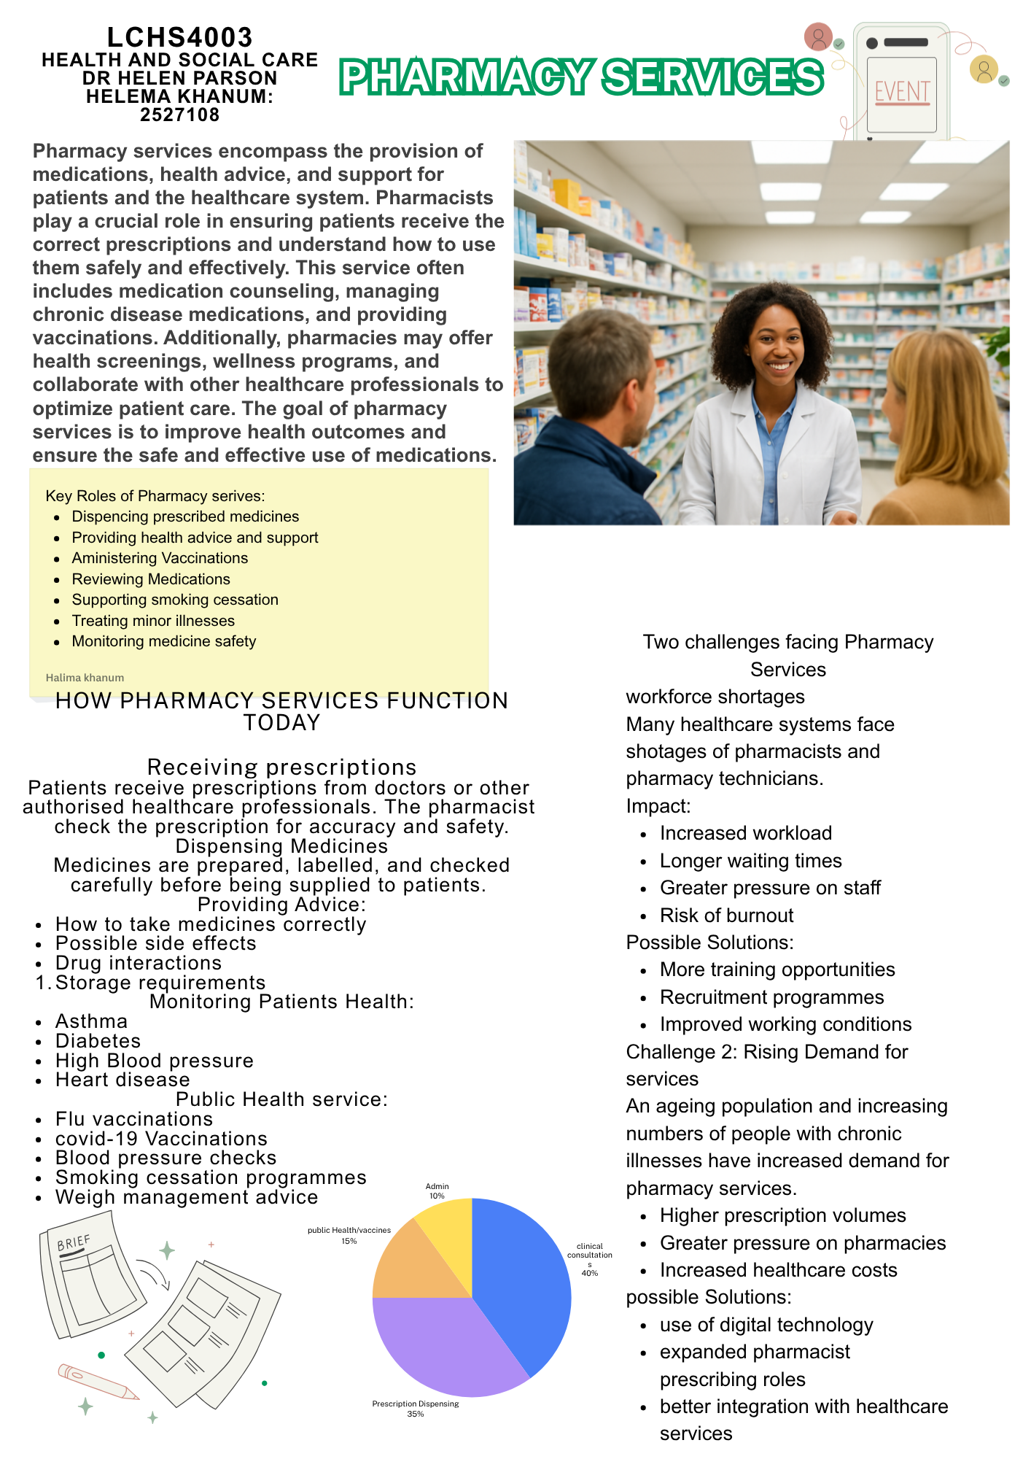

Community Mental Health Services: History, Current Function and Importance
Community Mental Health Services (CMHS) are an essential part of the United Kingdom’s health and social care system. They provide support and treatment for individuals experiencing mental health difficulties while enabling them to remain within their communities rather than being treated in long-term psychiatric hospitals. These services were developed to promote independence, social inclusion, and recovery for people with mental health conditions.
The origins of community mental health services can be traced to the mid-twentieth century. Before the 1950s, many people with mental illnesses were treated in large psychiatric institutions, often isolated from society. However, concerns about poor living conditions, human rights, and the effectiveness of institutional care led to a process known as deinstitutionalisation. In the UK, the Mental Health Act 1959 encouraged a shift away from asylum-based care towards treatment within the community. This policy change reflected growing recognition that individuals could achieve better outcomes when supported in their own social environments rather than in long-term hospital settings. Community-based services continued to expand throughout the 1960s, 1970s, and 1980s, becoming a central component of mental health care provision.
Today community mental health services operate through multidisciplinary teams that include psychiatrists, mental health nurses, psychologists, social workers, occupational therapists, and support workers. These professionals work together to assess needs, develop care plans, provide treatment, and coordinate support. The services offer a range of interventions, including psychological therapies, medication management, crisis support, employment assistance, and physical health monitoring. Modern NHS policy emphasises integrated care, ensuring that mental health support is delivered as close to home as possible and tailored to the individual's needs.
Despite their benefits, community mental health services face several challenges. One strength is that they promote recovery and independence by helping individuals remain connected to family, education, employment, and community networks. Research suggests that community- based care can reduce social exclusion and improve quality of life compared with institutional care.

However, the effectiveness of these services is often limited by funding pressures, short shortages, and increasing demand. Reports have highlighted difficulties such as long waiting times, high caseloads, and workforce shortages, which can affect the quality and accessibility of care. Some service users report feeling unsupported or experiencing delays in receiving appropriate treatment, while healthcare professionals have raised concerns about unmanageable workloads.
The significance of community mental health services lies in their ability to enhance the quality of life of service users. They provide support that enables individuals to manage symptoms, maintain relationships, and participate in everyday activities. Access to local mental health services can reduce hospital admissions, support recovery, and improve overall wellbeing. Furthermore, community-based care encourages person-centred practice, allows services users to have greater involvement in decisions about their treatment and support NHS reforms continue to promote integrated and personalised approaches to ensure that people with severe mental health needs can live well within their communities.

In conclusion, community mental health services emerged from the movement away from institutional care and have become a key part of modern health and social care provision. Although challenges such as staff shortages and rising demand remain, these services play a vital role in supporting recovery, these services play a vital role in supporting recovery, independence, and social inclusion. By delivering care within local communities, they help improve the quality of life for individuals living with mental health conditions and contribute to a more compassionate and effective system of care.
Reference List (Harvard Style)
Department of Health and social care (2026) Community mental health services: government's response to the Health and Social Care Committee’s report. Available at: http://www.gov.uk/government/publications/community-mental-health-services-governments-response-to-be-the-health-and-social-care-committees-report (Accessed:18 June 2026).
NHS England (2025) Community mental health services. Available at: https://www.england.nhs.uk/mental-health/adults/cmhs/ (Accessed: 18 June 2026).
Martin, F.M. (1984) Between the Acts: Community Mental Health Services 1959-1983. London: Nuffield Trust.
World Health Organization (2007) Community mental health Services will lessen social exclusion. Geneva: WHO

