Name: Ross Van Den Eeckhaute-Jones
Student P Number: P151366
Module Title: Wireless Networks and Simulation
Module Code: ACCA5004
Assignment Title: Design and Evaluation of Computer Networks
Module Lecturer: Dr Carlene Campbell
Date: 25/04/2018
Design and Evaluation of Computer Networks

Ross Van Den Eeckhaute-Jones
University of Wales Trinity St. David
Swansea, Wales
Rvandeneeckhaute-jones.151366@student.uwtsd.ac.uk

Abstract— This paper will include research, design, implementation and evaluation of BPSK (Binary Phase Shift Keying) modulation techniques, along with the design, implementation and evaluation of WSN (Wireless Sensor Network).
Keywords—Wireless Simulation, BPSK, UWTSD

Introduction
This document will provide experience of using wireless simulation software at the MAC (Media access control) and physical layer. The performance of different modulation techniques will be explored. The main focus will be on BPSK (Binary shift phase keying).

Starting with research into the modulation scheme and techniques of BPSK, the paper will lead into conducting an experimental study based on the above researched modulation scheme BPSK. The experiment will make use of Simulink to create a model based on BPSK. The performance of the model will be evaluated at differing points while introducing increasing levels of noise affecting the channel. The main performance parameters used will be Bit Error Rare (BER) against SNR. Where possible, results of the experiment will be linked back to the previous research to see if it is accurate.

The concluding section of this document will include the design and evaluation of a Wireless Sensor Network to accommodate a Smart Factory. The WSN (Wireless Sensor Network) will include ways to monitor Occupancy, Secured entry, Fire safety, Lighting and Motion detection.
The system must be viewable from the Warehouse Managers PC as well as the Reception PC and Health and Safety Officers Smart Device. The WSN must also be accessible remotely by “Warehouse Secure”, a security contractor.

Table of Contents
Section | Page No.
Cover Sheet | 1
Abstract | 2
Introduction | 2
Figures and Tables | 3-6
Research on BPSK and modulation schemes | 7-8
Simulink BPSK experiment and results | 9-10
Netsim WSN experiment and results | 11-12
Conclusion | 13
References | 14

List of Figures and Tables
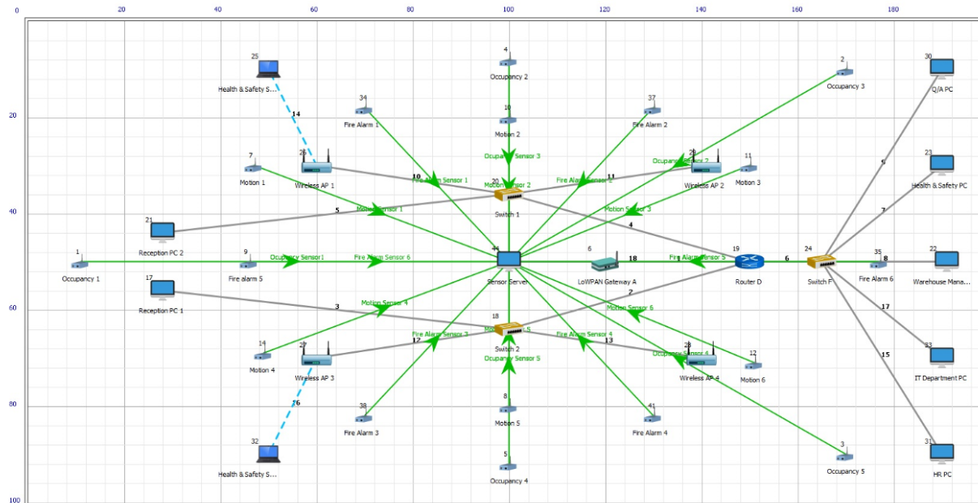

Figure 1. Netsim Wireless Sensor Network

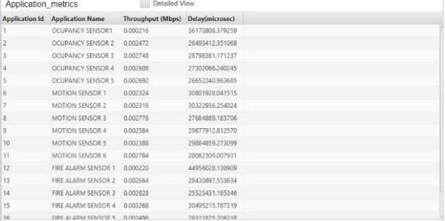

Figure 2. Packet Delay from WSN NetSim Simulation

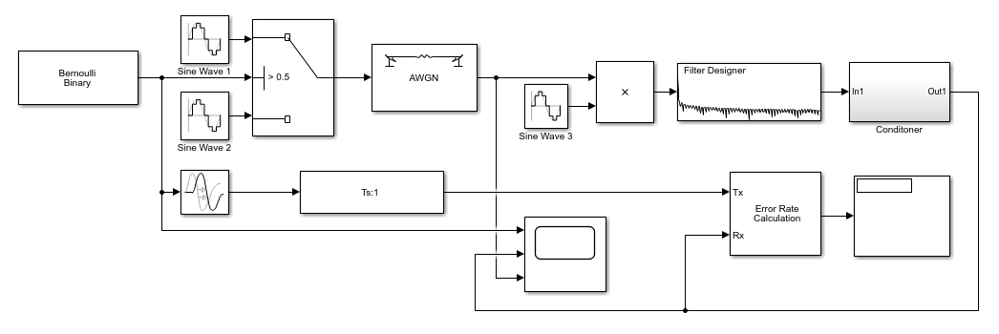

Figure 3. Simulink setup for BPSK simulation

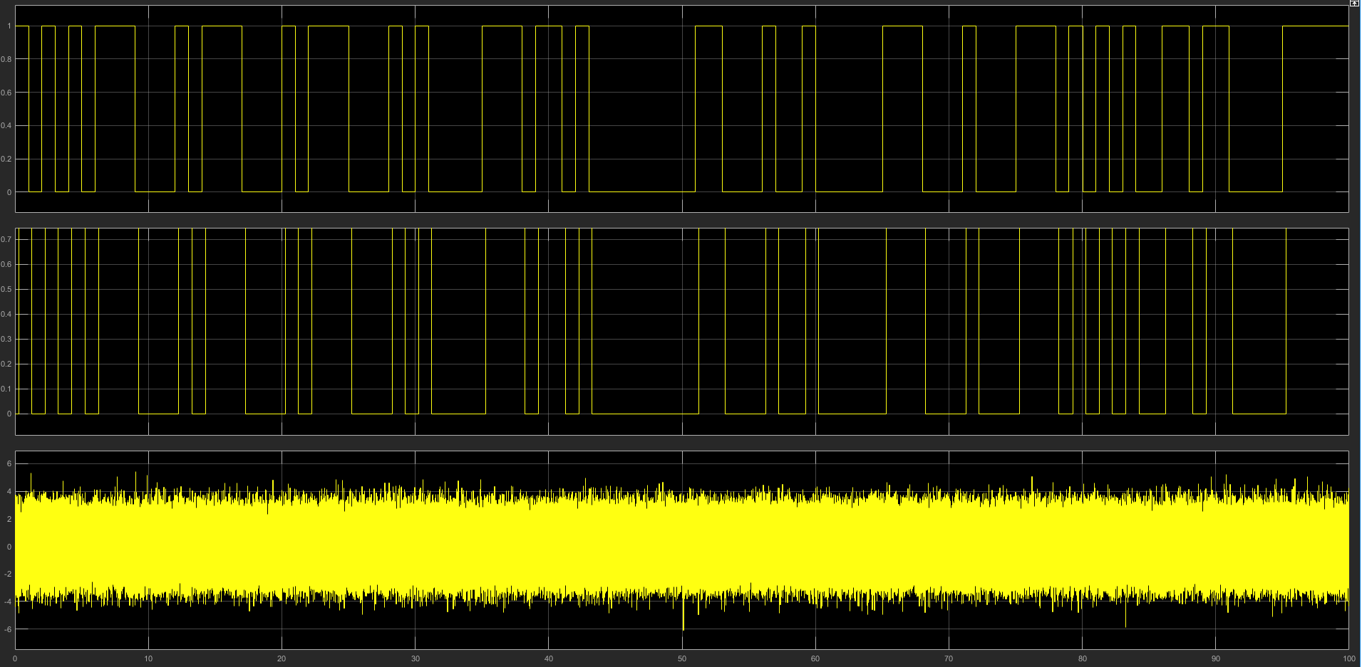

Figure 4. Simulink 0 Db noise simulation

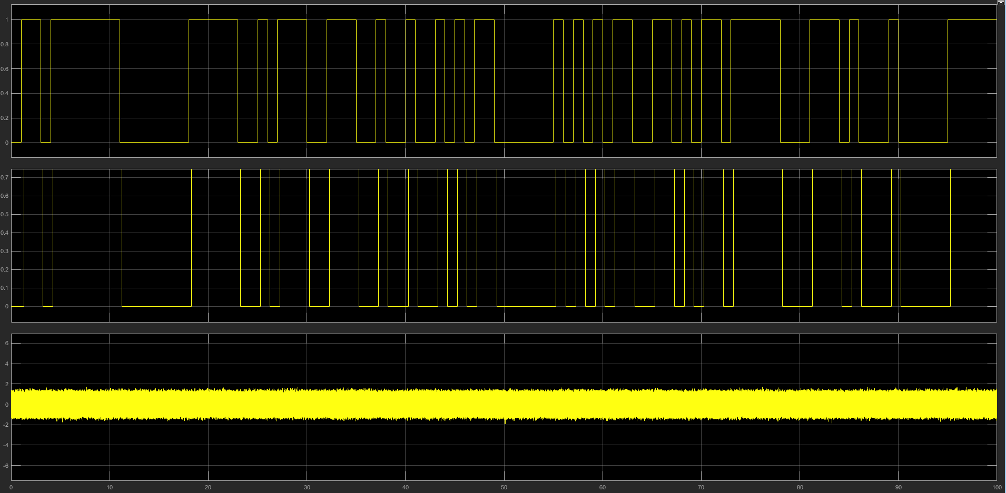

Figure 5. Simulink 15 Db noise simulation

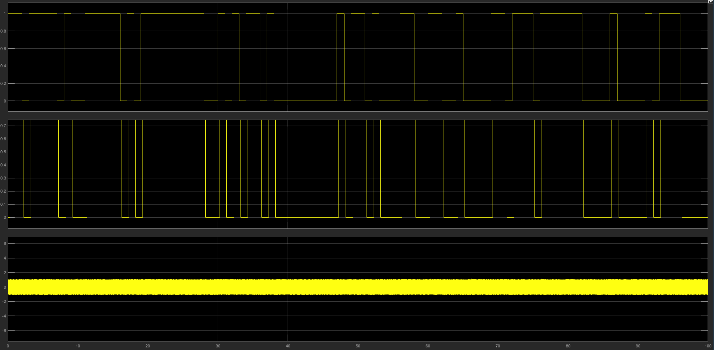

Figure 6. Simulink 30 Db noise simulation

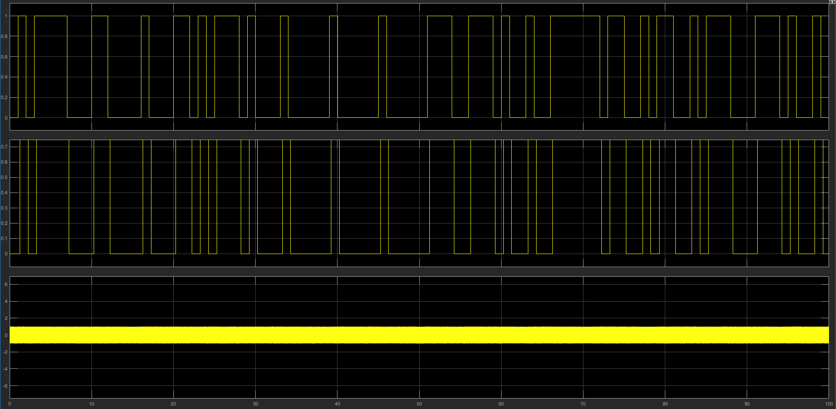

Figure 7. Simulink 60 Db noise simulation

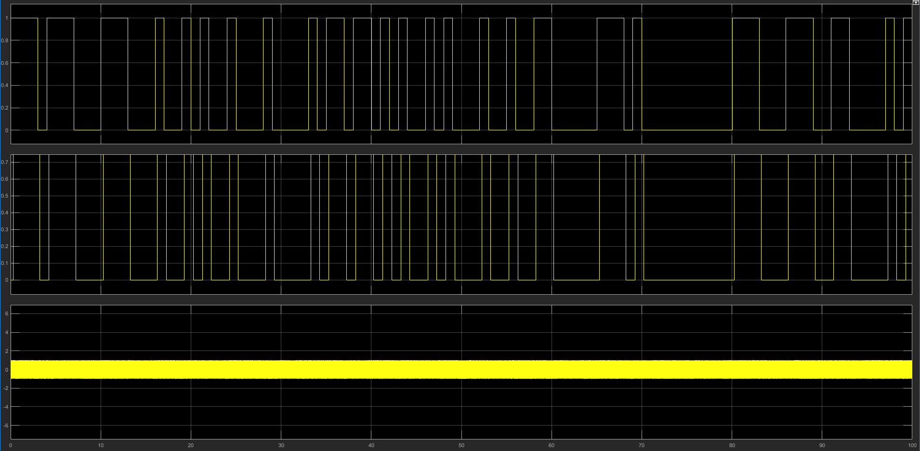

Figure 8. Simulink 100Db noise simulation

Research of Modulation Schemes

The function of modulation/demodulation in a communication system is to translate to and from both communication data and information signals. which can be sent and received between two systems. Demodulation allows received data to be translated back to the original communication data. [1]

A typical communication transaction starts with communication data, which is translated into an information signal using modulation. Modulation translates the communication data into an information signal using varying amplitude, frequency or phases to store and transport the data. The information signal is sent to the receiver. The receiver then demodulates the information signal back into the original communication data [1]

Modulation/Demodulation allows a signal to be sent over longer range as there is less data lost over distance. Modulation also allows the signal to be sent using antennas much smaller than required if the signal was not modulated, in some cases it would be impractical or even impossible to build antennas to accommodate such large unmodulated signals. [1,2]

Modulation can allow multiplexing, which is the ability for two or more signals to be transmitted over the same channel simultaneously. Modulation also improves quality of reception from receivers leading to less lost data and more accurate data communication. [1]

BPSK is the simplest form of PSK (phase shift keying). BPSK uses two phases, a 0 and a 1 as a variable. Due to BPSK having the lowest number of variables, BPSK suffers the least from noise levels compared to other modulation schemes. However due to BPSK operating using only 1 bit, it is incapable of reaching the data modulation/transfer levels of other modulation techniques such as QPSK and QAM. [1-3]

Software like MATLAB can allow simulation of a range of real world situations, for example simulating the latency of systems of various sizes and distances, bandwidth limits of different hardware or hardware setups, user limits of network systems and a massive range of real world scenarios. [1,4,5]

A real-world scenario could be simulating the WIFI range and signal strength of a building to see if 3 wireless access points would provide sufficient coverage, or if a 4th or even 5th wireless access point would be worth the extra cost to increase connectivity in high traffic areas of a building.

More data that could be discovered from these simulations could be black spot analysis, to access if a black spot needs to be eliminated due to being a high traffic area, or if it is fine as it is due to there being no need of a connection in that area of the premises. [5]

High traffic areas may require more powerful hardware due to bandwidth limits being regularly met, resulting in slow connections in high traffic areas This kind of information can come from simulated environments. [5]

Modulation schemes such as BPSK can be implemented into communication systems to allow modulation of sent and received signals. Communication systems that do not make use of modulation will suffer from loss of data, slow data transfer rates as well as incurring more costs of infrastructure to send unmodulated data. Unmodulated data is also more susceptible to security risks as the data is sent as it is, and not in an unreadable form. [1-4]

Advantages of BPSK [1]

- Can be sent with lower infrastructure than unmodulated data requires (smaller antenna)
- Reduces signal mixing resulting in less data loss when sending information
- Increased range due to sending a simpler, modulated signal instead of a varying frequency signal.
- Quality of reception is increased due to modulated signals being less affected by noise
- Supports multiplexing
- Efficient power usage while sending smaller number of bits compared to other modulation schemes
- Fast receive times due to less time to demodulate data

Disadvantages of BPSK [1]

- Lower bitrate compared to other modulation schemes
- Not as efficient as other modulation schemes

There are pros and cons of both simulations and real-life scenarios. Simulations can accomplish testing on a scale that may be impractical or even impossible in a real world, especially when dealing with expensive or mission critical projects. [4,5]

Simulations however can only quantify so many variables. A single non-accounted for variable could cause a catastrophe in a real-world setting. [4,5]

The sheer scale possible with simulations usually results in accurate outcomes due to the ability to repeat thousands and thousands of simulations in a relatively small time frame. [4,5]
Cost is another huge factor in deciding between simulation or real-world testing. A network layout for a factory that has 1000 employees can be designed and be ready for simulation in potentially hours, as well as the ability to move, add and delete some design aspects at the click of a mouse. [5]

To setup and test a real-world scenario of that size would take a huge amount of time and money without the ease of modifying the setup which could include having to order more hardware in (delivery time) schedule more workers to work on site [4,5]

To be able to build and modify a real-world scenario in a software program can also add to innovation by being able to quickly and easily make small changes which would not even be thought of in a real-world scenario due to taking more time or may not even be viewed as possible. [5]

Real world Testing does have its benefits. Factors which may go unseen in a simulation environment may cause huge problems in a real world, which would only arise in a real-world setting. For example, a simulation which expects too much from a real person with human error being a bigger problem than expected could produce inaccurate results. [5]

Simulink BPSK Experiment

A simulation environment will be set up using Simulink. The simulation will be carried out at the MAC – Physical layer. Expanding on the previous research, BPSK will be analyzed evaluating various performance factors.

A simulation will be carried out to analyze how noise can affect BPSK signals. The performance will be evaluated at differing levels of noise, using BER (Bit error rate) against SNR (Signal to noise ratio) as the performance parameters. Where possible, results will be linked to the previous research carried out in this paper.

Simulink BPSK Experiment Results

A Simulation has been set up using Simulink. The simulation allows analysis of the BPSK signal while suffering from differing levels of noise. The simulation allows analysis at the MAC – Physical layer.
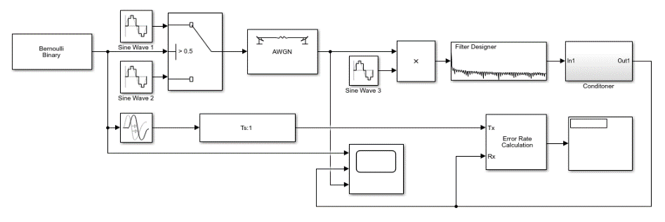

Figure 3. BPSK simulation

Below are the results of the BPSK simulations.
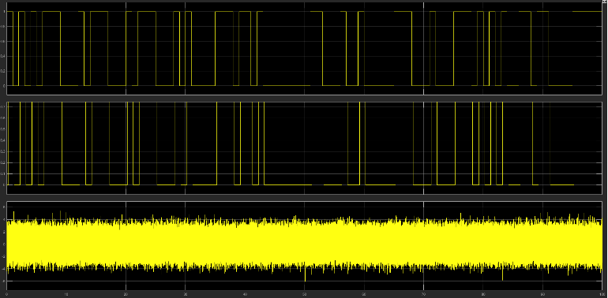

Figure 4. Simulink 0 Db noise simulation
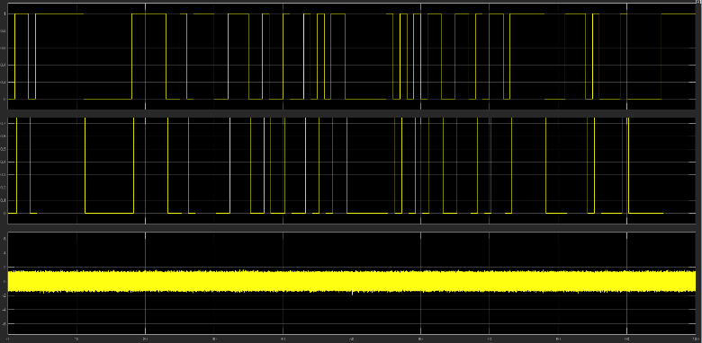

Figure 5. Simulink 15 Db noise simulation
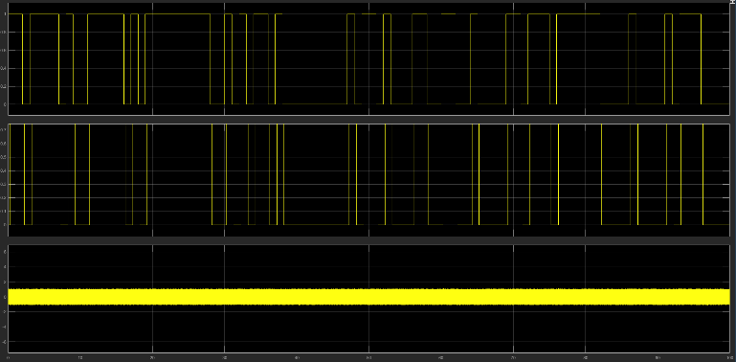

Figure 6. Simulink 30 Db noise simulation
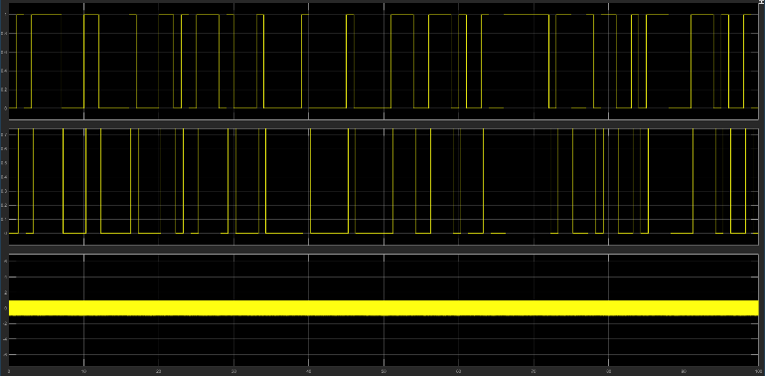

Figure 7. Simulink 60 Db noise simulation
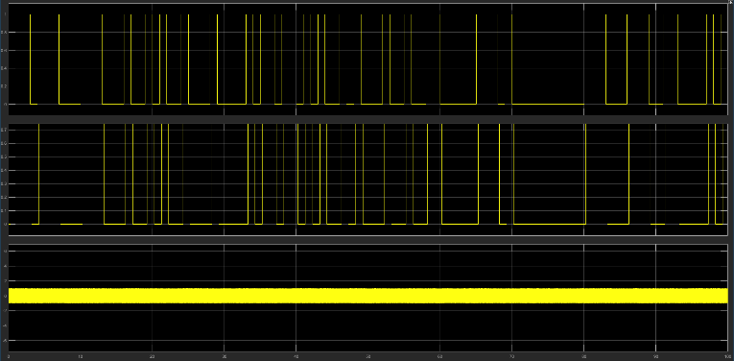

Figure 8. Simulink 100 Db noise simulation

As seen in the images from the simulations, the signal to noise ratio is very similar past the 30Db range.

At 0 noise level, the signal to noise level ranges roughly from -6.1 to 5.5.
At 15 Db of noise, the signal to noise ratio ranges from -1.7 to 1.7.
At 30 Db of noise, the signal to noise ratio ranges from -1.1 to 1.1.
At 60 Db of noise, the signal to noise ratio ranges from -1.1 to 1.1.
Past 100 Db of noise, the signal to noise ratio ranges very closely from -1 to 1.

Netsim WSN Experiment

A simulation scenario will be designed using NetSim. The simulation will be based on the requirements set for the “Smart Factory” which require the smart factory to include sensors for occupancy, secured entry, fire safety lighting and motion detection.

The Wireless Sensor Network will be able to be viewed by the warehouse manager, reception, the health and safety officer’s devices as well as being accessible remotely by the “Warehouse Secure” security contractor.

The performance of the Wireless Sensor Network will be measured using packet delay, which will give an accurate representation of the timings of each sensor, and if that would be a suitable for each type of sensor.

Netsim WSN Experiment Results

A Wireless Sensor Network has been created to fit the required needs of a factory. The factory has requested a “Smart Factory” setup including sensors for occupancy, secured entry, fire safety, lighting and motion detection.

As well as the previously mentioned requirements, the network will be linked to the warehouse managers PC, receptions PC and the safety officer’s smart device. “Warehouse Secure”, a security contractor will also be granted access to the network to remotely monitor security data and sensor information.

Below is the designed Wireless Sensor Network. To meet the requirements set by the factory, the WSN includes:
- A central sensor server
- 6 light controlling motion sensors
- 5 secured entry occupancy sensors
- 5 fire alarms
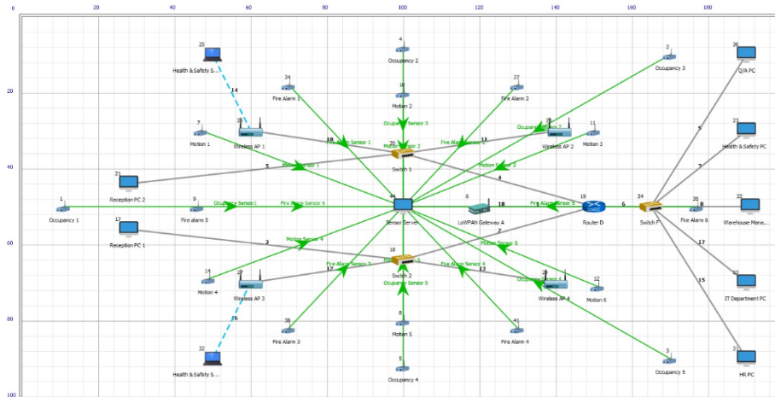
- 4 wireless access points

Figure 1. Wireless Sensor Network Design

After designing the WSN using NetSim, the simulation was analyzed to view information such as packet delay, complexity, bandwidth efficiency and robustness.

Figure 2. Packet delay from WSN simulation
The delay results for the various sensors range from 25 seconds to 44 seconds. This time is unacceptable for the sensors use. An acceptable time for each of the sensors is listed below:

Sensor | Acceptable Response Time (s)
Occupancy | 5-10 Seconds
Secured Entry | 0-3 Seconds
Fire safety | 0-3 Seconds
Motion detected lighting | 0-3 Seconds

Occupancy sensors can afford to have a longer response time than the other sensors. Occupancy sensors monitor the total number of people inside the factory. Due to this, the time it would take for the occupancy information to be inaccurate is equal to the max response time of the sensor, and how many people could enter or leave during that time. User experience as long as the motion sensor is functional is the same if the sensor takes 1 second or 20 seconds.

Secured Entry sensors must be faster, as anything slower than 3 seconds per person to securely enter the factory could result in massive queues and potentially result in more workers being late. Also, workers will not want to spend longer than 3-5 seconds waiting to clock in or gain access to their workplace, due to this the user experience is directly affected by the delay from the Secured Entry sensor.

Fire safety sensors can be a critical in safety for the factory, both the employee safety and factory infrastructure/hardware/data. It is critical that the fire safety response times are fast. A long delay in fire safety sensors could result in employee injury or death, as well as damage to factory equipment hardware and data. Fast fire safety response times ensures maximum evacuation success for employees as well as the best chance of not losing important data and hardware inside the factory.

Motion detected lighting allows lights to be controlled by movement. This results in reduced electricity costs for the factory and ease of use for the employees. A response time of over 3 seconds could be a health and safety hazard in the workplace due to workers potentially tripping or walking into things in the dark. A response time of under 3 seconds would be ideal.

The results of the NetSim simulation displayed delays on all sensors at unacceptable levels. This may be due to improper simulation setup, or perhaps the network would benefit from separate servers for each type of sensor to better manage the workload on the system from the sensors.

Conclusion

Overall, BPSK is a suitable modulation scheme for many real world scenarios however can be inefficient with bandwidth as it can only send 1 bit at a time, whereas QPSK and QAM can send more.
The wireless sensor network was designed with each requirement in mind and followed a suitable layout for the factory. The Wireless sensor network suffered from delay problems which may have been caused by having every sensor communicating with a single sensor server, where it may be beneficial to have separate servers for each type of sensor, or some kind of setup to reduce the load on the single sensor server.

References
[1] “Explain the need for modulation in a communication system – Electronics Post.” [Online]. Available: https://electronicspost.com/explain-the-need-for-modulation-in-a-communication-system/. [Accessed: 18-Apr-2018].
[2] “Design and Implementation of BPSK Transmitter and Receiver for Software Defined Radio on a Model Based Development Platform.”
[3] A. Khan, A. K. Singh, D. K. Gupta, and D. K. Vimal, “Communication System Using BPSK Modulation,” Int. J. Sci. Eng. Res., vol. 4, no. 5, 2013.
[4] B. Patnaik and P. K. Sahu, “Optimized ultra-high bit rate hybrid optical communication system design and simulation,” Opt. - Int. J. Light Electron Opt., vol. 124, no. 2, pp. 170–176, Jan. 2013.
[5] X. Xu, W. Wang, L. Yi, J. Rong, and A. Wang, “Simulation of Frequency Hopping Communication System Based On MATLAB.”

marking criteria and Student FEEDBACK

This section details the assessment criteria. The extent to which these are demonstrated by you determines your mark. The marks available for each criterion are shown. Lecturers will use the space provided to comment on the achievement of the task(s), including those areas in which you have performed well and areas that would benefit from development/improvement.

Common Assessment Criteria Applied (Assignment 1) | Marks available | Marks  awarded
1. Research-informed Literature
Extent of research and/or own reading, selection of credible sources, application of appropriate referencing conventions.
More credible sources could be consulted. Report lacks diversity of sources and materials used. (Grade mark: 40.00%) | 15 | 6
2. Knowledge and Understanding of Subject
Extent of knowledge and understanding of concepts and underlying principles associated with the discipline.
Lack depth of research just giving general information. Consulting more research article would have improve this area. (Grade mark: 40.00%) | 15 | 6
3. Analysis
Analysis, evaluation and synthesis; logic, argument and judgement; analytical reflection; organisation of ideas and evidence
Your report lacks discussions. You could cross-referenced your discussions with your research aspect. Your abstract, introduction and conclusion need improvement; see comment given in your report. Try to stick to the IEEE layout to ensure that the document will flow. The lack of evaluation in the results for BPSK may affect the understanding or impact on the WSN. (Grade mark: 43.33%) | 30 | 13
4. Practical Application and Deployment
Deployment of methods, materials, tools and techniques; application of concepts; formulation of innovative and creative solutions to solve problems.
The lack of testing and results makes it difficult to bring the report to conclusion. No mention of Path loss and how the delay was implemented. No discussion regarding Packet Loss or Throughput which are 2 of the basic elements for testing a WSN (Grade mark: 45.71%) | 35 | 16
5. Skills for Professional Practice
Attributes in professional practice: individual and collaborative working; deployment of appropriate media; presentation and organisation.
Report readable. Could do with some formatting and improve grammatically.  (Grade mark: 50.00%) | 5 | 2.5

Assignment Mark (Assessment marks are subject to ratification at the Exam Board. These comments and marks are to give feedback on module work and are for guidance only until they are confirmed. ) | Late Submission Penalties (tick if appropriate) |  | 44%
 | Up to four weeks late |  | 44%
 | First Attempt? |  | 44%

