Jon Morgan (2501590)

Student Name: Jon Morgan
Student Number: 2501590
Course: Applied Computing
Module Name: Web and Database Concepts
Submission Date: 21st of November 2025
Contents
Introduction: 2
Requirements: 3
Implementation: 4
Evaluation 8
References 17
Appendices: 18

Introduction:

This Report presents the design, development and evaluation of a website with multiple pages that is focused on promoting Welsh Culture through a festival. The report begins with a brief introduction to the website, describing it’s purpose, why it was created, and it’s intended target audience. Later, the report provides a screen shot of it’s code on both the Homepage, and Style sheet. To ensure the website was flawless, I ran it through a validator that identifies any issues with the code. I later evaluated my my work by considering three different terms and applying them to the quality of my website: Usability, accessibility, and SEO. To further analyse my work, with reference to WCAG 2.1, I evaluated and briefly discussed the four main principles that provide the foundation for web accessibility. And then finally, the final task was to compare two live websites to gain an idea of how they have similar functions and then to ultimately decide which website was better after considering multiple different areas.

Requirements:

The main goal of my website was to expand and hopefully educate others on the rich culture that exists within the heart of Wales. The country is naturally stocked with culture making this exercise easy to research and make into a website. Ultimately, the goal was to create an experience that educates but also entertains. In doing this, people of all ages will be attracted to the culture and want to know more. The Event’s webpage was written primarily in English to boost popularity and to ensure that those who are interested are aware of where to go and when. The Page demonstrates information such as, Traditional foods, activities, music, and festival stalls, all of which contribute toward showing others the rich heritage rooted within Wales. The website is primarily written in English with the intention of prioritising inclusivity. Presenting in English widens the target audience to a larger category of people such as, tourists, students, and cultural enthusiasts. The event is also very effective for people who seek authentic insights into Welsh heritage. The audience most likely have little to no knowledge regarding the Welsh, meaning the website has been accommodated in such a way that is both accessible and welcoming for them. The page has not only been structured accessibly but also designed intricately. Appropriate Welsh colours such as Red, White, and Green. Along with appropriate colours, an image of the Welsh dragon has been placed on the home page to draw the user’s attention and demonstrate the formality of the website. My website has also been ensured to be accessible on multiple devices with readable fonts and sizes for text. The Welsh language has been used in several areas but has been kept at a minimal to ensure the user can efficiently navigate the website without issues such as confusion or visual clutter.

Implementation:

Homepage:
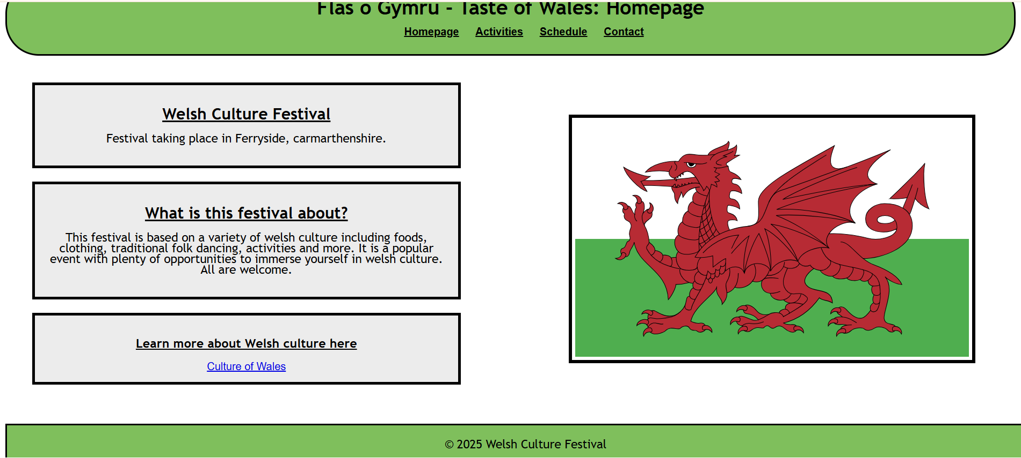

Activities:
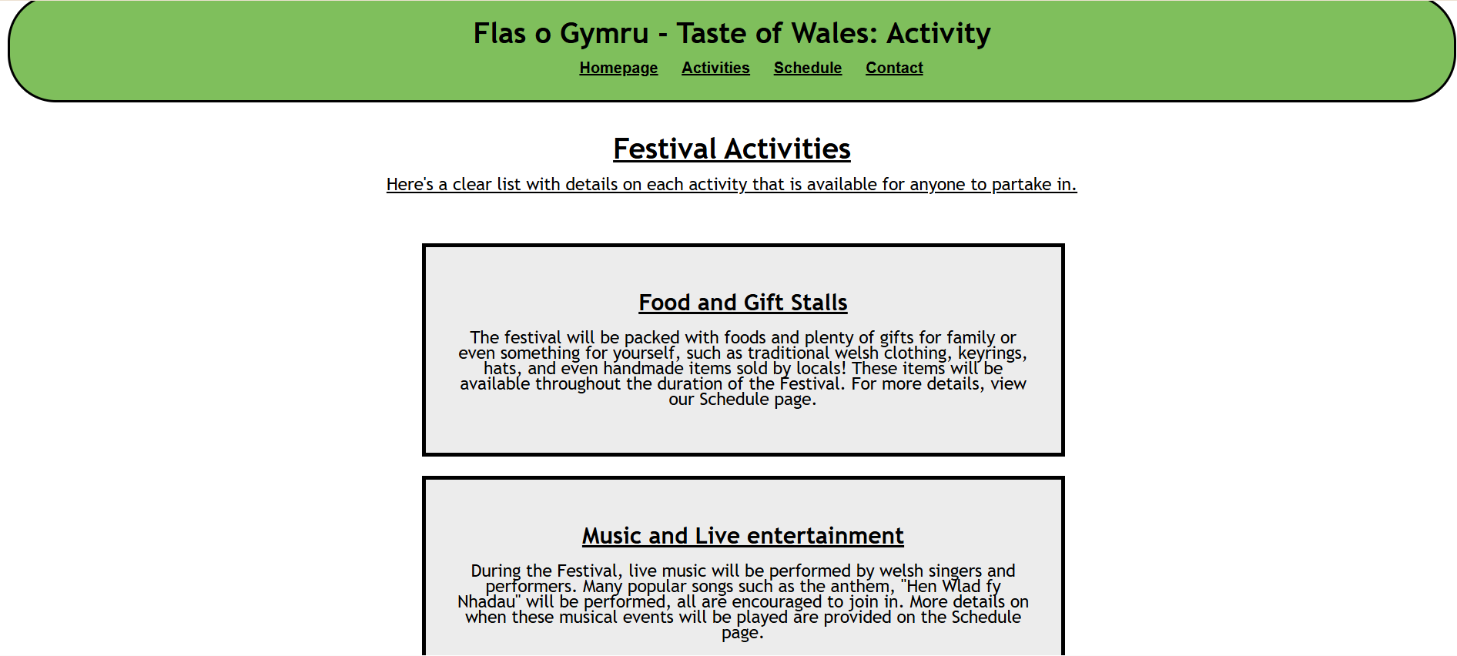

Schedule:
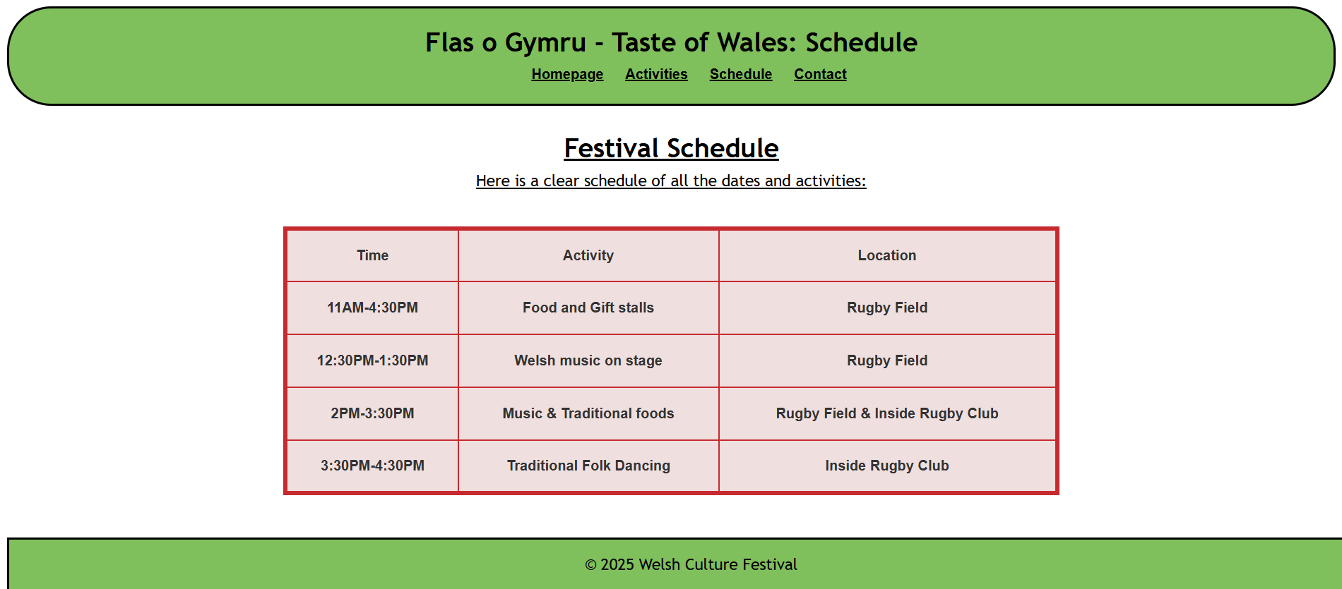

Contact:
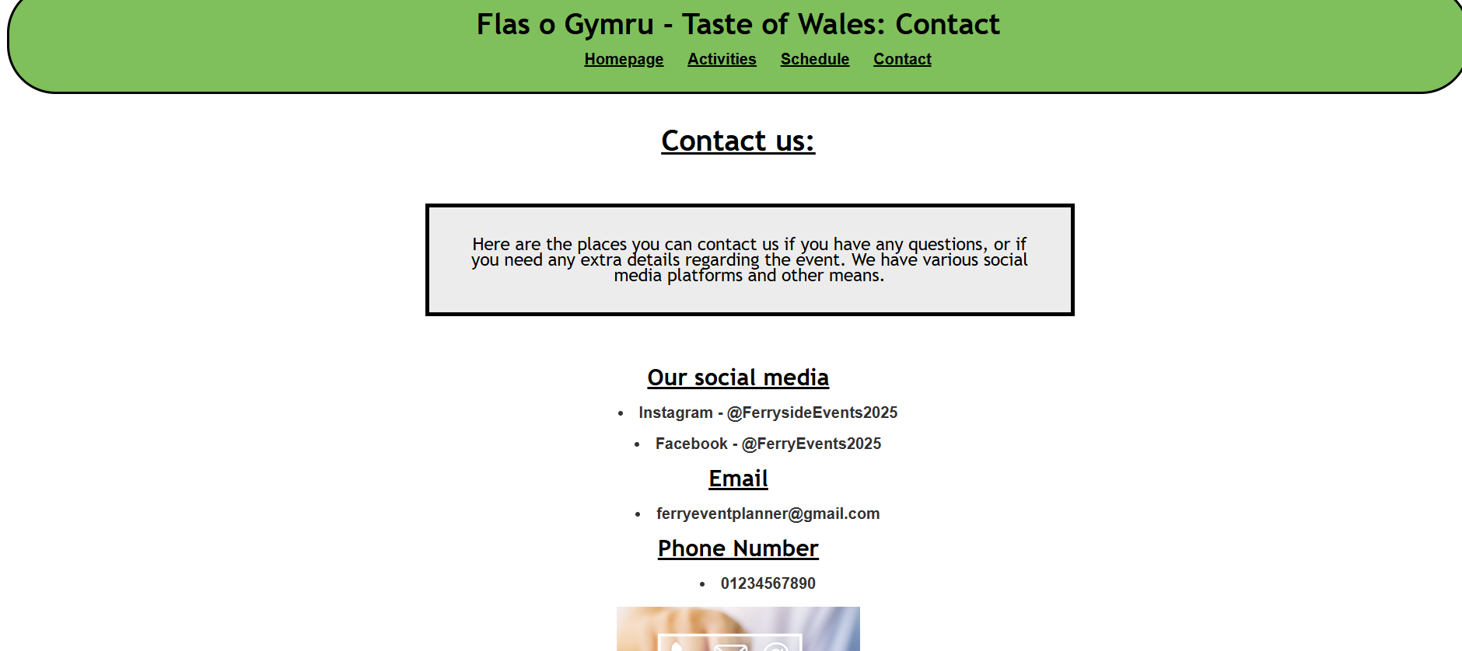

Validating HTML/CSS:
I will be using validators to assess the quality of my HTML and CSS file. This way I will be able to be certain as to whether there are any issues within the code that could ultimately affect the quality of the Website.
HTML (before):
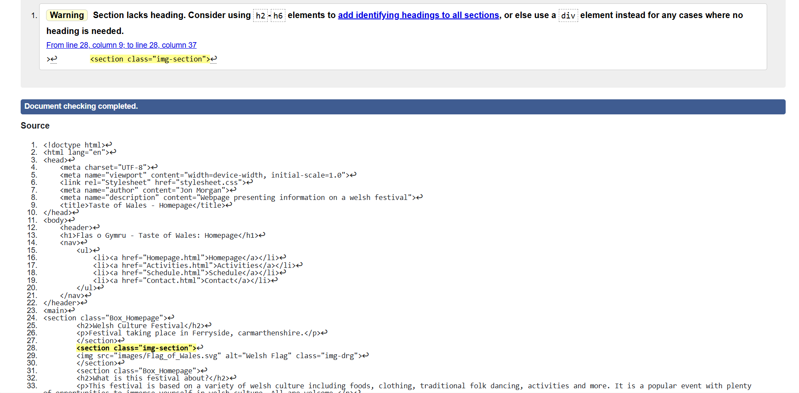

The validator has picked up on an error within my homepage. I have incorrectly used a <section> tag without a heading. To be correct, I should have used a <div> tag instead. There are no further issues with the page.

HTML (after):
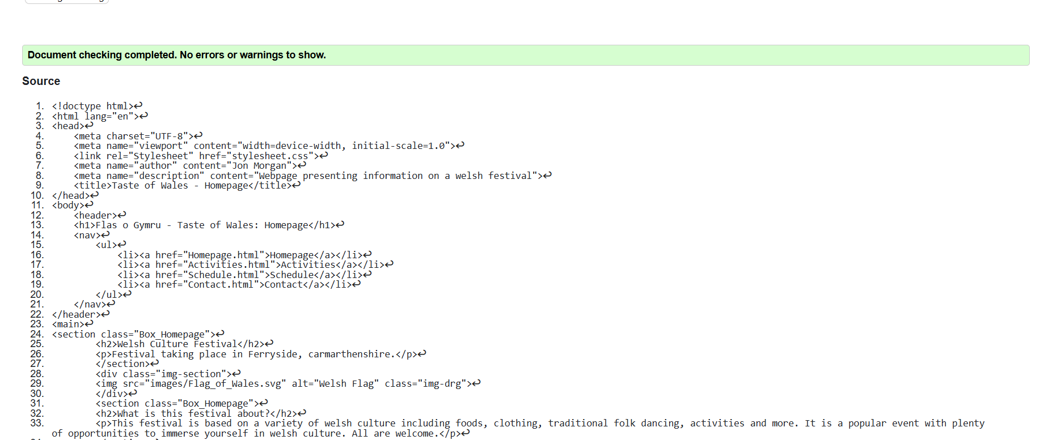

To correct the mistake, I changed the <section> tag to a <div> tag. I understand that I was incorrect as each <section> tag requires a header tag to go along with it. If there is not header tag, the alternative would be to use a <div> tag instead. The validator has found no further issues with the webpage.
CSS:
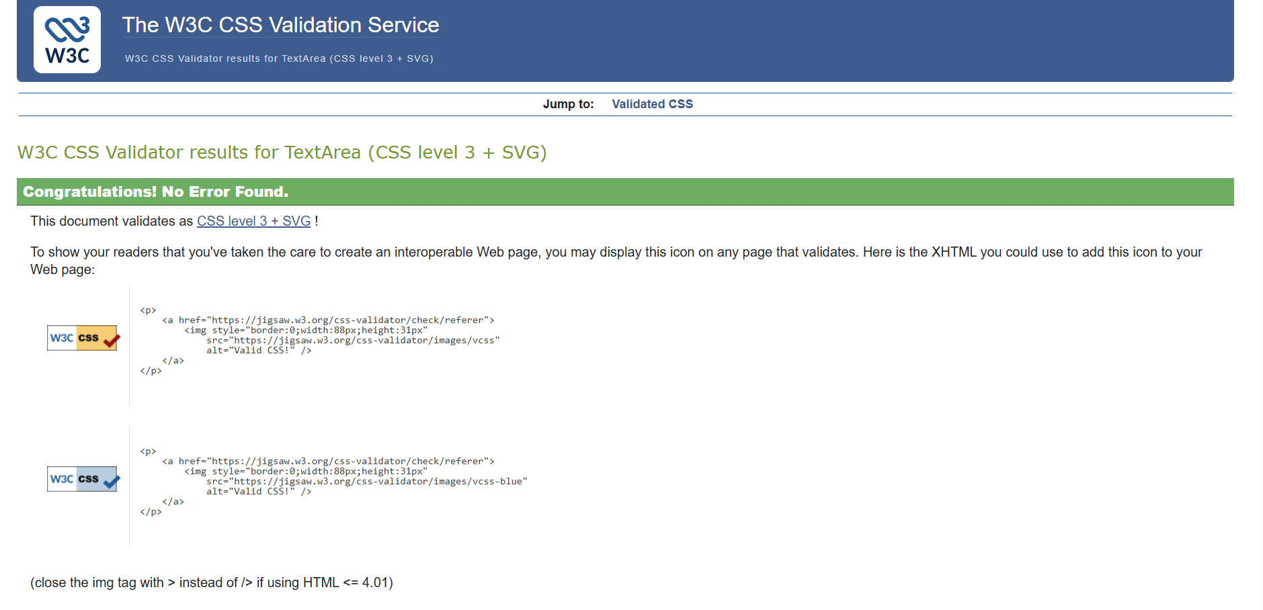

After running the CSS file through the validator, I can confirm there are no issues with the styling sheet.

Evaluation

Website usability:
The importance of website usability is vital for success in all websites regardless of the aim or purpose. In many cases, the website is the first interaction users have with the brand or event meaning presenting professionally and effective is vital to ensure that the user doesn’t leave and never return. It is vital that the website is built around the users needs, meaning the website must be easy to navigate, have a logical structure and also help users find information as swiftly and effectively as possible. This is important because users will visit the website for a specific reason, whether that’s to buy something or to find out information, the longer it takes for them to break down and comprehend the website, the higher the chance they will leave and not return. Despite the structure and layout of the website being of upmost importance, having a user-friendly website can also be the deciding factor between them choosing this website or a competitor. “On the Web, usability is a necessary condition for survival. If a website is difficult to use, people leave.” Having a responsive website on all devices widens and solidifies that most users will find the info they are looking for by merely navigating the pages of the website. A repetitive amount of visual clutter can also make the website feel too overbearing or overstimulating, which is why it’s important to have short precise points that clarify what you’re trying to get across.[1]

Accessibility
Accessibility much like usability, is vitally important when creating a website due to the variety of people who may or may not have some form of disability/ies. Ensuring inclusivity through the website guarantees that people with visual, auditory, motor or cognitive impairments can navigate and interact with the webpages without issue and that they aren’t excluded from certain content or services. Also, having accessibility options helps all users not just people with disabilities. For example, having captions can help in noisier environments or bold text can help if your eyes are strained. Accessible sites also widen the range of people that may enter and view the website and what it has to offer, thus improving engagement and retention. Having accessibility features within your website also demonstrates a sense of social responsibility and inclusivity, a sense of maturity and trust with others. This builds a solid reputation for whatever your website is marketing. A relatively large percentage of people in countries such as America struggle with some form of disabilities, which is why when designing webpages it is vital to consider these people and their situation, “In the US alone, 275 of adults have disabilities that may require assistive technologies to access online content,” This statement alone is enough to consider why accessibility is not optional but vital. [2]

Search engine optimisation:
Search engine is no less important as the others because it ensures that websites are made discoverable, competitive, and are aligned with user’s needs. Without ‘SEO’ most websites would be unable to be shown to it’s intended audience. Factors such as, Visibility, competitive edge, and ‘traffic generation’ all play key roles in an effective website. Firstly, SEO makes websites appear in search engine results, increasing the odds of others viewing your website, secondly, competitive edge gives the opportunity to smaller websites to compete against more popular websites by using key words to narrow down the search. Finally, traffic generation regardless of the type, is “primarily used to draw visitors to your website, whether that is done through unpaid search engine results (organic traffic), or paid traffic.” The benefits of SEO include, things such as brand exposure and long-term growth, both of which are vital for a steady growth within a webpage. [3]

Evaluation of my Website:
Usefulness:
Through analysing my website, I can confirm that many areas such as the design of my and its functionality are both at a comfortable level. The design choice in my website was chosen with careful consideration. Before deciding to side with a Welsh theme, I reflected on the many times I have found difficulty in navigating websites due to overly complicated, and overstimulating designs most websites bear. The simplistic design of my website was made with the intention of creating an easy, yet informative site that functions at a sufficient level. My focus was on a Welsh festival, an abundance of writing or information was not necessary for the planning or structuring of this event which allowed me to create these easily navigable pages. Simple designs like tables or lists or merely small paragraphs were also an option for me as they perfectly convey the info that is necessary. Despite the purposeful lack of over-designs, in the future it might be beneficial or attractive to add more colour, or images to the website in an attempt to draw more users.
Search engine optimisation (SEO):
During the creation of my website, a number of SEO techniques were used as a means of helping the visibility and to create a general image of my website to help search engines promote my page more often. Through using techniques such as <title>, <a> and <img>, I have successfully given search engines a general idea of what my website is about. This is mostly useful when people who are interested/looking for the content presented on my page, the search engine can guide them in my direction. Using said tags throughout my webpage also gives the engine a sense of how well organised the page is. Having a sufficient amount of <h1> and <h2> tags shows the search engine that my page professional, along with tags such as <a href> which shows the engine that my content is related to other pages of similar content. Typing text on the link also helps the user understand that there is more information related to what they’ve just read. More examples of how SEO tags are vital would be through ‘Meta tags’. Meta tags such as viewport tags allow the website to be viewed on an array of devices such as, laptops, phones, tablets and more. Using these tags essentially tells the website that the page can be used on many different platforms which is a huge rankings booster as the search engine can be certain that anyone can access it.

Accessibility:

Perceivable:
When creating the website, I ensured that the information displayed was readable and easy to perceive. Examples of this would be, alternative text for images and ensuring that the contrast between colours aren’t too extreme. I used the contrast checker platform to check the quality of the contrast between the colours on each page of the website, after doing so I am certain that the colours are safe and considered good to use for people who have any issues with their sight. Consistency is also key throughout all the webpages, ensuring that the structure is the similar if not the same. For my tables I kept a clear and understandable structure, text sizes remain the same and colouring remained simple for the sake of being accessible to all. Text replacement on images is also important, and I ensured that for any images I used throughout the website has the option to change to text if any issues may arise.

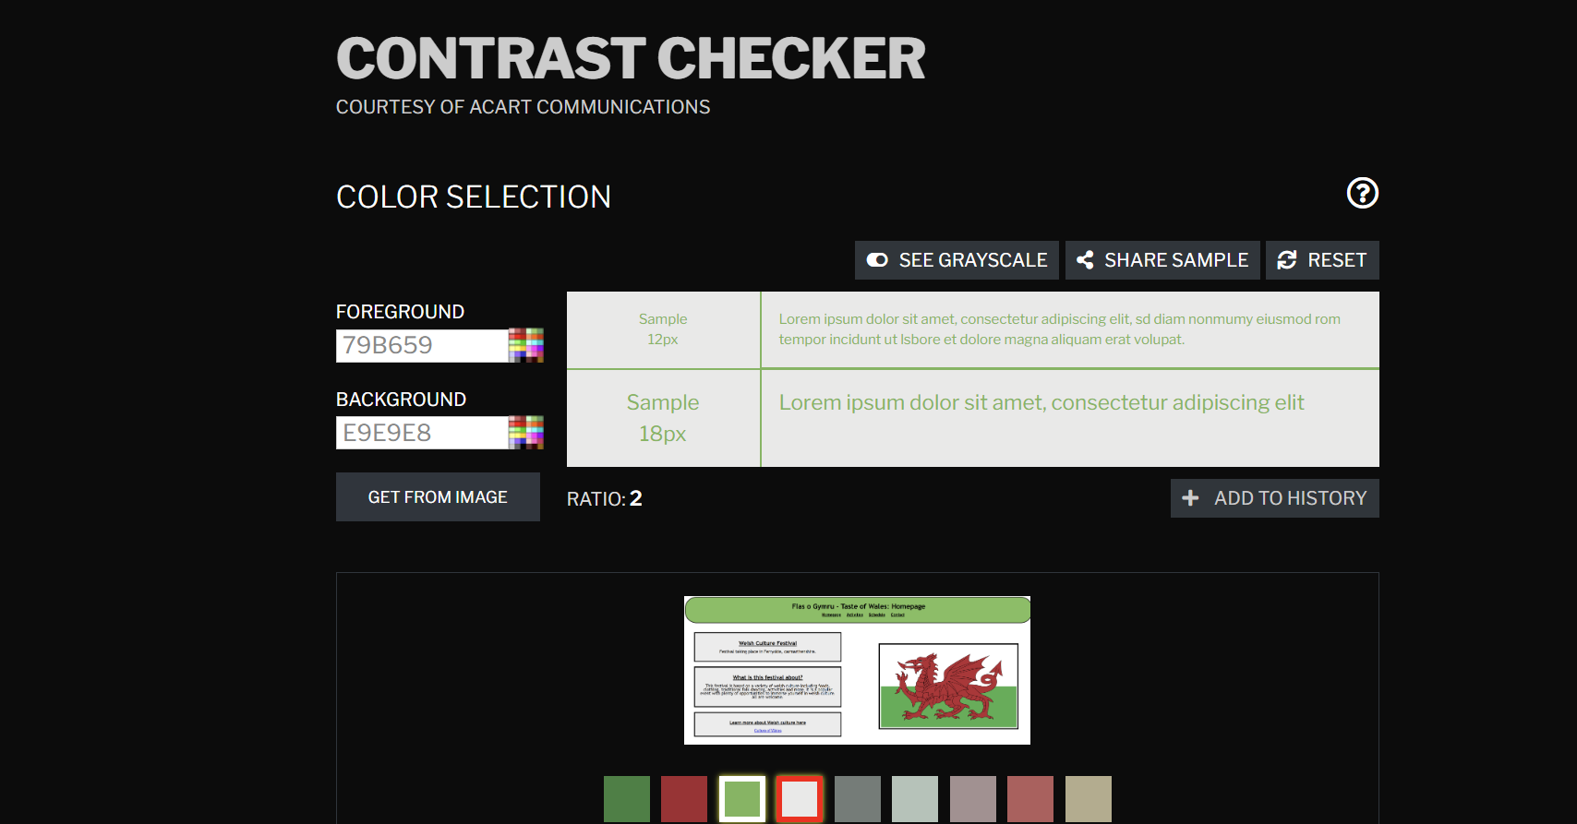
This is an image of the contrast checker. http://contrastchecker.com/

Operable:
Operable, much like perceivable is important for its own reasons. The website being operable in many areas like the tags functioning, the page being clear, and the style sheet functioning are all vital when considered as a collective within the website. Having all the pages work in synch and correctly is required for the user to have a positive experience. When designing my webpage, I tested the website through a variety of means such as, by opening the page on different devices and pasting the code into code checkers on websites such as validator.w3. Smaller details such as links highlighting when hovered over, page’s gentle colours, and similar designs throughout the website all contribute to a fluid and effective experience when navigating through the site and its pages.

Understandable:
Readable content is arguably the most important part of creating the website as most users decide whether they wish to continue using thew website or move to another in roughly 0.05 seconds, “In the era of the Tinder speed swipe, it takes just a tenth of a second to decide.” With this knowledge, it’s clear that first impressions are most important with the website, meaning sections such as headings, and main bodies of text have to be appealing. Ways to accomplish this would be through menus, links, and buttons should be in the same spot on all pages. Having a predictable design layout also would help users feel more confident when navigating the pages. Keeping the same flow, having interactive areas within the website will increase activity on the page but keeping it simple and intuitive is essential as overly complicated/overstimulating webpages will deter users and harm the overall experience. [4]

Robust:
Using proper HTML coding and validating it afterward is an essential section of the ‘Robust’ area because having correct coding is essential for assistive technologies such as screen readers, magnifiers and other tools to interpret the code and what it is trying to convey. This ensures that people with any level of disability can rely on the site at any point in time whether that is now, or a decade from now. Another important part of robust is ensuring that the website works on multiple different browsers such as google, edge, and Firefox. Using CSS to style the website also allows for specific adjustment on different sections such as the size or width of an object or text. This is important because the website should be visually pleasing on all web browsers. Finally, as mentioned before, providing ‘fall-back’ text when an embedded video or an image doesn’t load is a perfect way of informing others with or without disabilities what that certain element was for/about.

Comparing 2 live websites:
When viewing websites with similar properties such as Argos and Amazon, it can be difficult to determine which of the two have the better overall waultiy due to the high funding that went into creating the two. To be able to determine which of the two has better features, comparing factors such as Usability, Accessibility, SEO, Mobile friendliness, and conclusion all help roughly determine which website shines in which areas. To compare the difference between websites, I have decided to go with Argos and Amazon. These two websites are perfect examples of effective and popular websites meaning they have many different features that might be of similar or different quality.

Usability:
To begin the comparison, a check between both websites main pages will be a sufficient way to view which page has the objectively better/more attractive homepage. The quality of the homepage can be the determining factor as to whether the user will stay and continue browsing or move to the next. Lead contributing elements such as If the page feels clunky, or confusing can lead to the user feeling discouraged or could also potentially leave them unwilling to browse any further. More key components of usability would be efficiency and clarity. Being able to swiftly complete tasks is considered essential as most users attention span does not last long enough to sit and wait for a slow website to load, whether that’s when waiting for the site to load, when making a purchase, or contacting support. When comparing the actual websites, Argos has a simpler design, no extreme colours or overstimulating text unlike Amazon’s orange background which can seem distracting and hurtful upon strained eyes. Argos also seems easier to navigate as there is a bar to select a specific category of item, whereas Amazon does not have this, instead it displays an array of ‘deals’ which the user might find unhelpful as the item that has this ‘deal’ may be completely unrelated to what the user is searching for.

Argos’ homepage:
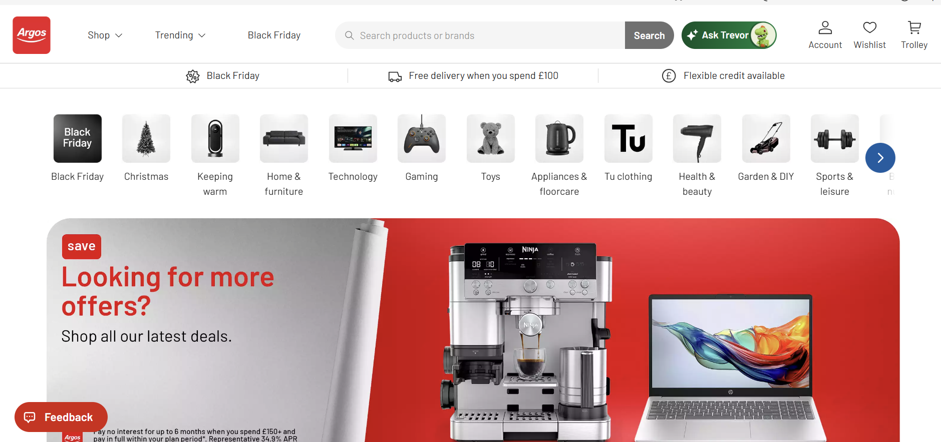

Amazon’s Homepage:
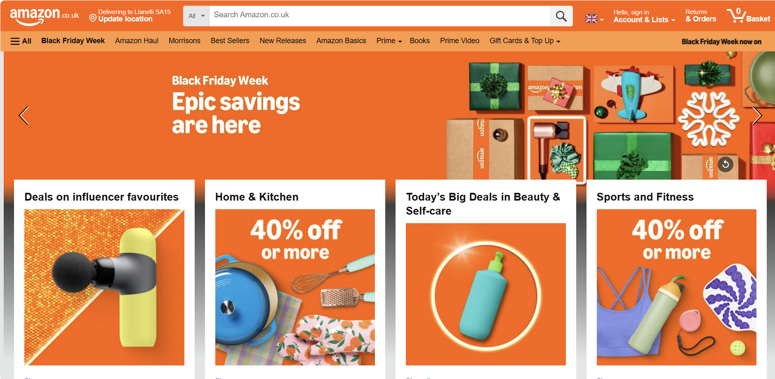

Accessibility:
Both Amazon and Argos offer accessibility features for their users but in different ways. Amazon directly offers features that benefit the user both directly on the website, but also on their other devices such as the Kindle. For their on-website support, they offer services such as; hearing support, vision support, mobility support and website navigation. And off the website they offer similar accessibility but to a different extent such as the visibility on a kindle. As for Argos, they only provide accessibility for their webpages. This includes keyboard navigation, assistive technology compatibility, and a fully customisable display. Both offer a very large array of features, although Amazon’s accessibility features reach slightly further as their reach goes beyond websites, but to other devices also. Their accessibility features are also more extensive. As stated on amazon’s website; “Accessibility means everyone, regardless of any disability or condition they may have, can receive the same benefits from a product or service.” These are not just empty words as Amazon have proved themselves with their extensive accessibility options. [5]

Argos accessibility:
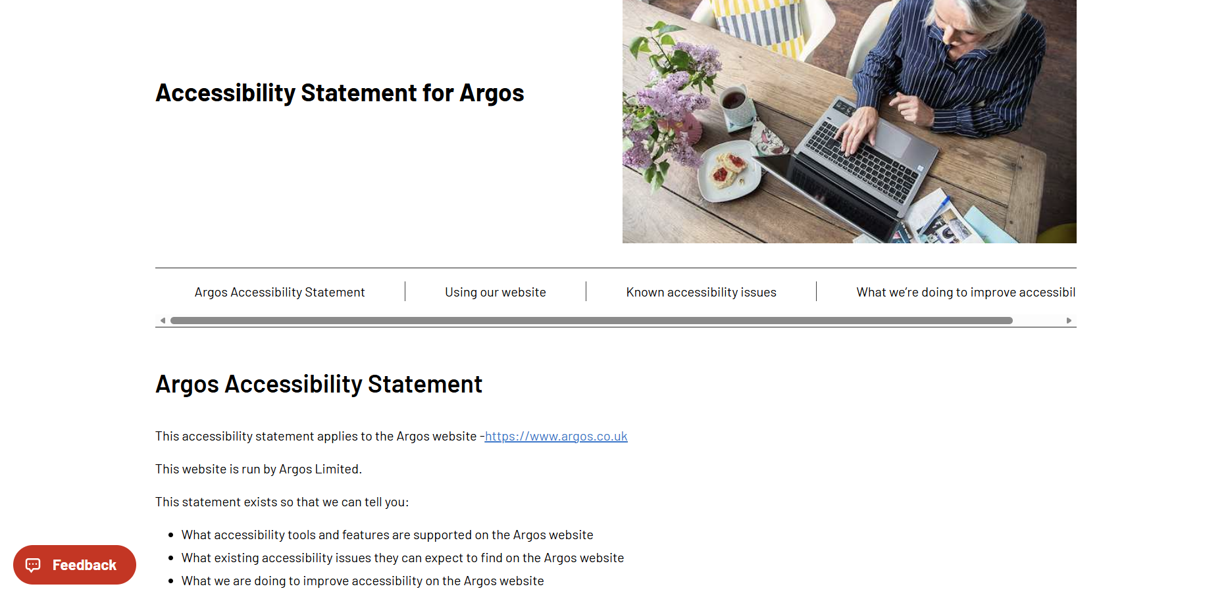

Amazon accessibility page:
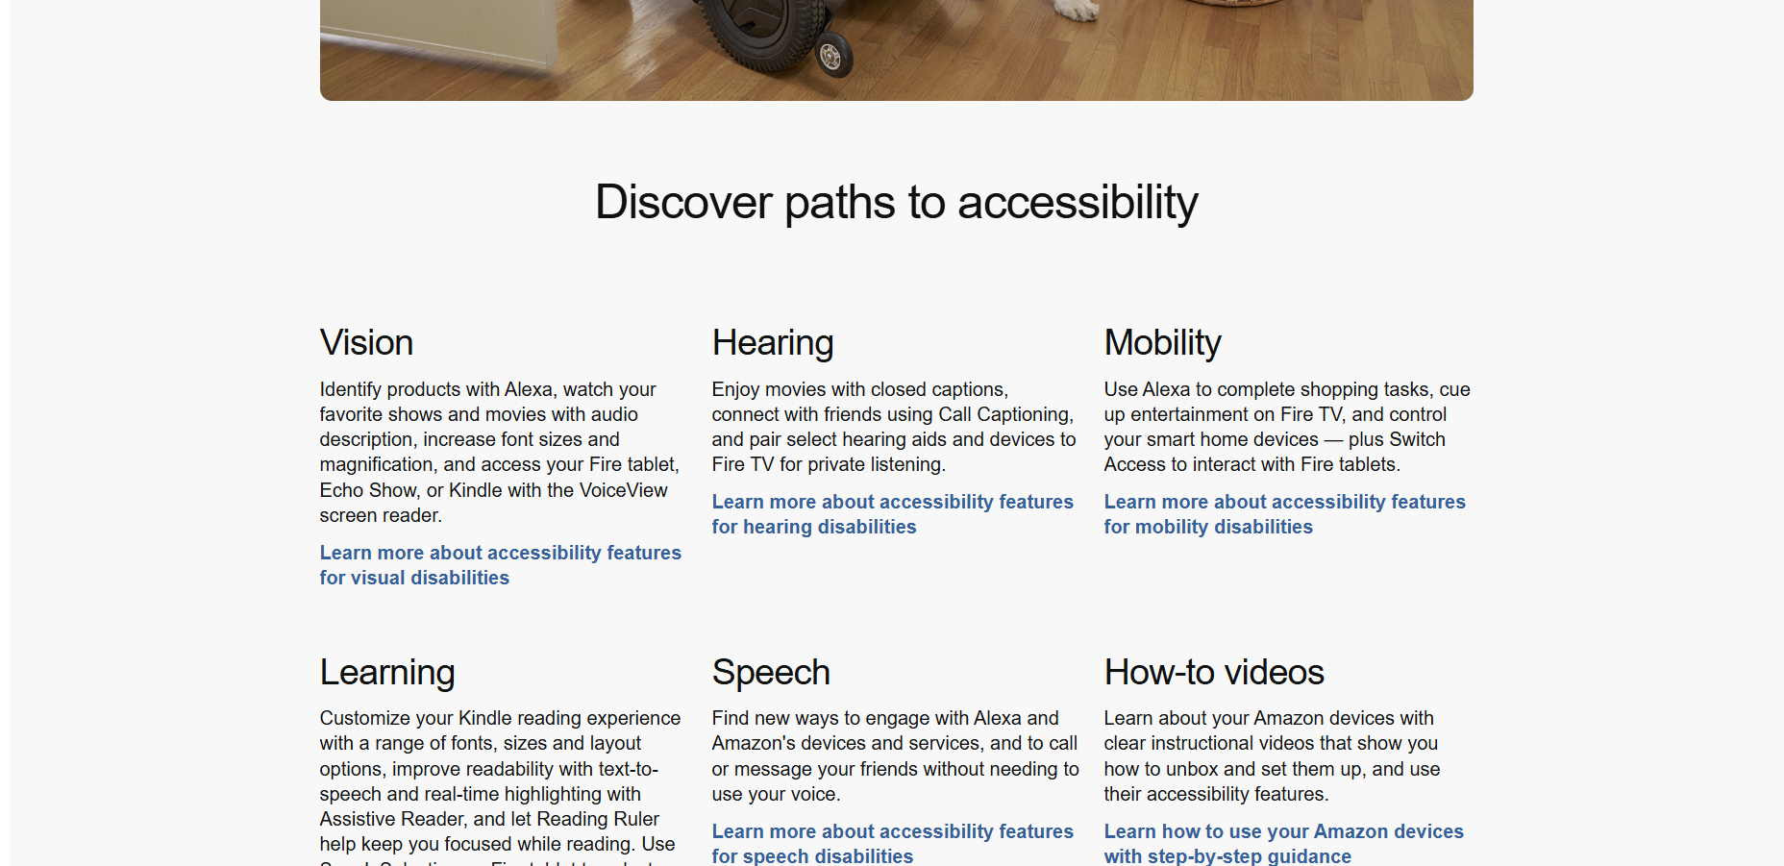

SEO:
Both Argos and Amazon use tags for SEO for many reason, Primarily, they use these tags as a means of ranking their products in both google searches and other search engine algorithms which ultimately maximises the amount of clicks and sales they get. Using these tags also helps make their product pages visible and discoverable. Both companies will use tags such as <title> to display primary information about a specific item such as a brand, or model. Argos for example, would use these tags to display categories, or even to display products. These tags, along with others are all used to improve keyword relevance and help search engines understand the content that is being shown inside of the website. Both Amazon and Argos do a great job of utilising this method.

Mobile friendliness:
Both Amazon and Argos are highly mobile friendly, although they approach this through different methods. Amazon optimises it’s product listing for mobile first shopping, Meaning they primarily expect people to do their shopping through a casual device like a phone. Argos on the other hand gives a wider range of options for their customers. When shopping with Argos, you have multiple means of doing so, for example, in person in their stores, online on a laptop, or on your mobile device. Due to this, argos’ onlin experience may not be as developed as Amazon’s because they don’t whole heartedly rely on the internet for sales. Amazon’s entire company is founded on the fact that anyone can shop online without issue, conveniently, meaning their mobile sector, regardless of the device whether that be a phone, tablet or laptop, they will have a smoother more developed scene.

Conclusion:
To conclude, I believe that for an online experience, Amazon is more reliable and a smoother experience for 3 main reasons. Firstly, Amazon is primarily an online company, meaning they rely on the online aspect of the shopping more heavily than Argos. Secondly, Amazon is a far bigger company than Argos, meaning their reach is larger and wider. This means they have more products and are more reliable. And thirdly, Amazon have a larger accessibility sector that branches across multiple devices and onto other applications such as the kindle.

References

Bibliography
[1]
J. Nielsen, “Usability 101: Introduction to usability,” Nielsen Norman Group, Jan. 03, 2012. https://www.nngroup.com/articles/usability-101-introduction-to-usability/ (accessed Nov. 15, 2025).
[2]
L. Humans, “Why is accessibility important in web design?,” Literal Humans, May 16, 2024. https://literalhumans.com/accessibility-web-design/ (accessed Nov. 16, 2025).
[3]
Microsoft Copilot, “Microsoft Copilot,” Microsoft Copilot, 2025. https://copilot.microsoft.com/ (accessed Nov. 17, 2025).
[4]
R. Bentley, “Michon,” Michon Ltd, Feb. 10, 2023. https://michoncreative.co.uk/articles/website-first-impressions-you-have-just-0-05-seconds-to-impress/?cn-reloaded=1 (accessed Nov. 20, 2025).
[5]
Amazon, “How accessibility powers inclusion and innovation at Amazon,” US About Amazon, May 19, 2022. https://www.aboutamazon.com/news/devices/how-accessibility-powers-inclusion-and-innovation-at-amazon

Appendices:
<!doctype html>
<html lang="en">
<head>
<meta charset="UTF-8">
<meta name="viewport" content="width=device-width, initial-scale=1.0">
<link rel="Stylesheet" href="stylesheet.css">
<meta name="author" content="Jon Morgan">
<meta name="description" content="Webpage presenting information on a welsh festival">
<title>Taste of Wales - Homepage</title>
</head>
<body>
<header>
<h1>Flas o Gymru - Taste of Wales: Homepage</h1>
<nav>
<ul>
<li><a href="Homepage.html">Homepage</a></li>
<li><a href="Activities.html">Activities</a></li>
<li><a href="Schedule.html">Schedule</a></li>
<li><a href="Contact.html">Contact</a></li>
</ul>
</nav>
</header>
<main>
<section class="Box_Homepage">
<h2>Welsh Culture Festival</h2>
<p>Festival taking place in Ferryside, carmarthenshire.</p>
</section>
<div class="img-section">
<img src="images/Flag_of_Wales.svg" alt="Welsh Flag" class="img-drg">
</div>
<section class="Box_Homepage">
<h2>What is this festival about?</h2>
<p>This festival is based on a variety of welsh culture including foods, clothing, traditional folk dancing, activities and more. It is a popular event with plenty of opportunities to immerse yourself in welsh culture. All are welcome.</p>
</section>
<section class="Box_Homepage">
<h3>Learn more about Welsh culture here</h3>
<a href="https://en.wikipedia.org/wiki/Culture_of_Wales">Culture of Wales</a>
</section>
</main>

<footer>
<p>&copy; 2025 Welsh Culture Festival</p>
</footer>
</body>
</html>

<!doctype html>
<html lang="en">
<head>
<meta charset="UTF-8">
<meta name="viewport" content="width=device-width, initial-scale=1.0">
<link rel="Stylesheet" href="stylesheet.css">
<meta name="author" content="Jon Morgan">
<meta name="description" content="Webpage presenting information on a welsh festival">
<title>Taste of Wales - Activities</title>
</head>
<body>
<header>
<h1>Flas o Gymru - Taste of Wales: Activity</h1>
<nav>
<ul>
<li><a href="Homepage.html">Homepage</a></li>
<li><a href="Activities.html">Activities</a></li>
<li><a href="Schedule.html">Schedule</a></li>
<li><a href="Contact.html">Contact</a></li>
</ul>
</nav>
</header>
<main>
<h1 class="Page_Title">Festival Activities</h1>
<p class="Page_Paragraph">Here's a clear list with details on each activity that is available for anyone to partake in.</p>
<br>
<section class="Box_Center">
<h2 class="Activity_h2">Food and Gift Stalls</h2>
<p>The festival will be packed with foods and plenty of gifts for family or even something for yourself, such as traditional welsh clothing, keyrings, hats, and even handmade items sold by locals! These items will be available throughout the duration of the Festival. For more details, view our Schedule page. </p>
</section>
<section class="Box_Center">
<h2 class="Activity_h2">Music and Live entertainment</h2>
<p>During the Festival, live music will be performed by welsh singers and performers. Many popular songs such as the anthem, "Hen Wlad fy Nhadau" will be performed, all are encouraged to join in. More details on when these musical events will be played are provided on the Schedule page.</p>
</section>
<section class="Box_Center">
<h2 class="Activity_h2">Traditional Foods</h2>
<p>The festival will be packed with traditional dishes throughout the entire experience including foods like Welsh cakes, Cawl, and bara brith. These foods are the ideal choices if you wish to endulge and immerse yourself in the rich culture Wales has to offer.</p>
</section>
<section class="Box_Center">
<h2 class="Activity_h2">Traditional Folk Dancing</h2>
<p>Traditional folk dancing is a centuries old tradition that Welsh people to this day still practice as a means of celebrating and connecting with their Welsh heritage.</p>
</section>
<section class="Box_Center">
<p class="details_activity">For additional Info, navigate to the Schedule page.</p>
</section>
</main>
<footer>
<p>&copy; 2025 Welsh Culture Festival</p>
</footer>
</body>
</html>

<!doctype html>
<html lang="en">
<head>
<meta charset="UTF-8">
<meta name="viewport" content="width=device-width, initial-scale=1.0">
<link rel="Stylesheet" href="stylesheet.css">
<meta name="author" content="Jon Morgan">
<meta name="description" content="Webpage presenting information on a welsh festival">
<title>Taste of Wales - Schedule</title>
</head>
<body>
<header>
<h1>Flas o Gymru - Taste of Wales: Schedule</h1>
<nav>
<ul>
<li><a href="Homepage.html">Homepage</a></li>
<li><a href="Activities.html">Activities</a></li>
<li><a href="Schedule.html">Schedule</a></li>
<li><a href="Contact.html">Contact</a></li>
</ul>
</nav>
</header>
<main>
<h1 class="Page_Title">Festival Schedule</h1>
<p class="Page_Paragraph">Here is a clear schedule of all the dates and activities:</p>
<br>
<table>
<tr>
<th>Time</th>
<th>Activity</th>
<th>Location</th>
</tr>
<tr>
<th>11AM-4:30PM</th>
<th>Food and Gift stalls</th>
<th>Rugby Field</th>
</tr>
<tr>
<th>12:30PM-1:30PM</th>
<th>Welsh music on stage</th>
<th>Rugby Field</th>
</tr>
<tr>
<th>2PM-3:30PM</th>
<th>Music & Traditional foods</th>
<th>Rugby Field & Inside Rugby Club</th>
</tr>
<tr>
<th>3:30PM-4:30PM</th>
<th>Traditional Folk Dancing</th>
<th>Inside Rugby Club</th>
</tr>
</table>
</main>
<footer>
<p>&copy; 2025 Welsh Culture Festival</p>
</footer>
</body>
</html>

<!doctype html>
<html lang="en">
<head>
<meta charset="UTF-8">
<meta name="viewport" content="width=device-width, initial-scale=1.0">
<link rel="Stylesheet" href="stylesheet.css">
<meta name="author" content="Jon Morgan">
<meta name="description" content="Webpage presenting information on a welsh festival">
<title>Taste of Wales - Homepage</title>
</head>
<body>
<header>
<h1>Flas o Gymru - Taste of Wales: Contact</h1>
<nav>
<ul>
<li><a href="Homepage.html">Homepage</a></li>
<li><a href="Activities.html">Activities</a></li>
<li><a href="Schedule.html">Schedule</a></li>
<li><a href="Contact.html">Contact</a></li>
</ul>
</nav>
</header>
<main>
<h1 class="Page_Title">Contact us:</h1>
<br>
<p class="Box_Center">Here are the places you can contact us if you have any questions, or if you need any extra details regarding the event. We have various social media platforms and other means.</p>
<br>
<section>
<h2 class="Activity_h2">Our social media</h2>
<ul class="Contact_page_list">
<li>Instagram - @FerrysideEvents2025</li>
<br>
<li>Facebook - @FerryEvents2025</li>
</ul>
</section>
<section>
<h2 class="Activity_h2">Email</h2>
<ul class="Contact_page_list">
<li>ferryeventplanner@gmail.com</li>
</ul>
</section>
<section>
<h2 class="Activity_h2">Phone Number</h2>
<ul class="Contact_page_list">
<li>01234567890</li>
</ul>
</section>
<img src="images/Contact.jpg" alt="Contact-us" class="contact">
<br>
<p class="Box_Center">Please do not hesitate to contact us if you require any additional info regarding this event.</p>
</main>
<footer>
<p>&copy; 2025 Welsh Culture Festival</p>
</footer>
</body>

p{
Color:black;
font-size:18px;
font-family:'Trebuchet MS', 'Lucida Sans Unicode', 'Lucida Grande', 'Lucida Sans', Arial, sans-serif;
}
header{
border:3px solid black;
background-color:rgb(106, 193, 76);
border-radius:50px;
padding:10px;
text-align:center;
}
body{
background-color:white;
font-family:Arial, Helvetica, sans-serif;
font-size:16px;
line-height:1em;
color:#333;
}
h1{
color:black;
font-size:30px;
font-family:'Trebuchet MS', 'Lucida Sans Unicode', 'Lucida Grande', 'Lucida Sans', Arial, sans-serif
}
h2{
color:black;
font-family:'Trebuchet MS', 'Lucida Sans Unicode', 'Lucida Grande', 'Lucida Sans', Arial, sans-serif;
text-decoration:underline;
}
.Activity_h2{
text-align:center;
color:black;
font-family:'Trebuchet MS', 'Lucida Sans Unicode', 'Lucida Grande', 'Lucida Sans', Arial, sans-serif;
}
.details_activity{
font-weight:bold;
Color:red;
}
h3{
color:black;
font-family:'Trebuchet MS', 'Lucida Sans Unicode', 'Lucida Grande', 'Lucida Sans', Arial, sans-serif;
text-decoration:underline;
}
nav ul li{
display:inline;
margin: 0 10px;
}
nav ul li a{
text-decoration:underline;
color: black;
font-weight:bold;
}
a:hover{
color:red
}
main{
padding:20px;
}
.Box_Homepage{
border: 4px solid black;
padding:15px;
margin: 20px;
background-color: rgb(236, 236, 236);
max-width:600px;
text-align:center;
}
.Box_Center{
border: 4px solid black;
padding:30px;
margin: 20px;
background-color: rgb(236, 236, 236);
max-width:600px;
text-align:center;
position:relative;
left:390px;
}
footer p{
padding:20px;
text-align:center;
background-color:rgb(106, 193, 76);
position:relative;
bottom:0%;
width:100%;
font-family:'Trebuchet MS', 'Lucida Sans Unicode', 'Lucida Grande', 'Lucida Sans', Arial, sans-serif;
border:3px solid black;
}
.img-drg{
border:5px solid black;
width:40%;
padding:5px;
position:absolute;
top:-100px;
right:40px;
}
.img-section {
position:relative;
}
table{
width:60%;
margin:10px auto;
border-collapse: collapse;
text-align:center;
border:5px solid #D80027;
}
tr{
height:60px;
border:2px solid #d80027;
}
th{
background-color: #f2dede;
font-weight:bold;
border:2px solid #d80027;

}
.Page_Title{
text-align:center;
text-decoration:underline;
}
.Page_Paragraph{
text-align:center;
text-decoration:underline;
}
.Contact_page_list{
text-align:center;
list-style-position:inside;
font-weight:bold;
}
.contact{
width:250px;
display:block;
margin:auto;
}

