
Cover Page

Software Solutions for Business

Prepared by: Mahmoud Attwa
student number : 2532386
Student email : 2532386@student.uwtsd.ac.uk

Assignment
A comprehensive report exploring contemporary digital tools used in business operations, including e-commerce platforms, office applications, communication tools, and collaboration software.

Document Overview
This report covers:
- E-commerce website builders (Wix, Shopify)
- Mind-map of contemporary software applications
- Office applications (Word, Excel, PowerPoint, Access)
- Communication and collaboration tools (Gmail, Zoom)
- Practical demonstrations of selected features

Contents
Introduction 1
Task 1. e-Commerce Website builders/software solutions 1
1.1 Wix 1
1.2 Shopify 1
Task 2. Mind-map of contemporary software applications 1
2.1 Describe mind mapping and explain the benefits of using mind mapping 1
2.2 Create a mind map of contemporary software applications 2
Task 3. Office Applications 2
3.1 Four office software solutions for business operations 2
Ms Word 2
Ms Excel 2
Ms PowerPoint 2
Ms Access 2
3.2 Test any two features 2
Mail Merge 2
IF Statement 3
Task 4. Communication and Collaboration applications 3
4.1 One contemporary Communication and one Online Collaboration 3
Gmail 3
Zoom 3
4.2 Test one feature of a freely available Communication (1) and one feature of a Collaboration (1) application 3
Gmail 3
Zoom 3
Conclusion 4
References 4

Introduction
Contemporary digital tools play a central role in modern business operations, communication, and productivity As organizations continue to adopt technology driven processes, software applications have become essential for managing data, supporting collaboration, and improving workflow efficiency. This document explores a range of widely used digital solutions, beginning with e commerce website builders such as Wix and Shopify which enable businesses to establish and manage online stores with ease. It then examines contemporary software applications through a structured mind map highlighting how different tools support areas such as project management communication analytics and organizational operations.
The report also provides an overview of four core office applications Microsoft Word, Excel PowerPoint and Access explaining their features, advantages, and limitations in business environments. Practical demonstrations of selected features including Mail Merge in Word and the IF statement in Excel illustrate how these tools enhance automation and decision making Finally the document evaluates modern communication and collaboration platforms such as Gmail and Zoom along with a brief test of features from Microsoft Outlook and Microsoft Teams.
Overall, this document offers a clear and comprehensive understanding of essential digital tools used in today s professional and academic settings showing how they contribute to effective communication streamlined operations and improved organizational performance

Task 1. e-Commerce Website builders/software solutions


wix

Wix began as a general-purpose website builder but has evolved into a robust e-commerce solution tailored for small and medium-sized businesses. Its standout feature is a true "drag-and-drop" editor, offering users unparalleled design freedom. Wix also offers AI-powered website creation tools—such as Wix ADI—capable of generating a fully functional website based on user input, making the platform highly attractive to beginners and businesses that prioritize visual design and ease of use.

1.2 Shopify


This is a specialized e-commerce platform designed specifically for large-scale online sales. It powers millions of stores worldwide and is widely considered the industry standard for serious online retailers. According to numerous comparisons, Shopify offers best-in-class e-commerce infrastructure, featuring advanced capabilities for inventory management and multi-channel selling (across platforms such as Amazon, Instagram, Facebook, and eBay).

Task 2. Mind-map of contemporary software applications

2.1 Describe mind mapping and explain the benefits of using mind mapping

This mind map visually organizes a wide range of contemporary software applications into clear functional categories such as project management communications analytics human resources finance and marketing Each branch highlights key tools used in modern organizations making it easy to understand how these diverse software solutions support daily operational processes
The mind map presents a broad, organised overview of modern software applications used across different business and technical domains. At its centre is the concept of contemporary software, from which multiple branches extend, each representing a specialised functional area. These branches highlight how digital tools support organisational activities, streamline workflows, and enhance decision-making in today’s technology-driven environment.
One major branch focuses on
Supply Chain Management, illustrating platforms that help organisations coordinate logistics, forecasting, and inventory planning. These tools enable companies to maintain efficient product movement and respond quickly to market changes. Another branch highlights
Project Management, showcasing applications that assist teams in planning tasks, tracking progress, and managing deadlines. These solutions promote structured teamwork and improve project visibility.
The mind map also includes a
Communication and Collaboration category, emphasizing tools that facilitate messaging, virtual meetings, and shared workspaces. These applications have become essential for remote and hybrid work environments, enabling real-time interaction and collective productivity. Closely related is the Customer Support and Helpdesk branch, which features systems designed to manage client inquiries, automate responses, and improve service quality.
A significant portion of the map is dedicated to
Business Intelligence and Analytics, representing platforms that transform raw data into meaningful insights. These tools help organizations analyses trends, measure performance, and make evidence-based decisions Similarly
Research and Development branch highlights specialized engineering and scientific software used for modelling simulation and design
The mind map also covers
Procurement showing tools that support purchasing processes supplier management and contract handling
Risk Management and Compliance and Cybersecurity and IT Management appear as separate branches, reflecting the growing importance of safeguarding digital assets monitoring threats and ensuring regulatory adherence.
Administrative functions are represented through
Accounting and Finance software which assists with budgeting invoicing and financial reporting The
Human Resources branch includes platforms that manage employee records, recruitment and performance evaluation. Marketing and sales activities are also featured with tools that support promotional campaigns content creation customer relationship management and sales tracking
Operations Management appears as a core branch, showcasing systems that integrate various organizational processes and support day operational efficiency.
Overall, the mind map provides a clear visual summary of how diverse software categories contribute to modern organizational performance, demonstrating the interconnected nature of digital tools in contemporary business environments.

2.2 Create a mind map of contemporary software applications

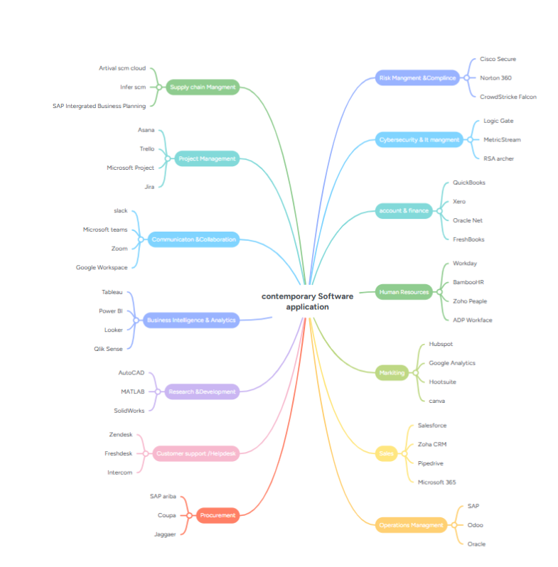 Task 3. Office Applications

3.1 Four office software solutions for business operations

Ms Word


Microsoft Word is a digital tool used for creating written documents of all kinds including academic work business files, and everyday writing tasks It belongs to the Microsoft 365 family which means it can be accessed on computers phones, and through the web. Because it works across different devices users can continue their work wherever they are

Key Features
User-Friendly Workspace The layout is designed so people can quickly locate tools and begin typing without confusion
Flexible Formatting Options Word allows deep control over how text looks from font styles and colors to page layout spacing and alignment helping users produce clean organized documents
Built-In Templates Instead of starting from scratch, users can choose from ready made designs for resumes letters reports and other document types
Rich Media Support Images diagrams tables charts and shapes can be inserted to make documents more visual and engaging
Writing Assistance Tools: Word includes automatic spelling and grammar checking to help improve clarity and reduce mistakes
Mail Merge Function: This feature helps generate personalized documents for many recipients such as customized letters or address labels
Smart Typing Tools AutoCorrect fixes common typing errors instantly while AutoText lets users save frequently used phrases for quick reuse
Document Statistics Word can show details like total word count which is useful for assignments or professional writing

Benefits

Simple enough for beginners yet powerful for advanced users
Offers strong tools for producing polished, professional documents
Works smoothly across different devices and supports many file types
Supports teamwork through shared editing and comments
Improves writing quality with built-in language tools
Connects well with other Microsoft apps like Excel and PowerPoint

Limitations
Some features require a paid Microsoft 365 subscription
Older computers may struggle with the full desktop version
Advanced tools may take time to learn
Real-time collaboration works best in the online version

Ms Excel

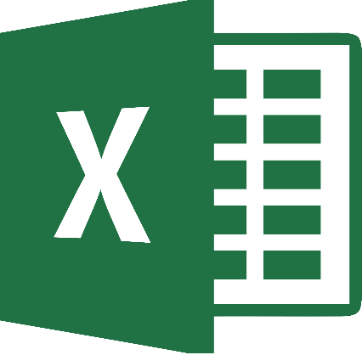
Microsoft Excel is a spreadsheet program designed to help users organize information, perform calculations, and analyses data. It allows people to work with numbers and text in a structured grid, making it useful for tasks in education, business, finance, and research. Excel also includes tools for creating charts and summaries, which help turn raw data into clear visual insights.
Key Features
Excel provides a grid-based workspace where users can store and manage different types of data. It contains a large collection of built-in functions that support mathematical operations, logical comparisons, statistical calculations, and data lookup. The software also offers several visual tools such as charts, graphs, and conditional formatting that make patterns and trends easier to understand.
For deeper analysis, Excel includes advanced features like PivotTables and scenario modelling, which allow users to reorganize large datasets and explore different outcomes. Automation is another major strength: through Visual Basic for Applications (VBA), users can create scripts that handle repetitive or complex tasks without manual effort.
Benefits
Excel is widely valued because it can be used for many different purposes, from simple record-keeping to advanced data modelling. Its interface is easy for beginners to learn, yet it provides powerful tools for users who need detailed analysis. Excel also works smoothly with other Microsoft 365 applications, making it easier to share information and collaborate across platforms.
Because Excel is commonly used in schools, offices and professional environments, learning how to use it effectively is a practical skill that applies to many fields. Its ability to produce charts tables and structured reports helps users communicate their findings clearly and professionally.
Limitations
Although Excel is a versatile tool, it has some restrictions. It is not designed to manage extremely large or highly complex datasets, and performance can slow down when a file contains too many formulas macros or worksheets Manual data entry also increases the risk of mistakes, which can affect the accuracy of results.
Excel does offer collaboration features, but they are not as smooth or advanced as those found in platforms built specifically for real-time teamwork. Additionally, some of Excel’s more advanced tools require a paid Microsoft 365 subscription, which may limit access for certain users.
.

Ms PowerPoint

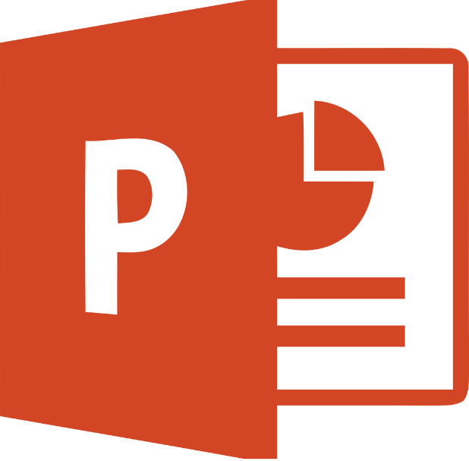
PowerPoint is a presentation tool used to create visual slides for teaching, business, and communication. It allows users to combine text, images, charts, and multimedia to deliver clear, engaging messages. With templates, animations, and design tools, PowerPoint supports structured storytelling, though effectiveness depends on careful slide design and presenter skill

Features
PowerPoint provides a slide-based workspace that allows users to organize information visually. The software includes tools for inserting text, images, charts, audio clips, and videos, enabling the creation of multimedia-rich presentations. It also offers a wide range of design templates, themes, and transition effects that help structure content and enhance visual appeal. Features such as animations, Slide Master editing, and Presenter View support both the creation and professional delivery of presentations. Furthermore, PowerPoint integrates with other Microsoft 365 applications, allowing users to import data from Excel, Word, and online sources.

Advantages
PowerPoint is widely popular because it simplifies the presentation of complex information into a clear, engaging format. Its interface is user-friendly for beginners while offering advanced design tools for those requiring more sophisticated layouts. The ability to combine text, visual elements, and multimedia makes it an ideal choice for academic lectures, business meetings, training sessions, and public speaking. Cloud integration enables collaborative editing, allowing multiple users to contribute to the same presentation. Cross-device compatibility ensures that presentations can be easily shared and viewed in diverse environments.

Limitations
Despite its versatility, PowerPoint has some limitations; for instance, the overuse of animations or multimedia can distract the audience and reduce clarity if not handled carefully. The software relies heavily on manual design choices, which can lead to inconsistent formatting or slides cluttered with elements. PowerPoint is not the ideal choice for environments requiring high interactivity or relying heavily on data that needs real-time updates. Large presentations containing numerous images or videos may experience performance issues. Furthermore, the software's effectiveness depends on the presenter's skills; poorly designed slides can undermine communication, even if the content itself is strong and exceptional.


Ms Access

Microsoft Access is a desktop database system designed for individuals and small organizations that need a practical way to store organize and analyses structured information. It combines a graphical interface with relational database concepts allowing users to build data driven applications without advanced programming knowledge. Access includes tools for creating tables, designing forms, generating reports, and building queries, all within a single environment. It also supports automation through macros and VBA enabling users to streamline repetitive tasks and customise how their databases behave.
Key Features
Access provides a set of integrated components that simplify database creation. Its table designer allows users to define fields data types and relationships between tables The query builder offers visual tools for filtering sorting and analyzing information, while forms make data entry more intuitive through user friendly layouts Reports help transform raw data into structured summaries suitable for printing or sharing Access also includes templates wizards and import export tools that make it easy to start new projects or connect with external sources such as Excel Word or web data Multi user support allows several people to work with the same database simultaneously and compatibility with SQL and VBA gives more advanced users room to extend functionality.
Advantages
One of the main strengths of Access is its accessibility. It is easy to install, simple to learn and does not require specialized database training. Its integration with Microsoft Office makes it convenient for organizations already using Word Excel or Outlook Access is also cost-effective compared to enterprise level systems making it suitable for small businesses It offers automation tools ready-made templates, and flexible import/export options which reduce development time. For moderate workloads, Access can handle substantial datasets and allows shared editing for teams working on the same file.
Limitations
Despite its benefits, Access has several constraints. It is not designed for very large databases, and performance declines as file size grows or when many users access the system at once. All data is stored in a single file, which can slow down operations and increase the risk of corruption. Advanced features such as triggers or scheduled tasks require external tools or complex coding. Access is available only on Windows and requires specific Microsoft 365 plans limiting its accessibility. Version compatibility issues may also arise when upgrading older databases to newer releases

3.2 Test any two features

Mail Merge
Its feature in Microsoft Word is a tool for automatically creating personalized Mail Merge is one of the most practical automation tools built into Microsoft Word, designed to create large numbers of personalized documents without manually editing each one. Instead of preparing individual letters, certificates, labels, or emails one by one, Mail Merge connects a main Word document with an external data source and automatically inserts unique information for every recipient. This makes it especially valuable in business communication, education, marketing and administrative tasks where accuracy and consistency are essential
The process begins with preparing a primary document, which acts as the template. This file contains the general text that will appear in every copy along with placeholders known as merge fields that represent the variable information. These fields might include names addresses dates membership numbers or any other personalized details. The second component is the data source which can be an Excel spreadsheet an Access database a CSV file or even an Outlook contact list. Each row in the data source corresponds to one recipient, and each column represents a specific piece of information.
Once the document and data source are linked Word automatically generates a full set of customized outputs. Users can preview each merged document before finalizing ensuring that the fields are correctly placed and the formatting remains consistent. After verification the merged documents can be printed, saved individually or sent directly as email messages.
Mail Merge significantly reduces repetitive work, minimizes human error and ensures professional consistency across large batches of documents It is particularly useful for sending invitations, producing certificates generating mailing labels, or distributing standard letters to many people at once By combining automation with personalization Mail Merge helps organizations communicate efficiently while maintaining a human touch
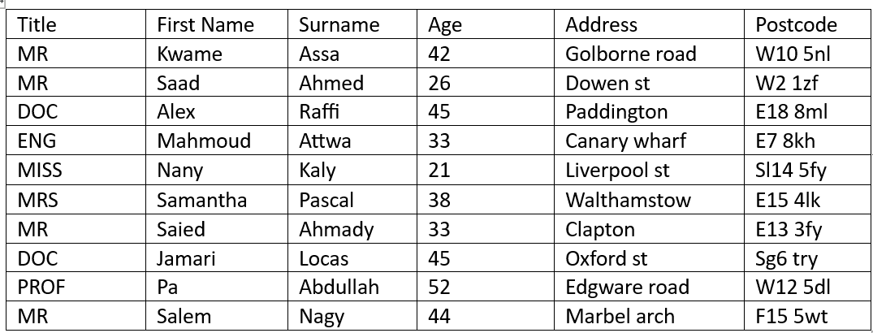
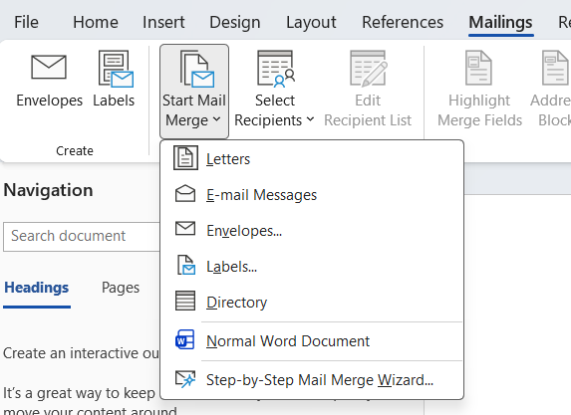
START WITH CHOCE MALINGS
CLICK ON START MAIL MERGE
THEN CHOCE LETTERS
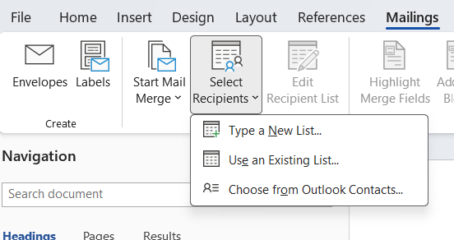
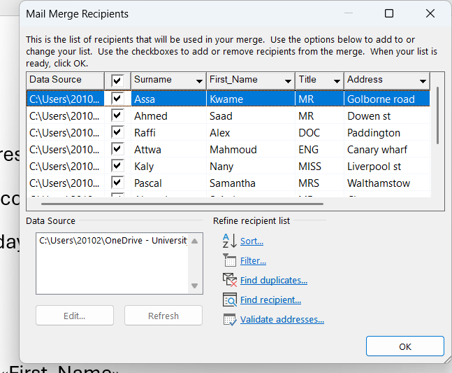
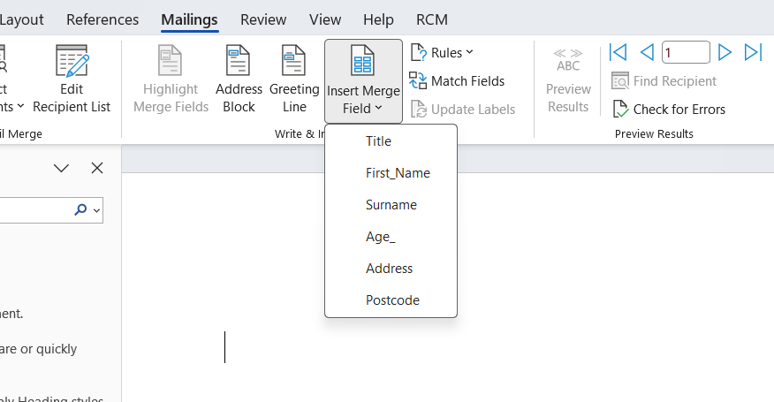

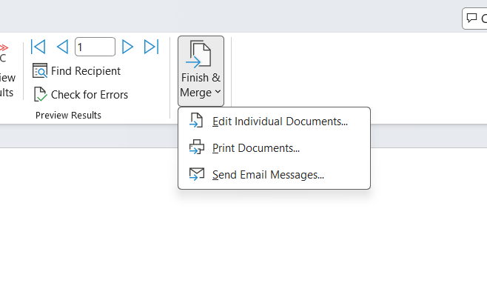
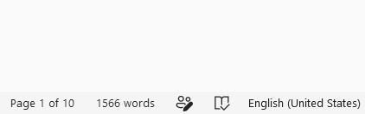

IF Statement
The IF function in Excel is a tool that lets a spreadsheet make simple decisions by checking whether a condition is true or false. Instead of the user manually comparing values, Excel can automatically test the data and return a specific response depending on the result. This gives spreadsheets the ability to behave intelligently and adjust their output whenever the data changes.
The function works by evaluating a logical test and then choosing between two possible outcomes. The logical test can compare numbers, check equality, or determine whether a value falls above or below a certain limit. People often use it to see if sales reach a target, if a student has passed a module, or if stock levels are too low.
A major advantage of the IF function is that it can return many types of results. It can display text, numbers, formulas, or even other functions. This makes it useful for categorizing information, calculating alternative values, or triggering additional actions. For example, a company might use IF to label items as “High Priority” or “Low Priority,” while teachers may use it to automatically assign grade bands.
Excel also allows several IF functions to be combined inside one formula, creating what are known as nested IFs. This lets users check multiple conditions in order and produce more detailed results. Although nested formulas can become long, they offer precise control over how data is interpreted.
Another strength of the IF function is that it updates instantly whenever the underlying data changes. This helps maintain accuracy across large spreadsheets and reduces the chance of human error. Whether used in budgeting, stock control, reporting, or academic work, the IF function helps turn raw data into clear and useful information.
Overall, the IF function is a key feature in Excel that supports logical thinking, automation, and efficient data management. It allows users to build spreadsheets that respond intelligently to different situations.

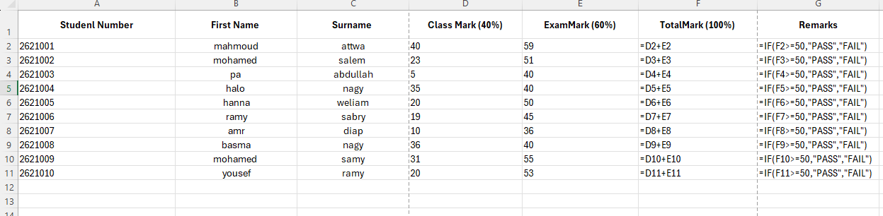

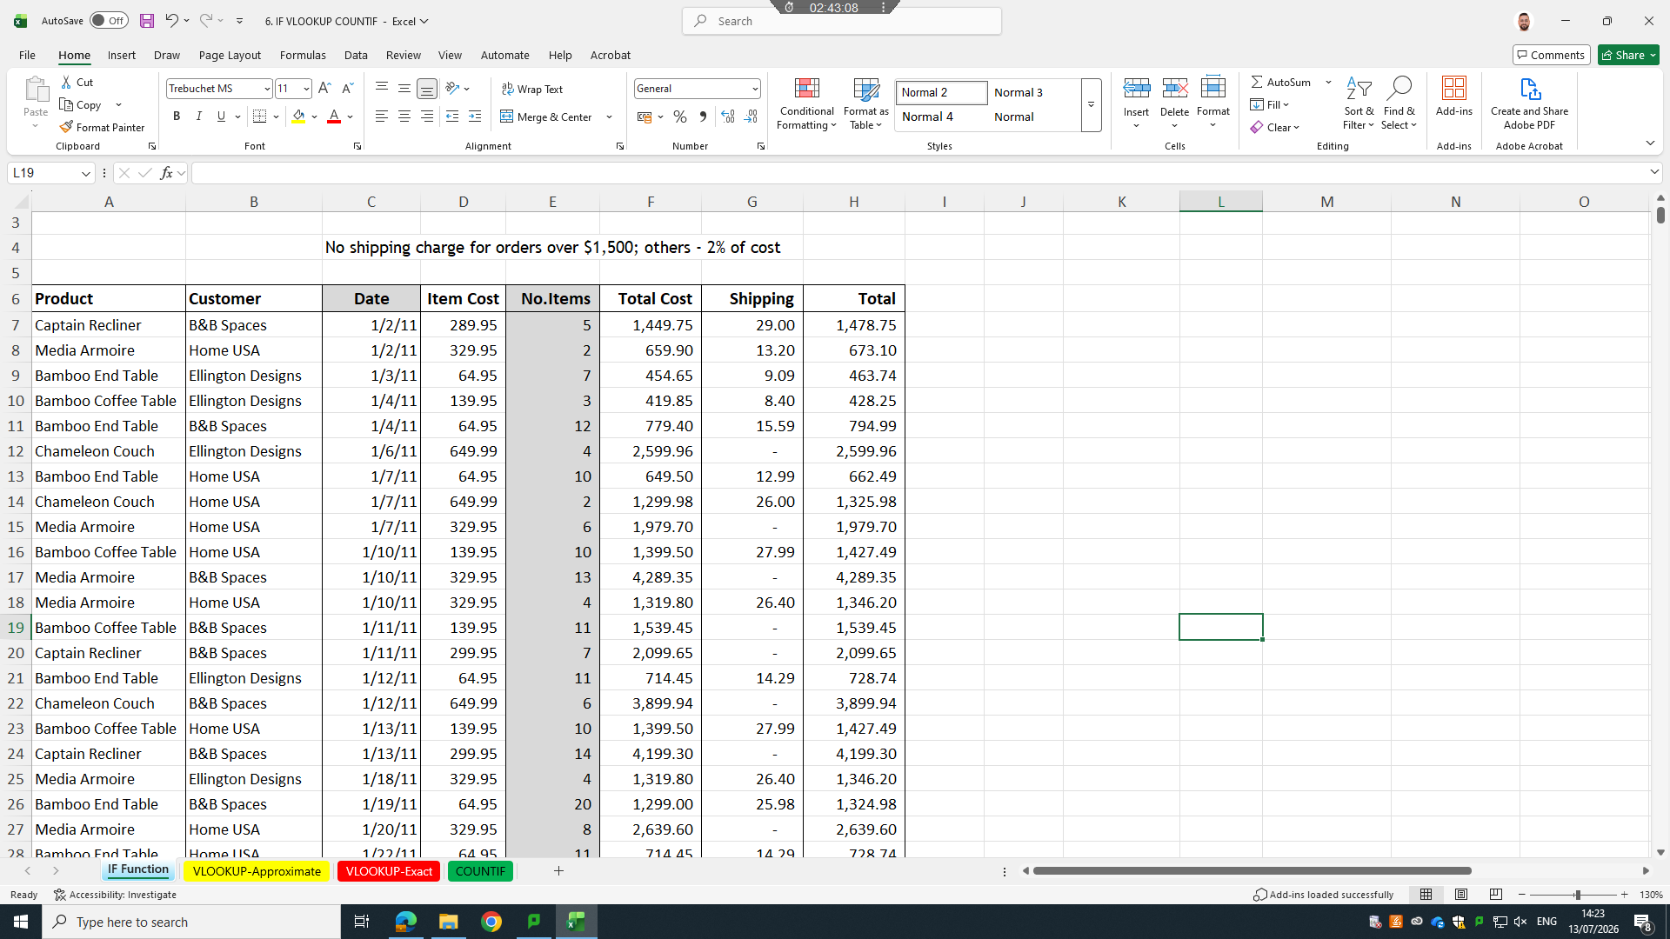

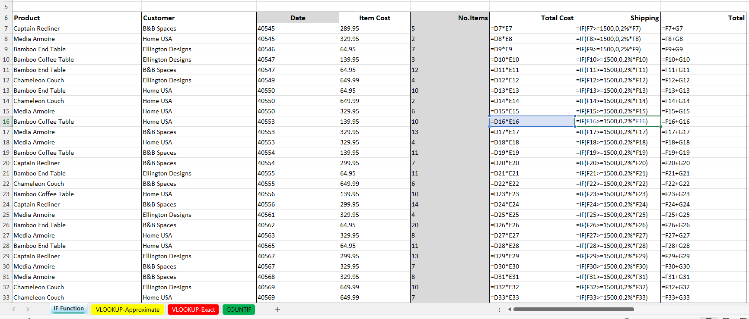

Task 4. Communication and Collaboration applications

4.1 One contemporary Communication and one Online Collaboration

Gmail


Gmail is one of the most widely used digital communication platforms in the modern business world serving as a central tool for managing email, coordinating tasks and supporting organizational communication Since its introduction by Google
Gmail has evolved from a simple email service into a multifunctional communication hub that integrates cloud storage productivity tools and intelligent automation Its design focuses on speed accessibility and reliability making it suitable for individuals small businesses, and large enterprises.
At its core Gmail provides a clean and intuitive interface that allows users to send receive and organize messages efficiently. The platform uses labels, filters categories and advanced search functions to help users manage large volumes of communication. These organizational tools reduce clutter and allow employees to locate important information quickly, which is essential in fast paced business environments Gmail cloud based nature ensures that messages and files are accessible from any device enabling seamless communication across desktops laptops tablets and smartphones
One of Gamils most significant strengths is its integration with the broader Google Workspace ecosystem. Users can access Google Drive Calendar Meet Docs and Sheets directly from their inbox allowing communication and collaboration to occur in the same environment This integration reduces the need to switch between applications and supports smoother workflows For example employees can schedule meetings share documents or collaborate on files without leaving Gmail making it a central point for daily operations
In recent years, Gmail has incorporated advanced AI features that enhance productivity and communication quality. Tools such Smart Compose assist users in drafting messages quickly and professionally. AI-powered summaries help users understand long email threads without reading every message, which is particularly useful for managers handling large projects. These intelligent features reduce time spent on routine communication and improve clarity across teams.
Security is another major advantage of Gmail. Google uses multiple layers of protection, including spam filtering, phishing detection encryption and suspicious activity monitoring. These features help safeguard sensitive business information and reduce the risk of cyberattacks Gmail’s security infrastructure is continuously updated, making it a trusted platform for organizations that require secure communication channels.
Despite its strengths, Gmail has limitations. Heavy reliance on cloud storage means users must have stable internet access Organizations with strict data-control policies may prefer on premise email systems. Additionally while Gmail’s interface is user-friendly, managing very large inboxes can still become overwhelming without proper organization.
Overall, Gmail remains a leading communication tool due to its reliability intelligent features, and deep integration with Google Workspace. It supports efficient information exchange, enhances productivity and provides a secure environment for modern business communication


Zoom

Zoom Cloud Meetings became one of the most influential digital tools during the COVID-19 pandemic transforming how individuals organizations and institutions communicated The platform originally designed for video conferencing and online collaboration quickly evolved into a global communication solution as lockdowns and social distancing measures forced people to rely on virtual interaction. The document highlights how Zoom’s accessibility, ease of use, and broad functionality made it a preferred choice for remote work online learning and virtual social engagement
Zoom’s core strength lies in its simple interface, which allows users to join meetings with minimal technical knowledge. Features such as high quality video, screen sharing, chat messaging, and virtual backgrounds made the platform versatile for different communication needs During the pandemic these features supported classrooms business meetings religious gatherings and even social events like birthdays and weddings The platform s ability to host large numbers of participants also made it suitable for webinars conferences and organizational training sessions.
The document emphasizes that Zoom’s cloud-based architecture contributed significantly to its widespread adoption. Because meetings run on remote servers rather than local devices, users could participate from laptops tablets or smartphones without requiring powerful hardware This flexibility was essential during the pandemic when people relied on personal devices at home. Additionally Zoom s cross-platform compatibility ensured that users across Windows macOS Android and iOS could communicate seamlessly
Another important aspect discussed is Zoom’s role in supporting continuity Businesses used the platform to maintain operations hold team discussions, and coordinate projects. Schools and universities adopted Zoom for virtual classrooms enabling teachers to deliver lessons and interact with students despite physical closures Religious organizations used it to conduct services, while families used it to stay connected. In this sense, Zoom became more than a communication tool; it became a social lifeline.
However the document also acknowledges limitations. As usage increased, concerns emerged about privacy security and Zoom fatigue The sudden surge in global users exposed weaknesses in encryption and meeting protection leading to incidents of unauthorized access Although Zoom later introduced stronger security measures the early issues highlighted the challenges of rapid expansion. Additionally, prolonged screen time caused exhaustion for many users, demonstrating that virtual communication cannot fully replace physical interaction.
Despite these challenges, Zoom s impact during the pandemic was profound It enabled continuity in education business and social life at a time when physical contact was restricted The platform demonstrated how digital tools can support resilience and adaptability during global crises. Its success also accelerated long term changes in work culture with remote and hybrid models becoming more accepted worldwide.
Overall Zoom Cloud Meetings stands as a defining example of how technology can support communication collaboration, and social connection during periods of disruption. Its widespread adoption reflects both its functional strengths and the changing expectations of modern digital communication.

4.2 Test one feature of a freely available Communication (1) and one feature of a Collaboration (1) application

Start to open hub then chose inbox to open the email

Microsoft outlook

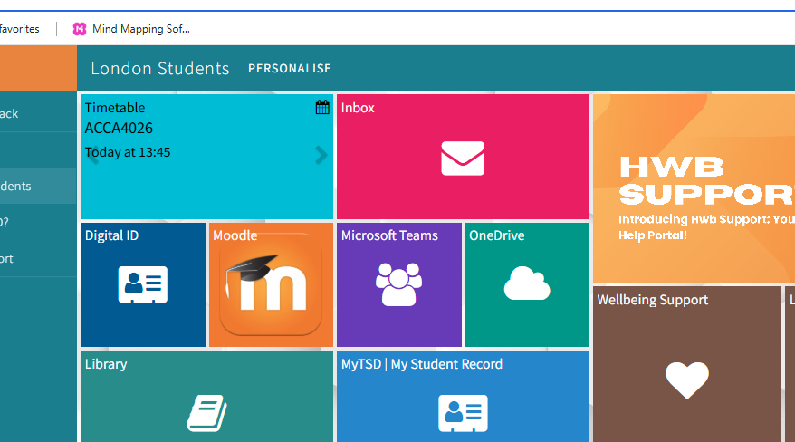

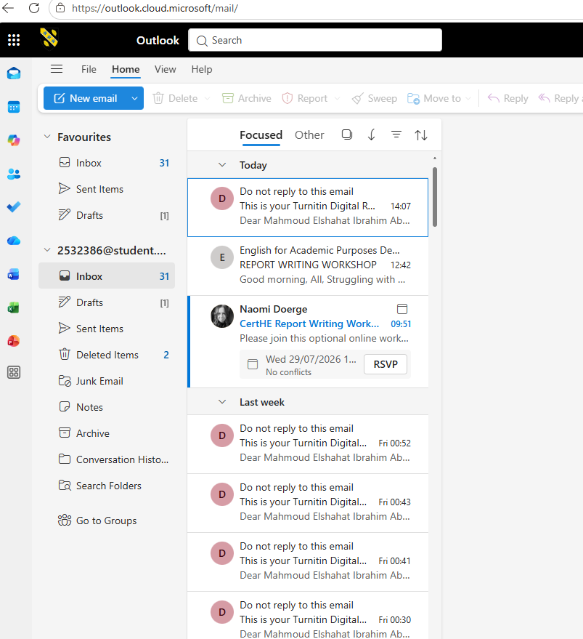
Then prese on the new email and start to write the receiver
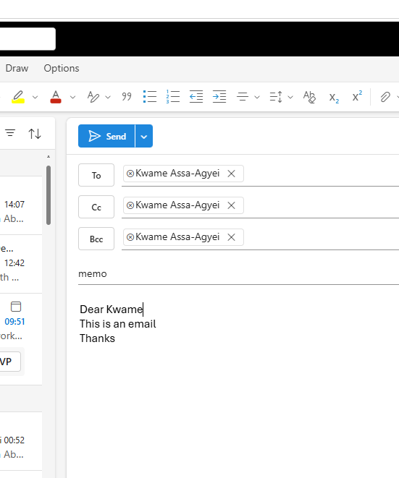

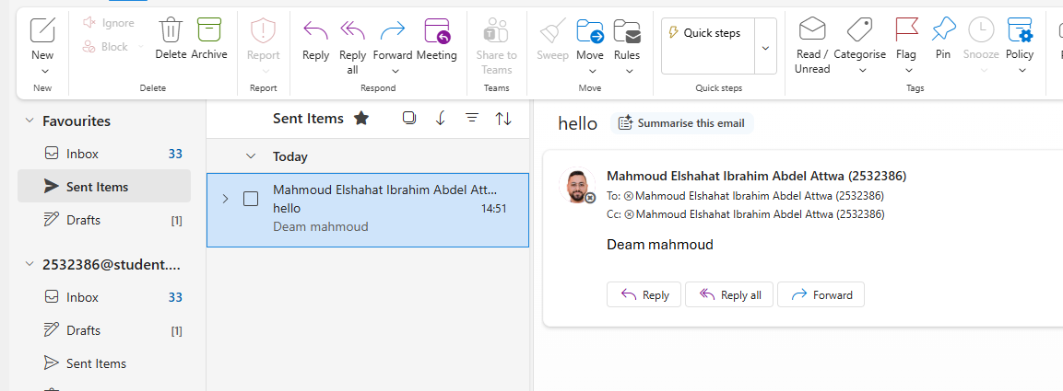
If you want to send email later you can chose Schedule send

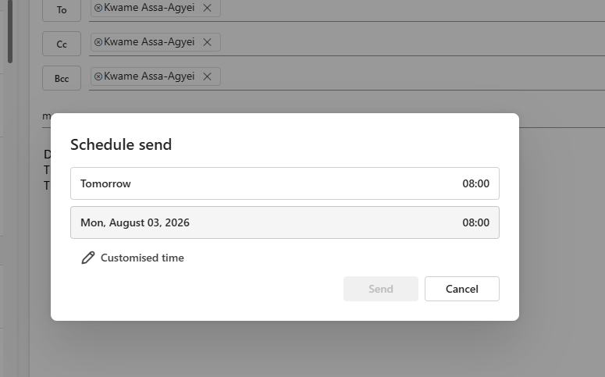

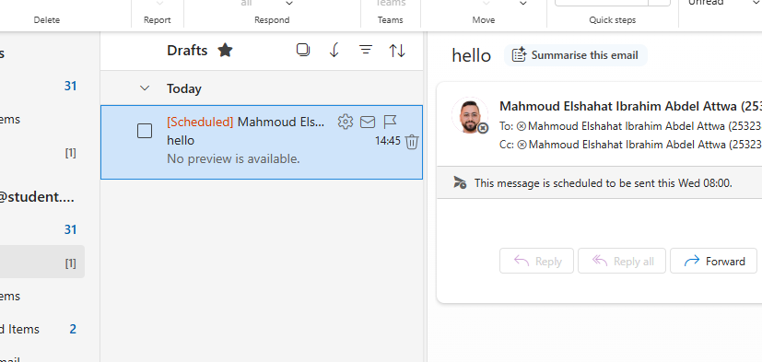

Microsoft Teams
Steps to make meeting in Microsoft
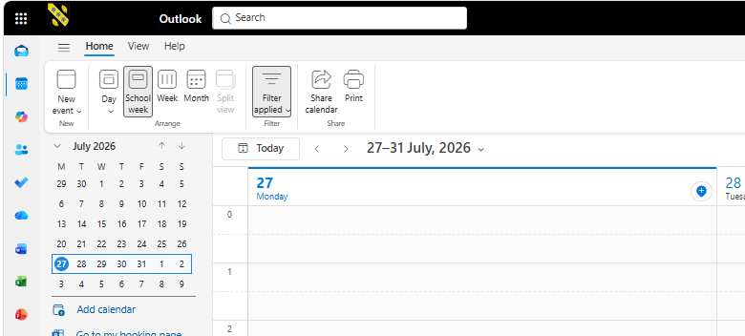
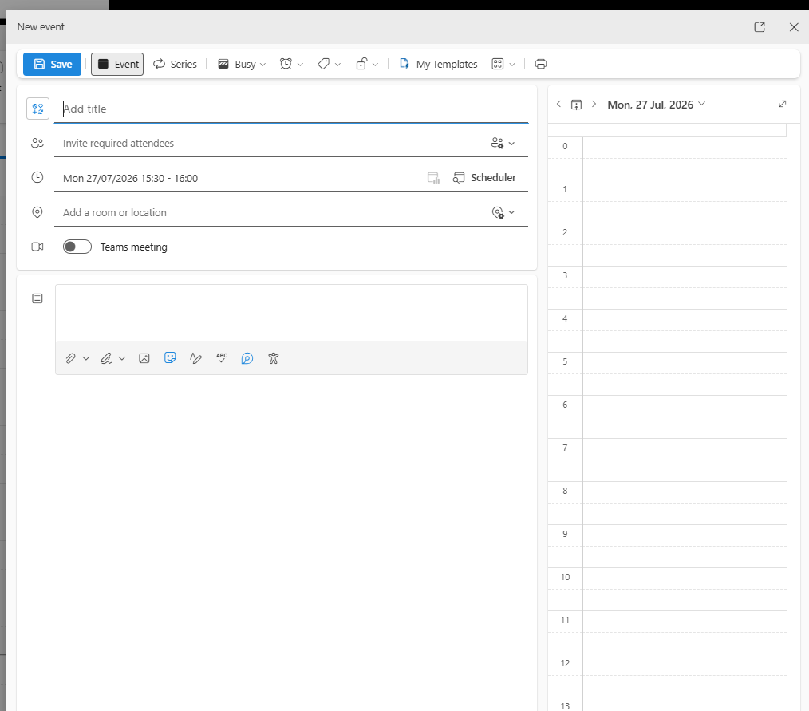

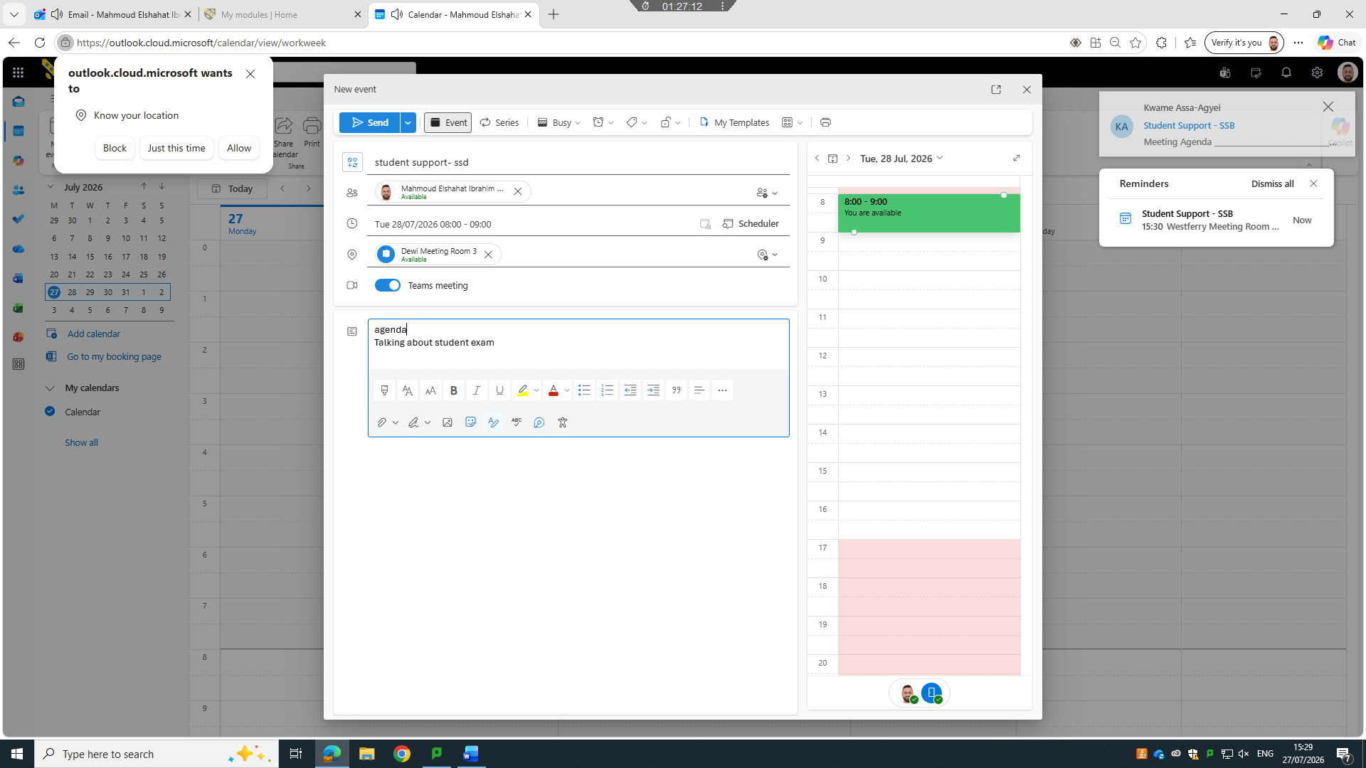

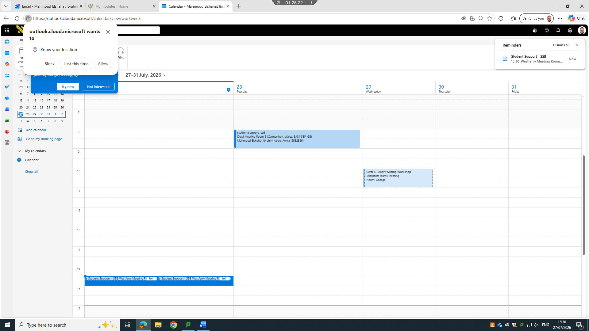


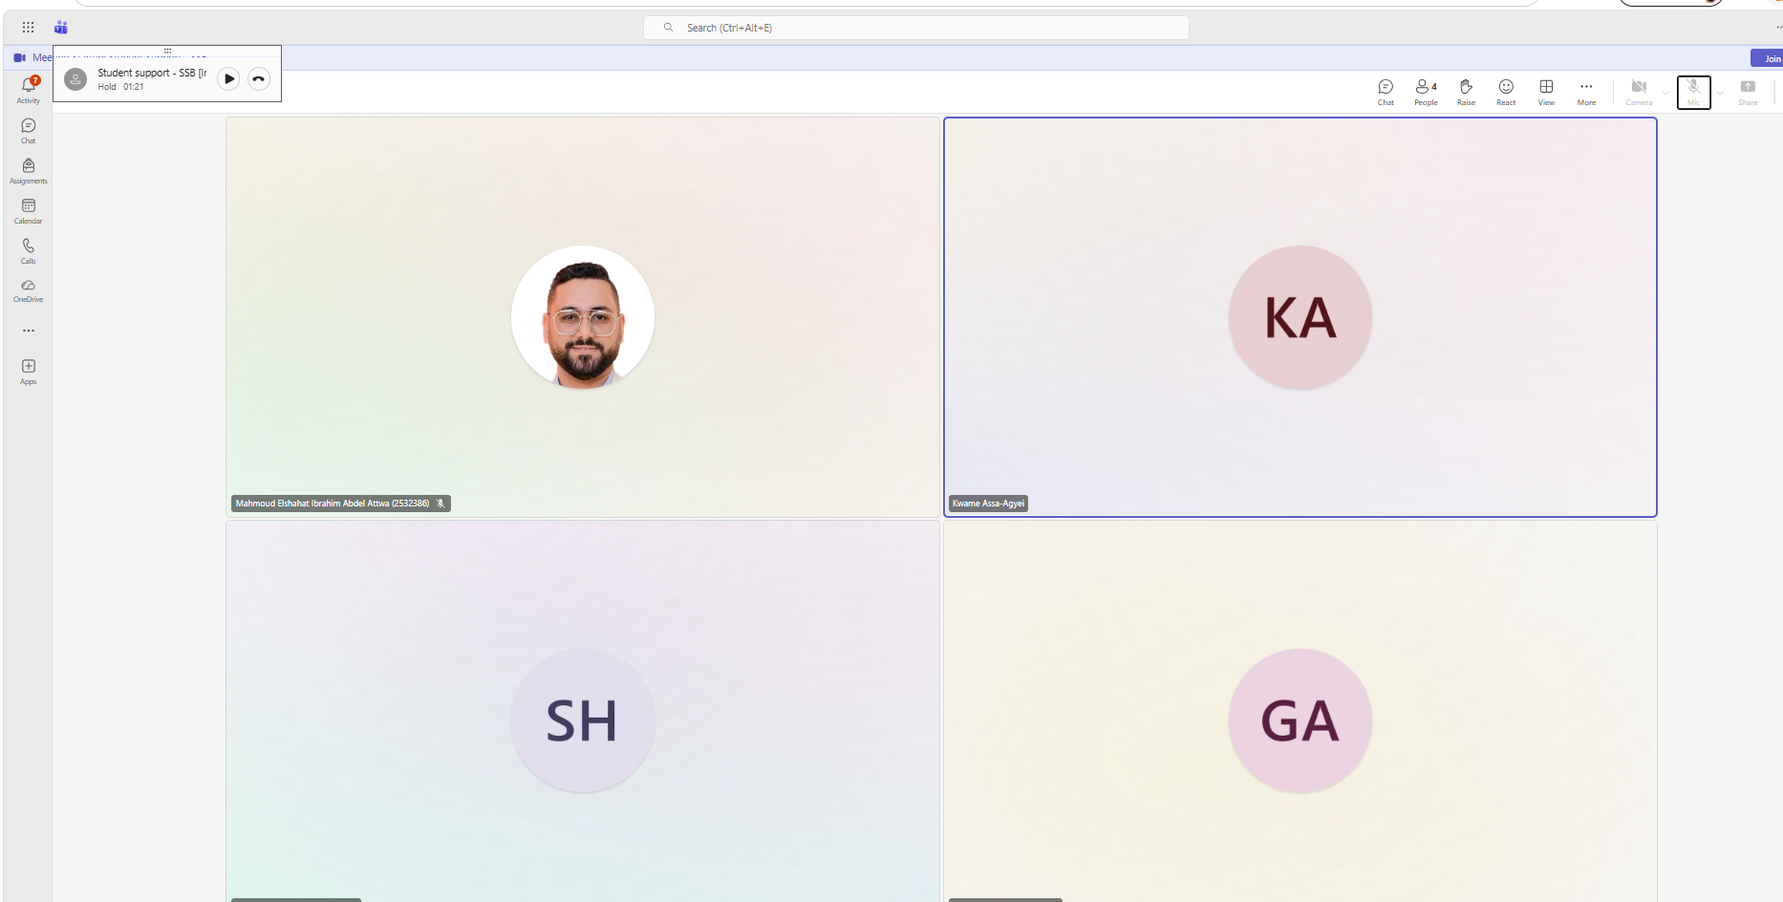

Conclusion

This document has explored a wide range of contemporary digital tools that support modern business operations communication and productivity Beginning with e-commerce platforms such as Wix and Shopify the report highlighted how website builders enable organizations to establish an online presence and manage digital sales efficiently The mind map provided a structured overview of today s software landscape showing how different applications contribute to areas such as project management communication, analytics human resources, and organizational operations
The examination of core office applications Microsoft Word Excel PowerPoint and Access demonstrated how these tools form the foundation of everyday business tasks. Their features advantages and limitations illustrate the importance of selecting appropriate software to meet organizational needs Practical demonstrations of Mail Merge and the IF statement further showed how automation and logical functions enhance accuracy reduce repetitive work and support informed decision making

References
[1] Sanjay Prajapat. "what is Microsoft word." [Online]. Available: https://www.igmguru.com/blog/what-is-microsoft-word

[2] Paul McFedries, Microsoft Excel 2019 Formulas and Functions,
References
[3] Tarsem Singh&nbsp. "Advantages & Disadvantages of MS Access." ScaleupAlly. [Online]. Available: https://scaleupally.io/blog/advantages-disadvantages-of-ms-access
References
[4] Allan M Jones, "Bioscience Education," pp.1–13, [Online]. Available: https://www.tandfonline.com/doi/full/10.3108/beej.2003.02000004#abstract
References
[5] jeanna raffa&nbsp. "What are if-then statements in Excel and how to use them." lonos Digital Guide. [Online]. Available: https://www.ionos.co.uk/digitalguide/online-marketing/online-sales/excel-if-then-statements/
[6] nancy conner, google apps,
[7] nancy conner, google apps,
[8] K. Lücke, "qualimero," 29 3 2026. [Online]. Available: https://qualimero.com/en/blog/shopify-vs-wix. [Accessed 26 6 2026].

[9] Tarsem Singh&nbsp. "Advantages & Disadvantages of MS Access." ScaleupAlly. [Online]. Available: https://scaleupally.io/blog/advantages-disadvantages-of-ms-access
[10] jeanna raffa&nbsp. "What are if-then statements in Excel and how to use them." lonos Digital Guide. [Online]. Available: https://www.ionos.co.uk/digitalguide/online-marketing/online-sales/excel-if-then-statements/
[11] Allan M Jones, "Bioscience Education," pp.1–13, [Online]. Available: https://www.tandfonline.com/doi/full/10.3108/beej.2003.02000004#abstract
[12] Paul McFedries, Microsoft Excel 2019 Formulas and Functions,
[13] Sanjay Prajapat. "what is Microsoft word." [Online]. Available: https://www.igmguru.com/blog/what-is-microsoft-word
[14] gapaidi. "Forming a team." [Online]. Available: https://moodle.uwtsd.ac.uk/mod/scorm/player.php?a=6771&currentorg=unit_3_topic_1_ORG&scoid=14549&sesskey=X4TYj1I9ku&display=popup&mode=normal
[15] Brown B. "Forming a team." [Online]. Available: https://moodle.uwtsd.ac.uk/mod/scorm/player.php?a=6771&currentorg=unit_3_topic_1_ORG&scoid=14549&sesskey=X4TYj1I9ku&display=popup&mode=normal
[16] brown. Forming a team,

[17] R. Cole, "ecom calc tools," 26 4 2026. [Online]. Available: https://ecomcalctools.com/blog/compare/shopify-vs-wix/. [Accessed 26 6 2026].

