Project Management

Assessment 1

Name: Liviu Cosmin Popescu
Student Number: 1813114

Table of Contents
Introduction 2
Company background 2
Project rationale 2
Project scope 3
Aim and objectives 3
Deliverables 3
Schedule plan 4
Work Breakdown Structure 6
Stakeholder engagement 6
Communication management plan 8
Quality management plan 8
Cost benefit analysis 9
Risk management plan 10
Methodology 11
Challenges faced by Sainsbury while implementing SCM in workplace 12
Conclusion and recommendations 13
References 14

Introduction
Developing a business environment required undertaking a project management plan in an appropriate way determining its aim in improving business operations. The significance behind constructing a documented project management plan lies in the fact that it establishes a framework based structural approach in managing activities that are to be executed during the development. The study claims to identify a project management plan that is proposed by Sainsbury organisation, operating in the market environment of UK. The sudden breakout of covid-19 has left impact over the organisation regarding the reduction of production and sales affecting their profit statements. The study plans to deploy a centralised supply chain management system that would manage supplies in a constricted way such that loss regarding production and sales are eliminated.

Company background
Sainsbury has been identified to be an organisation operating in the market environment of UK dealing with Supermarket products for the customers specialised in groceries. The estimated annual revenue growth for the company has been reported on the basis of the last year to be £219 million through an employee strength of 116,400 individuals (Sainsburys.co.uk, 2020). Due to the sudden break, out of covid-19 the issues regarding the company's supply and productions has been drastically affected. This led the business executives and managers to reduce a project management plan that would respond to the changes that are to be made within their business operations to maintain a sustainable position in the market.

Project rationale
The impact of covid-19 has affected business organisations in reducing their regular activities drastically to a lower level. As exclaimed by Quarshieet al., (2016), this led several companies to take upon strategic measure in managing their supply and sales activities. Similarly, Sainsbury faced issues regarding the management of their supply materials as it constituted a regular flow whereas the sales quantity has reduced drastically. This led the company to suffer from reduction in annual revenue growth due to which the stability of the company in the competitive market has been threatened. The business executive is of Sainsbury thereby evaluated the implementation of supply chain management system within their operational environment to keep a balance within their production and sales activities.

Project scope
The scope of the project pertains undertaking the supply chain constraints of Sainsbury organisation during the covid-19 pandemic situation in order to keep the business position intact. The project illustrates and implementation plan of supply chain management system as a centralised IT/IS Technology that would help the company in keeping a track of the materials of production in a controlled way. The project aim, objectives and deliverables have been proposed on the basis of the development plan initiated by the business managers of Sainsbury. The project would also illustrate a risk management plan that would identify the challenges faced by the company in meeting project objectives. The overall budget of the project has been estimated to be £50,000 and the time of delivery of the project outcomes is projected to be six months.

Aim and objectives

Aim
The aim of the project is to deliver a supply chain management system in favour of Sainsbury organisation during the COVID 19 pandemic situation in the UK market.
Objective
- To understand the impacts of COVID 19 over busies organisations
- To evaluate supply chain management in maintaining business stability during COVID 19 situation
- To analyse the effectiveness of supply chain management in maintaining production and sales of Sainsbury
- To recommend methodological approaches sustaining the implementation of supply chain management

Deliverables
Deliverables | Time | Duration
Project initiation document | Initiation phase | 31 days
Contractual agreement with stakeholders | Initiation phase | 8 days
Contractual agreement with employees | Initiation phase | 8 days
Requirement specification document | Initiation Phase | 15 days
Authorised documents from government organisations | Initiation phase | 4 days
Design plan of SCM implementation | Execution | 48 days
Quality control document | Planning | 10 days
Risk management plan | Planning | 10 days
Communication framework | Planning | 10 days
Budget plan | Planning | 10 days
Test case plan | Controlling and monitoring | 17 days
Closure document | Project closure | 10 days
Table 1: Deliverables

Schedule plan
Task Name | Duration | Start | Finish
Initiation | 31 days | Mon 03-08-20 | Mon 14-09-20
Stakeholder engagement | 8 days | Mon 03-08-20 | Wed 12-08-20
Employee engagement | 8 days | Thu 13-08-20 | Mon 24-08-20
Requirement specification | 15 days | Tue 25-08-20 | Mon 14-09-20
Planning | 40 days | Mon 14-09-20 | Fri 06-11-20
Resource management plan | 10 days | Fri 21-08-20 | Thu 03-09-20
Budget plan | 10 days | Mon 14-09-20 | Fri 25-09-20
Communication plan | 10 days | Mon 28-09-20 | Fri 09-10-20
Quality assurance plan | 10 days | Mon 12-10-20 | Fri 23-10-20
Risk management plan | 10 days | Mon 26-10-20 | Fri 06-11-20
Execution | 63 days | Sat 07-11-20 | Tue 02-02-21
Design implementation | 32 days | Mon 09-11-20 | Tue 22-12-20
Supply chain evaluation | 16 days | Wed 23-12-20 | Wed 13-01-21
Alignment of sales and production segments | 12 days | Thu 14-01-21 | Fri 29-01-21
Installation of SCM system | 2 days | Mon 01-02-21 | Tue 02-02-21
Controlling and monitoring | 17 days | Wed 03-02-21 | Thu 25-02-21
Testing | 8 days | Wed 03-02-21 | Fri 12-02-21
Change detection and implementation | 9 days | Mon 15-02-21 | Thu 25-02-21
Closure | 10 days | Thu 25-02-21 | Wed 10-03-21
Documentation | 10 days | Thu 25-02-21 | Wed 10-03-21

Table 2: Schedule management plan
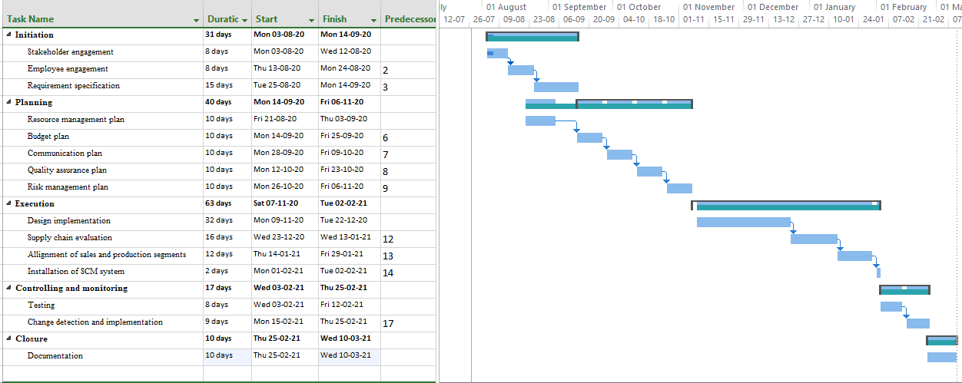
Figure 1: Gantt chart

Work Breakdown Structure
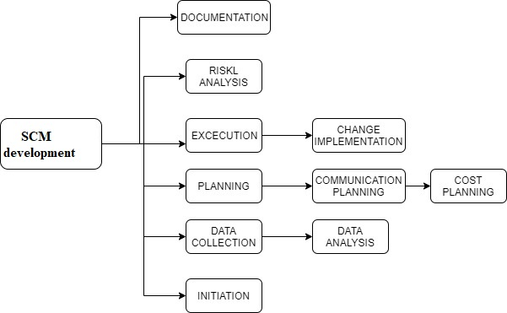
Figure 2: Work Breakdown Structure

Stakeholder engagement
Stakeholder type | Stakeholder name | Roles and responsibilities | Priority
Internal | Owners | - The owners are responsible to make relevant decisions regarding the implementation of supply chain management in the operational environment of Sainsbury  - Any changes to the project that are to be made during its evaluation would be decided by the owners based on their company situation | High
Internal | Employees | - Employees are responsible to execute the activities that are proposed in the project development plan of supply chain management for Sainsbury  - The employees are to work under the supervision of the project manager throughout the project development phases from it initiation to its completion | Low
External | Suppliers | - As Sainsbury plans to evaluate their supply chain management systems the suppliers are considered as the major stakeholders that would be the centralised figure of the development  - The contractual agreements that are made with the suppliers are to be altered aligning the impact of covid-19 over the business | High
External | Customers | - Customers are considered as one of the major stakeholders due to their contribution in increasing the sales of the company products and services  - The supply chain management plan is totally dependent upon the sales that are attained by the customer due to which the rate of supplies would be varied | High
External | Investors | - The completion of the project would require and amount of £50,000 that is to be gained from the engagement of investors  - The payback of the invested sum of money would be obtained from the company side after the successful completion of the project | High
External | Government | - The responsibility of the business executives of Sainsbury is to gain authorised legal certificate in favour of the supply chain management plan from the government organisations  - The legal permits would provide the development plan with certain legislative measures that would align the company policies with that of the government ones | Moderate
Table 4: Stakeholder engagement plan

Communication management plan
Communication Type | Communication medium | Received by | Initiated by | Priority | Frequency
Status update | Reports and Emails | Stakeholders | Project manager | Low | Weekly
Change management | Documented | Project manager | Owners | Moderate | Monthly
Assistance | Voice over | Employees | Team leader | High | Daily
Meeting | Face to face | Project team | Project manager | High | Monthly
Requirement specifications | Emails and reports | Suppliers | Project manager | High | Weekly
Table 5: Communication Plan

Quality management plan
Activity | Quality assurance
Stakeholder engagement | Stakeholders need to be engaged through contractual agreement based on their field of interest and contribution to the project plan
Requirement specification | Project requirements are to be mentioned in an early stage for appropriate budget calculations and time determination
Resource management plan | The execution of project activities needs to be aligned with appropriate resource allocation to eliminate the chance of excessive cash flows
Budget plan | Every activity of the project needs to be aligned with a particular budget allocation for its completion
Communication plan | Effective communication between the project participants would enhance the project in meeting its desired objectives
Risk management plan | Mitigation Strategies for every risk that are possible to occur to the project need to be addressed
Design implementation | The design of the supply chain management system need to be aligned with the current organisational framework of Sainsbury
Installation of SCM system | the installation of SCM system need to be compatible with the current management technique applied by the company
Change detection and implementation | Changes to the project needs to be made after testing of the issues that lie behind the development
Documentation | Every activity that has been executed within the project is to be documented with reasonable justification
Table 6: Quality management plan

Cost benefit analysis
Activity | Estimated cost (£) | Actual cost (£) | Associated benefits (%) | Ratio
Stakeholder engagement | 200 | 250 | 25 | 0.8
Employee engagement | 100 | 200 | 50 | 0.5
Requirement specification | 1500 | 2000 | 33 | 0.75
Resource management plan | 300 | 200 | 50 | 0.67
Communication plan | 300 | 200 | 50 | 0.67
Quality assurance plan | 100 | 300 | 30 | 0.33
Risk management plan | 400 | 300 | 33 | 0.75
Design implementation | 6000 | 5000 | 20 | 0.83
Supply chain evaluation | 10000 | 12000 | 20 | 0.83
Alignment of sales and production segments | 3000 | 2000 | 50 | 0.67
Installation of SCM system | 7000 | 6000 | 16 | 0.86
Testing | 8000 | 5000 | 60 | 0.63
Change detection and implementation | 13000 | 8000 | 62.5 | 0.62
Documentation | 100 | 100 | 0 | 0
Total | £50000 | £41550 | Cost benefit ratio | 0.63
Table 7: Cost-Benefit analysis
Analysis
The cost-benefit analysis has been performed in favour of Sainsbury Organisation in implementing supply chain management within their business environment. The result of the ratio has been identified to be estimating 63% benefits that the company would be earning after having maintained the estimated cost for every project activity. The result has been associated with the quality and time constraints maintained throughout the project plan search that the company would be able to draw profits from their newly established technological implementation.

Risk management plan
Risk type | Risk description | Impact | Mitigation | Responsible individual
Operational risk | Without implementing a methodological approach there would not be a sequential way of executing activities in the project, that may lead to a relevant outcomes and excessive cash flows | Medium | Every operation that is undergone in the project of implementing supply chain management in Sainsbury required to be instructed and supervised by the project manager in order to attain pre-established goals and objectives | Project manager
Budgetary risk | Sainsbury's supply chain management project is expected to encounter excessive cash flows which may result in financial loss for the company | High | The establishment of a sustainable budget plan for the supply chain development would enable the project manager to keep the activities within the estimated cost that has been invested for the project | Finance manager
Decision making risk | Without possessing an appropriate decision-making ability the project manager may not be able to complete the execution of activities in desired time and cost which may result in project failure | High | The implementation of a particular strategic measure to improve business operations required effective decision making in order to meet the expected goals and objectives of the project | Owners
Technological risk | Supply chain management is considered as an IT/IS Technology which requires skilled individuals to implement it within organisation operation without which it may not maintain stability while execution | Low | The implementation of appropriate technological requires effective skills and knowledge for the same in order to cope up with completing the successful implementation of SCM | Employees
Time management risk | Delay in completion of the tasks that are mentioned in the development of the supply chain management plan may lead to delay in project delivery | Medium | Every activity that has been considered to be executed for the supply chain management development need to be completed in expected lines and within estimated budget | Project manager
Table 8: Risk management plan

Methodology
The selection of an appropriate methodology for the implementation of a strategic measure in business operations is considered as a critical decision that is made by the owners of an organisation. In the case of Sainsbury’s organisation, the company has suffered from gaining annual revenue growth due to the sudden break out of covid-19 pandemic (Nicola et al., 2020). Due to this incident the company has lost control of its supply activities as there occurred a sudden reduction in the sales section of their business. As the company plans to evaluate supply chain management as an IT/IS Technology within their centralised business environment, it is expected that a suitable framework of methodology would be selected by the business executives.
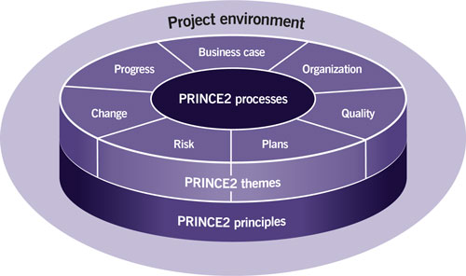
Figure3: Prince2 Methodology
(Source: Influenced by Mousaei and Javdani, 2018)
Considering the available methodological approaches, it has been observed that prince2 methodology enable an organisation to implement a particular strategy in an efficient way reducing the cost and time constraints accordingly. In other words,Estekiet al., (2020) stated that the application of prince2 methodology analyses various sections of the business in a segmented way. This enables the project manager to execute project activities simultaneously that are independent of each other. For instance, the quality management plan and risk management plan that has been deduced in the initiation phase could be executed simultaneously as both management activities are not interrelated of each other. In this way, the overall development plan is expected to be delivered in pre-established and estimated time.

Challenges faced by Sainsbury while implementing SCM in workplace
Challenges are common barriers that arises two governing bodies while executing a project management plan that are related to benefit an organisation. Sainsbury plans to implement supply chain management system within their workplace environment to keep control of their sales and production operations. For this purpose, the business managers plan to evaluate a project that would help implementing the same. The following challenges have been identified that are estimated to be faced by the business executives while developing the project (Linand Blikstein, 2018).
- There is a chance of encountering project delay as the availability of employees for the project development may be reduced due to the occurrence of pandemic covid-19.
- The cost of materials for the development may vary drastically during this current situation due to which excessive cash flows maybe attained

Conclusion and recommendations
Concluding from the aspects of supply chain management, the application of this IT/IS technology enable and organisation to keep a track of the production materials that is purchased from dedicated suppliers. In other words, Sainsbury would be able to keep control of their products depending upon the dales they attain in their regular business activities. The selection of prince2 methodology would enable the business executives of Sainsbury to execute project operations in a simultaneous and sequential way. This indicates a reduction in the time of delivery of project outcomes which would benefit the company producing close and completion time. Additionally, the project identifies several challenges that the company may face while executing the project activities which are to be mitigated with appropriate solutions for the successful completion of the project. Hence, it could be stated that the company would be able to retain their position in the competitive market intuitively by having a controlled production and sales segment through the SCM system.

References
Esteki, M., Gandomani, T.J. and Farsani, H.K., 2020. A risk management framework for distributed scrum using PRINCE2 methodology. Bulletin of Electrical Engineering and Informatics, 9(3), pp.1299-1310.
Lin, V. and Blikstein, P., 2018. Learning loops: Affordances and challenges of Project Bloks. International Society of the Learning Sciences, Inc.[ISLS]..
Mousaei, M. and Javdani, T., 2018. A new project risk management model based on scrum framework and Prince2 methodology. International Journal of Advanced Computer Science and Applications, 9.
Nicola, M., Alsafi, Z., Sohrabi, C., Kerwan, A., Al-Jabir, A., Iosifidis, C., Agha, M. and Agha, R., 2020. The socio-economic implications of the coronavirus and COVID-19 pandemic: a review. International Journal of Surgery.
Quarshie, A.M., Salmi, A. and Leuschner, R., 2016. Sustainability and corporate social responsibility in supply chains: The state of research in supply chain management and business ethics journals. Journal of Purchasing and Supply Management, 22(2), pp.82-97.
Sainsburys.co.uk (2020). About Us. Available at: https://www.sainsburys.co.uk [Accessed on 16.7.2020]
Statista.com (2020). Sainsbury's underlying sales revenue in the United Kingdom (UK) 2011-2019. Available at: https://www.statista.com/statistics/491410/sainsbury-underlying-sales-revenue-united-kingdom-uk/#:~:text=Sainsbury%27s%20underlying%20sales%20generated%20a,in%20the%20nine-year%20period. [Accessed on 14.7.2020]

