
Programme: BA Business Management
Module: Leadership and management, theory and practice
Module code: LCBB6003
Assignment Title: Component 1
Coursework: Essay
Student Name: Lachezar Nikolov
Student ID: 1916906@student.uwtsd.ac.uk
Submission Date: 23/08/24

TASK 1
Leadership and management are two very separate roles in a business. Leadership is the ability to influence individuals or teams to achieve specific goals and objectives. It can be also considered as a quality or skill that any individual can possess (Genza, 2021, p.21). Leaders are responsible for setting the values and goals of an organisation and helping others see those goals by connecting the dots. They envision the corporate values and align other employees with them. On the other hand, management is the process of organising a business and directing the workflow, business operations, and employees in the workplace (Kinicki and Williams, 2020, p.11). The main goal of management is to create a positive and healthy work environment which increases employee efficiency and productivity. Leaders and managers are often confused to be the same. The roles of a manager differ a lot from that of a leader. The prime focus of a leader is to design strategies to achieve organisational goals and make the employees realise those goals. Whereas, the focus of a manager lies in influencing the employees, increasing their motivation and engagement, and extracting the maximum efficiency and productivity from them. A manager needs to have certain leadership skills in them to effectively manage their teams and employees. However, there are cases where leaders do not have or bother with managerial skills. For example, Steve Jobs, the co-founder of Apple, has excellent leadership qualities (Tedlow, 2020, p.35). He has been efficiently leading the company and has revolutionised the tech industry with innovative products like iPhones and iPads. However, his role is not that of a traditional manager. There are separate management teams and managers that monitor the daily operations of the business and help realise his visions.
There is a lot of overlapping of skills and abilities that leaders and managers have. However, the area of focus and roles are what makes them different. The Great Man Theory of Leadership suggests that great leaders are born and not made (Refer to Appendix 1). According to this theory, some individuals have inherent talent and skill sets that make them natural leaders (Benmira and Agboola, 2021, p.23). These qualities are not found in everyone. This theory is based on two assumptions - great leaders are born with leadership skills, and great leaders rise to the occasion when the time is right. The theory endows the principle that leaders are meant to lead because of their Internet leadership skills. However, the difference between leadership and management implies that managing employees is not an inherent trait of a leader. The skill set of a manager needs to be developed with hard work and patience. The CEO of Tesla and SpaceX, Elon Musk can be considered as a born leader. The leadership quality, innovation, and vision of that man are extraordinary (Khan, 2021, p.14). It includes the introduction of electric cars and space exploration. These things have changed the landscape of technology and business. However, some managers work under him to achieve his visionary goals. Hence, a leader doesn't need to possess managerial skills in some scenarios.
The statement "a manager can be a leader but a leader cannot be a manager" highlights the distinction between the roles and responsibilities of a leader and that of a manager. There is a misconception that being a manager makes an individual a great leader. It is the way of thinking of the Great Man theory which is about having inherent leadership skills. However, this is not true. The role of leaders is to ask questions and that of a manager is to answer those questions. Therefore, managers are responsible for not only pleasing their leaders but also managing and organising their teams and helping them achieve targets and goals (Barham et al., 2020, p.45). Hence, they must possess effective leadership skills. Managers come up with various strategies and plans to manage their workforce effectively and gain results from them. Decision-making is another vital role of a manager. They often let their employees participate in the decision-making process during team meetings. It brings innovation and creativity to the table and increases employee engagement. Leaders set the organisation's goals but managers put in the effort to lead the employees and achieve those goals. For instance, Jeff Bezos, the founder of Amazon has led to the disruptive growth of the company and changed the e-commerce business greatly (KUMAR, 2023, p.32). His vision and customer-based thinking have led to the grand success of Amazon. However, there are managers employed under him who oversee day-to-day operations and drive the organisation forward. They monitor, train, and develop their employees to deal with customers properly and cater to their needs.
Leaders are considered visionaries whereas managers can be considered as the heart of a business organisation since they are the reasons for realising the vision and goals of a leader (Karwan et al., 2021, p.20). Managers organise tasks and implement strategies to manage their employees so that the goals of the leaders can be realised. Thus, managers need to have leadership skills to influence their employees. The Behavioural Theory of Leadership proposes that leadership is not a trait but a set of learned behaviours (Refer to Appendix 2). It suggests that anyone can become a leader with the appropriate guidance and the willingness to adapt leadership skills (Fries et al., 2021, p.9). The theory defines leadership skills as a behaviour that can be honed and refined over time. Leadership qualities are not defined by who a person is. It is rather defined by their actions and behaviour. Thus, managers can develop effective leadership skills over time so that they can manage their teams and their organisation better. They must possess friendly and polite behavioural traits to get familiar with employees and understand their requirements. Bill Gates is the co-founder of Microsoft. The man possessed a great leadership skill and vision and he led Microsoft to early success and revolutionised the software industry (Yoffie and Cusumano, 2021, p.22). However, he is not responsible for delegating operational responsibilities. Those are the roles of his managers and various departments of the organisation. Thus, it can be clearly said that leaders may or may not have managerial skills depending on the situation and size of a company. However, managers must be good leaders to lead their teams effectively and extract the maximum productivity out of them.

TASK 2
The usage of employability skills is necessary to manage and lead people. Managing people to do a particular task can be tricky (Yoffie and Cusumano, 2021, p.22). Therefore, if I can communicate with people smoothly, then it can be helpful for me to share my concerns and ask them for help in any situation. I can manage people by sharing with them my achievement stories and it is an effective way to motivate them for work. Hence, I can say that communication skill is an important skill to manage people. Another approach is the ability to mentor others.
Mentoring others to handle their task shows a great leadership quality. I can make sure that others can rely on me and serve me whenever I need them. In this way, I can provide a learning environment for others, and this can be helpful for others too.
I need to enhance my problem-solving abilities to make sure people find it convenient to help. Otherwise, no one will show interest in serving someone who is not capable of doing his tasks. Problem-solving skill comes under another skill to help others with their problems. It leads to making important decisions and enables us to create designs to meet the required requirements.
The last skill that comes to my mind is setting a goal. In a team, I need to make sure others are known of the goals that are set. In this way, people can set their minds as per the goal. Therefore, they will work according to the required set of goals so that negligence can be avoided.
Leading a horse towards water is a responsibility but fetching them is not a task of a leader neither one shall do that (Yoffie and Cusumano, 2021, p.22). All human beings have different mindsets and their way of thinking. Therefore, telling them to do what they want can be uncertain. It is very important to make others realise why they should do the work, rather than telling them directly to do the work. Engaging the employees to do a particular work makes them feel their worth. Instead of telling them directly, offer them a rationale. In this way, they will find out ways to do the tasks. Also, it won't make others feel that they are being forced to do a particular work. This engagement skill is very useful when we tend to make the other person feel that they want to do the particular task and not someone else is forcing them to. Human beings have a strong need to feel free to make decisions and not be in anyone's control. A good leader knows how to make others feel important and control people by not having a direct controlling attitude towards them.
Language is another skill in my opinion which plays an important role in dealing with the psychology of the human brain. The command and controlling styles of a leader are very crucial when it comes to managing people in an organisation. No one wants to work under someone who is controlling in nature. Therefore, I shall always have to be more informative and less controlling. Then only, an organisation will obey me as a leader and work smoothly under any circumstance. Providing people with rationale, makes them think that they are worthy of the task. Thus, it allows them to impute the task or event which makes people feel their importance and belief towards the organisation.
Communication skills are one of the most effective skills that can allow individuals to communicate with others and express their points of view (Faber et al., 2024, p.4). It also helps the individuals to clarify their thoughts and reciprocate to others by involving them in a conversation. In my childhood, I have always faced issues while communicating with others because of my introverted nature. I used to sit alone and because of low communication, I failed to make many friends. However, as I was growing I started to read many books and get help from an expert who has guided me to improve my communication. Hence I can say that my communication skills are now moderate and I will need to enhance them more. However, this skill has increased my confidence and ability to collaborate with others.
Mentorship ability is another ability that allows a person to lead a team or take the leadership position to guide the team in the right way (Mboto et al., 2024, p.6). During my higher academic classes, I was assigned as a mentor of a group in a project. Thus I have given my best to complete the role and I have gathered many experiences that have enriched me to get success in future. However, I felt that I could have contributed much better during the mentorship. Henceforth I will need to develop it more to gather the knowledge of being a successful leader in future. Problem-solving skills denote the ability to solve problems, even critical ones (Zhou et al., 2024, p.10). However, since childhood, I have been weak at problem-solving, hence facing issues like low marks in mathematics and analytical papers and so forth. I have realised the importance of problem-solving because it helps individuals solve critical problems in both their personal and professional lives. Hence I will need to enhance this skill and improve my ability to solve any kind of problem. Setting goals is very crucial for business and personal development as well. Setting a proper goal will contribute to moulding my character because it helps a person to be more sincere and dedicated.
For organisational performance improvement communication plays a significant role. For example, Unilever is a British multinational company that upholds strong communication within its diverse departments and this is one of the reasons for its success. Strong mentorship abilities also impact organisational performance positively. In this regard, Elon Musk can be exemplified because his extraordinary transformational mentorship has helped Tesla to be one of the largest automobile manufacturing companies in the whole world (Francisco, 2024, p.34). An organisation that upholds a strong problem-solving team access the best expertise and success. For instance, Tesco can be considered because they have a strong problem-solving team which have resolved many issues like data breaches, legal scandals and so forth. Goal setting is the main motto of a business company to achieve success in future. Unilever is a company that has set some strong goals that also help them to fulfil their societal and environmental promises.

Reference List
Barham, H., Dabic, M., Daim, T. and Shifrer, D. (2020) The role of management support for the implementation of open innovation practices in firms. Technology in Society, 63, p.101282. https://irep.ntu.ac.uk/id/eprint/40605/1/1359203_Dabic.pdf
Benmira, S. and Agboola, M. (2021) Evolution of leadership theory. BMJ leader, pp.leader-2020. https://bmjleader.bmj.com/content/leader/5/1/3.full.pdf
Faber, E.L., Colthorpe, K., Ainscough, L. and Kibedi, J. (2024) Students' approaches to developing scientific communication skills. Advances in Physiology Education. https://journals.physiology.org/doi/pdf/10.1152/advan.00009.2024
Florida Tech Online. (2020). Top 8 Leadership Theories. [online] Available from: https://www.floridatechonline.com/blog/psychology/top-8-leadership-theories/. (Accessed 12 July 2024)
Francisco, C. (2024) The Power of Influence: Leading by Example for Greater Role and Productivity. Available at SSRN 4862247. https://dx.doi.org/10.2139/ssrn.4862247
Fries, A., Kammerlander, N. and Leitterstorf, M. (2021) Leadership styles and leadership behaviors in family firms: A systematic literature review. Journal of Family Business Strategy, 12(1), p.100374. https://www.sciencedirect.com/science/article/pii/S1877858520301017
Genza, G.M. (2021) But what is leadership? A systematic review of the leadership concept in view of heightened educational leadership in Africa. leadership, 12(9). https://pdfs.semanticscholar.org/2d86/9ea318134f8ad4001d38018a23a9dd6e27c6.pdf
Karwan, D.H., Hariri, H. and Ridwan, R. (2021) Visionary leadership: what, why, and how. European Union Digital Library. http://repository.lppm.unila.ac.id/35598/1/PROSIDING%20Int%20Karwan%26Hariri%20et%20al%202021%20Visionary%20Leadership.pdf
Khan, M.R. (2021) A critical analysis of Elon Musk’s leadership in Tesla motors. Journal of Global Entrepreneurship Research, 11(1), pp.213-222. https://doi.org/10.1007/s40497-021-00284-z
Kinicki, A. and Williams, B.K. (2020) Management: A practical introduction. McGraw-Hill. https://thuvienso.hoasen.edu.vn/bitstream/handle/123456789/12764/Contents.pdf?sequence=1&isAllowed=y
KUMAR, A. (2023) Jeff Bezos: The Entrepreneur with a Difference. International Journal of Applied Social Science, 10(5), pp.397-401. http://scientificresearchjournal.com/wp-content/uploads/2023/07/Social-Science-10_A-397-401.pdf
Mboto, W.A., Enamhe, D.C., Akah, P.E., Bukie, F.B., Ede, V.I., Eyang, B.O., Abonor, L.B., Elemi, O.L., Ushie, C., Upeh, U.B. and Mboto, H.W. (2024) Mentorship: A Panacea for Success. International Journal of Religion, 5(5), pp.262-270. https://doi.org/10.61707/mxeh5k71
Tedlow, R.S. (2020) The Sky above and the Mud below: Two Books about Steve Jobs. Business History Review, 94(4), pp.835-852. https://doi.org/10.1017/S0007680520000756
Yoffie, D.B. and Cusumano, M.A. (2021) Strategy Rules: Five Timeless Lessons from Bill Gates, Andy Grove, and Steve Jobs. http://dspace.vnbrims.org:13000/jspui/bitstream/123456789/4809/1/Strategy%20Rules%20Five%20Timeless%20Lessons%20from%20Bill%20Gates%2C%20Andy%20Grove%2C%20and%20Steve%20Jobs.pdf
Zhou, T., Luo, Y., Xiong, W., Meng, Z., Zhang, H. and Zhang, J. (2024) Problem-solving skills training for parents of children with chronic health conditions: a systematic review and meta-analysis. JAMA paediatrics. 10.1001/jamapediatrics.2023.5753

Appendix
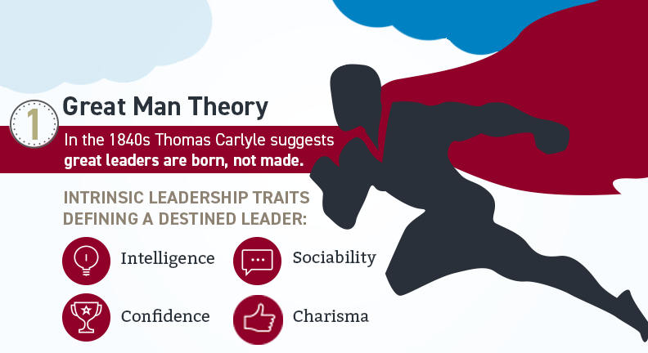
Figure 1: Great Man Theory
(Source: Florida Tech Online, 2020)
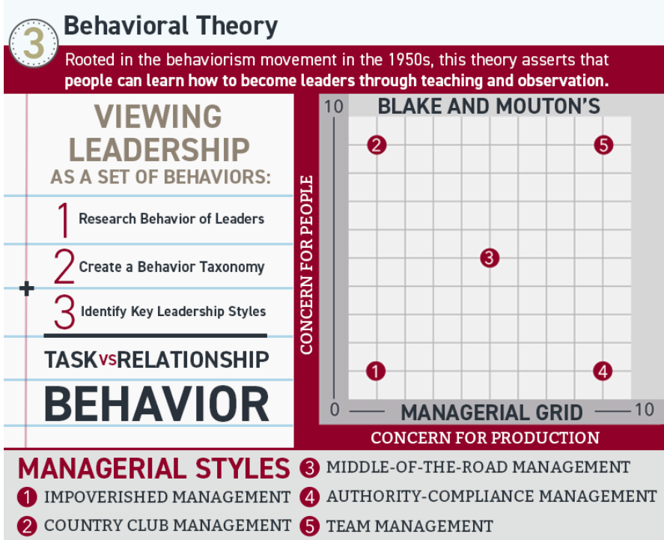
Figure 2: Behavioural Theory
(Source: Florida Tech Online, 2020)

