MARIA LOUISE HENRY
Student number: 1909403
Module Code: BMSW4003
Module Title: DIGITAL SKILLS AND RESEARCH METHODS

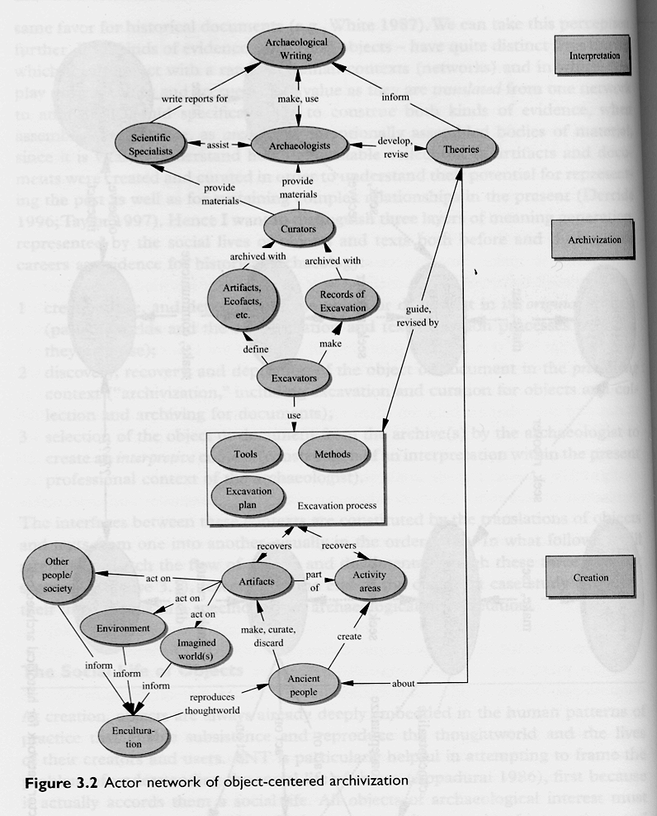

Lecturer: YAJESH KUMAR

“THE WHOLE, “IS THE INTERNET A GOOD THING OR A BAD THING?” WE’RE DONE WITH THAT. IT’S JUST A THING. HOW TO MAXIMIZE ITS CIVIC VALUE, ITS PUBLIC GOOD THAT’S THE REALLY BIG CHALLENGE.”
~ CLAY SHIRKY, 2010

TABLE OF CONTENTS
ACKNOWLEDGEMENTS 2
ABSTRACT 2
1.0 TITLE 3
2.0 INTRODUCTION 3
3.0 RATIONALE 3
4.0 OBJECTIVES 4
5.0 METHODOLOGY 4
5.1 Primary data collection 4
5.2 Secondary data collection: 5
6.0 RESULTS 5
6.1 Primary Data Analysis: 5
6.1.1 Perceived ease of access to the internet: 5
6.1.2 Perceived ease of use 6
6.1.3 Perception of own ICT skills 6
6.1.5 Perceived usefulness of Moodle 7
6.1.6 Student-teacher interaction and class dynamic 7
6.1.7 Overall perception 7
6.2 Secondary Data Analysis 8
7.0 CONCLUSION 9
7.1 Limitations 9
7.2 Recommendations 10
8.0 REFERENCES 11
9.0 APPENDICES 13
Appendix 1: Survey questionnaire 13
Appendix 2: In-class and own research notes 15
LIST OF CHARTS
Chart 1: Perceived ease of access 6
Chart 2: Perceived ease of use 6
Chart 3: Confidence in ICT skills 6
Chart 4: Not commuting to school 6
LIST OF GRAPHS
Graph 1: Ease of access Vs age 6
Graph 2: Ease of use Vs gender 6
Graph 3: Usefulness of Moodle 7
Graph 4: Communication, Feedbacks and participation 7
Graph 5: Overall perception - Moodle Vs traditional physical classroom 8

ACKNOWLEDGEMENTS
I praise the good Lord of glory, God Almighty for his goodness, preserving me and my household through times like these. I appreciate my family for the understanding and the support they have given me in every way, to encourage me in undertaking these studies. My sincere regards also goes to my lecturer, Yajesh Kumar, who not only teach brilliantly, but also explores means of ensuring that his lectures are understood. I cannot forget my classmates, sometimes I miss lectures due to personal pressures and there would always be someone willing to fill me in, thanks much and God bless you all.

ABSTRACT
The employment of the Virtual learning environments (VLEs), either to support traditional classroom learning or singularly for online degrees, is universally adapted in every institutions of higher learning and the UWTSD is not left out, where Moodle is the VLE of choice. This study reports on a survey of 12 respondents, sampled from Level 4 Health and Social Care students of UWTDS, London campus, respecting their experiences on the use of Moodle for their learning. The questionnaire method of data collection was employed and the 3-part questions bordered on students’ ease of use of Moodle and easy accessibility to the internet, ICT skills, implications of Moodle to their learning with respect to productivity, independence and motivation, interactions and community and their thoughts for the future. Respondents lay claim to productive learning and tasks accomplishments, ICT skills improvement, ease of use, and flexibility regarding time, space and pace. However, respondents did not seem to enjoy independent study as majority of them claim that physical class dynamic was vital to their learning, and besides, communication with lecturers and receiving feedbacks pose a serious issue. These responses were compared with published studies on same parameters and there was a great level of agreements. The singular point of deviation being that of independency and motivation. Though there were limitations especially with non-representative sample, deductions and recommendations offered will still prove invaluable to the college as indicated areas for attention in promoting Moodle use is diligently considered.

1.0 TITLE

THE IMPACT OF VIRTUAL LEARNING ENVIRONMENT (VLE) – MOODLE ON STUDENTS’ LEARNING EXPERIENCE IN THE UNIVERSITY OF WALES TRINITY SAINT DAVID (UWTSD), LONDON CAMPUS.

2.0 INTRODUCTION
Virtual Learning Environment (VLE), Learning Management Systems (LMS), Collaborative Learning Environments (CLE), Managed Learning Environment (MLE), Computer Mediated Communication (CMC) are terms, often used synonymously, to typically reference a set of web based software system designed to facilitate learning and teaching, utilising digital tools to create online activities aimed at augmenting the student's learning experience (JISC, 2009a; Awan, 2013). A typical VLE package include curriculum mapping (breaking curriculum into segments for easier navigation by students), electronic communications (e-mail, strung discussions, Web publishing, virtual classrooms, chats, etc.), and Internet links to external curriculum materials (Awan, 2013). A selection of free and commercial VLEs exist, employed by educational institutions, including the WebCT, Moodle, Blackboard, as a means, either to support physical face-to-face classroom instructions, or to wholly deliver educational content (Martín-Blas and Serrano-Fernández, 2008). Moodle is the VL platform of choice used by the UWTSD, to host e-learning content. This research therefore, seeks to explore the impact of VLE, with particular reference to Moodle, on students’ learning experiences in the UWTSD. Therefore, let it be understood that in this report, VLE and Moodle are used interchangeably. To achieve this objective, both primary and secondary data will be collected from classmates and relevant published works respectively, will be perused. These data will be analysed and compared to arrive at rational deductions, which will provide the grounds for proposed recommendations. Scanned excerpts from personal online research, in-class exercises, as well as the lecturer’s feedbacks, where possible, will be appended (Appendix 2).

3.0 RATIONALE
Robust empirical evidence suggests that the use of a VLE positively impacts students’ achievement by giving some form of study flexibility, increasing students’ motivation to learn, as well as encouraging independent learning (JISC, 2008; Barker and Gossman, 2013; UCI, 2014). Students on VLE can complete tasks, either in class or at their own time, location and pace, and contributions to discussions could be synchronous and asynchronous (JISC, 2009b). Notwithstanding, these apparent advantages are critically contested by researchers, underlining serious setbacks intrinsic to VLE utilisation, despite its vast content repository benefits. At the top of the list are limited active learner participation (Donnelly and O'Rourke, 2007; Blin and Munro, 2008), technical issues and limited access to lecturer-student dynamics (UCI, 2014), lacking motivation and lessening social interaction with classmates (Cosgrave et al., 2011). However, in spite of these negatives, there is no higher education institution today that operates solely on the traditional face-to-face classroom concept without the added use (and for some, total use) of VLE. Consequently Alves et al. (2017), believe that, such strong and universal adoption of VLEs justify the concern with such environments, to evaluate their impact on students’ performance, thereby informing the rationale for this study.

4.0 OBJECTIVES
The objectives of this study are:
- To understand the impact of the VL system, Moodle, as an online learning resource in the UWTSD, by conducting a primary research study to explore the experiences of Level 4 Health and Social Care students of the institution.
- To examine and compare published views with deductions from the primary research for a possible relativism.
- To propose recommendations based on derived conclusions towards a possible more functional and effective dynamic of the use of the VL system, Moodle in UWTSD.

5.0 METHODOLOGY
5.1 Primary data collection: An opinion survey on respondents’ experiences and perceptions respecting their usage of Moodle was conducted with the specified population, utilising the questionnaire survey method of data collection (Appendix 1). The choice for this method was grounded on its cost effectiveness, convenience and data availability (Creswell, 2003). Participants were advised of the anonymous and voluntary nature of the survey. Overall, 22 questions were asked, divided into 3 sections. Part one contained 4 significant biodata questions which could have implications for Moodle users’ experiences. Part 2 contained closed questions which explored students’ overall personal and learning experiences. The last 4 questions were open-ended, permitting respondents to freely give their thoughts on issues not covered in the closed section. The closed answer options ranged from ‘Strongly Agree’ to ‘Strongly Disagree,’ captured on a 6-point Likert scale, with ‘Not Sure’ in the 6th column, to depict a possible lack of confidence in one’s understanding of the system. 20 questionnaires were given out, 15 were returned out of which 3 were dropped due to haphazard or grossly scanty entries. Hence only 12 returns were deemed valid for analysis; 7 males and 5 females.

5.2 Secondary data collection: Published literatures (books and journals) on the subject were perused for relevant data. Searches were also carried out on the internet using search engines, particularly, google and google scholar, for credible sources of information such as E-journals, PDF and reliable web pages from institutions and research bodies like Research Gate. Specialist databases on the online library of the UWTSD was also explored for relevant e-books and e-journals. To ensure source credibility, books and journal articles were prioritised over web pages and where possible, more recently published works were preferred to older ones.

6.0 RESULTS
6.1 Primary Data Analysis: The Microsoft excel software was used to analyse the raw data and meaningful cross tabulated charts and graphs were derived to show relationships between the variables. The data was mainly quantitatively analysed due to word count restriction.

6.1.1 Perceived ease of access to the internet: While all respondents agree to have easy access to the internet, majority of them (58%) strongly agree (Chart 1 below), with the largest age group being those in the 28-32 years age bracket (Graph1 below).

Graph 1: Ease of access Vs age

Chart 1: Perceived ease of access

6.1.2 Perceived ease of use
Chart 2: Perceived ease of use

Graph 2: Ease of use Vs gender

While all respondents agree on their ease of use of Moodle, majority of them (42%) are a bit unsure of themselves (Chart 2) and most of these are females (Graph 2). The ratio of men to women in this study is quite insignificant to impact results.

6.1.3 Perception of own ICT skills 6.1.4 Offering convenience
Chart 4: Not commuting to school

Chart 3: Confidence in ICT skills

As depicted in Chart 3 above, most students claim confidence in their ICT skills. Chart 4 shows that most students like the idea of not having to drive/commute to school (Q14), this is a form of convenience that comes with the use of Moodle.

6.1.5 Perceived usefulness of Moodle
Graph 3: Usefulness of Moodle

Interestingly, in all 4 parameters respondents show equal degree (42% ‘Agree’) of claims of the usefulness of Moodle to their progression (Graph 3). However, there is a ‘strong disagreement’ (50%), respecting the ‘Independence’ variable which highlight most students’ unacceptance of the lack of face-to-face dynamics of study. The question asked students to attest to being self-motivated and enjoying independent study (Q9). This expression was significantly underscored in the open questions.

6.1.6 Student-teacher interaction and class dynamic
Graph 4: Communication, Feedbacks and participation

Respondents express the need for face-to-face interactions with tutors and classmates above the Moodle system (Graph 4). While relatively fewer, a construct of the unrepresentative sample population, students complain of delayed feedbacks from and lack of communication with lecturers.

6.1.7 Overall perception
There is no strong agreement for Moodle to replace traditional classroom setting in future (Graph 5 below). Conversely, there are strong disagreements to this thought. Also, respondents do not see Moodle as being comparable to physical classroom. They clearly state in the open questions that Moodle could only act as a support to face to face classroom setting, a secondary construct.
Graph 5: Overall perception - Moodle Vs traditional physical classroom

It is also important to note that, in the open questions, respondents applauded Moodle for flexibility; learning at one’s pace, place and time, as well as aiding the improvement of their ICT skills. They however complained that Moodle engenders serious distractions and therefore, non-motivating and time wasting

6.2 Secondary Data Analysis
The first televisual college credit classes was launched by the University of Houston in 1953. By the 1960s, instructors were utilising various electronic teaching technologies to manage course content (Firefly, 2020). VLE concept is therefore, not that novel, what we are witnessing is an ever continuing evolution. Debates respecting its use borders on what negative side effects could accompany its numerous perceived benefits. Researchers argue that there is a qualitative difference between simply placing a course online and teaching online, and that online pedagogies are appreciated by students only in relation to the degree by which they seem to simulate or replicate an equivalent traditional classroom experience (e.g., Martín-Blas and Serrano-Fernández, 2008; Cosgrave et al., 2011; UCI, 2014). This statement resonates with that of the respondents in this study. Barker and Gossman (2013) reported from their study that while collaboration is lacking when using Moodle, a slight majority of their respondents claimed that its use had a positive impact on their learning, and the flexibility it affords is important for encouraging independent learning. This conclusion agrees with the primary survey on the first two counts, while differing in the ‘independent’ outcome. Awan (2013) also deduced from his study that learners have sufficient knowledge of ICT skills required to successfully access and utilise the VLE platform. They also claim to have access to enabled devices, and claim to find the VLE easy to use. These claims all tally with the results of the primary study here. In 2014, UCI conducted a similar study and concluded that, while students claimed to enjoy the convenience offered by VLE, it neither contributed to effective communication, nor promotes participation and interaction, corroborating the expressions here. Obviously, results of the primary research presented above, though with small sample, seem to agree with conclusions from published reports on students’ experiences on Moodle, except for the ‘independent’ result.

7.0 CONCLUSION
Petrova (2005) who conducted an elaborate study of Moodle proffer that the learning system has much to offer to all stakeholders — educators, managers and students. While these claims are founded, institutions have much to do to make Moodle holistically wholesome as a learning dynamic. Moodle has a lot of benefits as evidenced from the primary data and published works. Respondents claim to enjoy the flexibility it affords, as well as continuous practical grooming on ICT skills. It improves students’ productivity and helps accomplish tasks, exposes students to almost unlimited online resources for study. The only point of difference is in the respondents’ dissatisfaction with independent learning. Participants claim that having to go online so often results in time wasting as one could endlessly roam online without finding their search. Sometimes, it is an outright distraction as one could totally abandon what they were supposed to do and wander off. Most significantly, in this study, respondents decried the loss of their social interactions and say that interactions with classmates and lecturers are critical to their learning, and especially, as communication with lectures are not guaranteed, making it difficult to seek assistance and receive feedbacks. For reasons such as these, VLE could only remain as an adjunct, never a replacement to the face-to-face learning construct.

7.1 Limitations
- Primarily, because of the lockdown situation, data collection was highly impaired, and so very few respondents’ could be reached. The sample population is small, not representative of the actual and therefore, though findings largely tally with prior published works, they may not be generalised respecting the target population. This is a major setback to this study.
- This form of study requires the triangulated form of analysis, whereby, respondents’ opinions in their own words are highlighted in a qualitative paradigm. However, due to word count limitation, the data was only quantitatively analysed and selectively so.

7.2 Recommendations
In consonance with the purpose of this study, these recommendations will only address the issues underscored in the primary research:
- The University should consider minimum requirements for directed use of Moodle by students.
- Strategies to encourage non-directed use of Moodle should be implemented.
- The Moodle platform should be made as interactive as possible, a system could be arranged where students could reach their tutors, and receive the much needed attention, rather than an environment restricted to a role as an information repository. This could be achieved by tutors giving a specific time frame, a reference period where students could go online and find them directly. That way if any student misses such time boundary, they could always plan for the next day, or when convenient.
- Freshmen should be taught ICT skills, it should not be taken for granted that everyone is ICT proficient. Some participants’ responses underlie a lack of the skill.
- Students should be taught how to navigate through Moodle in particular, and the internet in general. Refresher courses should be organised periodically to encourage, motivate, and importantly, inculcate a sense of discipline while online in users and potential users.

8.0 REFERENCES
Alves, P., Miranda, L. and Morais, C. (2017) The Influence of Virtual Learning Environments in Students' Performance. Universal Journal of Educational Research, 5 (3), pp. 517-527.
Awan, R. N. (2013) Students Opinions on the Use of a Virtual Learning Environment at a Higher Education Institution in Dubai. International Journal of Science and Applied Information Technology (IJSAIT), 2 (2), pp. 1-5.
Barker, J. and Gossman, P. (2013) The learning impact of a virtual learning environment: students’ views. Teacher Education Network (Tean) Journal 5 (2), pp. 19-38.
Blin, F. and Munro, M. (2008). Why Hasn't Technology Interrupted Academics' Teaching Practices? Understanding Resistance to Change Through the Lens of Activity Theory. Computers & Education, 50 (2), pp. 475-490.
Cosgrave, R., Rísquez, A., Logan-Phelan, T., Farrelly, T., Costello, E., Palmer, M., McAvinia, C., Harding, N. and Vaughan, N. (2011) Usage And Uptake Of Virtual Learning Environments In Ireland: Findings From A Multi Institutional Study. The All Ireland Journal of Teaching and Learning in Higher Education (AISHE-J), 3 (1) pp. 00030.1-00030.14.
Creswell, J. W. (2003) Research Design: Qualitative and Quantitative Approaches. SAGE, London.
Donnelly, R. and O'Rourke, K. C. (20070. What Now? Evaluating eLearning CPD Practice in Irish Third-Level Education. Journal of Further and Higher Education, 31 (1), pp. 31-40.
Firefly Learning (2020) What is a Virtual Learning Environment (VLE)? Retrieved from: https://fireflylearning.com/what-is-a-virtual-learning-environment-vle [Accessed 21/04/2020].
Joint Information Systems Committee (JISC) (2008) Exploring Tangible Benefits of e-learning External Relation. Retrieved from: https://issuu.com/jiscinfonet/docs/tangible-benefits [Accessed 21/04/2020].
Joint Information Systems Committee (JISC) (2009a) Effective Practice in a Digital Age. Retrieved from: https://www.jisc.ac.uk/podcasts/effective-practice-in-a-digital-age-30-jun-2009 [Accessed 05/05/2020].
Joint Information Systems Committee (JISC) (2009b) Effective Use of VLEs. Retrieved from: www.jiscinfonet.ac.uk./effective-use-of-VLEs [Accessed 03/05/2020].
Martín-Blas, T. and Serrano-Fernández, A. (2008) The role of new technologies in the learning process: Moodle as a teaching tool in Physics. Computers & Education, 52, pp. 35-44.
Petrova (2005) Moodle as a virtual learning environment. Retrieved from: https://www.researchgate.net/publication/43092365_Moodle_as_a_virtual_learning_environment [Accessed 05/05/2020].
The University of California, Irvine (UCI) (2014) Online Learning - Student Perception Survey. Retrieved from: https://sites.uci.edu/eee/files/2015/09/onlinelearningsurvey20092014.pdf [Accessed 21/04/2020].

9.0 APPENDICES

Appendix 1: Survey questionnaire

QUESTIONNAIRE
Dear fellow students, while the Virtual Learning Environment (VLE) on the Moodle platform has always been a welcomed adjunct to our physical learning construct for us at the University of Wales Trinity Saint David (UWTSD) London Campus, the unfortunate advent of corona virus pandemic (COVID-19), has however, made this learning concept the only choice, and we cannot tell whether there will ever be such normalcy as we used to experience. Certainly, there are issues and challenges with this total deviation from the traditional norm of learning. This questionnaire is meant to explore your views on this issue, relative to your experiences thus far. You could not be right or wrong in your sincere answers and your participation is totally anonymous and voluntary. The collection of biodata are for statistical purposes only. Many thanks for your kind response. MARIA LOUISE HENRY, ID: 1909403, UWTSD.

Please simply tick the right answers.

- What is your Gender? Male ( ) Female ( )

- What is your age bracket? 18 - 22 ( ) 23 – 27 ( ) 28 - 32 ( )
33 or more ( ).

- What is your civil status? Married ( ) Single ( )

Other ( ) Please state …………………………………….

- Do you have children? Yes ( ) No ( )

SN | Student’s appraisal of  VLE use | Strongly Agree | Agree | Somewhat Agree | Disagree | Strongly Disagree | Not Sure
1 | I can easily access the internet as needed for my studies
2 | I am very confident in my ICT skills
3 | The VLE system is very easy to understand and use
4 | The VLE system is very useful for learning purposes
5 | VLE is better and can totally replace physical classroom for the future
6 | VLE for me is the same as physical classroom learning
7 | VLE increases my learning productivity and helps me better accomplish my tasks
8 | VLE enhances my knowledge in IT skills and research
SN | Student’s appraisal of  VLE use | Strongly Agree | Agree | Somewhat Agree | Disagree | Strongly Disagree | Not Sure
9 | I am self-motivated and enjoy working independently
10 | I prefer the assistance of other students in physical classroom situation
11 | With Moodle, I can ask my teacher questions and receive a  quick response
12 | Face-to-face contact with my instructor is necessary for my learning.
13 | Assessments and feedbacks from lecturers are not easily obtained
14 | I like the idea of not having to drive/commute to school

15. Any other comments respecting your personal experience with Moodle?
_________________________________________________________________________________________________________________________________________________________________________________________________________

16. Any other advantages for you not listed above?
_________________________________________________________________________________________________________________________________________________________________________________________________________

17. Any other disadvantages for you not listed above?
_________________________________________________________________________________________________________________________________________________________________________________________________________

18. Any suggestions on how Moodle could be improved for you?
_________________________________________________________________________________________________________________________________________________________________________________________________________
Thank you so much for your time.

Appendix 2: In-class and own research notes


