BMPF7013 - INDEPENDENT STUDY

1. Portfolio: On Developing a Personal Coaching Model for Teaching Singing

Introduction and Rationale

This study will investigate and compare various coaching methods in order to synthesise a personal coaching method for my teaching practice. This paper will explain my choice of Acceptance and Commitment Therapy (ACT) as the core underlying structure for this method.

I am a peripatetic singing teacher, working in a local high school and the local university, and have been teaching in this capacity for almost two decades. The initial direction of my studies in my degree course has been towards the alleviation of music performance anxiety (MPA) symptoms, which can be crippling. In the course of my teaching career, I have seen an increasing prevalence of anxiety among my students, (now, I think, exacerbated by the global pandemic), and I believe that coaching can have a positive effect with regard to this. Having done a considerable amount of research into coaching disciplines, although I am still concerned with MPA, and intend to design my first proper research project with this at its centre, I am also fascinated by emotion itself: what it is, how we are affected by it, and the possibilities of guiding students out of negative perceptions of themselves and the world and into positive ones.

I have a particular insight into MPA, as I myself have suffered this to the point of ending my performance career.

Severe anxiety is thought of as a social phobia, which manifests as anticipation and fear of failure and humiliation; anxiety/panic attacks; avoidance of stress or performance situations; performance impairment, and shyness and low self-esteem (Petrovich, 2004). Frequently discussed symptoms of anxiety include shaking, increased blood pressure and heart rate, and hyperventilation (Robertson & Eisensmith, 2010, Arneson, 2010, Hunnicutt & Winter, 2011, Bailey, 2019).

Previous Research

ACT can also be used as a coaching method, when it is termed Acceptance and Commitment Coaching (ACC). While my previous studies were concentrated on ACC and how to train myself to implement it among my students, I am now taking into consideration the use of other coaching methods in conjunction with it. I am also deeply affected by the studies of Lisa Feldman Barrett, who runs the Affective Science Laboratory at Northeastern University in Boston Massachusetts. Her work caused for me an exciting moment of cognitive dissonance, where I suddenly questioned all that I had previously believed about emotion, the subject most important to my studies in coaching. A neuroscientist and psychologist, Dr Barrett and her team show that your ‘experiences and behaviors are created in the moment by biological processes within your brain and body’ (Barrett, 2017, p32), and that emotions are not, as previously thought, a reflex, separate from our rationality, ‘artifacts of evolution’ (Barrett, 2017, pxi). We therefore “construct” within our brains our emotions as well as every other experience of the outside world. If this is true, and her work is certainly very compelling, could I perhaps integrate some of her theories into a coaching model such as ACC?

ACC or ACT is a branch of cognitive behavioural therapy (CBT) that has been found to be effective in the treatment of musicians suffering MPA (Juncos & Markman, 2016, Juncos et al, 2017). There is a structural neatness to it which is very appealing: it uses something called the “hexaflex” model (see Appendix 1) giving a six session coaching structure, and consisting of the following components:
- Contact with the Present Moment
- Acceptance
- Defusion
- Self as Context
- Committed Action
- Values
As clients/students are taken through and indeed around this model, they can learn to understand their own anxiety and emotions better and be less constricted by them. Specifically as applied to MPA, the six stages can also be defined as:
- Being aware of the performance and the playing itself
- Letting go of the struggle: “I am good enough”
- Letting go of unhelpful thoughts while playing
- Being an observer of one’s own performance
- Commitment to the music and to one’s values
- Understanding of why one is playing in the first place
(see Appendix 3) (Paiva e Pona, 2015)

I have been trained in ACT by David Juncos, and although I have not yet had the necessary performance opportunities to put it to the test, I feel that its principles have indeed helped with my singing and teaching.

The meditation part of the “Contact with the Present Moment” component has become part of my daily routine; I find I can “Accept” my anxieties as a natural part of my life without letting them control me; I have better concentration while singing so that unhelpful thoughts can be “Defused” and have less power over me; I find it increasingly easy to stand back from myself and become an observer and see “Myself in Context”; and I have a better understanding of my personal “Values” and find I can align and “Commit to my Actions” with them overall. All of the components also function circularly, each aiding and merging into the other and into all. If I can bring these concepts to my students, I believe they equally will find benefit from them.

Theresa Shaw in her study of 2020 (Shaw, Juncos & Winter, 2020) used the GROW model developed in the 1980s by Alexander and Renshaw (Alexander, 2010) and further developed by Whitmore (2009) as a helpful structure to support ACC. GROW consists of:
- ‘Goal setting for the session as well as short and long term
- Reality checking to explore the current situation
- Options and alternative strategies or courses of action
- What is to be done, When, by Whom and the Will to do it’
(Whitmore, 2009, p55). Also useful is the “Precision Model” (see Appendix 7), which narrows down the contents of a coachee’s statements, i.e.: who exactly? what do you mean?, and aims to narrow and focus any generalisations: more than who? better than what?, etc. It is difficult to find fault with this very simple model, which can also be interpreted as Goal, Reality, Options and Wrap-up (Alexander, 2010). This model ‘is possibly the most widely used of all the models’ (Bates, 2015, p155), and so certainly worth taking into serious consideration in my work.

I find that I have been using many of the principles of these various coaching models in my own teaching for many years. However, what I do not have at present is any kind of formal structured approach to the psychological aspects of teaching singing, and this is what I intend to explore.

Planned Programmed of Study

My aims and objectives are:
- To widen my knowledge and comprehension of diverse coaching methods
- To continue to increase my abilities in coaching those with MPA
- To further develop and acquire coaching tools and techniques
- To expand my coaching abilities into other areas of performance, maintaining a concentration on performance anxiety
- To consider the possibility of formulating my own coaching model for use by others.

GANTT Chart:
July 2020 | August 2020 | September 2020 | October 2020 | November 2020 | December 2020 | January 2021
Topic
 | Reading
 |  | Reading
 |  |  | Reading
 |  |  | Synthesis | Synthesis
 |  |  |  | Portfolio | Literature Review
 |  |  |  |  | Draft Submission
 |  |  |  |  |  | Submission

Literature Review Process

A. Methodology

I originally approached my studies into the incorporation of ACC in my practice from a subjective ontological viewpoint, which is still valid, although slightly modified, as my original goal was to resume some level of performance. Though I intend to continue towards this goal, I have made a decision not to include this element in my planned research project. My main objective has become building a personal coaching model incorporating any useful ideas and practices from other coaching models into ACC and GROW, and in particular, anything I can make use of from the work of Dr Barrett. In my writing, I was guided by Randolph (2009), citing Cooper’s Taxonomy of the five characteristics of literature review: focus, goal perspective, coverage, organisation, and audience.

Research into coaching methods involves some understanding of psychology, and this has been a major element of my studies. The subject of psychology is fascinating, but huge, and my time and word count was limited; at a certain point I had to narrow my focus to the study of coaching itself. I do feel that the reading I have done into psychology has been useful and will contribute to my coaching ability.

With regard to undertaking my research, as well as my previous methods of searching the databases of the two University libraries available to me, I signed into publication collections such as Academia.com, who helpfully sent me reams of articles to sift through for information relevant to my studies. I was directed early on to “The Complete Handbook of Coaching” (Cox, Bachkirova & Clutterbuck, eds, 2018), which gives concise lists of many coaching methods in present use, and similarly, “Excellence in Coaching” (Passmore, ed, 2006), and Bob Bates’ “The Little Book of Big Coaching Models” (2015) to help me narrow down the overwhelming amount of information on the subject of coaching; I sought to clarify a number of methods which I felt corresponded to my own beliefs and experience. What became obvious to me early on was how interrelated so many coaching methods are. For instance, a great many of the authors cite Gallwey’s “The Inner Game of Tennis” (1974) (Drake, 2018, Tschannen-Moran, 2018 and others), the principles of which I took from a “sequel”, “The Inner Game of Music” (Green, 1986). I also sought guidance in psychological principles from “Performance Psychology in Action” (Hays (Ed), 2009). With these as a basis, I looked into peer reviewed articles with regard to the subjects raised.

My last independent study concentrated on ACT, so my interest was in exploring GROW and other models, from which I could extract useful strategies to enhance my practice. My concern is to formulate a structure for practical research to be undertaken in my next MA module. I envisage a project using ACC and GROW on one or two participants chosen from my existing or former students, most likely online, separate and distinct from singing lessons. The number of sessions would follow the six session model of ACT.

Into these sessions, I would like to find a way of incorporating the principles of the “body balance”, emotional granularity and increased vocabulary, all salient elements relating to Dr Barrett’s work. I envisage that “body balance” could be included in the “contact with the present moment” or meditation/mindfulness stage; and increased vocabulary and emotional granularity in the defusion stage of ACT. As part of the project, I would like to call upon my tutors to review and comment upon recorded sessions with my participants.

I must also formulate ways of gathering data from these sessions, using qualitative and/or quantitative methods. At present, my thinking is that I can use KMPAI and AAQ-II (see appendices 4 & 5) questionnaires, together with structured and unstructured interviews to collect meaningful data. With regard to the concept of emotional granularity, I have found a helpful worksheet (see appendix 6), which it may be possible for me to modify if necessary. The student participants will also receive singing lessons from me, while allowing time to review/discuss any issues relating to the coaching sessions. I would also seek to find ways to take into consideration in these lessons what I have read regarding coaching elite performers.

Following this independent study, the first module of my MA course, I would like to test the coaching further in group settings with the goal of performance, provided of course that we are at that stage able to sing in live situations. I am doubtful as to the validity of measuring performance outcomes using the internet and non-live audiences.

B. Contributory Inputs

Historically, it seems that the coaching industry began with sport, and later moved into industry and the performing arts. Therefore, my initial research followed a path well-trodden, as my first thoughts about alleviation of MPA were to seek out solutions in sport psychology, the principles of which are ‘applicable to all performing arts’ (Kenny, 2011, p43). With regard to the relationship between sport and musical performance, I found it particularly interesting that while relaxation techniques were prevalent in MPA literature, sport psychology investigates the beneficial effects of the physiological symptoms of fear, which can also be viewed as excitement (Nideffer, 1992, Wagstaff et al, 2012). Many singers and musicians will recognise the feeling of “arousal” before a performance and its beneficial effect, and this also is documented by Green (1986).

Sport psychology teaches that there are two contrasting types of anxiety: cognitive and somatic, with cognitive anxiety (or worry) often giving a negative effect, while somatic anxiety (or arousal) giving the opposite (Wagstaff et al, 2012). Athletes can learn to view anxiety symptoms as helpful and accept them as a natural feature of competition (Wagstaff et al 2012).

Coaching methods that stood out to me as of interest included Cognitive Behavioural Coaching (Williams, Palmer & Edgerton, 2018), Solution Focused coaching (Grant & Cavanagh, 2018), Gestalt coaching (Bluckert, 2018), Ontological coaching (Sieler, 2018), Transpersonal coaching (Rowan, 2018), Skills and Performance coaching (Tschannen-Moran, 2018) and EMDR (Foster & Lendl, 1996).

C. Focus of Present Research:
Acceptance and Commitment Coaching, Narrative Coaching, Neurolinguistic Programming

Language is the most powerful tool a coach has at her disposal. In Rogerian, or talk therapy developed in the 1940s and 1950s, the purpose was to ‘increase a person’s feelings of self-worth, reduce the level of incongruence between the ideal and actual self, and help a person become more fully functioning’ (Miller, 2012, p5). The coach must develop effective questioning skills; questions must be designed to make the coachee think, and are far more important than the answers (Whitmore, 2009). Questions should be open to encourage autonomy.

At the basis of ACT is relational frame theory (RFT), which relates to ‘how human suffering is created by entanglement with the cognitive networks made possible by language’ (Fletcher & Hayes, 2005, p315). The power of language becomes increasingly apparent in coaching and in any understanding of human growth and behaviour. RFT is therefore an important concept to grasp. From our early cognitive development, we learn to equate words and events until they become interchangeable (Hayes, Strosahl & Wilson, 1999) and early childhood traumas are also thought to be physically stored in the brain (Arneson 2010, c. Kruger, 1993). This fusion of symbols and referents can cause psychological harm (Hayes, 2004); again, the centrality of the careful use of language in coaching is obvious. Harris (2012) also gives a helpful guide to teachers to stand back and let the student talk; far too many teachers of music and singing spend the bulk of the lesson talking to the student. Importantly also, a teacher must let a student take the time to think about answers to the teacher’s questions.

The concept of RFT draws me towards narrative coaching, where the coach ‘helps people shift their stories in order to generate new options and new results’ (Drake, 2018, p109). I believe that we can relate some of the principles of RFT into how we work in narrative coaching. The stories that we tell about ourselves are strongly connected to how we live our lives. Narrative coaching encourages clients to let go of their unhelpful stories and seek out new ones, also related to ACT’s “defusion” and “self as context”.

Also of interest is neurolinguistic programming (NLP) as first outlined by Robert Dilts in the 1980s. In NLP, we are aware that we ‘act not upon the world, but upon [our] interpretation of the world’ (Grimley, 2018, p185), and the coach works with that “representation”. Again, this works with the language people use, and that they can ‘mistake their interpretations of reality for reality’ (Grimley, 2018, p146). Bates (2015) explains that we must ‘accept the person; change the behaviour’ (p103). The coach must understand that a person’s behaviour is not who they are. McLeod (2016) points out the ‘linkages between certain coaching skills and neurological states that are thought to create neuroplastic change in the brain’ (p29, c. Thompson & Collingwood, 2006). McDermott (2006) states that NLP ‘delivers practical tools that can greatly improve performance’ (p146). He points to three “primary processes” which we use to make sense of our experience: deletion, generalisation, and distortion, and provides methods the coach can use to challenge each of these.

Coaching Elite Performers

I also became interested in coaching in elite sports, and from there, about coaching those in life or death situations, such as the military, firefighters and medics, and generally in the research relating to performance psychology, or ‘the study and application of psychological principles of human performance to help people consistently perform in the upper range of their capabilities and more thoroughly enjoy the performance process’ (Cooper, 2019, p 64, c. APA Division 47, 2019). Performance psychologists seek to help performers ‘manage their emotions (especially anxiety) and feel thoroughly prepared and ready for action’ (p65). For elite performers, ‘meeting high standards is a way of life’ (p65-66, c. Mainwaring, 2009) with the goal being perfection. Perfection must be the goal for surgeons, for example, as failure can lead to loss of life.

Mainwaring (2009) points to adaptive perfectionists, who exhibit high self-esteem and ability to cope with stress. Elite classical musicians exhibit ‘a deep commitment to music and/or excelling, non-materialistic goals, a strong sense of self, a positive perspective based on continued growth and learning, and an abiding love for and enjoyment of music and music making’ (Talbot-Honeck & Orlick, 1998, p61). This ethos seems to encapsulate the transpersonal model, as it puts the performer into context with the wider universe, and less centred on the individual.

In the military, soldiers are drilled to “mental toughness” or resilience; the 'ability to be self-motivated, maintain confidence and focus under pressure, be in control of emotions, and consistently perform close to one’s potential’ (Hammermeister, Pickering & Lennox, 2011, p4, c. Jones, Hanton & Connaughton, 2007&2002). There are similarities between sport and the military: Olympic games are based on military skills. Wagstaff, Arthur & Hardy (2018) undertook a study in a military situation to test the essentially sports coaching, cross-disciplinary model of High Performance Coaching to measure satisfaction with training and resilience. It seems to me that coaching in these professions can offer solutions that may benefit any performer.

Constructed Emotions

While I have investigated several different methods of coaching, my thinking about how I work and what goes on in my students’ lives has now been deeply influenced by what I have so far read of Dr Barrett. Our perceptions of the world around and within us are shaped from infancy through language and inherited assumptions. This is absolutely necessary to our survival, as without the constant interpretations and predictions of our brains, our environment would be nothing but noise: we must predict events rather than react to them, reactions being far too slow for survival. Our ‘emotions are not reactions to the world. You are not a passive receiver of sensory input but an active constructor of your emotions’ (Barrett 2017, p31). Within our heads, we “simulate” the world. This is how the brain processes the information of the senses. We think of thinking, perceiving and dreaming as different mental events, but they can all be grouped into simulation; this is central to how we create our emotions (Barrett, 2017, c. Chanes & Barrett 2016). These simulations prime the nervous system to respond to any events, i.e., we are ready before any events happen to respond to them.

So far, my assumptions of brain function were based on the “classical” model that I was taught, which is strongly refuted in Barrett’s work. For instance, the classical view of the “triune brain” from Paul MacLean, an American neuroscientist of the 1960s, consists of ‘the reptilian complex, the paleomammalian complex (limbic system), and the neomammalian complex (neocortex), viewed each as independently conscious, and as structures sequentially added to the forebrain in the course of evolution’ (Wikipedia, 2020). This idea of the function of the limbic system is an erroneous assumption based on Broca’s “limbic lobe”, thought to be the seat of base emotions in the brain, which supposedly lies ‘between ancient “reptilian” circuits in the brainstem for hunger, thirst, and so on, and the new uniquely human layers of cortex that regulate mankind’s animalistic emotions’ (Barrett, 2017, p168). Modern neuroscience shows this to be false and brain evolution experts ‘no longer take it seriously’ (Barrett, 2017, p168). Instead, Barrett shows that the brain is infinitely complex and interconnected, and that our emotion and cognition are not antagonistic components of ourselves, where we must use our minds to control our base, instinctive emotions.

If the above is true, and there are many papers in neuroscience to support this, I believe that I should look further into this concept in order to influence how I work with my students. However, I need to seek some supervision in the principles I have taken from Barrett’s writing: emotional granularity, where a client is encouraged to increase the vocabulary of their experience; the concepts of constructed emotion, where perhaps one can gain insight into their own perceptions of their experience; and perhaps most importantly, the concept of the “body budget”, or how to maintain physical and psychological health through activity and the altering of one’s cognition.

I am seeking in my research:
- An exploration of different coaching models
- A roadmap of how to incorporate aspects of other coaching models into my practice
- Gaining wider knowledge to better accommodate the individual needs of my students

Critical Reflection

In the course of my studies in this degree programme, I have continued to teach singing, and have taken what opportunities I can to introduce what I have learned into my work with students, and what I learn doing that also becomes incorporated into my research: the hermeneutic circle described by Laverty (2003), and in Gibbs’ (1988) reflective cycle. With my research in mind, I have been keeping journals for myself (personal, practice, anxiety), and also on my work with students, referring to Moon (2006), who helpfully outlines journal keeping methods and the importance of categorisation and formatting, so that I can embed new ideas into my practice. Clarity of what I wanted and needed to learn has taken a long time to find; I feel I am only now slowly climbing out of Schön’s “swampy lowlands” (cited in Bolton, 2014).

My studies so far have provided me with new ways of viewing my work with students, but I have not yet reached a stage where I feel any real confidence in application of the coaching methods I have researched. There have been numerous instances where I feel I have not listened properly to what my students are saying, and where I have given inadequate responses to their needs. I am somewhat reassured, however, to read in the literature that this is entirely normal. I have come to understand that I have been “coaching” for many years now, as a teacher of singing must always be attuned to clues regarding students’ inner lives, and accumulate strategies to eliminate “blockages” in their progress. My hope is that the research will influence my future practice and help me to understand better how to enable that progress.

In searching for the all-important framework for my further research, I will ask myself these questions:

What is the problem I am attempting to solve? If I look at MPA, as previously discussed, I know how devastating this can be for a singer or musician. Apart from my own singing career, I have found in my years of teaching what seems to be an increasing prevalence of anxiety among my students. In order for them to focus on what is important to them, namely singing, they must learn to shift their focus away from their time and energy-consuming emotional problems.

How can I achieve this? Inescapably, I must train myself to understand more of psychology, and then find ways to apply what I learn in my work with students. Luckily for me, I find this sort of research fascinating. I must also find a workable structure for coaching sessions, and then measure my participants’ progress using reliable methods, quantitative, qualitative, or both.

So far, I can look back upon lessons and workshops I have taught and see how my studies have influenced my practice. I can list several examples: a case where in a workshop, a student who showed excellent performing ability in the studio was obviously experiencing difficulty in performing to her audience. I decided to try a technique gleaned from Barry Green’s “The Inner Game of Music” (1986), where an anxious student is invited to be aware of their own physiological responses to the situation, i.e., rapid heart rate, breathing, etc., and then asked to run up and down stairs (in our case, round and round the room); and then immediately try singing again, this time with an inescapably raised heart rate and rapid breathing. At that point, this student found singing before an audience much easier and less terrifying. Green (1986) recommends that students apply this technique to their daily practice and this student informed me later that she had incorporated this into her practice, and that she found it very helpful. There can be a parallel observed here in “stress inoculation training” (Meichenbaum, 1985), where one can build “psychological antibodies” to anxious situations. In other cases, dipping into the components of the ACT hexaflex, I have introduced the concept of values and goals into the lessons, as values, according to Paiva e Pona (2015) are perhaps the most important component of ACT. My students seem to have found this viewpoint extremely interesting, and I hope, helpful. Other components of ACT I have been trying to incorporate so far are acceptance and defusion. Another example of my new tools came when a student entered my studio complaining that he was having a panic attack relating to an upcoming performance, and that he needed to lie down on the floor. While he was down there, I decided to try some techniques of “self-talk” (Green, 1986, Jackson, 2010), and asked him to think about his feelings when things are going well in a performance. We gradually narrowed the vocabulary relating to this feeling down to two words. We then continued with this lesson (upright), while I asked him to say these words, first out loud and then silently, before we sang each exercise and phrase. He reported subsequently that he used this technique in his further performances, as he found it helpful.

All of the above instances were instructive to me in that these coaching methods were effective for my teaching, although I continue to question my own understanding and application of them. I believe that as I progress through the degree course, and particularly through my planned practical programme, a useful structure may become more clear.

My previous research focused on MPA, as this issue was so very close to my heart; I have been a long time sufferer myself, and this combined with age and menopause effectively ended my desire to perform. Having now been taken through the stages of ACT, and also having been influenced by my research into the psychology of emotion, I feel that I have much more of a handle on my own emotional reactions to events. The relief from my own cycle of anxiety has been revelatory. I feel that I can be much more of use in the studio to my students and this makes me eager to continue on my chosen path. However, I have become interested in expanding my MPA focus into all forms of coaching, as I increasingly see the parallels of coaching singers with MPA to coaching other performers who are blocked for any reason in their progress.

Ethical Considerations

It is essential to keep research using participants on an ethical basis. Any use of ACC or any amendments I may choose to make to it need to be thoroughly discussed with my tutors before I begin coaching sessions with any participants. My main concern is that my research causes no harm. It must also be clear to all involved, including myself, that I am not a counsellor or therapist, but a coach. I must choose my participants carefully, and I will seek supervision for the choices I make before asking anyone to join the study. I also expect that I will be under the overall supervision of a psychologist throughout. For the study I was to undertake before the pandemic, I sought ethical approval from University of Wales Trinity St David, and also obtained a signed permission letter from University of Portsmouth, where I intend to carry out my project. The parameters of the next project need to be reviewed, but I envision no problems obtaining permission.

2. Literature Review - A Study into Coaching Methods for the Assessment of Use in Performers

This study is for the purposes of synthesising coaching methods in order to provide a personal framework for my own coaching practice. I will conduct this literature review thematically as follows:

- History of coaching;
- Principles and rationales of coaching;
- Review of coaching models;
- Focus into relevant models for personal practice;
- Constructed emotions;
- Methods of application

1. History of Coaching

The word “mentoring” comes from the character of Mentor in the Odyssey, who was appointed tutor to Odysseus’ son Telemachus (Chambers, 2014). The word “coach” is thought to come from the town of Kocs in Hungary, where horse drawn carriages were manufactured (Bachkirova, Cox & Clutterbuck, 2018, c. Online Etymology Dictionary). The word “trainer” supposedly came from Oxford University slang circa 1830 for a tutor ‘who “carried” a student through an exam’ (pxxx). The term “coaching” was later in that century applied to those involved in improving athletic performance.

Coaching was then applied in industry in the 1900s for the education of young recruits. A coach ‘was typically a more experienced employee, often with managerial authority’ over -their coachees (pxxx). This position then transformed from simple instruction to ‘self-managed experimentation and intrinsic observation’ by the coachee (pxxx).

Coaching may be distinguished from teaching, counselling or consulting, as ‘aiming at individual development of “enhancing well-being and performance”’ (Bachkirova, Cox & Clutterbuck, 2018, pxxxi, c. Grant & Palmer, 2002). However, this definition does not fully define coaching as distinct from other consultative practices. Bachkirova, Cox & Clutterbuck (2018) define coaching as involving ‘structured, focused interaction and the use of appropriate strategies, tools and techniques to promote desirable and sustainable change for the benefit of the client’ (pxxvix), with roots in ‘social psychology, learning theory, theories of human and organizational development, and existential and phenomenological philosophy’ (pxxvix).

It can be assumed that from the growing prevalence of coaching in athletics and industry, at least in the last two centuries, the practice is efficacious. Financial considerations are paramount in industry and nearly so in sport, and therefore huge resources are commanded in its augmentation. Musicians, actors and dancers now use the advances in sport psychology to enhance performance. Kenny (2011) states that sport psychology principles are ‘applicable to all performing arts’ (2011, p43), and Quarrier (2013) notes, ‘musicians are athletes too.’

Coaches have turned to philosophy and psychology for solutions to coachees’ problems. Teachers have sought ways of helping students think more effectively by use of the Socratic method of teaching: asking simple questions, ‘unaffected by preformed conclusions’ to develop latent ideas in pupils (Chambers, 2014, p1479). Coaching is by nature “solution focused”, and looks towards where the coachee is going rather than where they have been.

2. Principles and Rationales in Coaching

Someone wishing to coach for performance will benefit greatly from some knowledge of psychology, and to this end, a performance coach can profitably look towards sport psychology for solutions to their clients’ performance issues; and a frequent issue troubling singers and musicians is music performance anxiety (MPA). MPA rates have been measured as significant in orchestral musicians, and even higher in musicians at university level (Kenny, Davis & Oates, 2004, Juncos, 2017, Fishbein et al, 1988, Hunnicutt & Winter, 2011).

Anxiety, or fear, produces physiological symptoms, including sweating, shaking, nausea, increased blood pressure and heart rate, hyperventilation, hot or cold extremities, gastrointestinal discomfort or irregularity and hypervigilance (Robertson & Eisensmith, 2010, Arneson, 2010, Hunnicutt & Winter (2011), symptoms which may severely impact upon performance. Fear engenders these responses to dangerous situations, enabling us to fight, fight or flee, actions unavailable to us when performing.

Many studies seek answers to the problems of performance anxiety (PA), which interferes with confidence, and our working memory (defined by Robertson & Eisensmith, 2010), necessary for performance, is hampered by the conscious thoughts brought on by fear. Teachers seek to deny or repress anxiety in themselves and their students, as it is associated with negative experience; but it is important to realise that if we weren’t anxious, we wouldn’t create anything (Senyshyn, 1999). Anxiety is part of us and it is no use trying to run away from it. However, there is no denying that MPA has curtailed many a musical career.

The most common approaches to MPA alleviation have focused on mindfulness and relaxation techniques (Arneson, 2010, Elliott, 2010, Green, 1986, Robertson & Eisensmith, 2010). Practice, deep breathing, positive self-talk, mock performance and medication also have varying degrees of effectiveness (Matei & Ginsborg, 2017, c. Kenny et al 2014).

Self-talk and hypnosis have been explored in MPA alleviation (Emmons & Thomas 1998, Green 1986, Nideffer, 1992, and others). Self-hypnosis is widely used by athletes, who often find it more helpful than relaxation techniques (Jackson, 2010, McCarthy, 2012, Green 1986). As previously discussed, goal setting, self-efficacy and use of imagery are often discussed in PA alleviation, and also self-determination theory (Gilchrist & Mallett, 2017) to enhance autonomy, and positive reinforcement (Flett, Sackett & Camiré, 2017, c. Smith, Smoll & Cumming, 2007). Progressive difficulty exercises are used in military, police and firefighting training for learning to cope with anxiety situations (Richards, 2012), and Reid (2012) points out the importance of the experience of loss, the absence of which can be problematic when a performer has no coping strategies for its inevitable occurrence.

‘Standard treatments of anxiety do not seem to be directly transportable to treatment’ for MPA, according to Kenny (2005, p204). Studies relating to MPA alleviation have considered behaviour rehearsal (Kenny, 2005, c. Kendrick, Craig, Lawson & Davidson, 1982), cue-controlled relaxation (c. Sweeney & Horan, 1982), desensitisation (c. Reitman 1997), cognitive restructuring (c. Sweeney & Horan, 1982), standard CBT (c. Harris, 1987, Roland, 1993, Kendrick et al 1982), meditation (c. Chang, 2001), biofeedback (c. McKinney, 1984), music therapy (c. Montello, 1989, Montello, Coons & Kantor, 1990), hypnotherapy (c. Stanton 1994), Alexander technique (AT) (c. Valentine et al 1995), and drugs (c. Lehrer, 1987, Nubé, 1991). Behaviour rehearsal, cognitive restructuring, and relaxation ‘all had significant positive effects on performance quality’ (p205). Drugs, hypnotherapy and AT showed some efficacy (Kenny, 2011), and music therapy showed good results. However, Kenny (2005) advises that at the time of writing, this research was at its early stages, and further research was needed.

Together with pharmacology, CBT has been considered the most effective treatment for many psychological disorders, depression and anxiety in particular (Kenny, 2011), aiming to shift the focus away from the self and the audience and towards the music. However, Eifert & Forsyth (2005) note that CBT is not a proven cure for anxiety, as a significant number of sufferers fail to respond to it; and with regard to MPA, CBT has not been shown to significantly improve performance quality, which is of primary importance to musicians and singers (Juncos, 2017).

There is recognition of the positive benefits of anxiety, which can be separated into cognitive anxiety (CA), or worry, and somatic anxiety (SA), or arousal. CA can be useful if it encourages rehearsal and practice, although it can have negative effects if it manifests during performance, while SA can be extremely beneficial before or during a performance, and may raise the performer to excellence (Wagstaff et al, 2012).

In this review, I will concentrate on three main themes in coaching: use of imagery, self-efficacy or confidence, and goal setting.

As anxiety is considered a problem for many, methods are sought for its alleviation, including relaxation and mindfulness, imagery, and goal setting (Arneson, 2010, Elliott, 2010, Green, 1986, Robertson & Eisensmith, 2010), all of which seem to increase self-confidence and are widely used among elite athletes (Wagstaff et al, 2012). According to Green (1986) imagery can be used in a physical way, or kinesthetic rehearsal, which makes use of ‘those parts of the central nervous system that will be involved in physical execution’ (p58). Imagery is thought to speed the learning process, and studies show a physical response to imagery (Caldwell 1998/1998); it enhances motor control, fuels motivation and regulates emotion (McCarthy, 2012, c. Casby & Moran, 1998; Murphy, Nordin & Cumming, 2008). Imagery is also currently used in fields such as ‘health care, motor learning and skill acquisition’ (Andersen, 2009, p13-14).

Sports coaches seek to build self-efficacy (SE), or confidence (Feltz, Short & Sullivan, 2008; Jackson, 2010), ‘those beliefs regarding individuals’ capabilities to produce performances that will lead to anticipated outcomes’ (Gould, 2009, p57, c. Bandura 1997), central to sporting success. In the military, a confident soldier ‘is mentally agile and makes better decisions in the face of adversity and pressure’ (Hammermeister, Pickering & Lennox, 2011, p8, c. Zinsser, Bunker & Williams 2010), and self-confident performers become more persistent when things are difficult, while those without confidence avoid challenge (Balague, 2009, c. Bandura 1997). SE influences one’s goals, effort and persistence, and confidence is perceived as the most important element of success for elite performers (Gould, 2009). SE relies upon experiences of ‘personal accomplishment, vicarious experience, verbal persuasion and physiological states’ (Jackson, 2010, p67-68, c. Bandura, 1977); with personal (or performance) accomplishments recognised as the most important (Petrovitch, 2004). Jackson (2010) defines self-efficacy as confidence in one’s own ability ‘to develop strategies and complete tasks necessary to be successful in various endeavours’ (p67-68). Petrovitch (2004) talks about self-efficacy in relation to music as ‘the belief in one’s ability to use effective coping skills with the result of a successful outcome in performance’ (p25).

Use of imagery is widely used in sport (Wagstaff, Neil, Mellalieu & Hanton, 2012). ‘Imagery involves quasi-sensory and quasi-perceptual experiences of which we are consciously aware and which do not require stimulus conditions to produce their genuine sensory or perceptual counterparts’ (Monsma & Overby, 2004, c. Richardson 1967). Imagery can be a form of vicarious experience, and a coach can help a coachee ‘mentally rehearse past successes or even desired future… success’ (Jackson, 2010, p69). Williams, Palmer & Edgerton (2018) look at imagery techniques, relating to goals, motivation, anger reduction, coping, relaxation, resilience enhancement, and time projection in cognitive behavioural coaching (CBC). As applied to singing, Clements (2008) tells us that ‘vocal expression is… governed by the singer’s powers of visualisation and mental imagery’ (p1-2), and also notes the correlation between imagery in music and sport. Caldwell (1997/1998) says that the student of music should ‘truly and completely imagine with all of the senses’ (p68), and that she can prepare by imagining previous successful performances, remembering them in “incredible detail.” The teacher can assist the student in constructing these positive images.

Goal setting is considered ‘the workhorse of the mental skills canon’ (Andersen, 2009, p13-14). Many coaching methods point to the benefits of goal setting. Research in this regard finds overall ‘supporting goal setting as a performance-enhancement technique’ (Wagstaff, Arthur & Hardy, 2018, p344). Williams, Palmer & Edgerton (2018) list the achievement of realistic goals as the primary aim of CBC, pointing to SMART goals (Specific, Measurable, Achievable, Realistic, Time-Bound). This method trains coachees to find and understand their goal blocking thoughts. Coaching is full of acronyms, many of which refer to goals: STRIDE - Strength, Target (goal), Reality, Ideas, Decision, Evaluation (Othman & Yee, 2015, c. Thomas & Smith, 2009); and OSKAR - Outcome (goal), Scale, Know-How, Affirm + Action, and Review (c. Jackson & McKergow, 2007), among others. Grant & Cavanagh (2018) state that a coach’s job is to help coachees focus on goals, and make goal setting explicit. But goals must be realistic, as “dream” goals may hold a coachee back (Rowan, 2018, Alexander, 2010). Neurolinguistic programming (NLP) coaching looks to “well-formed outcomes”, and advises to ensure the coachee really understands their goals; the goal is considered of primary importance (Grimley, 2018). The GROW model of coaching lists Goal setting as the first step, followed by Reality, Options and Wrap-up (Alexander, 2010). Goals should have a long term aim, and “Reality” will help define steps to be taken to achieve these (Whitmore, 2009). There are end goals, or dream goals, and performance goals, which are more achievable. Again, goals should be realistic, or there is no hope, but challenging, or there is no motivation. They should be positive and not negative (“I must not do…”).

3. Review of Coaching Models

Investigation of coaching models shows certain linkages, crucially among them the importance of language.

CBC is a problem and solution focused coaching. It addresses clients’ ‘unhelpful cognitive “schema” [which] can lead to negative automatic thoughts’ (Williams, Palmer & Edgerton, 2018, p18), and aims to enhance a client’s thinking skills and achieve realistic goals. The coachee’s assumptions are challenged by use of ‘perspective, persistence and positive thinking’ (p19). Williams, Palmer & Edgerton (2018) provide catchy acronyms to demonstrate helpful and unhelpful types of cognition to clients (PITS and PETS, SITS and SATS, etc.). However, it is advised that CBC is ‘only appropriate for use when the coach is CBC trained and is receiving supervision’ (p30).

Grant & Cavanagh (2018) put forward the Solution Focused (SF) approach to coaching which relies on an assumption of positive change as an inevitable occurrence and an expected outcome of coaching, and Grant (2006) points out that coaching is always “solution-focused”. SF arose in the 1950s and 1960s from Milton Erickson’s approach to strategic therapy, which focused on solutions rather than root causes (Grant & Cavanagh, 2018), further developed in the 1980s by Berg & Shazer among others (Grant, 2006). SF ‘places primary emphasis on assisting the client to articulate and define a desired future state, and then helps them develop thinking and action pathways’ (Grant & Cavanagh, 2018, p36). The central tenet is that looking for cause and effect is a waste of time, and arguably counter-productive (c. Jackson & McKergow, 2007). SF is based on brief solution-focused therapy of M H Erikson and his Brief Family Therapy Center established in the 1950s, where focus was on solutions rather than root causes. In SF, the coach sees the coachee as fundamentally capable of solving his own problems, and concentrates on the use of a collaborative working alliance between coach and coachee.

Gestalt therapy, based on existentialist philosophy (Kierkegaard, Sartre, Heidegger) was developed by Fritz & Laura Perls and Paul Goodman in the 1950s from psychoanalysis, field theory, existential philosophy and humanistic therapy. It was postulated that we need to impose order on our experience (Gestalt - German for pattern, shape), and was defined by Perls as the ‘psychology of the obvious’ (Bluckert, 2018, p67). Gestalt coaching aims to assist a client in understanding ‘their own process’ (p69), their habitual ways of thinking and behaviour, with ‘emphasis on the role that awareness plays in achieving effective behaviour and a healthy way of life’ (p69, c. Saner 1999). It is ‘present-centred’ (p76), focused on the here and now. Bluckert notes that ‘all good coaching and mentoring is based on raising awareness as the starting point for learning and change’ (p77). This method is recommended for a client struggling to find a solution to a problem (Bates, 2015); but it is important to note that this method takes time.

Ontological coaching (ontology - ‘the study of being,’ the ‘nature of human existence’ (Sieler, 2018, p95)) encourages the coach to be a “perturber”, thereby triggering change in the client’s nervous system, which aids autonomic change of behaviour to achieve goals. It looks at the ‘way of being, which consists of the dynamic interplay between language, moods and physiology’ (p95), and uses a flexible conversational process, enabling a client to have new insights into their way of being. The coach’s primary responsibility is to manage her own way of being, which will enable acute observation, and to be a humble learner. However, the coach must be respectfully firm when addressing the coachee’s behaviour.

Transpersonal coaching, developed in the 1980s by Ken Wilbur (Rowan, 2018), draws on Jungian psychology as developed by Roberto Assaglioli in 1911, who felt humans possessed a “higher nature” than animals, and that our frustrations stem from lack of purpose and meaning in our lives. He proposed the idea of “psychosynthesis” and transpersonal psychology (Whitmore, 2009, Rowan, 2018), which delves deeply into the realm of the spiritual. It is about the ‘interconnectedness of individuals, families, communities and organizations’ (Whitmore & Einzig, 2006, p159, c. McBeath & Wynne 1985). Its aim ‘is to get rid of illusions and false assumptions’ (Rowan, 2018, p145), and go ‘beyond the personal and the authentic into the realm of the sacred, the numinous, the holy, the divine’ (Rowan, 2018, p141). But Rowan notes that this is not for everyone; he believes it works best for “creative” people.

Tschannen-Moran (2018) outlines Skills and Performance Coaching (SPC), which makes many references to Gallwey’s “Inner Game of Tennis”, i.e. the importance of expanding mindful awareness or “natural learning”, the use of imagining alternative possibilities, deep-breathing meditation, visualisation of successful performances, using people as resources, and very importantly, letting the “voice in the head” get out of the way, a point which corresponds to “defusion” in ACT. SPC is not about instructions and incentives, and underlines the efficacy of that self-directed learning.

EMDR may be a ‘promising adjunct to coaching for workplace performance enhancement’ (Foster & Lendl, 1996, p155). EMDR was developed by Francine Shapiro in 1987 as ‘rapid treatment for anxiety and traumatic stress (p155), and there are studies showing EMDR was more effective than other treatments for PTSD (c. Wilson, Becker & Tinker, 1995).

4. Focus into relevant models for personal practice

Out of cognitive behaviour therapy (CBT), a modified version of behaviour therapy, Hayes, Strosahl & Wilson (1999) developed acceptance and commitment therapy (ACT), an approach ‘that embraces elements of both traditional behavior therapy and traditional CBT’ (px), adding new elements such as functional contextualism (c. Biglan & Hayes, 1996 and others). Importantly, with application to vocal coaching, ACT can be applied by someone unqualified in psychology (Hill & Oliver, 2019; Eifert & Forsyth, 2005). With its elegant “hexaflex” model designed for coaching sessions (see Appendix 1), also modified as the “inflexahex” model by Ciarocchi (2012) (see Appendix 2), coaches may find application of this method extremely valuable for PA.

Special consideration must be given to therapy or coaching for MPA in vocalists, as they ‘rely on both their vocal and breathing apparatuses when performing, and both work differently when anxious than when calm’ (Juncos, 2017, p2). Research has been undertaken applying ACT to musicians and vocalists with some promising results (Juncos & Markman, 2016; Juncos et al, 2017; Juncos & Paiva e Pona, 2018; Shaw, Juncos & Winter, 2020), and my intention is to add to ACT research for MPA. The aim of ACT is not anxiety symptom reduction, but ‘MPA and overall distress [can be] significantly reduced’ (Juncos & Markman, 2015, p1). Juncos & Markman also showed in their study that ACT can increase performance quality, a central consideration to any singer or musician.

ACC used in conjunction with the GROW model has already proved useful in coaching for MPA as outlined in one study (Shaw, Juncos & Winter, 2020). I have personally been taken through ACT/ACC, and have made a decision to follow this path in my coaching practice. I have also been drawn to other coaching models which I hope to be able to incorporate into my work.

The importance of language in coaching cannot be overstated. One of ACT’s core components is relational frame theory (RFT), where ‘human language and cognition is the ability to learn to relate events under arbitrary contextual control’ (Hayes, 2004, p648). Our language is central to our society and our psychology. Verbal relations in humans occur early in development, and we learn to equate words and events until they become interchangeable. ‘When we think, reason, speak with meaning, or listen with understanding, we do so by deriving relations among events’ (Hayes, 2004, p649). Two coaching models I have looked at particularly emphasise language: narrative coaching (NC) and NLP.

NC ‘helps people shift their stories in order to generate new options and new results’ (Drake, 2018, p109). Stories are strongly connected to how we live our lives. NC coaches try to see what the client’s story needs at a particular moment. Drake notes that people seeking coaching are looking for new stories; they need to let go of the ones that aren’t working and increase their narrative agility. People’s core identities ‘reflect the stories they keep telling and living’ (p113). These identities can be adapted so that clients can learn more desireable behaviours; they are helped to see the limitations of their narratives. ‘Change happens when people make shifts in their stories about who and how they are as author of their stories, as agent in the narratives around them and as activist on behalf of more generative narratives’ (p115). Drake notes that NC works best for people who are comfortable with mindfulness and self-reflection; willing to work at an emotional and metaphorical level, and able to articulate their experience.

NLP was developed by Richard Bandler and John Grinder in the 1970s, and can be broken down as:
- Neuro - how the senses make sense of the one’s environment;
- Linguistic - the communication system that has influence on oneself and others;
- Programming - the ‘succession of steps designed to achieve a particular outcome’
(Bates, 2015, p102). In NLP, there is a supposition that all people are different, and there are ‘powerful systematic relationships between the conscious mind and the unconscious mind based on personal histories and internal interpretations of those histories’ (Grimley, 2018, p184). People ‘mistake their interpretations of reality for reality’ (p186). We ‘act not upon the world, but upon [our] interpretation of the world’ (p184), or representation, and the coach works with that representation; but the coach focuses less upon the content of that representation, and more upon its pattern. McLeod (2016), citing Weinberg (2014) states that neuroplastic change occurs in coaching where there is ‘purposeful motivation, sense of achievement (gratification) and enriched environment’ (p30). A coach should challenge negativity (c. Palmer & Szymanska, 2007). Establishing rapport between coach and coachee is essential, with the purpose of triggering mirror neurons (c. Rossi, 2006), thereby releasing oxytocin, a hormone which improves trust (c. Kosfield, 2005, Baumgartner, 2008), and dopamine, generated by gratification, which is related to ‘synaptic plasticity in the brain’ (c. Schultz, 1998), or the growth of new connections in the brain; new pathways or wiring. Rapport comes from ‘perceived empathy, trust and belief, and a positivistic setting’ (p31). The coachee is helped to become fascinated in herself, which can lead to emotional intelligence (c. McLeod, 2002). Challenge is gradually increased once trust is established, which facilitates learning, or synaptic plasticity. NLP is a model for giving people ‘choice where previously they had no choice’ (Grimley, 2018, p184). It uses the paradigm of transformational grammar, with an emphasis on linguistics and liberating ourselves from language (c. Bostic St Clair & Grinder 2001, Grinder & Elgin, 1973). Authentic and realistic goals are emphasised.

5. Constructed Emotions

My reading has led me to the work of Lisa Feldman Barrett, and to a desire to incorporate the concepts of constructed emotion into my coaching practice. In her book “How Emotions are Made” (2017), Barrett explains the theory of constructed emotion (pxiii): we are not ‘passive receiver[s] of sensory input but… active constructor[s]’ of our emotions (p31). Our brains use “simulation” to process the information of the senses. Thinking, perceiving and dreaming are considered different mental events, but they can all be grouped into simulation, priming a response in the nervous system; and this is central to how we create emotions (c. Chanes & Barrett, 2016). Simulations are created from physical sensations inside the body: bellyaches might be interpreted as disgust, longing or anxiety. ‘An emotion is your brain’s creation of what your bodily sensations mean, in relation to what is going on around you in the world’ (p30). Your experiences and behaviours ‘are created in the moment by biological processes within your brain and body’ (p32).

Neuroscientists speak of the universal experience of “affect” or ‘the general sense of feeling,’ “valence”, which is pleasant or unpleasant, and “arousal”, which is high or low, agitated or calm (p72), forming an “affective circumplex”, or a combination of valence and arousal, which is always “on.” It is a ‘fundamental, psychologically irreducible property of the human mind’ (Barret & Bliss-Moreau, 2009, p1). There is an assumption that our perceptions of the external world translate directly into behaviour, but ‘affect is never a property of a stimulus - it is a feature of a person’s response to that stimulus’ (p8, c.Winkielman, 2003 and others). We often rely on our “gut feeling”, which may be erroneous: a study showed that judges ‘were significantly more likely to deny parole to a prisoner if the hearing was just before lunchtime’ (p74-75, c. Danziger et al, 2001) - hunger was being interpreted as gut feeling. Personal interpretations of bodily sensations vary widely - rapid heart rate may be interpreted as fear, but also as excitement or erotic stimulation (Gendron & Barrett, 2019).

We also experience “interoception”, or what is going on inside of our bodies, and this is a core ingredient of emotion (Barrett, 2017). We then make predictions from external and internal stimulus based on past experience (c. Clark, 2013 and others). We are not ‘reactive animal[s], wired to respond to events in the world, but architect[s] of [our] experience’ (p152). Prediction is far faster than reaction. The brain ‘issues motor predictions to move your body well before you become aware of your intent to move’ (p60, c. Wolpe & Rowe, 2015). These predictions make sense of the noisy ambiguity of information we are constantly receiving (c. Barrett & Simmons, 2015). They also define our view of emotions in ourselves and others.

Babies and children are taught to categorise experiences with emotional terms. “Anger” can relate to many different internal and external events together with our personal physical responses to them. We therefore learn to associate emotion words with sensations that can be extremely varied: emotion words are not emotion facts (Barrett, 2017). Emotions are real, but only by consensus, as when we distinguish a flower from a weed. We live and die for this consensus, or social reality, which controls our finances, our laws, our education and healthcare, and our emotion concepts, or socialisation, is passed through the generations. Different emotion concepts become apparent in other cultures: there is even a culture that has no emotion defined as “fear” - the !Kung people of the Kalahari, and in the Utka Eskimos, no “anger; in Tahitians no “sadness” (c. Briggs, 1970, Levy 1975). There are emotions which do not exist in our English-speaking culture: “hygge” in Denmark, “tocka” in Russia (spiritual anguish), “age-otori” in Japanese (the feeling one has when one looks worse after a haircut) (c. Primsleur, 2014).

Barrett (2017) emphasises the importance of a well-balanced “body budget”, which is ‘regulated by predictive circuits in your interoceptive network’ (p177). Diet, sleep and exercise, as well as human touch, green surroundings and natural light all contribute to a healthy body budget. A poor body budget will impact upon the immune system.

Increasing our vocabulary also helps us to construct our experiences in new ways. Barrett discusses the concept of emotional granularity (EG), or the volume of words individuals use to describe their emotional states; the ‘differences in the precision of emotional experience’ (Barrett & Bliss-Moreau, 2009, p1). Those with low EG may ‘complain of physical symptoms and report feelings of affect but fail to experience them as emotional’ (p107), and also fail to recognise emotions in others. Those with high EG may also be categorised as emotionally intelligent, and would have many tools for flexible and functional responses to events. High EG scores ‘are associated with better emotion regulation skills and lower prevalence of some psychiatric symptoms and disorders’ (de Franca Souza, Brazoli & Silvestrin, 2019, p2). ‘Distinguishing between pain, stress, and emotion’ is a form of EG (Barrett, 2017, p207). Arachnophobes have benefitted from categorising sensations with greater granularity (p182, c. Kircanski et al, 2012), and schizophrenics with greater EG fare better than those without (p183, c. Kimhy et al, 2014). High EG is shown to produce reduced impulsivity (de Franca Souza, Brazoli & Silvestrin, 2019, p4, Tomko et al, 2015), and aggression (c. Pond et al, 2012). Children taught EG show improved social skills and better academic outcomes (c. Harris, de Rosnay & Pons, 2005; de Rosnay, Pons, Harris & Morrell, 2004). EG generally increases with age, but intervention can improve EG in the young (Gendron & Barrett, 2019).

Being introduced to the concept of constructed emotions has changed my personal outlook. My new understanding allows me to “construct” my emotions differently; and I would like to find ways to impart this knowledge to my students. However, my research has so far failed to uncover coaching models specifically addressing constructed emotions, and I will seek supervision before attempting to apply this in my practice.

6. Methods of application - the way forward

‘Coaching is very much a pragmatic trade, drawing on borrowed theory’ (Bates, 2015, pxxii). Cox, Bachkirova & Clutterbuck (2018) advocate ‘a pragmatic pluralist approach’ to coaching (pxxxiv) and recommend coaches to explore different approaches and choose what to integrate into their personal practice. There are numerous coaching models, but correlations exist among them; in particular, use of language and listening, focus on the future, importance of goal-setting, use of imagery, and of primary importance, ethical considerations. Coaching is widely unregulated, although there are professional coaching bodies with established standards of ethical practice. These bodies have common ethical codes:
- Do no harm;
- Duty of care;
- Awareness of limits;
- Respect for the client’s interests;
- Respect for the law
(Brennan & WIldflower, 2015, c. Bond, 2015). There are big no-nos for coaching - lying to clients, having sexual relations with them; but there are also subtler boundaries to be aware of: not promising unrealistic outcomes; not only do no harm, but endeavour to work for positive good (Brennan & Wildflower, 2015).

ACC has shown promising results in application to musicians and vocalists (Juncos & Markman, 2015; Paiva e Pona, 2015; Shaw, Juncos & Winter, 2020), most importantly in enhancing performance quality (Juncos & Markman, 2015). Shaw, Juncos & Winter (2020) used ACC in conjunction with the GROW model with promising results.

As anxiety is so prevalent among my students, and because students often prefer teachers over therapists with regard to such psychological problems (Shaw, Juncos & Winter, 2020, c. Williamson & Thompson), I will continue to concentrate on MPA in my practice. If I accept the pragmatic, pluralist approach recommended by Cox, Bachkirova & Clutterbuck (2018), and concentrate on language at the core of coaching, it should be possible to incorporate elements of NC and NLP into ACC sessions, as well as concepts of EG and body budget. My own exploration of constructed emotion has informed my practice, and also my perceptions of my own emotional life; with experience, I should be able to use these models to be an effective coach for performance.

Bibliography
Alexander, G (2006) ‘Behavioural coaching - the GROW model’ in Passmore, J (Ed), Excellence in Coaching, 3rd Ed, Kogan Page Ltd
Alexander, G (2010) ‘Behavioural Coaching - the GROW Model’ in Passmore, J & Association, F C (Eds) Excellence in Coaching: The Industry Guide, ProQuest Ebook Central
Andersen, M B (2009) ‘The “Canon” of Psychological Skills Training for Enhancing Performance’ in Hays, K F (Ed) Performance Psychology in Action, American Psychological Association, Washington, DC
Antony, M M (2015) Cognitive behaviour therapy, Encyclopaedia Britannica, Encyclopedia Britannica Inc., https://www.britannica.com/science/cognitive-behaviour-therapy
Arneson, C (2010) Performance Anxiety: A Twenty-First Century Perspective, Journal of Singing, Volume 66(5):537-546
Bailey, R (2019 updated) The Amygdala’s Location and Function in the Brain, Fear and the Amygdala www.thoughtco.com/amygdala-anatomy-373211
Bachkirova, T, Cox, E & Clutterbuck, D (Eds) (2018) The Complete Handbook of Coaching, Sage
Balague, G (2009) ‘Competition’ in Hays, K F (Ed) Performance Psychology in Action, American Psychological Association, Washington, DC
Barrett, L F (2017) How Emotions are Made, MacMillan
Barrett, L F & Bliss-Moreau, E (2009) Affect as a Psychological Primitive, Adv Exp Soc Psychol 41:167-218 doi:10.1016/S0065-2601(08)00404-8
Bates, B (2015) The Little Book of Big Coaching Models, Pearson
Bluckert, P (2018) ‘The Gestalt Approach to Coaching’ in Cox, E, Bachkirova, T & Clutterbuck, D (Eds) The Complete Handbook of Coaching 3rd Ed, Sage
Bolton, G (2014) Reflective Practice: Writing and Professional Development, London: Sage
Brennan, D & Wildflower, L (2018) ‘Ethics and Coaching’ in Cox, E, Bachkirova, T & Clutterbuck, D (Eds) The Complete Handbook of Coaching 3rd Ed, Sage
Caldwell (1997/1998) The Performer Prepares, American Music Teacher 47(3):31
The Chambers Dictionary, 3rd Ed (2014), Chambers Harrap Publishers Ltd.
Ciarrocchi, J (2012) Acceptance and Commitment Therapy: Overview and evidence, Acceptandchange.com
Clements, JF (2008) The Use of Imagery in Teaching Voice to the Twenty-First Century Student, Florida State University Libraries Electronic Theses, Treatises and Dissertations, The Graduate School
Cooper, S E (2019) Introduction to Special Issue on Coaching Elite Performers, Consulting Psychology Journal: Practice and Research, Vol 71(2), 63-71
Drake, D (2018) ‘Narrative Coaching’ in Cox, E, Bachkirova, T & Clutterbuck, D (Eds) The Complete Handbook of Coaching 3rd Ed, Sage
Eifert, G H & Forsyth, J P (2005) Acceptance & Commitment Therapy for Anxiety Disorders, New Harbinger Publications, Oakland, CA
Elliott, M (2010) Singing and Mindfulness, Journal of Singing, 67(1):35-40
Ely, MC (1991) Stop Performance Anxiety!, Music Educators Journal, 78(2):35-39
Emmons, S & Thomas, A (1998) Power Performance for Singers, Journal of Singing, 56(4):61-62
The Editors of Encyclopaedia Britannica (2019) Behaviourism, Encyclopaedia Britannica, https://www.britannica.om/science/behaviourism-psychology
Feltz, D L, Short, S E & Sullivan, P J (2008) Self-Efficacy in Sport, Champaign IL: Routledge
Fishbein, M., Middlestadt, S. E., Ottati, V., Strauss, S., and Ellis, A. (1988). Medical problems among ICSOM musicians: overview of a national survey. Medical Problems Among ISOC Musicians, Senza Sordino Art.3,1–8
Fletcher, L & Hayes, S C (2005) Relational Frame Theory, Acceptance and Commitment Therapy, and a Functional Analytic Definition of Mindfulness, Journal of Rational-Emotive and Cognitive-Behavior Therapy, Vol 23(4):315-336
Flett, M R, Sackett, S C & Camiré (2017) ‘Understanding effective coaching antecedents and consequences in Thelwell, R, Harwood, C & Greenlees I The Psychology of Sports Coaching Research and Practice, Abingdon: Routledge
Foster, S & Lendl J (1996) Eye Movement Desensitization and Reprocessing: Four Case Studies of a New Tool for Executive Coaching and Restoring Employee Performance After Setbacks, Consulting Psychology Journal: Practice & Research, Vol 48(3), 155-161
De Franca Souza, M T, Brazoli, C & Silvestrin, M (2019 - preprint) Measuring emotional granularity in school-age children, ResearchGate, doi:10.31234/osf.io/56wkd
Gendron, M & Barrett, L F (2019) A Role for Emotional Granularity in Judging, Oñati Socio-Legal Services [online], 9(5), 557-576, doi.org/10.35295/osis.iisl/0000-0000-1087
Gibbs, G (1988) Learning by doing: a guide to teaching and learning methods, Oxford: Further Education Unit
Gilchrist, M & Mallett, C J (2017) ‘The theory (SDT) behind effective coaching in Thelwell, R, Harwood, C & Greenlees I The Psychology of Sports Coaching Research and Practice, Abingdon: Routledge
Gould, D R (2009) ‘Confidence’ in Hays, K F (Ed) Performance Psychology in Action, American Psychological Association, Washington, DC
Grant, A M & Cavanagh, M J (2018) ‘The Solution-Focused Approach to Coaching’ in Cox, E, Bachkirova, T & Clutterbuck, D (Eds) The Complete Handbook of Coaching 3rd Ed, Sage
Grant, A M (2006) ‘Solution-focused coaching’ in Passmore, J (Ed) Excellence in Coaching, 3rd Ed, Kogan Page Ltd.
Green, B with Gallwey, W T (1986) The Inner Game of Music, New York: Doubleday
Grimley, B (2018) ‘The NLP Approach to Coaching’ in Cox, E, Bachkirova, T & Clutterbuck, D (Eds) The Complete Handbook of Coaching 3rd Ed, Sage
Hammermeister, J, Pickering, M & Lennox, A (2011) Military Applications of Performance Psychology Methods and Techniques, Journal of Performance Psychology, Issue 3
Harris, P (2012) The Virtuoso Teacher, Faber
Hayes, S C (2004) Acceptance and Commitment Therapy, Relational Frame Theory, and the Third Wave of Behavioral and Cognitive Therapies, Behavior Therapy 34:639-665
Hayes, S C , Strosahl, K D, Wilson, K G (1999) Acceptance and Commitment Therapy, The Guildford Press, NY
Hill, J & Oliver, J (2019) Acceptance and Commitment Coaching, Routledge, NY
Hunnicutt, H W & Winter, A S (2011) Musical Performance Anxiety: Adapting Psychotherapy Techniques of Desensitization to the Voice Studio, Part 1, Journal of Singing, 67(3):331-336
Jackson, D (2010) How personal trainers can use self-efficacy theory to enhance exercise behaviour in beginning exercisers, Strength and Conditioning Journal 32(3): 67-71
Juncos, D G & Markman, E J (2016) Acceptance and Commitment Therapy for the treatment of music performance anxiety: A single subject design with a university student, Psychology of Music 44(5):935-952
Juncos, D G, Heinrichs G A, Towle P, Duffy K, Grand S M, Morgan M C, Smith T D, Kalkus E (2017) Acceptance and Commitment Therapy for the Treatment of Music Performance Anxiety: A Pilot Study with Student Vocalists, Frontiers in Psychology, June 2017, 8(986), doi: 10.3389/psyg.2017.00986
Kenny, D T (2005) A Systematic Review of Treatments for Music Performance Anxiety, Anxiety Stress & COping, 18(3):183-208, doi:10.1080/10615800500167258
Kenny, D T (2011) The Psychology of Music Performance Anxiety, Oxford Scholarship Online doi:10.1093/acprof:0s0/9780199586141.001.0001
Kenny, D T, Davis, P, Oates, J (2004) Music Performance Anxiety and occupational stress amongst opera chorus artists and their relationship with state and trait anxiety perfectionism, Anxiety Disorders, 18:757-777
Laverty, S M (2003) Hermeneutic Phenomenology and Phenomenology: A Comparison of Historical and Methodological Considerations, International Journal of Qualitative Methods 2(3)
Mainwaring, L M (2009) ‘Working with Perfection’ in Hays, K F (Ed) Performance Psychology in Action, American Psychological Association, Washington, DC
Matei, R & Ginsborg, J (2017) Music performance anxiety in classical musicians, BJPSYCH International Vol 14(2), doi:10.1192/S2056474000001744
Mayer, J D, Caruso, D R & Salovey, P (2016) The Ability Model of Emotional Intelligence: Principles and Updates, Emotion Review Vol 8(4), 290-300
McCarthy, P (2012) ‘Enhancing positive emotions in sport’ in Thatcher, J, Jones, M & Lavallee, D (Eds) Coping and Emotion in Sport 2nd Ed, London & New York: Routledge
McDermott, I (2006) ‘NLP coaching’ in Passmore, J (Ed) Excellence in Coaching, 3rd Ed, Kogan Page Ltd.
McLeod, A (2016) ‘“Neuro-Coaching” - A Humanistic, Facilitative Approach to ‘Aha’ Experiences’, in Cheap, J (Ed) Acuity - Enhancing and Advancing Neuro-Linguistic Programming, Vol 5, The Association of NLP
Meichenbaum, D (1985) Stress Inoculation Training, New York: Pergamon Press
Miller, A (2012) Instructor’s Manual for Carl Rogers on Person-Centered Therapy, Psychotherapy.net
Monsma, E V & Overby, L Y (2004) The Relationship Between Imagery and Competitive Anxiety in Ballet Auditions, Journal of Dance Medicine & Science, Vol 8(1), 11-18
Moon, J A (2006) Learning Journals: A Handbook for Academics, Students and Professional Development, Taylor & Francis Group
Murphy, S (2009) ‘Isolation’ in Hays, K F (Ed) Performance Psychology in Action, American Psychological Association, Washington, DC
Nideffer, R M (1992) Psyched to Win, Champaign, IL:Leisure Press
Othman, N & Yee, C S (2015) Empowering Teaching, Learning and Supervision Through Coaching in Action Research, Journal of Management Research, Vol 7(2), 98-108, doi:10.5296/jmr.v7i2.6931
Paiva e Pona, E I V de (2015) Applying Processes of the Acceptance and Commitment Therapy to Enhance Music Teaching and Performance, Linz, MA Dissertation
Pecen, E, Collins, D, MacNamara, A (2016) Music of the Night: Performance practitioner considerations for enhancement work in music, Sport, Exercise, and Performance Psychology, 5(4), 377-395, doi:10.1037/spy0000067
Petrovich, A (2004) Performance Anxiety: How Teachers Can Help, The American Music Teacher, 53(3):24-27
Quarrier, J (2013), Musicians are Athletes Too, Yoga Phys Ther 2013, 3:3 DOI: 10.4172/2157-7595.1000141
Randolph, J J (2009) A Guide to Writing the Dissertation Literature Review, Practical Assessment, Research & Evaluation, 14(13):1-13
Reid, C (2012) ‘Losing to win: a clinical perspective on the experience of loss among elite athletes’ in Thatcher, J, Jones, M & Lavallee, D (Eds) Coping and Emotion in Sport 2nd Ed, London & New York: Routledge
Richards, H (2012) ‘Coping processes in sport’ in Thatcher, J, Jones, M & Lavallee, D (Eds) Coping and Emotion in Sport 2nd Ed, London & New York: Routledge
Robertson, D U & Eisensmith, K E (2010) Teaching Students about Performance Anxiety: The Scratch Pad Pop-Up Model, Music Educators Journal, 97(2):31-35
Rowan, J (2018) ‘The Transpersonal Approach to Coaching’ in Cox, E, Bachkirova, T & Clutterbuck, D (Eds) The Complete Handbook of Coaching 3rd Ed, Sage
Senyshyn, Y (1999) Perspectives on Performance and Anxiety and Their Implications for Creative Teaching, Canadian Journal of Education, 24(1):30-41
Shaw, T A, Juncos, D G, Winter, D (2020) Piloting a New Model for Treating Performance Anxiety: Training a Singing Teacher to Use Acceptance and Commitment Coaching With a Student, Frontiers in Psychology 11:882, :10.3389/fpsyg.2020.00882
Sieler, A (2018) ‘Ontological Coaching’ in Cox, E, Bachkirova, T & Clutterbuck, D (Eds) The Complete Handbook of Coaching 3rd Ed, Sage
Stoddard, J A, Afari, N (2014) The Big Book of ACT Metaphors, New Harbinger Publications, Oakland CA
Talbot-Honeck, C & Orlick, T (1998) The Essence of Excellence: Mental Skills of Top Classical Musicians, Journal of Excellence, Vol 1
Tschannen-Moran, B (2018) ‘Skills and Performance Coaching’ in Cox, E, Bachkirova, T & Clutterbuck, D (Eds) The Complete Handbook of Coaching 3rd Ed, Sage
Wagstaff, C R D, Arthur, C A & Hardy, L (2018) The Development and Initial Validation of a Measure of Coaching Behaviours in a Sample of Army Recruits, Journal of Applied Sport Psychology, 30: 341-357
Wagstaff, C R D, Neil, R, Mellalieu, S D, Hanton, S (2012) ‘Key Movements in Directional Research in Competitive Anxiety’, in Thatcher, J, Jones, M & Lavallee, D (Eds) Coping and Emotion in Sport 2nd Ed, London & New York: Routledge
Whitmore, J (2009) Coaching for Performance, Fourth Edition, Nicholas Brealey Publishing, London
Whitmore, J & Einzig, H (2006) ‘Transpersonal Coaching’ in Passmore, J (Ed), Excellence in Coaching, 3rd Ed, Kogan Page Ltd
Wikipedia (2020) en.wikipedia.org/wiki/Triune-brain
Williams, H, Palmer, S & Edgerton, N (2018) ‘Cognitive Behavioural Coaching’ in Cox, E, Bachkirova, T & Clutterbuck, D (Eds) The Complete Handbook of Coaching 3rd Ed, Sage
Yerkes, R M & Dodson, J D (1908) The Relation of Strength of Stimulus to Rapidity of Habit-Formation, Journal of Comparative Neurology and Psychology, 18, 459-482

APPENDICES

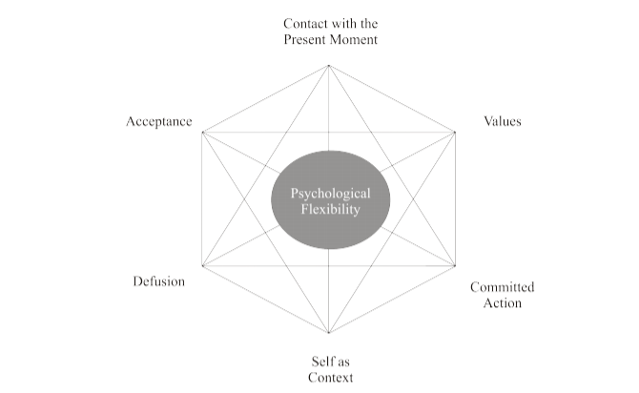

- Hexaflex diagram from Dr Joseph Ciarocchi, ACT Fact Sheet, Acceptance and Commitment Therapy: Overview and Evidence, acceptandchange.com
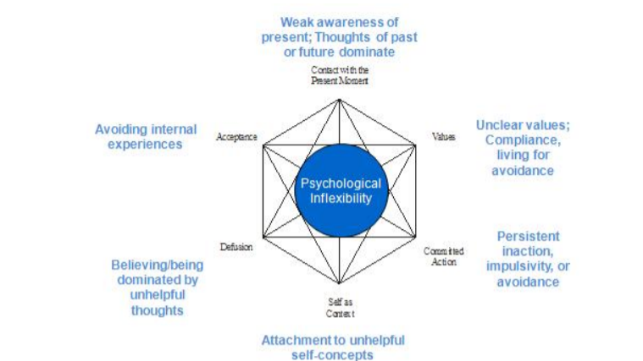

2. Inflexahex diagram from Dr Joseph Ciarocchi, ACT Fact Sheet, Acceptance and Commitment Therapy: Overview and Evidence, acceptandchange.com

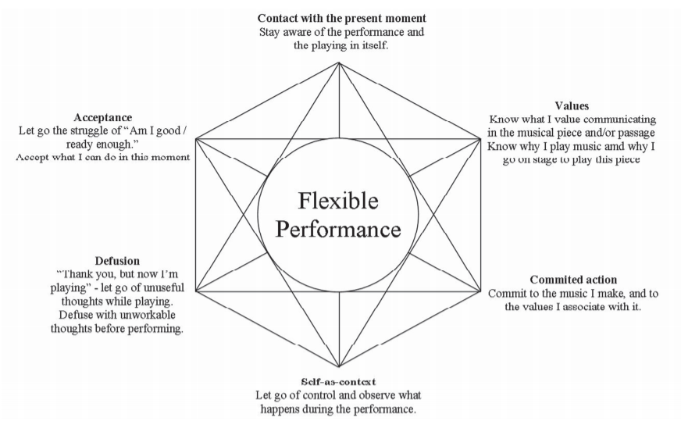

3. Flexible Performance Adapted Hexaflex from Paiva e Pona (2015)

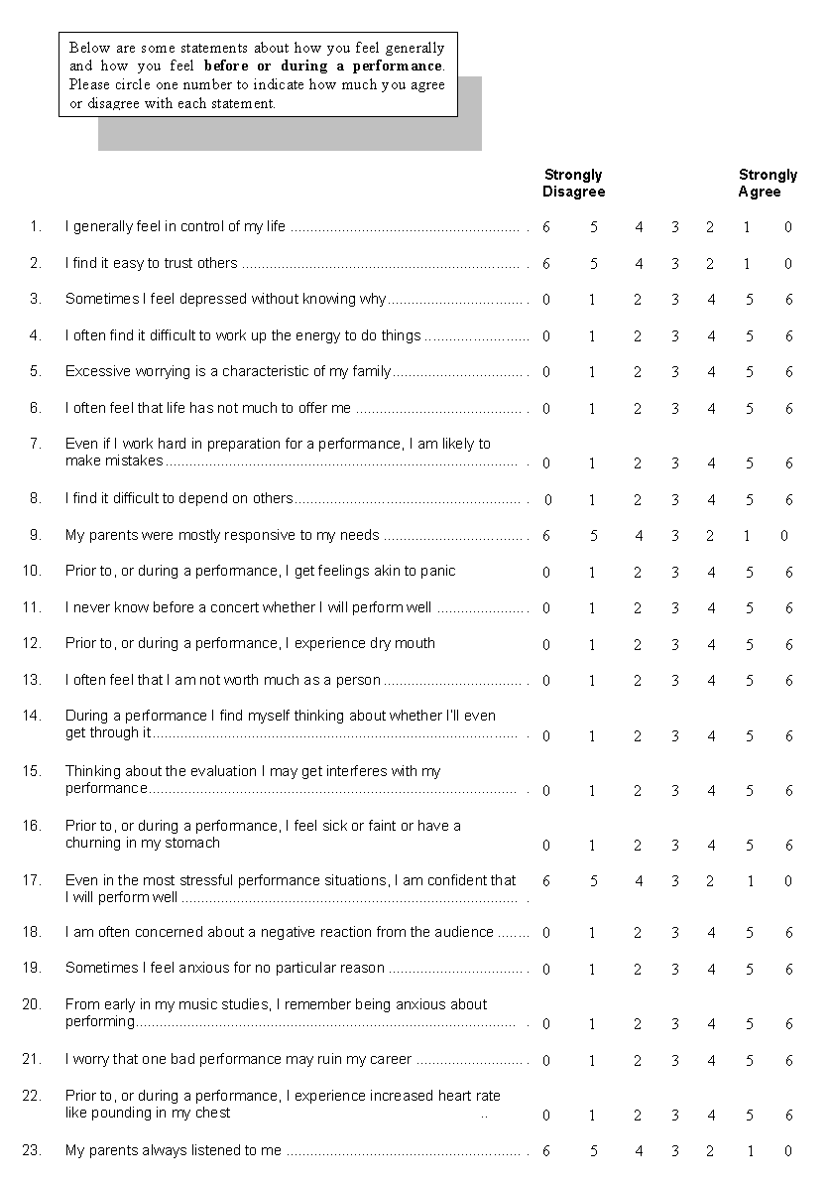

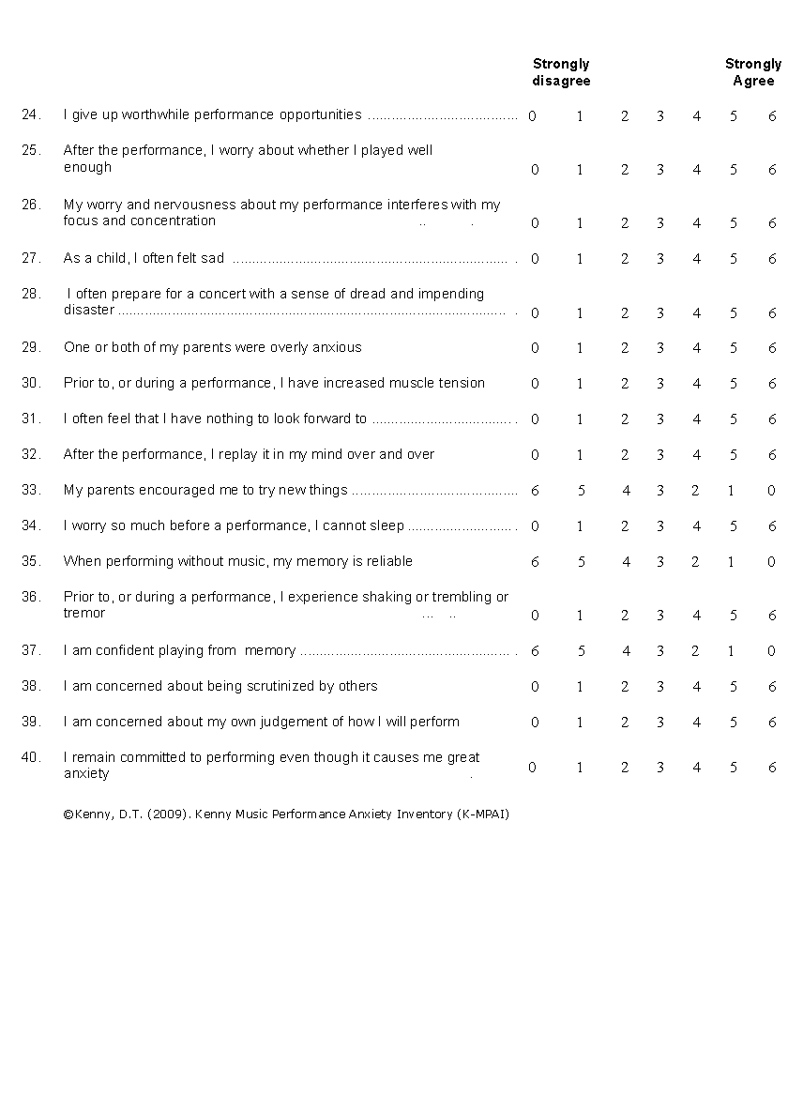
4. KMPAI Questionnaire

AAQ-II

Below you will find a list of statements. Please rate how true each statement is for you by circling a number next to it. Use the scale below to make your choice.

1 2 3 4 5 6 7
Never Very Seldom Seldom Sometimes Frequently Almost Always
True True True True True Always True
True

My painful experiences and memories make it difficult for me to live a life that I would value. | 1 | 2 | 3 | 4 | 5 | 6 | 7
I’m afraid of my feelings. | 1 | 2 | 3 | 4 | 5 | 6 | 7
I worry about not being able to control my worries and feelings. | 1 | 2 | 3 | 4 | 5 | 6 | 7
My painful memories prevent me from having a fulfilling life. | 1 | 2 | 3 | 4 | 5 | 6 | 7
Emotions cause problems in my life. | 1 | 2 | 3 | 4 | 5 | 6 | 7
It seems like most people are handling their lives better than I am. | 1 | 2 | 3 | 4 | 5 | 6 | 7
Worries get in the way of my success. | 1 | 2 | 3 | 4 | 5 | 6 | 7

5. AAQ-II Questionnaire, Bond, FW, Hayes, SC, et al, 2011

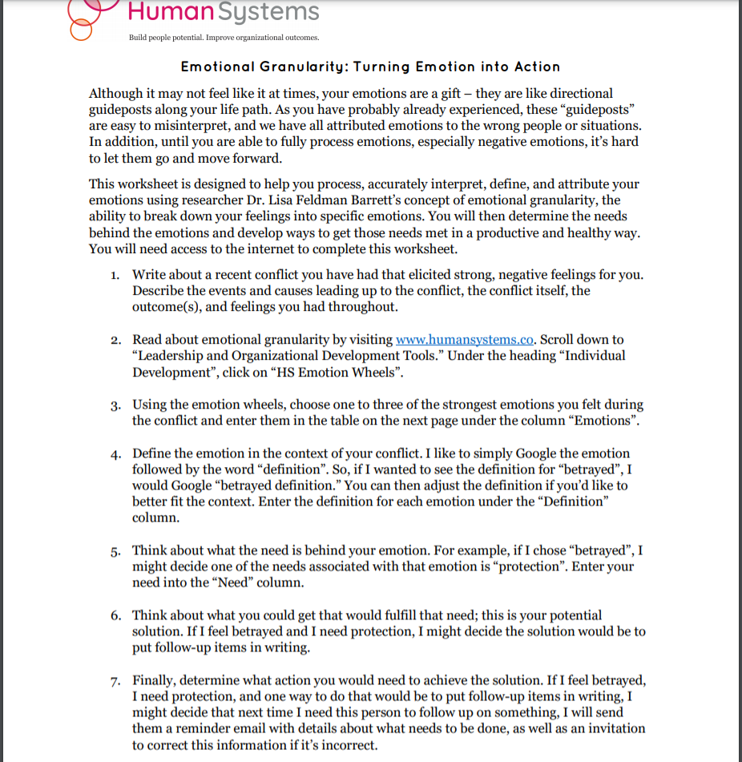
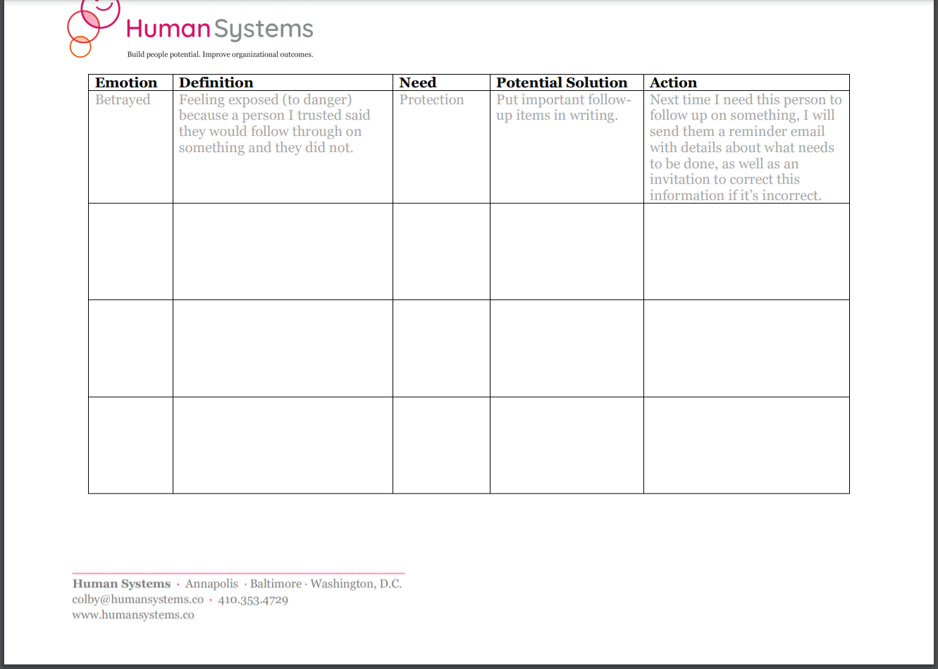
6. Emotional Granularity Worksheet, www.humansystems.co

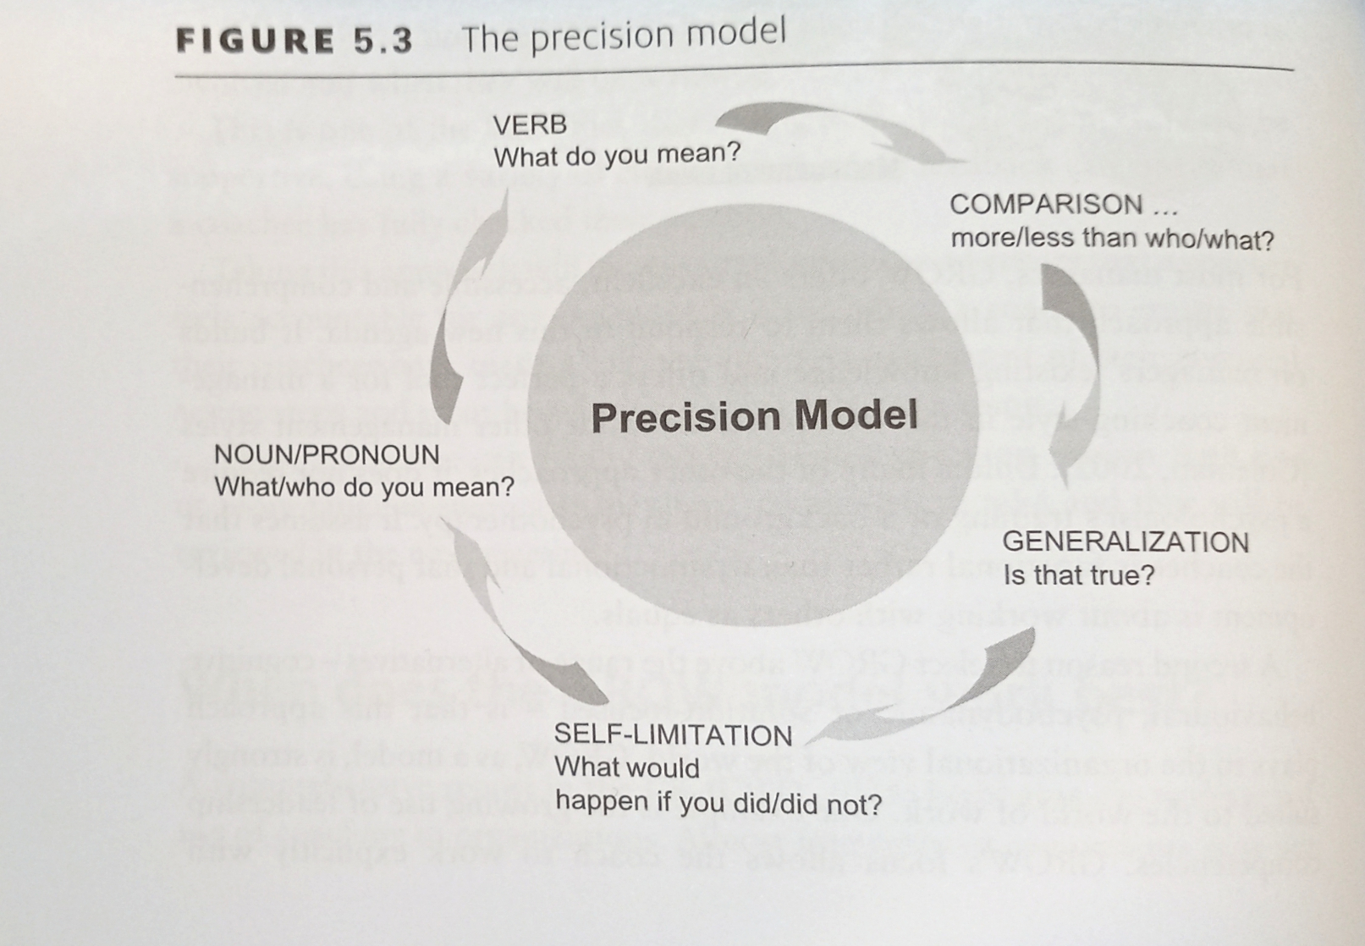 7. GROW precision model from Alexander, G (2006)

