SOFTWARE DEVELOPMENT (PYTHON)
ASSESSMENT 1

Module Name | Software Development
Programme | BSc Cloud Computing
Modul Code | ACCB4017
Lecture | Renuga Jayakumar
Student ID | 2125335
Student | Stefan Leonard Bitu

TABLE OF CONTENTS
PART A (UNDERSTANDING) 4
A1 4
Answer 4
A2 6
Answer 6
A3 8
Answer 8
PART B (IMPLEMENTATION) 12
Exercise 1 - Name, Age and Height 13
Logical stages 13
Pseudo code 13
Program code 14
Testing the code (Python) 17
Exercise 2 - Area of shaded part in a circle 18
Logical stages 18
Pseudo code 19
Program code 21
Testing of code (Python) 25
Exercise 3 - Miles travelled in a week and mileage 26
Logical stages 26
Pseudo code 26
Program code 27
Testing the code (Python) 30
Exercise 4 - Pairs 31
Logical stages 31
Pseudo code 31
Program code (Python) 32
Testing the code (Python) 37
Reference list 40

PART A (UNDERSTANDING)

A1
What is a variable and why are they important in writing programs? Discuss the way variables are handled in the programming language you have studied (e.g. static vs. dynamic typing).

Answer
A variable is a name containing characters and numbers and is used to denote a known value (Bayen, Kong and Siauw, 2020). For example, m = 2 asks the programming language to assign the known value ‘2’ to the variable ‘m’. In python, ‘=’ is the assignment operator unlike mathematics where ‘=’ denotes a truth statement. The operator is used to assign values and during the program, we use the variable name to call upon the value saved in the computer memory and perform operations on it.
Python is a dynamic language (Chen et al., 2020), which means that it checks for error in the program code during the run-time as opposed to static typing (such as in C) where the check for errors happens during the compile time. The two major advantages of dynamic typing in a program is, (1) the program will run and execute even if it contains errors, and (2) we need not declare the data type of the variable.
- The following code will give a type error in a static typing program, but not in Python.
- The code also assigns a string type to the variable ‘jam’ without declaring the data type. The last command shows that the program saved the string ‘Hello’ as a string type.

jam = 'Hello'  if False:  jam = jam-1  else:  print(jam * 3)  print (type(jam)) | OUPUT  HelloHelloHello  <class 'str'>

A2
Explain what an if/else statement is, how and why they are used, and give a code example of when you would use one. Include in your answer a discussion of the use of multiple conditions.

Answer
What is an if/else statement?
An if/else statement is a branching statement (Bayen, Kong and Siauw, 2020). The condition provided after the ‘if’ statement is evaluated and if found true, the block of code attached to the statement is executed. If the condition is found to be false, the block of code under the ‘if’ statement is not executed and block of code under the ‘else’ statement is executed.

General syntax
if logical condition:
CODE 1
else:
CODE 2

How is it used?
An if/else statement is used in Python as a flow-control tool (Python Software Foundation, 2022). If the condition provided is true, then execute the following statements given under the ‘if’ statement. If not, execute the statements under ‘else’. Additionally, more conditions can be provided using the ‘elif’ statement (formed from else-if).

Why are they used?
The relevance of an if/else statement is the ability to perform selective execution of a block of code.

EXAMPLE
print ("Please enter the time.")  time = float(input())  print ("The time is: ", int(time),"o' clock")  if time<12 and time>6:  print ("Good day")  elif time>=12 and time<16:  print ("Good afternoon")  elif time>=16 and time<21:  print ("Good evening")  elif time>=21 and time<24:  print ("Good night")  else:  print ("Sheesh, did I wake you?") | OUTPUT-1  Please enter the time.  4  The time is: 4 o' clock  Sheesh, did I wake you?  OUTPUT-2  Please enter the time.  23  The time is: 23 o' clock  Good night

The above example can be used to greet a user based on the time they enter. The multiple conditions are used for the different times of day.

A3
Explain why loops are needed in a program and when you might use a ‘for’ and a ‘while’ loop. Give suitable examples of each in the programming language you have studied.

Answer
Loops are required in a program to execute a block of code (Bayen, Kong and Siauw, 2020) more than once to achieve a particular task such as (i) printing the elements of a list, (ii) running a mathematical function such as division to find the factors, and (iii) print the characters of a string.

FOR-loop
A ‘for’ loop is also known as a definite loop because the end of the loop is defined in the ‘for’ statement. The variable iterates over the sequence provided in the for-loop statement.

General syntax
for variable in sequence:
CODE

EXAMPLE
It can be used to print the elements of a list or print out a command like, “Enter the name of student no. 1” multiple times changing only the student number. It is demonstrated in the following code. In the code, the function ‘range()’ is used to set the sequence on which the variable will iterate over. The range() function takes three inputs – range(start, stop, step). The third attribute is optional, default step = 1. For example, a range (1,4) would take values from 1 to 3 with a step of 1. At 4, the loop ends and it won’t run the block of code.

a=[]  n=3  #The list and variable ‘n’ is initialised  #The last value of the range is not used within the loop,  #therefore to set ‘n’ as the last value, n+1 is used.  for i in range(1,n+1):  print ("Enter the name of student no. ", i,":")  a.append(input())  for j in range(0,n+1):  print (a[j])  #In the second for-loop, the variable is incremented from  #0 because the append command adds the element to the  #0th position in the list ‘a’.  #Indentation is important. The last command saves the  #given name to a list in the position ‘i’. | OUTPUT:  Enter the name of student no. 1:  Anton  Enter the name of student no. 2:  Derek  Enter the name of student no. 3:  Gigi  Anton  Derek  Gigi

- The loop iterates the value of ‘i’ from 1 to n.
- The output of the above code will look like:

WHILE-loop
Unlike the ‘for’ loop, a ‘while’ loop can be used without defining the end. Therefore, it is also known as an indefinite loop. It often results in an infinite loop if the condition provided in the statement is always true. The program exists the loop when the code under the statement makes the condition false.
General syntax
while logical condition
CODE

EXAMPLE
In the code, we ask the user to enter a number for which they wish to know how many times it is divisible by 2.
# 'a' is the number which the user enters  # i is the variable which will change during the while loop  a=int(input("Enter the number: "))  count=0  i=a  while (i>1.5):  i = i/2  count+=1  print (a," can be divided by 2:-",count,"times.") | OUTPUT  Enter the number: 100  100 can be divided by 2:- 6 times.

- The condition based on which the loop ends is used to perform calculations within the loop.
- The output of the code is shown below.

PART B (IMPLEMENTATION)
*Note: In all the programs, an error was found to be common – Value Error.
This error arises when the user enters a value different from the one asked for.
For example: if the user was asked to enter a number and the program saves it into an integer type variable. Then, the program will stop executing and display a ‘ValueError’ if the user entered a space or a string, when any mathematical function is performed on the variable. The figure B(i) shows the error.
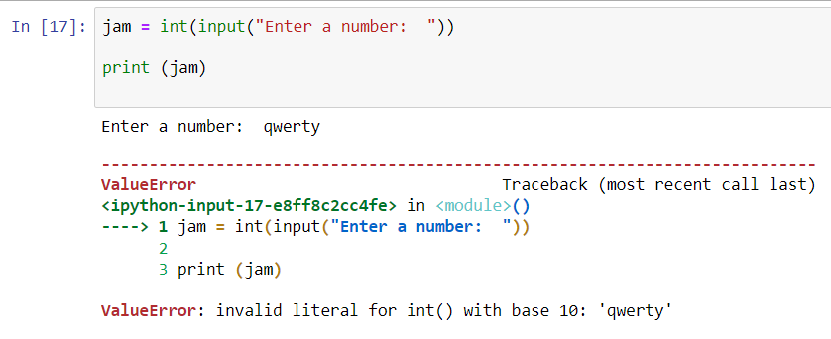
Figure B(i): Demonstration of ValueError similar to all the exercises
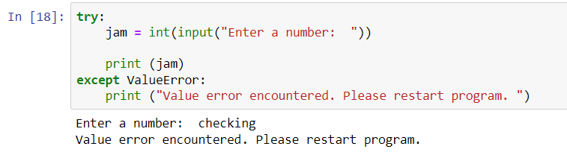
Figure B(ii): Solution of ValueError used in Exercises 1 through 4

As shown in figure B(ii), all the exercises uses the try-except statement as the solution for the error.

Exercise 1 - Name, Age and Height

Logical stages
- To check for validity of the height and age entered, a minimum and maximum was set
- The minimum height was set at 0.4m, and the maximum at 1.7m
- The minimum age was set at 3, and the maximum at 120
- In the program, a ‘while’ loop was used to iterate the block of code which asked the user to enter the height or age and save it to a variable. Additionally, the validity was checked within the loop and the user was asked to re-enter the height or age.

Pseudo code
Define function ex1()
- Ask user to enter name and save it to the variable ‘name’
- Set minimum and maximum values for height
- Initialise i =0
- While i stays =0
  - Ask user to enter height in meters
  - If height is less than the minimum value, then display message
  - If height is more than maximum, then display message
  - Else - height was found to be valid. Hence, set the value of i to 1.
- While j stays =0
  - Ask user to enter age
  - If age is less than 3, then display message
  - If age is more than 120, then display message
  - Else - age was found to be valid. Hence, set the value of j to 1.
- Display the name, age and height

Define function main()
- Call ex1()

Call main()
*Note: the try-except was added to control the value error.

Program code
def ex1():

name = str(input("Please enter your name: "))

#The minimum and maximum value for height
min = 0.4
max = 1.7

#The try-except statement for taking care of ValueError
try:

#The while loop which asks the user to enter their height
#and checks for its validity. If found invalid, the loop runs again.
#If valid, i=1 and the loop ends.
i=0
while i==0:
height = float(input("Please enter your height in meters: "))

if height < min:
print ("That seems a bit too small - even for a baby. Enter again, please.\n")

elif height > max:
print ("That seems a bit too tall. Enter again, please.\n")

else:
i=1

#This while loop asks the user to enter their age.
#Checks for validity and like the last while loop,
#stops after the name is found to be valid.
j=0
while j==0:
age = int(input("How old are you?: "))

if age<3:
print ("Please enter again, you can't be that young.\n")
elif age>120:
print ("Are you sure you entered the age correctly? Give it another go, please.
\n")
else:
j=1

print ("Thanks, you entered: ",name,"-", age,"years old -", height, "m tall")

#The try-except statement for taking care of ValueError
except ValueError:
print ("\n*******You didn't put a number - Start the program again,
please.*********")

def main():

ex1()

main()

Testing the code (Python)
- Valid and invalid entries
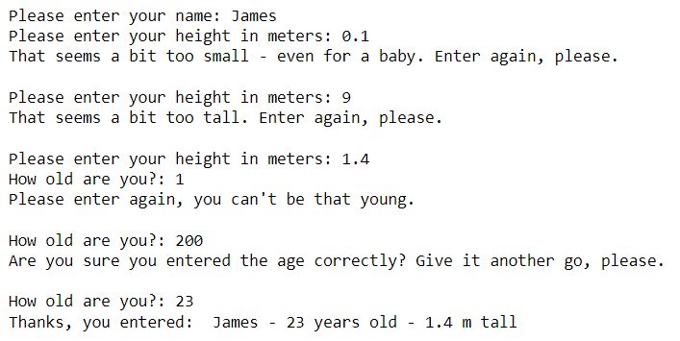
Figure B1.1: Valid and invalid values entered by the user

- Value error
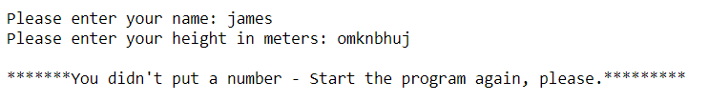
Figure B1.2: The program using try-except statement for value error

Exercise 2 - Area of shaded part in a circle

Logical stages
- The math library of python was used in this program to use the value of pi
- Area of circle is given by – pi * (radius)², where r = radius of circle
- Area of square and rectangle – length * width
- Area of shaded part = area of circle – (area of square + area of rectangle)
- For a square or rectangle within a circle, the validity of the values entered by the user was decided based on the following conditions.
  - Max side of square = √2 * radius = max length of rectangle = max width of rectangle.
  - Max area of square and rectangle combined = (√2 * radius)*(√2 * radius)

Calculation of maximum side (side-condition)

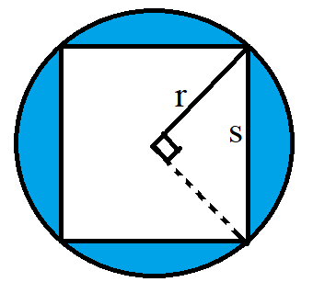
Figure B2.1: The largest square within a circle

The largest possible square within a circle is depicted in the above figure. According to the Pythagoras theorem (Chambers, 1999), the side of the square ‘s’ can be calculated using the triangle in the figure. Therefore, the side = radius * √2.
The largest possible rectangle within the circle is a square, and hence, the same rule applies for rectangle.

Calculation of maximum area (area-condition)

If the user enters the values such that the shapes overlap with each other, then the limit of the sides is set by the combined area of the shapes.
The maximum combined area = area of a square of side s (where s = radius * √2)

Pseudo code
Import math library

Define function ex2()
- Initalise g = 0
- While g remains 0
  - Ask user to enter radius of circle
  - If found invalid, then display message and repeat step 2
  - If found valid, then assign g =1
- Calculate area of circle and save it in variable ‘area1’
- Calculate value of square root (2) and save it in variable ‘rootoftwo’
- Initialise h = 0
- While h remains 0
  - Initalise i = 0
  - While i remains 0
    - Ask user to enter side of square
    - If found invalid, then display message and restart step b
    - If valid, then assign i =1
  - Initialise j = 0
  - While j remains 0
    - Ask user to enter width of rectangle
    - If invalid, then display message and restart step d
    - If valid, then assign j =1
  - Initalise k = 0
  - While k remains 0
    - Ask user to enter length of rectangle
    - If invalid, then display message restart step f
    - If valid, then assign k =1
  - Calculate area of square and save it in variable ‘area2’
  - Calculate area of rectangle and save it to variable ‘area3’
  - Calculate maximum area and save it to variable ‘maxarea’
  - If sum of ‘area2’ and ‘area3’ is found to be more than ‘maxarea’, then display message and restart step 6
  - Else, assign h = 1
- Calculate the area of the shaded part and display the result

Define function main()
- Call ex2()
Call main()
*Note: the try-except was added to control the value error.

Program code
#calling the math library to use math.pi
import math
def ex2():
print ("Please enter all values in cm")

#The try-except statement for taking care of ValueError
try:

#The following while loop ends
#once the user enters a valid
#radius of circle
g=0
while g==0:
roc = float(input("\nPlease enter radius of circle: "))

if roc<=0:
print ("Invalid value. Please enter again.")
else:
g=1

#math.pi gives the value of pi
area1 = math.pi * roc * roc
rootoftwo = math.sqrt(2)

#Nested while loops.
#The main while loop works on the area-condition
#and the other loops within, work on the side-condition.
#Refer to logical stages (last point) for more info.
h=0
while h==0:

i=0
while i==0:

sos = float(input("\nPlease enter side of sqaure: "))

if sos<=0 or sos>(rootoftwo*roc):
print ("Invalid value. Please enter again.")
else:
i=1

j=0
while j==0:

wor = float(input("\nPlease enter width of rectangle: "))

if wor<=0 or wor>(rootoftwo*roc):
print ("Invalid value. Please enter again.")
else:
j=1

k=0
while k==0:

lor = float(input("\nPlease enter length of rectangle: "))

if lor<=0 or lor>(rootoftwo*roc):
print ("Invalid value. Please enter again.")
else:
k=1

#Calculating the area condition
area2 = sos * sos
area3 = wor * lor
maxarea = 2 * roc * roc

if (area2 + area3) > maxarea:
print ("\nThe square and rectangle combined have crossed the circle's boundary.
Please enter again.\n")
else:
h=1

area = area1 - (area2+ area3)
print ("\nThe shaded area is ",round(area,1),"squared cm")

#The try-except statement for taking care of ValueError
except ValueError:
print("\n***********You entered an invalid number - Restart the program again,
please.**********")

def main():
ex2()

main()

Testing of code (Python)
- Valid and invalid entries
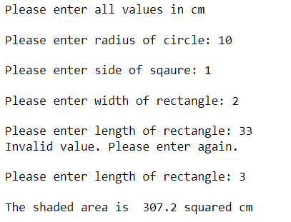
Figure B2.2: Valid and invalid values

- Value error
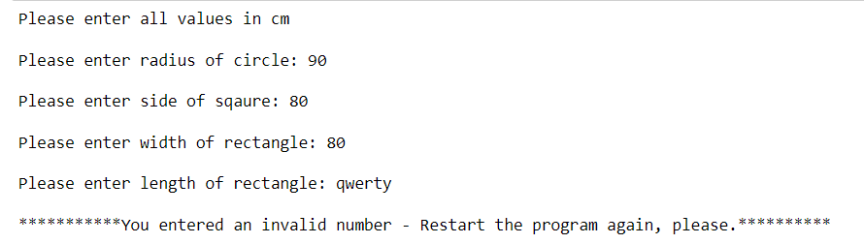
Figure B2.3: The program using try-except statement for value error

Exercise 3 - Miles travelled in a week and mileage

Logical stages
- A global function ex3() was created for exercise no. 3
- Two lists were created to save the days of the week and save the number of miles travelled by user every day
  - ‘miles’: Used to save the values entered by user
  - ‘days’: Used to display the respective day of the week
- The cost of petrol was calculated using the following formula.

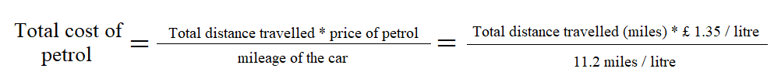
Figure B3.1: Formula for calculating total cost of petrol for the week

Pseudo code
Define function ex3()
- Initialise the two lists ‘miles’ and ‘days’
- ‘For’ loop iterating over ‘i’ from 0 to 6
  - Initialise ‘j’ to 0
  - While j = 0
    - Ask user to enter number of miles for i^{th} element of list ‘days’ and save it in variable ‘m’
    - If invalid entry, then display message and restart step b
    - If valid, then j =1
  - Append the value of ‘m’ to the list ‘miles’
- Initialise the variable ‘total’ (=0) to save the total distance travelled by user
- ‘For’ loop iterating over ‘i’ from 0 to 6
  - Add i^{th} element of the list ‘miles’ to the variable ‘total’
- Display total miles travelled
- Calculate total cost of petrol using formula
- Display total cost

Define function main()
- Call ex3()

Call main()
*Note: the try-except was added to control the value error.

Program code
def ex3():

#The list 'miles' will save the value entered by the user
#The list days is used for displaying the various days

miles=[]
days = ['Monday', 'Tuesday', 'Wednesday', 'Thursday', 'Friday', 'Saturday', 'Sunday']

#The try-except statement for taking care of ValueError
try:

#The for loop asks the user to enter for each day of the week
for i in range(0,7):

#In case of invalid entry, the while loop asks the user again for the same day
#The variable j acts like a switch
#We exit the while loop when j turns on (j=1), i.e., valid entry

j=0
while j==0:

print ("Enter miles for ",days[i],":")
m = float(input())

if m<=0:
print ("Invalid. Please enter again ---\n")
else:
j=1

#The append command adds the entered value to the list 'miles'
miles.append(m)

#Calculating the total distance travelled in the week
total=0
for i in range(0,7):
total += miles[i]

print ("The total miles travelled in the week was: ", total)

#These two values were given in the exercise 3
rate = 1.35
mileage = 11.2

#The formula used to calculate total cost of petrol for the week
totalCost = total * rate / mileage
print ("Total cost of petrol for the week: £", totalCost)

#The try-except statement for taking care of ValueError
except ValueError:
print("\n*********You didn't enter a valid number. Restart the program,
please.**********")

def main():
ex3()

main()

Testing the code (Python)
- Invalid entry by user and total cost
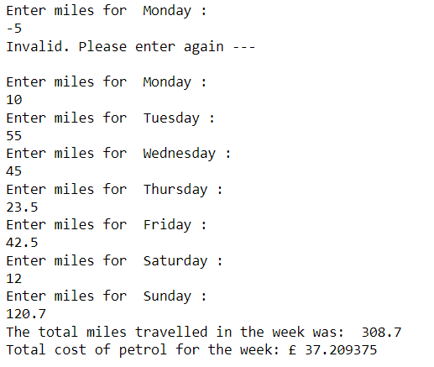
Figure B3.2: Invalid entry by user and total cost

- Value Error
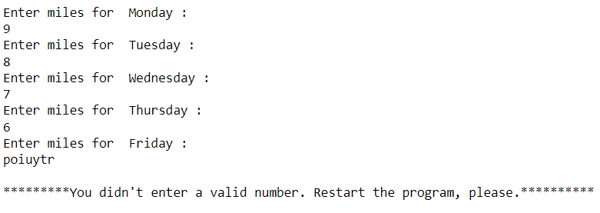
Figure B3.3: The program using try-except statement for value error

Exercise 4 - Pairs

Logical stages
- A global function ‘ex4()’ was created for exercise no. 4
- Two lists were created to maintain the playing board - ‘l1’ and ‘l2’.
- A dictionary ‘dict’ was used to place the pairs in positions 0 to 11.
- A while loop was used to implement the game

Pseudo code
Function ex4()
- Display welcome message
- Save the unopened board in two lists
- Create a dictionary to place the pairs in positions 0 to 11
- While no. of turns < 18
  - If the game is over, then display message and exit
  - Display the board
  - Ask the user to enter guess no. 1 & 2
    - If guess = 123456 (password set by admin for exit), then exit
    - If guess is out of range, then display message
    - If guess coincides with an open tile, then display message
    - If guess 1 is same as guess 2, then display message
    - If match is found, then display message and update the board
    - If match is not found, then reveal the positions guessed by the user
  - After turn 10, display the number of turns left
  - Display number of turns completed
  - Increment the variable containing number of turns
  - Restart step 4

Function main()
- Call ex4()

Call main()
*Note: the try-except was added to control the value error.

Program code (Python)
def ex4():

print ("Welcome to the pairs game! There are 6 pairs to find.\nHere is the board:")

l1 = [0,1,2,3,4,5,6,7,8,9,10,11]
l2 = ['?','?','?','?','?','?','?','?','?','?','?','?']

dict = {
1: "Spider",
2: "man",
5: "mouse",
7: "dog",
9: "bat",
10: "tortoise",
11: "Spider",
0: "mouse",
8: "man",
3: "tortoise",
4: "bat",
6: "dog"
}

#The try-except statement for taking care of ValueError
try:
i=1
while(i<18):

#The following loop checks if the user has
#found all the pairs.
count=0
for k in range(len(l2)):
if l2[k] =='X':
count+=1
if count == 12:
print ("\n Well done! You've found all the pairs in ",i-1,"turns.")
break

#Print the new and updated board
print ("\n",l1,"\n",l2)

g1=0
g2=0

#The following code saves entered value in 'int' data type

g1 = int(input("Please enter guess 1: "))
g2 = int(input("Please enter guess 2: "))

#This condition allows the admin to enter a password
#and exit the while loop

if g1==123456 or g2==123456:
print ("\n ---Exiting--- \n Congrats, you've entered the admin zone. Enjoy
coding.")
i=19
break

#This condition checks for invalid entries
elif g1>11 or g1<0 or g2<0 or g2>11:
print ("Does not exist. Take another turn, please.")

#This condition checks if user guessed an already open position
elif l2[g1] =='X' or l2[g2] =='X':
print ("\n Atleast one of them is already known. Try elsewhere.")

#This condition checks if user enter same guess twice
elif g1==g2:
print ("\nHey! What are you trying to pull here? Take another turn, please.")

#This condition checks for a match
elif dict[g1] == dict[g2] and g1!=g2:
print ("Well done, that's a match on",dict[g1],"!")
l2[g1] = 'X'
l2[g2] = 'X'

#This condition works for a non-match and
#displays the positions guessed by the user
else:
print ("Not a match, position",g1,"was",dict[g1],"and
position",g2,"was",dict[g2])

#This condition works after 10 turns and
#dislpays no. of turns left
if i>10:
print ("\n BEWARE, you're left with",16-i, "turns.")

print ("You've had ", i,"turns so far.")
i+=1

#The try-except statement for taking care of ValueError
except ValueError:
print ("\n******You did not enter a valid number. Run the program again,
please.******")

def main():
ex4()

main()

Testing the code (Python)
- Guesses are matched and game is over:
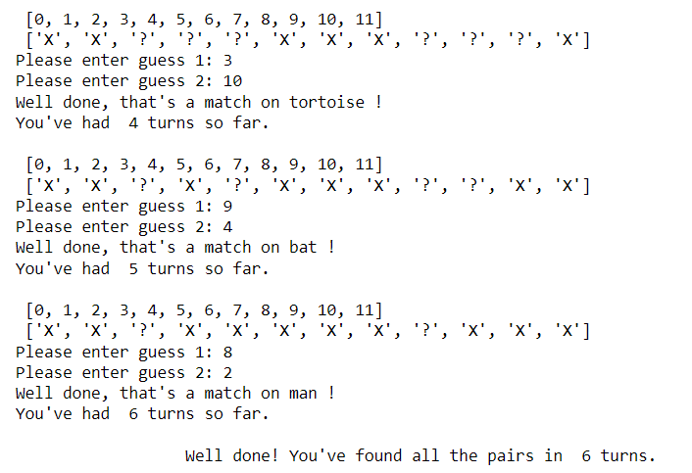
Figure B4.1: All pairs found - game solved

- Guess number out of the range [0-11]
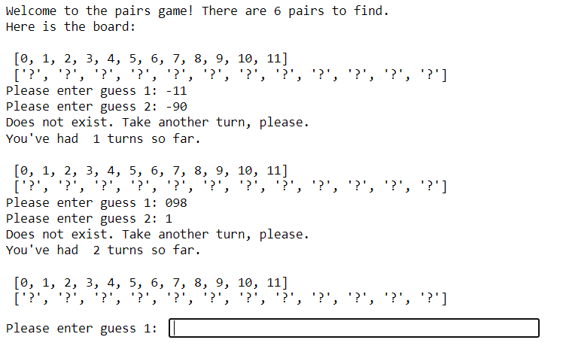
Figure B4.2: User guessed a position number which is not present on the game board

- Guess coinciding with a pair which has already been found
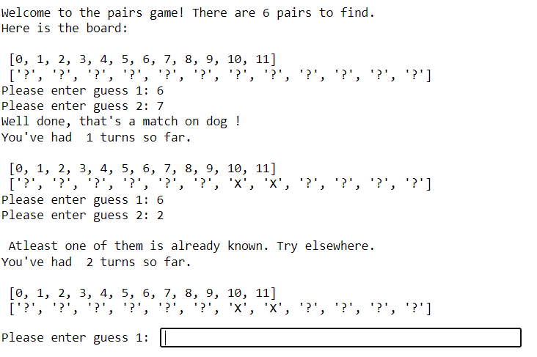
Figure B4.3: User entering a position number whose pair is already found

- Guesses are same
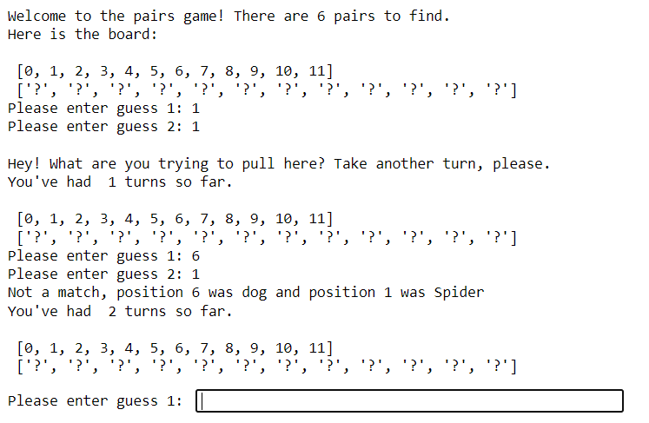
Figure B4.4: User entered the same position for both guesses and a non-match

- Non-match and admin exit
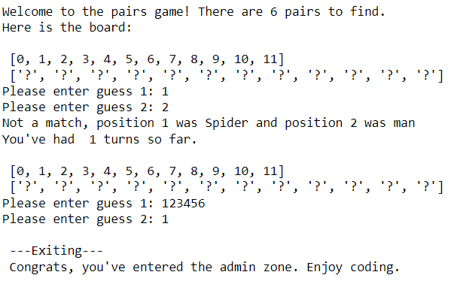
Figure B4.5: Non-match and entering password for exiting game

- Value error
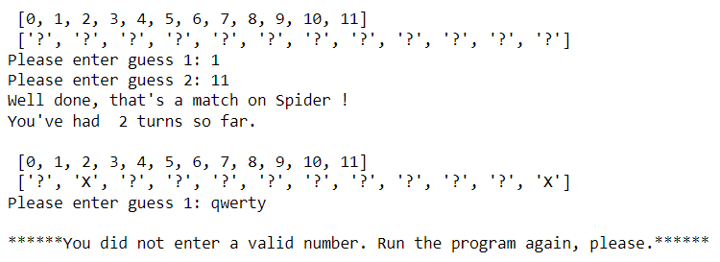
Figure B4.6: The program using try-except statement for ‘ValueError’

Reference list
Bayen, A., Kong, Q. and Siauw, T. (2020). Python Programming and Numerical Methods: A guide for Engineers and Scientists. [online] S.L.: Elsevier Academic Press. Available at: https://pythonnumericalmethods.berkeley.edu/notebooks/chapter04.01-If-Else-Statements.html [Accessed 30 Jul. 2022].
Chambers, P. (1999). Teaching Pythagoras’ Theorem. Mathematics in School, [online] 28(4), pp.22–24. Available at: http://www.jstor.org/stable/30212035 [Accessed 31 Jul. 2022].
Chen, Z., Li, Y., Chen, B., Ma, W., Chen, L. and Xu, B. (2020). An Empirical Study on Dynamic Typing Related Practices in Python Systems. In: Proceedings of the 28th International Conference on Program Comprehension (ICPC ’20). New York, NY, USA: Association for Computing Machinery, pp.83–93. doi:10.1145/3387904.3389253.
Python Software Foundation (2022). 4. More Control Flow Tools — Python 3.8.3 documentation. [online] Python.org. Available at: https://docs.python.org/3/tutorial/controlflow.html [Accessed 30 Jul. 2022].

