
Data Security & Compliance
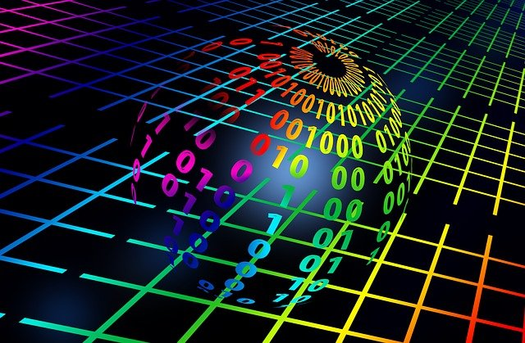
^{[1]}
School of Applied Computing | Assignment Title:  Research and Case Scenario in Data Security and Compliance | Code: ACCA 5034
Module:
Data Security and Compliance

Student:  Theresa Darzins  No 1909721 | Programme: Computing Portfolio  BSc/HND Computing | Lecturer: Carlene Campbell  Date: 7th December 2021

Contents
1.0 INTRODUCTION 1
1.1 Structure 1
1.2 Aims 1
1.3 Objectives 1
2.0 TASK 1 – SECURITY AND PERSONNEL 2
2.1 Personnel Information Security Training 2
2.1.1 Phishing 3
2.2 Information Security Organization Structure 5
2.2.1 Options for Placing Information Security Function Within the Organization 5
2.3 Positions in Information Security 6
2.3.1 Information Security Job Titles and Qualifications 7
2.3.2 Functions of the CISO/Security Analyst 7
2.4 Information Security Professionals 9
2.4.1 Attributes Organizations Seek when Hiring Information Security Professionals 9
2.5 Critical Conditions when Dismissing an Employee 10
2.5.1 Work Terminations 10
2.6 How Considerations For Temporary/Contract Employees Differ 10
2.6.1 Temporary Employees - Special Safety Precautions 10
2.6.2 Job Candidates Should Not be Allowed in Secure Areas During Interview 11
2.7 Descriptions of Tasks/Functions For Employment of Professionals in Information Security 12
2.7.1 Standard Information Security Personnel Practices 12
2.8 Information Security Career Path 13
2.8.1 Professional Credentials 14
3.0 TASK 2 - CASE SCENARIO FLOW-TECH THREAT INTELLIGENCE CO. 15
3.1 Security 16
3.1.1 Vulnerability Discovery Testing 16
3.1.2 Pros and Cons of Vulnerability Discovery Test Methods 17
3.1.3 Overview of Security 19
3.1.4 Components of an Information System 21
3.1.5 Systems Development Life Cycle Waterfall Methodology 27
3.1.6 The DevOps Approach 34
3.1.7 Actions – The Need for Security 35
3.2 Compliance – Legal, Ethical and Professional Issues 36
3.2.1 General Computer Crime Laws 37
3.2.2 Financial Reporting 37
3.2.3 Main UK Computer Security Laws 37
3.2.4 Data Security for Payment Cards 38
3.2.5 Organizations of Interest to Information Security Experts 38
3.2.7 Actions – Compliance – Legal, Ethical and Professional Issues 38
3.3 Planning for Security 40
3.3.1 Policies 41
3.3.1.1 Differences between Policies Standards and Guidelines 42
3.3.1.2 Details of Types of Security Policies: 43
3.3.1.3 Policy Management 44
3.3.2 Governance and Security Planning 44
3.3.2.1 The Security Framework Basis 44
3.3.2.2 Responsibilities and Functional Role Examples 45
3.3.2.3 ISO/IEC 2700 Certification Standard 46
3.3.2.4 Development of Support for the Security Framework 46
3.3.2.5 Spheres of Security: Foundation of the Security Framework 47
3.3.2 Contingency Planning 48
3.3.2.1 Major Sources of Physical Loss 49
3.3.3.2 Physical Security Controls 50
3.3.3.3 Data Interception 51
3.3.3.4 Types of Uninterruptible Power Supplies 51
3.3.3.5 Lights Out Server Room 53
3.3.3.6 Components of Contingency Planning 53
3.3.3.7 When to use the IR, DR, and BC plans: 55
3.3.3.8 Containment is Part of the Planning Process 58
3.3.4 Actions - Planning for Security 60
3.4 Risk Management 61
3.4.1 Overview 62
3.4.2 Risk Identification 68
3.4.3 Control 71
3.4.4 Quantitative vs Qualitative Practices 75
3.4.5 Actions - Risk Management 76
3.5 Organisation Structure – Security and Personnel 77
3.5.1 Personnel Security Training 77
3.5.2 New organisation Chart - Information Security 77
3.5.3 New Position in Information Security 78
3.5.4 Information Security Professional Qualifications Matrix 78
3.5.5 Critical Conditions for Dismissing an Employee 78
3.5.6 Temporary/Contract Employees 78
3.5.7 Job Descriptions for Information Security Professionals 78
3.5.8 Information Security Career Path Development 78
3.5.9 Actions - Organisation Structure – Security and Personnel 79
3.6 Protection Mechanisms – Information Security Maintenance 80
3.6.1 Monitoring the Environment 82
3.6.2 Security Maintenance Models 88
3.6.3 Digital Forensics 91
3.6.4 Actions -Protection Mechanisms – Information Security Maintenance 92
3.7 Recommendations 93
3.7.1 The Need For Security 93
3.7.2 Compliance – Legal, Ethical and Professional Issues 96
3.7.3 Planning for Security 96
3.7.3.1 Policies 96
3.7.3.2 Governance and Security Planning 98
3.7.3.3 Contingency Planning 98
3.7.4 Risk Management 98
3.7.5 Organisation Structure – Security and Personnel 98
3.7.6 Protection Mechanisms – Information Security Maintenance 99
4.0 CONCLUSION 100
4.1 Task 1 Security and Personnel 100
4.2 Task 2 Case Scenario Flow-Tech Threat Intelligence Co. 101
5.0 REFERENCES 103
6.0 APPENDICES 105
6.1 Hardening 105
6.2 Policies – Use of Mobile Devices to Access Co. Network 113

Table 2-1 Options For Placing the Information Security Function within the Organization 5
Table 2-2 Information Security Job Titles and Qualifications 7
Table 2-3 CISO/Security Analyst Functions and Requirements 8
Table 2-4 Attributes Information Security Candidates Need in Order of Importance 9
Table 2-5 Certification Descriptions 14
Table 3-1 Vulnerability Discovery Methods 18
Table 3-2 Predictive Methods of Vulnerability Discovery Pros and Cons 19
Table 3-3 Measures Taken to Harden the System 20
Table 3-4 Classifications of Data Owners, Custodians and Users 22
Table 3-5 The Functional Team Working to Achieve This 23
Table 3-6 Although CIA Triangle Relevant Threats Multiplied Into: 25
Table 3-7 The System is Designed To 26
Table 3-8 The Top-Down Approach is Best 27
Table 3-9 The Formal Approach Proposed To Solve Problems on Structured Sequence /Procedure to Investigate: 28
Table 3-10 The Logical Design Consists of: 29
Table 3-11 The Six Phases 29
Table 3-12 ACTIONS - The Need for Security 36
Table 3-13 Due Diligence Required in Laws and Ethics to Avoid Liability 37
Table 3-14 General Employee Terms and Conditions Re Information Security 37
Table 3-15 General Computer Crime Laws 38
Table 3-16 Main UK Computer Security Laws 38
Table 3-17 Payment Card Industry Data Security Standards (PCI DSS) 39
Table 3-18 Professional Organizations of Interest for Information Security Professionals 39
Table 3-19 ACTIONS - Compliance - Legal, Ethical and Professional Issues 40
Table 3-20 What The Security Framework Achieves 41
Table 3-21 Information Security Programs that May be Adapted 42
Table 3-22 Differences Between Policies, Standards and Guidelines - Details 43
Table 3-23 Types of Security Policies 44
Table 3-24 ISO/IEC 27001 Formal Specification Outline 47
Table 3-25 Development of the Security Framework 47
Table 3-26 Web Resources to Aid Organizations in Development of Best Practices 48
Table 3-27 Levels of Control 49
Table 3-28 Donn B. Parker's Seven Major Sources of Physical Loss 50
Table 3-29 Fundamental Ways Used to Intercept Data 52
Table 3-30 The Four UPS or Uninterruptible Power Supplies 52
Table 3-31 Planning for Unknown Problems (Adverse Events) 54
Table 3-32 Contingency Planning 55
Table 3-33 The Elements of a Business Impact Analysis 57
Table 3-34 Pipkin's Three Categories of Incident Indicators 58
Table 3-35 Concerning Possible Indicators; Four Types of Incident Candidates 58
Table 3-36 Containment Actions 59
Table 3-37 Site and Data Contingency Strategies Identified 60
Table 3-38 ACTIONS - Planning for Security 61
Table 3-39 Risk Management; Communities of Interest Responsibilities’ 63
Table 3-40 System, Information Asset and Risk Management Components 64
Table 3-41 Risk Appetite and Residual Risk 66
Table 3-42 Example of Vulnerability Assessment in Order of Priority 68
Table 3-43 Teams With Representation Across all Affected Groups Are to Plan: 70
Table 3-44 Definition of Terms 70
Table 3-45 Sample Inventory Worksheets 71
Table 3-46 Once Ranked Vulnerability Worksheets Completed; Organization Chooses 1 of 5 Strategies for Risk Control 72
Table 3-47 Summary of Risk Control Strategies used by NIST SP 100-30 and ISACA and ISO/IEC 27001 etc. 73
Table 3-48 Summary of Control Strategies 74
Table 3-49 The Preferred Approach Accomplished by Means of: 75
Table 3-50 Cost Benefit Analysis 76
Table 3-51 Loss Expectancy 77
Table 3-52 ACTIONS - Risk Management 77
Table 3-53 Information Security Training 78
Table 3-54 ACTIONS - Organisation Structure - Security and Personnel 80
Table 3-55 The Primary Aspects of Information Security Risk Management 81
Table 3-56 Factors Likely to Change in and Organization's Information Security Environment 81
Table 3-57 Information Security Maintenance Terms 82
Table 3-58 Vulnerability Intelligence Sources 87
Table 3-59 Vulnerability Assessments 88
Table 3-60 Changes to be Made in SP800-100 to Adapt for Use in Security Management Maintenance 90
Table 3-61 ACTIONS - Protection Mechanisms - Information Security Maintenance 93

Figure 2-1 Sitkin's Intelligent Failure Model 2
Figure 2-2 Framework Reporting Main Components of Phishing Attack and the Relationships Among Them 4
Figure 2-3 Positions in Information Security 6
Figure 3-1 Illustration of Computer Network Vulnerabilities from RAND Report R-609 21
Figure 3-2 Components of an Information System 24
Figure 3-3 The CIA Triad 25
Figure 3-4 The McCumber Cube 26
Figure 3-5 Top-Down and Bottom-Up Approach 27
Figure 3-6 SDLC Waterfall Methodology 28
Figure 3-7 Relating Security Considerations in the Initiation Phase 1 30
Figure 3-8 Relating Security Considerations in the Development/Acquisition Phase 2 31
Figure 3-9 Relating Security Considerations in the Implementation/Assessment Phase 3 32
Figure 3-10 Relating Security Considerations in the Operation/Maintenance Phase 4 33
Figure 3-11 Relating Security Considerations in the Disposal Phase 5 34
Figure 3-12 The DevOps Approach 35
Figure 3-13 Policies, Standards, Guidelines, and Procedures 42
Figure 3-14 Responsibilities and Functional Role Examples 46
Figure 3-15 Spheres of Security 48
Figure 3-16 Mantraps 51
Figure 3-17 Types of Uninterruptible Power Supplies 53
Figure 3-18 Components of Contingency Planning 54
Figure 3-19 Contingency Planning Timeline 56
Figure 3-20 Major Steps in Contingency Planning 57
Figure 3-21 Components of Risk Management 65
Figure 3-22 Residual Risk 67
Figure 3-23 Risk Identification 69
Figure 3-24 Risk Control Cycle 72
Figure 3-25 New Organisation Chart - Information Security 78
Figure 3-26 External Monitoring 83
Figure 3-27 Internal Monitoring 84
Figure 3-28 Planning and Risk Assessment 85
Figure 3-29 Vulnerability Assessment and Remediation 86
Figure 3-30 Readiness and Review 87
Figure 3-31 The Maintenance Model 89
Figure 3-32 Information Security Measurement Program Implementation 90
Figure 3-33 Conversion Strategies 91
Figure 3-34 The Digital Forensics Process 92
Figure 3-35 The Network Before Changes Implemented 95
Figure 3-36 Logical Diagram of the Network After Changes Made 96
Figure 3-38 The Ten-Step Approach 98
Figure 6-1 - D-Sniff Password Sniffing in Non-Switched Environment 106
Figure 6-2 - Scoop LM Tool Sniffing NT Usernames and Encrypted Passwords 107
Figure 6-3 Three Machines Connected by a Switch 108
Figure 6-4 The Man-in-the-Middle Attack 109
Figure 6-5 Machine A's ARP Cache Before C Sends Spoof ARP Packet 110
Figure 6-6 Machine A's ARP Cache After C Sends Spoof ARP Packet 111
Figure 6-7 Summary of the Setup of Machines on Isolated Network 112
Figure 6-8 Ettercap Man-in-the-Middle Tool 112

INTRODUCTION

1.1 Structure
    - Introduction
    - TASK 1 – Security And Personnel
- Personnel Information Security Training
- Information Security Organization Structure
- Positions in Information Security
- Information Security Professionals
- Critical Conditions when Dismissing an Employee
- How Consideration for Temporary/Contract Employees Differ
- Job Descriptions For Hiring Information Security Professionals
- Information Security Career Path
    - TASK 2 - Case Scenario Flow-Tech Threat Intelligence Co.
- Security
- Compliance – Legal, Ethical and Professional Issues
- Planning for Security
- Risk Management
- Organisation Structure – Security and Personnel
- Protection Mechanisms – Information Security Maintenance
- Recommendations - Implementing Information Security
    - Conclusion
- Task 1 Security and Personnel
- Task 2 Case Scenario Flow-Tech Threat Intelligence Co.
    - References
    - Appendices

Aims
Show how Data Security and Compliance work.

Objectives
Understanding key areas and gaining overview

TASK 1 – SECURITY AND PERSONNEL

2.1 Personnel Information Security Training
^{[2]} Ransomware attacks snowballed in 2021, and this is decimating organizations, customers, and society in general, so it is imperative to improve awareness training.
A learning mindset needs to be fostered in both individuals and at organization levels to prevent data breaches.
A double loop learning process which integrates ‘intelligent failure’ processes would improve the current single loop practice, that simply concentrates on training followed by results.
Whilst success benefits short-term goals, failure enables learning. Failure is a by-product of innovation and acts as a valuable tool; small prior failures provide information about problems, which leads to recognition, providing experience for future problems.
Figure 2-1 Sitkin's Intelligent Failure Model
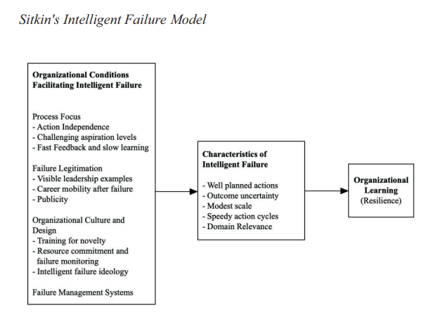
Key Points:
- Focus is the process not the outcome
- Legitimize failure to remove potential fear of addressing issue
- Organization must be supportive and not penalize individuals
- Focus on systems that produce failure not individuals (processes and policies may be the cause of employees’ non-compliance)
- Intelligent failure needs to occur in a part of the system that is important to the organization
An organization that regularly updates its information security assumptions after evaluating their information security awareness results, significantly enhances the double loop learning process.

2.1.1 Phishing
^{[3]} It is reported by IBM that 95% of incidents are due to humans. In the last 10 years phishing websites have increased by 1,726%.
The aviation industry (DuPont) lists The Dirty Dozen most prevalent are due to:
- Miscommunication
- Laxity
- Uninformed/uneducated
- Bafflement
- Disunity
- Exhaustion
- Scarcity of funds
- Time limit
- Feebleness (not being allowed to express concern/ideas)
- Pressure
- Lack of understanding/knowledge (working or online) environment
- Norms: workplace practices developed over time that influence other behaviours
Cybersecurity attacks succeed because users are unaware of their vulnerabilities and have a lack of knowledge of the risks and their consequences. Duplicitous telephone/text messages and text messages can seem to come from legitimate companies the user has accounts/services with. This leads them to hand over data to the hacker.

Figure 2-2 Frame of Reference showing Sources of Phishing Attempts and how Related

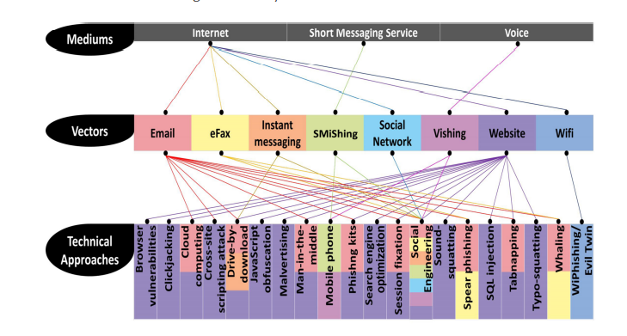

Information Security Organization Structure

^{[4]} An Individual should not make decisions where to place information security in the company.

Inside the various sectors a representative decides on placement according to their respective requirements.

Options for Placing Information Security Function Within the Organization
Table 2-1 Information Security Function Placement
^{[4]}
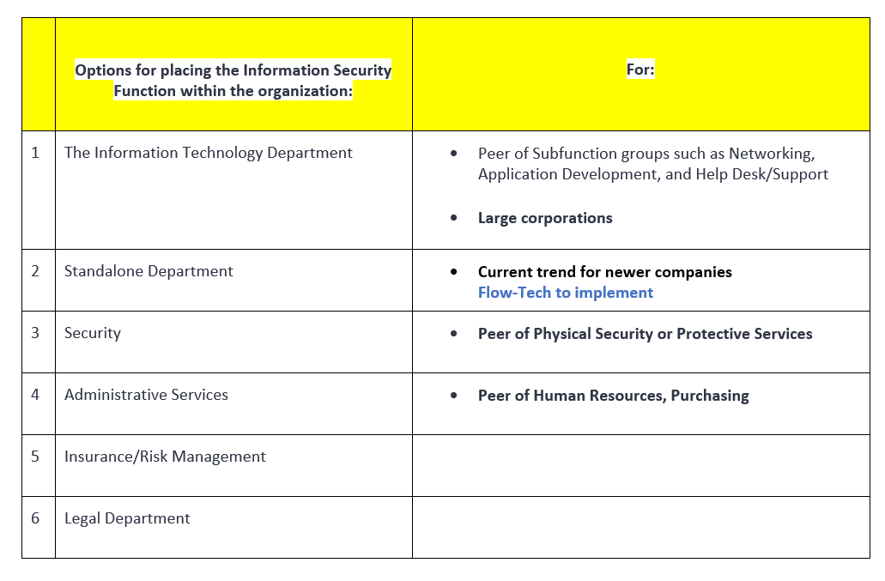

Positions in Information Security

Figure 2-3 Positions in Information Security
^{[4]}

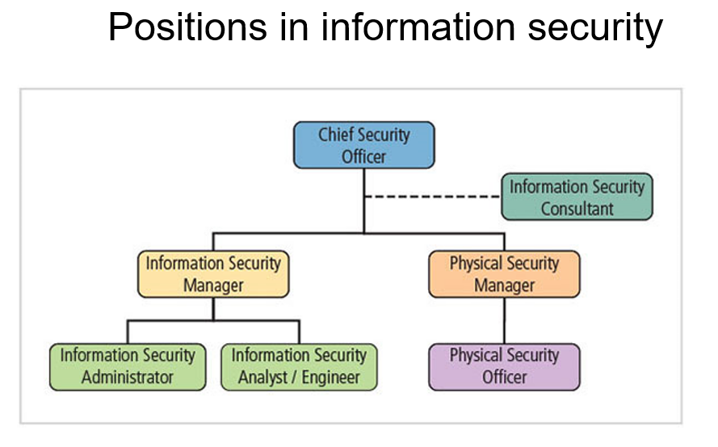

Information Security Job Titles and Qualifications
Table 2-2 Information Security Job Titles and Qualifications
^{[4]}
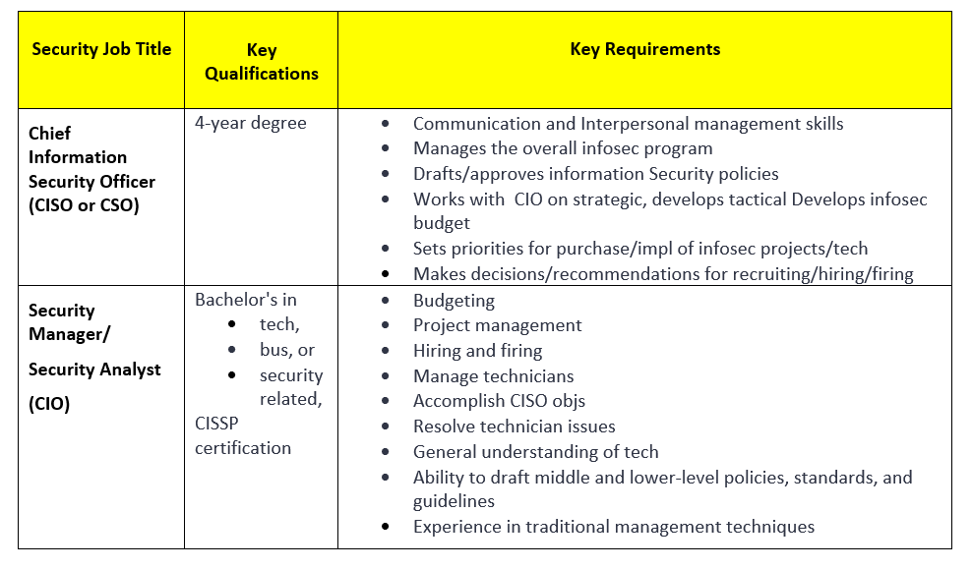

2.3.2 Functions of the CISO/Security Analyst
^{[4]} At the top is the CISO, the Information security officer , although it is not on an executive level. The CISO reports to the Chief Information Officer (CIO). CISO’s manage at the business level and technological aspects take a backseat. Nevertheless, they need to be highly conversant in all aspects of information security. The CISO is the designer of the information security program.

Table 2-3 CISO/Security Analyst Functions and Requirements
^{[4]}
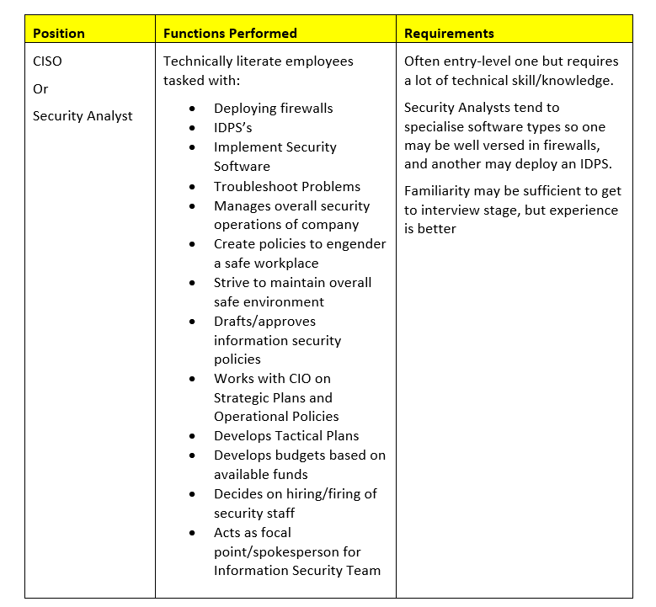

Information Security Professionals

^{[4]} Professional infosec personnel are highly sought after.
- Predicted career opportunities will rise 32% up until 2028.

To stand out candidates will need to:
- possess certifications like CISSP and SSCP
- show they are adaptable
- show passion for their job

Attributes Organizations Seek when Hiring Information Security Professionals
Table 2-4 Attributes Information Security Candidates Need in Order of Importance
^{[4]}
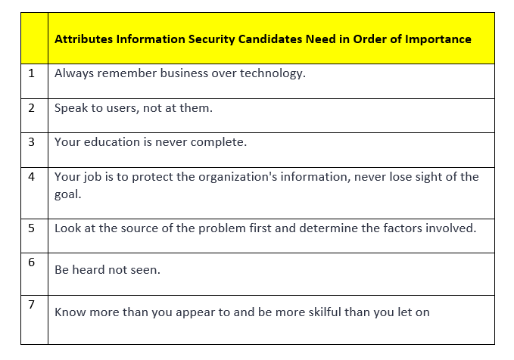

Critical Conditions when Dismissing an Employee

^{[4]} These are:
- Access to the system
- Media (removable)
- Drives
- All files
- Locking mechanisms
- Key cards
There are slight changes based on the type of termination, depending on whether it is friendly or hostile, as a friendly departure is usually planned.

2.5.1 Work Terminations
- Introduce limits to all areas once the resolution arrived at.
Good security practice is to treat every termination as a hostile departure because the employee may have become overly aggrieved by the process.
- The higher access privileges, the more critical the cessation process, and the greater credence is needed regarding legal documents like non-disclosure agreements.

How Considerations For Temporary/Contract Employees Differ

^{[4]} Temp/contract employees differ as they are not entrusted as much as staff. Permanent personnel are unlikely to know the scope of work temps are working on, and temps could wander into unsecured areas.
Permanent employees, however, are known by their peers, who would see if the employee was acting suspiciously and or breaking rules/protocols.

2.6.1 Temporary Employees - Special Safety Precautions
Temps/contractors have not been subject to the same rigorous screening and contractual obligations; however, they need access to sensitive information in the company.
Temps supplement workforce but are employees of the agency.
Temps’ access to Secure areas needs to be more restricted.
Important information should be restricted to the minimum necessary for their duties.
Some Companies require the temporary employee to sign:
- nondisclosure and
- fair use policies

Contract employees are hired to perform specific services for an organization; their contract being between the host and parent company, not between individuals.
Some contract employees require physical access to locations rather than access to information (with exceptions of technology contract positions).
For security purposes, they should only have access to the pertinent places to allow them to complete their duties. All restrictions and regulations would be stipulated in the initial hiring contract.
Consultants are taken on board for single purpose and are self-employed/co-opted from different organizations. They have their own security requirements and contractual obligations entering the job. All contracts must be specific and agreed upon before the job commences, and before they arrive at the premises.

2.6.2 Job Candidates Should Not be Allowed in Secure Areas During Interview
^{[4]} It is important to recognise job candidates are not employees; they are only ‘potential personnel; therefore, they should not be privy to the inner workings or procedures within the company.
Prying eyes pick up much more than consciously remembered and so may be able to retain enough information about the operations of the company to glean secret knowledge about information security functions. This could result in illegal spying within the company to gain organizational trade secrets.
During follow up interviews all Secure/Restricted areas should be avoided. Even though the individual has a high chance of being added as a resource within the company, caution is advisable with tours.

Descriptions of Tasks/Functions For Employment of Professionals in Information Security

^{[4]} It is important to use specific, clearly defined job descriptions for hiring Information Security professionals.
These job descriptions can be used to increase the degree of professionalism in the IT field as well as improve the consistency of roles and responsibilities.
The description tells the potential employee exactly what the employer wants.
Organizations need to beware of revealing access privileges to prospective employees when advertising vacancies

Standard Information Security Personnel Practices
- Records:
Keeping records of employees’ data

- Separation of duties:
Effective in safeguarding resources. Tasks requiring the handling of tactful information to be either fully or completely or partially carried out by more than one person.

  - Just one individual cannot be in control of very confidential data.
  - Improves Information Security as it makes employees accountable to their co-workers.
  - Before completion, two people review each other’s work.

- Rotation of Tasks:
Critical jobs carried out by more than one person

- Internal control to eliminate theft of company assets and reduce susceptibility by requiring employees to familiarize themselves with each other’s regular, individual duties sufficiently so as to detect any suspicious abnormalities in other employees work and perform his duties in his absence.
- A redundancy constraint; all employees are needed to carry out more than one task.

- Least Privilege Principle
Limitation in accessing information. Members can only work on the data needed for his/her job.

Information Security Career Path

^{[4]} Career paths for Information Security Professionals are:
- CISO (Chief Information Security Officer) or
- CIO (Chief Information Officer)
Other paths are:
- Information Technology,
- Security (Physical )
- Administration

Information Security professionals can work in:
- IT as an associate of subfunctions such as networks,
- Help Desk /Apps development
- Physical security as an associate of physical security/protective services and
- Administration as an associate of Personnel and/or Purchasing.
The most important thought for aspiring information security personnel must be the idea that their education is never finished.
Because technology changes qualifications become outdated quickly.

Professional Credentials
Table 2-5 Certification Descriptions
^{[4]}
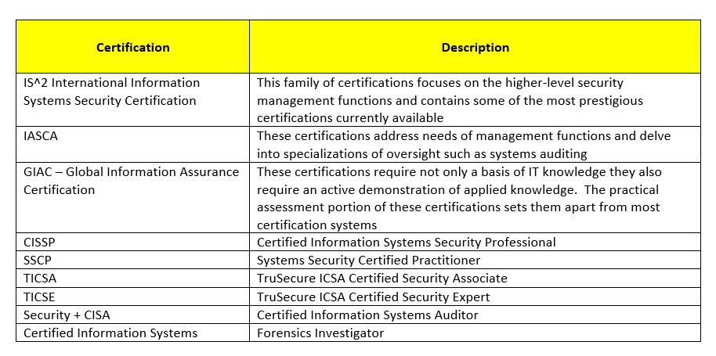

TASK 2 - CASE SCENARIO FLOW-TECH THREAT INTELLIGENCE CO.

Abstract
Flow-Tech’s Company network must be accessible by both authorised users and members of the public, on mobile devices, whilst simultaneously retaining sufficient integrity.
To fight cyberattacks a multi-pronged approach is necessary. Consistency is essential; therefore, the best defences are:

- Procedures/policies

- Malware reporting

- Staff training to stop social engineering

- Mobile devices need to have Anti-virus Software downloaded

- Encryption

There is no one panacea, so all must be activated to minimize risk.

Security

^{[5}} Data breaches have risen from 8,804 in 2005 to 11.7 billion in 2018. The 18 largest involved over 10.3 million individuals. Most originate from trusted insiders and include:
- privacy violations
- embezzlement of money
- stealing trade secrets
- information theft.
The average loss from an insider attack can exceed $8 million. CISA (US Cybersecurity and Infrastructure agency) state there are two types of organizations:
- those whose members have stolen intellectual property
- those whose members have already done so, but the organization does not know about it yet.

3.1.1 Vulnerability Discovery Testing
^{[6]} Security personnel use a variety of COTS (commercial off-the-shelf software) however, whilst this is potentially useful, it can be problematic to install ‘post implementation’ due to compatibility risks. In addition, the amount of rework it entails means it is more cost-efficient to address vulnerabilities during system design.
Assessments can be likened to a military ‘reconnaissance’ and are categorised as:
- Vulnerability
To uncover weaknesses
- Exploit assessments/penetration tests
Utilizing the above discovered vulnerabilities and exploiting them
Note: this stage is invasive, as if successful, impacts data integrity, confidentiality, and service availability
Vulnerability assessments use scanners to identify:
- IP addresses
- Open Ports
- Hostnames
- Weak Passwords
- Operating Systems
- Unencrypted data

3.1.2 Pros and Cons of Vulnerability Discovery Test Methods
Table 3-1 Vulnerability Discovery Methods
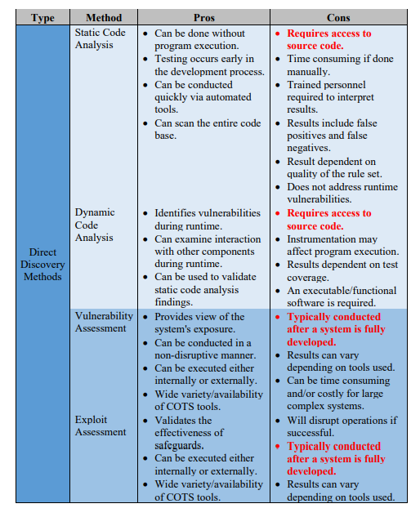

Table 3-2 Predictive Methods of Vulnerability Discovery Pros and Cons
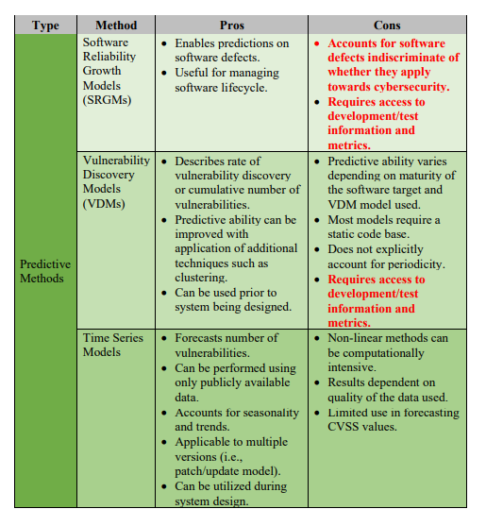

3.1.3 Overview of Security
Table 3-3 Measures Taken to Harden the System
^{[7]}
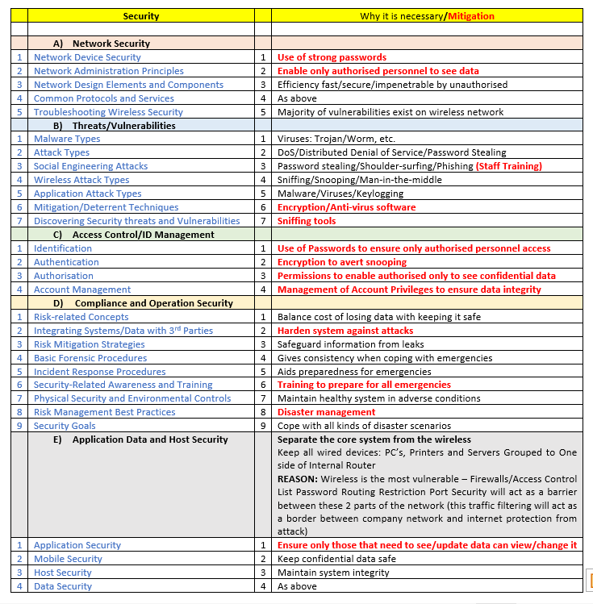
ACTIONS: All actions outlined in red on overview of Security

Figure 3-1 Network Weaknesses RAND Rprt R-609
^{[4]}
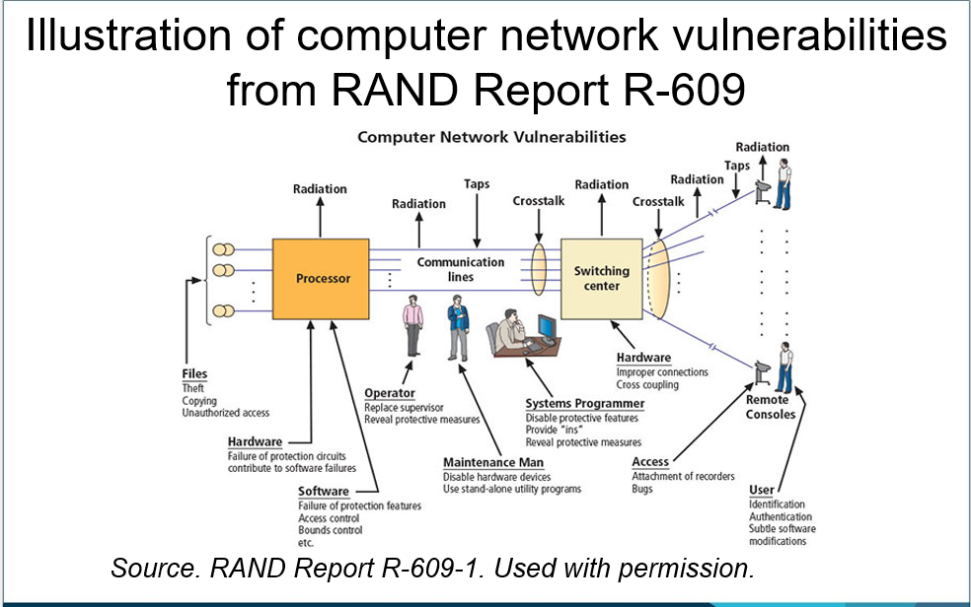

3.1.4 Components of an Information System
^{[4]} To achieve success these multiple layers of security must work in unison:
- Physical
- Personal
- Operations
- Communications
- Network
- Information

Table 3-4 Classifications of Data Owners, Custodians and Users
^{[4]}
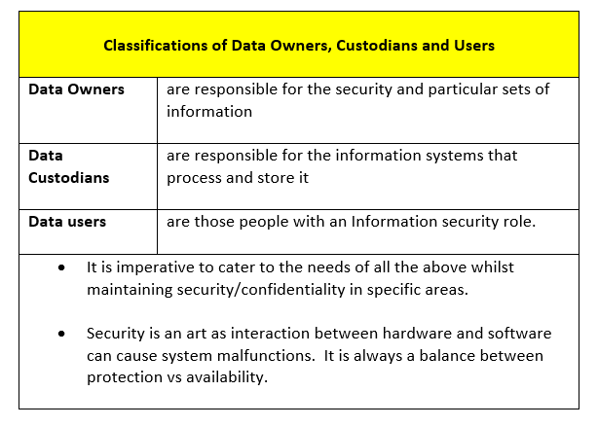

Table 3-5 The Functional Team Working to Achieve This
^{[4]}
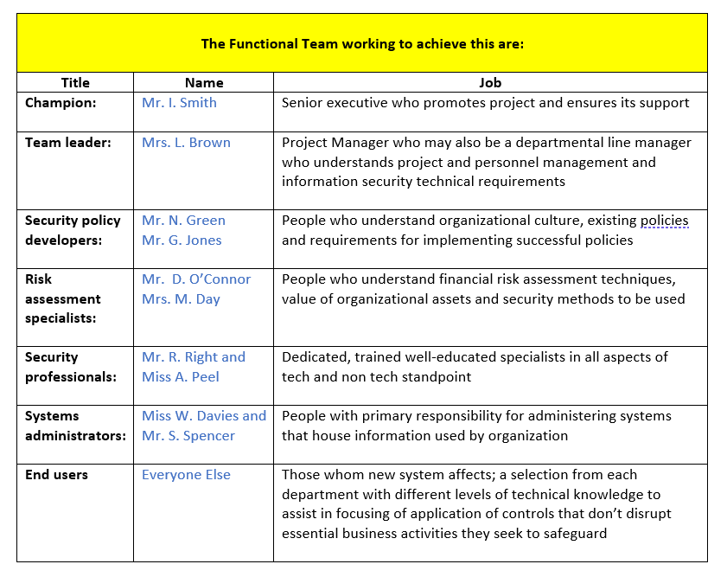

Figure 3-2 Components of an Information System
^{[8]}
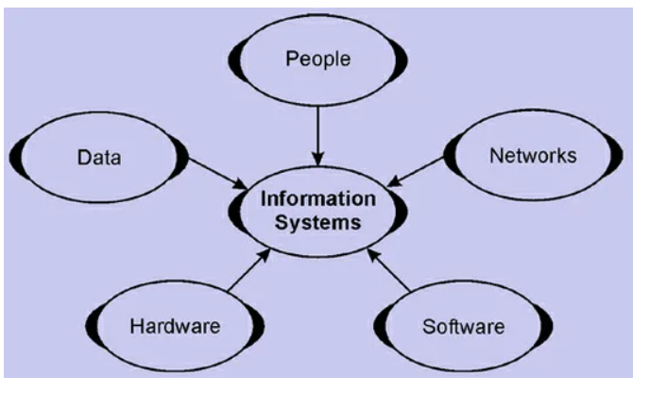
^{[4]} Security is protection from harm from adversaries, either intentionally or not, of:

- Operations
- Infrastructure
- People
- Functions
- Communications
- Information

Figure 3-3 The CIA Triad
^{[4]}
The CIA Triad

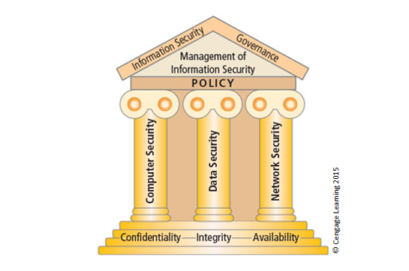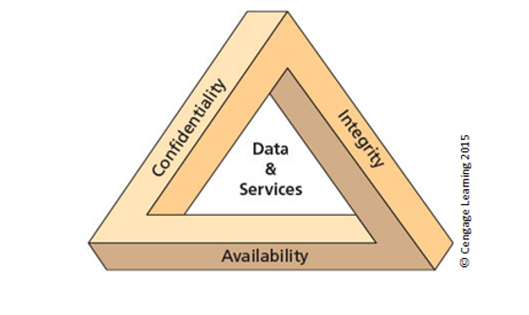
Table 3-6 Although CIA Triangle Relevant Threats Multiplied Into:
^{[4]}
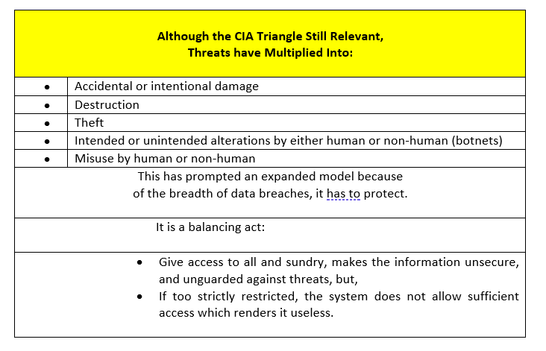

Figure 3-4 The McCumber Cube
^{[4]}
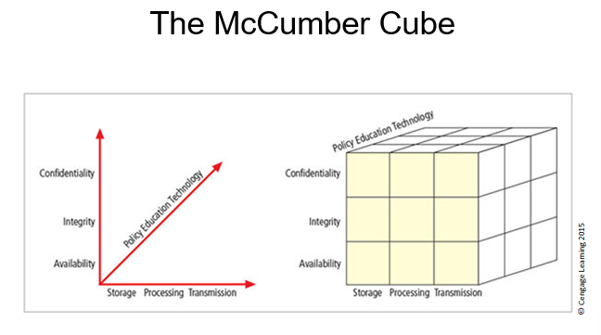
Table 3-7 The System is Designed To
^{[4]}
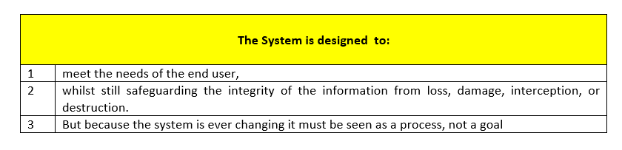

Grassroots is when system administrators attempt to improve security of their systems, which is what Flow-Tech has been trying to implement, but now needs further expertise.

Figure 3-5 Top-Down and Bottom-Up Approach
^{[4]}

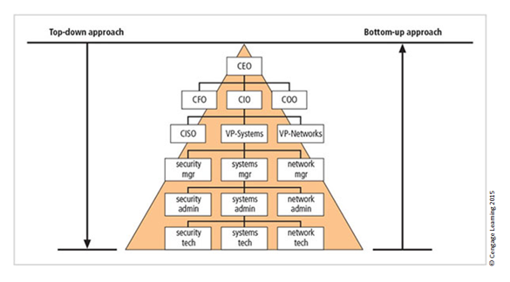
Whilst the technical expertise of the administrators is useful, as they work daily so have extensive knowledge, understanding threats and mechanisms to protect the system from them, they cannot be expected to solve all the problems without management intervention.

Table 3-8 The Top-Down Approach is Best
^{[4]}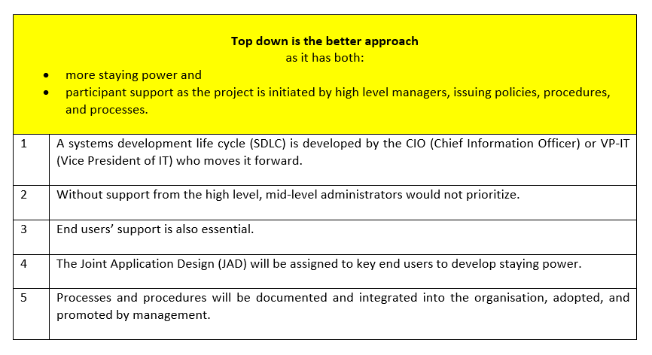

3.1.5 Systems Development Life Cycle Waterfall Methodology

^{[4]} SecSDLC security systems development lifecycle = a methodology for design implementation of security systems based on the SDLC (both contain same general phases)

Figure 3-6 SDLC Waterfall Methodology
^{[4]}
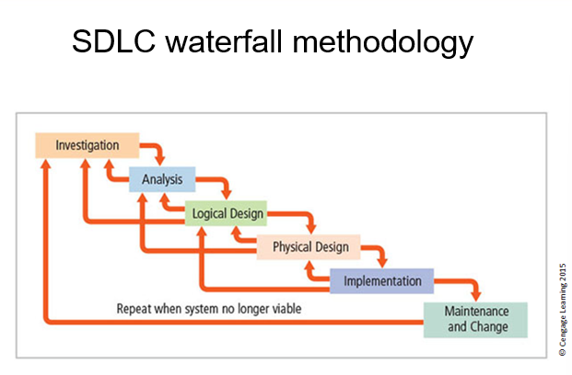
Table 3-9 The Formal Approach Proposed To Solve Problems on Structured Sequence /Procedure to Investigate:
^{[4]}
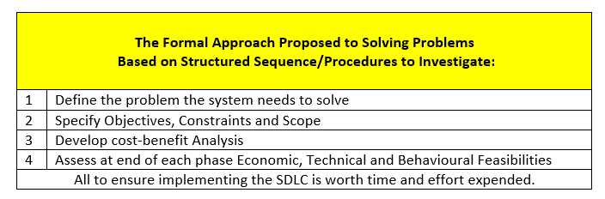

Table 3-10 The Logical Design Consists of:
^{[4]}
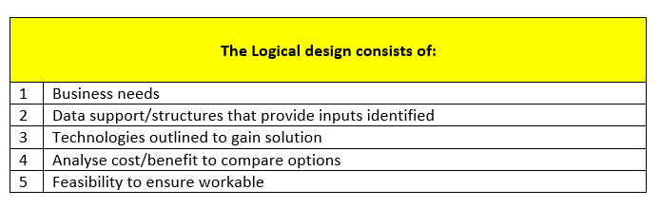

Table 3-11 The Six Phases
^{[4]}
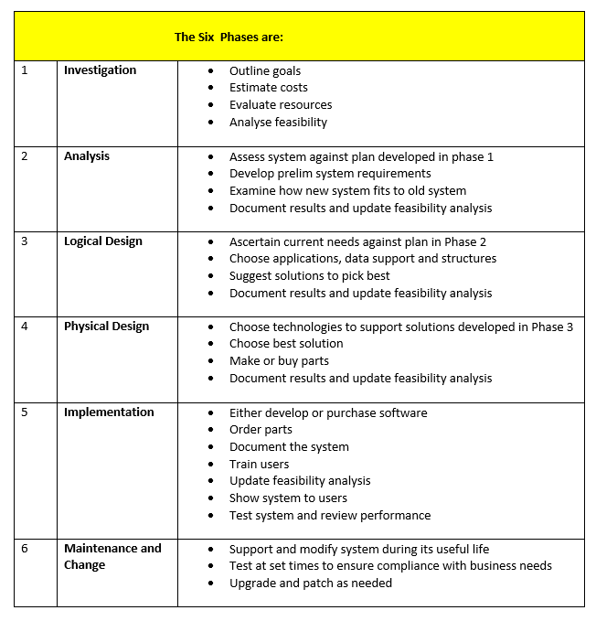

Figure 3-7 Initiation Phase 1
Source: NIST SP 800-64 Rev. 2
^{[4]}

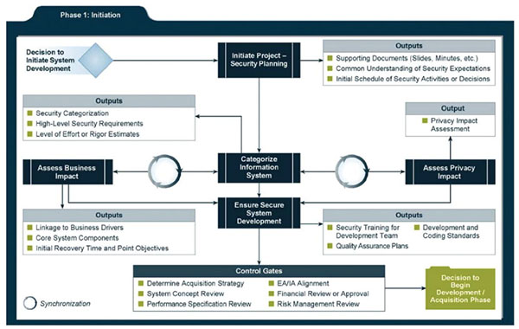

Figure 3-8 Development/Acquisition Phase 2
Source: NIST SP 800-64 Rev. 2
^{[4]}

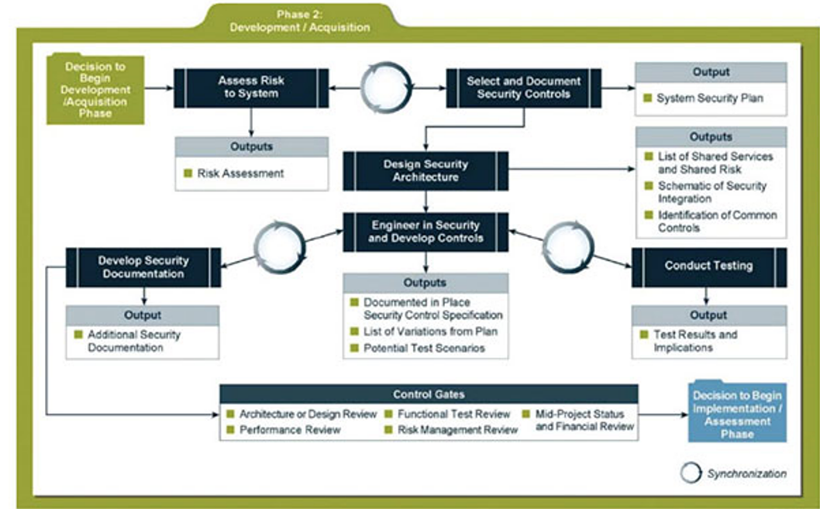

Figure 3-9I Implementation/Assessment Phase 3
Source: NIST SP 800-64 Rev. 2
^{[4]}

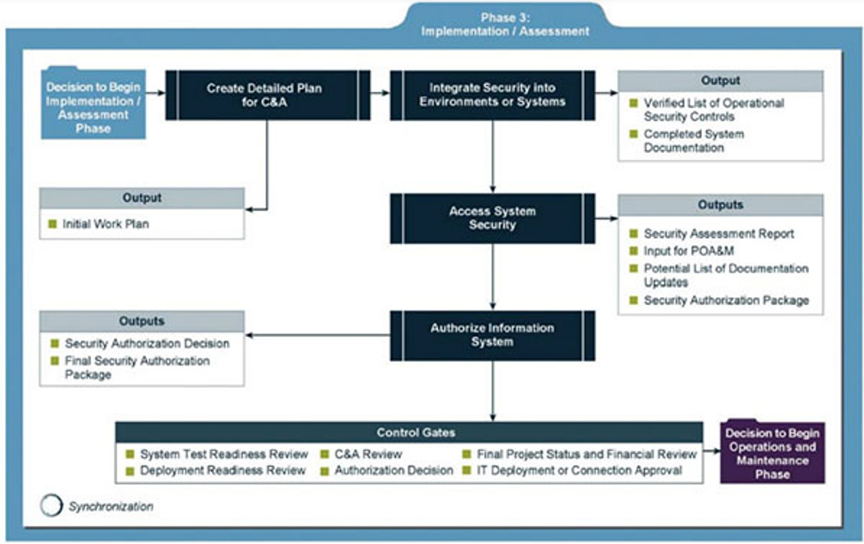

Figure 3-10 Operation/Maintenance Phase 4
Source: NIST SP 800-64 Rev. 2
^{[4]}

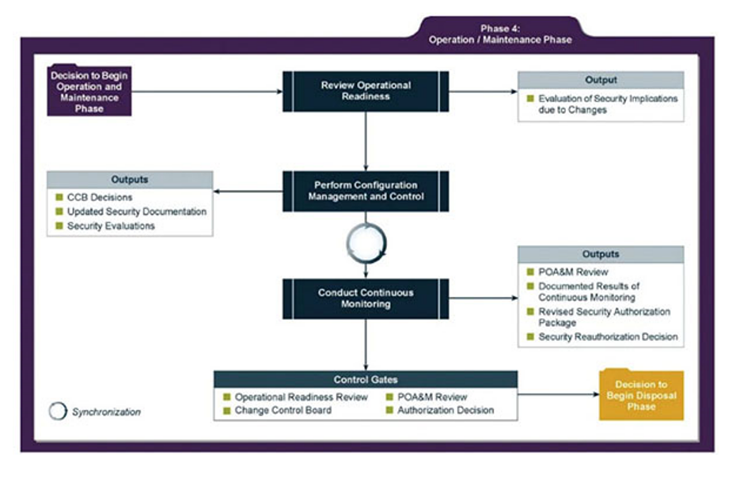

Figure 3-11 Disposal Phase 5
Source: NIST SP 800-64 Rev. 2
^{[4]}
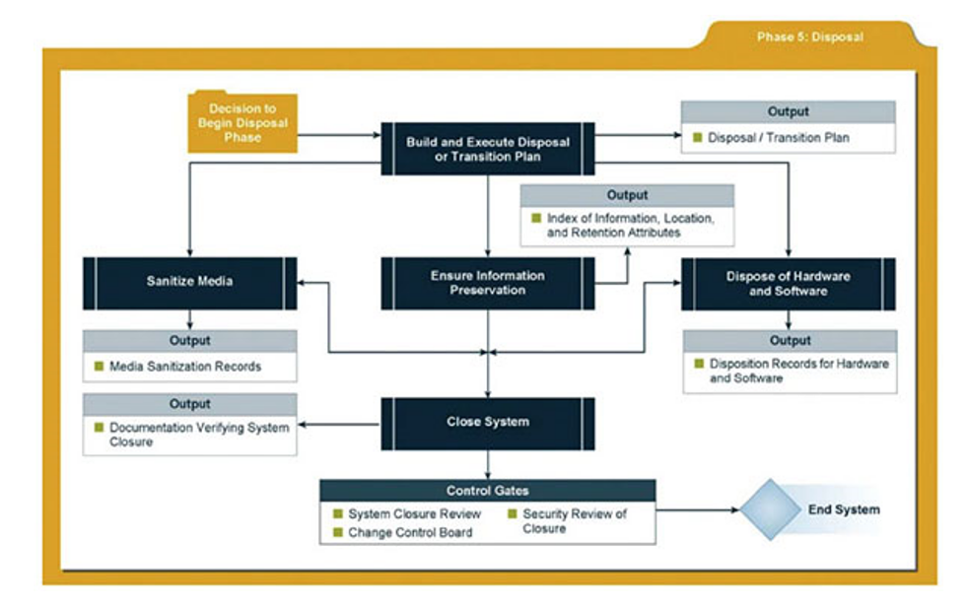

3.1.6 The DevOps Approach
^{[9]}
Figure 3-12 The DevOps Approach

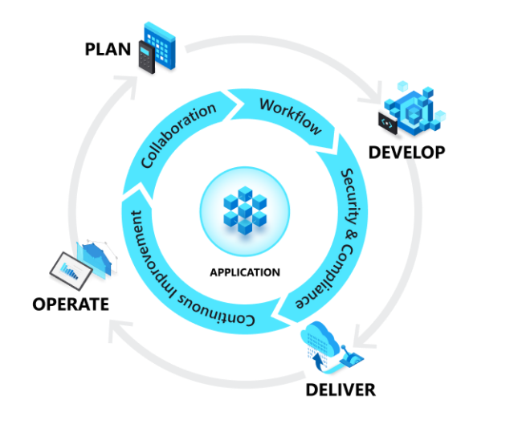
Planning: ideate define and describe features
Develop: Coding, writing, testing, reviewing
Deliver: Deploy into production
Operate: Maintain, monitor, troubleshoot
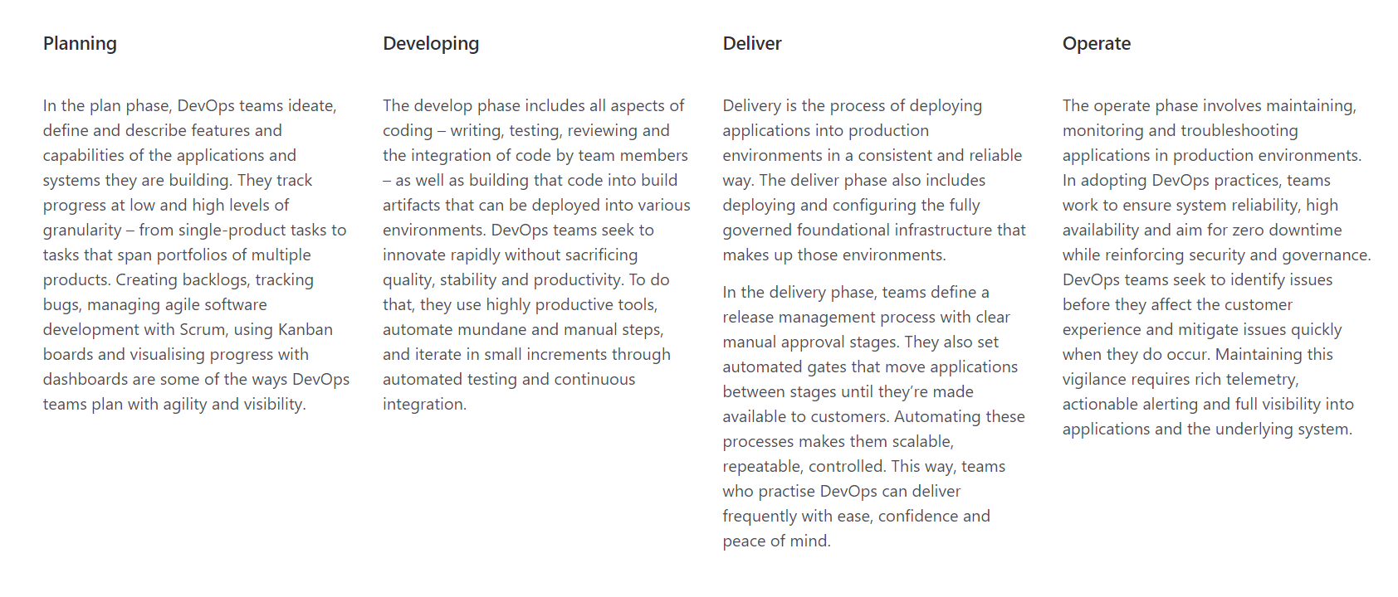

3.1.7 Actions – The Need for Security
Table 3-12 ACTIONS - The Need for Security
^{[4]}
Actions
Who Responsible | No. | For What
Information Security | 1 | Actions in red on Overview of Security see 3.1.3
Information Security | 2 | Vulnerability Discovery Testing - see 3.7.1 and Appendix 6.1
Information Security | 3 | Logical Diagram of Network Before and After (see above)
Functional Team | 4 | To liaise with Information Security to Achieve the above

Compliance – Legal, Ethical and Professional Issues

Table 3-13 Due Diligence Required in Laws and Ethics to Avoid Liability
^{[4]}
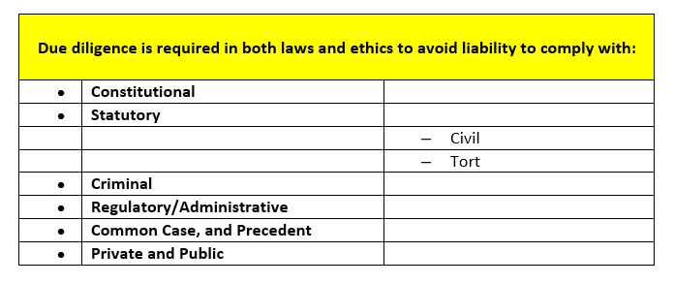
Table 3-14 General Employee Terms and Conditions Re Information Security
For ethics guidance, refer to Policies/Managerial Directives section in the:
^{[4]}
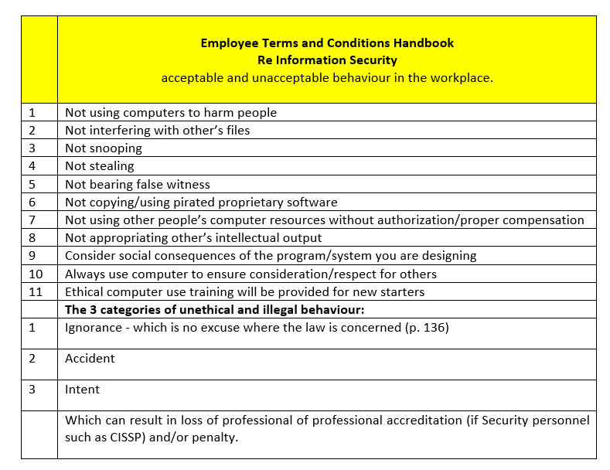

General Computer Crime Laws
Table 3-15 General Computer Crime Laws
^{[4]}
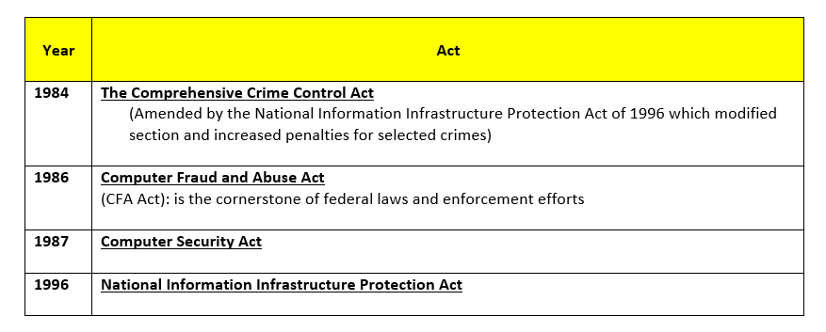

3.2.2 Financial Reporting
^{[4]} 2002 Sarbanes-Oxley Act

Main UK Computer Security Laws
Table 3-16 Main UK Computer Security Laws
^{[4]}

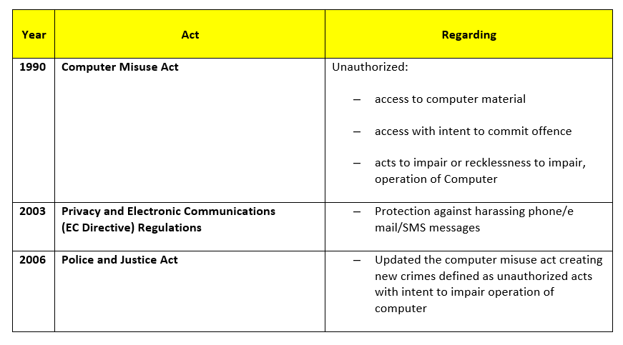

Data Security for Payment Cards
Table 3-17Data Security for Payment Card Standards
^{[4]}
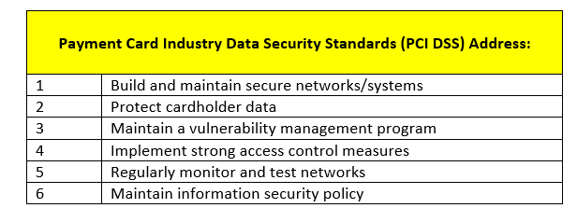

3.2.5 Organizations of Interest to Information Security Experts
Legal Department take control of matrix, as below, showing which employees have Professional Memberships.
Table 3-18 Professional Organizations of Interest for Information Security Professionals
^{[4]}
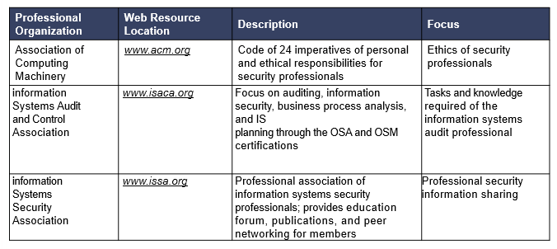
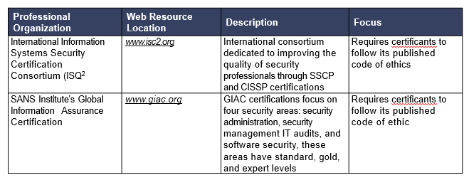

3.2.7 Actions – Compliance – Legal, Ethical and Professional Issues
Table 3-19 ACTIONS - Compliance - Legal, Ethical and Professional Issues

Actions
Who Responsible | No. | For What
Legal | 1 | Examine evidence if breach suspected
- Legal to check Information Security Credentials  - Information Security to keep Updated | 2 | Refer to Matrix of Security Personnel Qualifications to ensure compliance when recruiting Security Staff

Planning for Security

The Security Framework
^{[4]} It is proposed to gain assistance from Management to survey the needs of all those concerned to construct policies for information security forecasting designing and implementation to help in the design and implementation of a security infrastructure.
Table 3-20 What The Security Framework Achieves
^{[4]}
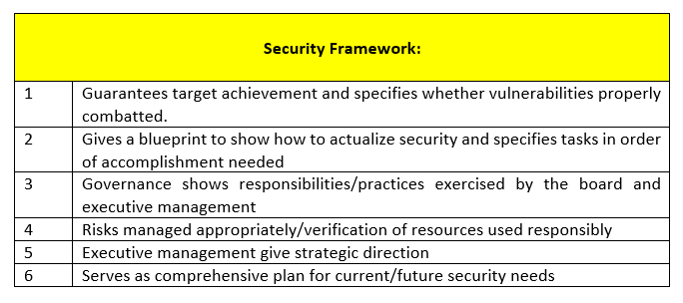

^{[4]} Information Security Programs
- Co-ordinated design is needed to draw up and keep up to date
- Strategic Plan to manage resources
- Planning for contingencies enables preparation to circumvent any/all unknown events
These aim to achieve:
- Strategic alignment
- Risk management
- Resource management
- Performance measurement
- Value delivery

Table 3-21 Information Security Programs that May be Adapted
^{[4]}
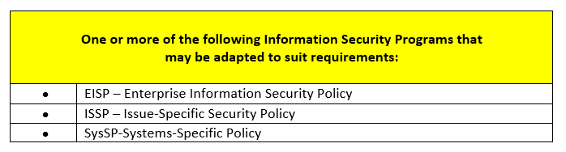

Policies
Figure 3-13 Policies, Standards, Guidelines, and Procedures
^{[4]}

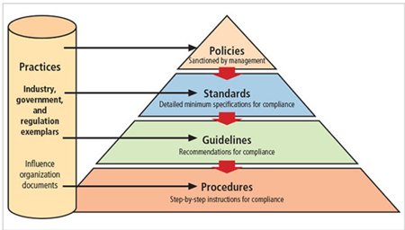

Differences between Policies Standards and Guidelines
Table 3-22 Differences Between Policies, Standards and Guidelines - Details
^{[4]}
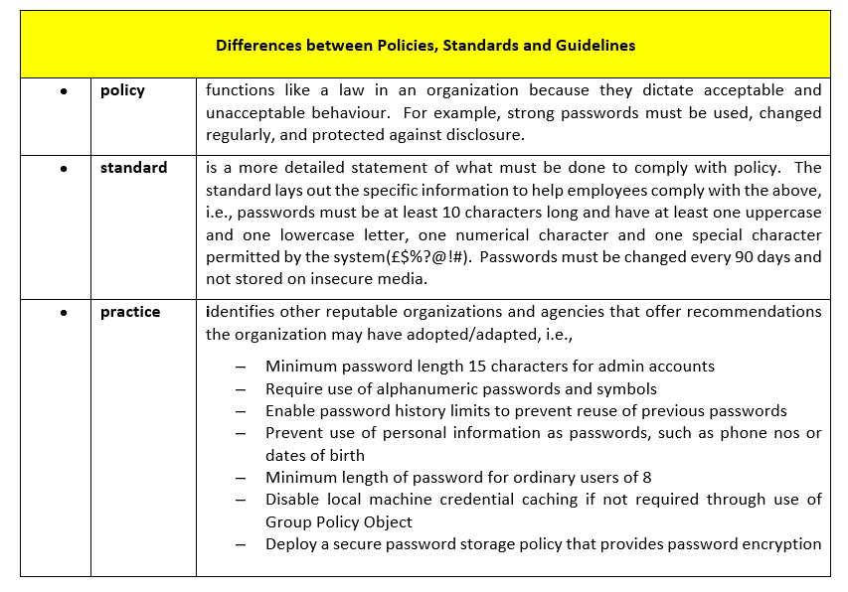

3.3.1.2 Details of Types of Security Policies:
Table 3-23 Types of Security Policies
^{[4]}

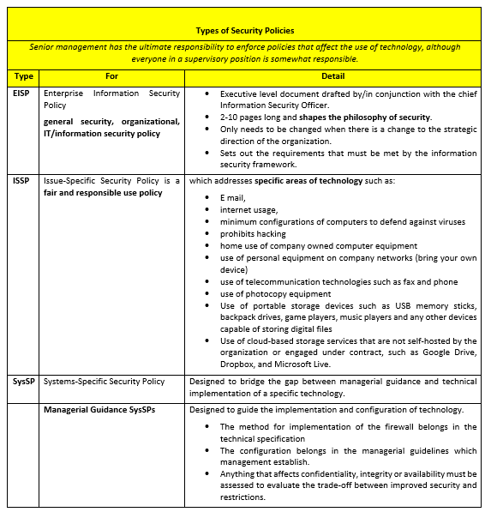

3.3.1.3 Policy Management
^{[4]} Policies constantly evolve so they must be carefully managed.
Credible policies need:
  - A manager who will be responsible
  - A regular review schedule
  - Make recommendations for reviews
  - Both issue and revision dates for policies
  - Policy management that is automated

3.3.2 Governance and Security Planning

3.3.2.1 The Security Framework Basis
^{[4]} The Security Framework is the basis for the design, selection, and implementation of:
- security policies,
- training/education programs and
- controls (technical)

3.3.2.2 Responsibilities and Functional Role Examples
Figure 3-14 Responsibilities and Functional Role Examples
^{[4]}

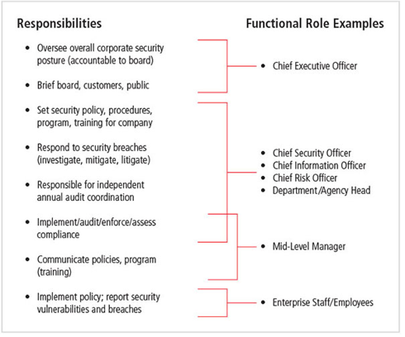

3.3.2.3 ISO/IEC 2700 Certification Standard
Table 3-24 ISO/IEC 27001 Formal Specification Outline
^{[4]}
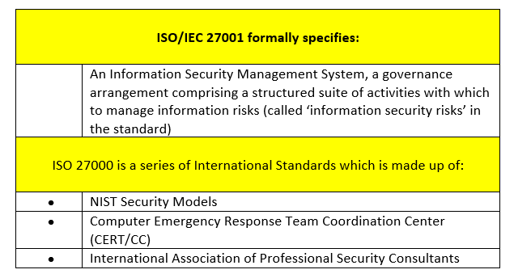

3.3.2.4 Development of Support for the Security Framework
Table 3-25 Development of the Security Framework
^{[4] [10]}
Security

1 | Backs up the company mission and is fundamental to good management.
2 | Must be cost effective bearing in mind owners are also responsible to external entities.
3 | Culpability must be specified:  - a comprehensive and integrated approach is essential
4 | Should be periodically reassessed; security is constrained by societal factors.
5 | There are thirty-three principles for securing systems
6 | ^{[10]} Benefits private companies gain from best practices federal agencies specify are:
 | “They can benefit by using awareness policies of federal agencies. Most agencies already have these policies in place. · Federal agencies are also very good at examining and processing evidence. This could be useful to private companies if some sort of theft or equipment loss or data loss were to happen. Attackers could be found much faster and easier if practices of federal agencies were followed”.

Table 3-26 Web Resources to Aid Organizations in Development of Best Practices
^{[4]}
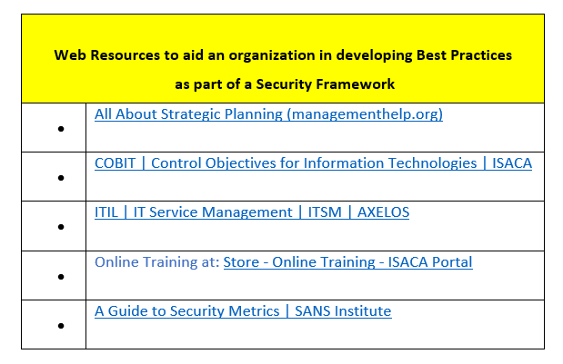

3.3.2.5 Spheres of Security: Foundation of the Security Framework
Figure 3-15 Spheres of Security
^{[4]}

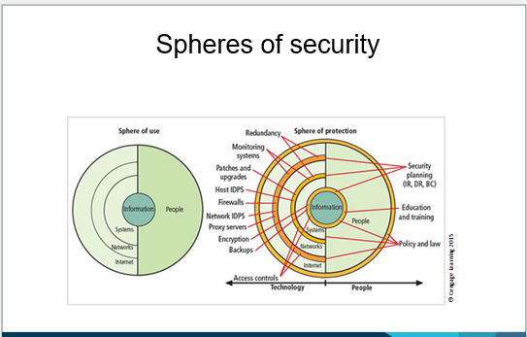

Table 3-27 Levels of Control
^{[4]}

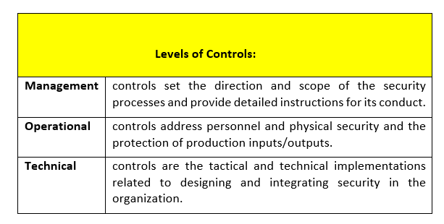

Contingency Planning
^{[4]} This includes:
- weather related disaster recovery
- physical loss of equipment
- loss of information
- power supply
- physical safeguarding of the servers etc.

This is different from routine management planning because plans are drawn up to enable business to carry on in the event of disasters

- Incidence Response (IR)
- Disaster Recovery (DR)
- Business Continuity (BC)

Major Sources of Physical Loss
Table 3-28 Donn B. Parker's Seven Major Sources of Physical Loss
^{[4]}

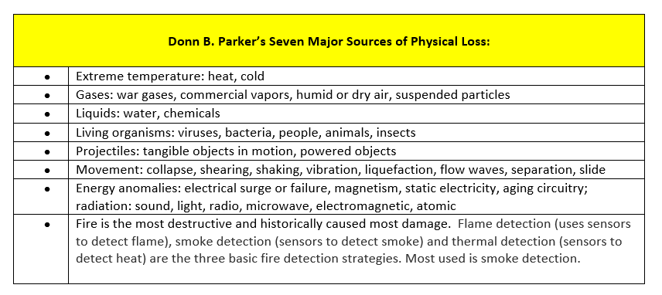

3.3.3.2 Physical Security Controls
      - ^{[4]} Walls, fencing, and gates
      - Guards
      - Dogs
      - ID cards and badges
      - Locks and keys
      - Mantraps
Figure 3-16 Mantraps
^{[4]}
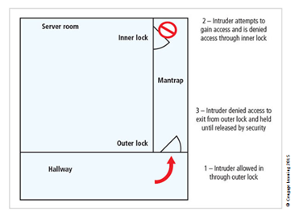
      - Electronic monitoring
      - Alarms and alarm systems
      - Computer rooms and wiring closets
      - Interior walls and doors

Data Interception
Table 3-29 Fundamental Ways Used to Intercept Data
^{[4]}

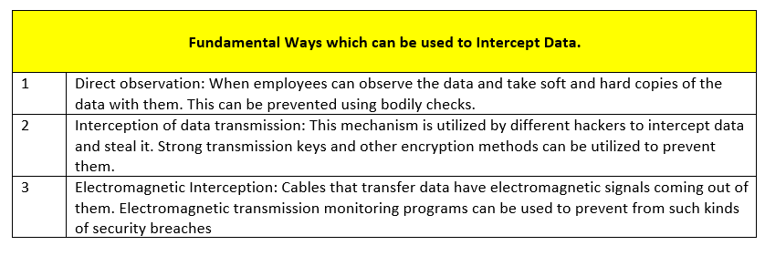

Types of Uninterruptible Power Supplies
Table 3-30 The Four UPS or Uninterruptible Power Supplies
^{[4]}

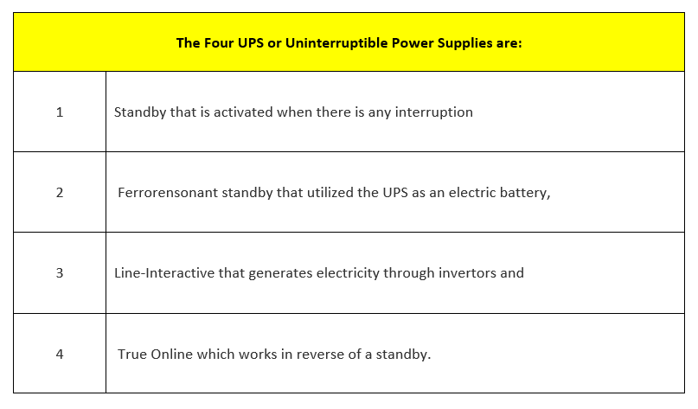

Figure 3-17 Types of Uninterruptible Power Supplies
^{[4]}

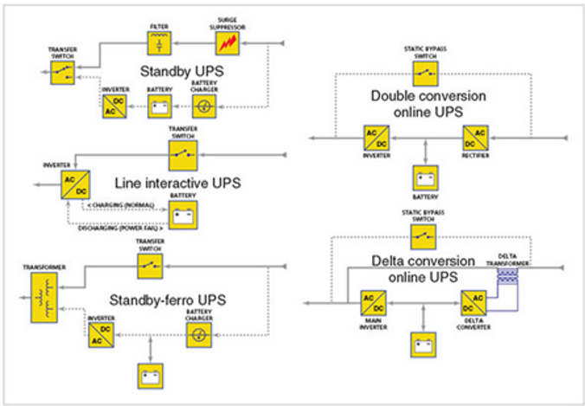

Lights Out Server Room

^{[11]} An automatic fire detection system is the best choice for a lights-out server room in the data centre, where no humans are physically present.
Table 3-31 Planning for Unknown Problems (Adverse Events)
^{[4]}
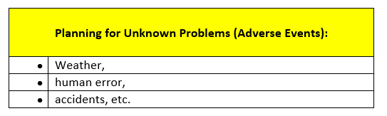

3.3.3.6 Components of Contingency Planning
Figure 3-18 Components of Contingency Planning
^{[4]}

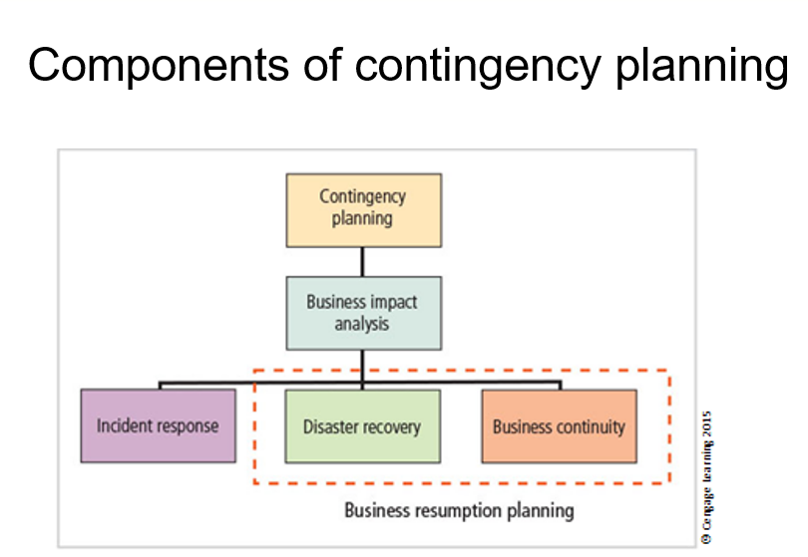

Table 3-32 Contingency Planning
^{[4]}

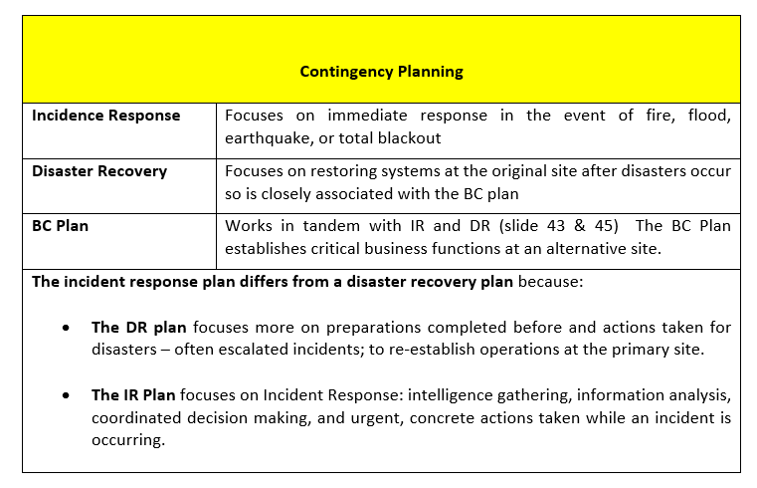

3.3.3.7 When to use the IR, DR, and BC plans:
Figure 3-19 Contingency Planning Timeline
^{[4]}

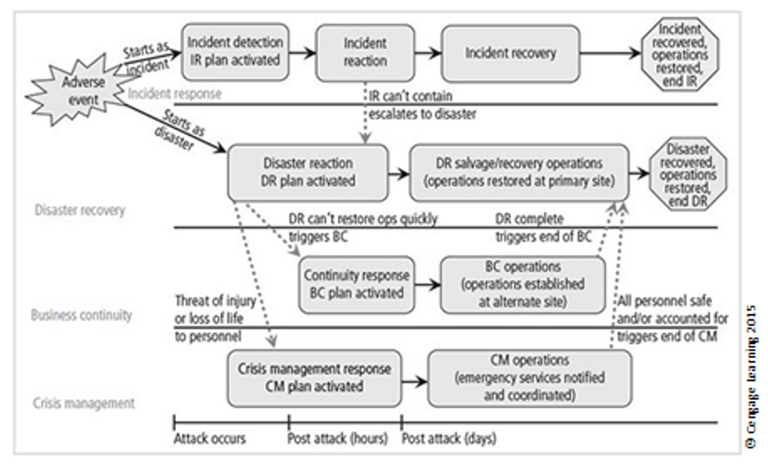

Figure 3-20 Major Steps in Contingency Planning
^{[4]}

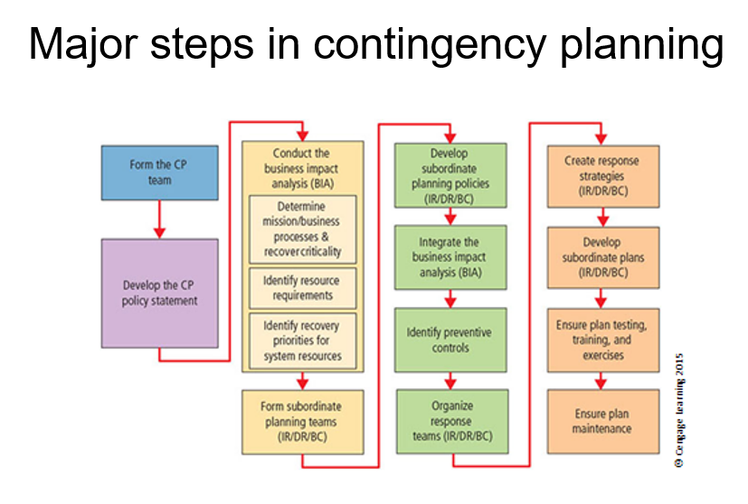
Table 3-33 The Elements of a Business Impact Analysis
^{[4]}

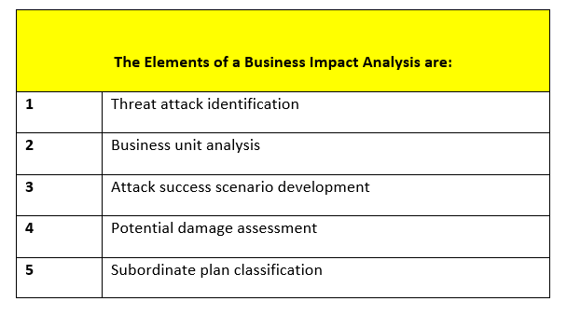

Table 3-34 Pipkin's Three Categories of Incident Indicators
^{[12]}
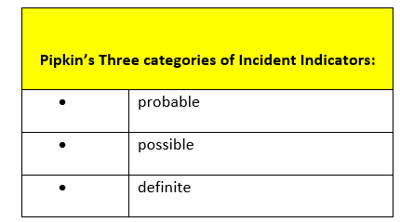
Table 3-35 Concerning Possible Indicators; Four Types of Incident Candidates

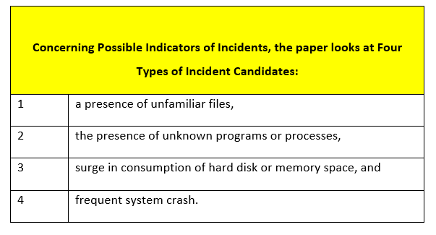

3.3.3.8 Containment is Part of the Planning Process
Table 3-36 Containment Actions
^{[4]}
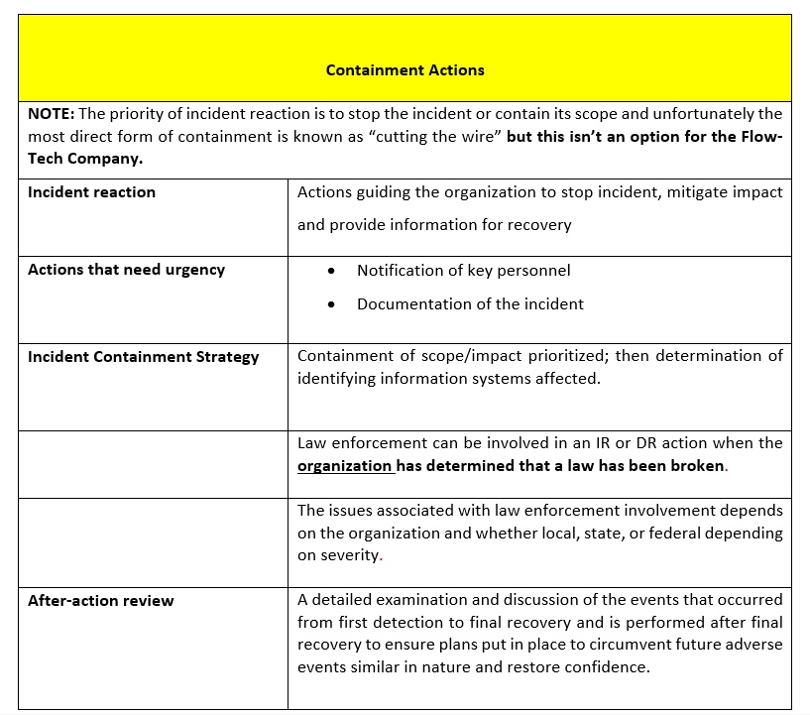

Table 3-37 Site and Data Contingency Strategies Identified
^{[4]}
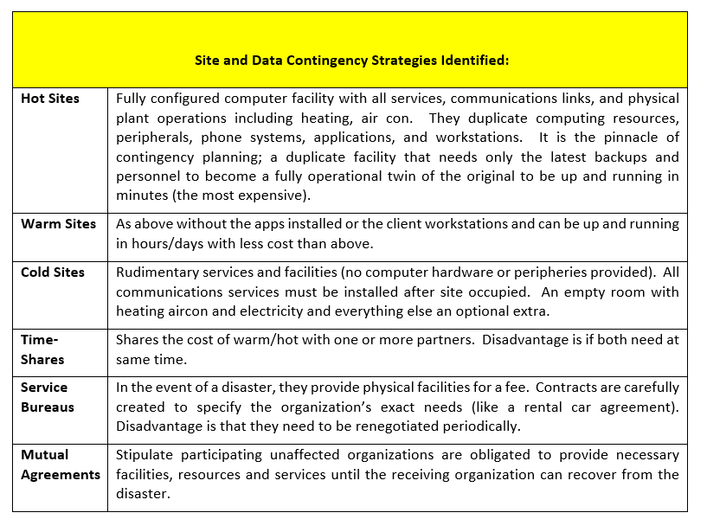

Actions - Planning for Security
Table 3-38 ACTIONS - Planning for Security
^{[4]}

Actions
Who Responsible | No. | For What
Information Security to write  Human Resources to enforce | 1 | Policy  Mobile Use: Terms and Conditions for use of mobile devices to access the company network are outlined in Appendix 6.2.
Information Security | 2 | Governance and Security Planning  Update Centralised Malware Matrix and Troubleshoot
Information Security | 3 | Contingency Planning  - Uninterruptible Power Supply  - Lights Out Server Room

Risk Management
^{[4]} Chinese General Sun Tzu Wu said:

“If you know the enemy and know yourself, you need not fear the result of a hundred battles. If you know yourself but not the enemy, for every victory gained you will also suffer a defeat. If you know neither the enemy nor yourself, you will succumb in every battle.”

Identification of risk is crucial in risk management for both:

- identifying vulnerabilities

making appropriate moves to ensure:

- confidentiality
- integrity, and
- availability

of all the components in the organization’s information system

and

- obviation of competitive disadvantage

– to avoid losing business.

A competitive disadvantage occurs when a company falls behind the competition in its ability to maintain the highly responsive services required in marketplaces.

Table 3-39 Risk Management; Communities of Interest Responsibilities’
^{[4]}

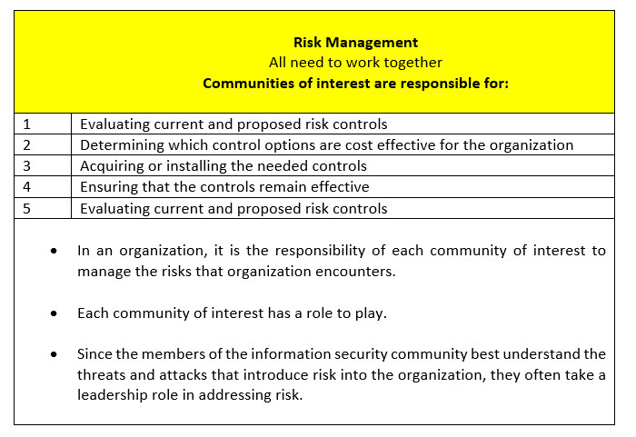

Overview
Categorization of Components of a System
^{[4]} Because networking subsystems focal point of attacks against the system, they are as special cases and not integrated with hardware and software components.

Some networking components need looking because they have to be reconfigured from their default settings to both serve their required purpose and maintain security.

Table 3-40 System, Information Asset and Risk Management Components
^{[4]}

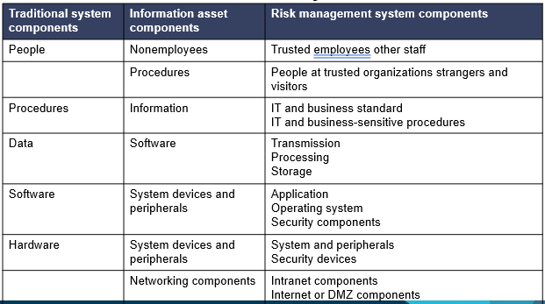

Figure 3-21 Components of Risk Management
^{[4]}

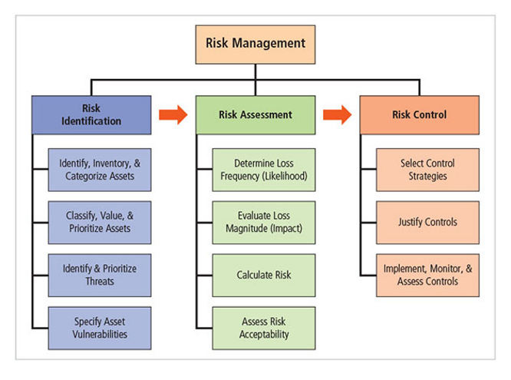

Table 3-41 Risk Appetite and Residual Risk
^{[4]}

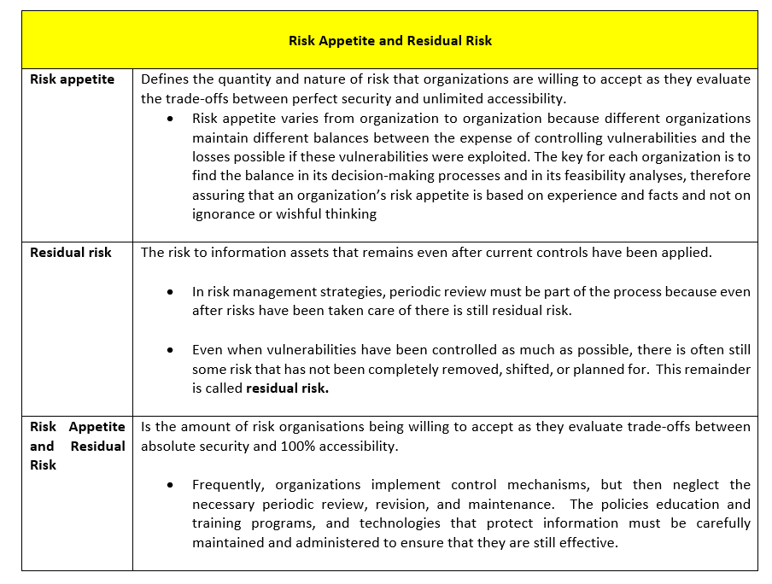

Figure 3-22 Residual Risk
^{[4]}

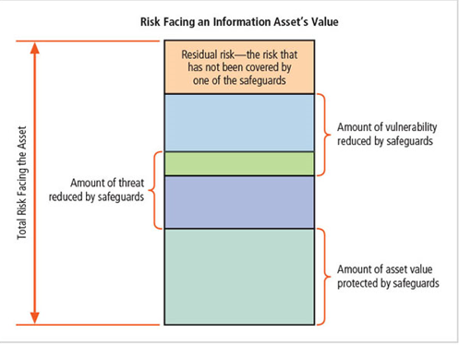

Table 3-42 Example of Vulnerability Assessment in Order of Priority
^{[13]}
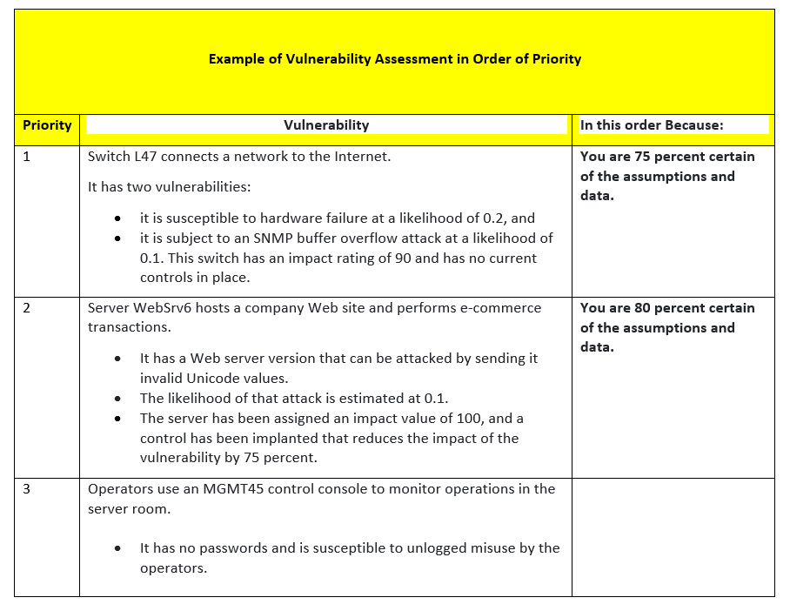

Risk Identification
Figure 3-23 Risk Identification
^{[4]}
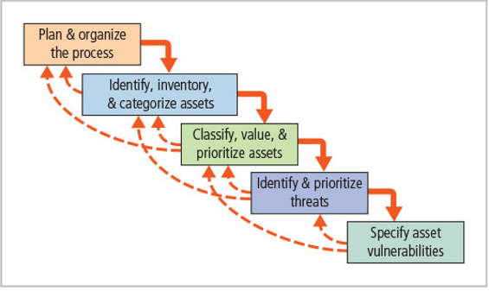Frequently, organizations implement control mechanisms, but then neglect the necessary periodic review, revision, and maintenance.
The policies education and training programs, and technologies that protect information must be carefully maintained and administered to ensure that they are still effective.

Table 3-43 Teams With Representation Across all Affected Groups Are to Plan:
^{[4]}

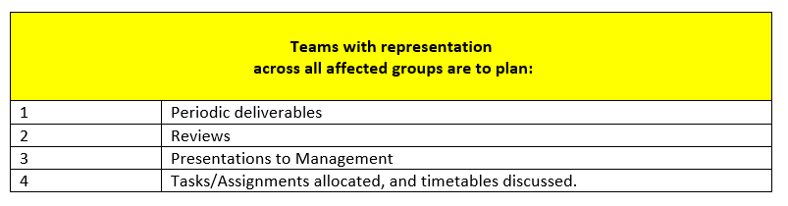
Table 3-44 Definition of Terms
^{[4]}
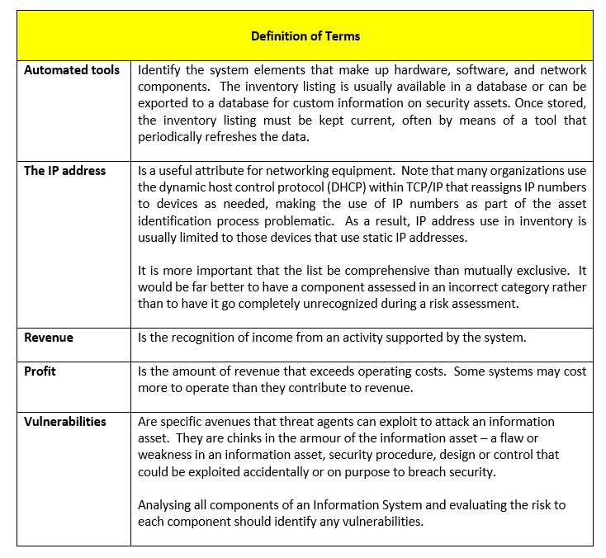

Table 3-45 Sample Inventory Worksheets
^{[4]}

Sample Inventory Worksheets
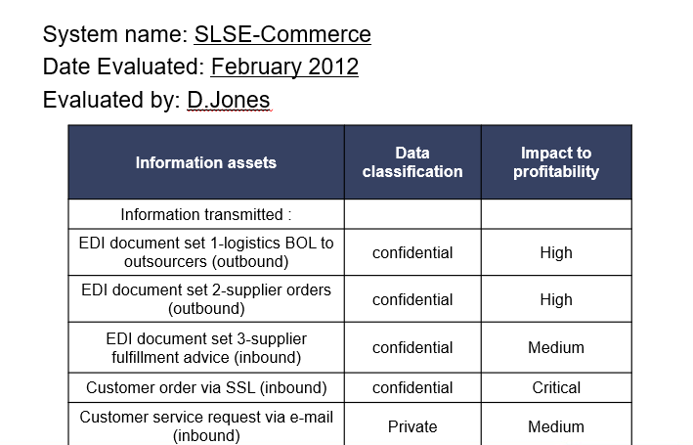
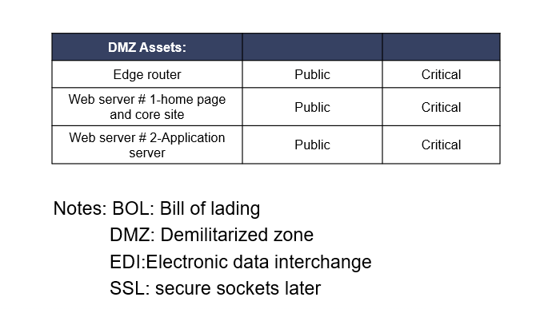

Control
Table 3-46 Vulnerability Worksheets Completed; Organization Chooses 1 of 5 Strategies for Risk Control
^{[4]}

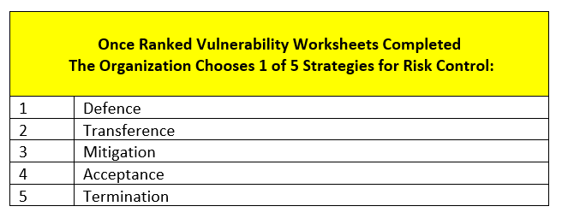

Figure 3-24 Risk Control Cycle
^{[4]}

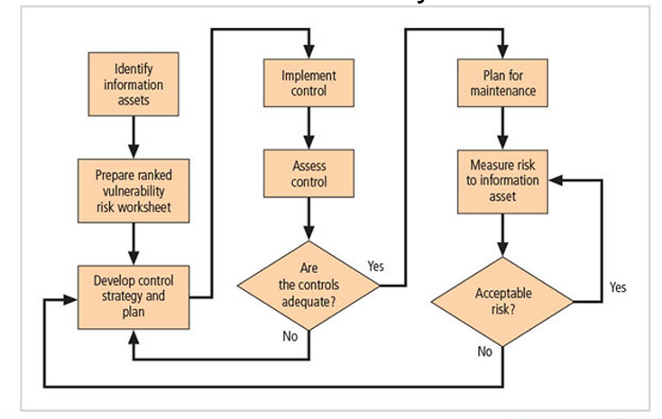
Table 3-47 Summary of Risk Control Strategies used by NIST SP 100-30 and ISACA and ISO/IEC 27001 etc.
^{[4]}

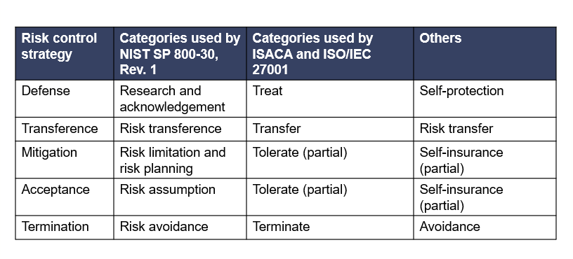

Table 3-48 Summary of Control Strategies
^{[4]}

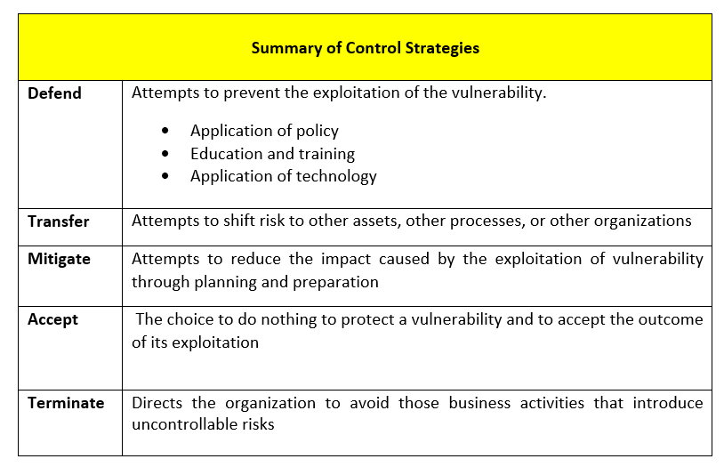

Table 3-49 The Preferred Approach Accomplished by Means of:
^{[4]}
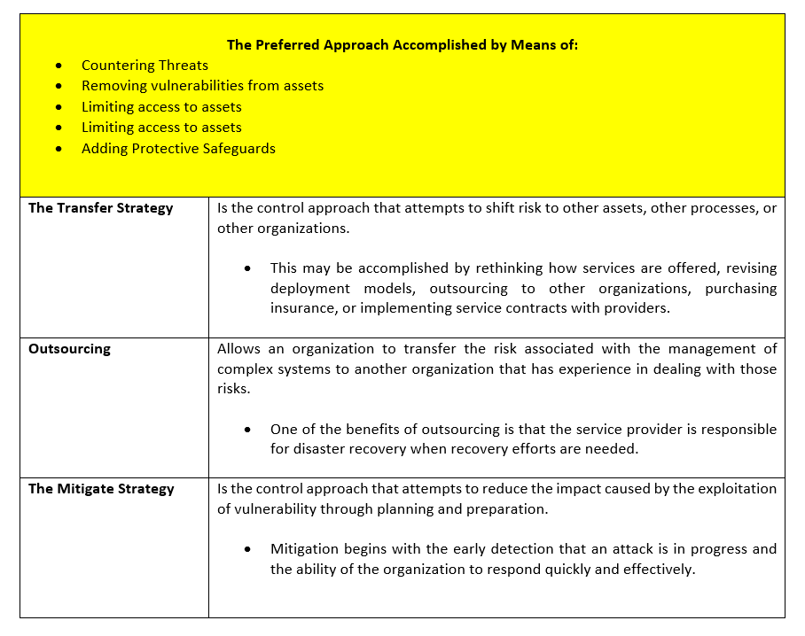

Quantitative vs Qualitative Practices
Table 3-50 Cost Benefit Analysis
^{[14]}
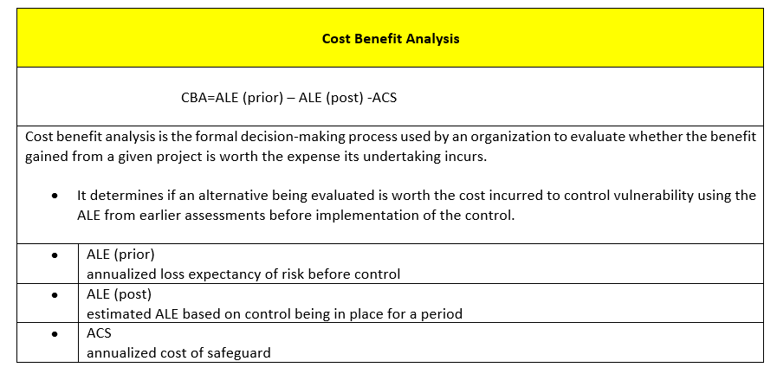

Table 3-51 Loss Expectancy
^{[4]}
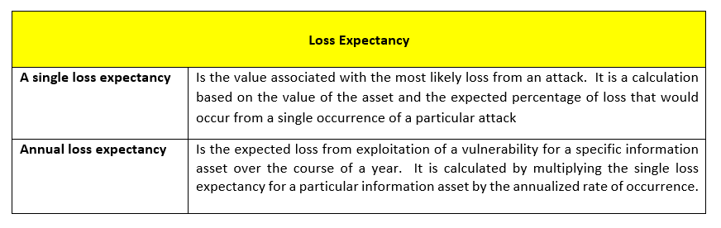

Actions - Risk Management
Table 3-52 ACTIONS - Risk Management
Actions
Who Responsible | No. | For What
Human Resources maintain  Information Security advise | 1 | Policy  Maintain Education and Training to ensure working properly.
Information Security to liaise with all | 2 | Evaluating current and proposed risk controls
Information Security to oversee | 3 | Deciding the controls are cost effective
 | 4 | Installing the controls necessary
 | 5 | Checking controls stay up to date
 | 6 | Evaluating current/proposed risk controls

Organisation Structure – Security and Personnel

- It is recommended that a new Information Security Department be set up to trouble shoot Information Technology issues throughout the company.
- Each department’s specific needs to be communicated to the CISO to ensure all their goals are met.

Personnel Security Training
Table 3-53 Information Security Training
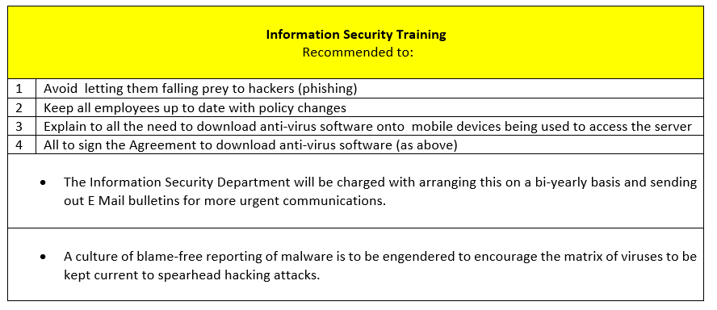

New organisation Chart - Information Security
Figure 3-25 New Organisation Chart - Information Security
^{[4]}

New Position in Information Security
A CIO/Security Analyst to aid the CISO is required to draft Information Security Policies; qualified with either:
- CISSP
- SSCP
- GIAC
- TISCA/ICSA

Information Security Professional Qualifications Matrix
The Information Security Department is charged with keeping a new Matrix up to date with Information Security’s Professional Qualifications.

Critical Conditions for Dismissing an Employee
All terminations are to be treated as hostile; and Information Security Policy is to remove access to all:
- removable media
- hard drives
- files, locks
- logical and key-card access
Legal Department to ensure that Non-Disclosure Agreements signed.

Temporary/Contract Employees
It is recommended that Temporary Staff routinely sign a Non-Disclosure Agreement and are restricted from gaining access to Secure Area unless specific to their job.
Human Resources Department to ensure their contract contains pertinent details on access allowed according to task they have been given.

Job Descriptions for Information Security Professionals
It is recommended that Job Descriptions be updated to aid:
- staff members in their jobs
- Human Resources to recruit suitable candidates

Information Security Career Path Development
The CISO will be tasked to design the Information Security Career Path for employees who have a role in Information Security.

Actions - Organisation Structure – Security and Personnel
Table 3-54 ACTIONS - Organisation Structure - Security and Personnel
Actions
Who Responsible | No. | For What
Information Security | 1 | Provide training for staff to avoid them falling prey to phishing/hackers and keep them up to date with policy changes  - Bi yearly  - All new starters within first month of employment
Information Security write Human Resources enforce | 2 | Ensure Mobile Anti-Virus policy signed by all
Information Security action  All Employees report in | 3 | A Matrix of all viruses/attacks to be kept Information Security reported in by Employees.  - A culture of blame-free reporting of malware is to be engendered to encourage the matrix of viruses to be kept current to spearhead hacking attacks.
Human Resources | 4 | Recruit CIO Security Analyst to assist CISO

Protection Mechanisms – Information Security Maintenance

Table 3-55 The Primary Aspects of Information Security Risk Management
^{[4]}
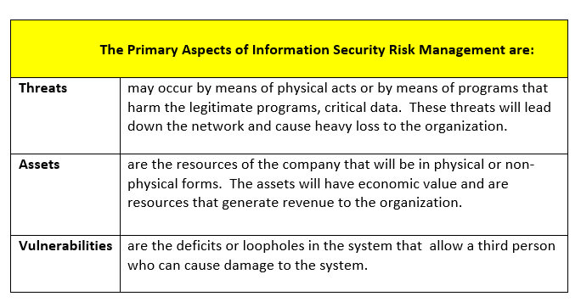
Table 3-56 Factors subject to Fluctuation
^{[4]}
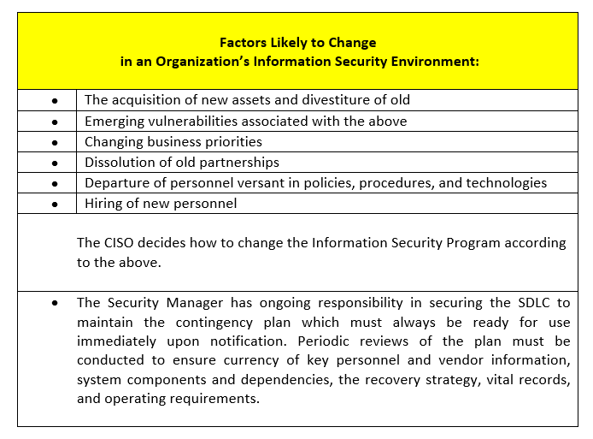

Table 3-57 Information Security Maintenance Terms
^{[4]}

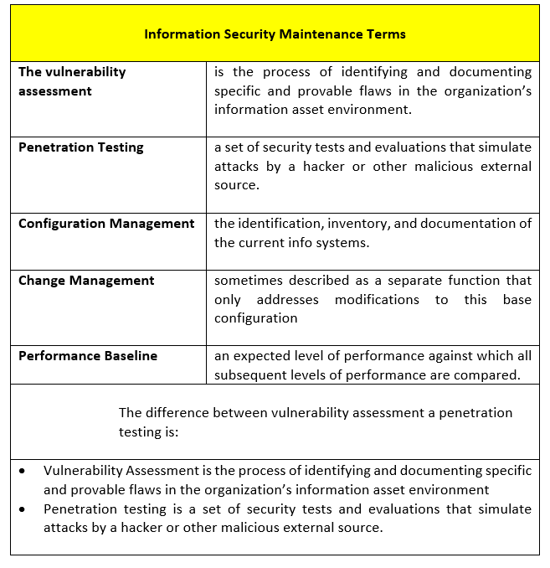

Monitoring the Environment
^{[4]} The components of the maintenance model focus on:
External monitoring: evaluation of external threats
Figure 3-26 External Monitoring
^{[4]}

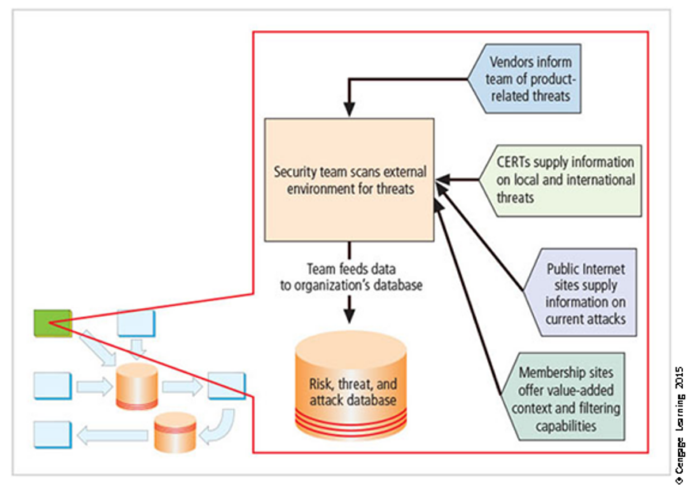
^{[4]} Internal monitoring; identification, assessment, and management of configuration/status of information assets in an organisation
Figure 3-27 Internal Monitoring
^{[4]}

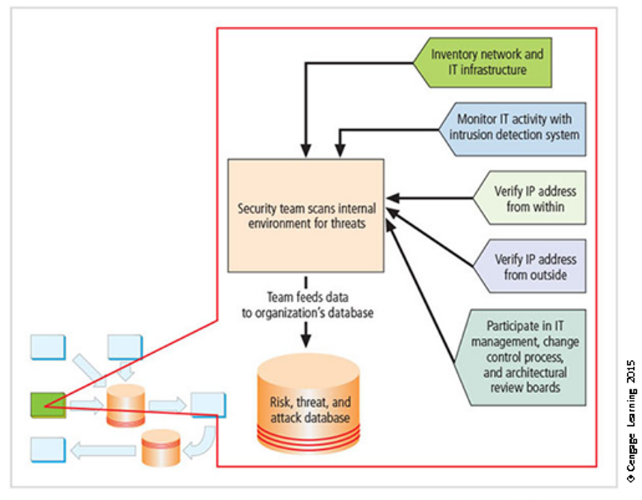

^{[4]} Planning and risk assessment; identifying and planning ongoing information security activities and identifying and managing risks introduced through IT security projects
Figure 3-28 Risk Assessment
^{[4]}

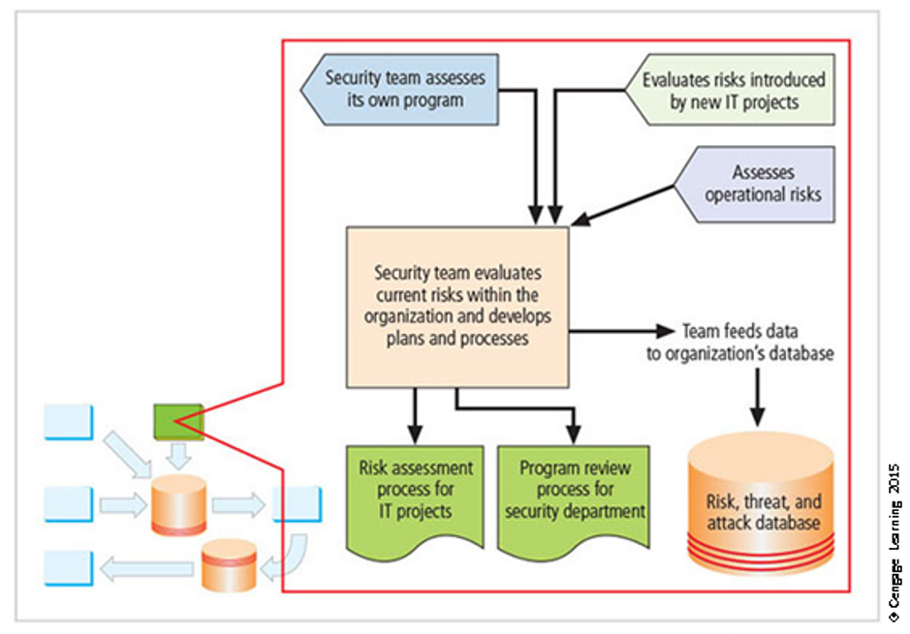

^{[4]} Vulnerability assessment and remediation; identifying specific documented vulnerabilities and remediating them in a timely fashion
The primary goal of the vulnerability assessment and remediation domain of the maintenance model is to identify specific documented vulnerabilities and remediate them in as quickly as possible. This is important because part of the process includes internet VA which finds vulnerabilities in an organizations public network.
Figure 3-29 Vulnerability Assessment and Remediation
^{[4]}
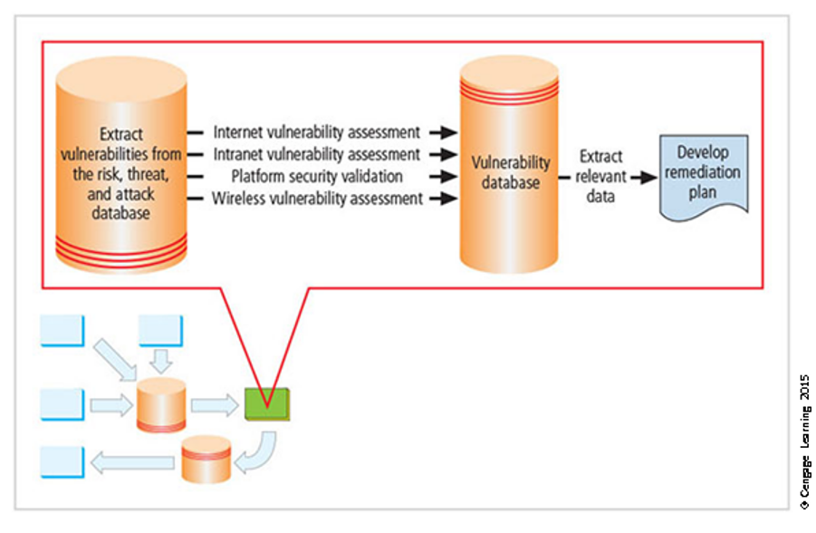

^{[4]} Readiness and Review; keep infoSec program functioning as designed and improve it continuously over time via policy review, program review, and rehearsals
Figure 3-30 Readiness and Review
^{[4]}

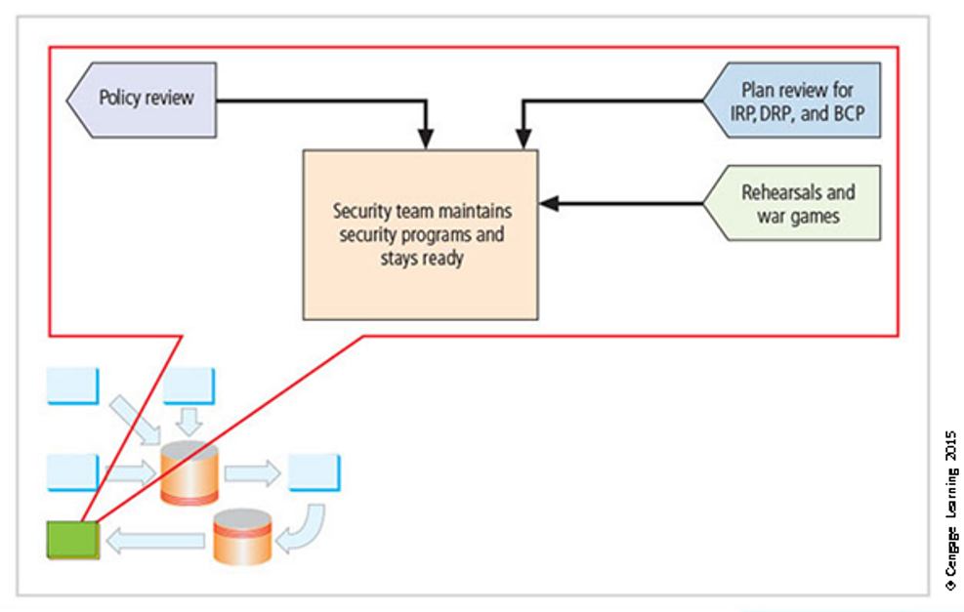
Table 3-58 Vulnerability Intelligence Sources
^{[4]}
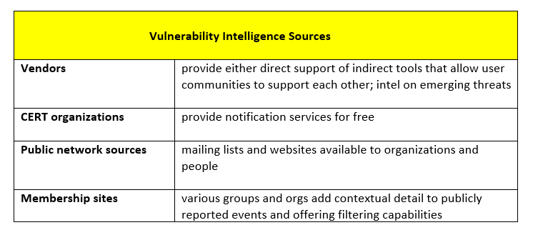

Table 3-59 Vulnerability Assessments
^{[4]}

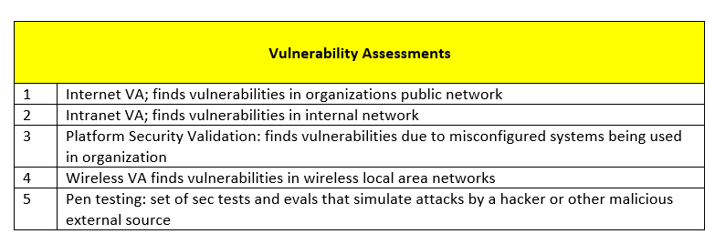
^{[4]} The objective of the external monitoring domain of the maintenance model
The main purpose of external monitoring is to provide early awareness of:
- Impending threats
- hackers
- loopholes
- threats
to enable the company to defend themselves. Intelligence gathering is handed over to the decision-makers.

Security Maintenance Models
Figure 3-31 The Maintenance Model
^{[4]}

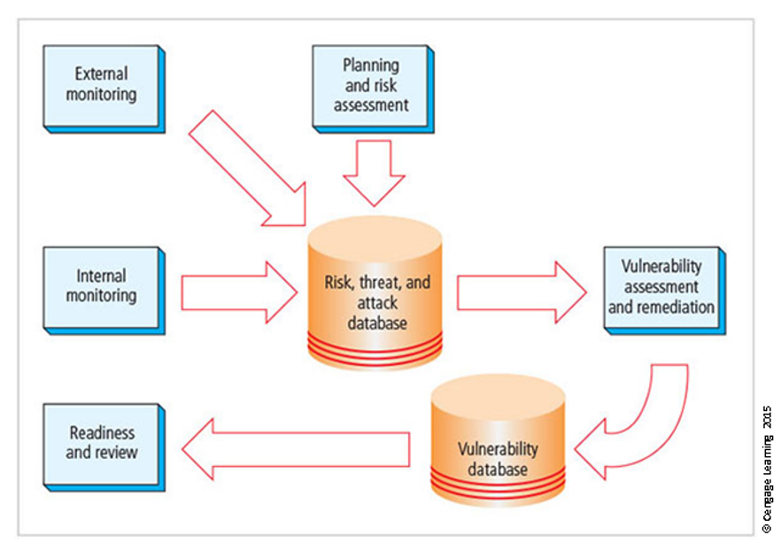
^{[4]} Management models - frameworks to structure managing a particular sets of business functions.

Table 3-60 Revisions to be Made in SP800-100 Adapt for Use in Security Management Maintenance
^{[4]}

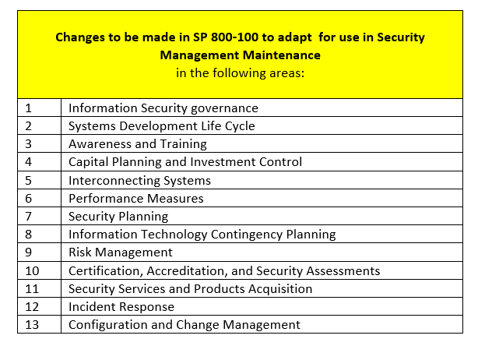
Figure 3-32 Information Security Measurement Program Implementation
^{[4]}

Information Security Measurement Program Implementation
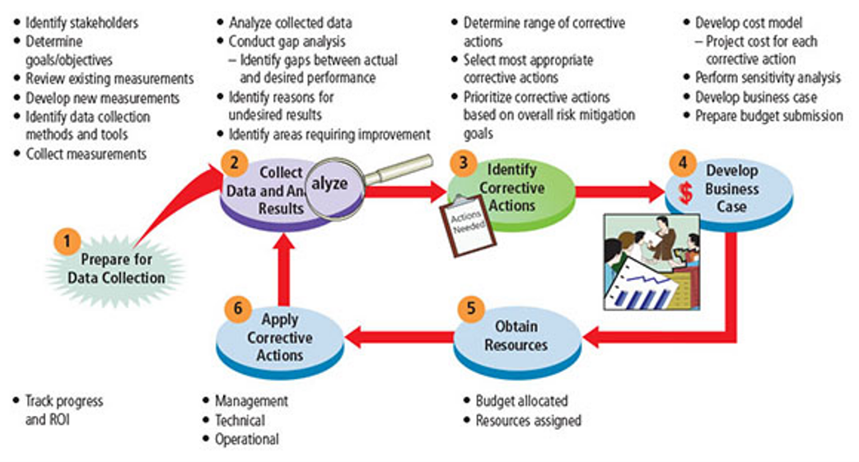
Figure 3-33 Conversion Strategies
^{[4]}

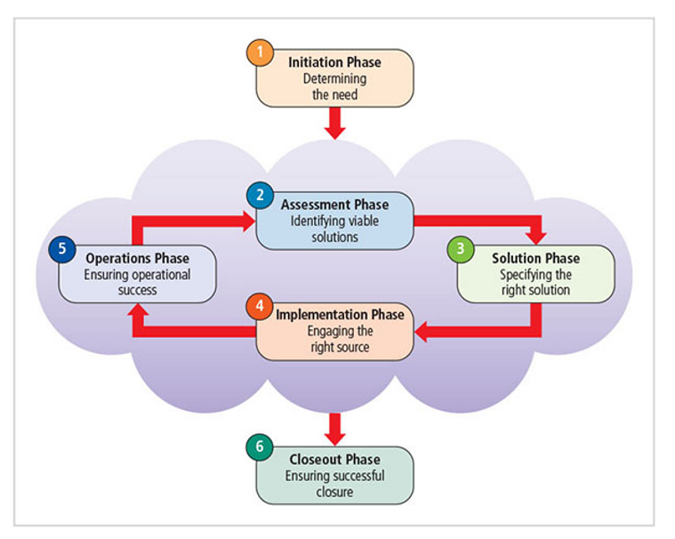

Digital Forensics
Figure 3-34 The Digital Forensics Process
^{[4]}

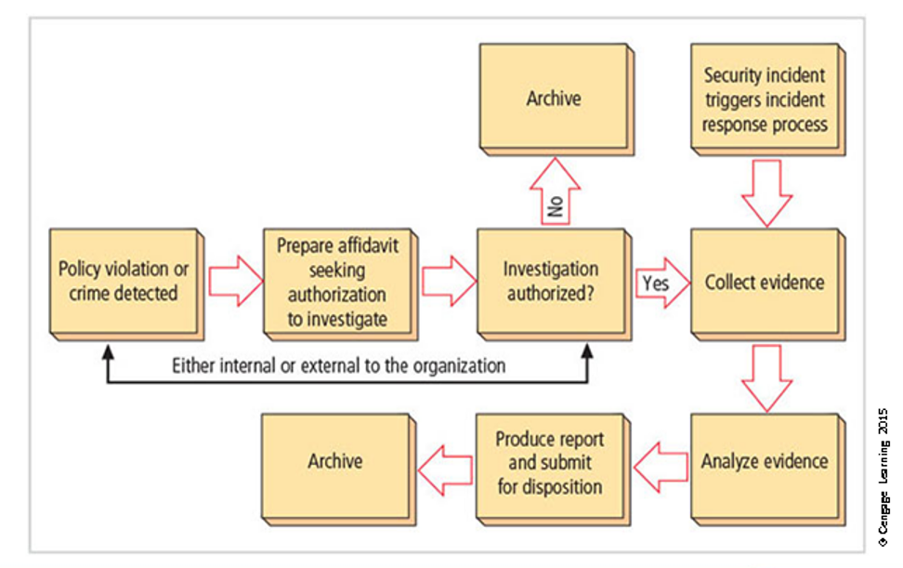
^{[15]} Digital forensics definition
“investigations that involve the preservation, identification, extraction, documentation, and interpretation of computer media for evidentiary and root cause analysis”

This process is implemented when an incident happens, and is instigated by an employee/other.
“It is used in business settings in investigations about an employee performing legal violations or breaking policy. Digital Forensics is also used to investigate any attacks on an information or tangible asset”

Actions -Protection Mechanisms – Information Security Maintenance
Table 3-61 ACTIONS - Protection Mechanisms - Information Security Maintenance
^{[4]}

Actions
Who Responsible | No. | For What
Information Security | 1 | Monitor Internal and External Environment to Evaluate Threats
Information Security | 2 | Analyse data to conduct Gap Analysis (areas needing improvement)
Information Security | 3 | Prioritize range of corrective measures and submit budget for resources
Information Security | 4 | Once budget approved incorporate corrective actions

Recommendations

3.7.1 The Need For Security
Vulnerability Discover/Network Changes

^{[16] [7]} System hardening utilizing Back Up plans/Sniffing Tools to record, analyse and circumvent cyberattacks.

- List vulnerabilities/detect attacks
- Safeguard information and record/prevent cyberattacks
- Design and detect attacks

For details see Appendix 6.1

Figure 3-35 The Network Before Changes Implemented
^{[7]}

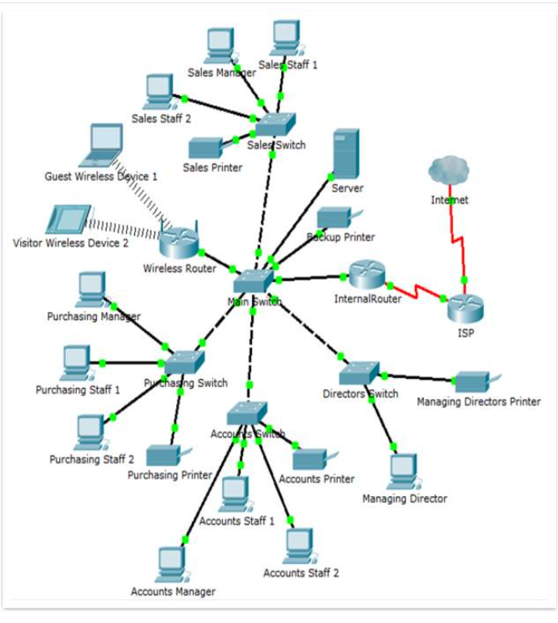
^{[17]} The following need to be implemented:
- Network – subnet partition
- Speed up and keep secure

- Threats and Vulnerabilities -Transform wireless to non-VLAN
- to avoid vulnerabilities

- Access Control and ID Management - Inter-VLAN routing used to separate different departments
- Eliminate waste of IP address and restrict access

- Application Data and Host Security – partition core system from wireless Firewall/Access Control List
    - Filtering traffic acts as barrier between network/ internet

- Security - Compliance and Operation
Use Back Up plans/ Sniffing Tools to record, analyse and prevent cyberattacks
    - Safeguard information and record/prevent cyberattacks

- Egress Filtering
- To see data leaving the network as well as entering

Figure 3-36 Logical Diagram of the Network After Changes Made
^{[7]}

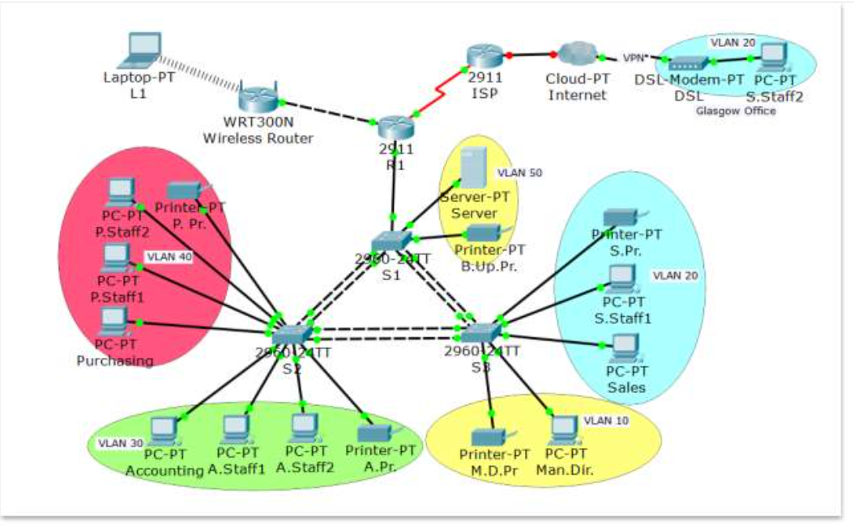

Compliance – Legal, Ethical and Professional Issues
- Law Breaches
- Matrix of Security Personnel Qualifications
Legal Department to:
- Keep online links to UK laws available for employees’ reference and in case of breaches
- Keep matrix of employees’ memberships up to date with Information from Information Security to ensure compliance when recruiting Information Security Staff

Planning for Security

3.7.3.1 Policies
- Mobile Use
- Ten Step Approach
See Appendix 6.2 for Mobile Use Terms and Conditions Policy to access the Company network.
^{[18]} The ten-step approach before changes implemented avoids adversely impacting other procedures.

Figure 3-38 The Ten-Step Approach
^{[17]}
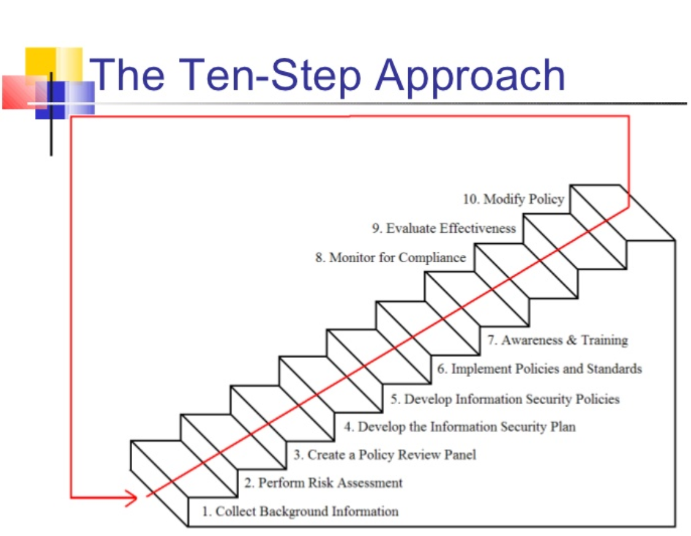

3.7.3.2 Governance and Security Planning
- Centralised Malware Matrix
Planning for Security – I.T. Department Manager to Keep Central Malware Matrix up to date to aid detection and resolution of problems.

3.7.3.3 Contingency Planning
- Uninterruptible Power Supply recommended.
- Lights Out Server Room recommended

^{[4]} Because the server room is a very sensitive area. The system takes air in filters and moves the air into section with a laser beam. If beam diverted/refracted by smoke, the alarm activates.

A key element is fire suppressor.
Clean agents don't leave any residue or interfere with the operation of electrical or electronic equipment.
  - FM-200, Inergen,
  - Carbon Dioxide,
  - FE-13

Risk Management
Policies
^{[4]} Human Resources responsible for the policies of education and training programs, and technologies that protect information. Maintenance needed to ensure still effective. Information Security to advise.

All Departments are responsible evaluation of current/proposed risk controls.

Information Security to oversee:
- Cost effective control options
- acquiring and installing controls
- evaluating current and proposed risk controls.

3.7.5 Organisation Structure – Security and Personnel
- Staff Training
Will be implemented to bi-yearly and to new starters within first month of employment
- ^{[4]} aid awareness of social engineering and keeping personal information safe.
- Keep staff up to date with any changes in procedures/policy

3.7.6 Protection Mechanisms – Information Security Maintenance
- ^{[4]} Monitor Internal and External Environment to Evaluate Threats
- Analyse data to conduct Gap Analysis (areas needing improvement)
- Prioritize range of corrective measures and submit budget for resource
- Once budget approved incorporate corrective actions

CONCLUSION

Task 1 Security and Personnel
^{[4]}
Summary

1 | Personnel Information Security Training
- It is imperative Organizations invest in the training of their employees to avoid data breaches.
- Intelligent failures enable organizations to learn by testing processes without blaming employees.
- This enables employees to alert management when processes result in data leakage
2 | Information Security Organization Structure
 | The information security function is spread across each department of the organization structure.
3 | Positions in Information Security
 | CISO and CIO in Information Security deal with staffing concerns and all issues in Information Security
4 | Information Security Professionals
- Business over technology
- Speak to users (not at them)
- Education never complete
- Protect organization’s information
- Source problem then determine factors involved
- Be heard not seen
5 | Critical Conditions when Dismissing an Employee
 | Treat all leavers as hostile terminations.
6 | How Considerations for Temporary/Contract Employees Differ
 | Special security precautions need to be taken for non-employees
7 | Job Descriptions for Hiring Information Security Professionals
- Clearly defined job descriptions are useful, both on the job and when hiring personnel, and helps to increase professionalism in the field.
- Information Security Practices involve:
- Keeping (confidential) Records
- Separation of Duties
- Job Task/Rotation
- Principle of Least Privilege
8 | Information Security Career Path
The top is CISO – Chief Information Security Officer or Chief Security Officer and below this:
- Security Manager/Analyst (CIO)
Other routes are through:
- IT/Physical Security /Administrative Services

4.2 Task 2 Case Scenario Flow-Tech Threat Intelligence Co.
^{[4] [7]} ACTIONS OVERVIEW
Information Security
Legal
Human Resources
All Employees

Department Responsible | No. | For What
- The Need for Security
Information Security | 1 | Actions in red on 3.1.3 Overview of Security
Information Security | 2 | Vulnerability Discovery Testing - see 3.7.1 and Appendix 6.1
Information Security | 3 | Logical Diagram of Network Before /After Hardening Network (as above)
Functional Team | 4 | To liaise with Information Security to Achieve the above
- Compliance – Legal, Ethical and Professional Issues
Legal | 5 | Examine evidence if Information Systems Law breach suspected
Legal to check InfoSec Credentials  Information Security to keep Updated | 6 | Refer to Matrix of Security Personnel Qualifications to ensure compliance when recruiting Security Staff
- Planning for Security/Contingencies
Information Security to write  Human Resources to enforce | 7 | Policy  Mobile: Terms and Conditions for use of mobile devices to access the company network are outlined in Appendix 6.2.
Information Security | 8 | Governance and Security Planning  Update Centralised Malware Matrix and Troubleshoot
Information Security | 9 | Contingency Planning  - Uninterruptible Power Supply  - Lights Out Server Room
- Risk Management
Human Resources to maintain  Information Security to advise | 10 | All Policies – Maintenance/Administration of all Education and Training programs, and technologies that protect to ensure still effective.
Information Security to liaise with all | 11 | Evaluating current and proposed risk controls
Information Security to oversee: | 12 | Determining cost effective control options
 | 13 | Acquiring or installing the needed controls
 | 14 | Ensuring that the controls remain effective
 | 15 | Evaluating current and proposed risk controls
- Organisation Structure – Security and Personnel
Information Security | 16 | Provide training for staff to avoid them falling prey to phishing/hackers and keep them up to date with policy changes  - Bi yearly  - All new starters within first month of employment
Information Security write /  Human Resources enforce | 17 | Ensure Mobile Anti-Virus policy signed by all
Information Security Action  All Employees to report | 18 | A Matrix of all viruses/attacks to be kept by I.S. reported in by all Employees.  - A culture of blame-free reporting of malware is to be engendered to encourage the matrix of viruses to be kept current to spearhead hacking attacks.
Human Resources | 19 | Recruit CIO Security Analyst to assist CISO
- Protection Mechanisms – Information Security Maintenance
Information Security | 20 | Monitor Internal and External Environment to Evaluate Threats
Information Security | 21 | Analyse data to conduct Gap Analysis (areas needing improvement)
Information Security | 22 | Prioritize range of corrective measures and submit budget for resources
Information Security | 23 | Once budget approved incorporate corrective actions

WORD COUNT
Task 1 | 1538
Task 2 | 4189
Main Report Sub Total | 5727
Figs Task 1 | 29
Tables Task 1 | 47
Sub Total | 76
Figs Task 2 | 385
Tables Task 2 | 620
Figs and Tables Total | 1005
Subtract all Figs & Tables Total | 1081
Net TOTAL | 4646
Words Left | 354
Allowable Overshoot | 500

REFERENCES
[1] | Software Binary System 1 – Free image on Pixabay, 2014 [Online] Available: https//Software Binary System 1 - Free image on Pixabay [Accessed 11 Nov 2021]
[2] | J. Guimaraes, "Information Security Awareness: Learning for Effectiveness." Order No. 28720178, St. Thomas University, Ann Arbor, 2021.
[3] | G. Desolda, L. S. Ferro, A. Marrella, T. Catarci, and M. F. Costabile, “Human Factors in Phishing Attacks: A Systematic Literature Review,” ACM computing surveys, vol. 54, no. 8, pp. 1–35, 2022, doi: 10.1145/3469886.
[4] | H. J. Mattord and M. E. Whitman, Principles of information security, 4. ed., international ed. Boston, Mass: Course Technology, 2012
[5] | J. Gaia et al, "Dark Traits and Hacking Potential," Journal of Organizational Psychology, vol. 21, (3), pp. 23-46, 2021. Available: https://www.proquest.com/scholarly-journals/dark-traits-hacking-potential/docview/2551250501/se-2?accountid=130472 [Accessed 11 Nov 2021]
[6] | R. L. Chow, “Leveraging Publicly Available Data and Prediction Models to Minimize Future Cyber Vulnerabilities During COTS-Based System Design,” ProQuest Dissertations Publishing, 2021.
[7] | “Security Procedures for a Small Computer Network” Accessed 11 Nov 2021 [Online] Available:https//Security Procedures for a Small Computer Network (ukdiss.com) [Accessed 11 Nov 2021]
[8] | “Components of an Information System – MBA Knowledge Base (mbaknol.com)” [Online} Available:https://Components of an Information System - MBA Knowledge Base (mbaknol.com) [Accessed 11 Nov 2021
[9] | “What is DevOps? DevOps explained” [Online] Available: https:// What is DevOps? DevOps explained | Microsoft Azure [Accessed 11 Nov 2021]
[10] | “What benefit can a private, for-profit agency derive from…ask2 (quesba.com)” [Online] Available: https//What benefit can a private, for-profit agency derive from... ask 2 (quesba.com) [Accessed 11 Nov 2021]
[11] | “cs3.uwsuper.ed/mgonnord/CH9 htm” [Online] Available: http://cs3.uwsuper.edu/mgonnord/CH9.htm [Accessed 11 Nov 2021]
[12] | D.L. Pipkin, “D.L. Pipkin’s Three Broad Categories of Incident Indicators – Running head D.L. Pipkin’s Three Broad Categories of Incident Indicators1 D.L. Pkpkin’s Course Hero” [Online] Available:https//D.L. Pkpkin's Three Broad Categories of Incident Indicators - Running head D.L.PIPKIN'S THREE BROAD CATEGORIES OF INCIDENT INDICATORS1 D.L Pkpkin's | Course Hero [Accessed 11 Nov, 2021]
[13] | My Assignment Tutor “assets for risk management” [Online] Available https:// assets for risk management – My Assignment Tutor [Accessed 11 Nov 2021]
[14] | Business Analyst Learnings “An Introduction to Cost-Benefit Analysis” [Online] Available: https//An Introduction To Cost-Benefit Analysis — Business Analyst Learnings [Accessed 11 Nov 2021]
[15] | Quizlet “CSC-303 Chapter 12 Flashcards” [Online] Available: https//CSC-303 Chapter 12 Flashcards | Quizlet [Accessed 11 Nov 2021]
[16] | T. King (2006, Jun/Jul) “Packet Sniffing in a Switched Environment. Sans Institute” [Online] Available: Packet Sniffing In a Switched Environment | SANS Institute  [Accessed: 11 Nov 2021]
[17] | A. Moesriami. (2012, Oct 10). Institute of International Finance. Information Security Policies and Standards “The Ten Step Approach” [Online] Available:  information-security-policies-and-standards-13-728.jpg (728×546) (slidesharecdn.com)  [Accessed: 11 Nov 2021]
[18] | Ntiva (2020) “Sample Bring your own Device Policy” [Online] Available:  Ntiva Sample BYOD Policy  [Accessed 22 Nov 2021]
[19] | AGJ Systems (2014, Sept 4) “AGJ Sample Mobile Device Policy” [Online]  AGJ-Sample-Mobile-Device-Policy.pdf (d2oc0ihd6a5bt.cloudfront.net)  [Accessed: 11 Nov 2021]

APPENDICES

Hardening

^{[16]} Threats are mainly from internal sources so changing to a switched environment adds more security.

Figure 6-1 - D-Sniffing in Non-Switched Environment (plaintext protocols)
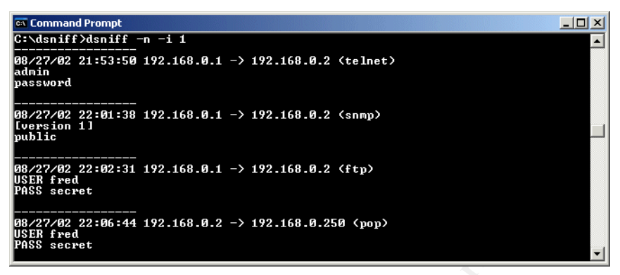
Eavesdrops on traffic, by putting network card in in ‘promiscuous’ mode enabling sight of traffic entering and leaving, to see passwords etc. ‘Dsnif’ and ‘Scoop LM’ two tools used.

Figure 6-2 - Scoop LM Tool Sniffing NT Usernames and Encrypted Passwords
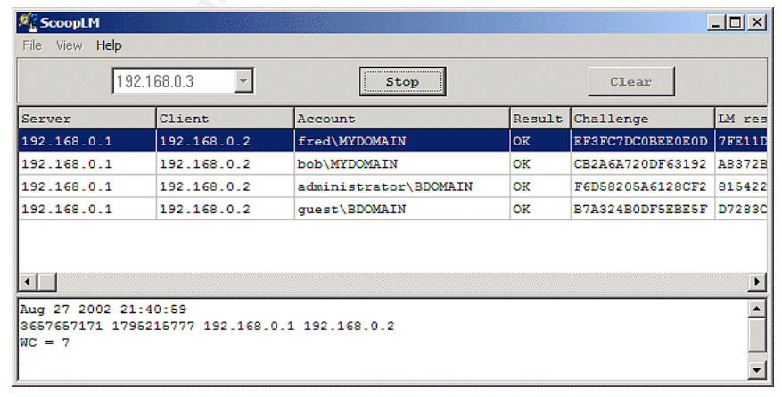

- runs Scoop LM,
- sniffs NT usernames and
- encrypted passwords.

Sniffed materials are:

- saved to temp file,
- loaded onto Beat LM ready for cracking.

Figure 6-3 Three Machines Connected by a Switch
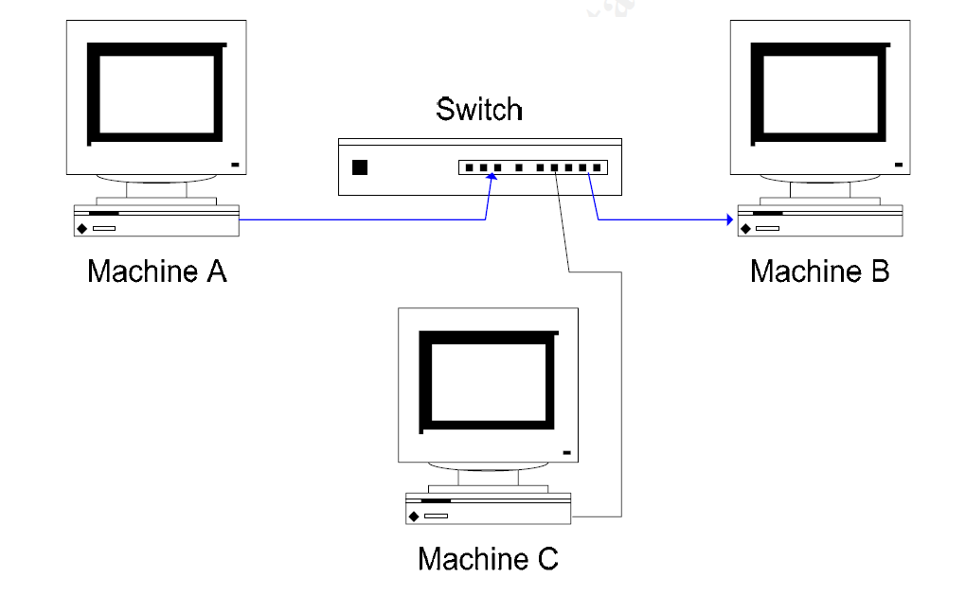

Follow arrows to see data flow
- Machine ‘C’ is blind to the network traffic between ‘A’ and ‘B’.
- Switch ensures traffic avoids unnecessary ports; it only uses ports ‘A’ and ‘B’ connected to.
- However, there are ways of subverting this enabling ‘C’ to snoop on ‘A’ and ‘B’.

Sniffing in Switched
Figure 6-4 A Man-in-the-Middle Attack
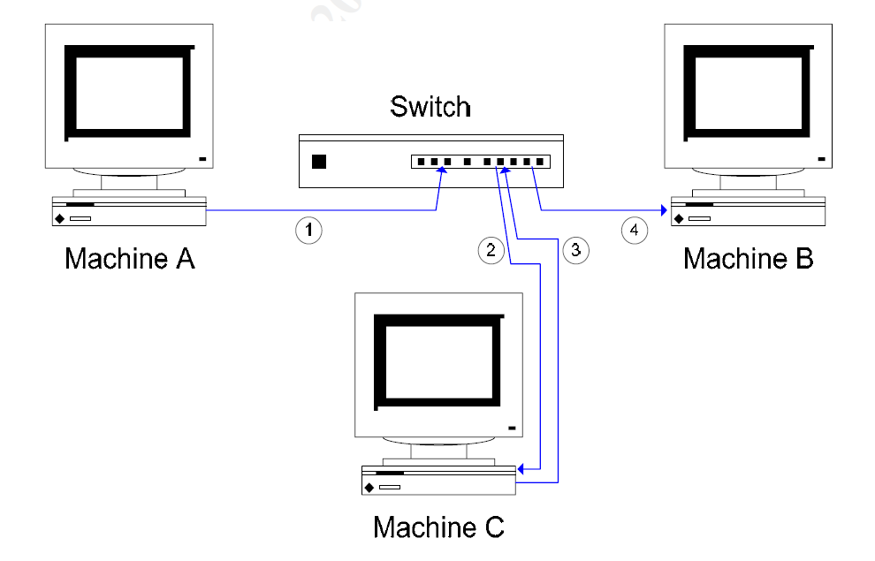
Snooping Techniques:

- ARP spoofing
- Flooding/duplication MAC
- Redirection of ICMP
- Spoofing DHCP
- Stealing Port

If ‘C’ wants to snoop on ‘A’ and ‘B’;

- ‘C’ poses as ‘B’ to ‘A’
- When ‘A’ sends data meant for ‘B’, it gets diverted to ‘C’.
- ‘C’ sends this information to ‘B’, pretending it came from ‘A’.
- ‘C’ also performs same for data from ‘B’, meant for ‘A’.

Figure 6-5 Machine A's ARP Cache Before C Sends Spoof ARP Packet
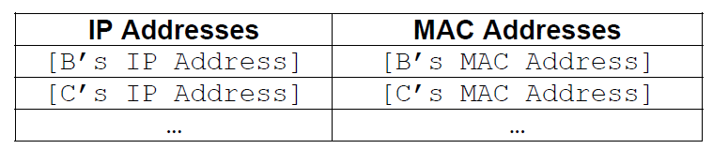
To enact ARP spoof, it is needed to know how ‘A’ and ‘B’ communicate. ‘A’ requires ‘B’s MAC address so:

    - ‘A’ checks its ARP cache to see if already has ‘B’s MAC address. If so, will use this, taking from ARP cache.

    - If not, ‘A’ broadcasts ARP request after this. ‘B’ responds with their MAC/IP address. ‘B’s IP/MAC address now filed in ‘A’s ARP cache, to use in future.

- ‘A’ can now send packets of data to ‘B’.
- For B to communicate with A, a similar process will take place.

A and B establish one another’s MAC addresses and send data through a switch: ‘C’ can snoop utilizing ARP spoof.

‘C’ pretends to ‘A’ it is ‘B’.

- network traffic to for ‘B’ re-routes to ‘C’.
- similarly, ‘C’ has to pose as ‘A’ in front of ‘B’.
- ‘C’ “infects” ARP cache for both ‘A’ and ‘B’.

This is easy because:

ARP is a stateless protocol not needing authentication, therefore ARP replay packet sent to hosts forces updates in the ARP cache.

- ‘C’ sent spoofed ARP packet to ‘A’, telling ‘A’ to forward packets meant for ‘B’ onto ‘C’.

- This spoofed ARP packet ‘C’ sent makes ‘A’ update own ARP cache.

- Now ‘A’s ARP cache updates it maps B’s IP address to ‘C’s MAC address.

- Thus, future messages from ‘A’ to’ B’ now re-routed via ‘C’.

Figure 6-6 Machine A's ARP Cache After C Sends Spoof ARP Packet
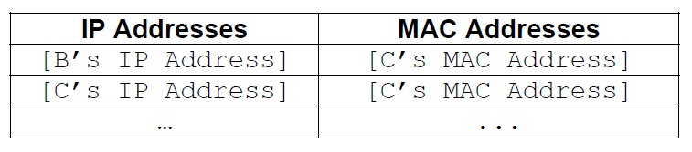
‘C’ acts like its B:

- by forwarding spoof ARP packets to ‘B’, instructing ‘B’ update ARP cache; ‘A’s IP address is mapped onto ‘C’s MAC address.

so:

- Packets ‘A’ sends to’ B’ are diverted to ‘C’.
- Packets ‘B’ sends to ‘A’ are diverted to ‘C’ as well.

Computer ‘C’ also ensures traffic it gets forwarded to its true receiver.

When ‘A’ forwards data meant for ‘B’, it is seen by ‘C’, but then forwarded to from ‘C’ on to ‘B’.

IP forwarding/application forwards data to the real recipient.

‘C’ intercepts data between ‘A’ and ‘B’. “Re-infecting” ARP Cache. The hacker needs to keep doing this to “re-infect” ARP cache because operating systems refresh ARP caches frequently (typically every 30 seconds).

IP Address/MAC Address Summary
Figure 6-7 Summary of the Setup of Machines on Isolated Network
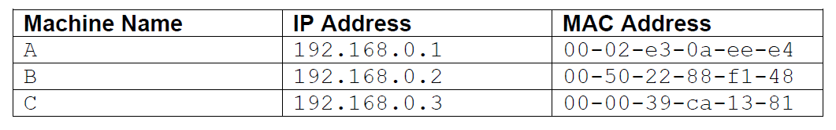

Figure 6-8 ARP Cache - Ettercap Man-in-the-Middle Tool

‘A’ prior
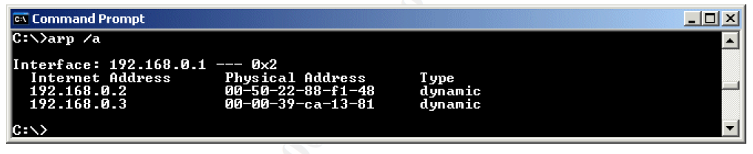
‘B’ prior
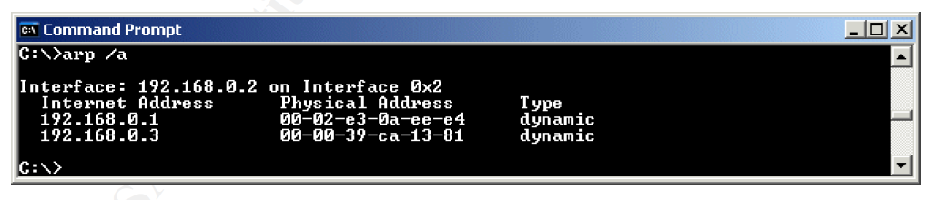
‘A’ post
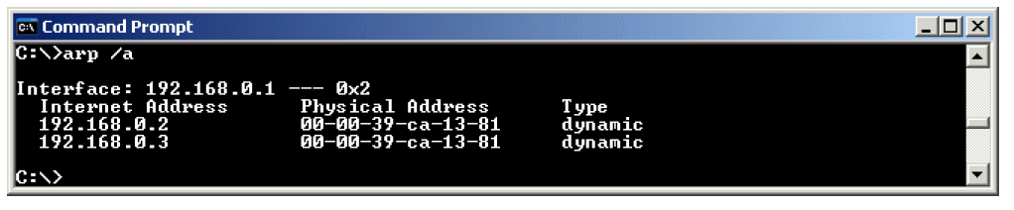
‘B’ post
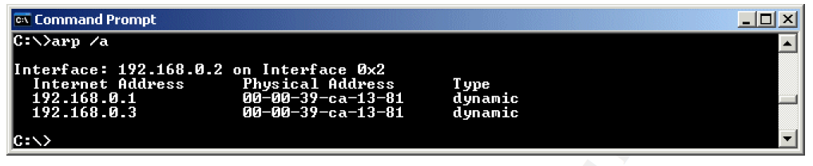

sniffing telnet ‘A’ and ‘B’
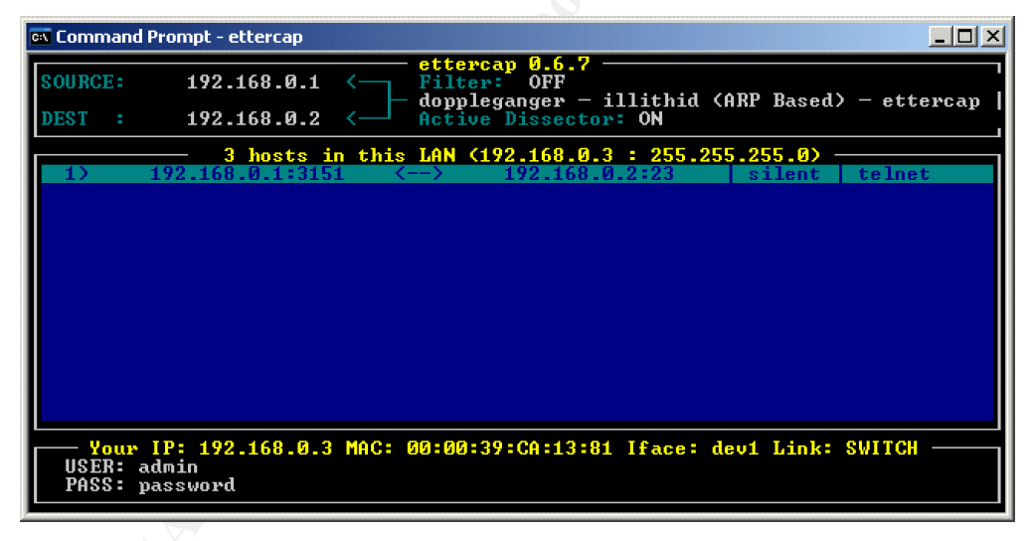
Cain ARP spoof to capture information passing between ‘A’ and ‘B’

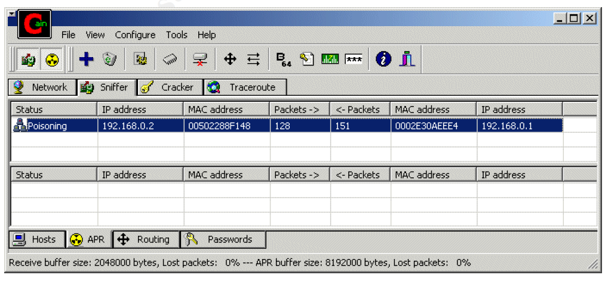

Detection of vulnerabilities of plain texts

  - ‘smtp’,
  - ‘pop3’,
  - ‘snmp’,
  - ‘ftp’,
  - ‘telnet’
  - ‘http’.

The most well-known encrypted protocol, vulnerable to attacks, is Microsoft’s LM (LAN Manager), to authenticate Windows clients.

NTLM better but still susceptible.

Encryption
The most viable solution to safeguard against packet sniffing is encryption.

It is inadvisable to let proprietary insecure app protocols or legacy cleartext on the network. Insecure ‘tellnet’ is not a good replacement for encrypted counterpart such as ‘ssh’ which stops eavesdropping. However, replacing all insecure protocols is extremely challenging.

A possible solution is to use ‘IPSec’ and by encrypting this, using plaintext still possible, so older protocols remain unaffected.

Policies – Use of Mobile Devices to Access Co. Network

^{[18]} Steps the Company and its Employees Need to follow when Connecting Personal Devices to the Company Network
The ‘bring your own device’ policy streamlines IT by allowing employees to connect their devices:
- Laptops
- Smartphones
- Tablets
to company resources.
Without stringent security practices these can become a risk; even more so when working from non-office locations.
Guidelines are given on what can/cannot be accessed via these devices.
Also, the steps to be implemented in the event of theft/loss of the device and/ or termination of employment are also specified.
Purpose: The policy outlines steps to follow on connection of personal devices to the company network. This protects data from unauthorized access/misuse.
Scope: Full-time and part-time employees, contractors, consultants, temps and all other personnel given access to the network.
What BYOD Includes:
- Desktops/laptops/tablets
- Smartphones
- Memory Drives/External HDD
- Ipods/iTouch/Watches/VR headsets/Augmented reality Glasses with WiFi Bluetooth
BYOD Policy Guidelines:
Whenever a device connects to the network it could:
- Introduce spyware/viruses
- Copy confidential information
- Introduce incompatible elements
- Lose data that would harm the company if in wrong hands

As a result of the above the network could incur unplanned downtime/data breaches. Worst case civil/criminal penalties for the user incurring huge costs.

IT Department Responsibilities

IT will ensure:
- Device does not have Static IP address that could introduce incompatibilities with network.
- No viruses, spyware or malware infection.
- No 3rd party software/applications that could pose a threat to the network.
- Device properly protected against above.
- Security to enforce password/biometric policy that locks device after 1 minute of inactivity and wipes content after 10 failed authentication attempts and wipes in event of loss/theft.
- Has critical security patches installed.
- Is properly encrypted if has potential to save company data.
- Is properly configured to access resources remotely.
- When decommissioned IT will remove encryption, VPN and anti-malware licensing and does not contain any protected, sensitive corporate, or proprietary information.
- IT reserves the right to remotely wipe device if lost/employee terminated and has not brought device in for decommissioning.
User Responsibilities:
- User should not disable security settings put on by IT.
- User should consult device manufacturer before asking IT for support.
- If user suspects malware infection they must immediately notify the IT .
- If user loses device they must immediately notify IT.
- Whenever user decommissions or returns device that has been authorized for co. use user must notify IT .
The link for the policy is below:
Ntiva Sample BYOD Policy
Please sign and return to IT.

