Figure 1 - The Agile Development Process  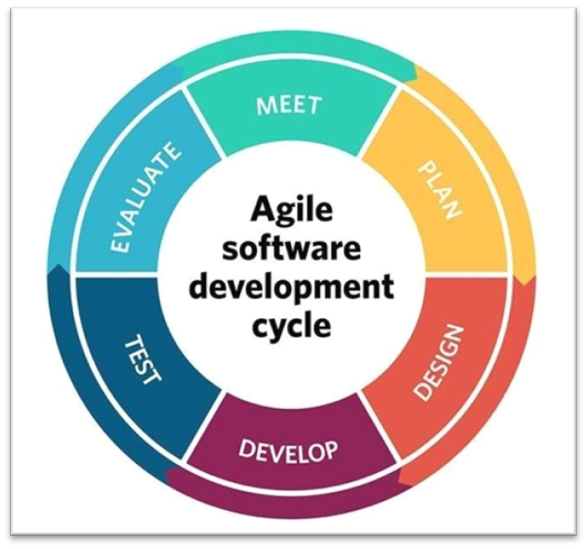  ACCA6027 – Software Engineering Principles and Practice | Abstract  Within the software development arena, the Agile development methodology is widely used. This report looks to explain the methodology and the benefits of using it, whilst completing the development of a game using this methodology.  Mark Huntly - 1809693  BSc Applied Computing (Web Development)

Table of Contents
1.0 Introduction 1
2.0 Agile Software Development 1
2.1 Software Design 1
2.1.1 Collaborative Design 1
2.1.2 Evaluation of the process 2
2.1.3 User Stories 2
2.1.4 Evaluation of the User Stories 3
2.1.5 Unified Modelling Language (UML) 4
2.1.6 Class Responsibility Collaborator (CRC) Card Design Approach 4
2.1.7 Evaluation of CRC Cards 5
2.1.8 Acceptance Criteria 6
2.1.9 Sequence and Wireframe Diagrams 6
2.2 Software Testing 7
2.2.1 Unit Testing 7
2.2.2 Test Driven Development (TDD) 8
2.2.3 Black Box Testing 8
2.2.4 White Box Testing 9
2.2.5 Testable Code 9
2.3 Version Control 10
2.3.1 Git 10
3.0 Conclusion 11
References 13
Appendix 15
Appendix 1 Planning Overview – Full Miro Board 15
Appendix 2 Planning Notes – Primary Goal 16
Appendix 3 Activities, Tasks and User Stories 17
Appendix 4 CRC Cards 19
Appendix 5 Sequence Diagram 20
Appendix 6 Wire Frame Diagrams 21
Appendix 7 Code Examples for Classes 22
Main Program 22
Player Class 22
Grid Class 25
Game Class 27
Counter Class 29
Appendix 8 XUnit Testing 31
Appendix 9 Full cycle of committing a class to a branch 32
Git Log 34
Appendix 10 Collaborative Agile meeting notes 35

1.0 Introduction
Emerson Taymor, author of the Agile Handbook, claims that the Agile methodology is a way to manage projects, specifically founded in software development. [1] It is growing in popularity as an alternative to the waterfall or spiral development methodology and is an iterative approach to development with a focus on producing a minimum viable product at the start followed by version-controlled release iterations thereafter. Within this report, the Agile development methodology will be discussed and broken down into a step-by-step process. Having been tasked to develop an application using elements from this methodology, the report will evaluate the result.
Testing is an important aspect to the process of software development also. Within this report, software unit testing will be discussed with examples of unit tests on written code to demonstrate.

2.0 Agile Software Development
The Agile philosophy is to put individual people and interactions over processes and tools and to offer working software over comprehensive documentation. The focus is on collaboration between client and developers to deliver this. This is shown through the Agile manifesto where the first principle is
“Our highest priority is to satisfy the customer through early and continuous delivery of valuable software.”
Which flows seamlessly into the third principle which is to
“Deliver working software frequently, from a couple of weeks to a couple of months, with a preference to the shorter timescale.” [2]
Whilst these are only two of the twelve principles of the manifesto, it demonstrates the collaborative and iterative nature of this methodology in order to prioritise working software delivered at the highest possible frequency.
As a result of this philosophy, Taymor suggests some of the advantages to this methodology to include:
- It is quick to market –
- There is flexibility –
- Risks are managed better –
- Better cost control –
- Tighter quality control –
[1]
For this assignment, elements of the Agile methodology have been used to design and plan the game of connect four as the task set out.

2.1 Software Design
There was collaboration and discussion around all the above points in order to establish a minimum viable product design to be developed. The rest of the work is carried out individually as per the brief. The evaluation of the design will be analysed.

2.1.1 Collaborative Design
The initial planning and design, as per the Agile philosophy, was discussed as a group of four in collaboration. This followed a step-by-step process.
- Work out the primary goal – The first step is to define the product and work out what it does. In this instance, quite simply, the primary goal of the app was to allow two players to play a game of connect four on a web application.
- Work out the main flow through activities – Discuss and list the top-line activities to define the process through the game. These activities give the flow through the application. This allows a framework for the architecture of the application to be developed.
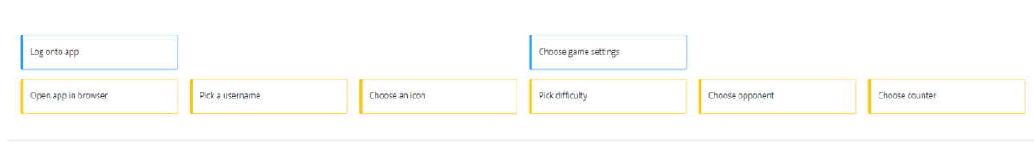
Figure 2 - Example of the tasks (in blue)
- Add tasks to the activities – Discuss and build a task list for each activity, ensuring the use of short verb phrases, and creating a flow between tasks. These help to give the flow to facilitate the tasks. They add substance to the task, building the functionality and architecture of the application by layer. This follows a story line, as each activity follows on from the last, enabling the use of the word ‘then’ between each activity.
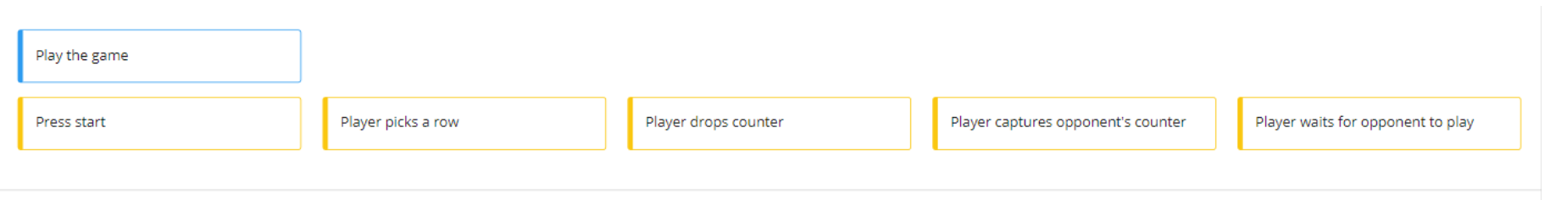
Figure 3 - Example of the activities (in yellow)
- Question each task – Create a discussion where each task listed is questioned and investigated to draw out the verbs in view of creating the user stories. As per the Agile principles, nothing is off the table and this involves everyone’s opinions within the group.
- Define User Stories – Create user stories for each task, through discussion creating an order from high necessity to low. These elaborate on the story line, building additional layers to the application architecture. These are discussed in more detail within section 2.1.2.
- Define the Minimum Viable Product (MVP) – Create minimum criteria for a working product as a first iteration. This is done in order to satisfy the first principle set out in the Agile Manifesto as discussed above [2] giving the customer a working and satisfactory product that is quick to market and allowing enhancements throughout the iterations.
- Produce Class Responsibility Collaborator (CRC) cards – In order to design an object-oriented program (OOP) as a product, CRC cards are produced to map the classes needed within the product.
- Sequence Diagrams – Create sequence diagrams to elaborate on the demonstration of the flow of the program through the product.
- Wire Frame Diagrams – These give a feel and design for the product to be developed.

2.1.2 Evaluation of the process
The process undertaken was a good process, and interesting seeing how one step led into the other, and each individual step helped visualise the following one. It is easy to see why this methodology is replacing the waterfall methodology in most cases as the development process as, for the reasons discussed in section 2.0.0, it is the quicker and more flexible method of getting product to market. The reason it is stated “in most cases” is that in the case of some products, it will be essential to have a flawless, fully functioning product. Take for example a bank application. In general, the minimum viable product (MVP), due to security and functionality, will need to be completed and tested fully before release. For this reason, the waterfall approach may be more advantageous as it is developed and tested until ready, and only released then. But for the most, being able to release quick with a MVP, where communication and collaboration in order to develop the ideas and apply version control, to be discussed in section 2.3, to release iteratively when upgrades have been made ensuring test driven development is conducted, to be discussed in 2.2, is a huge advantage to a fast paced, ever changing environment.

2.1.3 User Stories
User stories are a short, or brief. The aim of the user stories is to describe the features to the tasks listed, from the perspective of the user, or from the person requiring the capability. This builds on the design of the architecture through the tasks and activities, and are a requirement artifact, allowing a structure for the methods to be extrapolated for the design of the product. User stories are often very low tech, frequently being written on index cards, to build the picture of how the classes will be constructed and related for the Object-oriented Analysis and Design Approach for Requirements Engineering (OOADARE). [3]
These have a set format within the framework that are structured as follows:
“As a [type of user] I want to / would like to [perform an activity] so that I can [complete an action].”
In this structure, the user is the person, or system taking the action or receiving the results. The activity is the action that is performed by the system or product. Here it is also recommended by Zeaaraoui et al [3] to include the object or entity on which the action will be applied. The action to be completed is the feature given back to the user through their action.
As an example of this from the user stories for this assignment, the need for a player, as the user of the product, to be able to choose a row so they can drop the counter would be interpreted as follows:
“As a player I want to choose a row from 0-6 so that I can drop my counter in that row.”
One of the purposes these stories serve is to bridge the communication gap between the customer / user and the developer / programmers to help build an understanding between them.
There can be any number of user stories for a particular task. They are then prioritised in order of necessity. This enables the ability to define a minimum viable product (MVP) to produce the initial program release and the first iteration. [1] [3]
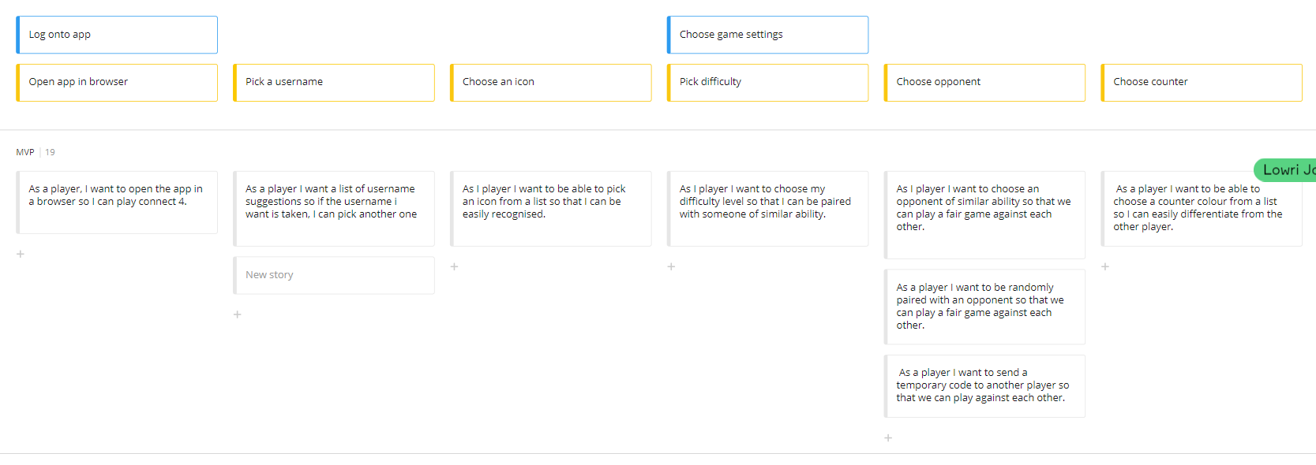
Figure 4 - Example of user stories (in grey)

2.1.4 Evaluation of the User Stories
The user stories produced within the design, as shown in the appendix, as well as the examples in figure four, were able to give insight into the design of the object orientated product in as much as it formed the verbs to develop the actions, or methods of the class, and the nouns to develop the classes or objects needed. These made it easy to extrapolate the classes and methods to create the collaborations and responsibilities as well as the classes, to enable the design of the full object orientated product. From the activities as a group, it is easy to see how these enhance the communication both between the members of the group, and how it would help between the developers, programmers and clients or any actor within the process.
Evaluating the group’s work, there are things done well, and things that could have been done better. Using an example from the above,
“As a player, I want to be able to choose my difficulty level so that I can be paired with a player of similar ability”
Things completed well were:
- The user stories were short and snappy, and followed the agile development methodology model.
- The stories flowed in an order, following the tasks, which in turn followed the activities.
- The design was wider than it was deep. This, in the group’s opinion, presented better storyboarding.
- There was sufficient information to take the development forward, and to produce the MVP in an object orientated manner.

The most prominent thing considered that could be done better is:
- More detail could have been added. Although this is a reasonably simple product, with limited functionality, the user stories were shallow. Although this was sufficient for the MVP, there could have been more depth in the stories to allow for more detail. This could have offered scope for potential future versions or iterations of the product. As an example of this, we could include player profiles in future releases, which would read as follows:

“As a player I would like to create a personal profile so that I am remembered and can save my status within the game.”

The process though, has a natural flow to the storyboarding and development of the product, and makes the design of the models easier as well as allowing good communication and collaboration between the team and actors within the development.

2.1.5 Unified Modelling Language (UML)
The UML was introduced in 1997 and is integral to the object orientated modelling process. This has evolved over the years and is now into its 2.x release. The models within UML are widely used by development professionals to communicate their work to stakeholders and actors within the project. [4]

2.1.6 Class Responsibility Collaborator (CRC) Card Design Approach
The CRC modelling process identifies user requirements through a low-tech method, grounded in UML. It is a simple to understand process that, as with the user stories, allows understanding between developers and users, allowing them to work closely together to understand the requirements. The model will be made up of a collection of these cards in order to represent the whole or a part of an application. A CRC card is divided into three sections.
- Class name – A class name is drawn from the user stories to perform the functions required within them. This is placed across the top of the card. The class allows a better understanding of the design of the objects within the product and relevant to it. As an example, in figure five there are four classes suggested for this project with the names:
  - Player
  - Game
  - Counter
  - Grid
These are the classes that will be represented in the program.
- Responsibilities – The responsibilities constitute what a class knows about or does. These are placed in the left-hand column of the card. As an example, using the cards created in figure five, the class named game has suggested responsibilities as follows:
  - Provide a list of icons for choosing
  - Display the grid
  - Display available opponents to play against
  - Provide difficulty levels
  - Start the game
  - Display win or lose messages
  - Finish the game
These can form the methods and structure the attributes of the class.
- Collaborators – In some cases, the classes will need gain information from, or use other classes to enable the responsibilities to be carried out. These are placed in the right-hand column of the card. As an example, the Game class in figure five needs the following classes to provide information in order to fulfil certain responsibilities:
  - Player class information to create the temporary player profile to start the game and display the list of icons for the player to choose and display a list of opponents available for the player to choose.
  - Grid class information and methods in order to display the grid for the game, to display win or lose messages and finish the game. As a side note, the Grid class in turn takes information from the Counter class to display the correct colour counter.
As a result, these are collaborators to the Game class. [5]
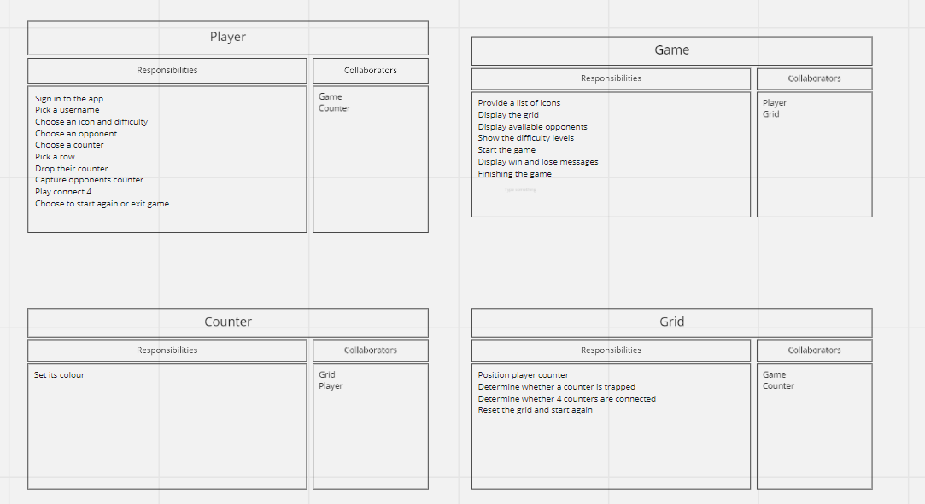
Figure 5 - example of CRC cards

2.1.7 Evaluation of CRC Cards
The CRC cards created by the group were in-line with the UML criteria and CRC card template. The information within them was easy to understand and well laid out. These cards made it easy to extrapolate the information to be able to program the object orientated application, some of which is shown as an example in figures six and seven. It was found however, when programming, slight alterations were needed to bring the application together. Experience of the process and within developing could have closed the gaps within the CRC cards.
There was some discussion between the group around these cards, and whether all the classes were needed, such as the Counter class. It was decided between the group to keep this class as it was good to separate the responsibilities to give higher cohesion. There is an argument for potentially breaking down the other classes however, the responsibilities form one purpose in general across each class.
Once again, on evaluation, the things done well were:
- Clarity of communication between the team with good discussion around what constitutes all the elements of the CRC card.
- Clarity of information provided within the CRC card, giving a reasonably comprehensive list of responsibilities.
And things that could have been done better are:
- Clearer understanding of the role the responsibilities play to make it even more comprehensive.
- Better linking between the collaborators to understand which classes will rely on which more.
The process was a very clear process and was very useful in helping to structure the elements and classes of the application. Clarity is given visually in a very easy format. [5] [6]
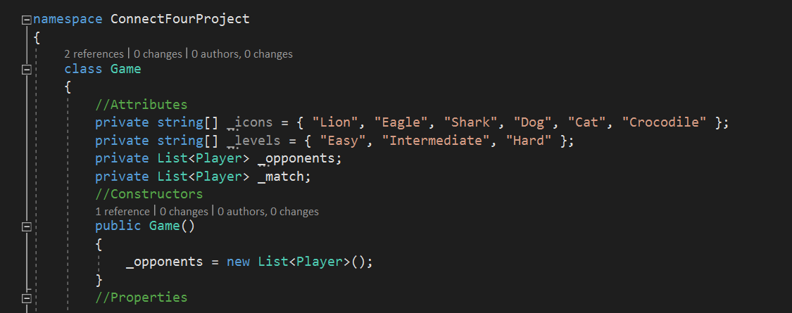
Figure 6 - Example of code for a class using CRC design
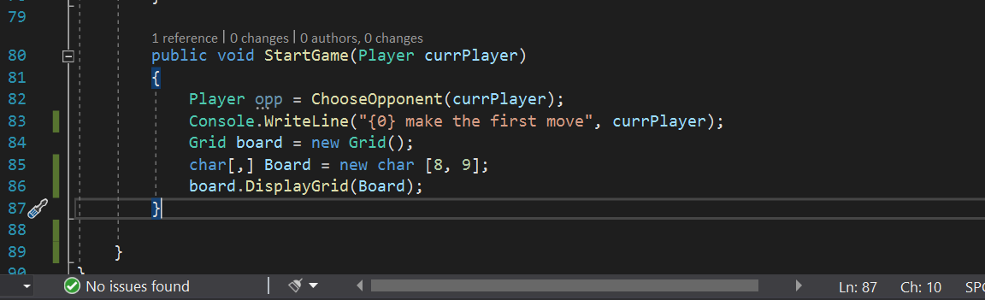
Figure 7 - Example of code for a responsibility using CRC design

2.1.8 Acceptance Criteria
At the start of the process, a scrum took place where an overview of the process was established, listing the primary goal of the application and listing acceptance criteria within the activities and tasks. This was then elaborated on within the user stories. It was felt in general though that the acceptance criteria, taken from the brief, was met with all the requirements listed within both the user stories and the CRC cards.
The importance of the acceptance criteria within the process is paramount. RubyGarage.org [7] maintain that three main reasons this is important are:
- Defining boundaries – This helps to confirm the desired application functions and showing when a user story is complete.
- Reaching a consensus – It removes ambiguity between the client and the development team. It clarifies conditions to be met by the client, equally it manages the expectations of the client.
- Providing a basis for testing – Knowing what is accepted as what is expected from the product, it provides a basis for testing, both negative and positive, checking if the product works as it should.
The last point is a crucial one, especially when building test driven development.

2.1.9 Sequence and Wireframe Diagrams
Using UML, sequence diagrams describe the dynamics of the application. The information can be extrapolated from the user stories, backlog and the CRC cards to display a two-dimensional diagram of time on the vertical dimension, and dynamic sequence on the horizontal dimension. On the vertical, time always flows from the top to bottom, running from each element or object along lines known as the lifelines. On the horizontal, lines run between the objects showing the interaction between them also known as messages. The spacing between the lines are irrelevant, only the order that they flow. Although it is normally considered an alternative to the CRC cards, it was found that by creating the CRC cards first, it enabled a better understanding of the classes for the flow. This enhances the modelling of the design to show the order of interactions, giving a good visual to help with programming the application. [8]
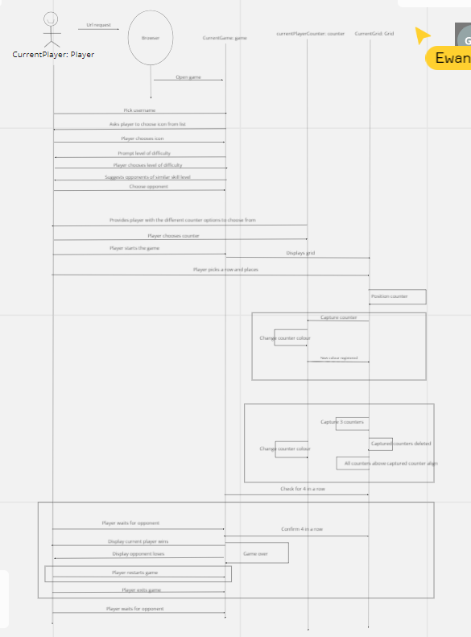
Figure 8 - Example of the sequence diagram
The wireframe diagram allows for a form of visual storyboard to aid in the design and development of the product. They are the link between conceptual structure, or architecture seen through the rest of the design process that has been discussed and the visual user interface, and even user experience design. It is easy to extrapolate the information for this from the user stories and enhances the clarity of understanding between the stakeholders. [9]
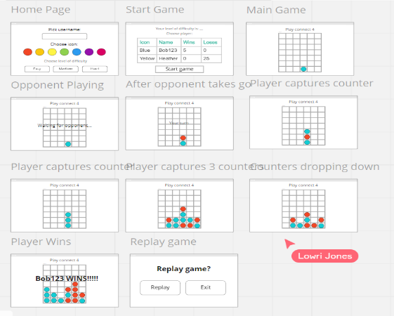
Figure 9 - Example of wireframing

2.2 Software Testing
Testing is a cornerstone to the software development lifecycle. It is purported to be the process of execution and evaluation of a system or program to find faults. This is done by activity aimed at the evaluation of an attribute or capability of the software to find that it meets software requirement. [10]

2.2.1 Unit Testing
Unit testing is important within object orientated programming. It is a method of testing an individual unit of code to compare the actual result with the expected, whether it be a class with multiple methods or a single method within a class. These produce tangible results that are verified automatically. [11]

2.2.2 Test Driven Development (TDD)

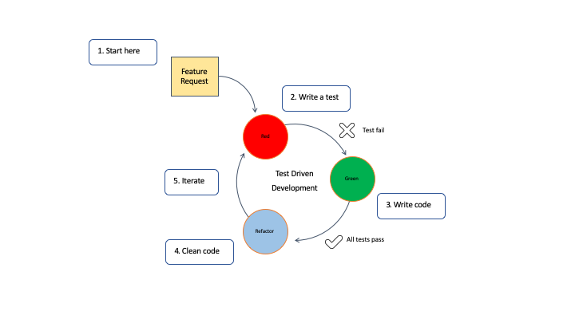
Figure 10 - Test driven development cycle [12]
TDD comprises unit tests into a cyclical development style or method which incorporates coding and testing in the form of writing the unit test first then writing the code to pass that test. [13]
As per figure eight, IBM propose a five-step approach to TDD:
- Read, understand, and process the features required.
- Transpose the requirement into a unit test. This will produce a failing test.
- Implement just enough code that fulfils the required feature. Run all tests and they should pass, if not repeat the step.
- Clean up and improve the structure of the code by refactoring.
- Repeat the cycle. [12]
Agile Alliance claim that, according to veteran practitioners,
“TDD leads to improved design qualities in the code, and more generally a higher level of ‘internal’ or technical quality, for instance improving the metrics of cohesion and coupling”. [13]
This is now considered a best practice within Agile methodology as by definition, Agile is iterative and quick to market so needs to produce clean working code for release at the earliest opportunity.

2.2.3 Black Box Testing
Also known as Behavioural testing or Specification-Based testing, black box testing method focuses on high level such as analysing the software functionality or behaviour, not knowing much about the internal structure or design of the code. It compares input values to output values. These include tests such as:
- Equivalence partitioning – dividing software unit input data into data partition enabling test cases to be derived.
- Boundary value analysis – testing at the extreme boundaries of values chosen.
- Fuzzing – using malformed data injection in an automated session to find implementation bugs.
- Cause – Effect graph – establishing the interdependency relationship between effects and their causes. The four basic symbol expressions being identity, negation, logic OR and logic AND.
- All pair – designing test cases to all possible discreet combinations of all paired input parameters.
- State transition – useful for testing the navigation of graphical user interfaces.
This method is done by testers based on the requirements criteria. [14]

2.2.4 White Box Testing
Also known as Structural testing or Glass Box testing, white box testing method is performed at the lower level and requires the knowledge of the internal structures, workings and logic of the source code in the application as this is what is investigated in detail. These include tests such as:
- Control flow – testing the program control flow as a model control flow. These favour simpler paths in greater numbers over complicated paths in fewer numbers.
- Branch – testing every control statement to test every option, true or false.
- Basis path – producing a logical complexity measure of procedural design as an approach for outlining a basic set of execution paths for testing.
- Data flow – testing and detailing how the program variables are defined and used.
- Loop – testing the validity of loop constructs. [15]
These tests ensure that:
- All independent paths within a unit are exercised.
- All logical decisions are verified on true and false values.
- All loops are executed within their operational bounds and internal data structures validity.
They also enable the discovery of logical error bugs within functions, design errors from the difference between the program’s logical flow and the implementation and syntax or typographical errors. These are generally tested by developers or testers with a programming knowledge. [16]

2.2.5 Testable Code
As a result of TDD, it could be argued that the code is developed in a testable way. For any development and testing method, it is crucial that the code is testable for quality assurance. To ensure that code is testable, it should be simple, understandable and transparent, it should also have high cohesion and be loosely coupled. This is explained better by Robert C Martin [17] within the following five principles:
- Single Responsibility – A class should only do one thing or hold one responsibility. Martin [17] describes the responsibility as a reason for the class to change and as a result, more than one responsibility could cause a conflict within the class when changing on that responsibilities axis, which becomes a consequence of higher coupling and lower cohesion. This of course depends on the responsibilities, as if the application does not cause the two responsibilities at different times, it is more simple and less complex to keep them within the one class. It is more testable, and easier to write tests for a class when it has one functionality.
- Open / Closed – The basis of this principle is that code is “open” for extension and “closed” for modification. The two attributes within this principle refer to existing code. When changing an application, it is far easier to write new code rather than having to go back over and change existing. The result of doing this could be less stable code due to the potential introduction of bugs into already working program functionality. The answer to this is encapsulation and abstraction. Using protected classes and dependencies from outside the class helps achieve this principle through polymorphism thus producing loose coupling between the classes.
- Liskov Substitution – This principle was written in 1988 by Barbara Liskov. The principle asserts that “Subtypes must be substitutable for their base types.” [17] In other words, a parent class does not need to know the behaviour of a child class as the child class behaviour should be the same as the parent class. It is important to keep the class hierarchies properly managed in this way so as not to violate the Liskov Substitution principle as well as the Open / Closed principle.

- Dependency Inversion – This principle asserts that “high-level modules should not depend on low level modules. Both should depend on abstractions.” and “Abstractions should not depend upon details. Details should depend on abstractions.” Put another way, within object orientated programming, higher-level classes that set the policies should not depend on the lower-level classes that handle implementation. When this happens, changes to lower-level classes will force changes to the higher-level policy makers thus potentially changing the identity of the application. The answer to this is to decouple the higher-level and lower-level classes through abstraction, using interfaces to communicate between them. This loose coupling is more testable.
- Interface Segregation – It is important that there are no ‘FAT’ classes. If these classes become too large, clients may implement methods they do not need to use or even need to know about. This also means that when one client makes a change, all other classes are affected. The way that this is resolved is to create client-specific interfaces, declaring only the methods invoked by its client. By inheriting the client-specific interfaces, it breaks down the dependence on methods that are not invoked, creating simplicity, high cohesion and loose coupling. [17]

2.3 Version Control
Simply put, version control records the changes to files, specifically software code, enabling a developer to recall specific versions. This allows the developer to revert code to previous states, whether that is a single file or class, or the entire project. It also allows the comparison of versions over time and the ability to see who last modified the code. This allows the ability to find what might be causing a problem and when the problem occurred or roll back to a version prior to the problem. Recovery is another advantage to version control, should you lose files. This has made version control an integral part of the developer’s arsenal of tools. The most popular system of choice is Git (gnu interactive tools). [18]

2.3.1 Git
By the above definition, Git provides integrity, as everything in Git is ‘checksummed’ using an SHA-1 hash before storing. Git will never overwrite, delete or change. It only adds to the versions saved.
There are three main stages that the files reside in. These are:
- Modified – the file has been changed within the working directory, also known as the working tree, but not yet committed to the database.
- Staged – a modified file is marked in its current version inside the ‘staging area’, a file within the Got directory, to go into the next commit snapshot.
- Committed – the data has been safely and permanently stored in the local database known as the Git repository.
The Git repository stores the metadata and object database for the project. The files are stored by the hash value of its contents rather than a filename, and referred to by the checksum, making it impossible to change the contents of any file. Git does not need to go to the server in order to get the history, it reads it from the local database. It can look up previous files and do a local difference calculation, giving instant feedback. This also means that developers can commit offline to the local copy and when there is a network connection, it will upload. [18]
For the above reasons, this makes Git version control essential for software developing, both individually and more so as part of a development team.
To conclude, it is agreed, “version control is a key tool in the software development process.” The advantages to using it are huge for both individual and team. It allows:
- Complete time stamped history of code development.
- Record of change to code, by who and when.
- Rollback if code becomes corrupt or lost.
- Better ability to trace bugs and fix problems through recording and comparing versions over time.
- The ability to collaborate through pulling and committing code for the team to access and contribute.
This benefits the process of code development and facilitates team input and collaboration making it a key tool.
A demonstration of the use of Git will be found in the appendix.

3.0 Conclusion
It is important as a developer to be aware of the full software development processes. Whilst waterfall and spiral have been prominent previously, Agile is fast becoming popular for object orientated development due to the flexible and iterative approach it takes with advantages being speed to market for a minimum viable project. This report incorporates all the development methods from an Agile approach, with UML at the heart of the communication and clear understanding. It is a clear way of collaborating within a team with one clear outcome and no ambiguity. It incorporates a test-driven development that helps with speed to market in the way object orientated code is written to succeed, ensuring all code is testable using the five Agile principles, known as SOLID principles. TDD is mainly possible due to the methodology of Agile, allowing a picture of the application development to be built first, giving knowledge of what features need to be tested. All this is backed up by version control tools such as Git to record progress and keep code. Example code written for examples of the development process as well as Git log demonstrations are shown in the appendix.

References

[1] | E. Taymor, Agile Handbook, New York: Philosophie.
[2] | M. Beedle, A. van Bennekum, A. Cockburn, W. Cunningham, M. Fowler, J. Highsmith, A. Hunt, R. Jeffries, J. Kern, B. Marick, R. C. Martin, K. Schwaber, J. Sutherland and D. Thomas, Manifesto for Agile Software Development (Agile Manifesto), Wasatch, Utah, 2001.
[3] | A. Zeaaraoui, Z. Bougroun, M. G. Belkasmi and B. Toumi, “User Stories Template for Object-Oriented Applications,” in Conference: Innovative Computing Technology (INTECH), Oujda, 2013.
[4] | S. W. Ambler, The Elements of UML 2.0 Style, Cambridge: Cambridge University Press, 2005.
[5] | S. W. Ambler, “CRC Modeling: Bridging the Communication Gap Between Developers and Users,” Ambysoft Inc., 29th November 1998. [Online]. Available: http://www.uml.org.cn/umlapplication/pdf/crcmodeling.pdf. [Accessed December 2020].
[6] | A. Raman and S. Tyszberowicz, “The EasyCRC Tool,” in the Second International Conference on Software Engineering Advances (ICSEA 2007), Cap Esterel, 2007.
[7] | Maryna Z, Dmitriy G, “Clear Acceptance Criteria for User Stories with Examples,” RubyGarage.org, 7th January 2020. [Online]. Available: https://rubygarage.org/blog/clear-acceptance-criteria-and-why-its-important. [Accessed 3rd January 2021].
[8] | T. Poranen, E. Makinen and J. Nummenmaa, “How To Draw a Sequence Diagram,” in Proceedings of the Eighth Symposium on Programming Languages and Software Tools (SPLST'03), Kuopio, 2003.
[9] | U. Ta, “Academia. edu,” [Online]. Available: www.academia.edu/24730465/The_Guide_to_Wireframing. [Accessed 2nd January 2021].
[10] | A. Lawanna, “The Theory of Software Testing,” Intelligent Transportation Systems Journal, vol. 16, no. 1, pp. 35 - 40, 2012.
[11] | M. Olan, “Unit Testing: Test Early, Test Often,” pp. 319 - 326, January 2003.
[12] | G. Steinfeld, “5 steps of test-driven development,” IBM, 7th February 2020. [Online]. Available: https://developer.ibm.com/devpractices/software-development/articles/5-steps-of-test-driven-development/. [Accessed 4th January 2021].
[13] | Agile Alliance, “TDD (Test Driven Development),” Agile Alliance, [Online]. Available: www.agilealliance.org/glossary/tdd/#q=~(infinite~false~filters~(postType~(~'page~'post~'aa_book~'aa_event_session~'aa_experience_report~'aa_glassary~'aa_research_paper~'aa_video)~tags~(~'tdd))~searchTerm~'~sort~false~sortDirection~'asc~page~1). [Accessed 4th January 2021].
[14] | “Black Box Testing: An In-depth Tutorial With Examples and Techniques,” Software Testing Help, 13th November 2020. [Online]. Available: www.softwaretestinghelp.com/black-box-testing/. [Accessed 4th January 2021].
[15] | M. Ehmer and F. Khan, “A Comparative Study of WHite Box, Black Box and Grey Box Testing Techniques,” International Journal of Advanced Computer Science and Applications, vol. 3, no. 6, pp. 6 - 15, June 2012.
[16] | “White Box Testing: A Complete Guide with Techniques, Examples and Tools,” Software Testing Help, 13th November 2020. [Online]. Available: www.softwaretestinghelp.com/white-box-testing-techniques-with-example/. [Accessed 4th January 2021].
[17] | R. C. Martin and M. Martin, Agile Principles, Patterns and Practices in C#, Prentice Hall, 2006.
[18] | S. Chacon and J. Long, “Getting started - About Version Control,” git-scm.

Appendix

Appendix 1 Planning Overview – Full Miro Board

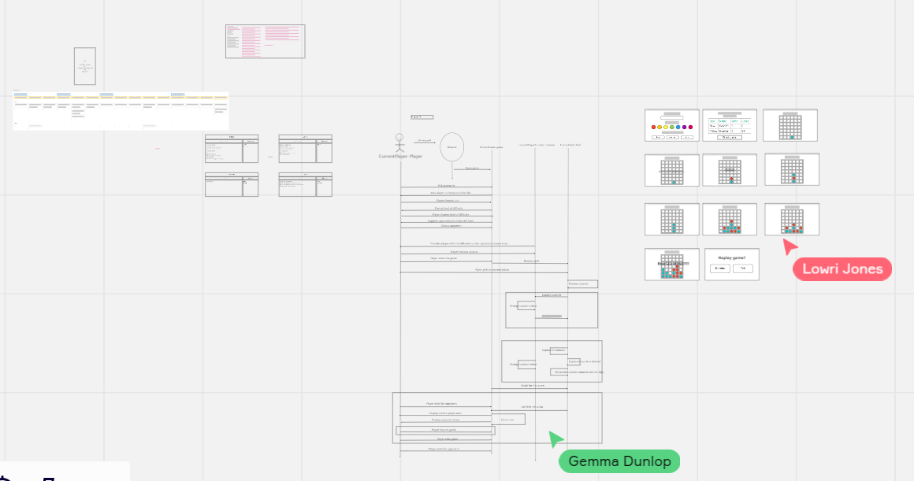

Appendix 2 Planning Notes – Primary Goal
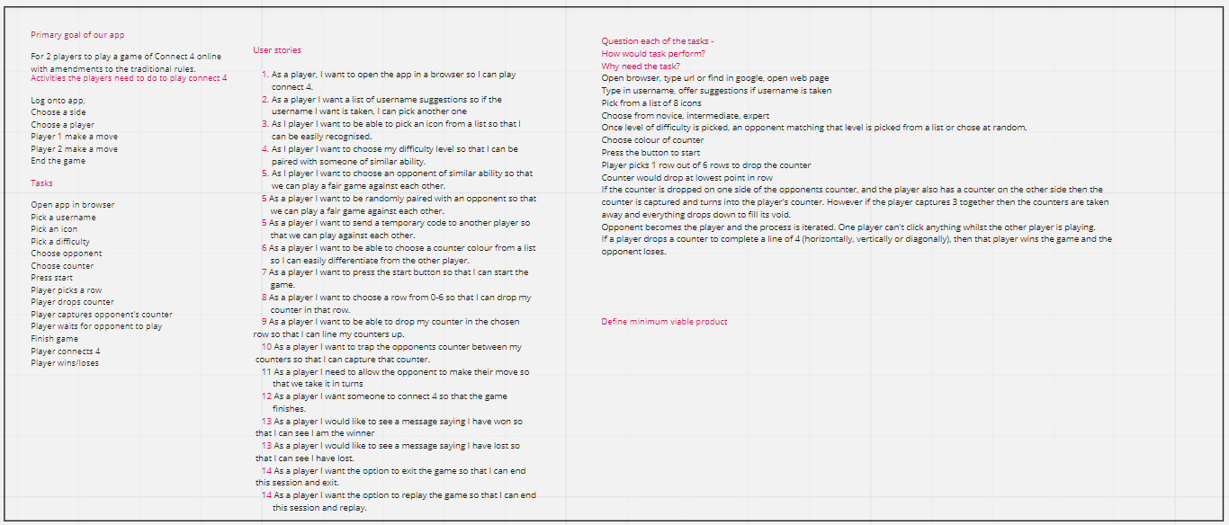

Appendix 3 Activities, Tasks and User Stories

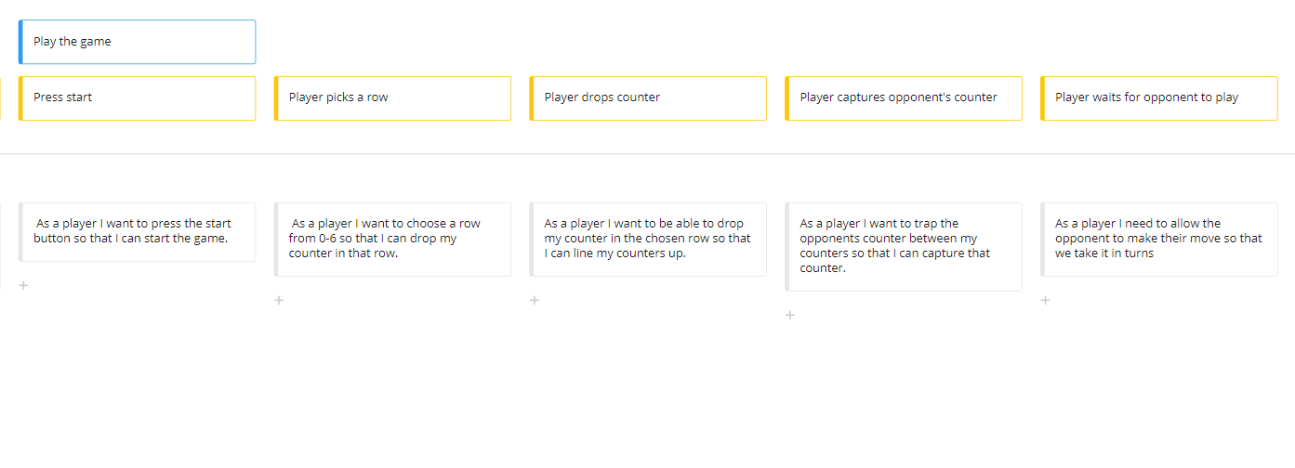
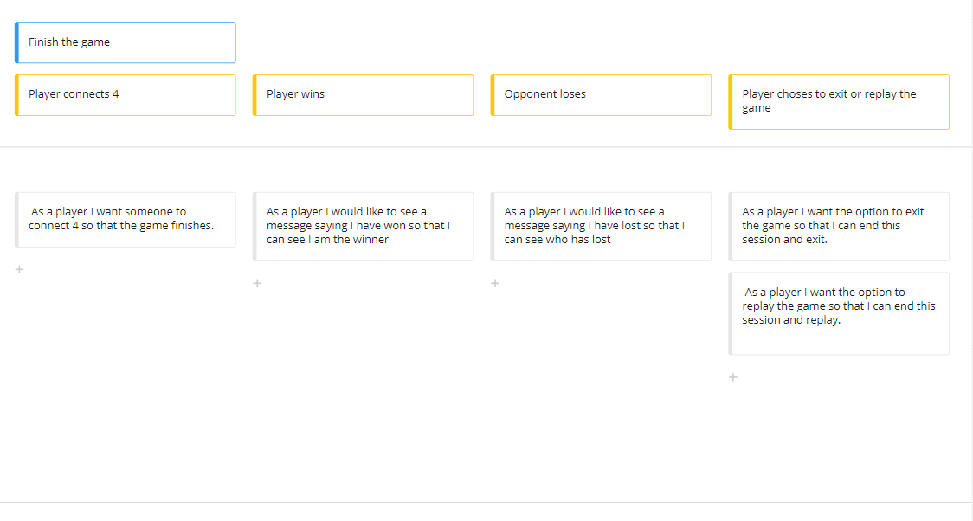

Appendix 4 CRC Cards

Appendix 5 Sequence Diagram

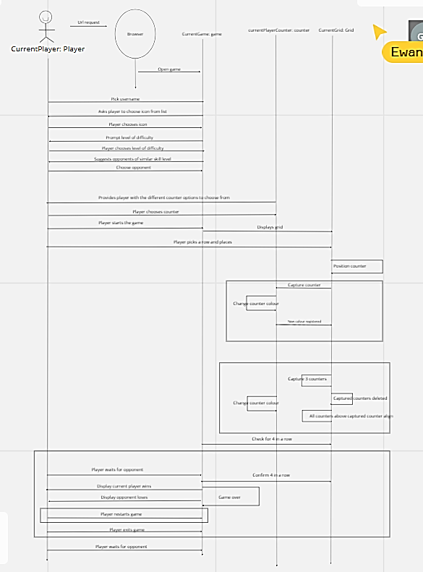

Appendix 6 Wire Frame Diagrams

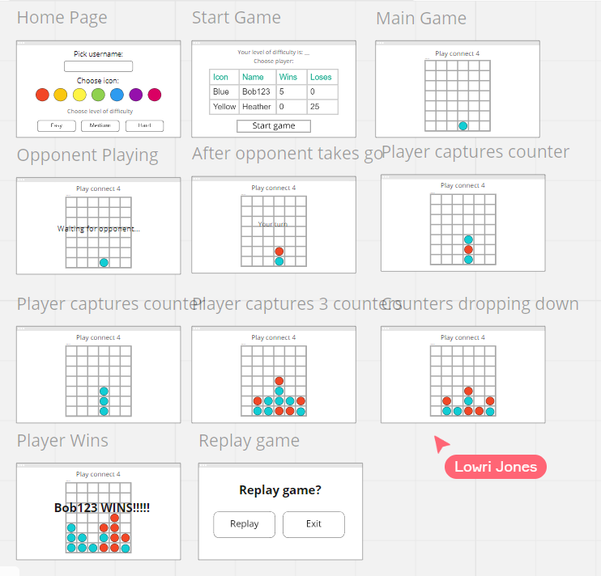

Appendix 7 Code Examples for Classes

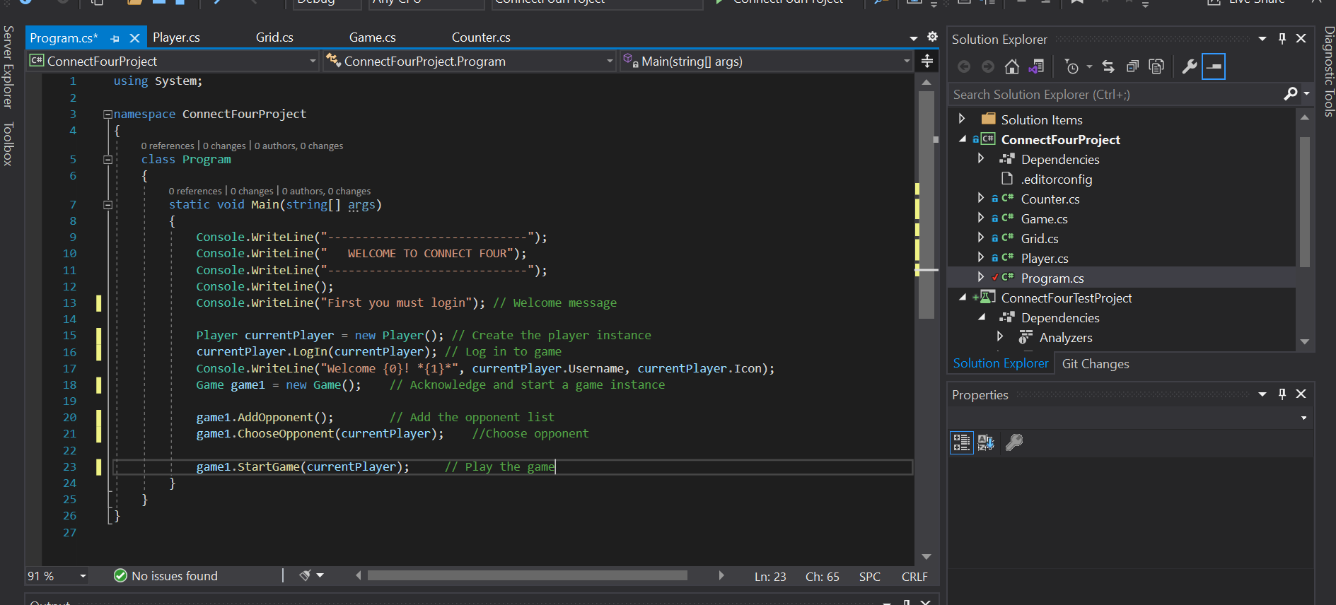

Main Program

using System;

namespace ConnectFourProject
{
class Program
{
static void Main(string[] args)
{
Console.WriteLine("-----------------------------");
Console.WriteLine(" WELCOME TO CONNECT FOUR");
Console.WriteLine("-----------------------------");
Console.WriteLine();
Console.WriteLine("First you must login"); // Welcome message

Player currentPlayer = new Player(); // Create the player instance
currentPlayer.LogIn(currentPlayer); // Log in to game
Console.WriteLine("Welcome {0}! *{1}*", currentPlayer.Username, currentPlayer.Icon);
Game game1 = new Game(); // Acknowledge and start a game instance

game1.AddOpponent(); // Add the opponent list
game1.ChooseOpponent(currentPlayer); //Choose opponent

game1.StartGame(currentPlayer); // Play the game
}
}
}

Player Class
using System;
using System.Collections.Generic;
using System.Text;

namespace ConnectFourProject
{
class Player
{
//Attributes
private string _username;
private string _colour;
private string _diff;
private string[] _icons = { "Lion", "Eagle", "Shark", "Dog", "Cat", "Crocodile" };
private string _icon;
//Constructors
public Player()
{

}

public Player(string pName, string pColour, string pIcon, string pDiff) // Construct player object
{
_username = pName;
_icon = pIcon;
_colour = pColour;
_diff = pDiff;

}
//Properties
public string Username
{
get { return _username; }
set { _username = value; }
}

public string Colour
{
get { return _colour; }
set { _colour = value; }
}

public string Icon
{
get { return _icon; }
set { _icon = value; }
}

public string Difficulty
{
get { return _diff; }
set { _diff = value; }
}
//Methods
public Player LogIn(Player currPlayer) // Log in to game
{
Console.WriteLine("Please type in a username:");
Username = Console.ReadLine();

Console.WriteLine("Please choose a counter colour:");
Colour = Console.ReadLine();
Counter cpCounter = new Counter(); // Instantiate counter
cpCounter.SetCounterColour(currPlayer); //Set the counter to be used by initial of colour

currPlayer.ChooseIcon(); // choose from list of icons

Console.WriteLine("Please choose a level of difficulty:");
Console.WriteLine("H = Hard, I = Intermediate or E = Easy.");
Difficulty = Console.ReadLine().ToUpper();

return currPlayer;
}

public int DisplayIconMenu() // list of icons
{

var x = "x";
int choose;

do
{
Console.WriteLine("Please choose an icon from the following using a corresponding number:");
for (int i = 0; i < _icons.Length; i++)
{
Console.WriteLine("Icon {0}: *{1}*", i + 1, _icons[i]);
}
x = Console.ReadLine();

} while (int.TryParse(x, out choose) != true); // turn choice into a number for switch case

return choose;
}

public void ChooseIcon() // choose from list of icons
{

int choice;

choice = DisplayIconMenu();

switch (choice)
{
case 1:
Icon = _icons[0];
break;

case 2:
Icon = _icons[1];
break;

case 3:
Icon = _icons[2];
break;

case 4:
Icon = _icons[3];
break;

case 5:
Icon = _icons[4];
break;

case 6:
Icon = _icons[5];
break;

default:
Console.WriteLine("Please enter a number between 1 and 6");
DisplayIconMenu();
break;
}

}
}
}

Grid Class

using System;
using System.Collections.Generic;
using System.Text;

namespace ConnectFourProject
{
class Grid
{
//Attributes
private char[,] _board;

//Constructors
public Grid()
{

}
//Properties
public char[,] Board
{
get { return _board; }
set { _board = value; }
}

//Methods
public void DisplayGrid(char[,] Board) // Draw and display a board
{
int rows = 6, columns = 7, i, ix; // Variables for rows and columns and for For loops

for (i = 1; i <= rows; i++) // Loop through 2d array rows first
{
Console.Write("|");
for (ix = 1; ix <= columns; ix++)
{
if (Board[i, ix] != 'X' && Board[i, ix] != 'O')
{
Board[i, ix] = '*';

Console.Write(Board[i, ix]);
}
}

Console.Write("| \n");
}

}
}
}

Game Class

using System;
using System.Collections.Generic;
using System.Text;

namespace ConnectFourProject
{
class Game
{
//Attributes
private string[] _icons = { "Lion", "Eagle", "Shark", "Dog", "Cat", "Crocodile" };
private string[] _levels = { "Easy", "Intermediate", "Hard" };
private List<Player> _opponents; // List of all players
private List<Player> _match; // List of matched players based on level
//Constructors
public Game() //construct new list of Player objects
{
_opponents = new List<Player>();
}
//Properties

//Methods
public void AddOpponent() //add opponents to the list - hard coded for testing game
{
Player player2 = new Player("C4Player", "Green", "Eagle", "I");
_opponents.Add(player2);
Player player3 = new Player("ComeBeatMe", "Pink", "Shark", "H");
_opponents.Add(player3);
Player player4 = new Player("NewToC4", "Orange", "Cat", "E");
_opponents.Add(player4);

}

public Player ChooseOpponent(Player currPlayer) //Instantiated player to choose an opponent from list
{ // at same level
int count = 1;
int choose;
Player chosenOpp = new Player();

_match = new List<Player>();

foreach (Player opponent in _opponents)
{
if (opponent.Difficulty == currPlayer.Difficulty)
{
_match.Add(opponent);
}
}

Console.WriteLine("Please choose one of the following opponents by choosing the corresponding number:");

foreach (Player opponent in _match)
{
Console.WriteLine("{0}: {1} *{2}*", count, opponent.Username, opponent.Icon);
count++;
}

string x = Console.ReadLine();

int.TryParse(x, out choose);

for (int i = 0; i < _match.Count; i++)
{
if (choose == i + 1)
{
chosenOpp = _match[i];
}
else
{
Console.WriteLine("Please choose a valid opponent");
}
}

Console.WriteLine("Your chosen opponent is {0}", chosenOpp.Username);
return chosenOpp;
}

public void StartGame(Player currPlayer) // Display the board and start a game
{
Player opp = ChooseOpponent(currPlayer);
Console.WriteLine("{0} make the first move", currPlayer);
Grid board = new Grid();
char[,] Board = new char [8, 9];
board.DisplayGrid(Board);
}

}
}

// Further methods would let players take turns

Counter Class

using System;
using System.Collections.Generic;
using System.Text;

namespace ConnectFourProject
{
class Counter
{
//Attributes
string _counterColour;
//Constructors
public Counter()
{

}
//Properties
public string CounterColour
{
get { return _counterColour; }
set { _counterColour = value; }
}
//Methods
public string SetCounterColour(Player currPlayer) //Set the counter to be used by initial of colour
{
string res = currPlayer.Colour.ToUpper();
CounterColour = res.Substring(0, 1);

Console.WriteLine("Your counter is {0}", CounterColour);
return CounterColour;
}

}
}

Appendix 8 XUnit Testing

Appendix 9 Full cycle of committing a class to a branch

markh@Westerose MINGW64 ~/Desktop/CodeProjects/Con4Backup/ConnectFourProject (master)
$ git status
On branch master
nothing to commit, working tree clean

markh@Westerose MINGW64 ~/Desktop/CodeProjects/Con4Backup/ConnectFourProject (master)
$ git checkout -b Player
Switched to a new branch 'Player'

markh@Westerose MINGW64 ~/Desktop/CodeProjects/Con4Backup/ConnectFourProject (Player)
$ git status
On branch Player
nothing to commit, working tree clean

markh@Westerose MINGW64 ~/Desktop/CodeProjects/Con4Backup/ConnectFourProject (Player)
$ git status
On branch Player
Untracked files:
(use "git add <file>..." to include in what will be committed)
Player.cs

nothing added to commit but untracked files present (use "git add" to track)

markh@Westerose MINGW64 ~/Desktop/CodeProjects/Con4Backup/ConnectFourProject (Player)
$ git add Player.cs

markh@Westerose MINGW64 ~/Desktop/CodeProjects/Con4Backup/ConnectFourProject (Player)
$ git status
On branch Player
Changes to be committed:
(use "git restore --staged <file>..." to unstage)
new file: Player.cs

markh@Westerose MINGW64 ~/Desktop/CodeProjects/Con4Backup/ConnectFourProject (Player)
$ git commit -m 'player class added'
[Player 0614d90] player class added
1 file changed, 135 insertions(+)
create mode 100644 Player.cs

markh@Westerose MINGW64 ~/Desktop/CodeProjects/Con4Backup/ConnectFourProject (Player)
$ git status
On branch Player
nothing to commit, working tree clean

markh@Westerose MINGW64 ~/Desktop/CodeProjects/Con4Backup/ConnectFourProject (Player)
$ git checkout master
Switched to branch 'master'

markh@Westerose MINGW64 ~/Desktop/CodeProjects/Con4Backup/ConnectFourProject (master)
$ git merge Player
Updating 14b0382..0614d90
Fast-forward
Player.cs | 135 ++++++++++++++++++++++++++++++++++++++++++++++++++++++++++++++
1 file changed, 135 insertions(+)
create mode 100644 Player.cs

markh@Westerose MINGW64 ~/Desktop/CodeProjects/Con4Backup/ConnectFourProject (master)
$ git log

Git Log

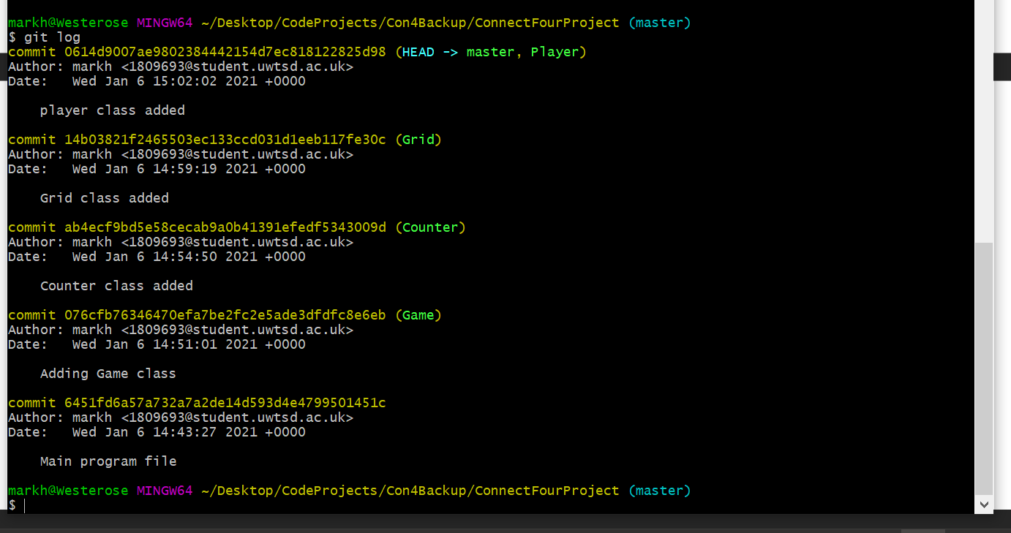

Appendix 10 Collaborative Agile meeting notes
First meeting – 30/11/2020
All team members were present in this meeting.
We started developing our user story map.
Define the main goal for us
- “To create a two-player game of connect 4”
Define the main goal for the users
- “To be the first to get 4 in a row”

Questions we’ve come across
- Are you looking for the design to be web application or console?
- If you capture 3 in one go is there a hole?
- The counter drops into the hole, or does it stay empty to be filled by next dropped counter?
- If there’s 2 counters above, do both counters drop down?

Plan of action
Come up with a list of what we think we need to do and compare next week to come up with a group list.

Second meeting – 4/12/2020
Mark, Ewan and Gemma were present at this meeting but Lowri wasn’t.
This is the meeting I missed.
The full plan was developed for the activities and user tasks.
The primary goal was also updated to the following.
“For 2 players to play a game of Connect 4 online
with amendments to the traditional rules.”

Plan of action for next meeting
To look back over the plan created today and see if there’s anything else to add.
Start to look at user stories.

Third meeting – 7/12/2020
All team members were present in this meeting.
We firstly went over the full plan developed last week.
At this point we were able to create a full list of the user stories needed.

Plan of action for next meeting
To look back over the list of user stories to see if there’s anything else to add.
Look at creating CRC cards.

Fourth meeting – 9/12/2020
All team members were present in this meeting.
We all looked over the user stories created and all team members were happy with the list and nothing needed to be changed.

CRC cards
- We all firstly went through the user stories and picked out the classes we identified.
- From this we started to develop our CRC cards with responsibilities and collaborators.
- We managed to finish the majority of the CRC cards in this meeting

Plan of action for next meeting
Finish CRC cards
Look at the CRC cards created and see if there is anything missing

Fifth meeting – 10/12/2020
All team members were present in this meeting.
During this meeting we all looked through the CRC cards we had started last week and had a discussion on it.
We had decided that we needed to alter some of the collaborators as they didn’t all suit.
After this had been done, all of the CRC cards were finished during this meeting.
Once the CRC cards had been finished, we all had a discussion about sequence diagrams ensuring all team members understood what we were doing.
We then started the sequence diagram.

Plan of action for next meeting.
Finish the sequence diagram
Start wire frame diagrams

Sixth meeting – 14/12/2020
All team members were present in this meeting.
In this meeting we completely finished the sequence diagram and discussed it ensuring we were all happy.
We also started our wire frame diagrams in this meeting.

Plan of action for next meeting
Finish wire frame diagrams
Go over everything to make sure we are all happy with what we have done.

Seventh meeting – 15/12/2020
All team members were present in this meeting.
In this meeting we finished the wire frame diagrams as a team.
We all went over the whole finished design we had created and had a deep discussion and decided we were all happy with what we had done.

