Betty Julie Millard
P150865 ACCA01005
COMPUTER ARCHITECTURE AND NETWORKS
DR KAPILAN RADHAKRISHNAN
AND
MR GARETH JONES

Abstract
This report covers a small digital media company, DigiProd, which is expanding and requires enough space to accommodate 38 staff and 10 staff that will be working remotely. The remote staff will be required to connect with the company and have VoIP capabilities.

Introduction
DigiProd is a small digital media company comprising of an Admin Manager, a Film Editor, two remote workers, and one temporary staff worker. DigiProd currently occupy one floor with five offices and a conference/lounge area.

Client Requirements
DigiProd wishes to expand the current office space to occupy an additional two floors that will allow for 38 staff. DigiProd also requires access for 10 staff that will be working remotely. There is a budget of £70,000.00.

Staff Positions:
Ground Floor
- 1 CEO (Administrative Manager)
- 1 HR Administrator
- 2 Sales/Marketing
- 1 Finance Assistant
First Floor
- 10 Web designers/Developers
- 5 Media Engineers
Second Floor
- 4 Film Editors
- 4 Graphics/Animation Engineers
- 4 Art Designers
- 4 Web and Graphics Design Interns
- 2 Media Technicians

Hardware Requirements:
- Servers – One for Email and Print and one for Web and Media
- Printers – Two network printers for staff, one printer for the CEO and one for HR and Finance Assistant
- PCs/MACs for 38 office positions
- VOIP phone system for office and Remote workers
- Video Conferencing Facility in Conference/Lounge and CEO Office
- Secured Wired and Wireless Connectivity
- High Speed Internet Connection.
It is assumed fibre optic internet is available. The main internet line will consist of a fibre optic line [1][2] which is a technology to send and receive high- bandwidth information over the internet using ordinary copper telephone lines to connect to the high-speed fibre-optic cable. Figure 1 illustrates how this works.
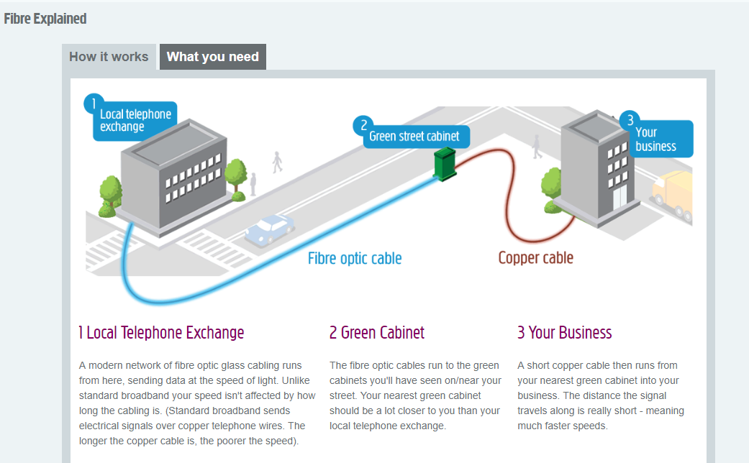
Figure 1 Fibre Explained [1]
The Internet Service Provider (ISP) will connect to a firewall as shown in Figure 2. A Firewall is a network security device that examines incoming and outgoing network traffic and determines whether to permit or stop specific traffic based on DigiProd’s pre-defined set of security rules [3][4].
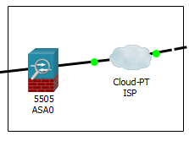
Figure 2 Firewall connected to the ISP

Packet Tracer
Packet Tracer is a program that allows network layouts to be created in a virtual scenario.
A Packet Tracer program is attached to the report to show how this proposal would work for your company. [5]–[9]
VoIP phones have not been configured in this program scenario but would be in DigiProd’s office.
For convenience all passwords in this program have been set to generic passwords (cisco, Password 123). In a real-world scenario an alphanumeric password consisting of a minimum of 8 characters, which should include at least one capital letter and special characters, is advised.
For workers who require remote login access, the use of a Virtual Private Network (VPNs)[10][11] is suggested. A VPN is a technique for safeguarding and encrypting communications when using the Internet. It is used to send and receive information while preserving the confidentiality of a private network. When accessing the Company Intranet, remote workers should be required to provide extra evidence while logging on. The use of a VPN token is advised. A VPN token can be software or hardware and is usually used with a two-factor authentication. This is done by the end user providing a randomized number followed by a password. This is then inspected by the recipient and either allowed if confirmed as a match or access is denied. Software token authentication is suggested for remote workers [12]. This can form part of a two factor authentication policy for all remote accounts.[11]
All routers and switches have been configured with Service-Password Encryption which cannot be cracked with a Cisco password cracker as shown in Figure 3.
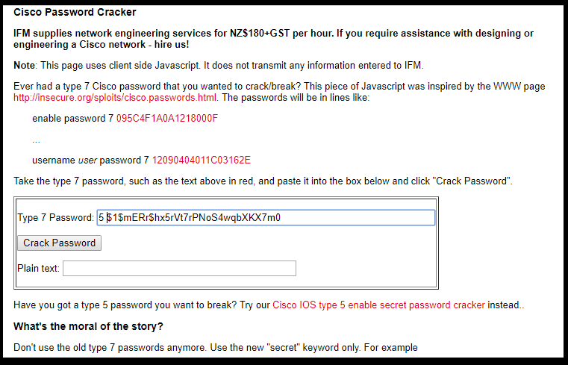
Figure 3 Service-Password Encryption
Using the “enable secret “password can be cracked with Cisco password cracker as shown in Figure 4. [13]
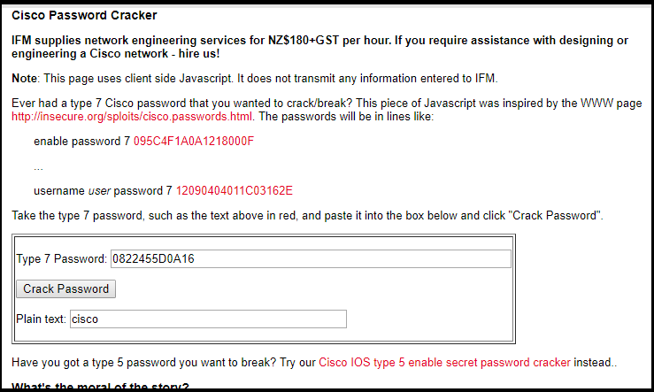
Figure 4 Cisco Type 7 Password Cracker (enable secret)
All PC’s are set-up to receive their IP addresses automatically using Dynamic Host Configuration Protocol (DHCP) which is a protocol to provide a central management distribution service for IP addresses in a network that is both quick and automatic.[14][15]

Hardware
Technical specifications for all hardware can be found at Appendix A.
Voice over Internet Protocol (VoIP) Phones have been installed on all floors and have been acquired for all remote staff. VoIP is an alternative way of making phone calls. It utilizes the Internet to achieve the connection which makes it more economical.[16][17]
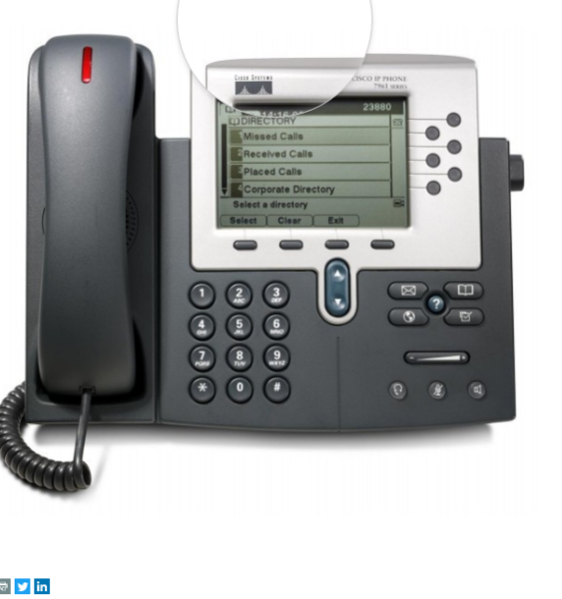
Figure 5 CISCO CP-7960G UNIFIED IP PHONE 7960G [17]
The ground floor has six desktop PCs being used for general office duties. Dell Inspiron desktop i5, running Windows 10 with 1TB hard drives are suggested for this operation.
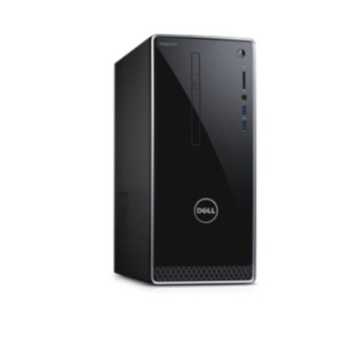
Figure 6 Dell Inspiron Small Form Factor Desktop [18]
Printers will be shared between the staff located on the ground floor. For the CEO a personal printer will be supplied. As the CEO also requires video conferencing, a “Logitech MeetUp Video Conferencing System”[19] is suggested. It has a 120-degree Field of Vision and is ideal for a small room. The same Conferencing System is suggested for the Conference Room.
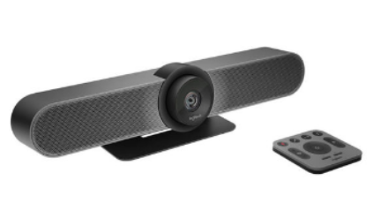Figure 7 Logitec MeetUp Video Conferencing System

The first floor will be open plan and will house 4 Film Editors, 4 Art Designers, 5 Media Engineers and 2 Media Technicians. The Dell Inspiron 5680 running Windows 10 has an 8th Gen Intel® Core™ processor and VR-ready graphics. This comes with a 2TB hard drive and is the recommended PC for them.
Figure 8 Dell Inspiron 3668 Desktop [18]
The second floor will also be open plan and will accommodate the 10 Web Designers/Developers, 4 Web and Graphic interns 4 Art designers. Hardware recommendations for the 10 Web designers is the Inspiron 3668 i7 desktop, running Windows 10 with 1 TB hard drives, and the Dell Inspiron 5680 for the 4 Art Designers and Graphic Interns.
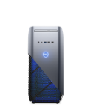
Figure 9 Dell Inspiron 5680 [18]
On the ground floor there is a Server Room. This will need to be kept locked for security and temperature controlled to stop the machined from overheating. In the Server Room, there will be a PowerEdge T44 server. This is capable of Web, Media, Mail, File and Print serving, as well as database applications. A Network Attached Storage (NAS) device is also housed in the Server Room [20]; a Qnap NAS with the capacity of 120TB memory. Both products allow room for growth.
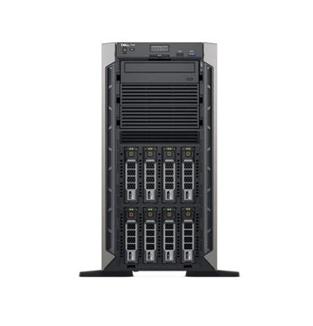
Figure 10 PowerEdge T44 Server [21]
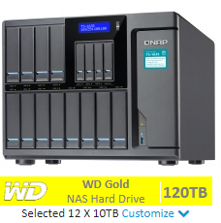
Figure 11 Qnap Nas 120 TB Memory [22]
All printers will be Hewlett Packard Colour LaserJet Pro model M254dw. They will be networked and accessed via a staff card for security.
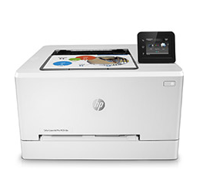
Figure 12 HP Colour LaserJet Pro M254dw [23]
A router, shown in Figure 13, will be situated in the Server Room. A router is usually the first security feature in your network. Inside your network it connects to devices via switches, and outside the network to the local Internet Service Provider.[24] The Cisco RV180 router has a firewall and a VPN all in the same piece of hardware, and has been specifically designed for small businesses as can be seen in Figure 14.
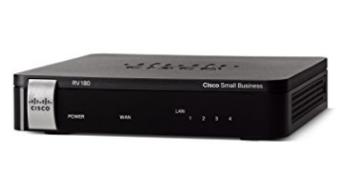
Figure 13 Cisco RV180-K9-G5 Small Business VPN [25]
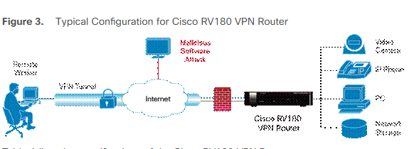
Figure 14 Typical Configuration for Cisco RV180 VPN Router [26]

A switch, shown in Figure 15, is a device that allows communication between connected devices in a local area network. A Cisco SF300-24PP 24 Port Fast Ethernet PoE+ Managed Switch will be used on all floors.

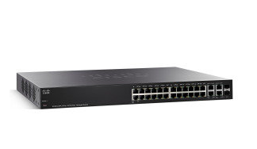
Figure 15 Cisco SF300-24PP 24 Port Fast Ethernet PoE+ Managed Switch [27]
Wireless Access Points (WAP), like switches allow devices to be connected to a wired network. [28] There will be a Cisco Small Business WAP561 on each floor.
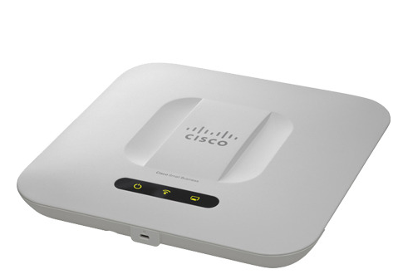
Figure 16Cisco Small Business WAP561 [29]

Conclusion
The total for the hardware came to £63536.09 leaving £6463.91 for additional miscellaneous such as wiring, connections and wires to connect monitors and computers. All the requirements have been met and a specification list for all the equipment is in Appendix A. The computers chosen are not top of the range, more middle of the range but will easily do the jobs required of them. The monitors and printers are also middle of the range and are capable of doing the job required of them.

Budget Breakdown
Product Name | Quantity | Price Per Unit | Total Price
Dell Inspiron 5680 | 23 | 1523.58 | 35051.54
Dell Wireless Keyboard and Mouse KM636 - UK/Irish
Dell Alienware 25 Monitor - AW2518Hf - 63.5cm(25") Black
Dell Inspiron 3668
Dell 24 Touch monitor - P2418HT - 60.5cm(23.8") Black | 10 | 1010.39 | 10103.9
Dell Wireless Keyboard and Mouse KM636 - UK/Irish
Dell Inspiron Desktop | 6 | 631.6 | 3789.6
Dell 24 Monitor | SE2416H - 60.4cm(23.8") Black
Dell Wireless Keyboard and Mouse KM636 - UK/Irish
Dell T440 Server | 1 | 1790.21 | 1875.54
Qnap NAS | 1 | 5871.6 | 5871.6
Voip Phones -Cisco 7960 G | 48 | 21.6 | 1036.8
Video Conferencing -Logitec MeetUp conferencing system | 2 | 2000 | 4000
Printers -HP LaserJet Pro | 4 | 129.99 | 519.96
Router | 1 | 59.95 | 59.95
Switches | 3 | 319.98 | 959.94
WAP | 3 | 182.39 | 547.17
 |  | TOTAL PRICE | 63536.09

Appendix A
Job Role: Ground Floor Personnel
Location: Ground Floor
Component | Recommendation
Processor:  (Manufacturer, Model, Speed) | Intel Core i5-7400 Processor (6MB Cache, up to 3.00 GHz)
Memory:  (Type, Amount) | 8GB DDR4 2400MHz
Hard Drive:  (Type, Capacity) | 1TB (64MB Cache) 7200 RPM SATA 6Gb/s
CD-ROM/DVD:
(Read, Read/Write, Speed)
USB Ports:  (Number, Location) | (2) USB 3.0 ports. (4) USB 2.0 ports . Ethernet port .
Video Card:  (Manufacturer, Model, Video RAM) | Intel® HD Graphics 630 with shared graphics memory
Sound Card:
(Manufacturer, Model)
Modem:
(Internal/External, Speed, Standard)
Network Card(s):
(Ethernet: speed, Wireless, Standard)
Operating System:  (Manufacturer, Version, Compatibility) | Windows 10 Home (64Bit) Multi-Language English, Swedish, Danish, Norwegian, Spanish
Monitor:  (Size, Resolution, Refresh Rate) | Dell 24 Monitor | SE2416H - 60.4cm(23.8")  Pixel Pitch. 0.2745 mm. Panel Type. IPS. Brightness. 250 cd/m². Screen Coating. Anti-glare, 3H Hard Coating. Horizontal Refresh Rate. 30 - 83 kHz.
Printer:  (Manufacturer, Model, Type, Speed) | - HP Color LaserJet Pro M254dw A4 Colour Laser Printer. Up to 21ppm Colour Print. Up to 10.3 Seconds First page. 600 x 600 dpi Print
Speakers:
(Manufacturer, Model, Type)
Internet Connection:
(USB, Ethernet, Wireless)
[30] [31]

Job Role: Web Designers/Developers
Location: First Floor
Component | Recommendation
Processor:  (Manufacturer, Model, Speed) | Intel® Core™ i7-7700 [7th Generation Intel® Core™ i7-7700 processor (8MB Cache, up to 4.20 GHz)]
Memory:  (Type, Amount) | 8GB DDR4 2400MHz
Hard Drive:  (Type, Capacity) | 128GB SSD+1TB GB 7.2k HDD
CD-ROM/DVD:
(Read, Read/Write, Speed)
USB Ports:  (Number, Location) | (2) USB 3.0 ports. (4) USB 2.0 ports . Ethernet port .
Video Card:  (Manufacturer, Model, Video RAM) | NVIDIA® GeForce™ GTX 1050 with 2GB GDDR5 graphics memory
Sound Card:
(Manufacturer, Model)
Modem:
(Internal/External, Speed, Standard)
Network Card(s):
(Ethernet: speed, Wireless, Standard)
Operating System:  (Manufacturer, Version, Compatibility) | Windows 10 Home (64Bit) Multi-Language English, Swedish, Danish, Norwegian, Spanish
Monitor:  (Size, Resolution, Refresh Rate) | 1920 x 1080 at 60 Hz.
Printer:  (Manufacturer, Model, Type, Speed) | - HP Color LaserJet Pro M254dw A4 Colour Laser Printer. Up to 21ppm Colour Print. Up to 10.3 Seconds First page. 600 x 600 dpi Print
Speakers:
(Manufacturer, Model, Type)
Internet Connection:
(USB, Ethernet, Wireless)
[30] [31]

Job Role: Media Engineers: Film Editors: Graphics/Animation Engineers: Art Designers: Web and Graphics Design Interns: Media Technicians
Location: First Floor and Second Floor.
Component | Recommendation
Processor:  (Manufacturer, Model, Speed) | Intel® Core™ i7 8700 (6-Core/12-Thread, 12MB Cache, up to 4.6GHz with Intel® Turbo Boost Technology)
Memory:  (Type, Amount) | 16GB, DDR4, 2400MHz; up to 32GB
Hard Drive:  (Type, Capacity) | 128GB M.2 SATA SSD + 2TB SATA 7200RPM HDD
CD-ROM/DVD:
(Read, Read/Write, Speed)
USB Ports:
(Number, Location)
Video Card:  (Manufacturer, Model, Video RAM) | NVIDIA GeForce GTX 1060 with 6GB GDDR5
Sound Card:
(Manufacturer, Model)
Modem:
(Internal/External, Speed, Standard)
Network Card(s):
(Ethernet: speed, Wireless, Standard)
Operating System:  (Manufacturer, Version, Compatibility) | Windows 10 Home 64bit English, Dutch, French, German, Italian
Monitor:  (Size, Resolution, Refresh Rate) | Dell Alienware 25 Monitor - 240Hz refresh rate and 1-ms response time
Printer:  (Manufacturer, Model, Type, Speed) | HP Color LaserJet Pro M254dw A4 Colour Laser Printer. Up to 21ppm Colour Print. Up to 10.3 Seconds First page. 600 x 600 dpi Print
Speakers:
(Manufacturer, Model, Type)
Internet Connection:
(USB, Ethernet, Wireless)
[30] [31]

Job Role: Server
Location: Ground Floor Server Room
Component | Recommendation
Processor:  (Manufacturer, Model, Speed) | Intel® Xeon® Silver 4108 1.8G, 8C/16T, 9.6GT/s, 11M Cache, Turbo, HT (85W) DDR4-2400
Memory:  (Type, Amount) | RDIMMS/LRDIMMS,  2666MT/s, 512GB max
Hard Drive:  (Type, Capacity) | 1TB 7.2K RPM SATA 6Gbps 512n 3.5in Hot-plug Hard Drive
Operating System:  (Manufacturer, Version, Compatibility) | Canonical® Ubuntu® LTS Citrix® XenServer®  Microsoft Windows Server® with Hyper-V Red Hat® Enterprise Linux  SUSE® Linux Enterprise Server VMware® ESXi
Job Role: Server
Location: Ground Floor Server Room
Component |  | Recommendation
Processor:  (Manufacturer, Model, Speed) |  | Annapurna Alpine AL-514 quad-core 1.7 GHz ARM Cortex-A15 CPU
Memory:  (Type, Amount) |  | 8GB Random Access Memory (RAM)  6Gb/s SATA to Gigabit Ethernet (1 Gbit/s)
Hard Drive:  (Type, Capacity) |  | 120TB of storage capacity
[30] [31] [22]

References

[1] “Our superfast fibre optic business broadband package guide | Plusnet Business,” 2018. [Online]. Available: https://www.plus.net/business/broadband-guide/fibre-optic-broadband/. [Accessed: 19-Apr-2018].
[2] C. Freudenrich PHD., “What are Fiber Optics? - How Fiber Optics Work | HowStuffWorks,” Internet, 2018. [Online]. Available: https://computer.howstuffworks.com/fiber-optic1.htm. [Accessed: 22-Apr-2018].
[3] “What Is a Firewall? - Cisco,” 2018. [Online]. Available: https://www.cisco.com/c/en/us/products/security/firewalls/what-is-a-firewall.html. [Accessed: 19-Apr-2018].
[4] “Password Policy Template.” [Online]. Available: http://www.itmanagerdaily.com/password-policy-template/. [Accessed: 20-Apr-2018].
[5] “Packet Tracer - DHCP Setup - YouTube,” 2009. [Online]. Available: https://www.youtube.com/watch?v=P_H9BLP-MRw. [Accessed: 24-Apr-2018].
[6] “dhcp packet tracer - YouTube,” 2017. [Online]. Available: https://www.youtube.com/results?search_query=dhcp+packet+tracer. [Accessed: 24-Apr-2018].
[7] D. Dhole, “How to Configure VOIP in Packet Tracer step by step - YouTube,” 2014. [Online]. Available: https://www.youtube.com/watch?v=_SXLy7UoZ_M. [Accessed: 24-Apr-2018].
[8] L. Rebelo, “Configure VOIP in cisco packet tracer - YouTube,” 2018. [Online]. Available: https://www.youtube.com/watch?v=Q12B89N5Ers. [Accessed: 24-Apr-2018].
[9] K. Gebhardt, “Configuring VoIP Phones in Cisco Packet Tracer - YouTube,” 2018. [Online]. Available: https://www.youtube.com/watch?v=RB4LiS2lIXo&t=533s. [Accessed: 24-Apr-2018].
[10] D. Athow, “What is a VPN (Virtual Private Network)? | TechRadar,” 2017. [Online]. Available: https://www.techradar.com/news/what-is-a-vpn. [Accessed: 20-Apr-2018].
[11] C. Hoffman, “What Is a VPN, and Why Would I Need One?,” 2016. [Online]. Available: https://www.howtogeek.com/133680/htg-explains-what-is-a-vpn/. [Accessed: 20-Apr-2018].
[12] US Dpepartment of Energy, “Using Two-Factor RSA Token with VPN User Guide Using Your RSA token with WebVPN,” 2013.
[13] “IFM - Cisco Password Cracker.” [Online]. Available: http://www.ifm.net.nz/cookbooks/passwordcracker.html. [Accessed: 19-Apr-2018].
[14] T. Fisher, “What Is DHCP? (Dynamic Host Configuration Protocol),” 2018. [Online]. Available: https://www.lifewire.com/what-is-dhcp-2625848. [Accessed: 20-Apr-2018].
[15] TechTarget, “What is DHCP (Dynamic Host Configuration Protocol)? - Definition from WhatIs.com,” TechTarget, 2017. [Online]. Available: https://searchnetworking.techtarget.com/definition/DHCP. [Accessed: 20-Apr-2018].
[16] N. Unuth, “An Introduction to Voice Over IP (VoIP),” 2018. [Online]. Available: https://www.lifewire.com/what-is-voip-3426730. [Accessed: 22-Apr-2018].
[17] “Refurbished Cisco IP Phone 7960G CP-7960G | Intelligent Servers,” 2018. [Online]. Available: http://www.intelligentservers.co.uk/ip-phones/cisco-cp-7960g-unified-ip-phone-7960g/?gclid=CjwKCAjwwuvWBRBZEiwALXqjwx_sxswno8xXaBDHY4OoTSKsuGT1qMg3hR74H6Pe9OEafn7yvYw-VhoCSIAQAvD_BwE. [Accessed: 21-Apr-2018].
[18] “Dell Search,” 2018. [Online]. Available: https://pilot.search.dell.com/dell inspiron desktop. [Accessed: 23-Apr-2018].
[19] “Logitech MeetUp Video Conferencing System – SMART kapp,” 2018. [Online]. Available: https://shop.presentations.co.uk/product/logitech-meetup-video-conferencing-system/. [Accessed: 21-Apr-2018].
[20] “What is network-attached storage (NAS)? - Definition from WhatIs.com,” 2018. [Online]. Available: https://searchstorage.techtarget.com/definition/network-attached-storage. [Accessed: 23-Apr-2018].
[21] “Dell EMC PowerEdge T440 Tower Server | Dell UK.” [Online]. Available: http://www.dell.com/en-uk/work/shop/servers-storage-and-networking/smart-value-flexi-t440-8x35-3106-1x8gb-1x1tb-72k-sata-h330-idrac9-express/spd/poweredge-t440/pet44001?selectionState=eyJGUHJpY2UiOjE3NzQuOCwiT0MiOiJwZXQ0NDAwMSIsIlF0eSI6MSwiTW9kcyI6W3siSWQ. [Accessed: 24-Apr-2018].
[22] “Qnap TS-1635-8G Desktop NAS 10GbE 120TB 16-Bay (12x 3.5inch , 4x 2.5inch ), RAID 0/1/5/6 (8GB RAM) + 10GbE SFP+ (12 X 10TB WD Gold) Buy today,” 2018. [Online]. Available: https://www.span.com/product/Qnap-Desktop-NAS-10GbE-TS-1635-8G-16-Bay-12x-3-5-4x-2-5-RAID-0-1-5-6-8GB-RAM-+-10GbE-SFP+~59441/spanstor=59091. [Accessed: 23-Apr-2018].
[23] “HP Color LaserJet Pro M254dw A4 Colour Laser Printer - T6B60A,” 2018. [Online]. Available: https://www.printerland.co.uk/HP-Color-LaserJet-Pro-M254dw-P140450.aspx. [Accessed: 23-Apr-2018].
[24] T. Fisher, “What Is a Router and How Does it Work?,” 2018. [Online]. Available: https://www.lifewire.com/what-is-a-router-2618162. [Accessed: 23-Apr-2018].
[25] “Cisco RV180-K9-G5 Small Business VPN Router: Amazon.co.uk: Computers &amp; Accessories,” 2018. [Online]. Available: https://www.amazon.co.uk/Cisco-RV180-K9-G5-Small-Business-Router/dp/B007QIRULQ. [Accessed: 23-Apr-2018].
[26] “Cisco RV180 VPN Router Data Sheet - Cisco,” 2018. [Online]. Available: https://www.cisco.com/c/en/us/products/collateral/routers/rv180-vpn-router/c78-697397_data_sheet.html. [Accessed: 23-Apr-2018].
[27] “Cisco SF300-24PP 24 Port Fast Ethernet PoE+ Managed Switch Product Description,” 2018.
[28] B. Mitchell, “What a Wireless Access Point Can Do for You,” 2018. [Online]. Available: https://www.lifewire.com/wireless-access-point-816545. [Accessed: 23-Apr-2018].
[29] “Cisco Small Business WAP561 - radi... | WAP561-E-K9 | £151.99 | Insight UK,” 2018. [Online]. Available: https://www.uk.insight.com/en-gb/productinfo/wireless-networking/0002119842-00000001?gclid=CjwKCAjwiPbWBRBtEiwAJakcpI2l403VjXKuhvXcRkQBiVP_wOEO3zu3V7nl96d1X_a-d0XfErh5nRoC1G0QAvD_BwE. [Accessed: 23-Apr-2018].
[30] “Inspiron 5680 VR Ready Gaming Desktop | Dell UK.” [Online]. Available: http://www.dell.com/en-uk/work/shop/cty/pdp/spd/inspiron-5680-gaming-desktop/bd568024. [Accessed: 23-Apr-2018].
[31] “HP Color LaserJet Pro M254nw A4 Colour Laser Printer - T6B59A,” 2018. [Online]. Available: https://www.printerland.co.uk/HP-Color-LaserJet-Pro-M254nw-P140446.aspx?source=AddwordsT6B59A&gclid=CjwKCAjwiPbWBRBtEiwAJakcpGtKiQarghht1Yj5aW8sCFnRNfMVWu4cPYuGKVntPdYfHVVQ-EghORoCg0kQAvD_BwE. [Accessed: 23-Apr-2018].

