MARKETING PLAN OF PREMIER INN PADDINGTON BASIN

Student name: Adriana Balica
Student ID:2232252
The module title: Marketing Essentials BMIH4005
Lecturer name: Cristopher Wilkins
Word count: 1314

Content table
Introduction 3
The 5C’s model 3
Marketing plan 4
Marketing mix 5
Action 5
Control 6
Conclusion 6
References 7
Appendices 9
Appendix 1-SWOT Analysis at Premier Inn Paddington Basin 9
Appendix 2-Premier Inn Audience Interests 9
Appendix 3-Bowman Strategy Clock 10
Appendix 4-PESTLE Analysis at Premier Inn Paddington Basin 11
Appendix 5-Gaant Chart for Premier Inn Paddington Basin 12
Component B Presentation 13-17

Introduction
This essay outlines a marketing plan for Premier Inn Paddington Basin hotel, developed for a marketing essential course. The plan aims to provide insight into creating effective marketing strategies using the hotel as a case study.
Premier Inn Paddington Basin hotel is a comfortable and affordable accommodation option located in Basin, ideal for both businesses and leisure travellers due to its central location.
The marketing plan focuses on improving brand awareness and attracting more consumers using the SOSTAC model and the 4P’s framework.
By implementing effective marketing strategies such as building strong customer relationships and providing excellent customer service, Premier Inn Paddington hotel can enhance its brand reputation and attract more guests. This marketing plan is useful for hotel management, marketing teams, and staff responsible for developing and executing marketing strategies.

The 5C’s model
Company: A SWOT analysis of Premier Inn Paddington hotel would involve identifying its strengths, weaknesses, opportunities, and threats (Appendix 1). Some potential strengths could be its prime location, well-designed rooms, and modern amenities. Weaknesses could include limited room options, or lack of unique features compared to competitors. Opportunities could include expanding the hotel’s reach through digital marketing or offering additional services (Birru et al., 2022). Threats could include the rise of alternative accommodation options or economic downturns affecting travel (Lin, 2016).
Customers: To effectively segment and target customers, Premier Inn Paddington hotel, could use tools such as SimilarWeb to analyse its website traffic and understand its audience demographics. Based on SimilarWeb data, Premier Inn Paddington’s audience is primarily interested in travel and tourism, with a focus on accommodation and hotels (Appendix 2). This suggests that the hotel’s customer base is likely made up of both leisure and business travellers (Innes, 2022).
Competitors: According to market research, Premier Inn Paddington faces competition from several other hotels in the area, including Travelodge and Holiday Inn. To stay competitive, Premier Inn Paddington can use perceptual positioning maps and Bowman’s strategy clock (Appendix 3), to better understand their position in the market and adjust their marketing and pricing strategies accordingly. Based on customer reviews and ratings, Premier Inn Paddington is perceived as a mid-range hotel, offering quality accommodations and services at an affordable price point. They may need to focus on differentiation strategies to stand out in the crowded market and attract more customers.
Collaborators: Premier Inn Paddington has established partnerships with various businesses in the travel and hospitality industry. They have partnered with CLEAN to ensure their guests have a clean and hygienic environment (Laundry and Cleaning News International,2017), and with Costa Coffee to offer guests a convenient coffee shop on site. Whitbread, the parent company of Premier Inn, has also partnered with various organizations to promote sustainable practices and reduce their environmental impact (Stepek,2019). These collaborations can help them enhance their brand image, increase customer satisfaction, and drive revenue growth.
Climate: Premier Inn Paddington faces macro environmental factors that can affect its operations and performance. For example, changes in government regulations and policies can impact the hotel industry, as well as shifts in economic conditions such as inflation and recession (Camilleri and Camilleri,2018). Social trends and demographic changes can also influence customer preferences and behaviours (Martins et al., 2011). The rise of technology and online platforms have brought new opportunities and challenges to the hospitality industry (Neuhofer et al.,2015), requiring Premier Inn Paddington to adapt and stay competitive. Being aware of these PESTLE factors (Appendix 4), can help Premier Inn Paddington make informed decisions and strategies to succeed in the market.

Marketing Plan
The marketing plan aims to differentiate the hotel from competitors, improve customer experience, increase online presence, target corporate clients, boost occupancy rates, increase customer loyalty, and promote sustainable growth.
The value proposition of Premier Inn Paddington is to offer affordable prices without compromising on quality, ensuring a comfortable and enjoyable stay for guests (Gillil, 2017). The hotel differentiates itself from competitors by providing consistent quality across all locations, with well-equipped rooms and friendly service. To communicate this value proposition, Premier Inn Paddington can use targeted marketing campaigns that highlight their affordable prices and quality accommodations. They can also leverage their partnerships with other businesses in the travel and hospitality industry, to offer package deals and promotions.
By linking their value proposition to their customer segments, Premier Inn Paddington can target corporate clients who are looking for affordable and reliable accommodations for business trips. It can affect the positioning of the hotel as a top choice for budget-conscious corporate travelers. Additionally, they can target families and leisure travellers who are seeking comfortable accommodations at an affordable price. It can position the hotel as a family-friendly and leisure-oriented option. Overall, this targeted approach will help Premier Inn Paddington stand out in the market and attract a diverse range of customers.

Marketing mix
Product: Premier Inn Basin hotel offers quality accommodations and services that cater to both leisure and business travellers. To differentiate from competitors, the hotel can focus on providing excellent customer service, comfortable rooms, and modern amenities such as high-speed internet and in-room entertainment options.
Place (Distribution): The hotel is located in a convenient and accessible location, close to public transportation and popular attractions. Premier Inn Paddington hotel can utilize various distribution channels such as online travel agencies (OTAs) like Expedia and Booking.com, as well as direct bookings through their website and phone reservations. They can also consider partnerships with airlines to offer packaged deals to attract more customers.
Price: The hotel can adopt a dynamic pricing strategy that considers market demand and seasonality to optimize pricing and revenue. To appeal to a wider range of customers, Premier Inn Paddington hotel can offer different price points, including special deals and discounts for longer stays or advanced bookings. The hotel can regularly review their pricing strategy to remain competitive and adjust as necessary.
Promotion: To increase brand awareness and attract more customers, Premier Inn hotel can employ various promotion strategies through RACE/Communications Mix. This includes:
- Reach: Utilizing social media platforms like Facebook and Instagram to reach a wider audience and utilizing influencer marketing to showcase the hotel’s amenities and services to potential customers (Kumar, 2021).
- Act: Creating a seamless booking experience through their website and online platforms, as well as offering loyalty programs and special promotions for repeat customers (Bhandari and Sin, 2023).
- Convert: Utilizing email marketing campaigns to follow up with potential customers and offering personalized offers and discounts (Jenkins, 2008).
- Engage: Encouraging customer feedback through social media and review platforms like TripAdvisor, and promptly responding to reviews and concerns to improve customer satisfaction and loyalty (O’Connor, 2010).
Overall, Premier Inn Paddington hotel’s value proposition is to provide affordable, quality accommodations with exceptional customer service and modern amenities. By focusing on these core values and utilizing effective marketing tactics, the hotel aims to differentiate from competitors and attract a diverse range of customers, including corporate clients and leisure travellers.
Action
The marketing plan can be implemented according to a Gannt chart that outlines the various marketing activities and their timelines (Appendix 5). The marketing channels schedule can be based on market research and customer preferences. The channels include social media advertising, email marketing, and event sponsorships.

Control
Success can be evaluated by monitoring and analysing key performance indicators, including but not limited to new customer acquisition, customer satisfaction ratings, and revenue growth (Chaffey and Ellis-Chadwick, 2012). These metrics can be tracked regularly to assess the effectiveness of the marketing plan and adjust as necessary (Fedoryshyna et al., 2021).

Conclusion
The marketing plan aims to improve the Premier Inn’s competitive position by differentiating the hotel from its competitors, improving the customer experience, and increasing its online presence. By focusing on corporate clients and targeting peak seasons, the hotel aims to increase occupancy rates and position itself as a leading player in the hospitality industry. To sustain growth, ongoing measurement and refinement of the marketing plan will be necessary.

References
- Bhandari, R. and Sin, M.V.A., 2023. Optimizing digital marketing in hospitality industries. Startupreneur Bisnis Digital (SABDA Journal), 2(1).

- Birru, A.C., Sudarmiatin, S. and Hermawan, A., 2022. Competitive strategies in the lodging service sector: Five porter analyses and case study SWOT analysis. Journal of Business and Management Review, 3(1), pp.001-017.

- Camilleri, M.A. and Camilleri, M.A., 2018. The marketing environment (pp. 51-68). Springer International Publishing.

- Chaffey, D. and Ellis-Chadwick, F., 2012. Digital marketing: strategy. Implementation and.

- Davies, P. (2018). Premier Inn-Costa Coffee demerger confirmed. [online] Travel Weekly. Available at: https://travelweekly.co.uk/articles/302429/premier-inn-costa-coffee-de-merger-confirmed [Accessed 8 May 2023].

- Fedoryshyna, L., Halachenko, O., Ohiienko, A., Blyznyuk, A., Znachek, R. and Tsurkan, N., 2021. Digital marketing in strategic management in the field of the tourism. Journal of Information Technology Management, 13(Special Issue: Role of ICT in Advancing Business and Management), pp.22-41.

- Gillil, N. (2017). What makes Premier Inn the world’s strongest hotel chain? [online] Econsultancy. Available at: https://econsultancy.com/what-makes-premier-inn-the-world-s-strongest-hotel-chain/ [Accessed 8 May 2023].

- Innes, M. (2022). Beyond ‘revenge travel’: How Premier Inn is changing its brand positioning amid cost crises. [online] Marketing Week. Available at: https://www.marketingweek.com/premier-inn-changing-brand-positioning/ [Accessed 8 May 2023].

- Jenkins, S., 2008. The truth about email marketing. FT Press.

- Kumar, P., 2021. Digital Marketing in Hospitality and Tourism. University of South Florida M3 Center Publishing, 17(9781732127593), p.3.

- Laundry and Cleaning News International (2017). CLEAN announces long-term partnership with Whitbread - Laundry and Cleaning News. [online] www.laundryandcleaningnews.com.
Available at:https://www.laundryandcleaningnews.com/news/newsclean-announces-long-term-partnership-with-whitbread-5811776 [Accessed 8 May 2023].
- Lin, X., 2016. Strategy analysis of a boutique and lifestyle hotel: a SWOT analysis.

- Martins, J.M., Yusuf, F. and Swanson, D.A., 2011. Consumer demographics and behaviour: Markets are people (Vol. 30). Springer Science &amp; Business Media.

- Neuhofer, B., Buhalis, D. and Ladkin, A., 2015. Smart technologies for personalized experiences: a case study in the hospitality domain. Electronic Markets, 25, pp.243-254.

- O’connor,P., 2010. Managing a hotel’s image on TripAdvisor. Journal of hospitality marketing & management, 19(7), pp.754-772.

- Stepek, J. (2019). How green is your hotel? [online]
www.businesstravelnewseurope.com.
Available at:
https://www.businesstravelnewseurope.com/Accommodation/How-green-is-your-hotel-
[Accessed 10 May 2023].

Appendices
Appendix 1-SWOT Analysis at Premier Inn Paddington Basin

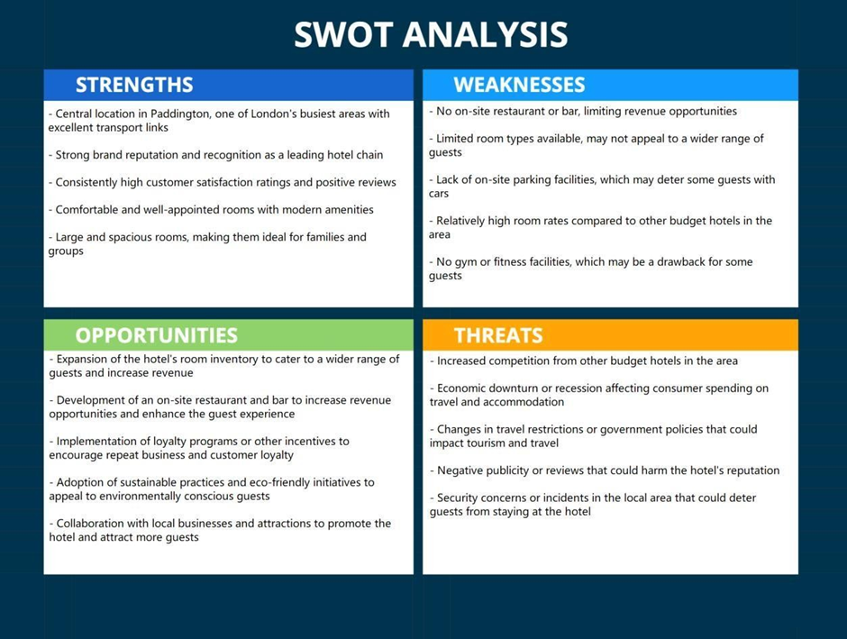
(Source:Adriana Balica )

Appendix 2-Premier Inn Audience Interests
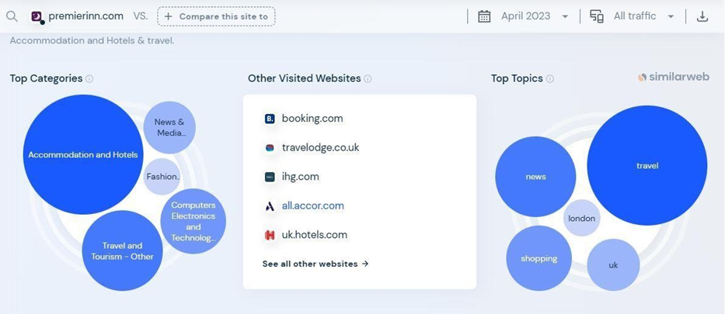
(Source:SimilarWeb)
Appendix 3-Bowman Strategy Clock

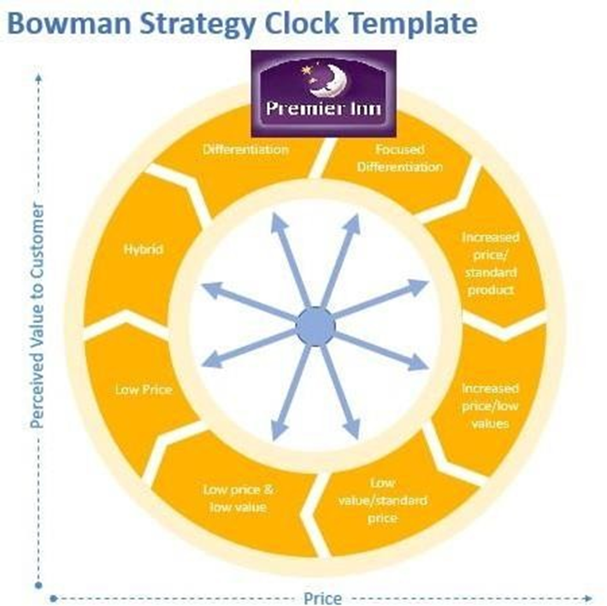
(Source:Adriana Balica )

Appendix 4-PESTLE Analysis at Premier Inn Paddington Basin
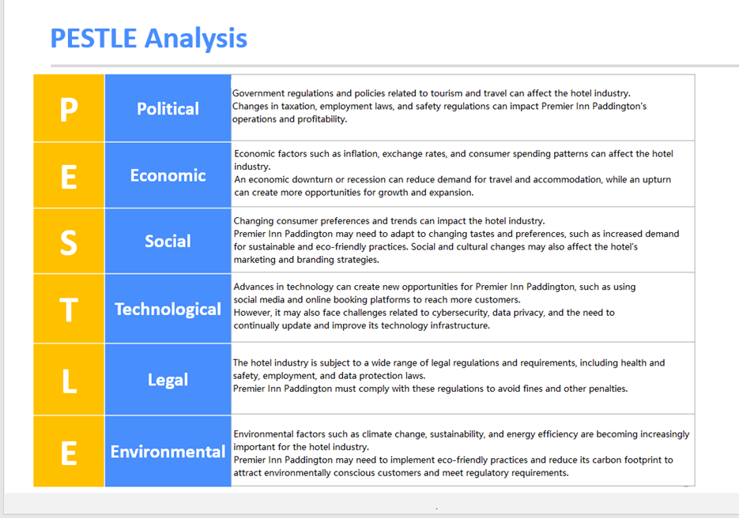
(Source:Adriana Balica)

Appendix 5-Gaant Chart for Premier Inn Paddington Basin
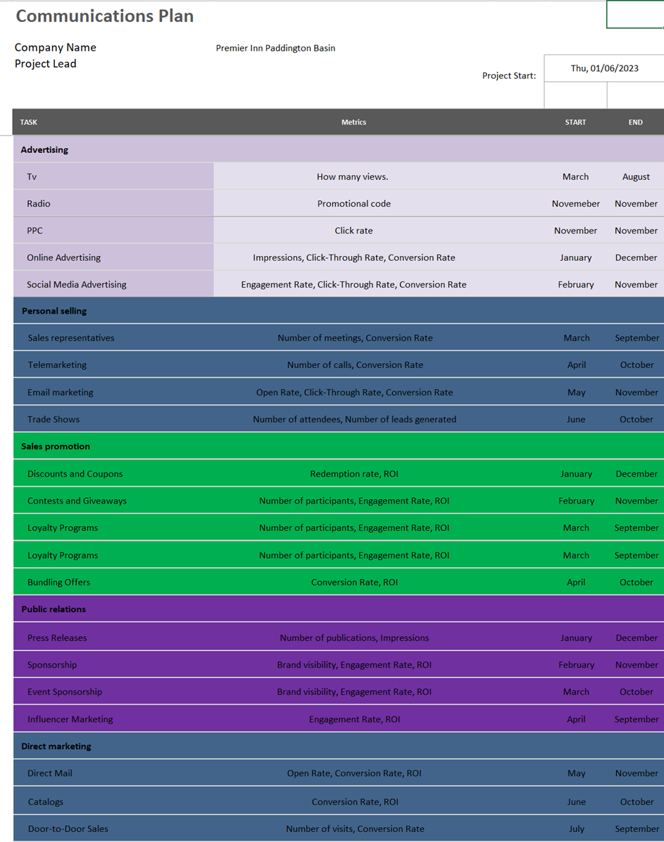
(Source:Adriana Balica)

Component B Presentation


