John Mur Assessment

-Discover a wild place
In this section, I will name and locate the place, discuss what I liked about it, why I think that it is special and worth my attention.

We chose to do a beach clean at Llansteffan beach, which is only 14km from Carmarthen. The Beach itself was ideal because it wasn’t too far away to drive to, and the access to it was easy too. We started our beach clean at the parking and walked our way around the Llansteffan castle, all the way to Scott’s Bay

The white line represents the direction we took in order for us to pick up as much litter as possible.

NB. We didn’t access Llansteffan Beach when it was at High tide.
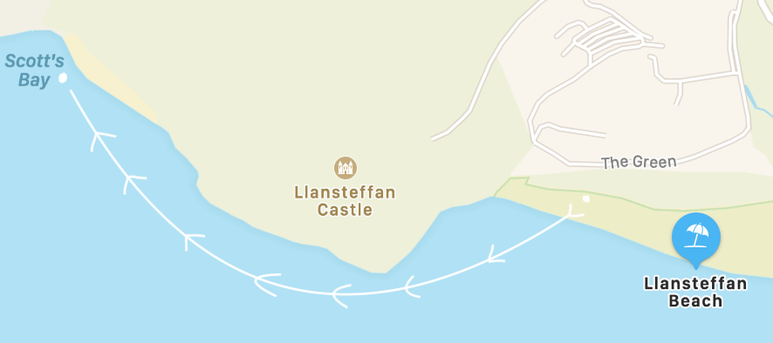

The reason we chose this beach was that Llansteffan is quite a popular tourist beach, with a good number of visitors that come and go, including locals which consequently means that there is often waste or litter to be picked up. Another point as to why we chose this beach, was because the difference between high tide and low tide means that the beach has more to offer in the sense that we had more areas to access. I think this beach was worth going to is primarily it is the closest beach to UWTSD and knowing that beaches are an important element of tourism connecting them to nature, it would be nice to have a beach like Llansteffan which is clean and nice to go to for some fresh air, to relax. To add to that, the beach is worth my attention because it’s one of the most scenic beaches I’ve visited in South Wales more precisely, Pembrokeshire.

-Explore its Wildness
In this chapter, I will be showing evidence of my visit to Llansteffan and what I have done to get to know this wild place. I will highlight the key natural characteristics of the beach itself.

YouTube private link: sent via email.

Before going to Llansteffan beach I did some research on the place to see if there was any important information I needed to know before going to do the beach clean. Firstly, I checked the weather in case of precipitation or rain coming through the Pembrokeshire area. I then checked the tide times, making sure we went for our beach clean safely knowing that it was low tide and without risk. Most of all I ensured before I left that I had a good layering on considering it’s nearly winter and the temperature is slowly dropping.
In terms of the natural terrain of this beach, it could be described as a safe and very spacious beach with easy access thanks to the parking and other paths that join it from the mainland of the Llansteffan village. The surface of the beach is flat with slight inclines in certain spots, all along the greenery of the beach there are walls of rocks that protect the forest when the sea is at high tide.

-Conserve and take responsibility
In this part, I will demonstrate the practical measures I have taken to conserve or otherwise protect the place.

As we started our beach clean, we tried to pick up as much litter as possible by spreading out away from each other for us to be more efficient. By using that technique, we were able to get a good amount of rubbish that was left on the ground. After filling our rubbish bags and finishing our beach clean at Llansteffan we ensured our bags were in the general waste and not in the recycling bins. We also made sure the litter that was situated on the borderline of the beach was collected to ensure that it didn’t blow back into the sea. This was an important task to all of us, in order to show care and respect to the marine wildlife and helping to keep the Pembrokeshire coast as clean as possible.

-Share your experiences
Here I will reflect on how I feel about the place after I have taken my first three steps. I will be reflecting on how the experience has impacted me and my attitudes toward wild places such as Llansteffan. Also, how does this experience relate to my own ambitions and interests? Finally, I will be writing a short statement explaining the reason why I have selected this type of format for my assessment

On arrival at the beach parking of Llansteffan, I was quite unsure about what I would find there. Whether I would find litter and general waste that washed up on the edge of the water, coming from somewhere else. As I started picking up rubbish, I realised there wasn’t that much on the ground which made me quite happy. It made me reflect on the fact that most people respect their environment and the tourist beaches and areas that they visit. From my experience, I do feel like there is still some effort to be made by others when it comes to taking care of natural spaces. Luckily, along the Pembrokeshire coastline the majority of the public beaches remain quite tidy and well-maintained thanks to several litter-picking organisations who organise and implement specific days to go and care for their local environment

