Change Makers: Creativity and Value Creation ACCA5033

Beccy Burrows 2200741

Contents

- Initial Idea Mind Map

- Moodboards and Inspiration

- Further Research

- Photobashing

- Sketches

- Final Design

- Design Choice Statement

- Bibliography

Initial Idea Mind Map
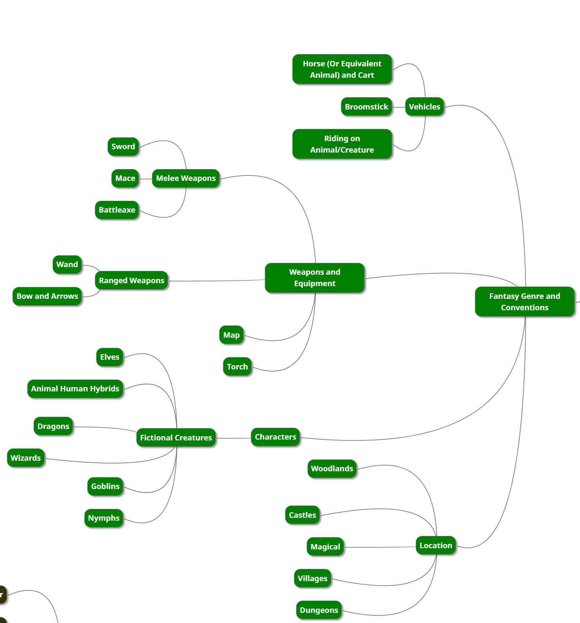
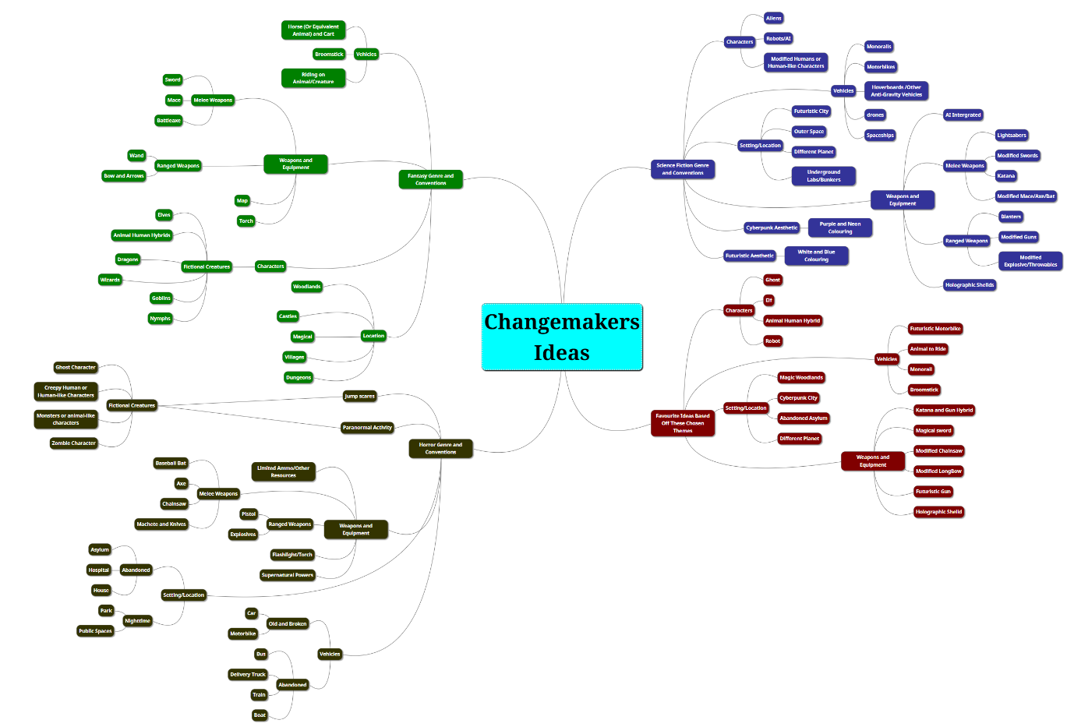

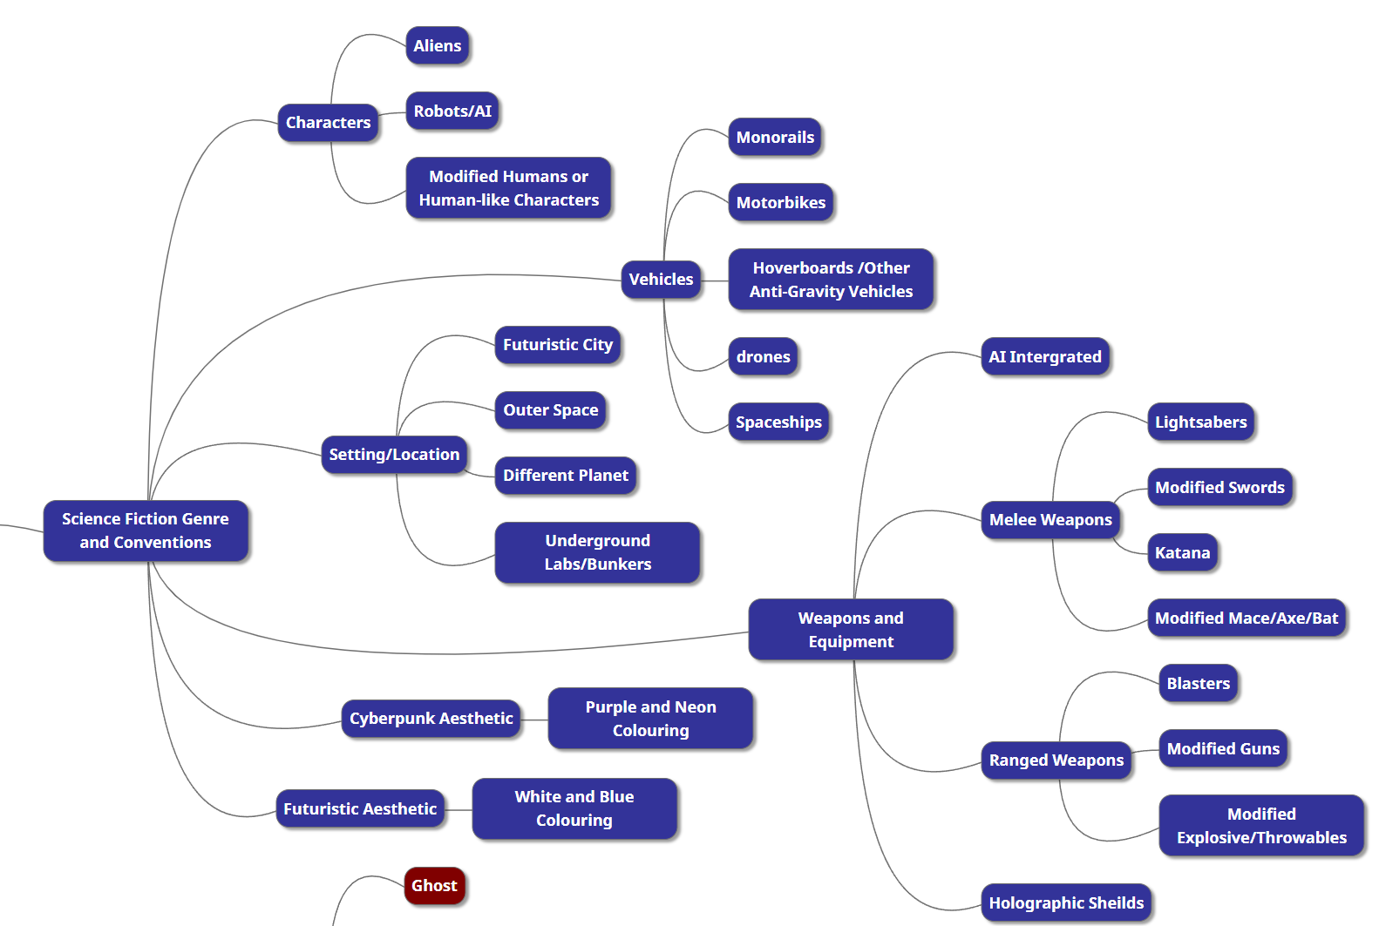
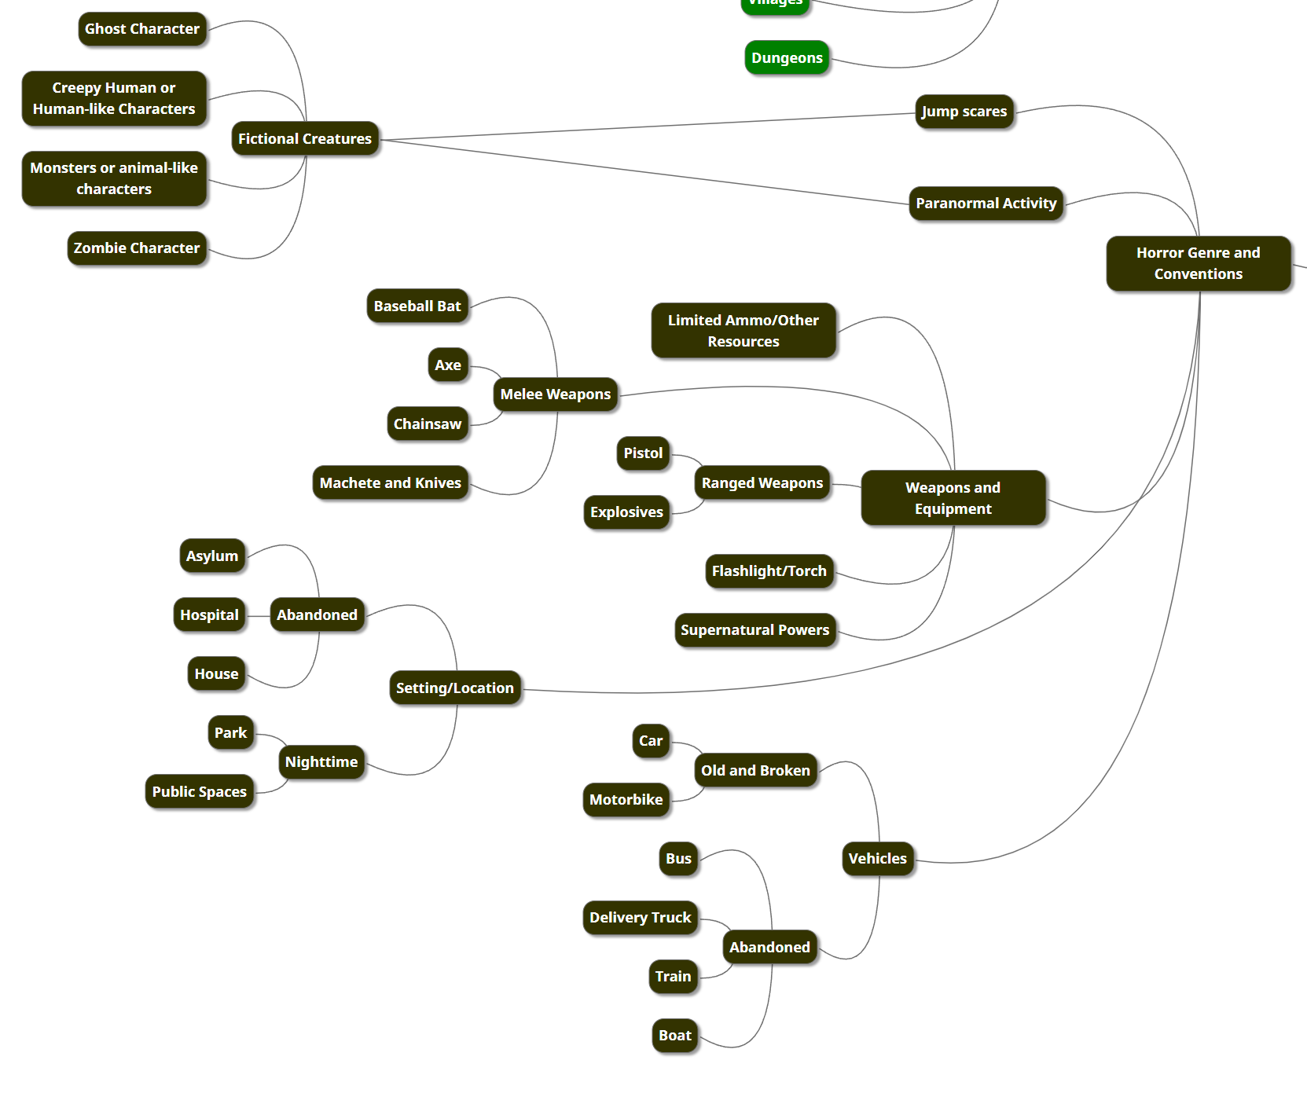

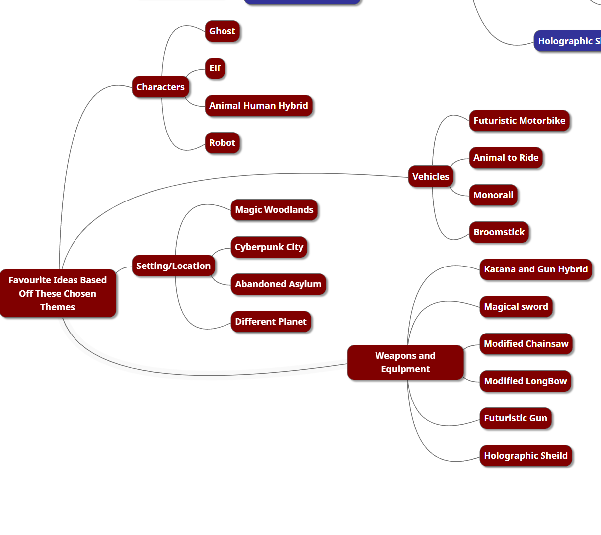Favourite Ideas From my Mind Map

- Katana and Gun Hybrid

- Animal to Ride

- Futuristic Motorbike

- Elf

- Ghost
Moodboards and Inspiration
Katana Gun Hybrid
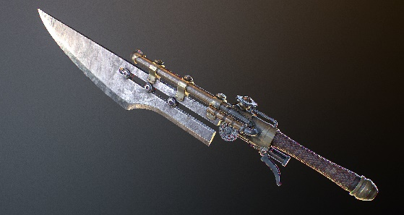
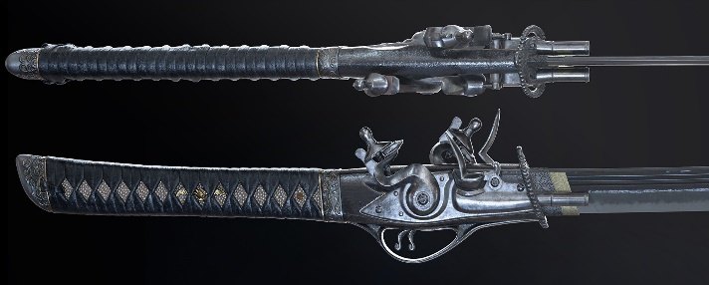

[1] [4]
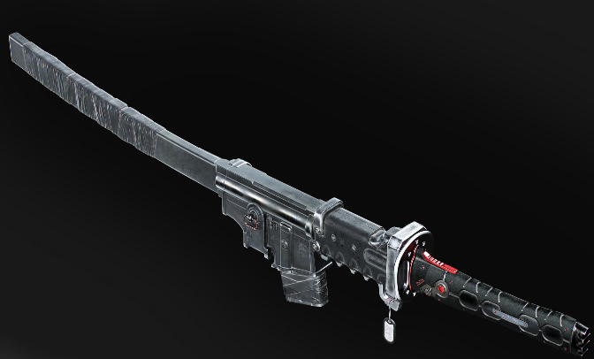
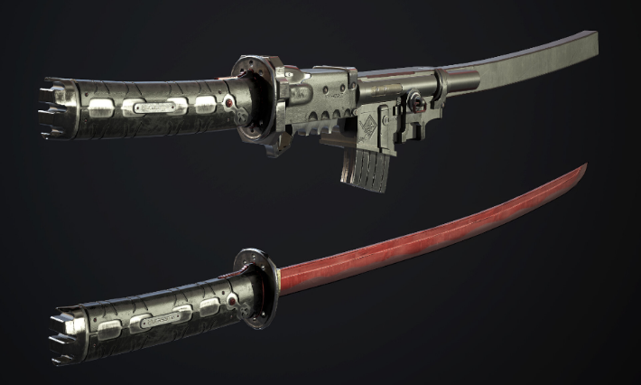

[2] [5]
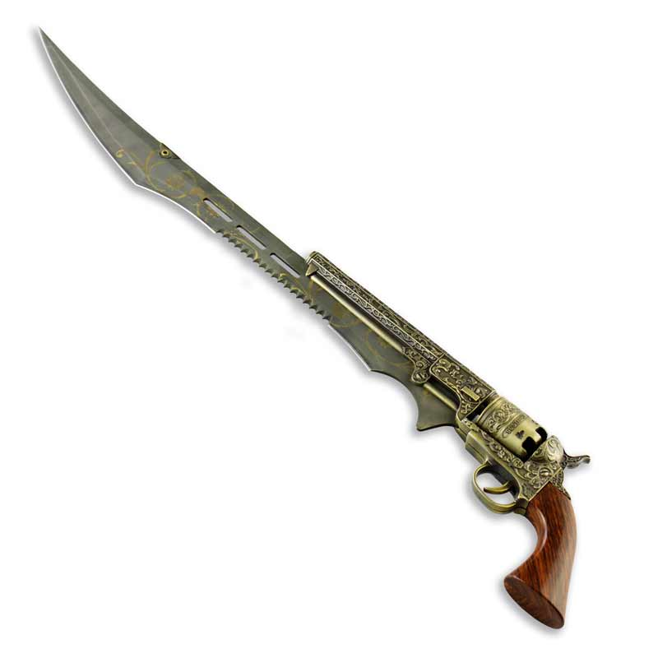
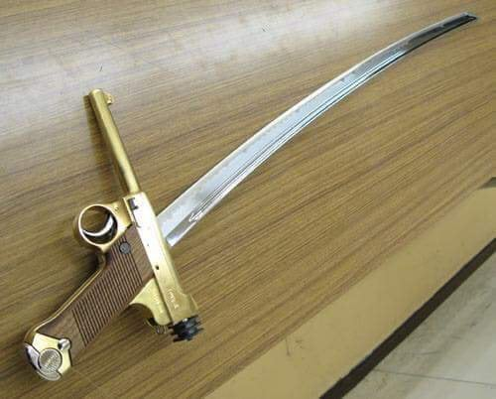

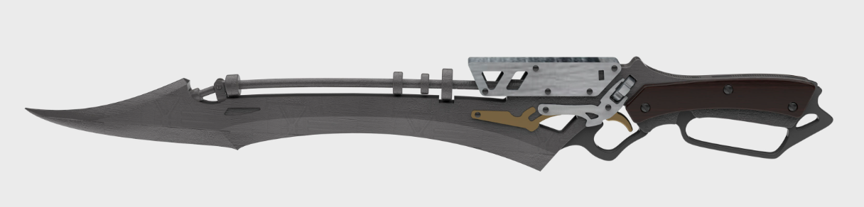
[3] [6]
[7]
Animal to Ride
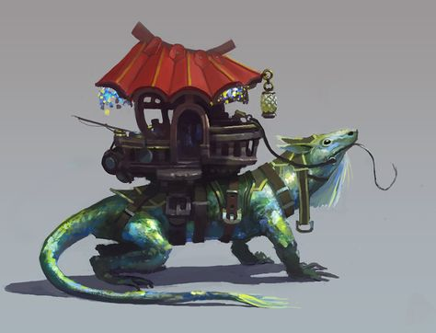
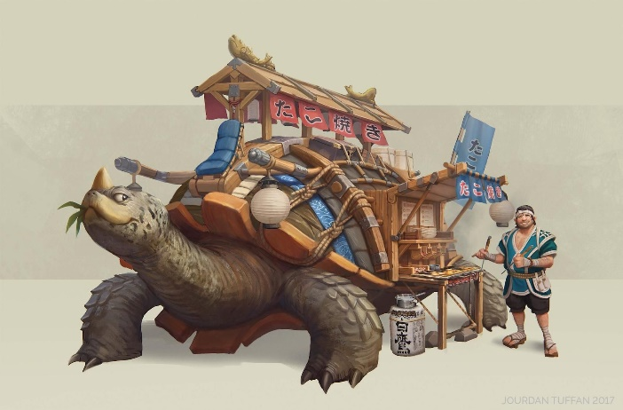
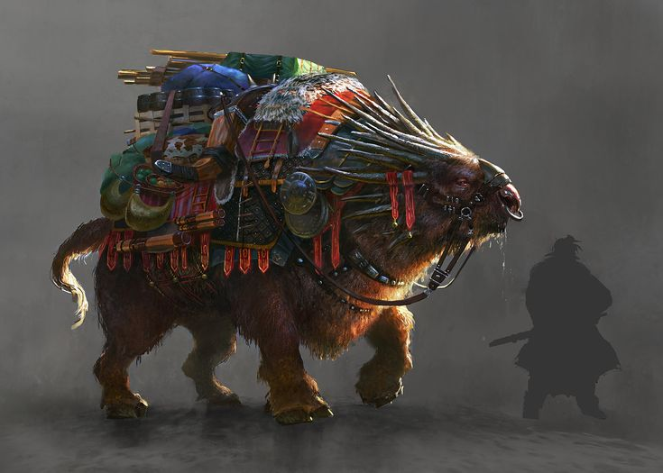
[8] [11]
[9] [12]
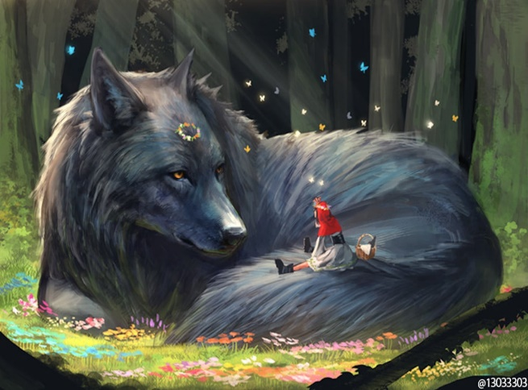

[10] [13]
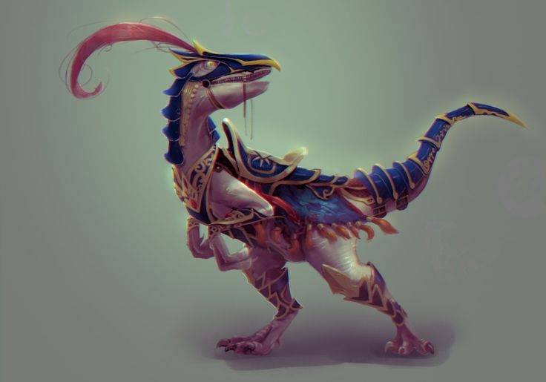
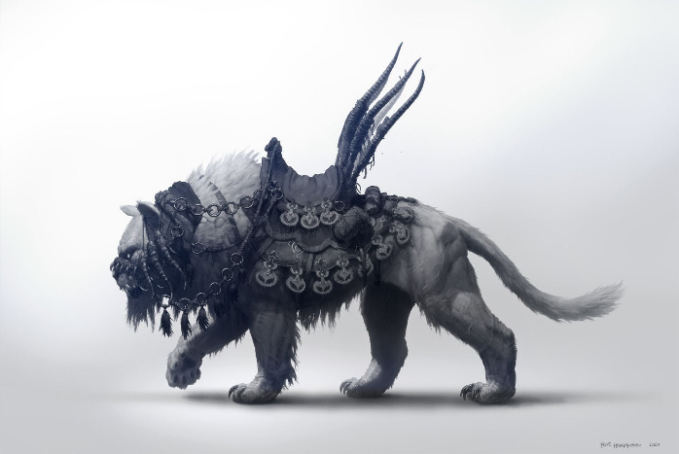

Futuristic Motorbike

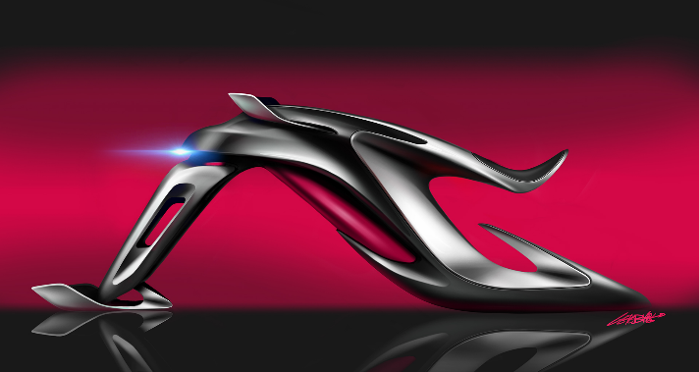
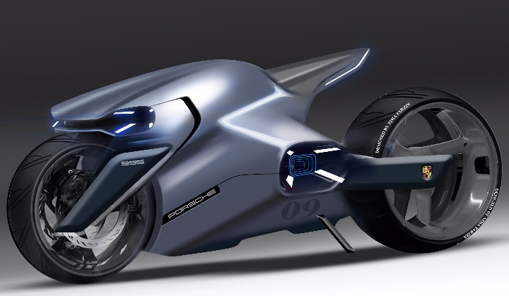

[14] [17]
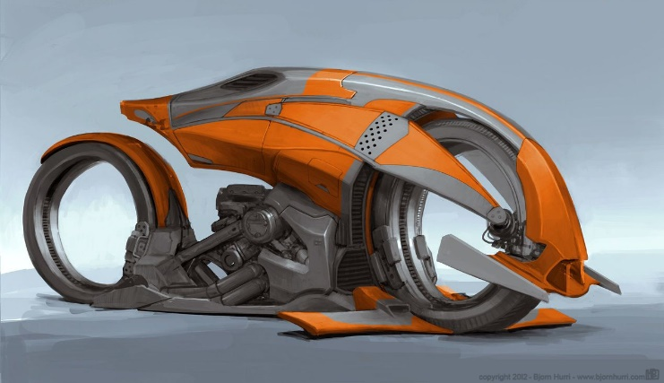
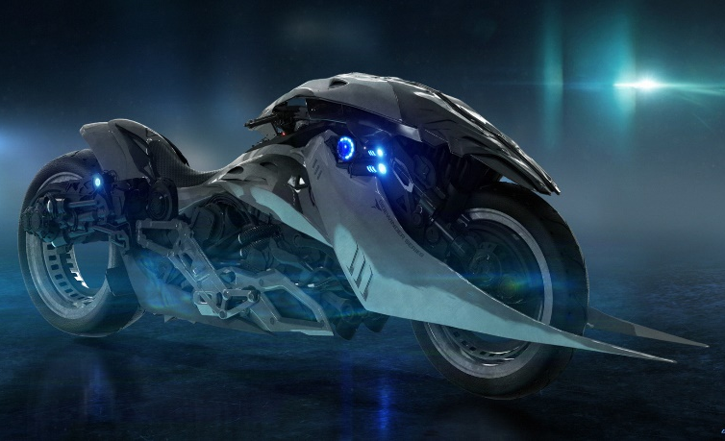

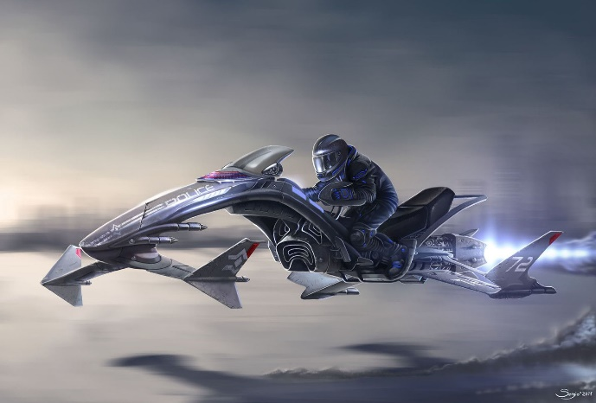
[15] [18]
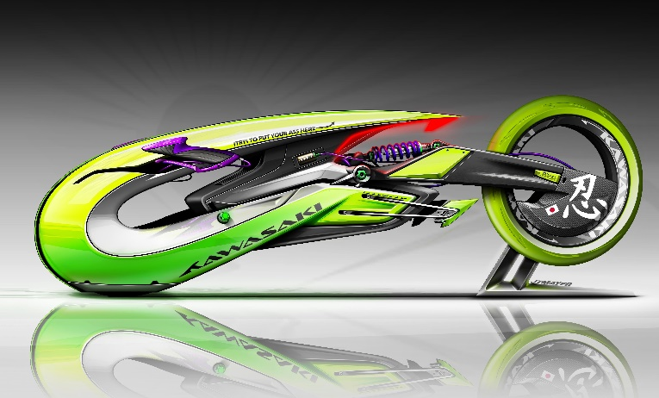
[16] [19]

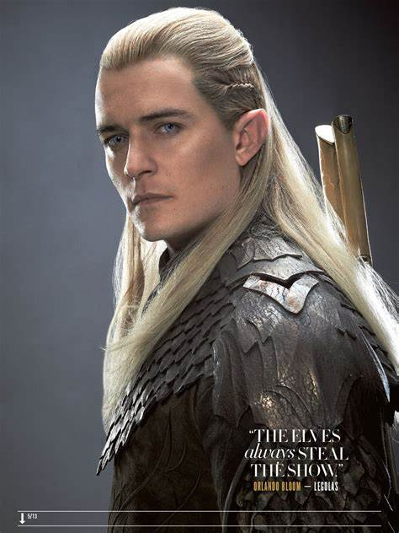
Elf
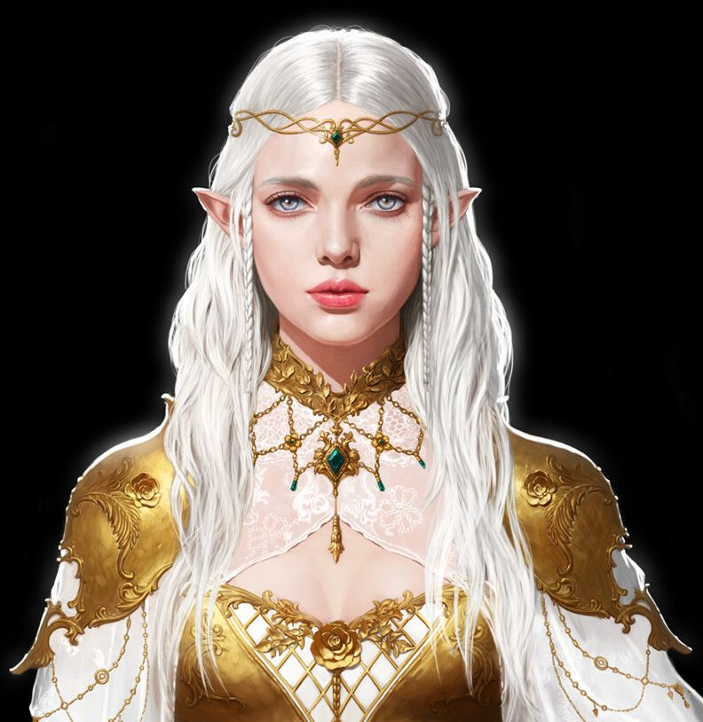

[20] [23]
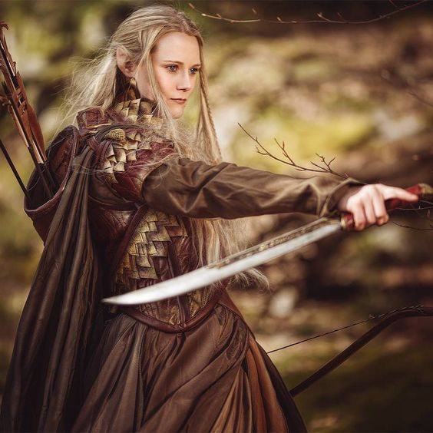
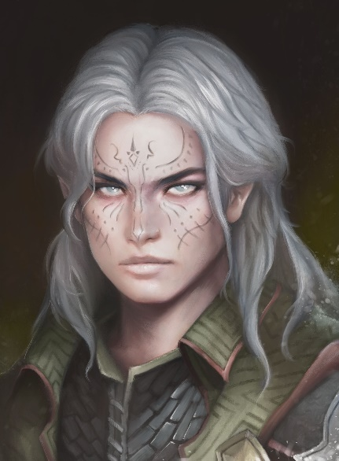

[21] [24]
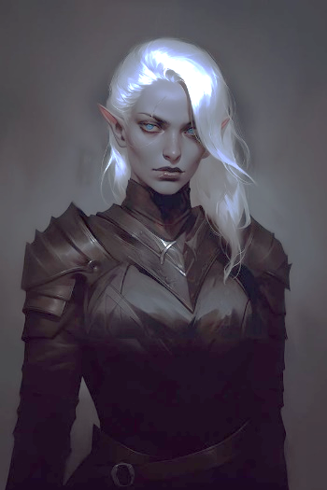
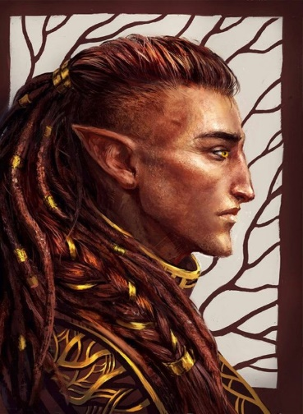

[22] [25]
Ghost
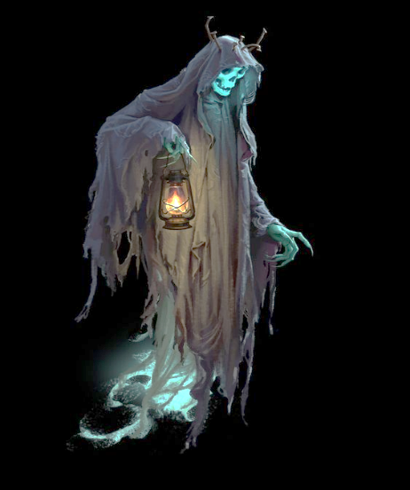


[26] [29]
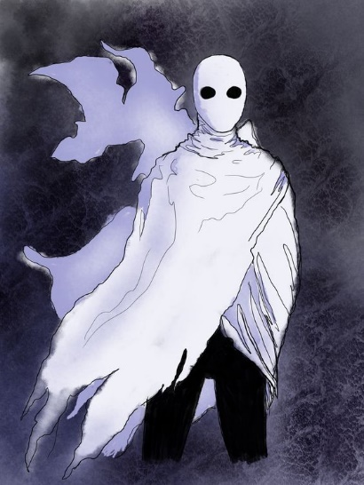
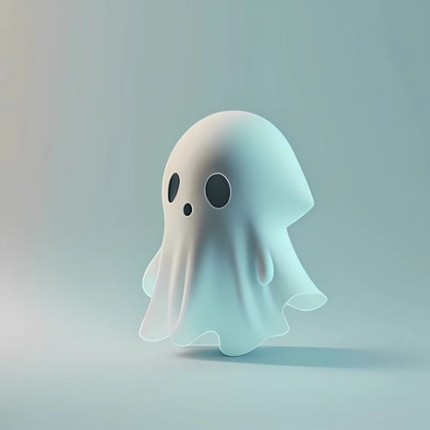

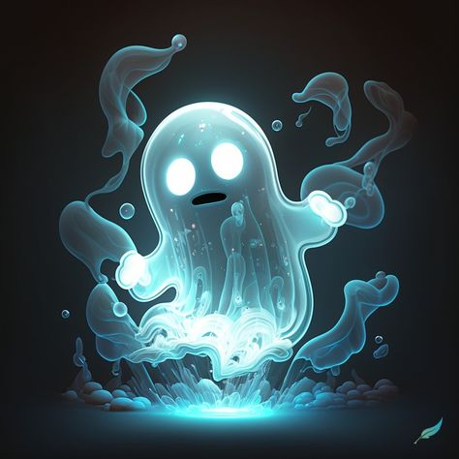
[27] [30]
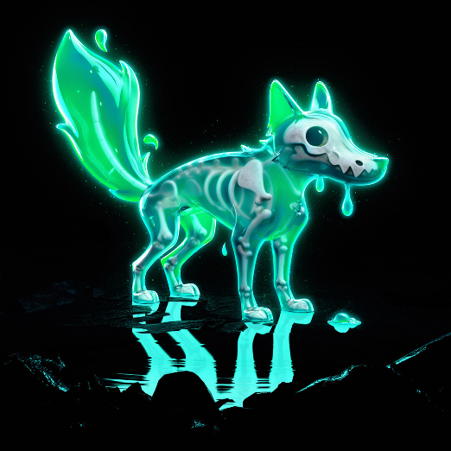

[28] [31]

Further Research

I decided to conduct further research into my top 3 ideas. To complete this, I looked at google scholar essays, encyclopaedia’s, religious passages, and community threads.

Further Research into a Katana Gun Hybrid
From specified google searches, such as ‘Katana Gun Hybrid Weapons In Media’, I was able to find out that such weapons exist in varying forms of media. Within the game Cyberpunk2077 ^{[32]}, players have the ability to create unique weapons and can craft a katana combined with a pistol. I looked into this more in depth to discover the fixings, placements, ergonomics, and anthropometrics of the Katana Pistol to try and grasp how a realistic weapon of such would be crafted. I also found that a katana gun hybrid was in the anime series RWBY^{[33]}. The weapon is wielded by the main character Blake Belladonna and is first seen within the first trailer for the tv show. The weapon, nicknamed the ‘Gambol Shroud’, can be stored as either one combined weapon, or two individual weapons^{[34]}. When the foldable blade is folded, the weapon looks like a Kama, a traditional Japanese tool primarily used for farming and is similar to a sickle^{[35]}. The weapon is aided by a ribbon, in which the main character is able to wrap around the trigger of the gun to use it whilst the blade is still up^{[34]}.
I also researched into historic guns that were similar to my idea. The Bayonet was a French weapon consisting of a knife or dagger and the end of a barrel of a gun, to serve the purpose of a normal firearm, and the melee ability to stab^{[36]}. The first few iterations of a bayonet were not that effective or efficient, as the blade slotted into the barrel meaning the gun was unable to fire whilst equipped with the blade. The Socket Bayonet consisted of a sleeve that fitted over the muzzle of the gun and locked into position which was the most efficient bayonet^{[36]}.
I then looked at a google scholar essay, where I was able to find the causes of reduction of the Bayonet, which to summarise, was due to modern firearms no longer needed as close combat^{[37]}. From this information, it could mean the most efficient design of this weapon I create, could be set in history to add further realism. (Depicted images, left to right [38],[39])
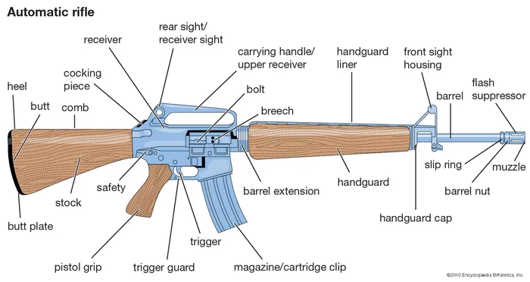

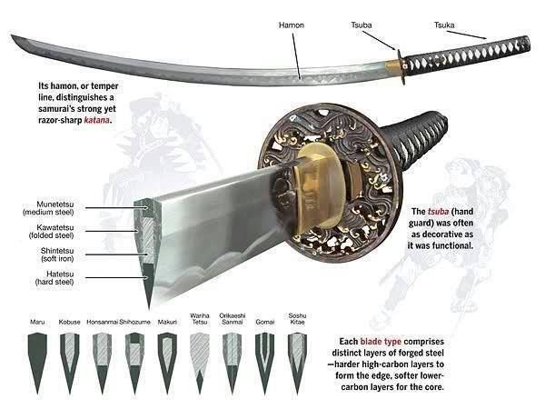
Further Research into a Futuristic Motorbike

To start my further research, I decided to google, ‘Futuristic Motorbikes In Media And Entertainment’. From this search I was able to find that the famous TRON: Legacy^{[40]} motorcycle was developed and manufactured in real life by the Parker Brothers^{[41]}. This information was able to help me have a more in depth look at a futuristic motorcycle, through being able to research what materials and measurements were used. The Artist Daniel Simon, the visionary who created the bike within the film worked with the Parker Brothers helped to create an electric bike that charged in 3 hours and reached a top speed of 70mph, nicknamed the Xenon^{[42]} the bike features electroluminescent strips on the rim of the wheels and carbon fibre around the steel chassis^{[42]}. The bike is also customisable with colour and added features by owners of the vehicles.
I looked into google scholar essays surrounding the future of motor vehicles and found out more about the innovation of modern motor vehicles and their specifications that are leading towards enhanced efficiency and power through inverted cooling systems, ceramic capacitors and battery-pack designs^{[43].} I decided to look into the parts that go into the manufacturing of a motorcycle, which would aid my designs to be more detailed and realistic. (Depicted images top to bottom [44], [45])
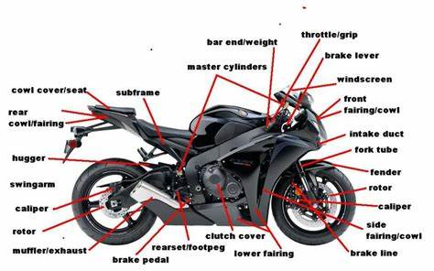

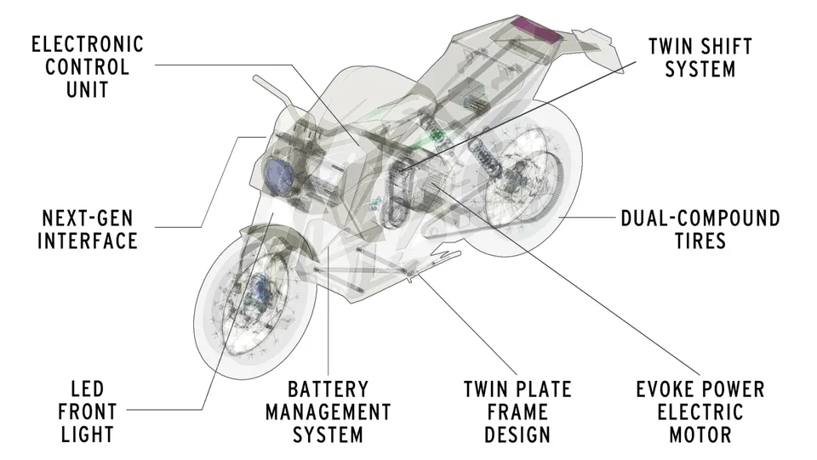

Further Research into a Ghost Character

I decided to look at ghost characters that already exist in the entertainment industry, specifically more within games. To do this, I googled ‘Ghost characters in games’ From this search I found ’13 most memorable video game ghosts’ ^{[46]}, which I wanted to research further, to try and determine why these characters were so memorable, and how I can implement memorability into my character. From this list, the top 4 were characters focused more on a family-friendly cute design, rather than a scary horror game design. Some of these characters included the Pac-Man Ghosts ^{[47]} and Boo’s from the Mario Franchise ^{[48]}. This enticed me into the idea of creating a ghost character for a family friendly or children’s video game, which was wildly different from my original concept of a ghost character for a horror genre.
As an artist, I was inspired by varying concepts of what a ghost can be, not just floating cloth or a see-through character. I looked into myths, legends, and religious texts to broaden my scope on what a ghost could be. I found out through varying google scholar essays and website articles that Roman Catholicism believe ghosts are malevolent spirits trying to connect contact to the human world, and it is looked down upon to try and create contact with them^{[49]}. In Islam, whilst ghosts are not believed in, the Qur’an mentions Jinn’s which are invisible beings that can possess/shapeshift into living beings^{[50]}. The most interesting belief of ghosts for me, was found in Judaism, where they believe a spirit is split into 3 aspects: One ascending to heaven, One wandering the human realm and One protecting a grave. Judaism also mentions ‘Ibburs’ who are spirits who act like a guardian angel or guide to humans^{[49]}. (Depicted images left to right [51],[52])
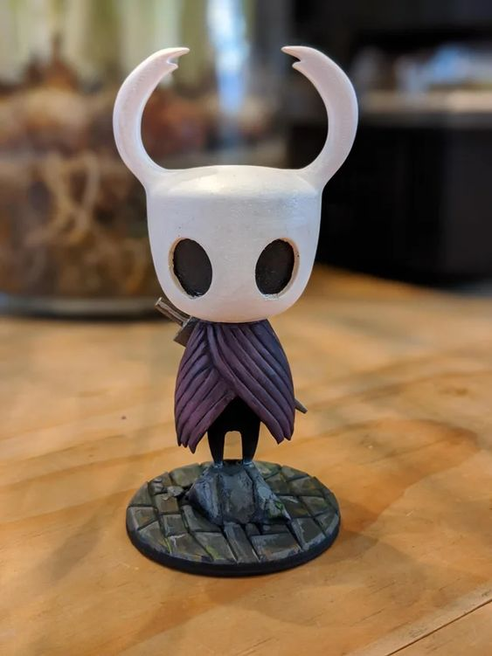
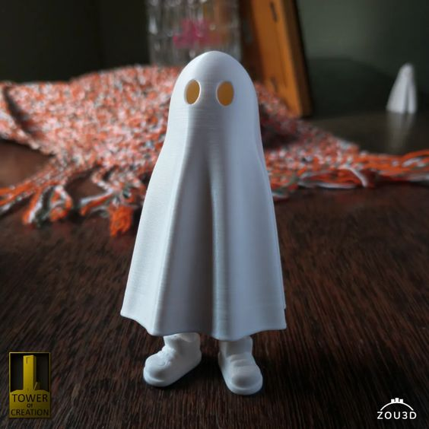
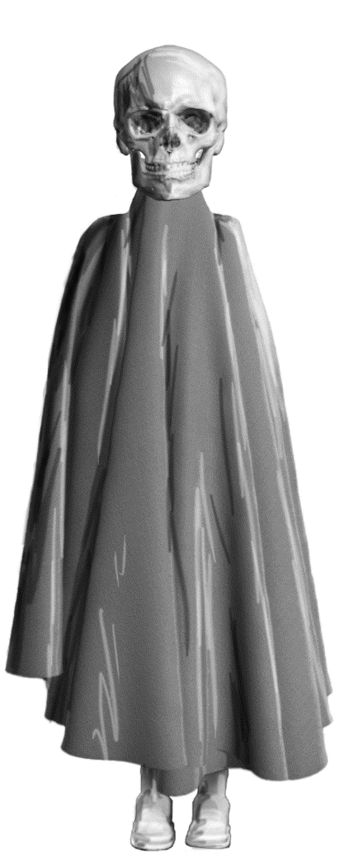
Photobashing

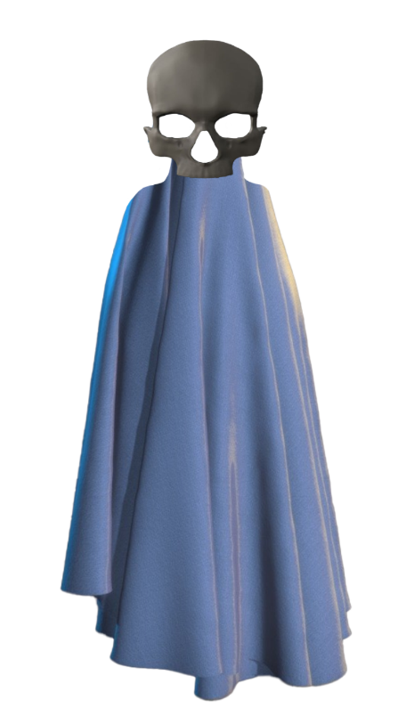
I decided to pick ‘Ghost Character’ as my favourite idea, and I decided to take this design further with Photobashing.

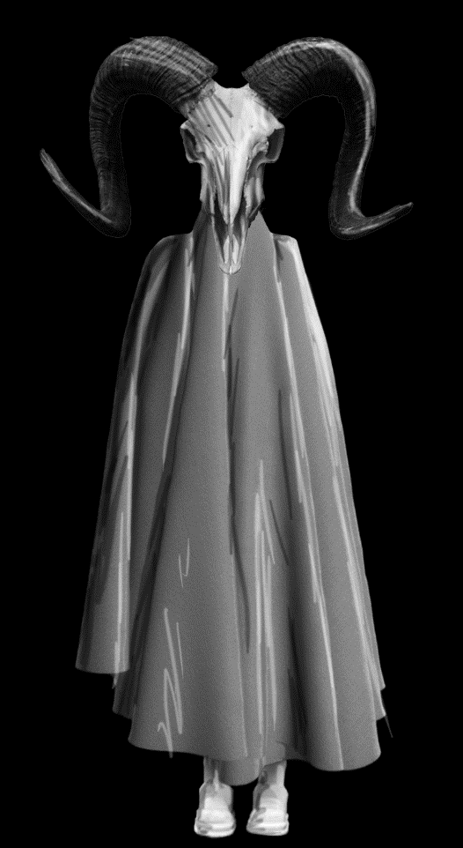
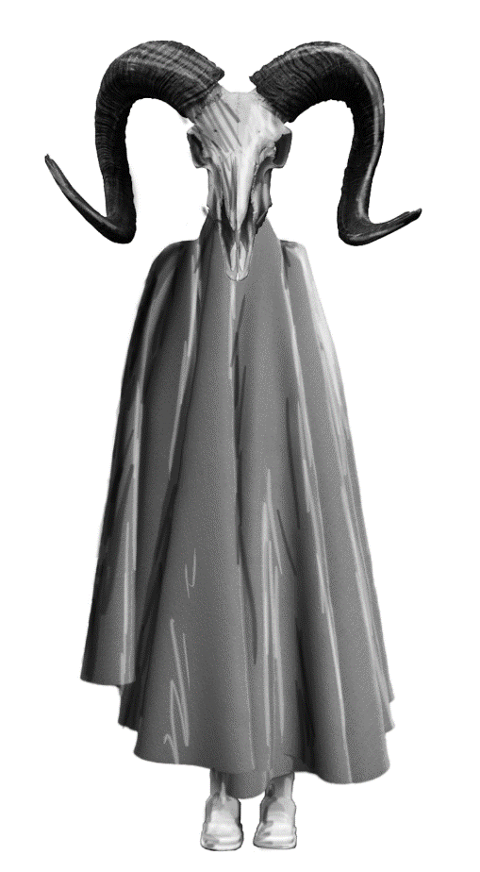
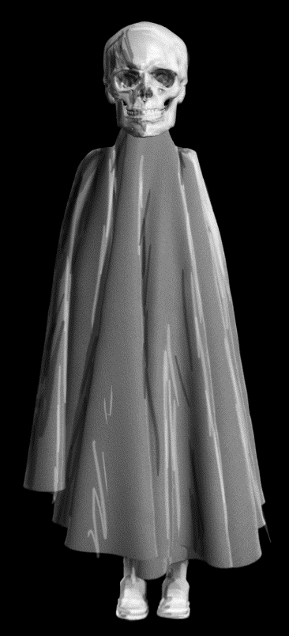

Photobashing
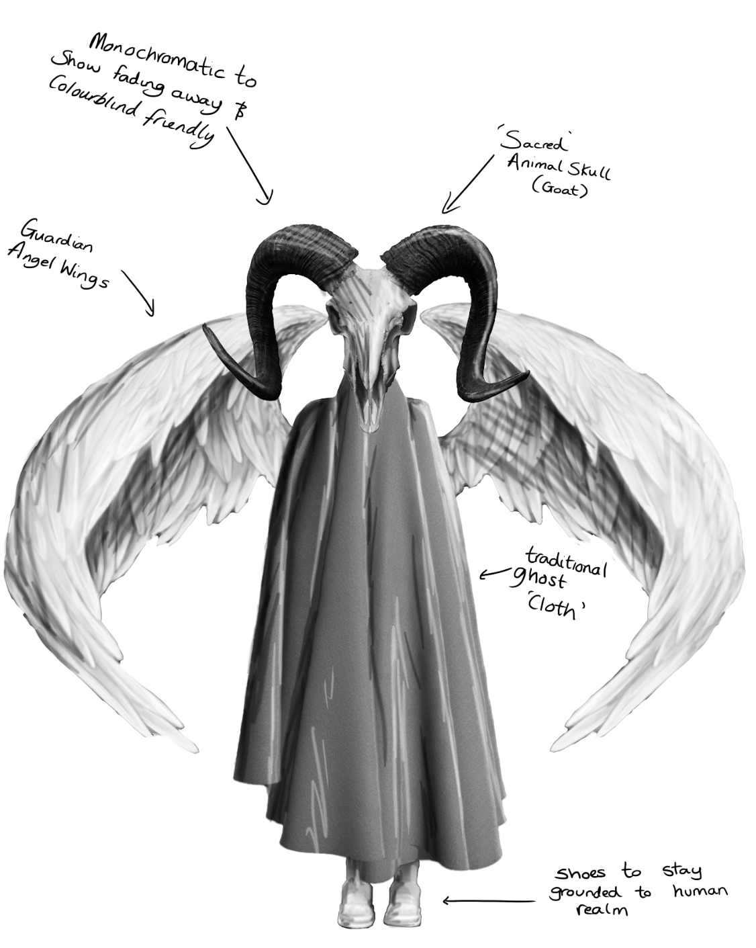

Photos used in Photobashing [53] [54] [55] [56] [57] [58]
Sketches
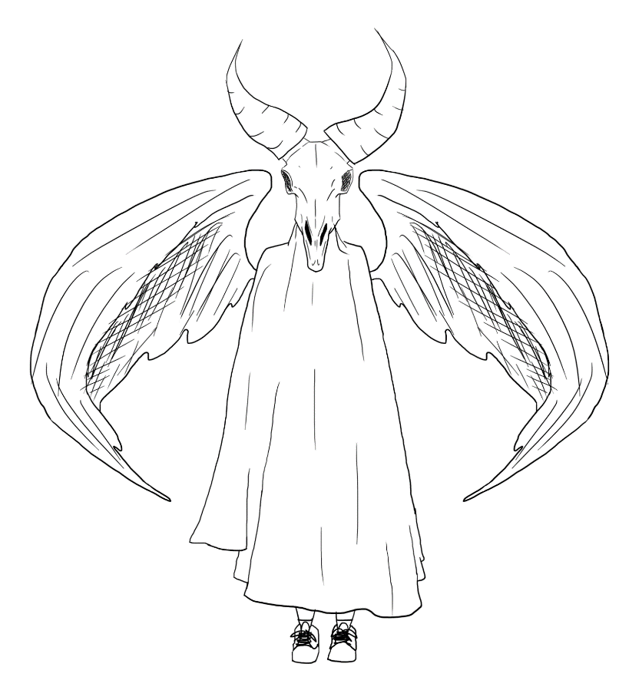
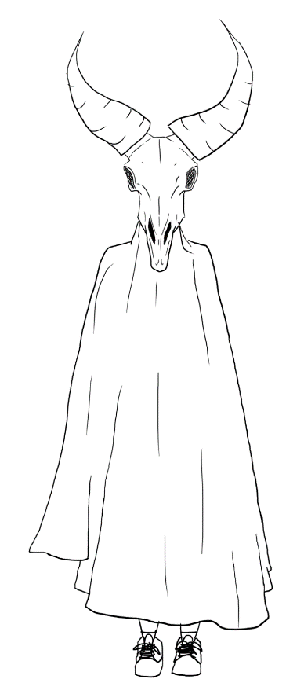

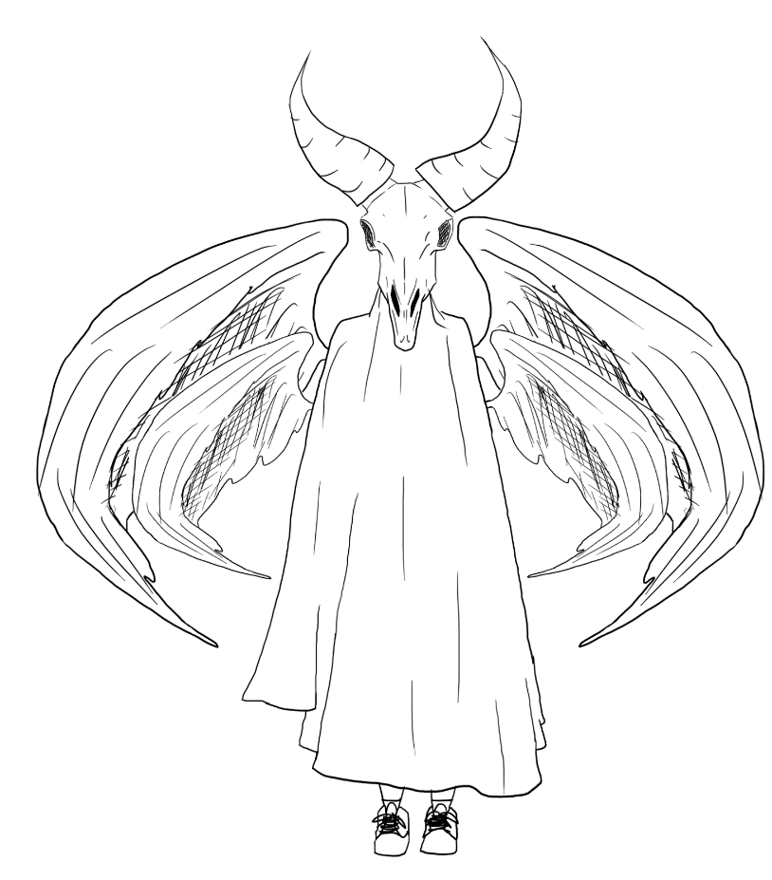
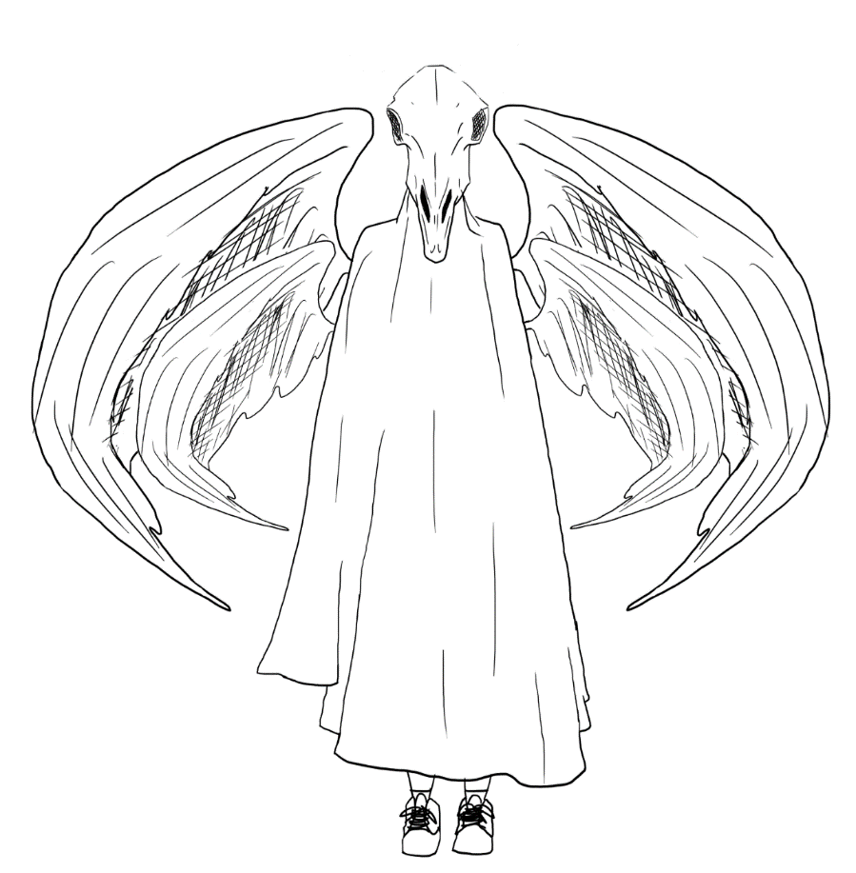

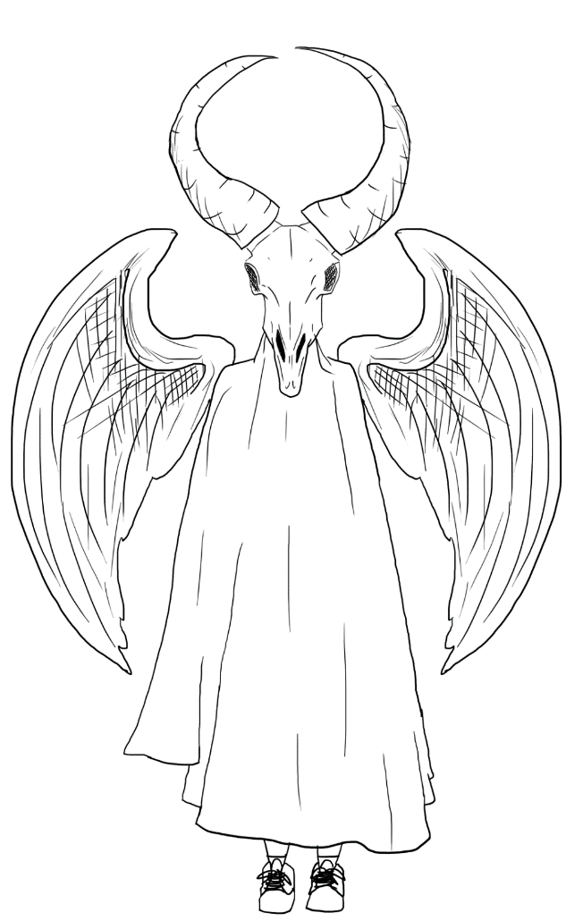
Sketches
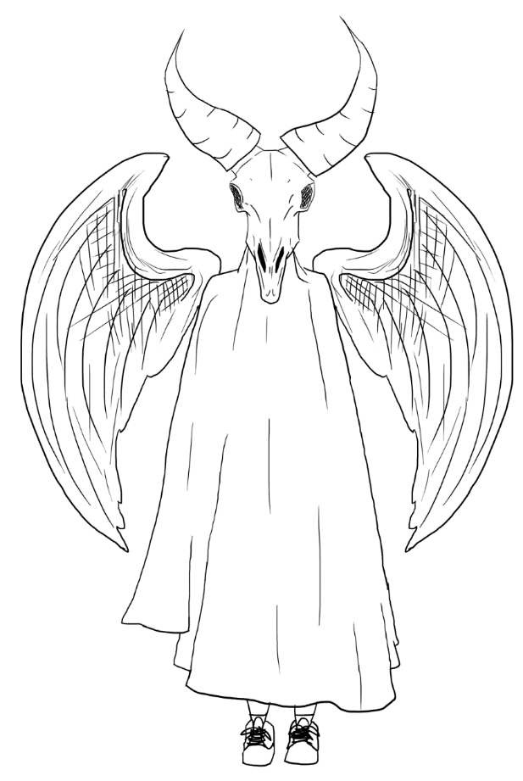

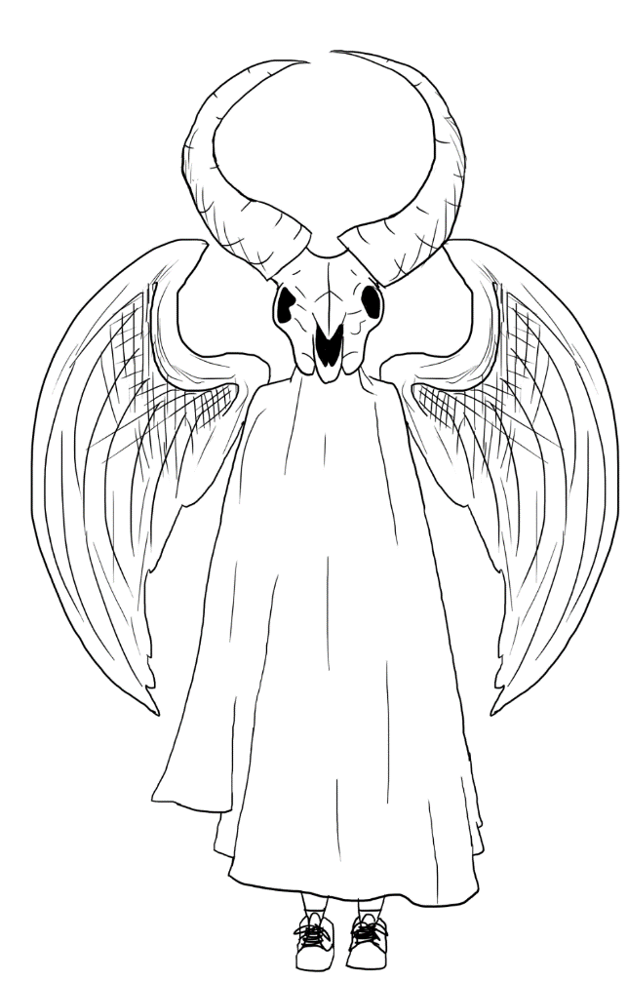
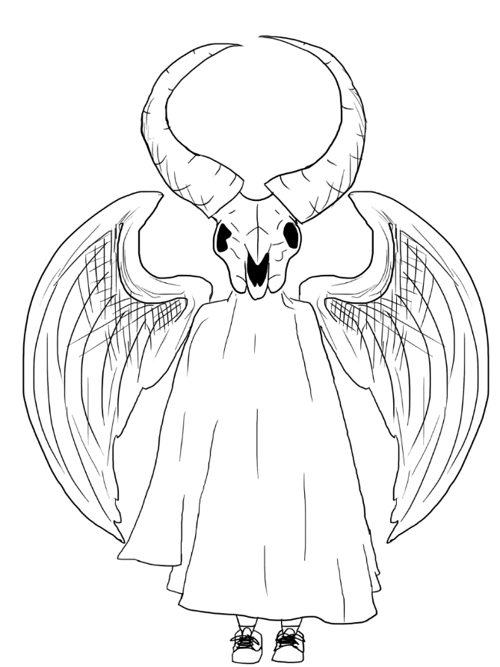

Different styles
Research and Development on my design in various memorable styles
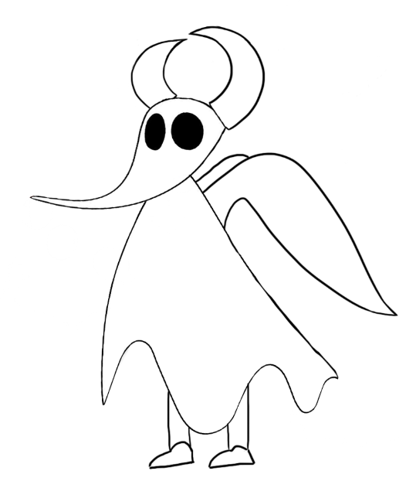
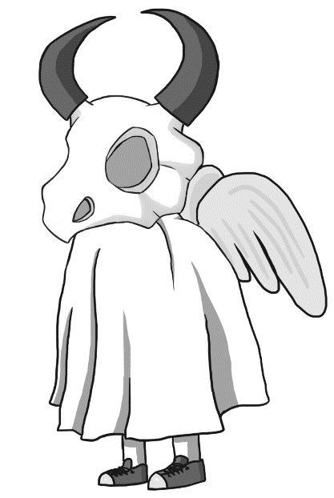

Nintendo ‘Cubone’ [59] Disney ‘Zero the Ghost’ [60]

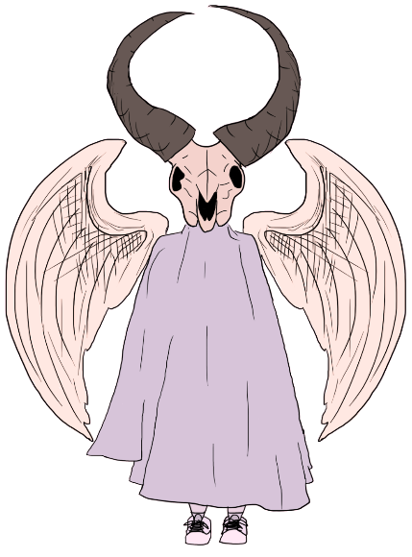
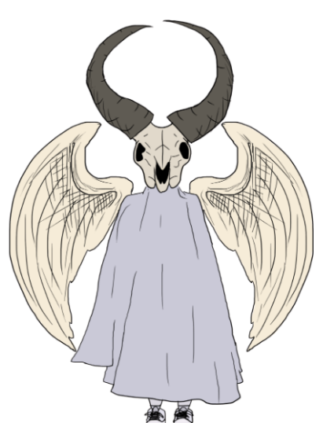
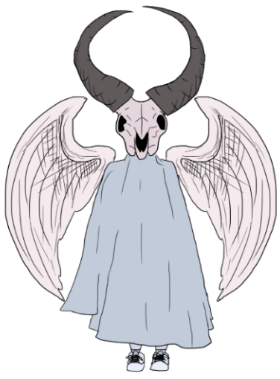
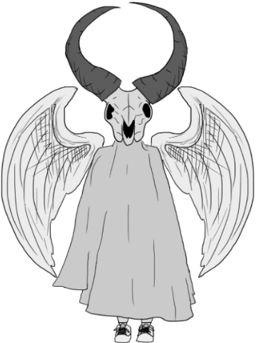
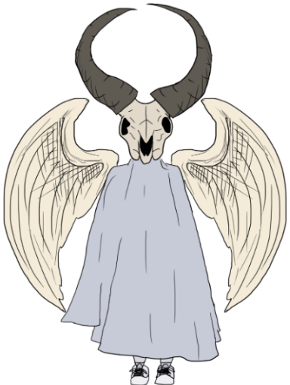
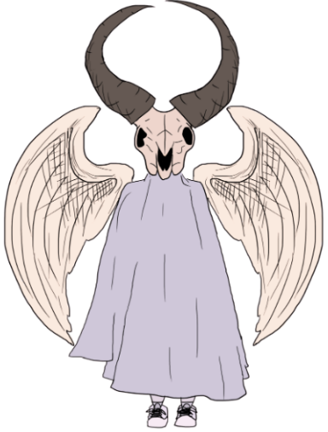
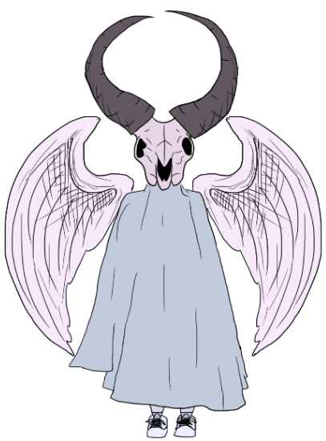
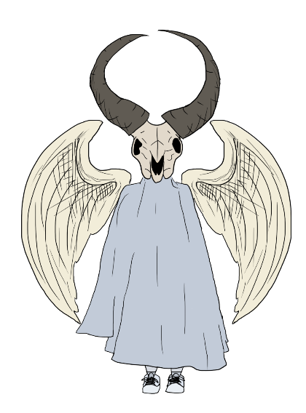
Colourblind Test [61]
Silhouette Test







Final Design
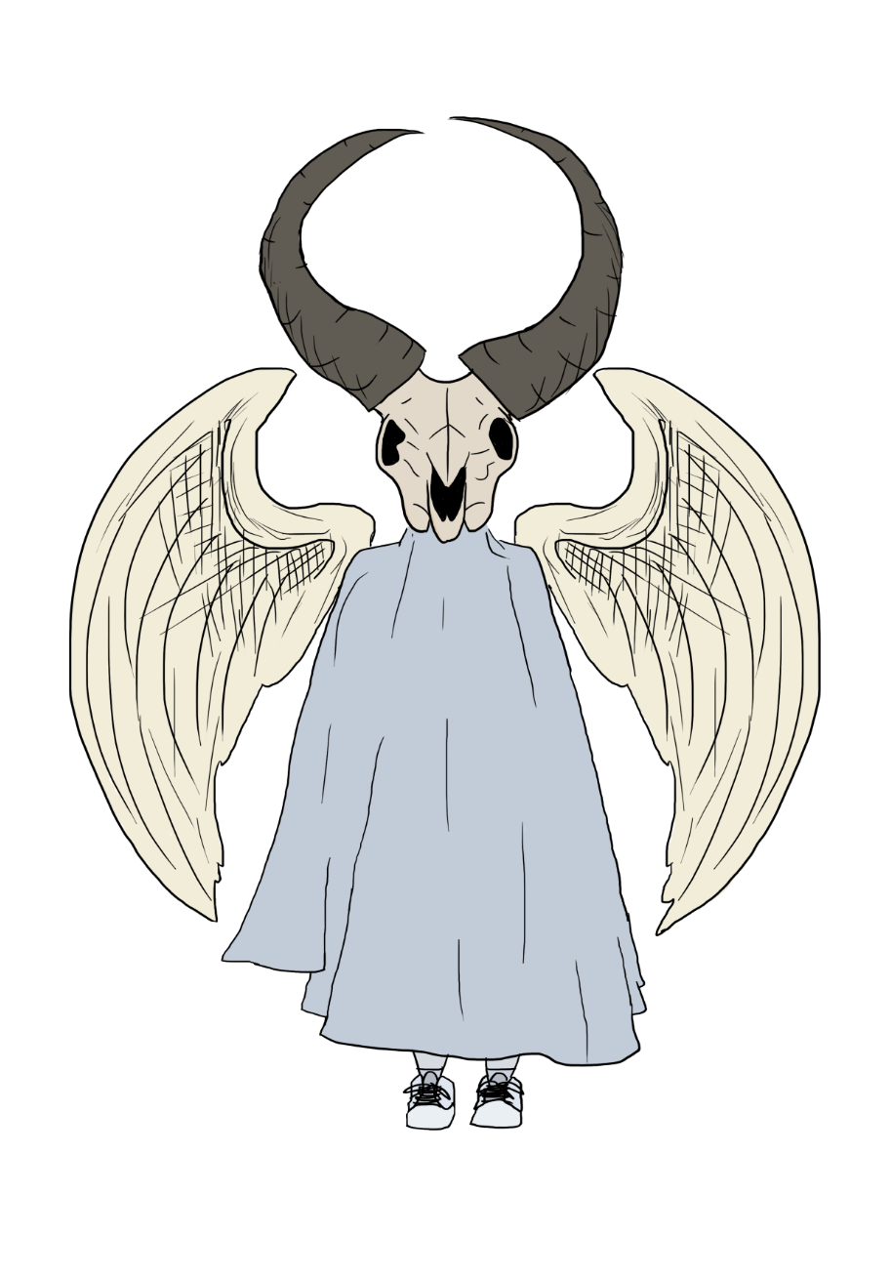
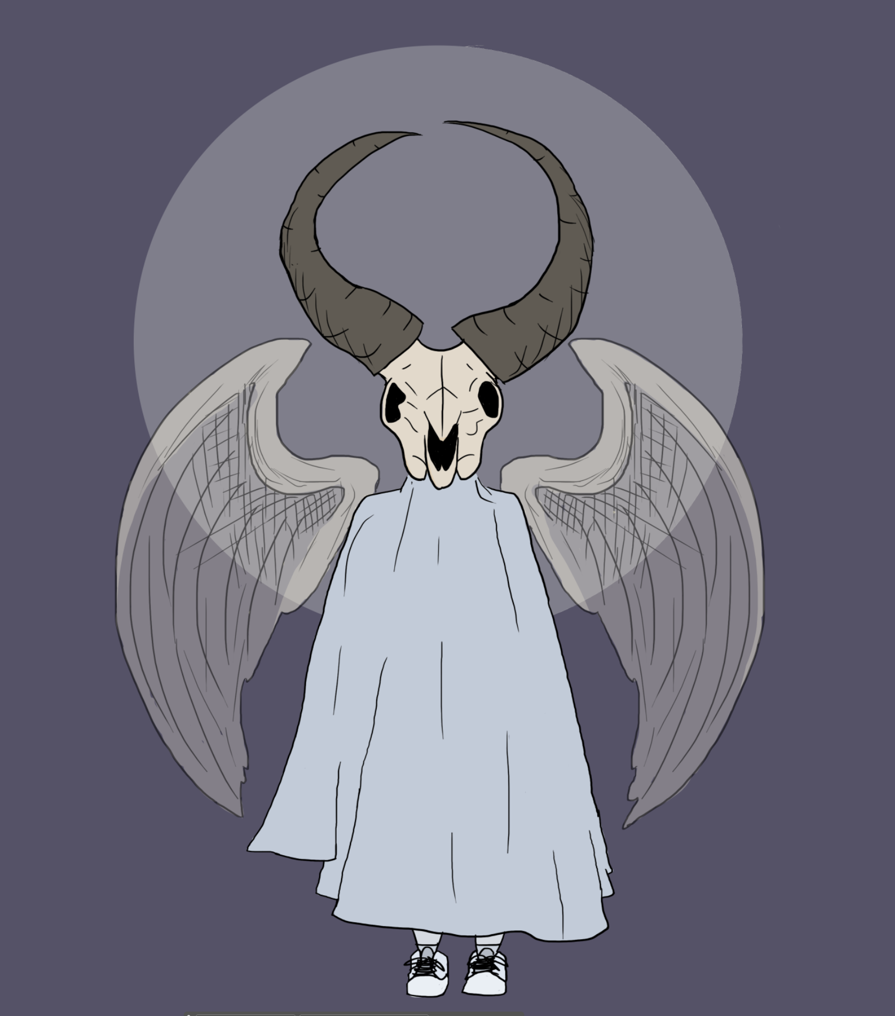
Final Design

Design Choice Statement

After doing in depth research into the science and religious aspects of ghosts, I knew that I wanted to base my character of realistic beliefs. My main inspiration was from Judaism which contains beings known as ‘Ibburs’ ^{[49]} who can shapeshift and act as guardian angels and protectors. I originally created a concept of using a human skull to portray my ghost character is grounded to the human realm, and in charge of guarding the body of their soul, however I decided to change this skull, as through researching further, I came across that in many religions, Goats are considered sacred, and good luck, so I wanted to incorporate this belief with the reinforcement of having a goats skull. This then enabled me to add more depth to my character by playing around with the goats horns. After playing around with some concepts, I decided to create a spherical shape with the horns, to symbolise a halo over my character, which helps to show my character is friendly and a guardian angel. I also wanted to incorporate legs to further show my character is grounded to the human realm. I wanted my character to appeal to family-friendly audiences, as this was a common factor that I found with the top most memorable ghost characters^{[46]}. To achieve this look, I decreased my characters height, to symbolise a child’s stature. I also made changes to the goat skull to appear friendlier and less scary, using rounder and smoother lining to appear cuter ^{[62]}. I decided I want my design’s silhouette to be well-pronounced and defined. To emphasise this, I moved one wing out slightly and cleaned up any misplaced lines to pronounce my characters silhouette further. I used pale, duller pastel colours to portray a more ghostly appearance, which is often connoted through these types of colours. I decided to make the wings of my character transparent to create a ghostly effect. The feathered wings are those similar to a bird, with a wingspan of up to 10 feet wide. These beings can grow up to 5 feet tall, averaging around 4’8’’. The body of my character appears to be made of cloth or fabric, draping down a thin skeletal body. The skull and horns of a goat appears real and made of bone, with a hollow inside, suggesting the cloth body is attached at the nape of the skull. The Horns are slightly asymmetrical to show natural form and growth. My character will stay close to the grave of their soul to protect the body and mind. These beings can often be found in graveyards, but are usually invisible to the naked human eye, only certain lights and cameras can detect and see their presence.

Bibliography

[1] Artstation - Motoki Nakazawa, https://www.artstation.com/motoki (accessed Feb. 13, 2024).
[2] “Katana with Gun Attachment,” Bing, https://www.bing.com/images/search?view=detailV2&ccid=gMtlfU52&id=040A5B4F066E774C953DCCCD2FF99A18E3B06A11&thid=OIP.gMtlfU52sy-RbL_SpP838QHaEK&mediaurl=https%3A%2F%2Fi.pinimg.com%2Foriginals%2F2f%2F97%2Fee%2F2f97ee6af031d02a248729872b8535f4.png&cdnurl=https%3A%2F%2Fth.bing.com%2Fth%2Fid%2FR.80cb657d4e76b32f916cbfd2a4ff37f1%3Frik%3DEWqw4xia%252bS%252fNzA%26pid%3DImgRaw%26r%3D0&exph=562&expw=1000&q=katana%2Bgun&simid=608038988892292502&FORM=IRPRST&ck=D80353F3A6F0C17EA7BEE5F079B55BDB&selectedIndex=13&itb=0&ajaxhist=0&ajaxserp=0 (accessed Feb. 13, 2024).
[3] Finally a katana gun, a solution to many problems. : R/gecko45 - reddit, https://www.reddit.com/r/Gecko45/comments/5gncgh/finally_a_katana_gun_a_solution_to_many_problems/ (accessed Feb. 13, 2024).
[4] “Gunblade steampunk: 3D model,” CGTrader, https://www.cgtrader.com/3d-models/military/melee/gunblade-steampunk (accessed Feb. 13, 2024).
[5] Artstation - Murasama Blade, https://www.artstation.com/artwork/G9laN (accessed Feb. 13, 2024).
[6] “Steampunk gun blade,” KarateMart, https://www.karatemart.com/steampunk-gun-blade (accessed Feb. 13, 2024).
[7] “OnlineResize. club. resize image, Crop Pics, add Instagram effect.,” onlineresize.club, https://onlineresize.club/2021-club.html (accessed Feb. 13, 2024).
[8] Imgur, “D&D ideas :: Merchants and shopkeeps,” Imgur, https://imgur.com/gallery/L4Ffudp (accessed Feb. 13, 2024).
[9] Artstation - Khitan Tiger Mount, https://www.artstation.com/artwork/dQXaW (accessed Feb. 13, 2024).
[10] Artworks | artstation, https://www.artstation.com/marketplace/game-dev/artworks/graphics-animation/artworks (accessed Feb. 13, 2024).
[11] “Animal Mount with House,” Bing, https://www.bing.com/images/search?view=detailV2&ccid=DDfwNMN%2B&id=3EC51F2DBA38EE9E05DE33E6733D9270A2F0C132&thid=OIP.DDfwNMN-set5Q03de36L5wAAAA&mediaurl=https%3A%2F%2Fi.pinimg.com%2F474x%2Fab%2Fa8%2F96%2Faba89643081365c55e737411ba0b0f29--creature-concept-fantasy-artwork.jpg&cdnurl=https%3A%2F%2Fth.bing.com%2Fth%2Fid%2FR.0c37f034c37eb1eb79434ddd7b7e8be7%3Frik%3DMsHwonCSPXPmMw%26pid%3DImgRaw%26r%3D0&exph=362&expw=474&q=fantasy%2Banimal%2Bcart&simid=607986212403161279&form=IRPRST&ck=DC03A0EE9B28C64BF81D26A53B689F82&selectedindex=4&itb=0&ajaxhist=0&ajaxserp=0&pivotparams=insightsToken%3Dccid_6i%252BumZ6t%2Acp_6206E20A316AC1CC63CA57AE4F3625E1%2Amid_AD031A25720642C4F9CFE49CCE34D9F9E45E247E%2Asimid_608021572809549130%2Athid_OIP.6i-umZ6tI0cVeGaSW7Lu%21_gHaE3&vt=0&sim=11&iss=VSI (accessed Feb. 13, 2024).
[12] “Irin’s mount, grosnez illustrateur: Fantasy creatures art, creature concept art, Fantasy Beasts,” Pinterest, https://www.pinterest.com/pin/irins-mount-grosnez--206602701634518287/ (accessed Feb. 13, 2024).
[13] S. Barnes, “Illustrator imagines a world where gentle giant animals live among humans,” My Modern Met, https://mymodernmet.com/monokubo-fantasy-digital-paintings/ (accessed Feb. 13, 2024).
[14] “Ideation: Motorbike design, concept motorcycles, Super Bikes,” Pinterest, https://www.pinterest.co.uk/pin/340092209348952181/ (accessed Feb. 20, 2024).
[15] Artworks by artists from around the World | Artstation, https://www.artstation.com/marketplace/game-dev/artworks (accessed Feb. 20, 2024).
[16] “Motorbike Design,” Pinterest, https://www.pinterest.co.uk/?show_error=true (accessed Feb. 20, 2024).
[17] M. Lefebvre, “Sketchbook // rendering,sketches ...,” Behance, https://www.behance.net/gallery/54129431/SKETCHBOOK-Renderingsketches- (accessed Feb. 20, 2024).
[18] “Speeder bike,” StarWars.com, https://www.starwars.com/databank/speeder-bike (accessed Feb. 20, 2024).
[19] Flying Bike, Sergio Botero, https://www.artstation.com/artwork/3V2mg (accessed Feb. 20, 2024).
[20] Artstation - Amelia 404, https://www.artstation.com/amelia404 (accessed Feb. 21, 2024).
[21] “Omupied - Digital artist,” DeviantArt, https://www.deviantart.com/omupied (accessed Feb. 21, 2024).
[22] “Pin by Jim Stevens on elves: Elf characters, character portraits, fantasy art men,” Pinterest, https://www.pinterest.fr/pin/138345019791337155/ (accessed Feb. 21, 2024).
[23] lilyZ, “The hobbit photo: Into the woods: Empire portraits: Elves,” Fanpop, https://www.fanpop.com/clubs/the-hobbit/images/34842109/title/woods-empire-portraits-elves-photo (accessed Feb. 21, 2024).
[24] “ Elf Ranger,” VK, https://vk.com/login?u=2&to=L2FsX2ZlZWQucGhwP3o9cGhvdG8tNTk3NDQ1MV80NTYyNDcyODIlMkZ3YWxsLTU5NzQ0NTFfNjY2NTI- (accessed Feb. 21, 2024).
[25] “Zeenith, the blue eyed drow: Dungeons and dragons characters, elves fantasy, character portraits,” Pinterest, https://www.pinterest.fr/pin/340514421841650426/ (accessed Feb. 21, 2024).
[26] Formform, Lyivan, and Gaf, “Cartoon ghost character: 3D model,” CGTrader, https://www.cgtrader.com/3d-models/character/fantasy-character/cartoon-ghost (accessed Feb. 21, 2024).
[27] “Pin by Sapphire on wonderful: Art toys design, cartoon character pictures, ghost games,” Pinterest, https://www.pinterest.co.uk/pin/32510428554811962/ (accessed Feb. 21, 2024).
[28] “Cute ghost: Ghost cartoon, spirit ghost, Cute Ghost,” Pinterest, https://www.pinterest.co.uk/pin/1092404453347438804/ (accessed Feb. 21, 2024).
[29] “Artstation,” YouTube, https://www.youtube.com/c/ArtStationHQ (accessed Feb. 21, 2024).
[30] “Pin by Schuyler J Thackeray on clothes: Character art, superhero art, fantasy character design,” Pinterest, https://www.pinterest.co.uk/pin/49047083432794102/ (accessed Feb. 21, 2024).
[31] Artstation - explore, https://www.artstation.com/search (accessed Feb. 21, 2024).
[32] “Get the ultimate cyberpunk 2077 experience,” Home of the Cyberpunk 2077 universe - games, anime & more, https://www.cyberpunk.net/gb/en/ (accessed Feb. 21, 2024).
[33] “The funniest content on the internet,” Rooster Teeth, https://roosterteeth.com/series/rwby (accessed Feb. 21, 2024).
[34] C. to R. Wiki, “Gambol shroud,” RWBY Wiki, https://rwby.fandom.com/wiki/Gambol_Shroud (accessed Feb. 21, 2024).
[35] “Kama weapon: Farmers used kama to fight samurai’s katana,” Malevus, https://malevus.com/kama-weapon/ (accessed Feb. 21, 2024).
[36] “Bayonet,” Encyclopædia Britannica, https://www.britannica.com/technology/bayonet (accessed Feb. 21, 2024).
[37] J. Y. Akerman, “XXVIII.-notes on the origin and history of the bayonet: Archaeologia,” Cambridge Core, https://www.cambridge.org/core/journals/archaeologia/article/abs/xxviiinotes-on-the-origin-and-history-of-the-bayonet/B36BEC2C7E6CF4DCA8A28D17B459F0FB (accessed Feb. 21, 2024).
[38] “Internal steel layers of a katana [600×450],” Pinterest, https://www.pinterest.co.uk/pin/359936195205158119/ (accessed Feb. 21, 2024).
[39] “Assault rifle,” Encyclopædia Britannica, https://www.britannica.com/technology/assault-rifle (accessed Feb. 21, 2024).
[40] “Tron: Legacy,” IMDb, https://www.imdb.com/title/tt1104001/ (accessed Feb. 21, 2024).
[41] P. Jackson, “The futuristic motorcycles you can actually ride,” Supercar Blondie, https://supercarblondie.com/top-10-most-futuristic-motorcycles/ (accessed Feb. 21, 2024).
[42] J. Osborn, “The Tron Motorcycle Bike is real and street legal,” Man of Many, https://manofmany.com/rides/motorcycles/tron-motorcycle-bike (accessed Feb. 21, 2024).
[43] “IEEE Research on Design Considerations for Next-Generation e-Motorbikes,” IEEE, https://ieeexplore.ieee.org/Xplore/home.jsp (accessed Feb. 21, 2024).
[44] “Motorbike Diagram,” Live, draw, and enjoy on getdrawings.com. get free drawings, vector graphics and how to draw tutorials, https://getdrawings.com/get-drawing#simple-motorcycle-drawing-63.jpg (accessed Feb. 21, 2024).
[45] “Application of IOT in automotive industry: Future of motorcycles,” Application Of IoT In Automotive Industry | Future Of Motorcycles, https://www.evokemotorcycles.com/application-of-iot-in-automotive-industry-future-of-motorcycles (accessed Feb. 21, 2024).
[46] T. Staff and G. Huston, “13 most memorable video game ghosts,” TheGamer, https://www.thegamer.com/best-video-game-ghosts/#:~:text=13%20Most%20Memorable%20Video%20Game%20Ghosts%201%2013,Celebrimbor%20From%20Shadow%20of%20Mordor%20...%20More%20items (accessed Feb. 21, 2024).
[47] “The official site for pac-man - video games & more,” MAN, https://www.pacman.com/en/ (accessed Feb. 21, 2024).
[48] “Nintendo UK’s official site,” Nintendo of Europe AG, https://www.nintendo.co.uk/ (accessed Feb. 21, 2024).
[49] “Do ghosts exist? what 7 major religions believe,” " Do ghosts exist? What 7 major religions believe, https://faithcounts.com/do-ghosts-exist-what-7-major-religions-believe/ (accessed Feb. 21, 2024).
[50] muslim1muslim18 et al., “Do ghosts exists according to Quran or Islam?,” Islam Stack Exchange, https://islam.stackexchange.com/questions/256/do-ghosts-exists-according-to-quran-or-islam (accessed Feb. 21, 2024).
[51] ZOU3D, “Zou ghost - ghost with legs,” Cults 3D, https://cults3d.com/en/3d-model/art/zou-ghost-ghost-with-legs (accessed Feb. 25, 2024).
[52] “Hollow Knight 3D printed and painted: Art Toy, sculpture art clay, knight,” Pinterest, https://www.pinterest.com.mx/pin/627055948130290468/ (accessed Feb. 25, 2024).
[53] “Skull Mask 3D models,” Sketchfab, https://sketchfab.com/tags/human-skull (accessed Feb. 25, 2024).
[54] bboycafardFollow, “Ghost cloth - buy royalty free 3D model by bboycafard,” Sketchfab, https://sketchfab.com/3d-models/ghost-cloth-53efcb237f384a80ab484f9f4b970bfc (accessed Feb. 25, 2024).
[55] “Human-skull 3D models,” Sketchfab, https://sketchfab.com/tags/human-skull (accessed Feb. 25, 2024).
[56] Wlad74 et al., “Istock,” iStock, https://www.istockphoto.com/photos/mountain-goat-skull (accessed Feb. 25, 2024).
[57] “Collection of angel wings (54),” Angel Wings - Beautiful Images and Symbols of Angels’ Wings, https://clipart-library.com/angel-wings.html (accessed Feb. 25, 2024).
[58] Ghost Model, https://dragonorders.com/loading/?extid=phfekkflpcekhfnbcllmhlhhhidnekkb&p=92004&v=400&url=https%3A%2F%2Fwww.etsy.com%2Flisting%2F1312274465%2Fkevin-the-ghost-with-posable-legs-3d&guid=1F8F0ADEE3054132B6AC7FA900AA2A62 (accessed Feb. 25, 2024).
[59] “Cubone Pokémon: How to catch, moves, pokedex & more,” Cubone Pokémon: How to catch, Moves, Pokedex & More, https://www.sportskeeda.com/pokemon/cubone (accessed Feb. 25, 2024).
[60] Contributors to The Nightmare Before Christmas Wiki, “Zero,” The Nightmare Before Christmas Wiki, https://the-nightmare-before-christmas.fandom.com/wiki/Zero (accessed Feb. 25, 2024).
[61] “Coblis - color blindness simulator,” Colblindor, https://www.color-blindness.com/coblis-color-blindness-simulator/ (accessed Feb. 25, 2024).
[62] A. Naghdi, “Shape language character design [Complete guide 2021] + examples,” Dream Farm Studios, https://dreamfarmstudios.com/blog/shape-language-in-character-design/ (accessed Feb. 27, 2024).

Google Scholar Essays
J. Y. Akerman, “XXVIII.-notes on the origin and history of the bayonet: Archaeologia,” Cambridge Core, https://www.cambridge.org/core/journals/archaeologia/article/abs/xxviiinotes-on-the-origin-and-history-of-the-bayonet/B36BEC2C7E6CF4DCA8A28D17B459F0FB (accessed Feb. 21, 2024).
“IEEE Research on Design Considerations for Next-Generation e-Motorbikes,” IEEE, https://ieeexplore.ieee.org/Xplore/home.jsp (accessed Feb. 21, 2024).
A. Naghdi, “Shape language character design [Complete guide 2021] + examples,” Dream Farm Studios, https://dreamfarmstudios.com/blog/shape-language-in-character-design/ (accessed Feb. 27, 2024).

