

Programme: MSc Data and Artificial Intelligence
Module: Data Security, Governance and Compliance
Module code: ACCA7028

Title: Designing an Integrated Data Security, Governance and Compliance Framework for AeroLink Logistics

Student Name: Hajee Muzahir Sheikdawood
Student ID: 2518747

Table of Contents
1. Introduction 4
2. Case Scenario Overview 5
Task 1. Research into Security Frameworks and Models 6
3.1 Introduction to Security Frameworks 6
3.2 Information Technology Infrastructure Library (ITIL 4) 7
3.3 NIST Cybersecurity Framework 2.0 8
3.4 COBIT 2019 9
3.5 ISO/IEC 27001 Information Security Management System 10
3.5.1 AI Security Frameworks 11
3.5.2 Cloud Governance Framework 12
3.5.3 AI-Based Risk Management 12
3.6 Critical Comparison of the Frameworks 14
Task 2. Security, Governance and Compliance Solution for AeroLink Logistics 15
4.1 Proposed Security Governance Framework 15
4.2 Governance and Strategic Security Planning 15
4.3 Compliance with Laws and Ethical Requirements 16
4.4 Security Policies and Procedures 16
4.5 Risk Management and Assessment 17
4.6 Security Management Models and Practices 17
4.7 Protection Mechanisms and Access Controls 17
4.8 Vendor and Service Level Agreement (SLA) Management 18
4.9 Incident Response, Business Continuity and Disaster Recovery 18
4.10 Contingency Planning 18
4.11 Research Methodology 19
4.12 Implementation Flowchart 20
4.13 Implementation Roadmap 22
4.14 Implementation Challenges and Leadership Considerations 22
5. Conclusion 23
5.1 Future Work 23
5.2 Recommendations 23
Reference 25

Abstract
The rapid transformation of cloud computing, artificial intelligence (AI), Internet of Things (IoT), and outsourced digital services is raising new challenges from a cybersecurity, governance and compliance perspective for AeroLink Logistics (ALL). Four widely accepted security frameworks are examined for this report: ITIL 4, NIST Cybersecurity Framework 2.0, COBIT 2019 and ISO/IEC 27001, in order to determine the most effective framework that can be used to tackle the security gaps in the organisation. This study is a qualitative case study approach with literature studies and industry best practices to analyse the current security situation and to draw up the integrated governance design. The proposed solution unifies governance, risk management, compliance, AI-driven security technologies and cloud security practices and practices with continuous monitoring in one system. These outcomes can be summarised as improved cyber resiliency, better organisational compliance with regulations, improved risk management, effective response to incidents, optimised security of data within the organisation and/or customers, and sustainable business operations, strengthened stakeholder trust and long-term organisational resiliency.

1. Introduction
Digital transformation has revolutionised the way organisations handle and secure data, with its adoption of cloud computing, AI, the Internet of Things (IoT), and remote working (Oyekunle and Boohene, 2024). Although these technologies can be efficient and innovative, they can also create a greater risk of cyber-attacks, such as data breaches, phishing, insider attacks, and ransomware (Bernardo et al., 2024) (Refer to Figure 1).
Figure 1. Types of Cyber Attack
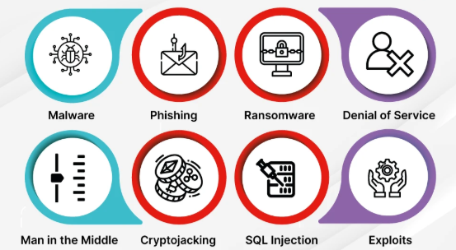
Source: Adapted from: Bernardo et al. (2024)
Cybersecurity cannot be done in isolation. To secure data and maintain business resilience, adherence to data protection regulations, systematic risk management, good governance, and recognised security frameworks must be implemented (Bernardo et al., 2024).
This report examines the security risks all experienced by AeroLink Logistics (ALL), reviews recognised security frameworks, and recommends combining security, governance, and compliance to enhance ALL's cybersecurity and compliance.

2. Case Scenario Overview
AeroLink Logistics (ALL), a multinational supply chain and logistics provider, relies heavily on cloud infrastructure, tracking devices with IoT, artificial intelligence, and outsourced IT services to drive and maintain its business globally (Aerolink Logistics, 2026). All these technologies increase the efficiency of operations and enable timely decision-making, but create serious cybersecurity and governance problems as well.
However, the organisation has suffered breaches of its data multiple times, including unauthorised access to shipment data for its customers as well as the sharing of images of personally identifiable information (PII) (Sharma, 2024). These incidents suggest problems with access control, identity management, encryption techniques, and monitoring systems. Additionally, some 88% of the ALL's IT infrastructure is handled by external service providers, under services categorised as Infrastructure-as-a-Service (IaaS) and Software-as-a-Service (SaaS) (IBM, 2021a; GeeksforGeeks, 2020) (Refer to Figure 2). This reliance on third parties poses challenges with regard to supply chain risk and limits control of key information assets within organisations.
Figure 2. SaaS, PaaS and IaaS
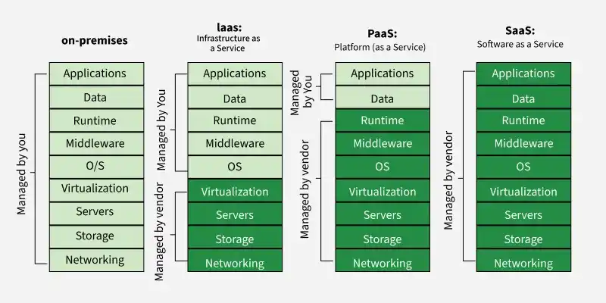
Source: Adapted from: GeeksforGeeks (2020)
The scenario also shows that there is no common security framework, structured compliance audit processes, formal risk management processes, governance mechanisms and clearly defined security responsibility for ALL. Comprehensive business continuity or incident response plans are not in place, adding to the vulnerabilities of the organisation.

Task 1. Research into Security Frameworks and Models

3.1 Introduction to Security Frameworks
An information security framework offers the structure to help organisations effectively protect their information assets, manage cyber risks and ensure legal and regulatory compliance. While they may be based on technology, they also create governance, organisational responsibilities, modernise the management processes and encourage continuous improvement (Nahum et al., 2026). Organisations are increasingly migrating to cloud environments, making use of cloud-based technologies such as artificial intelligence, Internet of Things (IoT) and remote work arrangements (Shonubi, 2025). They must be able to adopt recognised security frameworks to help ensure the confidentiality, integrity and availability of information.
The lack of a single security framework has been a factor in AeroLink Logistics (ALL) that has led to a mismatch in the security practices, governance weaknesses, lack of risk management, and lack of regulatory compliance within ALL (Metin, Dümer and Wynn, 2026). Choosing the right frameworks can help the organisation define cybersecurity goals, enhance its operational resilience, elevate its decision-making process, and implement a unified framework for managing cybersecurity with third-party service providers. It is widely accepted internationally that the following frameworks have complementary capabilities, some of which can be used to address the current security challenges of ALL.

3.2 Information Technology Infrastructure Library (ITIL 4)
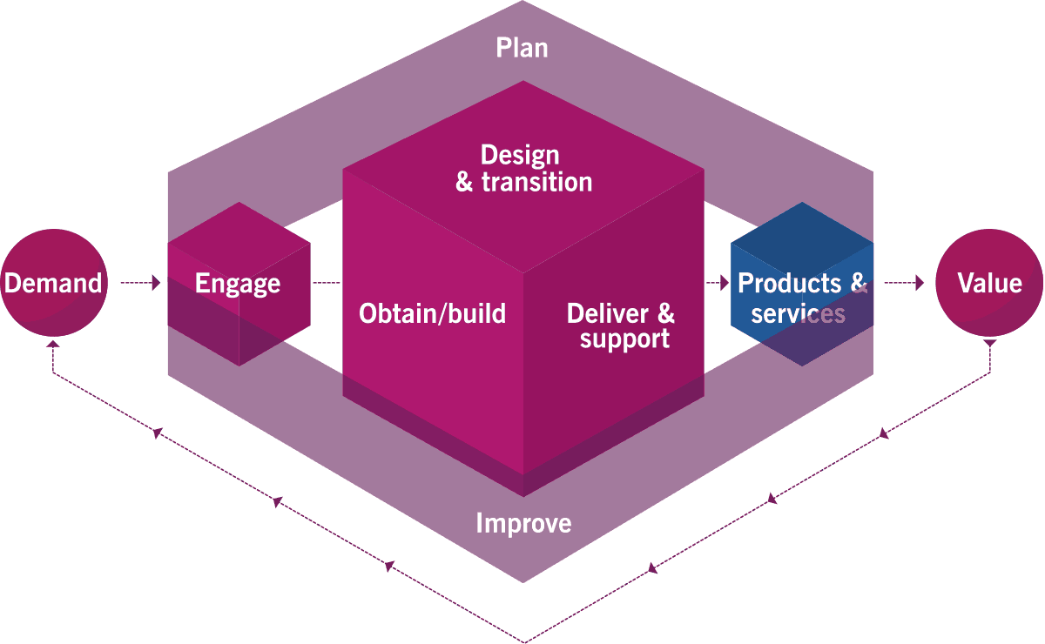
Figure 3: ITIL 4 Service Value Chain
(Source: Itsm. tools, 2026)
ITIL 4 is an international standard for IT Service Management (ITSM), centred around the business value of IT services, and managed effectively (Al-Ashmoery et al., 2021). While most frameworks are focused on cybersecurity controls, ITIL believes security is part of the lifecycle of the services and encourages ongoing service improvement, change management, incident management and service governance.
One of the key benefits of ITIL is that it helps to ensure consistency in operations. Where service management processes are clearly defined, errors in service configuration can be reduced, service disruptions can be minimised, and security activity or activities can be made an integral part of normal service operations (Kwarteng, Idoko and Azonuche, 2025). For AeroLink Logistics, ITIL might help in several ways to promote coordination and collaboration among all of its internal departments and service providers (its outsourcing partners). ITIL might help in standardising incident reporting, change approval processes, service monitoring and problem management. This is a significant asset because around 88% of all the organisation's infrastructure is handled by third-party vendors.
But ITIL, viewed as a stand-alone cybersecurity solution, has limitations. It enables security service delivery, and it prepares for security, but does not offer any detailed guidance for the areas of risk assessment, security governance or regulatory security compliance (Ilori, Nwosu and Naiho, 2024). An ITIL-based organisation can have efficient operation processes, but has many security gaps (Mahalle, Yong and Tao, 2020). ITIL should therefore be considered as a supporting framework which enhances operational management, instead of the complete information security framework.

3.3 NIST Cybersecurity Framework 2.0
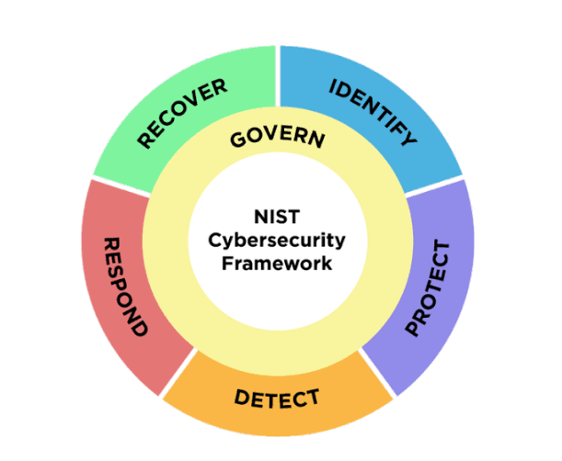
Figure 4. NIST Cybersecurity Framework (CSF) 2.0 Core Functions
(Source: www.saltycloud.com, 2026)
The NIST Cybersecurity Framework 2.0 refers to a risk-based management approach to cybersecurity, comprising six functions: Govern, Identify, Protect, Detect, Respond, and Recover (Salas-Riega et al., 2025). These functions aid companies in managing cyber risks throughout their security lifecycle. It has many strengths, such as adaptability, enabling organizations to tailor the framework to suit their size, risk profile, and industry. NIST can help AeroLink Logistics to provide better governance, identify key assets, provide better access controls and encryption, improve threat detection, and enhance incident response and recovery. It is therefore ideally suited for meeting the security and operational issues at hand in the organisation. The framework does not provide step-by-step instructions for implementation; however, it does provide the strategic guidance needed for successful implementation and requires experienced personnel and organisational commitment (Kohtamäki et al., 2012). However, NIST CSF 2.0 is one of the most extensive and widely used frameworks to develop a proactive and resilient cybersecurity programme despite this limitation.

3.4 COBIT 2019
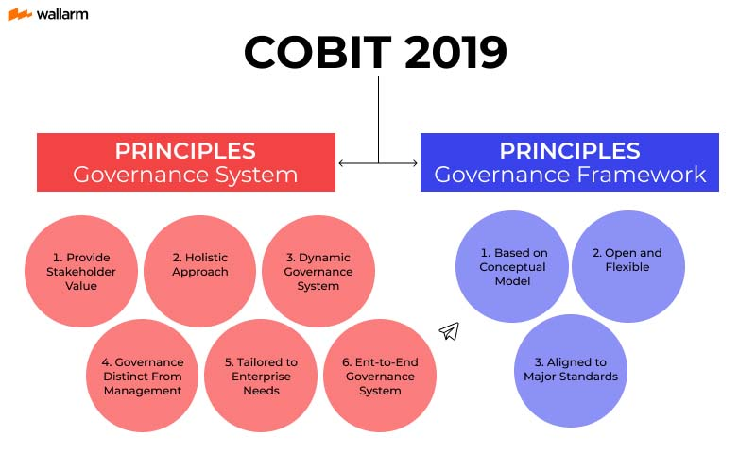
Figure 5. COBIT 2019 Governance System and Governance Framework Principles
(Source: wallarm.com, 2026)
COBIT 2019 is an enterprise governance framework which makes information technology supportive of the organisational objectives through governance, accountability, enterprise strategic planning and performance measurement (Muhammad, Angin and Aris Puji Widodo, 2019). One of its core strengths is the development of clear governance arrangements which clarify security responsibilities at all levels of the organisation. AeroLink Logistics would benefit from COBIT by enhancing management oversight and accountability and making cybersecurity a business priority, not an IT responsibility (Mizrak and Akkartal, 2024). It also facilitates ongoing performance monitoring using key performance indicators to see how successful security projects are. But rather than a technical security control, COBIT is more focused on governance. Thus, it must be used in conjunction with other frameworks like ISO/IEC 27001, NIST, and others, for holistic operational security and strong cyber assurance management (Lubis et al., 2026).

3.5 ISO/IEC 27001 Information Security Management System
ISO/IEC 27001 is an internationally recognised standard for setting up and sustaining an Information Security Management System (ISMS) (Culot et al., 2021). It aims to secure information by using security policies, organising information, continuously monitoring and continuously improving. One of the biggest benefits of ISO/IEC 27001 is that it includes an in-depth and complete system to satisfy this requirement, linking governance, risk management, supplier management, employee awareness and business continuity under one management system (Fortinet, 2026a). AeroLink Logistics aims to mitigate the key shortcomings mentioned in the scenario by implementing the standard, which covers issues such as weak governance, weak risk management, and weak formal security policies and compliance processes.
Table 1. Comparative Analysis of Information Security Frameworks
Framework | Primary Focus | Strengths | Limitations | Relevance to AeroLink Logistics
ITIL 4 | IT Service Management | Improves service delivery, incident management, continual improvement and change management | Limited technical security controls and governance guidance | Supports outsourced IT operations and improves coordination with third-party vendors managing 88% of infrastructure.
NIST CSF 2.0 | Cybersecurity Risk Management | Comprehensive lifecycle covering Govern, Identify, Protect, Detect, Respond and Recover | Does not provide detailed implementation procedures | Suitable for managing cyber threats, ransomware, cloud security and incident response.
COBIT 2019 | IT Governance | Establishes governance, accountability, strategic alignment and performance measurement | Focuses more on governance than technical security controls | Helps board-level decision-making and aligns cybersecurity with organisational objectives.
ISO/IEC 27001 | Information Security Management System | Provides comprehensive information security management, compliance, supplier security and continual improvement | Certification and implementation require significant organisational commitment | Supports governance, compliance, risk management and continuous security improvement.
Source: Self-Created

3.5.1 AI Security Frameworks
The integration of Artificial Intelligence (AI) is significant in the realm of modern cybersecurity due to its capacity for processing extensive security data volumes, recognising deviations from standard patterns and automating threat detection. Security Information and Event Management (SIEM), Security Orchestration Automation and Response (SOAR), Extended Detection and Response (XDR), and User and Entity Behaviour Analytics (UEBA) are technologies that help organisations identify advanced attacks in near real time, which is significantly quicker than what rule-based systems can achieve.
AI-powered security can enhance cloud infrastructure monitoring, IoT devices, logistics tracking and third parties for AeroLink Logistics. AI can automatically detect suspicious activity by a user and alert on ransomware activity, analyse network traffic and suggest quick incident response measures. Integration of AI security capabilities with NIST CSF 2.0, ISO/IEC 27001 would greatly enhance proactive threat identification, response time, and cyber resilience throughout the organisation.

3.5.2 Cloud Governance Framework
AeroLink Logistics' digital infrastructure can be said to be built on cloud computing, as the majority of the systems are based on Infrastructure-as-a-Service (IaaS) and Software-as-a-Service (SaaS). Cloud computing offers flexibility, scalability and cost efficiency, yet comes with governance issues of data ownership, regulatory compliance, identity management, and accountability for third parties.
Cloud governance delivers the policies, standards and controls that provide the Secured Cloud Resource throughout its lifecycle. Best practices for cloud governance include the use of identity and access management, encryption, security monitoring, continuous compliance assessment, and vendor accountability. By continuously authenticating users and checking the integrity of devices before providing access to the system, Zero Trust Architecture enhances cloud governance further. Cloud governance and ISO/IEC 27001 and COBIT 2019 will help AeroLink Logistics enhance regulatory compliance, mitigate vulnerabilities in cloud technologies, and continue running operations securely in various cloud environments.

3.5.3 AI-Based Risk Management
Conventional risk management practices find it difficult to detect fast-changing threats in AI-driven and cloud-based systems. AI-powered risk management complements traditional risk management methodologies with predictive analytics, machine learning and automated threat intelligence to proactively uncover new risks before they turn into a critical incident.
AeroLink Logistics can use AI for risk management systems to continuously scrutinise cloud platforms, IoT tracking devices, customer databases and supplier networks for unusual patterns of behaviour or potential vulnerabilities. AI can order risks according to the business impact, likelihood, and exploitability and point to the appropriate risk mitigation measures. The integration of risk assessment with Artificial Intelligence allows the organisation to shift from current cybersecurity management to cybersecurity risk governance, creating a greater operational resilience and preparing the organisation for business continuity.
Table 2. Framework Selection Matrix for AeroLink Logistics
Evaluation Criteria | ITIL 4 | NIST CSF 2.0 | COBIT 2019 | ISO/IEC 27001
Security Governance | Medium | High | Very High | High
Risk Management | Medium | Very High | High | High
Compliance Support | Medium | High | High | Very High
Incident Response | High | Very High | Medium | High
Business Continuity | Medium | High | Medium | Very High
AI Security Integration | Medium | High | Medium | High
Cloud Governance | Medium | High | High | High
Third-Party Vendor Management | High | High | High | High
Operational Efficiency | Very High | High | Medium | High
Overall Suitability for ALL | High | Very High | Very High | Very High
Source: Self-Created

3.6 Critical Comparison of the Frameworks
While all of the above offer essential advice and guidance, none is able to cover the entire scope of AeroLink Logistics' cybersecurity, governance and compliance needs. ITIL 4 supports greater efficiency and ICT service management, but it does not provide specific cybersecurity governance and regulatory compliance controls. NIST CSF 2.0 offers a holistic lifecycle of the risks and includes a strong focus on identifying, detecting and responding to threats in cybersecurity, but does not provide much implementation guidance. COBIT 2019 empowers enterprise governance by supporting successful alignment of cybersecurity with business goals, has improved accountability and performance monitoring, but requires supporting technical frameworks. While internal commitment is needed to implement it, ISO/IEC 27001 provides a complete ISMS which unites governance, compliance, supplier management and continual improvement aspects.
They are just a few of the signs of the growing use of Artificial Intelligence (AI), Cloud Computing and Internet of Things (IoT) technologies, which are creating new cyber threats that require more than just traditional security models to manage. The time to threat detection and automatically enable response to incidents is greatly enhanced by AI-powered Security Information and Event Management (SIEM) capabilities, Extended Detection and Response (XDR), Security Orchestration, Automation and Response (SOAR), and User and Entity Behaviour Analytics (UEBA). Similarly, Cloud Governance Models and Zero Trust Architecture enhance access control and regulatory compliance in cloud environments through identity management.
As the challenges and considerations outlined earlier, the best possible fit for AeroLink Logistics is an integrated governance structure within which ITIL 4 - Service Management, NIST CSF 2.0 - Cybersecurity Risk Management, COBIT 2019 - Strategic Governance, ISO/IEC 27001 - Information Security Management, and AI-powered security technologies for predictive threat detection and continuous security monitoring work hand-in-hand. This holistic strategy ensures the highest level of cyber resilience, governance, compliance, cloud security and protection for future threats.

Task 2. Security, Governance and Compliance Solution for AeroLink Logistics

4.1 Proposed Security Governance Framework
Based on COBIT 2019, NIST Cybersecurity Framework (CSF) 2.0, ISO/IEC 27001 and ITIL 4 (Metin, Sevim and Wynn, 2025), a simple integrated Security Governance Framework is proposed to remediate the weaknesses in AeroLink Logistics (ALL), which is identified as an integrated AI-driven. COBIT 2019 enhances Governance and accountability, and the NIST CSF 2.0 offers a lifecycle for cybersecurity. The ISO/IEC 27001 standard promotes the effective management and adherence to information security, while the ITIL 4 standard promotes service management and ongoing improvement in security. 06) The framework also includes Zero Trust Architecture, AI-powered Security Operations Centre (AI-SOC), and cloud governance, to better detect threats, secure cloud spaces, strengthen regulatory compliance, and boost cyber resilience among organisations.

4.2 Governance and Strategic Security Planning
Good governance is key to securing the alignment of cybersecurity to AeroLink Logistics' broader operational goals and initiatives, as well as boosting their organisational resilience. The Board of Directors should oversee via a cybersecurity plan, authorisations, resource assignment, and frequent reviews of its cybersecurity performance. In an organisation, a Cybersecurity Steering Committee needs to be formed to align on security efforts throughout various departments, and a Chief Information Security Officer (CISO) should be appointed to oversee the implementation of security strategies and compliance efforts. A risk committee, tasked with watching for new cyber risks and leading the management of cyber risk mitigation plans, should be created.

4.3 Compliance with Laws and Ethical Requirements
AeroLink Logistics (ALL) is a global logistics service company that is required to meet international and national cybersecurity standards to safeguard sensitive data and build stakeholder trust. The three principles for compliance should be aligned with the General Data Protection Regulation (GDPR), ISO/IEC 27001, along with the NIS2 Directive and the EU Artificial Intelligence (AI) Act, which would focus on securing data management, governance and the responsible implementation of AI (Lopes, Guarda and Oliveira, 2019). Security controls need to be assessed through regular compliance checks, and Data Protection Impact Assessments (DPIAs) should be carried out before the use of AI-powered or cloud-based systems. Ongoing regulatory monitoring will enhance legal compliance and mitigate organisational risk as well as customer confidence and business reputation.

4.4 Security Policies and Procedures
To ensure consistent organisational behaviour and reduce human-based cyber risks, including comprehensive security policies are necessary. AeroLink Logistics should have formal policies for password management, acceptable use, data classification, encryption, Bring Your Own Device (BYOD), incident reporting and access control as required in ISO/IEC 27001 Information security management system (Culot et al., 2021). An AI Governance Policy should outline the ethical, transparent, and secure application of the use of Artificial Intelligence, as well as adherence to new laws concerning the use of AI (Metin, Sevim and Wynn, 2025). A Cloud Security Policy should specify secure cloud configurations, encryption standards and continuous monitoring of cloud services (IBM, 2021b). A Remote Access Policy should require the use of Virtual Private Networks (VPNs), Multi-Factor Authentication (MFA) and endpoint protection to protect a remote working environment (Fortinet, 2026b). Moreover, a Vendor AI Policy should make sure that third-party providers meet the standards of security policies and data protection regulations with which the organisation is required to be compliant. Continuous compliance should be managed with regular policymaking and employee awareness initiatives to build and uphold organisational cyber-resilience.

4.5 Risk Management and Assessment
Risk management is not a one-time event but should be a continuous process to support proactive measures in cybersecurity instead of compliance measures. With regard to the databases of the AeroLink Logistics, AI-based risk assessment must be implemented based on predictive analytics (Waqdan, Louafi and Mouhoub, 2025) to identify emerging risks in cloud systems, IoT devices and the AI-based systems used for the logistics company. The MITRE ATT&CK framework can be used to help with threat identification and response, while the FAIR Risk Model can be utilised for quantitative risk analysis for decision making and efficient security resource allocation (Akinola, 2023).

4.6 Security Management Models and Practices
To provide continuous monitoring and go-to-backup when incidents occur, AeroLink Logistics should make use of an AI-based Security Operations Centre (AI-SOC). A combination of Security Information and Event Management (SIEM), Security Orchestration, Automation and Response (SOAR), User and Entity Behaviour Analytics (UEBA), and Extended Detection and Response (XDR) will enhance threat detection, automate security operations and shorten response times. Moreover, threat intelligence information should be integrated in real-time to detect new threats and incorporate additional barriers to protect organizations against advanced and complex attacks (Granadillo, Zarzosa and Diaz, 2021; Lubis et al., 2026).

4.7 Protection Mechanisms and Access Controls
AeroLink needs to adopt a layered approach to access control for protecting its critical information assets and cloud-based systems. To ensure everlasting verification of all users, devices and applications before access, irrespective of their network location, Zero Trust Architecture should be adopted (Metin, Sevim and Wynn, 2025). Multi-Factor Authentication (MFA) and adaptive authentication are methods that will enhance user verification by taking into account contextual authentication risk factors, including device, location and behaviour. Finally, Privileged Account Management (PAM) should secure high-risk accounts and privileged access, along with Identity Governance and Administration (IGA), ensuring proper user account access throughout the employee lifecycle, thereby minimising insider threats and improving regulatory compliance (IBM, 2021b).

4.8 Vendor and Service Level Agreement (SLA) Management
Of course, it is very important to manage vendors, as much of AeroLink Logistics' IT infrastructure is outsourced. Service Level Agreements (SLAs) should establish in clear terms the responsibilities for security, data protection requirements, procedures for incident reporting and relevant obligations to the regulatory bodies. Before deployment, AI vendor assessments should determine the security, transparency and ethical deployment of third-party AI solutions. Ongoing compliance with the organisational security requirements and contractual obligations, as well as identifying new vulnerabilities and weaknesses, must be monitored at vendor performance by continuous cloud compliance audit and third-party risk monitoring (Metin, Sevim and Wynn, 2025; Culot et al., 2021).

4.9 Incident Response, Business Continuity and Disaster Recovery
While preventive measures are necessary, no effort is made to eliminate cyber incidents; so AeroLink Logistics should have a detailed incident response and business continuity plan. The incident response process involves preparing and preparing systems so they can be available for the attack, response, containment, eradication, recovery from the incident, and post incident review (Ojo et al., 2024). AI threat detection can be used to automate threat detection; AI and digital forensics can assist with fast investigation and evidence collection; AI-powered incident response can be used to automate threat detection and prioritise security alerts.

4.10 Contingency Planning
AeroLink Logistics needs to develop a detailed contingency planning policy to (where possible) reduce disruption to the day-to-day running of operational systems when a cyber-incident occurs or systems fail. The plan should identify data regions, distantly located backup locations and cloud backup to ensure data availability and business continuity. Alternative communication means should be provided to ensure coordination in the absence of the primary means. There should be a dedicated crisis management team that will be responsible for decision-making regarding emergencies and coordinating emergency response activities. Automated failover should ensure that critical systems are available as needed; a well-stated recovery plan should focus on recovering needed business functions. Frequent Contingency testing and simulation will help further enhance organisational readiness and overall cyber resilience.

4.11 Research Methodology
The research design for this report is qualitative research, and the methodology used is the case study method with a study approach. Secondary research has been used as a method in the study, and it includes peer-reviewed articles from journals, reports from industry, international standards, as well as recognised cybersecurity frameworks such as COBIT 2019, NIST CSF 2.0, ISO/IEC 27001 and ITIL 4. In order to compare the strengths and weaknesses of these models, a framework analysis was performed to create the security governance model. It is the best approach to be used because it helps to understand the cybersecurity problems faced within the organisation and formulate practical recommendations based on the case scenario (Culot et al., 2021).

4.12 Implementation Flowchart
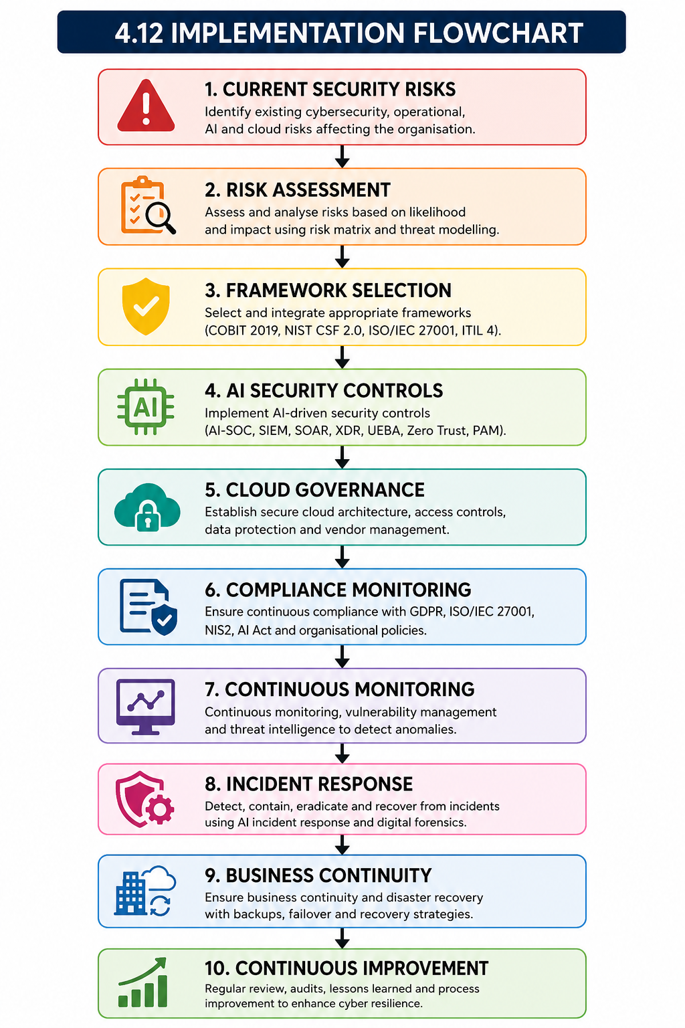
Source: Self-Created

4.13 Implementation Roadmap
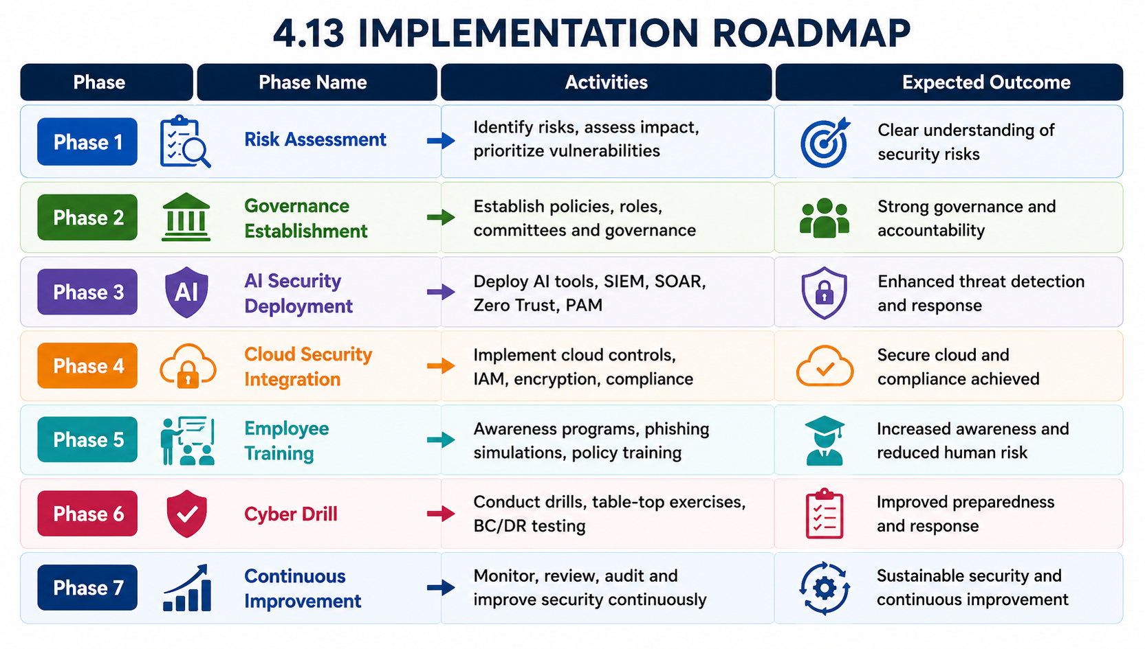
Source: Self-Created

4.14 Implementation Challenges and Leadership Considerations
Despite the potential benefits of implementing the proposed security construct, several challenges may arise, such as the influence of biased Artificial Intelligence (AI), security concerns associated with cloud, insights from internal personnel, vendor lock-in issues, implementation expenses, resistance to organisational change, regulatory complexity, and a shortage of cybersecurity skills (Akinola, 2023). To address these challenges, AeroLink Logistics needs to create an Executive Steering Committee to monitor the cybersecurity strategy and governance. A comprehensive Security Awareness Programme, regular cyber drills, table-top and annual security conferences should improve the competence of employees and preparedness of the organisation. Moreover, the regular sharing of Board reports on cyber security performance, the nature of cyber risks to the organisation and the compliance status will aid in an informed process for decision making, accountability and ongoing organisational development (Metin, Sevim and Wynn, 2025).

5. Conclusion
This report argues that currently, AeroLink Logistics does not have a comprehensive "cybersecurity" program in place to meet the challenges of cloud computing, artificial intelligence (AI), Internet of Things (IoT) technologies and third-party service providers, and that such an implementation would be effective if crafted in a unified cybersecurity approach that incorporates governance, risk management, compliance and advanced technical security controls. The ITIL 4, NIST Cybersecurity Framework (CSF) 2.0, COBIT 2019 and ISO/IEC 27001 were evaluated, and it was noted that each Framework covers different aspects, but there are significant overlaps that can be integrated to create a holistic Governance and other benefits, such as improving regulatory compliance, enhancing risk management, supporting effective incident response and ensuring effective business continuity.

5.1 Future Work
Going forward, further research efforts are needed to strengthen the proposed framework by including AI governance maturity assessment tools to assess the preparedness of an organisation and the effectiveness of AI-powered security controls. Digital Twins could be used to assist in cybersecurity simulations and resilience testing, and predictive cybersecurity with artificial intelligence and machine learning could help detect and prevent threats early. Regulatory reporting can be automated, and the effectiveness of governance can be enhanced through user-recorded compliance monitoring and continuous auditing with the aid of Artificial Intelligence (AI).

5.2 Recommendations
AeroLink Logistics should take a proactive approach to strengthen its long term cyber security resilience and adopt an AI-powered Security Operations Centre (AI-SOC) to enhance its continuous monitoring and incident response system. It is essential to implement continuous compliance monitoring to ensure compliance of GDPR and ISO/IEC 27001 and other relevant laws and regulations, and integration of cloud-native security controls to protect cloud systems.

Reference
Aerolink Logistics (2026). AerolinkLogistics. [online] Aerolink-logistics.com. Available at: [Accessed 13 July 2026].
Akinola, E. (2023). Redefining Governance, Risk, and Compliance (GRC) in the Digital Age: Integrating AI-Driven Risk Management Frameworks. World Journal of Advanced Engineering Technology and Sciences, 10(1), pp.264–282. doi:10.30574/wjaets.2023.10.1.0257.
Al-Ashmoery, Y., Haider, H., Haider, A., Nasser, N. and Al-Sarem, M. (2021). Impact of IT Service Management and ITIL Framework on the Businesses. 2021 International Conference of Modern Trends in Information and Communication Technology Industry (MTICTI). doi:10.1109/mticti53925.2021.9664763.
Bernardo, B.M.V., Mamede, H.S., Barroso, J.M.P. and dos Santos, V.M.P.D. (2024). Data governance & quality management—Innovation and breakthroughs across different fields. Journal of Innovation & Knowledge, [online] 9(4), p.100598.
Culot, G., Nassimbeni, G., Podrecca, M. and Sartor, M. (2021). The ISO/IEC 27001 information security management standard: Literature review and theory-based research agenda. The TQM Journal, 33(7), pp.76–105. doi:10.1108/tqm-09-2020-0202.
Essien, I.A., Cadet, E., Ajayi, J.O., Erigh, E.D., Obuse, E., Ayanbode, N. and Babatunde, L.A. (2022). Optimizing Cyber Risk Governance Using Global Frameworks: ISO, NIST, and COBIT Alignment. Journal of Frontiers in Multidisciplinary Research, 3(1), pp.618–629. doi:10.54660/.jfmr.2022.3.1.618-629.
Folashayo Abiodun (2025). The Risk of Exception in Security Findings: A Hidden Threat to Organizational Resilience. ResearchGate. [online] doi:10.13140/RG.2.2.32948.72326.
Fortinet (2026a). ISO/IEC 27001: Framework for Information Security Management System. [online] Fortinet. Available at: [Accessed 13 July 2026a].
Fortinet (2026b). What Is Remote Access and What Are the Risks? [online] Fortinet. Available at: [Accessed 13 July 2026b].
GeeksforGeeks (2020). Difference between SaaS, PaaS and IaaS. [online] GeeksforGeeks. Available at: [Accessed 13 July 2026].
Granadillo, G.G., Zarzosa, S.G. and Diaz, R. (2021). Security Information and Event Management (SIEM): Analysis, Trends, and Usage in Critical Infrastructures. Sensors, [online] 21(14), p.4759. doi:10.3390/s21144759.
IBM (2021a). What are IaaS, PaaS and SaaS? [online] Ibm.com. Available at: [Accessed 13 July 2026a].
IBM (2021b). What is encryption? [online] Ibm.com. Available at: [Accessed 13 July 2026b].
Ilori, O., Nwosu, N.T. and Naiho, H.N.N. (2024). A comprehensive review of it governance: Effective implementation of COBIT and ITIL frameworks in financial institutions. Computer Science & IT Research Journal, 5(6), pp.1391–1407. doi:10.51594/csitrj.v5i6.1224.
Itsm.tools, 2026. TOPIC RELATED TO ITIL 4 Service Value Chain. Viewed on 13th July 2026. From
Kohtamäki, M., Kraus, S., Mäkelä, M. and Rönkkö, M. (2012). The role of personnel commitment to strategy implementation and organisational learning within the relationship between strategic planning and company performance. International Journal of Entrepreneurial Behavior & Research, 18(2), pp.159–178. doi:10.1108/13552551211204201.
Kwarteng, R.A., Idoko, I.P. and Azonuche, T.I. (2025). Optimizing IT Incident and Problem Management Through Data Analytics and ITIL-Aligned Digital Workflows. International Journal of Scientific Research in Computer Science, Engineering and Information Technology, 11(6), pp.445–474. doi:10.32628/cseit2511666.
Lopes, I.M., Guarda, T. and Oliveira, P. (2019). How ISO 27001 Can Help Achieve GDPR Compliance. 2019 14Th Iberian Conference on Information Systems and Technologies (CISTI). doi:10.23919/cisti.2019.8760937.
Lubis, M., Luthfi, M.I., Saedudin, Rd.R., Muttaqin, A.N. and Lubis, A.R. (2026). The Integration of ISO 27005 and NIST SP 800-30 for Security Operation Center (SOC) Framework Effectiveness in the Non-Bank Financial Industry. Computers, 15(1), p.60. doi:10.3390/computers15010060.
Mahalle, A., Yong, J. and Tao, X. (2020). ITIL process management to mitigate operations risk in cloud architecture infrastructure for banking and financial services industry. Web Intelligence, 18(3), pp.229–238. doi:10.3233/web-200444.
Metin, B., Dümer, H.B. and Wynn, M. (2026). Aviation Cybersecurity Governance: Towards an Operational Framework and Solutions Agenda for the Airport Domain. Information, [online] 17(2), p.177. doi:10.3390/info17020177.
Metin, B., Sevim, S.B. and Wynn, M. (2025). Cybersecurity Strategy Development: Towards an Integrated Approach Based on COBIT and ISO 27000 Series Standards. Standards, [online] 5(4), pp.33–33. doi:10.3390/standards5040033.
Mizrak, F. and Akkartal, G.R. (2024). Prioritizing cybersecurity initiatives in aviation: A dematel-QSFS methodology. Heliyon, 10(16), pp.e35487-e35487. doi:10.1016/j.heliyon.2024.e35487.
Muhammad, Angin, M.P. and Aris Puji Widodo (2019). COBIT 2019 Framework in IT Governance: A Systematic Literature Review of Implementation Challenges and Benefits Across Various Industry Sectors. Journal of Renewable Energy, Electrical, and Computer Engineering, [online] 5(1), pp.99–105. doi:10.29103/jreece.v5i1.19501.
Nahum, N., Larsson-Olaison, U., Uman, T. and Achtenhagen, L. (2026). Corporate governance for digital transformation: The role of ownership and the board of directors. Technological Forecasting and Social Change, 223, p.124453. doi:10.1016/j.techfore.2025.124453.
Ojo, C., Osoko, E.A., Okolo, J.N. and Jaji, M. (2024). Incident response: A structured model from detection to containment and recovery. World Journal of Advanced Research and Reviews, [online] 24(1), pp.1401–1407. doi:10.30574/wjarr.2024.24.1.3148.
Oyekunle, D. and Boohene, D. (2024). Digital Transformation Potential: The role of Artificial Intelligence in Business. [online] ResearchGate. Available at: [Accessed 13 July 2026].
Salas-Riega, J.L., Yasmina Riega-Virú, Ninaquispe-Soto, M. and José Miguel Salas-Riega (2025). Cybersecurity and the NIST Framework: A Systematic Review of its Implementation and Effectiveness Against Cyber Threats. International Journal of Advanced Computer Science and Applications, 16(6). doi:10.14569/ijacsa.2025.0160672.
Sharma, A. (2024). THE IMPACT OF CYBERSECURITY BREACHES ON BIG BUSINESSES. International Journal of Advanced Research, [online] 12(10), pp.10–25. doi:10.21474/ijar01/19614.
Shonubi, O.A. (2025). The role of digital B2B platforms with industry 4.0 technological ecosystems(integration of cloud computing, artificial intelligence and internet of things) as a growth lever. Sustainable Futures, [online] 10, p.101041. doi:10.1016/j.sftr.2025.101041.
wallarm.com, 2026. TOPIC RELATED TO COBIT 2019 Governance System and Governance Framework Principles. Viewed on 13th July 2026. From
Waqdan, M., Louafi, H. and Mouhoub, M. (2025). Security risk assessment in IoT environments: A taxonomy and survey. Computers & Security, 154, p.104456. doi:10.1016/j.cose.2025.104456.
www.saltycloud.com, 2026. TOPIC RELATED TO NIST Cybersecurity Framework (CSF) 2.0 Core Functions. Viewed on 13th July 2026. From

