DS 1 Template

My Screenshots/Photos
- Please add 4–6 screenshots or photos of your digital life.
- You can use your phone or laptop.
- For each screenshot, write one or two sentences explaining what it shows.

Screenshot/Photo 1
[Insert Photo/Screenshot below]

[Write what this shows of your digital life]
This picture Is me using my phone on a video call on whatsap .
I often use this tool or better call it app to communicate with people around the world.

Screenshot/Photo 2
[Insert Photo/Screenshot below]

This picture is about me wireless listening pared by bluetooh headphones wich I manage apps like spotify downloading and even ajust noise cancelations

Screenshot/Photo 3
[Insert Photo/Screenshot below]
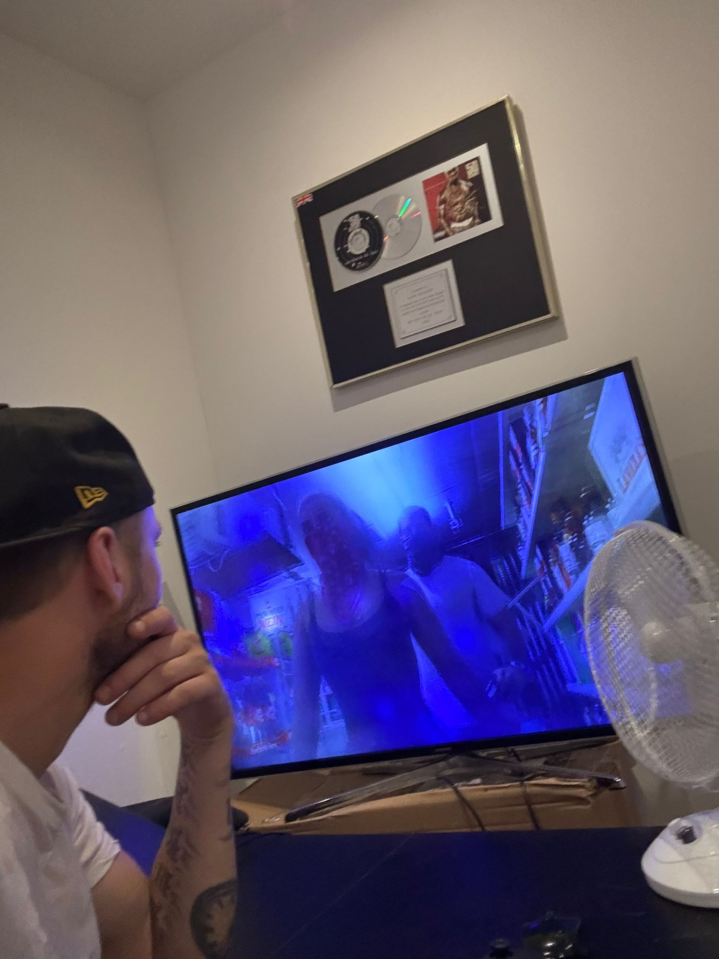
[Write what this shows of your digital life]
Im watching TV , and I use this tool to navigate on smart menus on Netflix or BBC Iplayer

Screenshot/Photo 4
[Insert Photo/Screenshot below]
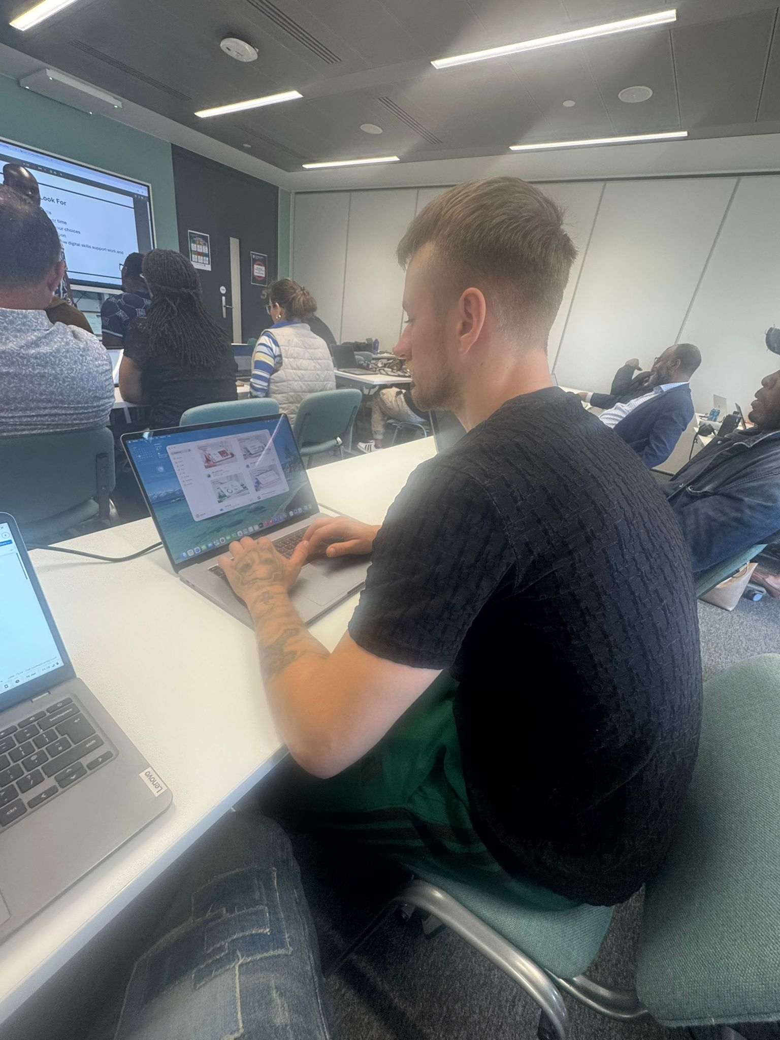
[Write what this shows of your digital life]
Digital skills are important for me and for every body
Im use my PC to complete tasks with apps like Word and I find it very useful becose makes things very easy in a day by day using this digital skill

Screenshot/Photo 5
[Insert Photo/Screenshot below]
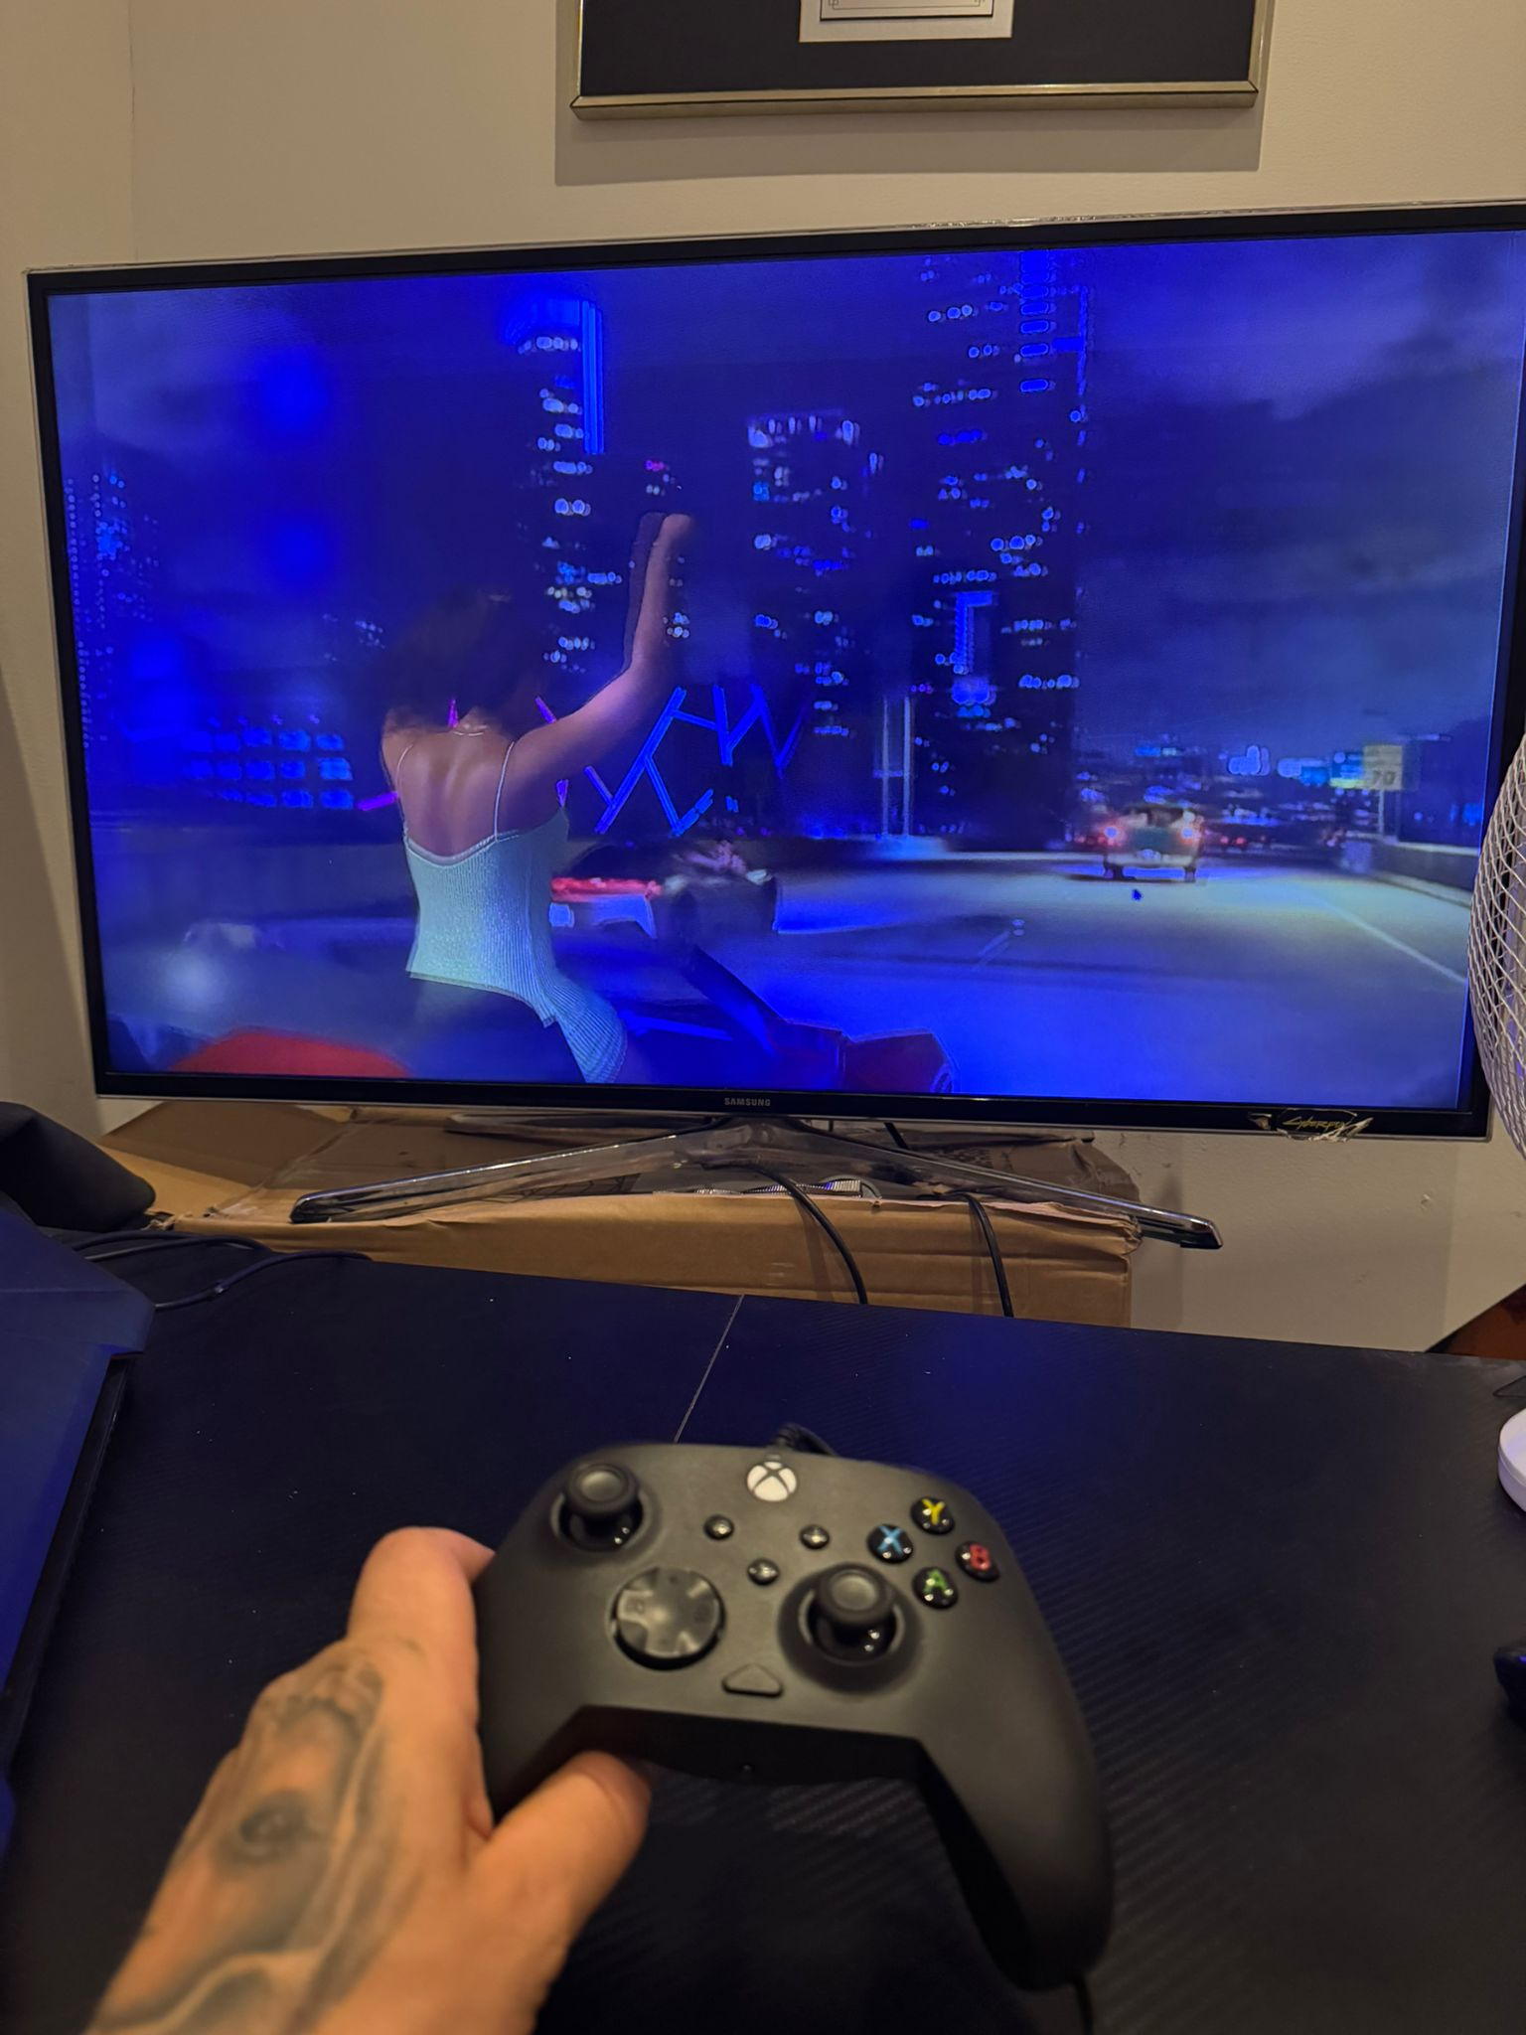
[Write what this shows of your digital life]
Im here paying games with I think is the most interactive way to use digital skills I use headset text chat , and party to coordinate strategies to team mates

Screenshot/Photo 6
[Insert Photo/Screenshot below]
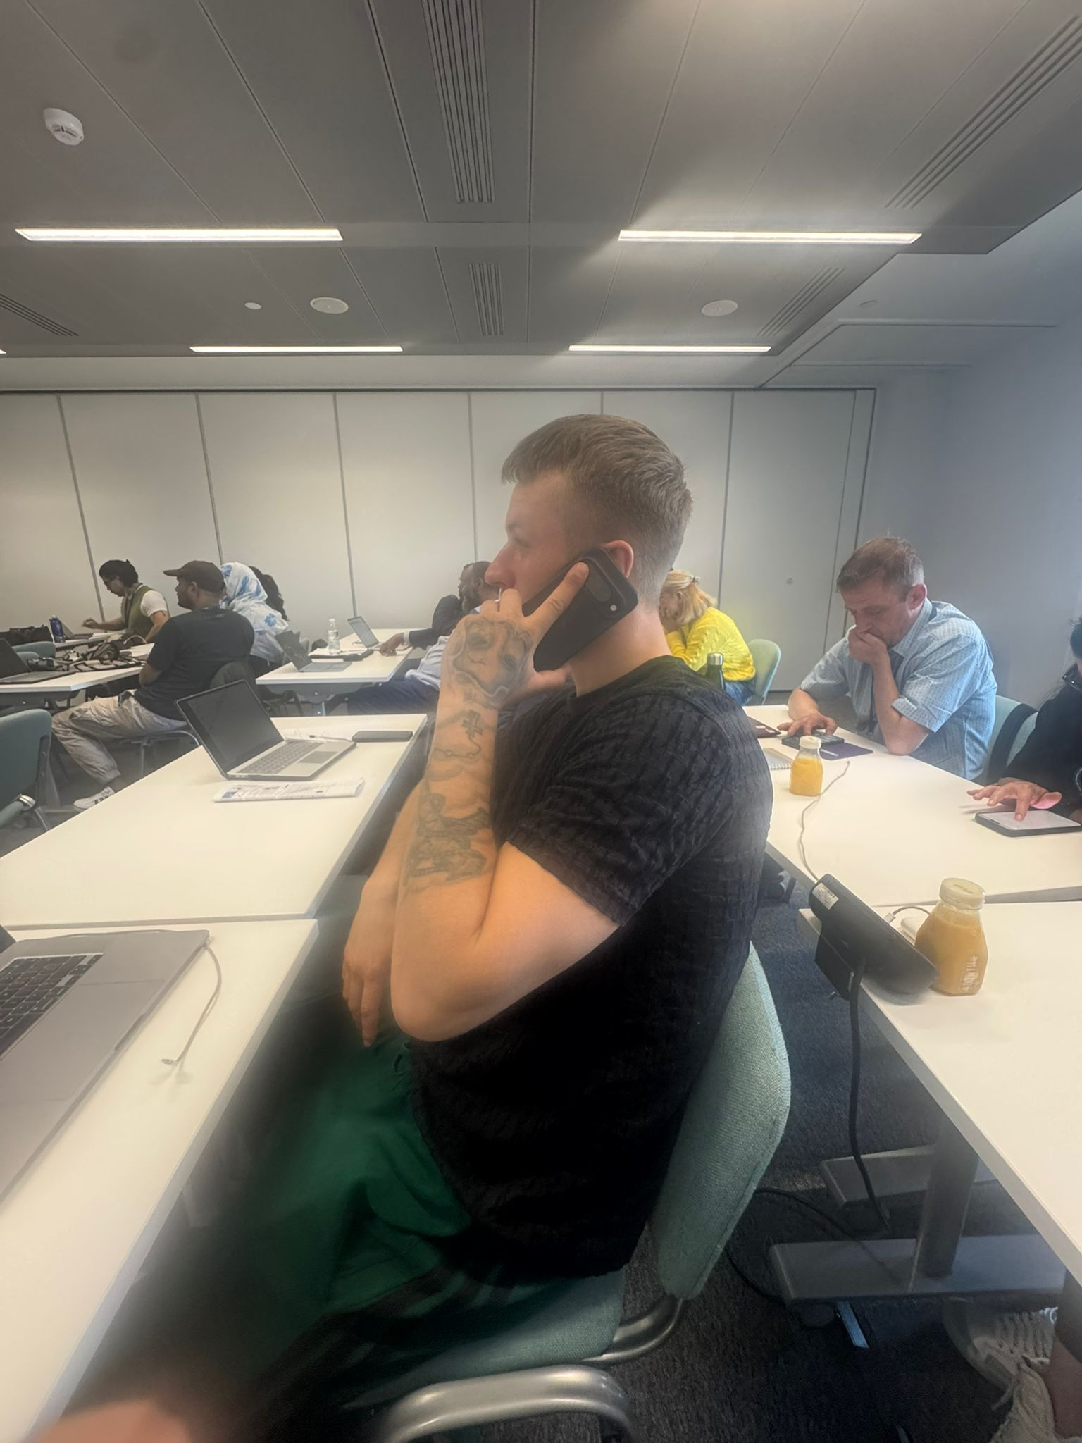
[Write what this shows of your digital life]
I use my phone every single morning I set my alarm digitally and I recibe daily calls

My Short Reflection
- Write 5–8 simple sentences about your digital life.
- You can use the sentence starters below if helpful.
My short reflection is that we use a lot of this digital skills and that this photos shows that the technology helps me every day .
My phone is like a tool that wakes me up and keeps me in touch with everyone when I play the tecnologgy becomes like a team that solves problems I use digital skills to communicate plan and do daylly tasks .

Sentence starters
- I use digital tools to …
- I feel confident when I …
- I want to improve …
- I often use these tools: …
- I sometimes feel nervous about …
- I hope this module will help me …
- Digital skills are important for me because …
You can write more if you want.

Submission Checklist
Before you submit, please check:
​​​ ☐ I added 4–6 screenshots
☐ I wrote short sentences for each screenshot
☐ I wrote my short reflection
☐ My work is my own
☐ My file opens correctly
​​☐ My file opens correctly

