Critical Analysis using film terminology (1500-2000 words)
Oliver Stone is renowned for his grit, realism and hard to face truth, particularly the films that revolve around historical figures and events. The benefits of such confrontation of history and truth on the big screen include visualisations of history, and a wider reach of audience. Furthermore, films are multi-dimensional, they provide various perspective on a non-linear level that allows an individual to form an opinion that is not restricted to black and white fact laid down in historical text; but rather the audience can gain an emotional perspective which when considered reasonable, can accentuate fact and expand understanding. Rosentstone identifies film contributes to how the modern population understand and gain insight to events and people in history. Furthermore, even when we know they are fanciful or ideological renditions of history, films have a profound influence how we see the past. (Rosenstone: 2006, p.4). For example, Stone’s depiction of JFK’s assassination led to the opening of a Congressional inquiry into the Warren Committee’s Report on the assassination of the President. The film adaption of Dan Browns The Davinci Code which explored historic groups such as The Knights Templar and Opus Dei, and boldly suggested an alternative, plausible story for Jesus. Arguably, Dan Brown sold a scandal, but what was delivered was a revived interest in art, historic Paris and the story of Jesus. Consequently, the following year of The Davinci Code (2006) saw a boom in visitors to the Louvre, surpassing 8 million for the first time in history (The Associated Press, 2007). Therefore, events were not only discussed, historic landmarks and museums were explored engaged with.
We are shocked from the beginning as the establishing shot zooms out of a dusty plane as new recruits including Taylor arrive. Immediately, life and death are put side by side as body bags are hurled onto planes for travel. At camp, a man is shaving, and his seat neighbour is fixing up a machine gun. Both tasks being carried out as casually and as mundane as each other, lifeand death live side by side here.
Providing narrative for the Vietnam War requires travelling beyond the explosions, murder, and misery. Stone presents this to us on the screen by determining perspective, a point of view, through Chris Taylor, a character whom he has confirmed as his alter ego basing his circumstances and experience on his own life story. Thematically, Chris is presented as our unlikely hero, a ‘crusader’. As Chris is writing letters to his grandmother, his thought process is provided through narration, and his on point observations regarding the disproportionate levels of working class soldiers to middle shift our focus from the war between America and Vietnam, to Americans and their own leaders. The ideologies of good and evil are personified and compressed into the two opposing forces of Barnes and Elias. Our first impressions of the characters are bold and suggestive from their encounters with Taylor, Barnes has no empathy, ‘You are a sorry ass mother’ – whereas Elias appears as a saviour hauling some of Chris’s unnecessary packing. The original script describes Elias as a ‘dark haired Indian kid of 23’ (Screenplay Explorer) which fits with the free spirit of Elias that Stone envisioned. This is still conveyed in his totem wearing and lack of helmet and uniform costume in the movie. He stands out against other veterans; his costumes’ sleeves are cut short and he wears a bandana instead of a helmet as a symbol and acceptance of death. His final scenes reflect ordinary laws of nature are slightly suspended as he survives numerous shots to the chest but still flees. He welcomes death arms raised, like Christ before falling to the ground, even in the screenplay he is ‘crucified’(IMSDB).
Elias is a stark contrast to Barnes, who’s deeply scarred face and bulging biceps are constantly flaunted as part of his costume; he is a symbol of aggravation, survival and violence. Before we get to know Barnes as a character, he displays merciless, violent behaviour when he shoots an injured Vietnamese soldier. It is no accident that Stone completely mirrored Barnes’ death scene to his own victim at the start; it is indicative of a circle, violence produces violence.
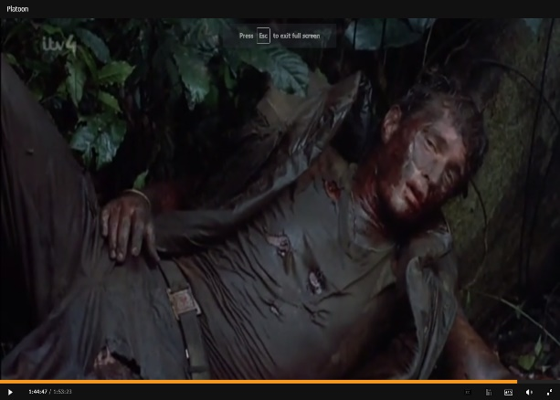
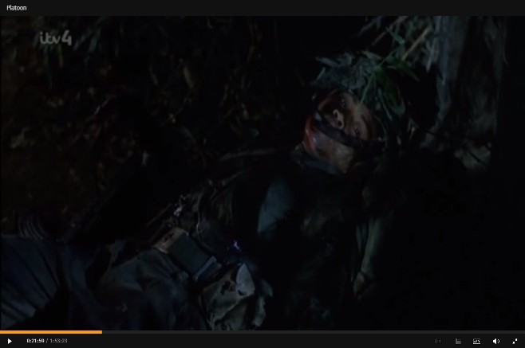

Platoon (1986) Platoon (1986)
So how do we escape the vicious circle? Taylor survives, he gets to go home because he remembered he was man, he woke up conscious after the final battalion. The setting now a lustrous green in contrast to the grey chaos of the night before he is reborn. His ending monologue as he ascends into the cloud preaches of the evil complexities of human nature, how they lost sight of the cause ‘the enemy was in us’. Nature has thematically run through the film throughout, and gradually, it became apparent that human nature was the most destructive. Chris’ consciousness alluded him from arrogance, and he survived the conflict between his two gods of war and their battle ‘for possession of [his] soul’(IMSDB). The original script was to fade out after Chris laments on his spiritual birth ‘borne of two fathers’ (Screenplay Explorer); the ending surmised the real battle for veterans and the editing of Chris’s final monologue was crucial to fashion a more positive ending that injected the uplifting notion of hope.
Platoon (1986) is a prime example of how film techniques can evoke more emotion or interest in a historical event than a textbook. Its realism is malleable throughout as we are confronted with raw, violent images of death and destruction and we can’t help wonder – is that far-fetched? His depiction is a far cry from the romantic perspective adopted by other filmmakers such as Randall Wallace in ‘We Were Soldiers’. The handsome, fresh faces proud to serve for America are a romanticised representation of soldiers headed into battle to fight for their country. The only romance to be found in Stones Vietnam, was represented in Taylor’s relationship with the working class (Bates, 1994). Class conflict is embedded into the war effort, Taylors voice over remarks the self-proclaimed ‘grunts’ forgotten were sent forward he is dubbed a ‘crusader’ by his platoon. Even before he explains his class position and motivations for joining, it is notable how he stands out against his fellow veterans. His poor, working class platoon have been made up as overly filthy and sweaty with stained costumes. Taylors face is comparatively unblemished and soft looking, particularly in the many close-up shots of his face. Even his injury during the ambush does not affect his face – it’s not until towards the end of the film does he begin to blend in with the others. This is significant as we journey with Taylor through the war, he sheds his middle class rich boy identity and the marks on his character appear on his skin. His ‘descent down into the mud’(IMSDB) with the working class is redemptive (Bates,1994), as though he had to be purged of his bourgeoise values to amend to unjust of the selective service system.
Nature plays a dominant role in how Stone humanises the Vietnam War. To start, we see the soldiers battle with the environment at all costs – the weather brings pathetic fallacy and personifies character confusion, the wildlife and heat continuously harass. Nature and its extremities are featured in the extreme close-ups of ants attacking skin, leeches, heat, snakes, exhaustion, and fear. The hot sun as it glares out view into distortion behind Taylors head in an upshot as he collapses from the heat. The high angled shot that tracks soldiers travelling through the jungle, pausing to show a fall and struggle, highlights their weakness and exposure to the elements. Audio analysis of scenes are layered and detailed, but the sounds of nature are also inexplicable, the diegetic sounds of the crickets in the jungle are continuous, even overbearing and drowning the dialogue on times. The nature dehumanises the soldiers, it’s an enemy in its own right until the ‘real’ enemy takes three of the platoon. The tone shifts from this moment onwards and resentment of the war exacerbates buried hatred, and their human nature becomes their new enemy – how could they let it go so far? They channel their grief and rage to the village and events spiral out of control resulting in the unlawful death of the village matriarch. There is a complete absence of non-diegetic sound but leave the overwhelming and incomprehensible sounds of children crying, women shouting in Vietnamese and gunfire. Short close ups to surrounding facial expressions amid horror and pity as they comprehend the current events. Our point of view is through Chris as he centralises the frame and we witness the destruction of property and breakdown of humanity. The significance of this setting was to provide shock element to the viewer; women and children in a pig pen and violation of innocent lives. The soldiers are determined to find meaning in what they are doing so they convince themselves the village is guilty, ‘He’s lying though his teeth!’, ‘Waste the fucker, then see who talks!’ (Platoon, 1986).
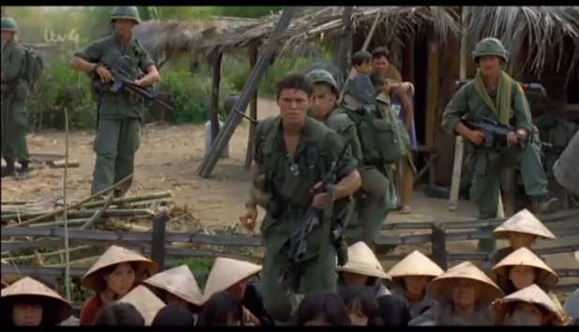
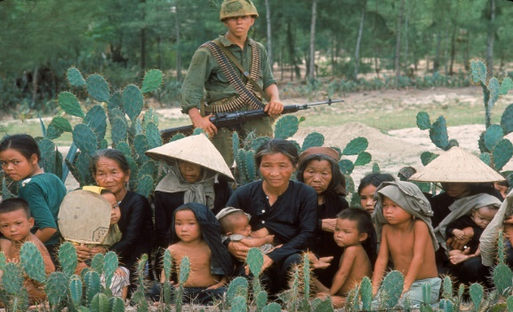

Platoon (1986) Schutzer (1965)

We root for Chris as he intervenes the rape of two villagers – a silent spectator and the victim who remains faceless. We hear her cries but interestingly, we do not see her face; this is not her story, it’s what she represents - the degradation of the soldiers’ moral compass.
Some may argue that placing Platoon (1986) at the forefront of Hollywood’s attempts to represent the ‘real’ Vietnam is rather misleading (Gruner, 2012, p.361) but we can’t deny it’s impact and how it continues to encourage debate over the Vietnam War. It has been re-released on DVD with further director commentaries and extras in a similar fashion to editions of an academic text. Stone fervently avoids commitment to the term historian, but it is undeniable that his body of work is consistent with an anthology of historical information like a traditional historian. His incorporation of realism into the frames of his works challenge what we perceive history to be. A muckraker disguised as a moviemaker, Stone demasks the lies and corruption of the American government and their mission in a depiction of ‘Vietnam As It Really Was’ (Corliss, 1987) and his brutal normalistaion of death and violence alongside humanity is created more than to just create thrill for a film audience, it’s to evoke an emotion response; Even now, Stone still hasn’t abated in his passion against the bullshit the Pentagon, the CIA and the government tell us – he still has the anger and the desire to ‘wake people up’. (Macnab, 2020)

Bibliography
Bates, M.J., 1994. Oliver Stone's "Platoon" and the Politics of Romance. Mosaic (Winnipeg), 27(1), pp.101–121.
Corliss, Richard "Platoon" Time Magazine 26 Jan. 1987:54-61
Denver Post. 2007. Louvre Set Visitor Record in 2006. [ONLINE] Available at: https://www.denverpost.com/2007/01/26/louvre-set-visitor-record-in-2006/. [Accessed 27 October 2020].
Gruner, O. (2012) ‘Vietnam and beyond: rethinking Oliver Stone’s Platoon (1976–2006)’, Rethinking History, 16(3), pp. 359–376
Macnab, G. (4th September 2020) ‘Speaking in Venice, Oliver Stone reveals the ‘’anger that fuels me’’, ScreenDaily, [https://www.screendaily.com/news/speaking-in-venice-oliver-stone-reveals-the-anger-that-fuels-me/5152868.article?referrer=RSS]
Rosenstone, R. (2006) History on Film/Film on History, Harlow, Essex: Longman/Pearson
Schutzner,P. (1965), Vietnam [ONLINE]. Available at: https://www.google.com/imgres?imgurl=https://ic.pics.livejournal.com/visual_archive/77503764/288020/288020_1000.jpg&imgrefurl=https://visual-archive.livejournal.com/46293.html?thread%3D91861&h=684&w=1000&tbnid=IIa2Z405QL9aZM&tbnh=186&tbnw=272&usg=AI4_-kSv_CM35PlJ4t4BGvqbCKDbnhvtHw&vet=1&docid=qsS_c_quCKHmuM&hl=en-GB [Accessed 23 October 2020].
Screenplay Explorer. 2020. Platoon 1986. [ONLINE] Available at: http://web.archive.org/web/20130901224810/http://screenplayexplorer.com/wp-content/scripts/Platoon.pdf. [Accessed 26 October 2020].
Stone, O. (1986). Platoon. [Online Video]. 28 October 2020. Available from: https://moodle.uwtsd.ac.uk/course/view.php?id=7287#section-5. [Accessed: 28 October 2020].
The Internet Movie Script Database. 1986. Platoon. [ONLINE] Available at: https://www.imsdb.com/scripts/Platoon.html. [Accessed 28 October 2020].

Word Count: 1757

