Student Name: Sam Digby Student Number: 1901067

Electronic Ignition & Fuel Injection Systems (M4X02197)

Contents
1.0 Introduction 1
2.0 Methodology 2
2.1 Dynamic testing 3
2.2 Static testing 4
2.3 Legislation and safe practise 5
2.3.1 Health and Safety at Work etc. Act 6
2.3.2 The Provision and Use of Work Equipment Regulations (PUWER) 7
2.3.3 Personal Protective Equipment (PPE) at work regulations 8
3.0 Results 9
3.1 LE3 K Jetronic 9
3.2 Motronic 1.5 11
4.0 Analysis 13
4.1 LE3 K Jetronic analysis 14
4.2 Motronic 1.5 analysis 15
4.3 fuel injector analysis 18
5.0 Differences in operating systems 20
6.0 Theoretical modifications made to one of the systems 21
6.1 Synchronised fuel injection 22
6.2 Knock sensor 23
6.3 Improvements in idle control 24
7.0 Conclusion 25
8.0 References 26
Appendix A: Speed reference signal for the fuel ECU (LE3 K Jetronic) 27
Appendix B: Secondary waveform for the LE3 K Jetronic system 28
Appendix C: Injector oscilloscope trace at idle (LE3 K Jetronic) 29
Appendix D: Injector oscilloscope trace while under acceleration parameters (LE3 K Jetronic) 30
Appendix E: Injector oscilloscope trace while under deacceleration parameters (LE3 K Jetronic) 31
Appendix F: Oscilloscope trace of the generation and delivery of the spark (Motronic 1.5) 32
Appendix G: Rotary idle valve oscilloscope trace (Motronic 1.5) 33
Appendix H: Mass Air flow and throttle potentiometer output oscilloscope traces (Motronic 1.5) 34
Appendix I: Lambda sensor oscilloscope trace (Motronic 1.5) 35
Appendix J: Engine Speed sensor oscilloscope trace (Motronic 1.5) 36
Appendix K: Fuel injector oscilloscope traces (Motronic 1.5) 37
Appendix L: Injection time at 80 degrees Celsius and the engine is idling (Motronic 1.5) 38
Appendix M: Fuel injection timing under acceleration (Motronic 1.5) 39
Appendix N: Fuel injection timing under deacceleration (Motronic 1.5) 40

Table of Figures
Figure 1- Close up view of the secondary wave form 15
Figure 2- Close up view of Appendix H 16
Figure 3- Section view of Appendix J, showing the signal indicating TDC to the ECU 17
Figure 4- Section view of Appendix K, showing the fuel injection period and back EMF 18
Figure 5- Section view of Appendix N, showing the overrun period 19
Figure 6- A section view of a wiring diagram showing the two ECUs incorporated with the LE3 K Jetronic system 20
Figure 7- A basic overall view of the Motronic 4.1 system. Note this is the 4.1 due to the presence of a throttle position switch (Source: https://saemobilus-sae-org.ezproxy.uwtsd.ac.uk/content/880135/#citations) 24

Table of Tables
Table 1- Dynamic test results for the K Jetronic system 9
Table 2- Fuel injector resistance check (LE3 K Jetronic) 9
Table 3- Auxiliary air valve resistance check 9
Table 4- Throttle switch resistance check 10
Table 5- Coolant temperature sensor resistance check (LE3 K Jetronic) 10
Table 6- Ignition coil windings resistance check (LE3 K Jetronic) 10
Table 7- HT lead resistance check (LE3 K Jetronic) 10
Table 8- Dynamic test results for the Motronic 1.5 system 11
Table 9- Throttle potentiometer resistance check 11
Table 10- Coolant temperature sensor resistance check (Motronic 1.5) 11
Table 11- Mass air flow sensor resistance check 11
Table 12- Air temperature sensor resistance check 12
Table 13- Idle control valve resistance check 12
Table 14- Injector resistance check (Motronic 1.5) 12
Table 15- Coil resistance check (Motronic 1.5) 12
Table 16- HT lead resistance check (Motronic 1.5) 12

Abstract
The aims of this report were to demonstrate the operation of two ignition and fuelling systems with an analysis that explains the inner workings of the systems. This investigation was conducted via a series of practical tests that were conducted within a test facility. This report serves as the write up of said tests. This report also includes a comparison of the systems tested and possible improvements to one of the systems is also included. Results were as expected apart from some anomalies caused by a skipping a step in the test procedure. Following a set test procedure would benefit in terms of eliminating any anomalies if these tests were performed again.

Introduction
Throughout the history of the automobile, the role of the ignition system and fuelling system is to deliver a high-quality spark and adequate fuel into the combustion chamber at the right time. The method of performing this task has changed over the years to improve the efficiency of the systems. These changes have been radical with the introduction of engine control units (ECUs) to manage these systems when previously, the ignition and fuelling systems have been mechanically timed.
With these improvements, the delivery of spark and fuel have become more efficient and with the use of ECUs, new operating procedures can be performed such as overrun and lean engine running.
This assignment covers two systems, the Bosch LE3 K Jetronic and the Bosch Motronic 1.5 ignition and fuelling systems. These systems have been tested in terms of functionality to a method which is also included in this assignment. During these tests, safe working practices and government legislation was followed to prevent unnecessary injury.
Once these tests were performed and the data was collected, an analysis is performed to explain what is happening in each scenario.
Because two systems are being tested, this assignment covers the differences of the two systems as they perform the same task in different ways. After this is performed, theoretical improvements to one of the systems will be suggested. These improvements are made to further improve the capabilities of the system in terms of delivering the required components for combustion more accurately.

2.0 Methodology
To conduct the tests a minimum of five personnel is required for the following:
- 1 to record the results
- 1 to control the oscilloscope
- 1 to control the engine
- 2 to take the readings
This distribution allows the results to be obtained efficiently. A reduction in personnel will decrease the overall efficiency of the group as one person will have to perform two different tasks.
Both tests made use of both a multi-meter and an oscilloscope. The reason behind this is because of the limitations of both systems. Although more advanced, the oscilloscope is a large piece of equipment and takes longer to set up when compared to the multi-meter. However, the oscilloscope can measure alternating currents accurately and can also monitor the engines temperature and battery voltage. The multi-meter in comparison to the oscilloscope is a small piece of equipment that can be set up quickly. Because of these advantages and disadvantage of both pieces of equipment, both are used for the tests as and when needed.
From here the methodology is split into two separate methodologies, dynamic testing and Static testing

2.1 Dynamic testing
Dynamic testing refers to tests performed with the engine running and at set temperatures. For both engines the setup for the dynamic tests followed the same procedure. The engines were prepared to use by fitting the following:
- Oil temperature probe
- Positive and negative crocodile clips onto the battery for battery voltage monitoring
- Extraction system onto exhaust
Once these were performed, the dynamic tests can commence. The procedure is as follows. First, the temperature is monitored and once up to a test temperature. The appropriate pins for each system was measured. These is a difference at this point as on the K Jetronic system the engine was turned off so the measurements could be taken. This varies from the Motronic 1.5 system where the engine was turned back on to measure some of the values such as the injection on time. Once the pins were measured and recorded. The engine was turned back on to warm up the next temperature. It is to be noted that on the Motronic 1.5 system not all pins were measured at every temperature interval. This was done because those pins related to solenoids being turned on or off.
This process is continued until the engine is at operating temperature (70 degrees Celsius for the K Jetronic and 80 degrees for the Motronic 1.5). At this point the static tests were then performed.

2.2 Static testing
Static testing refers to the tests performed with the engine ignition engaged or the engine is turned off. The engine is not cranked over for these tests. The static tests acquire data from the engine and then is compared against manufactures specifications. It is to be noted that the static tests were performed after the dynamic tests so the engine are up to their operating temperatures.
The tests comprise of testing each pin on the ECUs for the voltage values with both ignition on and off. To obtain this data, the multi-meter was heavily used due to the current being a DC current. This allows the multi-meter to be accurate. This being said, the oscilloscope was used as well due to its capability to measure alternating currents. Once all the pins were measured and the data was collected, a comparison using the manufactures specifications was made to see if the collected data aligns with the manufacture’s specifications.

2.3 Legislation and safe practise
Throughout the tests, all personnel followed the following regulations and legislation:
- Health and Safety at work etc. Act 1974
- Provision and Use of Work Equipment Regulations 1998
- Personal Protective Equipment at Work Regulations 1992
In addition to following the above legislation, all personnel behaved in an appropriate manner to prevent any injury. Additional equipment such as the carbon dioxide meter was used to monitor the CO levels inside the test room.

2.3.1 Health and Safety at Work etc. Act
The Health and Safety Act is an act that covers all professions to ensure the health and safety of workers. This covers but is not limited to:
- Provision of necessary training to use equipment provided (applies to employer)
- The maintenance of a safe working environment (applies to employer)
- The co-operation of employees to carry out health and safety procedures as set out by the employer
(Health and Safety at Work etc. Act, 1974)
During the testing that was conducted for this assignment, this regulation applies to the general work etiquette of the personnel present during the tests as well as previous lectures that covered the basis of these tests.

2.3.2 The Provision and Use of Work Equipment Regulations (PUWER)
The provision and use of work equipment regulations covers any form of machinery, apparatus, tools and instillations used at the place of work (Provision and Use of Work Equipment Regulations, 1998). This means that the organisation who owns the equipment must manage the risk from said piece of equipment.
This covers but is not limited to
- That the employer or organisation shall ensure that the work equipment is in an efficient state, in efficient working order and in good repair.
- Repairs, servicing and maintenance of work equipment that involves a specific risk to health and safety is restricted to designated personnel who have received adequate training.
(Provision and Use of Work Equipment Regulations, 1998)
During the testing that was conducted for this assignment, this regulation applies to the multi-meters, oscilloscopes and engine rig used.

2.3.3 Personal Protective Equipment (PPE) at work regulations
PPE is equipment that protects the user from any hazards that may occur during work. Appropriate PPE must be chosen for the relevant task to protect the user from risk. (Personal Protective Equipment at Work Regulations, 1992) PPE covers all manner of protective equipment from face-shields to safety boots, and it is the responsibility of the employee to use it.
During the testing that was conducted for this assignment, the dust coats and steel toe cap boots are covered by this regulation.

3.0 Results
This section only contains the tables of the results that was collected. For the scope traces of the LE3 K Jetronic please refer to appendix A through to appendix E. For the scope traces for the Motronic 1.5 system please refer to appendix F through to appendix N. In addition to this, the static test results take the resistance of the multi-meter leads in to account. This resistance was measured at 0.2Ω for both LE3 K Jetronic and Motronic 1.5 static tests. Also, to note is that any result that contains the value of N/R represents values that were not recorded.

3.1 LE3 K Jetronic
Table 1- Dynamic test results for the K Jetronic system
Temperature | Pin number
ºc | 8 (Ω) | 3 (ms) | 8 (V)
20 | 2500 | 4.5 | 1.9
30 | 990 | 3.3 | 0.9
40 | 720 | 3.2 | 0.8
50 | 500 | 3 | 0.64
60 | 390 | 2.8 | 0.5
70 | 600 | 2.7 | 0.7

Table 2- Fuel injector resistance check (LE3 K Jetronic)
Fuel injector resistance
Fuel injector number | Autodata Values | Recorded Values
1 | 15 - 17Ω | 16Ω
2 | 15 - 17Ω | 16Ω
3 | 15 - 17Ω | 16Ω
4 | 15 - 17Ω | 16Ω

Table 3- Auxiliary air valve resistance check
Auxiliary air valve
Autodata Value | Recorded Value
40Ω | 46.1Ω

Table 4- Throttle switch resistance check
Throttle Switch
Terminals | Autodata Values | Recorded Values
2 & 18 | 0Ω | 0Ω
3 & 18 | Infinity | Infinity

Table 5- Coolant temperature sensor resistance check (LE3 K Jetronic)
Coolant temperature sensor (NTC 2)
Temperature (Celsius) | Autodata Values | Recorded Values
20 | 2100 - 2900Ω | 2560Ω
63.8 | 270 - 390Ω | 600Ω

Table 6- Ignition coil windings resistance check (LE3 K Jetronic)
Ignition coil windings
Winding | Resistance
Primary | 0.9Ω
Secondary | 7420Ω

Table 7- HT lead resistance check (LE3 K Jetronic)
HT lead resistance
Lead 1 | 8690Ω
Lead 2 | 8850Ω
Lead 3 | 7710Ω
Lead 4 | 5620Ω

3.2 Motronic 1.5
Table 8- Dynamic test results for the Motronic 1.5 system
Temperature | Pin number
ºc | 45 (Engine off) | 45 (Ignition on) | 16 | 4 | 5 | 28
20 | 1530Ω | 3V | 3.5ms | 46% | OFF | OFF
30 | 995Ω | 2.5V | 3.6ms | 45% | OFF | ON
40 | 642Ω | 2V | 3.4ms | 46% | OFF | ON
50 | 426Ω | 3.7V | 3ms | 44% | ON | ON
60 | 314Ω | 1.3V | 3.2ms | 43% | ON | ON
70 | 237Ω | 1V | 2.9ms | 47% | ON | ON
80 | 241Ω | 1V | 3.3ms | 47% | ON | ON

Table 9- Throttle potentiometer resistance check
Throttle Potentiometer
Throttle position | Autodata Values | Recorded Values
Throttle closed | 1900 - 2000Ω | 1990 - 2000Ω
Throttle open | 1000 - 2000Ω | 2550Ω

Table 10- Coolant temperature sensor resistance check (Motronic 1.5)
Coolant temperature sensor (NTC2)
Temperature (Celsius) | Autodata Values | Recorded Values
20 | 2200 - 2800Ω | 1530Ω
80 | 270 - 330Ω | N/R

Table 11- Mass air flow sensor resistance check
Mass Air Flow Sensor
Autodata Values | Recorded Values
8 - 2500Ω | 33.6Ω
300 - 550Ω | 560Ω
290 - 520Ω | N/R

Table 12- Air temperature sensor resistance check
Air temperature sensor (NTC1)
Temperature (Celsius) | Autodata Values | Recorded Values
15 - 30 | 1500 - 3300 | 2550Ω
80 | 280 - 360 | N/R

Table 13- Idle control valve resistance check
Idle Control Valve
Autodata Values | Recorded Values
8Ω | 8.4Ω

Table 14- Injector resistance check (Motronic 1.5)
Injector Resistance
Autodata Values | Recorded Values
15 - 17Ω | 16.5Ω

Table 15- Coil resistance check (Motronic 1.5)
Coil resistance
Primary | 0.8Ω
Secondary | 7270Ω

Table 16- HT lead resistance check (Motronic 1.5)
HT Leads resistance
Lead 1 | 23000Ω
Lead 2 | 19300Ω
Lead 3 | 16400Ω
Lead 4 | 24100Ω

4.0 Analysis
Like previous sections, the analysis will be split into two showing the scope traces for both LE3 K Jetronic and Motronic 1.5 systems.

4.1 LE3 K Jetronic analysis
Appendix A shows the speed reference trace for the fuel ECU. This trace is needed for the fuel ECU so it knows the speed of the engine. However, this waveform is in a digital format. This is because the signal has been converted into a digital signal. There are disadvantages to this such as the loss of potentially vital data. When the analogue signal is converted into a digital signal, some data is lost in the conversion process.
This process is performed due to the fact that there are two ECUs. This means that the data needs to be converted into a digital format so that the ECU can read it.
Since there is a lot of cross over between the systems in terms of the voltage traces (i.e., the injector traces and the secondary waveform) the analysis will be shown in the next section.

4.2 Motronic 1.5 analysis
The generation and delivery of the spark is shown in Appendix F (the same trace is shown in Appendix B for the LE3 K Jetronic system). The trace starts above 0 volts and then drops below 0V. This drop in voltages is known as the dwell period. The dwell period is when current flows through the ignition coil via the primary coil. Typically, this takes 3 to 5ms but on modern systems the dwell period is calculated by the battery voltage. (Park, Han, Kasaragod Purushotham, and Baratta, 2015) The dwell period is important as it lets the voltage increase to a level required to create a good spark. It is of note that the primary coil increases the voltage before the voltage is induced into the secondary coil for further increases in voltage and delivery.
Once the voltage is created and sent to the spark plug, EMF is created. However, as shown in the Appendix F, a back EMF is created. This back EMF opposes the flow of the generated voltage, in this case the back EMF flows back into the ignition coil. Without this back EMF, the generated voltage would not be able to travel to the spark plugs.
After the back EMF is produced, the next section of the trace shows the spark line and the coil oscillations. The spark line (shown in figure 1) is the point where the generated voltage bridges the gap between the spark plug. This voltage needs to be high as the current needs to pass through a heavily compressed area. After the spark is produced, the coil oscillations occur. This section is where the coil has no current running through it. The oscillations occur due to the coils returning to a state where there is no current going through them.

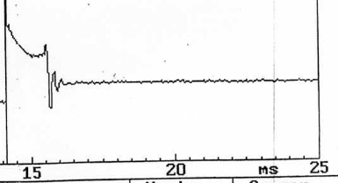
Coil oscillations
Spark Line
Figure 1- Close up view of the secondary wave form

Appendix G shows the oscilloscope trace for the rotary idle valve when the engine temperature is at 80 degrees Celsius. This rotary idle valve controls the idle speed of the engine by turning on and off when needed. This data, as shown in table 8, is presented as a percentage. This is convenient as the rotary idle valve operation takes 10 milliseconds (as a percentage this is taken as 100%). The data on table 8 shows the percentage on time. This means that if the percentages were converted into decimal form, the actual on time is shown in milliseconds.
Appendix H shows the relation between the throttle potentiometer and the mass air flow sensor. The relationship is seen throughout the oscilloscope trace as when the voltage output from the potentiometer (pin 53) increases, so does the voltage output on the mass air flow sensor. This relationship is apparent because the user is demanding an acceleration. The opening of the throttle brings in more air that has to pass through the mass air flow sensor (pin 7) hence the increase in the voltage output. This relationship is further stressed in figure 2.

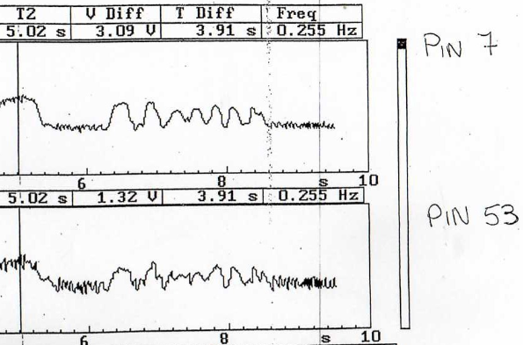
Figure 2- Close up view of Appendix H
As shown above, when the throttle is shut closed both the voltage outputs for the throttle potentiometer and the mass air flow sensor decreases. This down to the throttle being closed in the case of the potentiometer and the lack of demand for air in the case of the mass air flow sensor.

Appendix I shows the lambda sensor scope trace. The job of the lambda sensor is to monitor the air content of the exhaust gases. This is information is given as a voltage reading to the ECU with 1V meaning the engine is running very lean and 0V meaning the engine is running very rich. The ECU responds to this by altering the fuel injection map to compensate. Due to the age of the engine, the ECU can operate in the closed loop format only as open loop wasn’t developed for these engines.
It is to be noted however that both lambda sensor and engine must be up to temperature before the lambda sensor functions as there are set operating temperatures for lambda sensors to work as intended (Gruber, and Wiedenmann, 1980)
Appendix J shows the engine speed sensor. This sensor is using the disturbance of the magnetic field created by the sensor to measure when engine speed. The disturbance of the magnetic field is performed by teeth that are put into the flywheel. Since there are multiple teeth, the scope trace peaks frequently. The ECU measures the engine speed by the frequency of the peaks. However, there is one tooth that looks different on the scope trace and is shown again in figure 3.

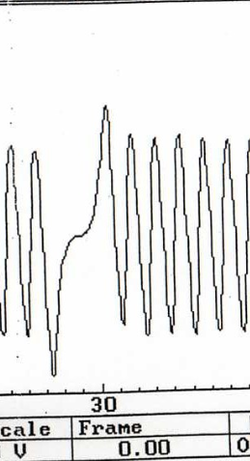
Indicates TDC to the ECU
Figure 3- Section view of Appendix J, showing the signal indicating TDC to the ECU
This trace is created by a large gap between two teeth and it tells the ECU that a piston is at top dead centre.

4.3 fuel injector analysis
Appendix K shows the fuel injector oscilloscope traces. Because this particular engine is a four cylinder, each pin controls 2 injectors. Due to the pattern of the scope traces, it can be induced that the Motronic 1.5 system follows a continuous injection system. Looking further into the scope pattern, it can be observed that there is a similar pattern to Appendix A. This is because of the injectors containing solenoids. The same principle mentioned earlier to describe the ignition coils operation can be applied here because a solenoid contains a coil. However, there is a difference. Shown below in figure 4, it clearly shows were the fuel is injected. It also shows where the back EMF occurs and why it does as well.

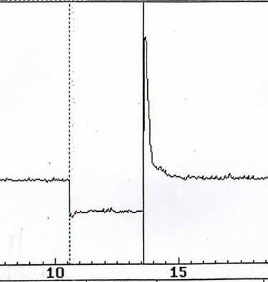
Back EMF caused by the solenoid closing
Fuel injection ends
Fuel injection starts
Figure 4- Section view of Appendix K, showing the fuel injection period and back EMF

Appendix L shows a singular bank of injectors (pin 16) when the engine is at idle and the temperature is at 80 degrees Celsius. This close up shot shows the principles explained in the paragraph above. However, it is important to take note of the injection time which equals 2.99 milliseconds. A similar scope trace is for the LE3 K Jetronic is provided in Appendix C.
In Appendix M, the same bank of injectors is shown but under acceleration parameters. This means that the fuel injection timing will change (injection timing equals 7.95 milliseconds) to put in as much fuel as possible to increase the engine speed and the vehicles acceleration. A similar scope pattern is shown in appendix D for the LE3 K Jetronic system.

Appendix N shows again the same bank of injectors but under deacceleration parameters. This means that several changes come into effect. The first of which is the amount of times the injector pulse decrease and the injection time decreases back down to around the same time as when the engine was idling. The third change is shown in figure below.

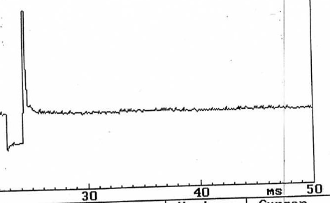
Overrun begins
Figure 5- Section view of Appendix N, showing the overrun period
This is known as overrun. It is a characteristic programmed into the fuel map which cuts off the fuel injection. On this system, the ECU also monitors engine speed so that if the engine speed drops below a pre-determined speed, the injectors will resume pulsing to prevent the vehicle surging. (Gorille, 1980)
The overrun process also occurs on the LE3 K Jetronic system, as shown in Appendix E

5.0 Differences in operating systems
This section, with conjunction with the technical analysis seen in 4.0 Analysis, shows the differences between the two systems that were analysed. This section will only describe the differences between the two systems. For a more technical analysis please refer to 4.0 Analysis.
The most obvious difference in these systems is the ECU. On the Motronic 1.5 system, a singular ECU controls both the ignition system and the fuelling system. This is different on the LE3 K Jetronic system. This system uses two ECUs. One is for the control of the ignition system and the other controls the fuelling system, as seen in figure 6. These two ECUs communicate together via a communications line also seen in figure

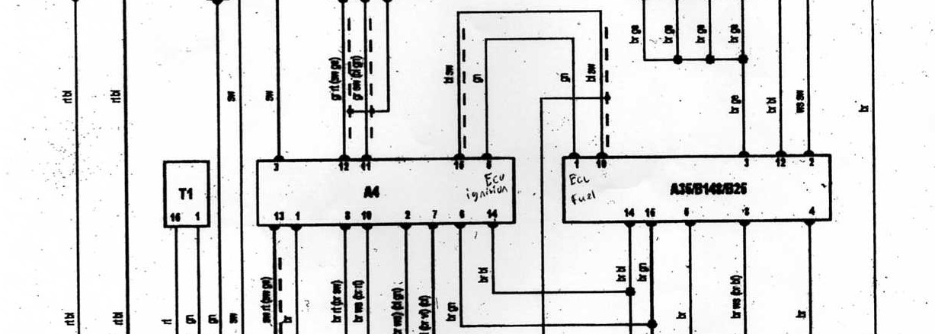
Communications line
Figure 6- A section view of a wiring diagram showing the two ECUs incorporated with the LE3 K Jetronic system
In terms of operating voltages, the LE3 K Jetronic system operates its sensors at battery voltage while the Motronic 1.5 system operates its sensors at 5V which is controlled by the ECU. Operating the sensors at a constant voltage is more advantageous in terms of self-diagnostics as the ECU will realise there is a fault somewhere when it receives the 5V back that it supplied. If the sensors are run at battery voltage like they are on the LE3 K Jetronic system. The ECU will have to calculate the battery voltage to see what it is before performing a self-diagnostic to see if the voltage signals coming beck are correct. This process does take time to perform and at higher engine speeds, it can cause the fuel or ignition to come in at the wrong time.
There is also a difference in parts between the two systems. The Motronic 1.5 system features a throttle potentiometer and air mass meter. The throttle potentiometer as previously mentioned can determine the angle of the throttle and convert this value into a voltage signal. This means that every angle can be measured unlike the throttle switch which is used of the LE3 K Jetronic system.
The air flow meter as previously mentioned uses a thermal sensor which is kept above the air temperature. Changes to the temperature of the thermal sensor is measured and sent of as a voltage signal to the ECU. Again, this is not present on the LE3 K Jetronic system.

6.0 Theoretical modifications made to one of the systems
For this section, modifications will be presented for one of the systems (in this case the LE3 K Jetronic system) to enhance the system’s ability to deliver fuel and the spark more accurately. The improvements suggested in this section and following sections are purely theoretical. This means that the instillation of these improvements is not considered.

6.1 Synchronised fuel injection
The LE3 K Jetronic uses continuous injection to deliver the fuel into the combustion chamber. This means that for every 360 degrees, half the fuel is injected into all the cylinders. With the fuel being injected into all the cylinders, regardless of what position they are in in terms of the Otto cycle. This results in hydrocarbons in high quantities inside the exhaust.
Synchronised fuel injection is when fuel is injected to the cylinders that are at the end of the compression stroke. Also, another difference is that all the measured fuel inside is injected at once. The benefits of this over the continuous injection is that the fuel is only going to the cylinder going to the power stroke. This means has several benefits:
- Less fuel consumption due to the fuel not being wasted on cylinders that are not going to use the fuel
- Improved emissions due to an overall reduction in the number of hydrocarbons in the exhaust
In addition to this the engine is able to stop fuel flow into a set number of combustion chambers. i.e. The ECU can shut down a cylinder for a number of reasons ranging from improved fuel economy to “limp home” mode parameters. This would be not possible with a continuous injection system as the fuel is injected continuously into all cylinders.

6.2 Knock sensor
An additional improvement to the LE3 K Jetronic is the incorporation of a knock sensor. This sensor monitors the engine for any form of knock that occurs. This does provide benefits that will save the engine from potential failure due to engine knock.
The ECU can monitor the engine for knock and if knocking does occur, the ECU can alter the ignition and fuel maps to prevent it from occurring.
There are some problems that do arise with this modification. Knock sensors in mass produced engines come with a large bandwidth. This is where the problem starts as due to the large bandwidth, other engine vibrations can be detected by the knock sensor (Pimenta, Trevas, Navegantes, and Souza Montemor, 2016). This means that the ECU can be delaying the ignition timing to prevent knock when in actuality, the engine is not knocking.
In conjunction with the previous point, when knock occurs a high intensity flash and a rapid increase of ionization occurs along with a vibration. Knowing this the use of optical probes and ionization detectors are used to detect engine knock (Heywood, 2018)

6.3 Improvements in idle control
The LE3 K Jetronic system has a noticeable lack of idle control measures. In the system there are only two systems that can adjust base idle.
- The auxiliary air device
- Idle adjuster screw
The auxiliary air device is operated by two strips of metal, both of which become malleable under different temperatures. When the temperature is low, the auxiliary air device opens and allows more air into the combustion chamber which will increase the base idle. The opposite occurs at higher temperatures.
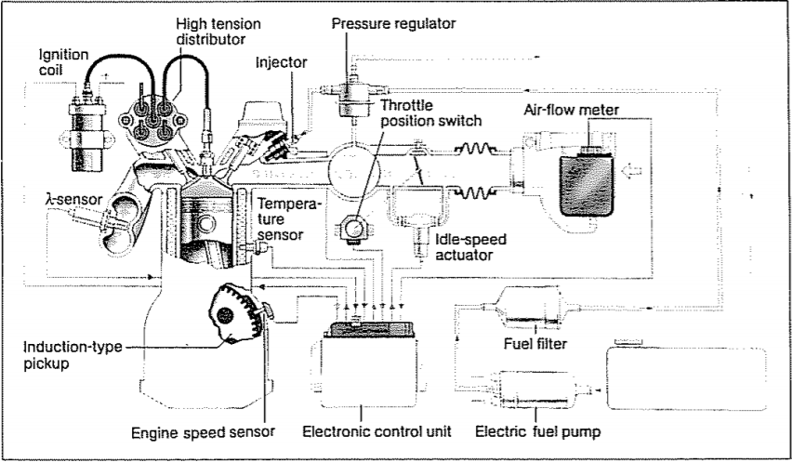
This device performs well but it has no communication with the ECU which can be improved on. The use of an idle speed actuator as seen on the Bosch Motronic 4.1 system (figure 7) improves on the auxiliary air device by being able to receive information from the ECU. This allows the ECU to examine all the contributing factors that affect the idle speed and using this information, the ECU can input the required change in position of the idle speed actuator to allow the idle speed to increase or decrease when needed. (Kaiser, Zechnail, and Plapp, 1988)
Figure 7- A basic overall view of the Motronic 4.1 system. Note this is the 4.1 due to the presence of a throttle position switch (Source: https://saemobilus-sae-org.ezproxy.uwtsd.ac.uk/content/880135/#citations)
This improvement also allows the ECU to compensate for engine wear as the ECU is now receiving all the information required to make said changes. This functionality is an improvement on the idle adjuster screw which was a crude measure to control the idle speed.

7.0 Conclusion
In conclusion, this report has covered all areas of these tests from the method which was used to the potential theoretical improvements that could be made.
In terms of the actual tests, there cannot be much improvement in the way they were conducted apart from being more careful with the sensors as one sensor was in the wrong place and as a result caused an anomaly that is highlighted upon. In terms of the legislation, they were followed in order to prevent any injuries or any potential failures in test equipment. By performing this, the tests went incident free and this helped improve the efficiency of performing the tests.
From the gathered results and the further analysis of them, it is shown that out of the two systems that were tested, the Motronic 1.5 system is a more advanced and effective system than the LE3 K Jetronic. The reasons behind this range from further enhancement in components to better analysis from the ECU on when to deliver the required components (Spark and fuel air mixture) at the right moment. This being said, both systems pail in comparison to what would eventually replace them due to new and improved technology being introduced.
Along with the technical analysis, an explanation on the differences between the Motronic 1.5 and the LE3 K Jetronic is provided to give an analysis on what components are different.
This section is then followed by a theoretical exercise on improving the less advanced LE3 K Jetronic system. This gives an opportunity on how to improve this system in terms of delivering spark and the fuel air mixture more accurately. This section does not consider the implementation of the improvements which does mean that the LE3 K Jetronic system may need a major overhaul to implement said improvements.
Overall, the results show that both of these systems proved to be serviceable for the time they were used but overtime newer systems and tighter regulations meant that both of theses systems needed to be phased out because they could not comply with the tighter emission standards.

8.0 References
Gorille, I. (1980) Digital Engine Control for European Cars, Available at: https://saemobilus-sae-org.ezproxy.uwtsd.ac.uk/content/800165/#abstract (Accessed: 25th May 2020).
Gruber, H. and Wiedenmann, H. (1980) Three Years Field Experience with the Lambda-Sensor in Automotive Control Systems, Available at: https://saemobilus-sae-org.ezproxy.uwtsd.ac.uk/content/800017/#abstract (Accessed: 25th May 2020).

Health and Safety at Work etc. Act 1974. Available at: https://www.legislation.gov.uk/ukpga/1974/37 (Accessed: 27th May 2020).
Heywood, J.B (2018) Internal Combustion Engine Fundamentals, 2nd edn., New York : McGraw-Hill Education.
Kaiser, G., Zechnail, M., and Plapp, G. (1988) Closed Loop Control at Engine Management System MOTRONIC, Available at: https://saemobilus-sae-org.ezproxy.uwtsd.ac.uk/content/880135/#citations (Accessed: 7th May 2020).
Park, J., Han, S., Kasaragod Purushotham, D. and Baratta,A. (2015) The Low Level Driver Design to Improve Dwell Timing of Engine Management System, Available at: https://saemobilus-sae-org.ezproxy.uwtsd.ac.uk/content/2015-01-1621/ (Accessed: 25th May 2020).

Personal Protective Equipment at Work Regulations 1992. Available at: http://www.legislation.gov.uk/uksi/1992/2966/regulation/1/made (Accessed: 27th May 2020).
Pimenta, C., Trevas, I., Navegantes, W. and Souza Montemor, R. (2016) Knock Sensor Background Analysis and Their Relation with Combustion Pressure Curve, Available at: https://saemobilus-sae-org.ezproxy.uwtsd.ac.uk/content/2016-36-0403/#abstract (Accessed: 24th April 2020).

Provision and Use of Work Equipment Regulations 1998. Available at: http://www.legislation.gov.uk/uksi/1998/2306/contents/made (Accessed: 27th May 2020).

Appendix A: Speed reference signal for the fuel ECU (LE3 K Jetronic)

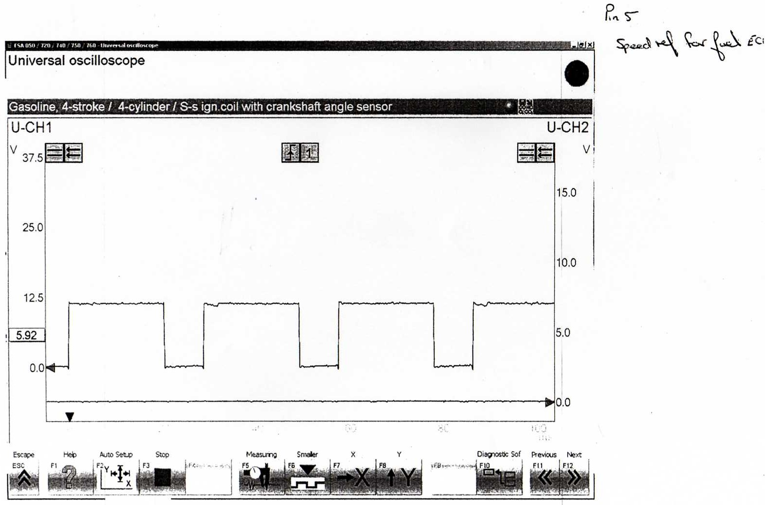

Appendix B: Secondary waveform for the LE3 K Jetronic system
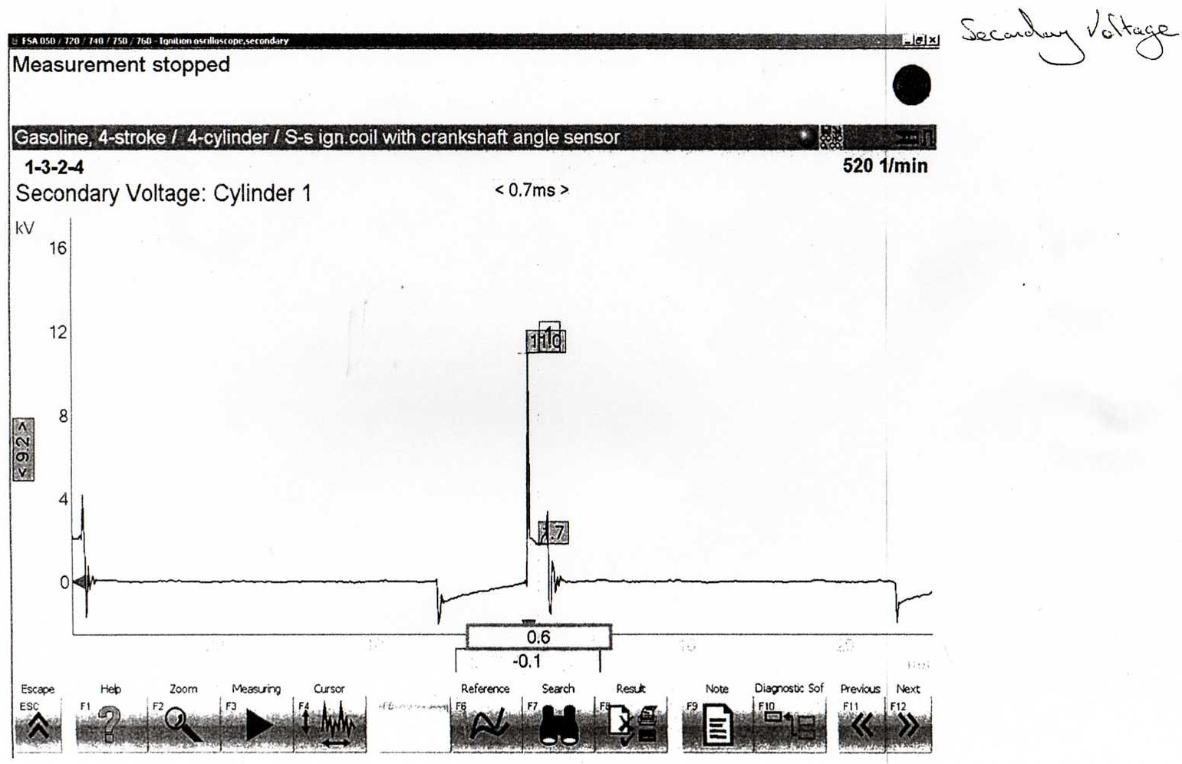

Appendix C: Injector oscilloscope trace at idle (LE3 K Jetronic)
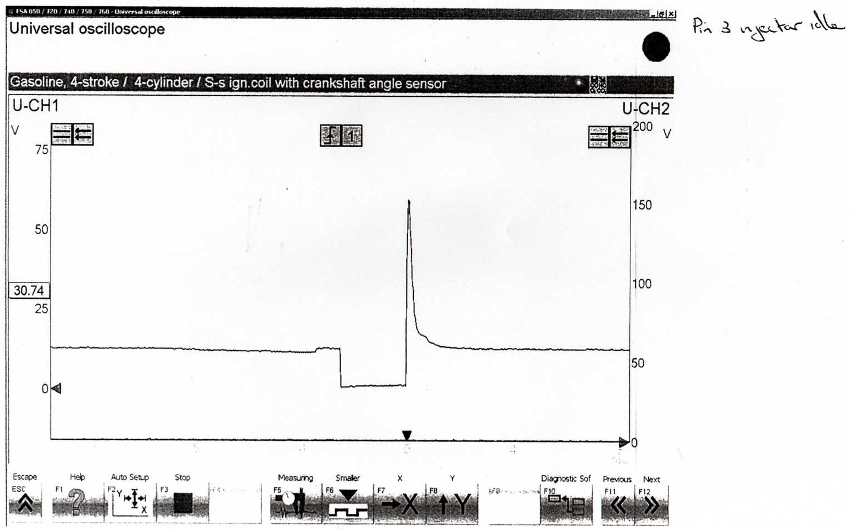

Appendix D: Injector oscilloscope trace while under acceleration parameters (LE3 K Jetronic)
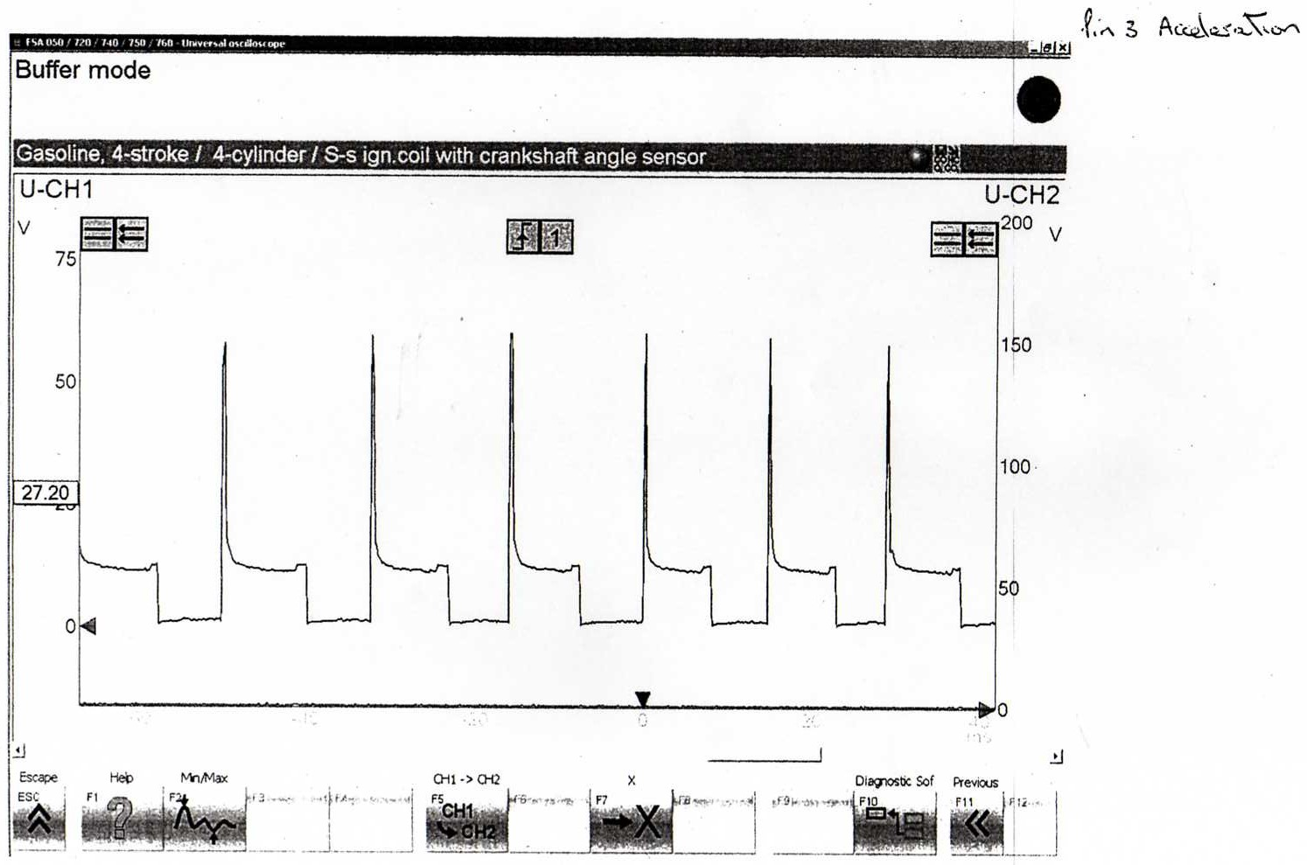

Appendix E: Injector oscilloscope trace while under deacceleration parameters (LE3 K Jetronic)
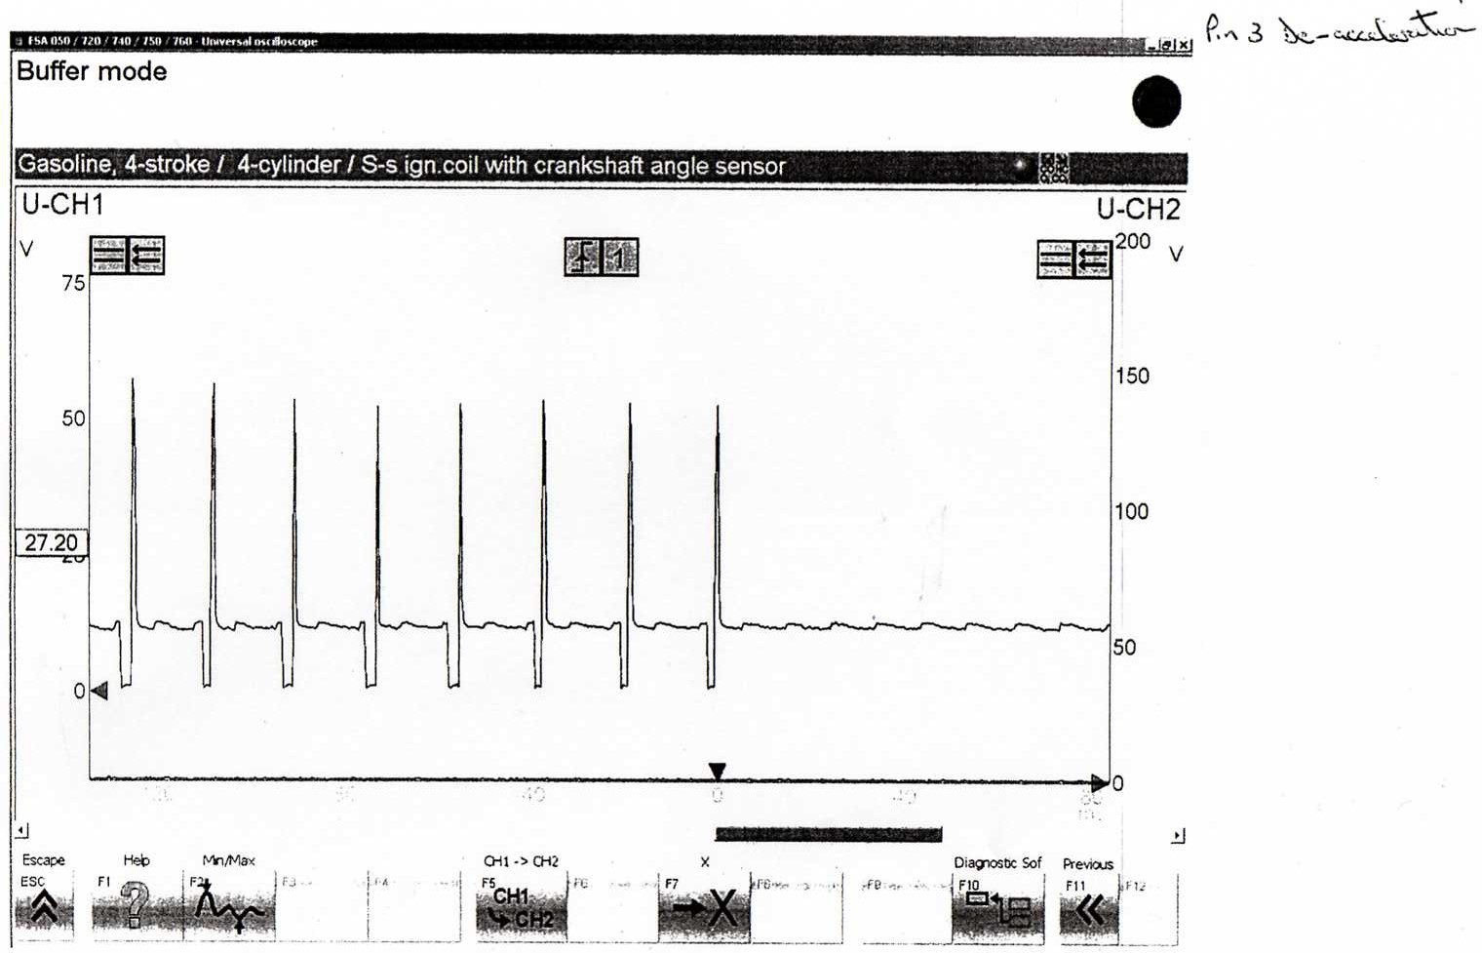

Appendix F: Oscilloscope trace of the generation and delivery of the spark (Motronic 1.5)
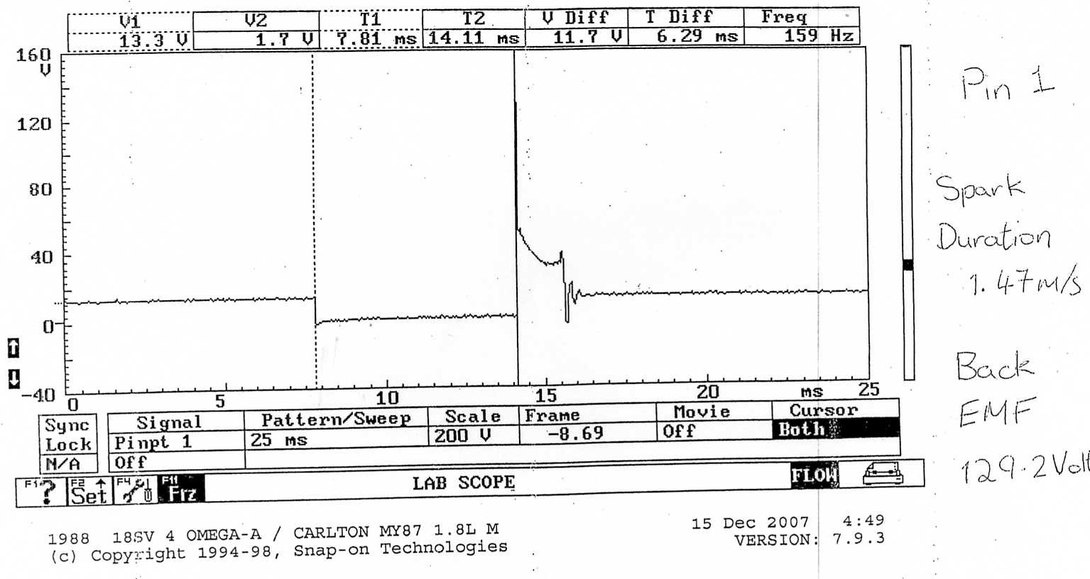

Appendix G: Rotary idle valve oscilloscope trace (Motronic 1.5)

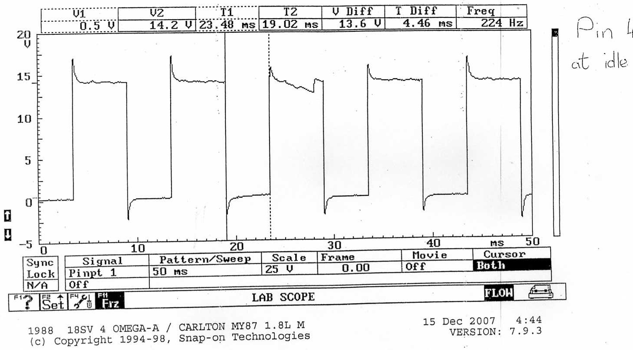

Appendix H: Mass Air flow and throttle potentiometer output oscilloscope traces (Motronic 1.5)
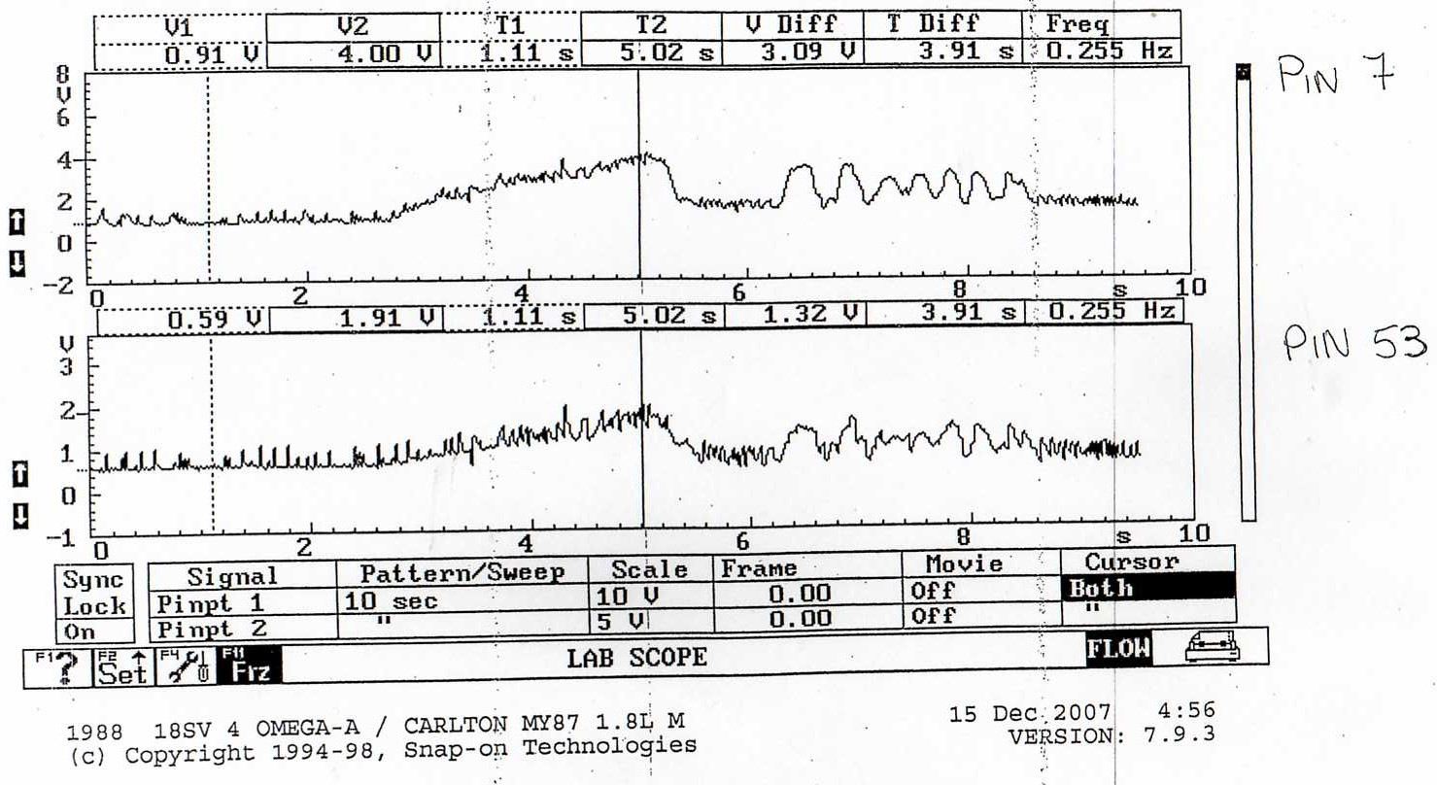

Appendix I: Lambda sensor oscilloscope trace (Motronic 1.5)
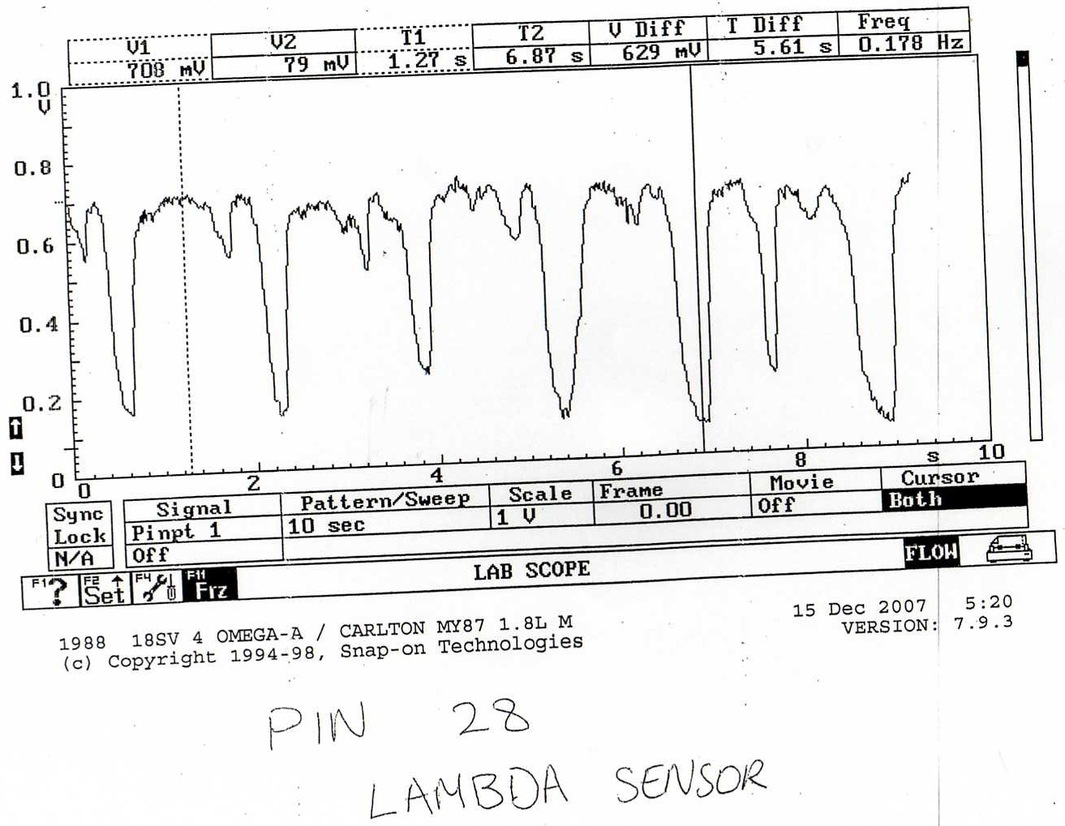

Appendix J: Engine Speed sensor oscilloscope trace (Motronic 1.5)
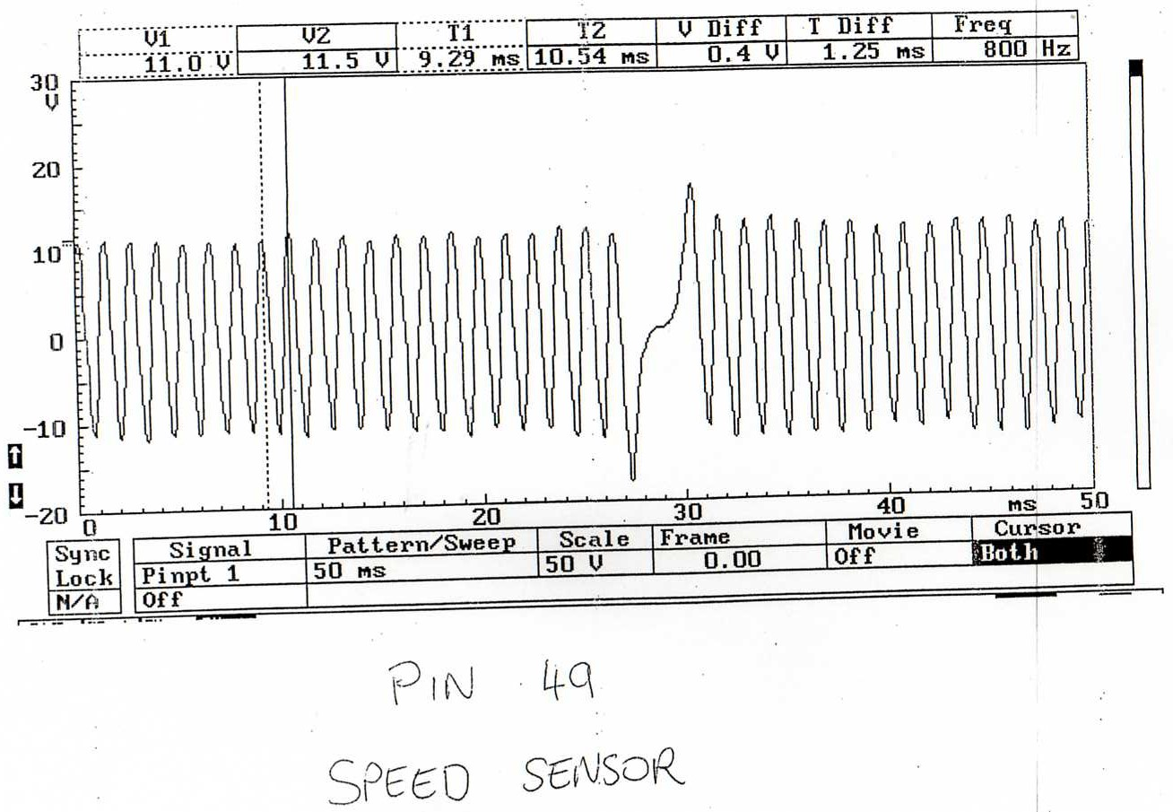

Appendix K: Fuel injector oscilloscope traces (Motronic 1.5)
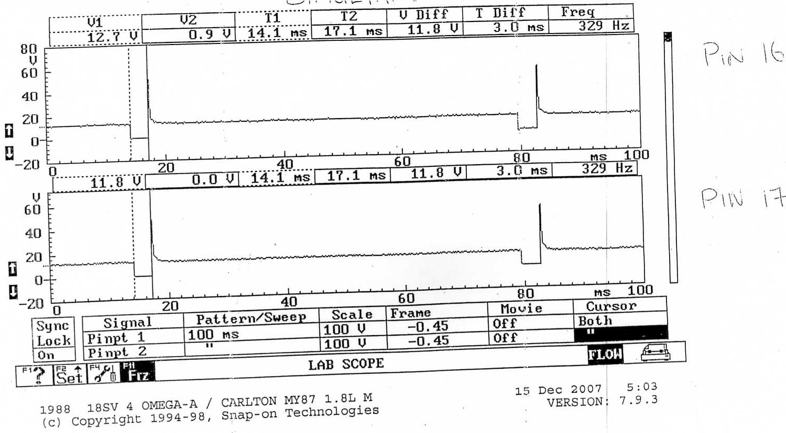

Appendix L: Injection time at 80 degrees Celsius and the engine is idling (Motronic 1.5)
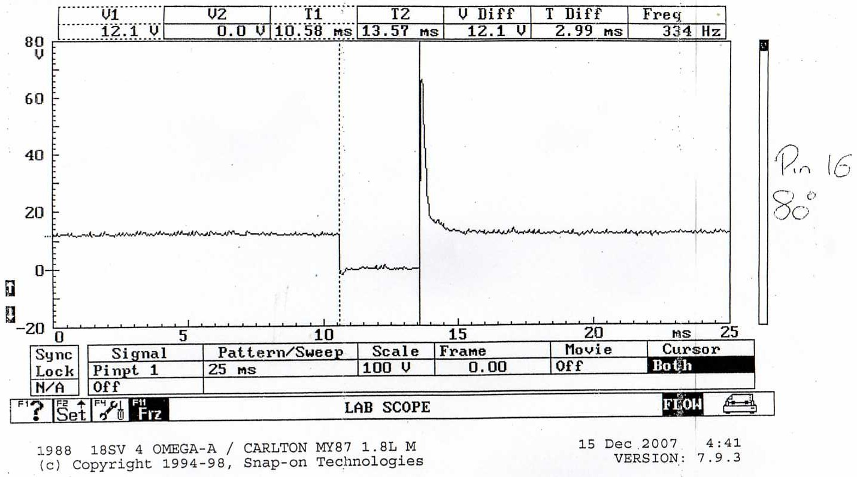

Appendix M: Fuel injection timing under acceleration (Motronic 1.5)
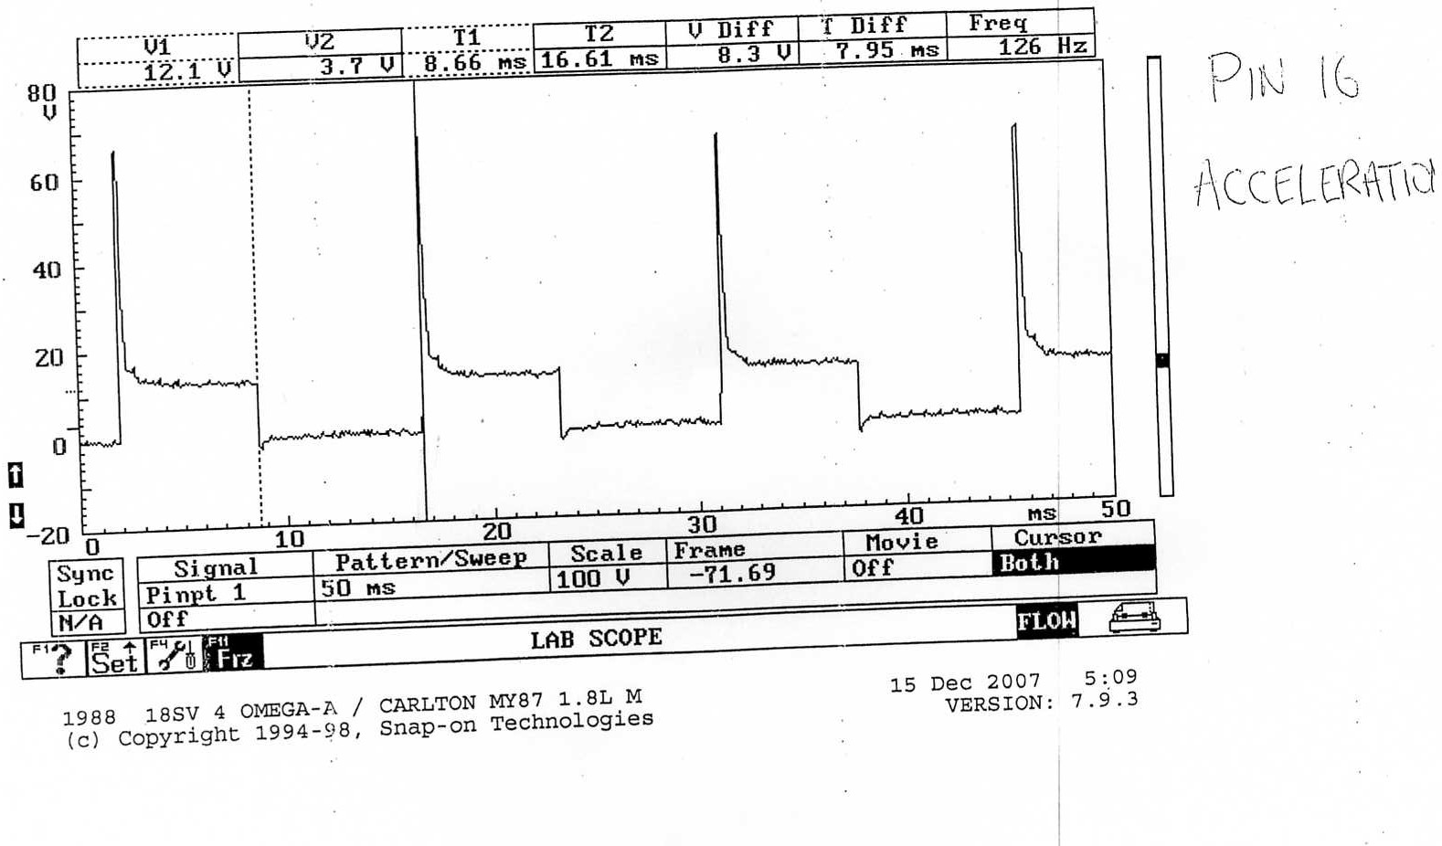

Appendix N: Fuel injection timing under deacceleration (Motronic 1.5)


