Digital Skills and Research Methods

Gias Ahmed
No- 1709681

University of Wales Trinity Saint David

Contents
Introduction 3
1. Use and importance of technology in the workplace 4
2. Social Media in the workplace 5
3. Workplace applications 6
4. Creating own professional presence through digital marketing 7
Conclusion 11
References 12

Introduction
Technology is the combination of methods, skills and techniques of science which solve scientific problems and create several sorts of goods and services for the wellbeing of the human being (Kirsch and Sullivan, 2013). Technology has become an integral part of the life of human being at present age. It is almost impossible to lead a day without using technology. Due to the blessing of technology, the burden of the human being has reduced to a great extent. Technology has made the human being smarter in all sphere of life. In the modern organizations, no activity can be accomplished without incorporating technology. This assignment has been prepared to analyse the effectiveness of the use of modern technology in the workplace including the use of contemporary techniques.

Use and importance of technology in the workplace
Use of technology in the workplace makes the organization more competitive and helps to get a competitive advantage. Technology is important in the present workplace due to the following reasons:
Efficiency and employability: Technology makes the employees efficient through enhancing employability skills in an organization (Ramsey, 2014). For example, use of software for the purpose of giving entry of any transaction instead of manual posting makes the task easier and faster. It requires less human resource and reduces the working time. Besides, all the tasks can be performed effectively without making any error. Apart from enhancing the efficiency of employees, technology reduces the operational cost of the organization.
Effective communication: Technology makes the communication much easier. At organization, the employees need to communicate with each other frequently. The communication is conducted not only with the internal employees but also with the external community to run the business. The traditional method use of telephone makes the communication sloth. At the present age, meetings are held staying in a remote area through the use of technology. In modern organizations, Skype, Facebook, email, what's app, messenger are used as an effective communication tool.
Competitive in the marketplace: Whatever service or product an organization provides, it has to compete. The competitors integrate technology into their operations. So, the particular organization must use technology to survive in the competition. The technology allows an organization to perform more activities effectively within the short time. For example, digital marketing helps an organization to introduce its product throughout the world and use of digital tools for sales help the organization to sell its products across the globe.
Accuracy: Technology ensures accuracy in all the operations of an organization. For example, in terms of accounting of the transactions and measuring the profitability modern technology like MS Excel can perform millions of transactions with its numerous computational formulas. The accounting software named QuickBooks helps the organizations to record sales, keep inventory, pay bills and manage the salary of the employees more accurately. With the help of technological tools, financial statement of an organization can be prepared within very short time previously which would require much time.
Industry relevant: There are some industry-relevant technologies that need to be used by the organizations (Fitzpatrick and Montgomery, 2015). For instance, the healthcare organizations need to use numerous technologies that are required mandatorily in the healthcare industry. Use of technology helps the organization being industry relevant.

Social Media in the workplace
In a research, it has come out that currently, almost 80% of the UK people use the smartphone and over 73% has the internet access. Moreover, around 69% UK people use social Media for different purposes (Savin-Baden and Tombs, 2013). Social Media as a part of technology and digital tool in the workplace is beneficial by the following ways:
Productivity: More than 34% of the employees use social media in the workplace with a view to taking a break from the pressure of organizational work. Experts suggest that the mental break acts as a catalyst for productivity (Apollon, Belisle and Régnier, 2014). Every employee need to take the mental break after having a lot of work pressure. Continuous work pressure lessens the productivity of the employees. Moreover, social media acts as a platform for sharing ideas and learning platform through getting the instant answer to any question.
Recruitment: Nowadays social Media have become the best solution for the recruiters. To get the best talent recruited for the organization, linked in, Instagram and even Facebook help the recruiters a lot. Younger generation likes to search for employment through social networks. So, organizations can pick the young talent and energetic employees advertising for recruitment through the social Media. On the other hand, young generation prefers those organizations that are technology-oriented and transparent because social Media force the organizations being transparent.
Social selling: The use of social media in terms of promoting the product and service is known as social selling. Social Medias like linked in, twitter help to make the organization as a trusted brand towards the customers. In the present period, employees of an organization post on social Media about the product and service of the organization. It can reach a large number of customers.
Data analysis: Most of the organizations have internal social media of which there are profiles of the employees. These profiles are created and updated based on the performance and skills of the employees. Certain skills, work experience, special performance and important dates of achievement are updated in their profile (Deiss and Henneberry, 2017). It helps the employers to evaluate and measure the performance of the employees. These internal Media also help to collect internal survey data and organizational trend in order to devise the organizational strategy. Apart from social use, theses Media help for the purpose of analysis tools.

Workplace applications
The employers and managers of organizations are highly concerned about the efficiency of the employees. The organizations use technology for the enhancement of the efficiency. But a number of technologies are emerging in the recent periods (Hamburg, 2017). The organizations need to apply the contemporary emerging technologies to adapt to the competitive market. The emerging technologies are embedded analytics, production studio technology, personal clouds, virtual personal assistants, etc.
Embedded analytics is an analytical and contextual tool that is used by the employees. This tool helps to analyse large data. This analytical tool is the more informed tool for the decision makers about wide population. On the other hand, production studio technology is also a new emerging amazing technology to be used in the workplace. Through this application employees can deliver the content internal presentation and sales collateral in innovative ways using tools like Nextgen Presentation, Infographics, podcasts, video etc. the use of these applications makes the employees more creative (Ryan, 2016). On the other hand personal cloud is an app or device that is consumer oriented. But employees use this app to their own preference. It makes them more active and engaged in the workplace activities. The virtual personal assistant helps the employees to have conclusive and effective decision from a complex situation in an organization. These types of apps include Echo, Google Now, Siri and Cortana.
Apart from that modern technologies are used in the organizations and workplace for a better market research. In the modern business world, social Media like Facebook, Twitter, Google+ have changed the landscape of market research of an organization. to use social Media it requires no previous knowledge or expertise. Through the use of social media, the organization can get more effective information about the customers. They can understand the customer preference collecting instant feedback from the customers with the help of social media (Anglim, 2016). Apart from the use of social media, organizations are using data analytics tool to have the conclusive decision regarding the market research. The data analytics technologies such as Mobile Communication Giant, O2 and mood sensing retail device help the organizations to know better about the customers. The employees of organization collect large data from the online and offline sources but all the data are not relevant for the research purpose. Technology helps the employees to cut irrelevant data for the market research.
It is a major issue for the organization to evaluate the information collected from various sources such as web pages, blogs, books, journal article videos and e-books. To evaluate the information at first the information collector should learn about the authority such as the experience, professional affiliation, other publications and education. In terms of collecting information from the web pages, the employees should choose the pages of an organization instead of the individual. The most important issue regarding the information is the accuracy of the information (Bryden and Salter, 2015). The data must be relevant to the real world and based on analyses, measurements, interpretation and conclusions.

Creating own professional presence through digital marketing
Most of the customers use tablet pc and smartphones. So, nowadays the most effective strategy for digital marketing is the conduction of marketing based on the mobile aps (Ryan, 2016). It can be possible to create multichannel with a view to engaging the customers with the brand. As a consequence all the relevant content regarding the brand can be reached to the customers easily. Food Express is an android app that has been created by the restaurant to have their own professional presence in the food industry.
Creating buyers through online: To understand the targeted audience, the first task is to create the profile of the potential customers using Google Analytics. The profile includes product goal, objectives, customer background and product content.

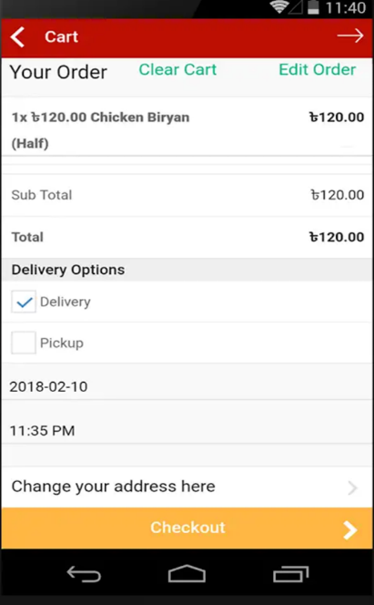
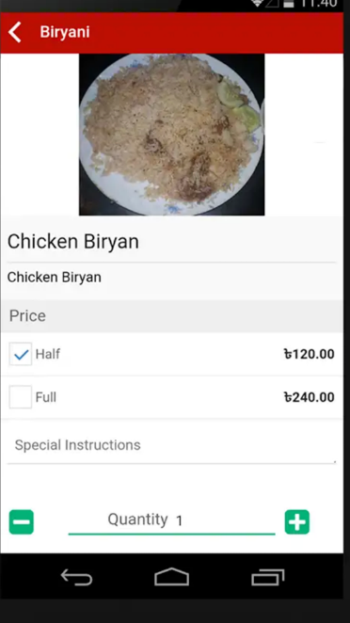
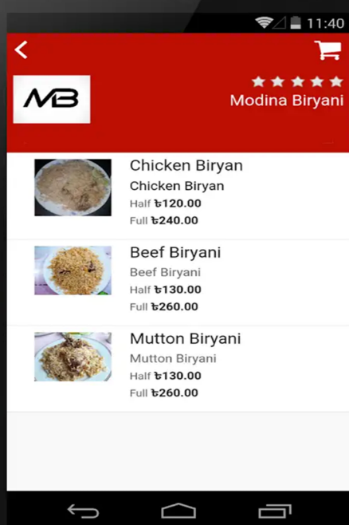



Figure: Food Express food deliver apps and its order process, source: (911 Food Express, 2018)
Setting goals: The manager of the business holds meeting in order to set goals for the business with the major stakeholders. The goal setting strategy includes the objectives of app based marketing, identification of potential audience, the process of engaging customers, online payment process and channel for delivering food.

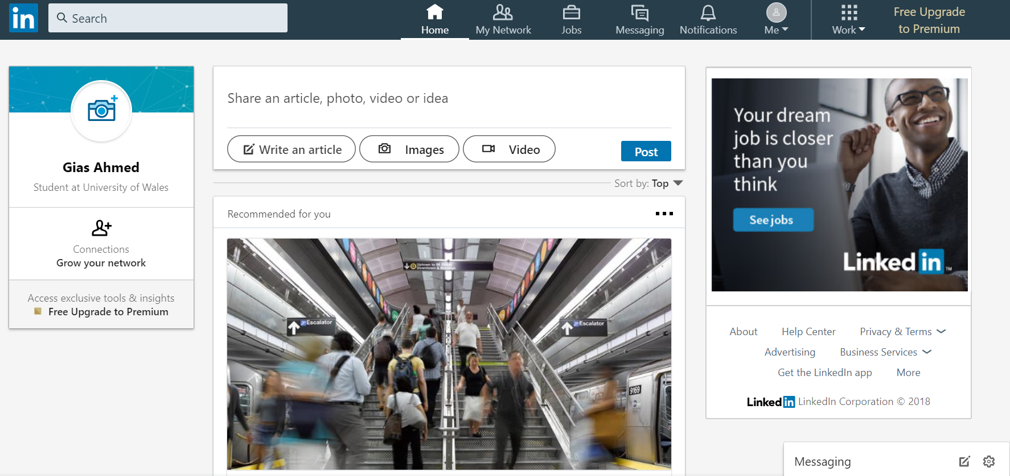Figure: LinkedIn account, source: (Linedin.com, 2018)
Establishment of performance measures: After the establishment of mobile apps for the business and professional presence at the online, the business needs to measure their marketing progress and efforts. The website, app and content should be mobile friendly in order to let the customers to have better understanding about the products (Ryan, 2016). It will ensure better customer engagement and customer service. They need to conduct proper monitoring of the overall digital marketing process.

Conclusion
This assignment has been conducted on the digital skills and research methods at the workplace. It has come out from the analyses what an influential role technology plays in the organization. Technology makes the employees efficient and communication more effective. Most importantly it helps the organization to survive in the tight competitive market. Social media as a bigger part of technology helps the organization in terms of enhancing productivity, recruitment and data analysis. In order to collect data from the social Media and other sites, the employees must be concerned about the accuracy of the information. Finally, the organization must adopt security strategy in the workplace.
References
Anglim, C. (2016). Privacy rights in the digital era.
Apollon, D., Belisle, C. and Régnier, P. (2014). Digital critical editions. Urbana: University of Illinois Press.
Bryden, C. and Salter, M. (2015). Social media in the workplace. Bristol: Jordans Publishing.
Deiss, R. and Henneberry, R. (2017). Digital marketing. Hoboken, NJ: For Dummies®, a Wiley brand.
Fitzpatrick, J. and Montgomery, K. (2015). Internet for nursing research. New York, NY: Springer Pub.
911 Food Express. (2018). 911 Food Express Online delivery-Nepalese Food Delivery. [online] Available at: http://911foodexpress.com/ [Accessed 1 May 2018].
Hamburg, I. (2017). Digital Skills For Eco-Innovative Entrepreneurship. Advances in Social Sciences Research Journal, 4(14).
Kirsch, G. and Sullivan, P. (2013). Methods and methodology in composition research. Carbondale, Ill.: Southern Illinois University Press.
Ramsey, A. (2014). Working in the archives. Carbondale: Southern Illinois University Press.
Ryan, D. (2016). Understanding digital marketing.
Savin-Baden, M. and Tombs, G. (2013). Research methods for education in the digital age.

