ACPA 7006 Management of New Product Design.
Assessment B
Developing the Design Brief.

Synopsis

The company has identified commercial opportunities for a chemical alcohol detector system to detect organic materials, including those generated by virus infections. They have prototyped the electronic and mechanical systems and will specify and source the electronics and mechanical elements from Eastern Europe or Asia. The company will engage a London-based company to design the physical envelope and appearance of the new Virus Detect. Final assembly, testing, packing, and shipping will be managed at the Welshpool factory. The company is approaching the development of this potential CDS (Chemical Detector System) in an 'Open Innovation' manner, with small concurrent R&D projects being undertaken in-house and in collaboration with the local university.
Electrochemical sensing of SARS-CoV-2 provides several advantages including high selectivity, relatively low-cost equipment and sensors, user-friendly, and rapid analysis that are suitable for miniaturization (to make point-of-care devices). Nanomaterials were used to modify the electrode due to biocompatibility, thereby avoiding the electrode fouling to offer improved detection limit, selectivity and sensitivity. However, the key challenge is to create electrochemical sensors for commercial point-of-care devices in clinical applications. Electrochemical devices such as point-of-care can provide simple, fast, highly sensitive, and accessible paths outside the laboratory settings, which can have a significant impact on remote areas and the people in self-isolation.
(Neeraj Kumar, 2022)

Table of Contents
1. Synopsis 2
2. Markets 4
3. Market Constraints 4
4. Product Description 5
5. Standards and Specifications 6
6. Product Design 6
7. Manufacturing Facilities 9
8. Prototype Testing 11
9. Packaging Considerations 12
10. Branding 13
11. Logistics/Shipping 14
12. Circular Econamy 15
13. Summary 16

References 18

Markets
The potential target market for COVID chemical detector systems is wide and includes:
- Healthcare facilities: Healthcare facilities are likely to be early adopters of COVID chemical detector systems, monitoring air quality and detecting COVID-19 presence in hospitals and clinics.
- Businesses: Businesses in high-risk environments, like airports, schools, and manufacturing facilities, may benefit from COVID chemical detector systems to protect employees and customers.
- Government agencies: Government agencies like CDC and WHO may be interested in COVID chemical detector systems to monitor the virus's spread and track public health measures' effectiveness.
- Individuals: Individuals concerned about COVID-19 exposure can use COVID chemical detector systems to monitor air quality in homes, offices, and public spaces.

- Market constraints

There are a number of factors and limitations within a specific market or industry that can affect our growth, operation, and success of businesses and products. Here are some common market constraints we could face:
Regulatory and Legal Constraints: Government regulations, standards, and compliance requirements can be significant constraints.
Market Size and Saturation: The size of the target market can limit growth opportunities.
Environmental and Sustainability Constraints: Increasing awareness of environmental issues and sustainability can limit certain types of products or industries that are perceived as environmentally harmful.
Cultural and Social Constraints: Cultural norms, social preferences, and demographic trends can constrain market acceptance.
Technological and Intellectual Property Constraints: Intellectual property rights, including patents and copyrights, can constrain innovation and market entry. Competitive Constraints: Fierce competition can limit pricing flexibility and profitability. Distribution and Supply Chain Constraints: Logistical challenges, disruptions in the supply chain, or limitations in distribution channels can affect the availability and delivery of products to customers.
Financial Constraints: Limited access to capital or funding constraints can hinder product development, marketing efforts, and expansion plans.
Market Research and Data Constraints: Lack of accurate market data and insights can make it challenging to understand customer needs and make informed decisions.

- Product description
The Company has successfully prototyped the electronic and mechanical systems that form the new product and will be engaging a London-based company to design the ‘physical envelope’ and appearance of the new Virus Detector.
The company has decided to adopt a similar strategy to that which they use for their current range of breathalyser products, i.e. sourcing the electronics and mechanical elements of the product externally, and undertaking final assembly, testing, packing and shipping at the company’s Welshpool factory.

    - Aesthetics

Handheld CDS system, easy to operate and built on a similar design to a handheld alcohol detection system used by law enforcement.

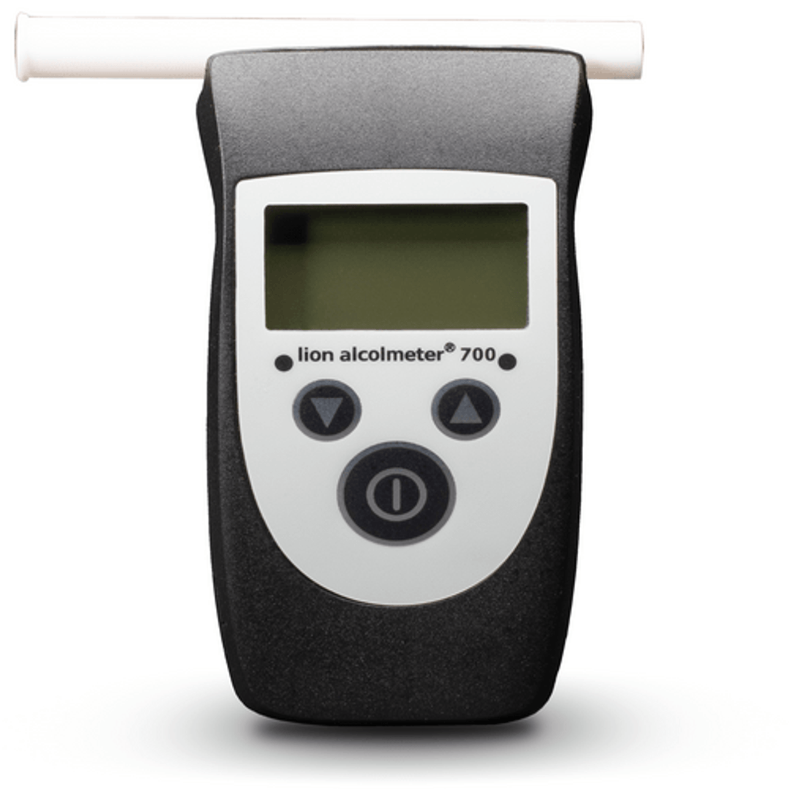

(lion laboratories, 2023)

    - Ergonomics

This compact handheld and highly accurate instrument features simple multi-use button functionality, internal memory for simple data capture, and an automatic sampling system and is available in multiple languages.

Instrument Dimensions 122mm x 63mm x 37mm
Weight 160g (including batteries)

(lion laboratories, 2023)

- Standards & Specifications

Here are the general steps and considerations we need to take for gaining approval for a COVID-19 breath tester in the UK:

- Regulatory Pathway: Determine the appropriate regulatory pathway for our device. Depending on the device's intended use and risk classification, it might need to undergo a rigorous assessment process.
- Conformity Assessment: Engage with a Notified Body, for conformity assessment. Notified Bodies are organizations designated by the MHRA to assess the conformity of certain medical devices.
- Clinical Evaluation: Conduct clinical evaluations to demonstrate the safety and performance of our breath tester. This involves collecting clinical data that substantiates our device's claims.
- Technical File: Prepare a technical file that includes all relevant information about our device, its design, manufacturing processes, and clinical data.
- CE Marking: as the device is classified as a medical device, we will need to obtain CE marking, which signifies that your product complies with EU regulations, including those applicable in the UK. Brexit has brought changes to this process, so we need to be sure to stay updated on the latest requirements.
- Registration: Depending on the classification, we may need to register your device with the MHRA. The registration process will vary based on the risk classification of your device.
- Testing and Validation: Ensure that our COVID-19 breath tester meets the necessary performance standards and accuracy requirements. This will include laboratory and clinical testing.
- Quality Management System: Implement a quality management system in accordance with ISO 13485 or an equivalent standard to ensure the consistency and reliability of your manufacturing processes.
- Labeling and Instructions for Use: Prepare clear and comprehensive labeling for our device, including instructions for use that are easy to understand for both healthcare professionals and users.
- Post-Market Surveillance: Develop a plan for post-market surveillance to monitor the safety and performance of our device once it is in use.
- Compliance with UK Laws: Ensure that our device complies with all relevant UK laws and regulations, including data protection and privacy laws.

- Product Design

Design Requirements:
Handheld CDS system will be based on the Alcometer/Breathalyser Lion 700 already in manufacture, its easy to operate and built on a similar design to a handheld alcohol detection system used by law enforcement. Easy to calibrate, Simple Red positive, Green negative output, Bluetooth capable of linking with a mobile app for recording purposes, system to be able to report to healthcare hub through wireless tech if not used through mobile app, or ability to connect to a printer for results. USB Type C charging, or AA battery power source, IP68 to withstand brutal conditions, and shockproof, Able to operate in certain temperature ranges.

Technical Specifications
Internal Dimensions | 122mm x 63mm x 37mm
Weight | 160gm (including batteries)
Approvals | EN15964
Sensor Type | Electrochemical Fuel Cell
Measuring Range | 0.02 to 2.0 mg/L BrAC
Operating Temperature Range | -5°C to +40°C
Power Supply | 2x AA batteries, lasts minimum 1000 tests
Calibration Adjustment | If checked regularly with a dry gas, calibrate every 12 months. Otherwise, to be calibrated every 6 months.
Calibration Standard | TBC
Operating Humidity Range | 10 to 95%, non-condensing
Memory | Up to 3,000 test records
Warranty | 12 months, parts and labour

(foursquare-healthcare, 2023)

  - Materials

• Mechanical Elements: The use of injection-molded parts from current suppliers with existing tooling is a cost-effective approach to manufacturing.
• Material Selection: Specify the type of material used for injection molding.
• Supplier Relationship: Ensure a strong relationship with our suppliers to maintain a consistent supply of high-quality components.
• Component Sourcing: If we plan to source fully assembled and tested circuit boards, select reputable electronic manufacturing services providers or suppliers who can meet our production requirements and quality standards.
• Quality Assurance: Implement thorough testing for the electronic components, including functional testing, to ensure the reliability and accuracy of the detector system.
• Compliance: Ensure that the electronic components used comply with relevant industry standards and regulations. Overall, the choice of materials and components is integral to the performance, quality, and reliability of our COVID-19 detector system. Thoroughly evaluate suppliers, conduct quality testing, and maintain strong supplier relationships to support a successful manufacturing process.

  - Typical Timeline for NPD Manufacture

Stage 1: Electronics Development
- Develop a system block diagram
Time to completion: As little as 1 hour, as long as a few weeks.
- Select the critical components
Time to completion: 1 to 4 weeks
- Develop schematic circuit design
Time to completion: 2 to 5 weeks
- Design the Printed Circuit Board (PCB)
Time to completion: 2 to 5 weeks
- Independent design review
Time to completion: 1 to 3 weeks
- Order PCB prototypes
Time to completion: 1 to 2 weeks
- Develop firmware and/or software
Time to completion: 1 to 6 months
- Evaluate and debug PCB prototypes
Time to completion: 5 weeks, most likely more

Stage 2: Enclosure Development
- Create 3D computer model
Time To Completion: 1 to 6 months
- Order enclosure prototypes
Time to completion: 1 to 2 weeks
- Evaluate and debug enclosure prototypes
Time to completion: 4 weeks, most likely more
- Prepare 3D model for mass manufacturing!
Time to completion: 12 weeks
Stage 3: Develop Your Retail Package
Time to completion: 1 to 4 months
(Predictable Designs, 2023)

- Manufacturing facilities
The company has decided to adopt a similar strategy to that which they use for their current range of breathalyser products, i.e. sourcing the electronics and mechanical elements of the product externally, and undertaking final assembly, testing, packing and shipping at the company’s Welshpool factory.
Preliminary research has indicated that China or Malaysia remains the most favourable source of electronic circuit boards - and that the UK or Europe would, for now, be seen as the favoured source for the moulded parts.
  - Quantity

Projecting sales growth from 750,000 units in year 1 to 3 million units in year 2 indicates significant expansion.
To understand the implications of this growth, we will need to consider various factors that could influence your sales, including market demand, marketing efforts, production capacity, and competitive dynamics. Here's a simplified breakdown of how we might approach this growth projection:

Year 1: 750,000 Units In the first year, our primary focus is on establishing our product in the market. We will likely need to allocate resources to product development, manufacturing setup, marketing, and sales efforts.
Production: Ensure that we have the manufacturing capacity to produce 750,000 units within the year while maintaining quality control.
Consider targeted marketing campaigns and partnerships to reach our target audience.
Market Research: Continuously gather market feedback and data to refine our product and marketing strategies.

Year 2: 3 million units, The second year involves rapid scaling to meet the increased demand. Here's a broad outline of what we need to consider:
Production Scaling: Ramp up production to meet the demand of 3 million units.
Ensure that our supply chain and manufacturing processes can handle this increase. This may involve international expansion if we are targeting markets outside our initial region.

- Distribution: Expand our distribution channels and partnerships to reach a wider audience. Consider collaborations with healthcare facilities, governments, or organizations to increase your reach.
- Quality Control: Maintain a strong focus on quality control even as we scale.
- Market Monitoring: Stay attuned to market trends, customer feedback, and any competitive developments. Be prepared to adapt our strategies as needed.
- Regulatory Compliance: Ensure that you meet all regulatory requirements as we scale, especially if we are expanding into new regions with different regulatory standards.

Rapid growth can pose challenges, including the need for sufficient capital, operational efficiency, and effective management.
Additionally, market conditions, competition, and unforeseen events (such as public health crises) can impact sales projections.

- Prototype Testing Stages

Prototype testing is a critical phase in the product development process. It involves assessing and refining the prototype to ensure that it meets the desired specifications and functionality before moving on to full-scale production. Prototype testing typically involves several stages, each with its own objectives and methods. Here are the key stages of prototype testing we have to follow:

- Alpha Testing: The primary goal of alpha testing is to evaluate the prototype`s functionality and features in a controlled environment.
- Participants: Internal testing by the product development team or engineers.
- Methods: Testers use the prototype extensively, often in a laboratory or controlled setting, to identify and fix any technical issues, bugs, or design flaws.
- Beta Testing: Beta testing takes the prototype beyond the internal team to a select group of external users. The aim is to gather feedback from real users and identify any usability issues or areas for improvement.
- Participants: A limited number of external users or early adopters who represent the target audience.
- Methods: Users engage with the prototype in real-world scenarios. This phase helps validate the product's usability and identify potential user pain points.
- Usability Testing: Focuses specifically on the user and user interface design aspects of the prototype.
- Methods: Testers perform specific tasks using the prototype while providing feedback on ease of use, intuitiveness, and overall satisfaction with the user interface. This phase helps ensure that the product is user-friendly.
- Participants: Testing is typically conducted by engineers or specialists. This phase helps identify performance bottlenecks and optimize the product's efficiency.
- Security Testing: Identify and address potential security vulnerabilities and threats in the prototype.
- Compliance Testing: Verify that the prototype meets regulatory and industry-specific standards and requirements.
- Methods: Testing and documentation are conducted to ensure that the prototype complies with relevant regulations and standards. This phase is crucial for products subject to specific industry regulations, like medical devices.
- Field Testing: Conduct real-world testing in the field or with a larger group of users to further validate the prototype's performance, functionality, and reliability.
- Participants: A broader and more representative group of users.
- Methods: The prototype is deployed in a real operational environment or with a larger user base. Feedback is collected to identify any issues that may not have been apparent in earlier stages. Each of these prototype testing stages serves a specific purpose in the product development process, helping to refine and improve the prototype before it progresses to full-scale production and market release.

  - Environment maintenance & repair

- Design for Durability and Reparability: Design the tester with longevity in mind, using durable materials and components. Ensure that it is easily repairable and upgradeable so that components can be replaced or updated rather than disposing of the entire unit when issues arise.
- Modular Design: Utilize a modular design that allows for the easy replacement of individual components. This extends the product's lifespan and reduces the need for frequent replacements.
- Reuse and Refurbishment: Establish a system for collecting and refurbishing used testers. After thorough cleaning and testing, they can be reissued to new users, reducing waste.

- Packaging Considerations

Who will be our intended audience?
The first and foremost requirement is to understand our target audiences well. This will help in directing some of the most crucial decisions in our packaging design. Hence, before starting the designing process, know and segment our customer profile.

What sales channels are we to use?
To determine the right elements of our packaging design, we need to select the various sales channels to use, such as retail stores, e-commerce shipping, etc. every sales channel has different requirements for packaging, which is essential to determine beforehand for a seamless process in terms of understanding the shipping features, storage space, safety, etc.

How should the images and graphics be presented?
The appearance of our packaging includes various factors, especially the fonts, images and graphics. To seal our customers’ first impression, we must focus on conveying the essence of the product through the packaging design and bringing a positive unboxing experience to the customer.

What is the normal supply chain path for our products?
There is always a risk of the product packaging being damaged during transit. Hence, understanding the standard supply chain path is paramount. Consider the shape, size and product type to determine the packaging elements accordingly. This will ensure the durability and security of your product throughout the transit.

What kind of material will be used for the packaging?
Our packaging material is equally responsible for how our design is presented in the final packaging. To maintain the structural integrity, look and feel of your product packaging, you must select the right material based on your desired price range, sales channel, safety requirements, etc.

What is the price of the packaging?
Starting from the design to the printing and assembly costs of the product packaging. We need to ensure that it is consistent with our goals and is sustainable for our budget for the future. We can also consult with a strategic packaging design specialist for assistance here.

Is the packaging environmentally friendly?
Sustainable and eco-friendly packaging always takes the cake for the consumers! We need to avoid using excessive plastics or materials that are harmful to the environment. The marketing team will have a new strategy of promoting the brand as an eco-friendly brand, gradually attracting more customers.
(Designer People, 2023)

- Branding
Branding a COVID-19 handheld chemical tester involves creating a strong and memorable brand identity for the product. An effective brand identity can convey trust, reliability, and innovation. Here are key elements to consider when branding our COVID-19 tester:
- Brand Name: Choose a name that is easy to remember and reflects the purpose and values of your product. It should also be distinctive to avoid confusion with other products.
- Logo: Create a unique and visually appealing logo that embodies the essence of your product. Consider using symbols or graphics that represent safety, health, and accuracy. The colour scheme should be chosen carefully to evoke the right emotions.
- Visual Identity: Develop a consistent visual identity that includes fonts, colour and design elements. This will ensure a professional look across all marketing materials and packaging.
- Packaging Design: The packaging should not only protect the product but also serve as a branding opportunity. It should prominently feature the product name, logo, and key benefits. Clear and informative packaging can instil confidence in potential users.
- Marketing: Create marketing materials such as brochures, flyers, and digital assets that reflect your brand's identity. These materials should educate customers about the product's features, benefits, and usage.
- Website: Build a user-friendly webpage for our existing site that provides detailed information about the product, including how it works, where to purchase, and customer reviews. An active online presence through social media channels can also help us with branding and customer engagement.
- User Experience: Ensure that the user interface of the product itself is consistent with our branding. An intuitive and user-friendly interface can enhance the overall perception of your product.
- Quality Assurance: Branding also includes the promise of quality and safety. Emphasize the rigorous testing and quality control measures our product undergoes to assure users of its reliability.
- Customer Support: Branding extends to the level of customer support you provide. Ensure that our customer support team is well-trained and responsive to inquiries or issues.
- Regulatory Compliance: Highlight any relevant certifications or approvals our product has obtained from regulatory bodies. This can build trust in the safety and efficacy of your product.
- Branding Campaigns: Develop branding campaigns that convey the message of our product effectively. These campaigns can include online advertising, social media promotions, and collaborations with healthcare professionals.

- Logistics/Shipping

Logistics and shipping are crucial aspects of bringing our product to market, especially for a COVID-19 detector system.
Efficient logistics and shipping processes ensure that our product reaches customers and end-users reliably and on time.

- Supply Chain Management: Establish a well-organized and efficient supply chain to source all the necessary components and materials required for the production of your COVID-19 detector system.
- Inventory Management: Implement inventory management systems to monitor the levels of raw materials and finished products. This helps prevent shortages or overstocking and ensures a smooth production process.
- Production and Manufacturing Location: Consider where your COVID-19 detector system will be manufactured. Proximity to suppliers, transportation hubs, and the target market can significantly impact logistics efficiency and shipping costs. This might include air freight, sea freight, road transport, or a combination of these depending on factors like distance, volume, and urgency.
- Shipping Costs: Calculate shipping costs accurately, factoring in the weight and volume of your products, shipping distances, and any additional charges customs, duties, taxes, etc.
- Packaging: Develop packaging solutions that protect your COVID-19 detector system during transit while also minimizing waste and environmental impact.
- Compliance and Regulations: Ensure compliance with international shipping regulations, including customs requirements and documentation. For medical or diagnostic devices, be aware of any specific regulations governing the shipment of such products. Consider factors like shipping speed, tracking capabilities, and cost-effectiveness.
- International Expansion: If you plan to sell your detector system internationally, understand the logistics challenges of shipping to different countries, including customs processes and import regulations.
- Reverse Logistics: Develop a strategy for handling returns and product recalls. Efficient reverse logistics processes are important, especially for medical devices.
- Tracking and Visibility: Implement tracking and visibility systems to monitor the status and location of shipments in real time.
- Contingency Planning: Develop contingency plans to address potential shipping disruptions, such as natural disasters, strikes, or global events (like a pandemic).

A well-organized logistics and shipping strategy not only ensures the timely delivery of your COVID-19 detector systems but also helps minimise costs and ensure customer satisfaction, It's a critical aspect of the overall product distribution process.

- Circular Economy
Implementing a circular economy approach for a COVID-19 handheld chemical tester involves designing, manufacturing, and managing the product in a way that maximizes resource efficiency, reduces waste, and extends the product's lifespan. Here are strategies we can incorporate for a circular economy model into the lifecycle of the tester:
- Design for Durability and Reparability: Design the tester with longevity in mind, using durable materials and components. Ensure that it is easily repairable and upgradeable so that components can be replaced or updated rather than disposing of the entire unit when issues arise.
- Modular Design: Utilise a modular design that allows for the easy replacement of individual components. This extends the product's lifespan and reduces the need for frequent replacements.
- Reuse and Refurbishment: Establish a system for collecting and refurbishing used testers. After thorough cleaning and testing, they can be reissued to new users, reducing waste.
- Recycling and Material Recovery: Ensure that the materials used in the tester are recyclable, and have a plan for recycling at the end of life. Recover valuable materials for use in new products.
- Product-as-a-Service Model: Instead of selling testers, consider offering the product as a service. Users subscribe to the testing service, and the provider retains ownership and responsibility for maintenance and upgrades.
- Take Back Programs: Implement take-back programs where users can return their testers at the end of life for proper recycling, refurbishment, or safe disposal.

- Summary
After conducting market research to identify trends, and opportunities, and understand target market needs for a handheld Covid Chemical Detector System, we have found through education and achieving the correct design requirements, this product even though outside the company’s normal market sector, would be a commercially viable and a profitable product to take to market. There are many sectors that we could market the product to, but we should target the largest potential for sales, such as Health Care, Businesses, and Travel. These three markets we believe would generate the most revenue and make the product successful.
Product Development: The COVID-19 handheld chemical tester is in the development phase, with a focus on creating a portable and accurate tool for virus detection.
Design Brief: A comprehensive product design brief has been established, outlining the project's goals, target audience, key features, design inspiration, timeline, budget, success metrics, and additional information.
Prototype Testing Stages: The product will undergo various prototype testing stages, including alpha testing for functionality, beta testing for user feedback, usability testing, performance testing, security testing, and compliance testing.
Materials and Electronics: Injection-molded parts and a single circuit board containing electronics are key components of the device.
Circular Economy: Implementing a circular economy approach involves designing for longevity, reuse, recycling, and resource efficiency, which can be applied to both materials and the product's lifecycle.
Branding: Effective branding involves creating a strong and memorable identity for the product, including the name, logo, tagline, visual identity, and marketing campaigns. Achieving this growth requires careful planning and resource allocation.
Market Success: To succeed in the market, it is essential we navigate market constraints, ensure our product quality meets regulatory requirements, and adapt to changing market conditions.

References
(2023, Sep). Retrieved from lion laboratories: https://www.lionlaboratories.com/products/alcolmeter-700/
(2023, Sep). Retrieved from foursquare-healthcare: https://www.foursquare-healthcare.co.uk/lion-alcometer-700-breath-alcohol-analysis-kit/
(2023, Sep). Retrieved from Predictable Designs: https://predictabledesigns.com/product-development-timeline-how-long-it-takes-to-develop-a-new-hardware-product/
Designer People. (2023). Retrieved from The 8 Steps in Packaging Design Process: https://www.designerpeople.com/blog/packaging-design-process/#:~:text=8%20steps%20for%20the%20packaging%20design%20process%20which,...%208%20Step%208%20%E2%80%93%20MARKET%20REVIEW%20
Neeraj Kumar, a. N. (2022). Electrochemical sensors for the detection of SARS-CoV-2 virus. Electrochemical sensors for the detection of SARS-CoV-2 virus.

