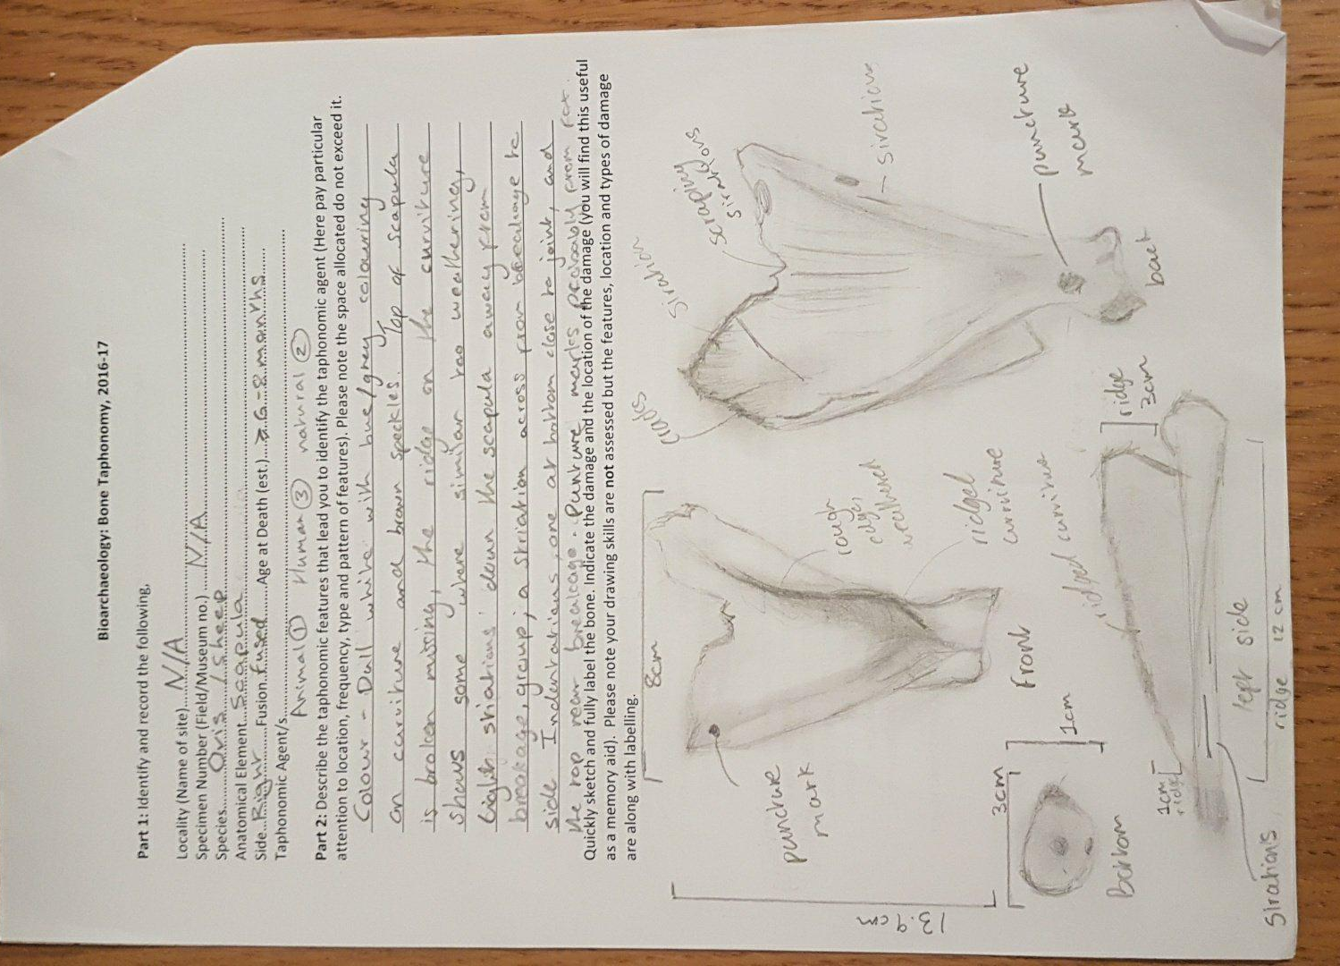
Part 3: In no more than 1000 words assess the main difficulties that may be faced when ascribing a
taphonomic history to your bone and based on your laboratory experience.

It is easy to label the bone, describe what condition the bone is in and to some extent what classification the bone belongs to but not necessarily the factors that have influenced the survivorship and taphonomic history of the bone.

Aspects of the bone I can identify is the species of the bone which is that of a cervus (sheep), what bone it is: a scapula (shoulder bone) and I can even identify some factors that have influenced the taphonomic history of this bone. I can identify that the bone: is one that belonged to animal that was an adult because the bone had fused making it around the age of 6-8 months of age at least at death (T. O’Connor) and because the bone is not pure white it indicates that it was not calcined and hence was robust and strong indicating that it was not buried in acidic soil otherwise it would of decayed, non-calcined bone also shows it was not burnt (K. Soblik, 2003).

The bone has a breakage towards the top of the scapula where the flat edge would be (it shows no indication of healing so it occurred either during or after death) and the upwards protruding ridge has wear on it that is indicative of weathering. So far we can deduce the bone was outside, but not if it was buried in the ground or not, as the weathering and missing piece suggest it was lying on the ground open to the elements, whilst the dappled grey coloring of the bone suggests that is was buried and with no recordings of where it was found or by who it is hard to guesstimate the burial status and where abouts of the bone.

The bone is relatively quite damaged as already sated it has a missing piece at the top of the scapula from a breakage but it also has puncture holes and striation marks; I can speculate what caused these marks which we did in the practical work in my lab team, we suggested that the puncture holes were that of an animal, more than likely a fox, we even took a piece of jaw bone from a fox and did a comparison to see if the teeth marks matched up to the puncture holes, they did. Which I took t a face value with little skepticism until I read Soblik’s book Archaeobiology; in here Soblik argues that dog is not man’s best friend and that as a result of this much of our bone assemblages will be scattered slightly and missing a few bones because dogs will go and munch on them (even the bones of humans), this then lead me to question if the puncture holes were in fact from a dog, after all dogs are often used to sheep herd and live on farms, a dog has access and means to attack a sheep or even just have access to the remains of the sheep.

Also it is extremely had to know why the animal died and if its injuries were apart of its death or after. This question has arisen because we do not know where it was recovered or what it’s assemblage. This is an important question as quite often the case animal bones and sacrifices are culturally key to every day human life, lamb and mutton (sheep) are also a part of many cultures diets, even in the present day (E.Reitz and E.Wing). The possibility that it has meaning also determines its burial status and may even explain the wear and damage that has occurred on the bone. If the site of its death is inhabited that can mean the bone is buried or even just left in a disposal heap hence leaving it open to the elements and foot fall resulting in the damaged occurred to the bone. However the same can also happen if the bone has been a part of cultural activity or rituality in the fact that even if something is buried animals often will disturb assemblages as a part of their everyday life such as burrowing and scavenging, this can mean that one bone can be dragged meters and further away from the carcass resulting in a bone being in an archaeological site but the rest of the body in a completely different area and leaving many questions open to answer and even leading to false interpretation of human activity such as consumption( E.Reitz and E.Wing).

The main factors influencing the lack of taphonomic history being ascribed to this bone is the fact that we don’t have site name or date for it nor do we know its assemblage or background of the site.

References:

Elizabeth J Reitz and Elizabeth S.Wing (1999). Zooarchaeology. 2nd ed. Cambridge Uk: Cambridge University Press. 112-113.

Kristin D. Soblik (2003). Archaeologist's Toolkit 5, Archaeobiology. Lanham, USA: A division of Rowman & Littlefield Publishers, Inc. page 22.
Terry O'Connor (2000). The archaeology of animal bones. Gloucestershire: Sutton Publishing Limited. 95, Table 8.2.

