
…

Student name: Alhajie Lowe
Student ID: 440651
Module name: Introduction to Health and Social Care
Module code:( LCH S4003-LON )
Lecturer name: Mohamed Aliyu

Table of Contents
Task #01: Create a poster (900 words Equivalent) 3
Task # 02 .A 600-word Essay 4
References 7

Task #01:
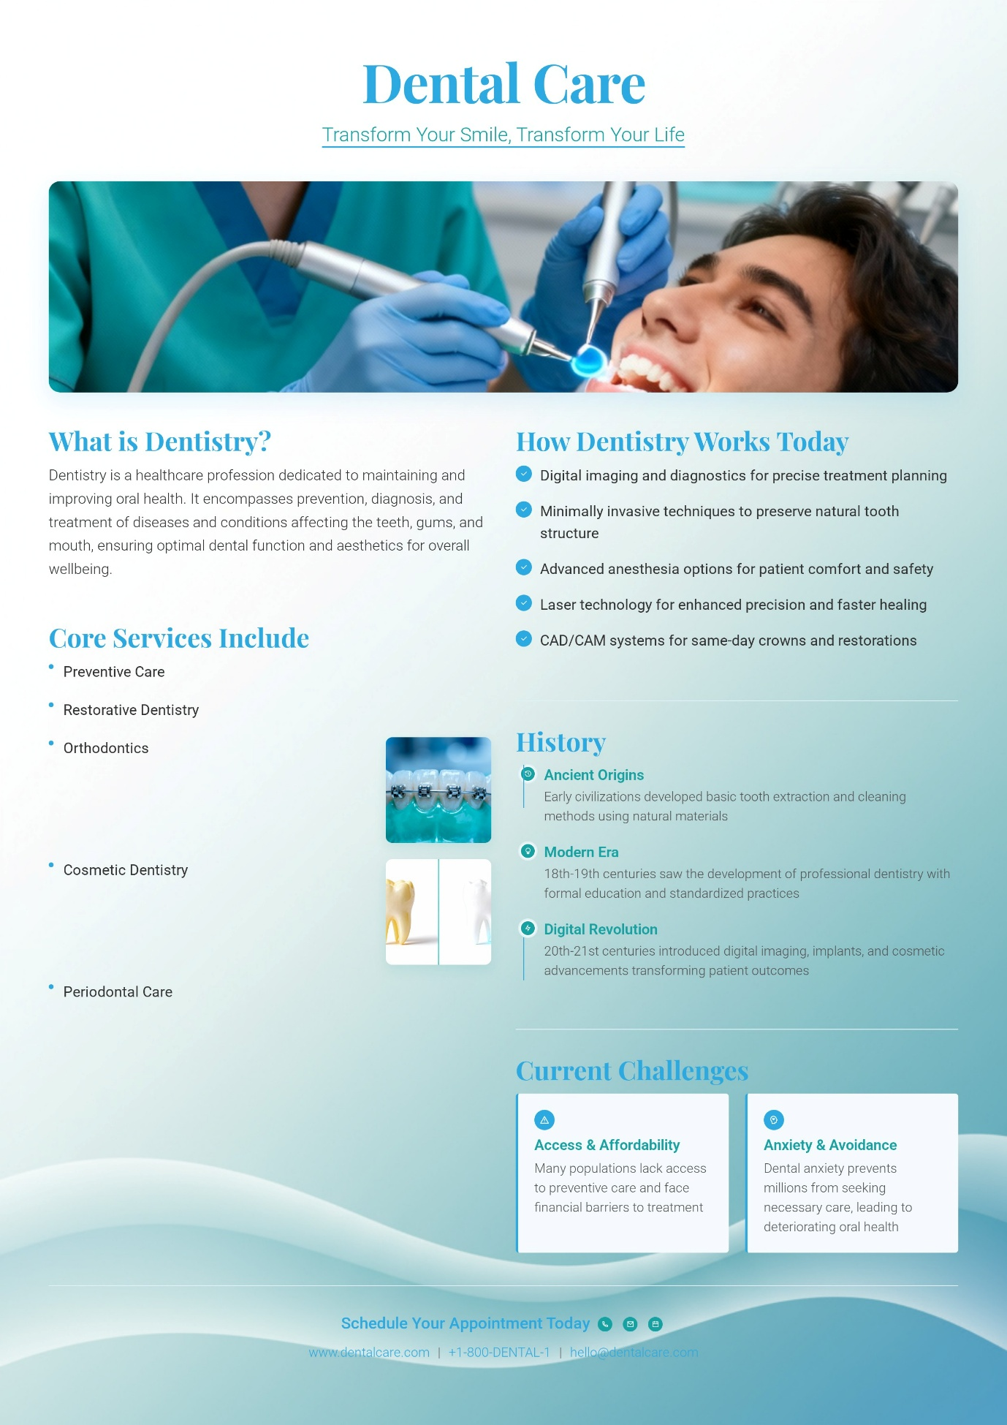

Task # 02:
The Origins, Principles, Structure and Functioning of the National Health Service (NHS)

The NHS was built on a pretty simple idea: it should be free when you need it, cover everything people actually need, and welcome everyone—no matter how much money you have in your pocket. The founder put it bluntly: “No one must be left out just because they can’t pay.” That line really stuck. It’s the heart of the whole thing.
How It Was Set Up
When the NHS launched, it got split into three main chunks. Regional boards ran the hospitals, executive councils took care of GPs and dentists, and local authorities looked after community health workers like midwives and nurses. But the truth? The whole thing was kind of a mess. Nobody seemed fully in sync, and people often got lost between the cracks.
Things didn’t stay that way. The NHS structure changed again and again. In 1974, everything got shuffled into Regional Health Authorities. The ‘80s and ‘90s brought a push for business-style management and market ideas—the government wanted the NHS to run more like a company. Then, in 2012, a big reform came along: the Health and Social Care Act. This law set up Clinical Commissioning Groups (CCGs), which family doctors led. But even that didn’t last. By 2022, those CCGs got replaced by Integrated Care Systems (ICSs), which try to get hospitals, GPs, and other services actually working together.
How It Works Today
These days, the NHS still runs mostly on public taxes. It’s now split into four national systems: NHS England, NHS Scotland, NHS Wales, and Health and Social Care in Northern Ireland. NHS England is the biggest. A national body and forty-two local ICSs plan and pay for care. Hospitals are managed by NHS Trusts or Foundation Trusts, while GPs aren’t NHS employees—they’re independent contractors. Most of the money (about 80%) comes straight from taxes. The rest is from National Insurance and a handful of small patient fees, like prescription charges.
In 2023/24, NHS England’s budget shot up to £165.1 billion. That’s a huge number, but still, a lot of people say it’s not enough for everything the NHS is expected to do.
The Way It Delivers Care
Public hospitals still cover most hospital care, but private companies have stepped in to handle more planned treatments, like minor surgeries. GPs, pharmacists, and dentists usually run their own practices under NHS contracts. Tech is a bigger deal now, especially after COVID—stuff like the NHS App and shared digital records are becoming normal.
But there’s one stubborn problem: social care (things like help for older people at home) isn’t actually handled by the NHS. Local councils run it separately, and that split causes trouble. Patients ready to leave hospital sometimes get stuck because there’s just no care waiting for them on the outside.
The Struggles and Challenges
People still care deeply about the NHS and believe in what it stands for. But right now, it’s struggling. Over the years, efforts to make it more like a market just made things more tangled. The 2012 reforms cranked up competition, but often just made planning harder. The new ICSs are supposed to bring back teamwork and fix some of that mess. Whether that’s enough—well, that’s the big question everyone’s asking.
Still, the NHS is struggling. Waiting lists are huge — over 7.6 million in 2024 — and there are over 112,000 staff vacancies. Since Brexit, it’s been harder to hire foreign doctors and nurses, making the shortage worse.
Wrapping It Up
In short, the NHS was built on a promise — that everyone deserves healthcare, no matter who they are. That promise still stands strong in people’s hearts, but the system has changed a lot under political and financial pressures. New models like ICSs try to bring back unity and collaboration, yet ongoing staff shortages and funding issues make things tough.

References
Arora, S. et al. (2023) ‘Private sector involvement in NHS elective care’, British Medical Journal, 381, p. 1234. doi: 10.1136/bmj.p1234.
Beveridge, W. (1942) Social Insurance and Allied Services. Cmd. 6404. London: HMSO.
British Medical Association (BMA) (2023) GP contract England 2023/24. London: British Medical Association. Available at: https://www.bma.org.uk/gp-contract (Accessed: 28 October 2025).
Charlesworth, A. and Johnson, P. (2024) Securing the future of the NHS. London: Institute for Fiscal Studies.
Department of Health (2012) Health and Social Care Act 2012. London: The Stationery Office.
Greer, S.L. (2016) ‘Devolution and health in the UK’, Health Economics, Policy and Law, 11(1), pp. 13–28. doi: 10.1017/S1744133115000291.
Hansard (1946) House of Commons Debate, 30 April, vol. 422, col. 1125.
Health Foundation (2023) NHS workforce shortages. London: The Health Foundation. Available at: https://www.health.org.uk/publications/nhs-workforce (Accessed: 28 October 2025).
HM Treasury (2024) Budget 2024: Health allocations. London: HMSO.
King’s Fund (2023) Integrated Care Systems explained. Available at: https://www.kingsfund.org.uk/topics/integrated-care/integrated-care-systems-explained (Accessed: 28 October 2025).
Klein, R. (2013) The new politics of the NHS. 7th edn. London: Radcliffe Publishing.
Lowe, R. (2005) The welfare state in Britain since 1945. 3rd edn. Basingstoke: Palgrave Macmillan.
National Audit Office (2022) Discharge delays in the NHS. London: NAO. Available at: https://www.nao.org.uk/reports/discharge-delays (Accessed: 28 October 2025).
NHS England (2014) Five Year Forward View. Leeds: NHS England.
NHS England (2024) NHS waiting list data – September 2024. Available at: https://www.england.nhs.uk/statistics/statistical-work-areas/rtt-waiting-times/rtt-data-2024-25 (Accessed: 29 October 2025).
Paton, C. (2021) ‘The NHS at 75: Marketisation and its discontents’, Political Quarterly, 92(3), pp. 445–453.
Webster, C. (1998) The National Health Service: A political history. Oxford: Oxford University Press.
Webster, C. (2002) The NHS: A political history. 2nd edn. Oxford: Oxford University Press.

