Student ID – 2131283
Student name – Nuro Aligas
Teacher Name: Bianca Sanfilippo

Module Code – LCHS4006
Module Title – Psychology in Health and Social Care
Assessment 2 – Report

Table of Contents
Introduction 3
Critical reflection on the psychological life span theory 3
Erickson’s psychosocial development theory 4
Comprehensive discussion on a psychological framework 6
Cognitive framework 6
Reflection of the learnt perspective on current and future career settings 6
Conclusion 7
References 8

Introduction
The domain of psychology in health and social care has attracted the attention of healthcare professionals and experts with the increased cases of the mental disorders taking a toll on the human population (Haslam et al., 2018). Psychological frameworks emerged as an essential component in recent times as it provides the primary ground for understanding the behaviour, development and perception of an individual suffering from an illness. Psychology for social and health care aims to identify the social and psychological factors associated with physical illness, impacting the quality of life, and provides psychological intervention for addressing the issue (McGilton et al., 2018). The purpose of this report is to critically reflect on one of the psychological life span theories such as Erickson’s psychosocial theory and provide an in-depth discussion on the psychosocial framework such as the cognitive framework of psychology. Furthermore, reflection on the current and future career settings is also provided in this study.

Critical reflection on the psychological life span theory
According to Maree (2021), psychological lifespan development refers to an overarching framework that entails the developmental study of individuals (ontogenesis) from conception to old age. Lifespan psychological theories are the series of the inter-connected propositions and concepts, which focuses on the intricacy of development in the historically transforming contexts. Among the different types of psychological life span theories, theory of psychosocial development proposed by Eric Erickson is selected for this study to aid nurses in the health and social care in terms of understanding the developmental activities of an individual under their care (Sutton, 2023). For instance, a nurse responsible for taking care of an infant, and knows that the development task is mistrust versus trust, she or he will make sure to address the requirements of the infant predictably and quickly. Erickson’s theory of psychosocial development is viewed as a useful and powerful tool for improving oneself and building self-awareness as it aids individuals to understand a learning of a person according to her or his personal differences. Therefore, it can be considered as an integral facet of the academics and healthcare as it assists in educating and supporting others (Sekowski, 2022).

Erickson’s psychosocial development theory
The theory of psychosocial development is a popular theory suggested by Erik Erickson in 1950 in his book “Child and Society” that attempted to explain the development of personality, which occurs through a wide range of stages since the inception of childhood. The Erickson’s theory of psychosocial development stated that the personality of an individual develops through eights stages from infancy to old age. It include trust versus mistrust (stage 1), doubt versus autonomy (stage 2), guilt versus initiative (stage 3), inferiority versus industry (stage 4), confusion versus identity (stage 5), isolation versus intimacy (stage 6), stagnation versus generativity (stage 7), and despair versus integrity (stage 8) (Khairani and Maemonah, 2021).
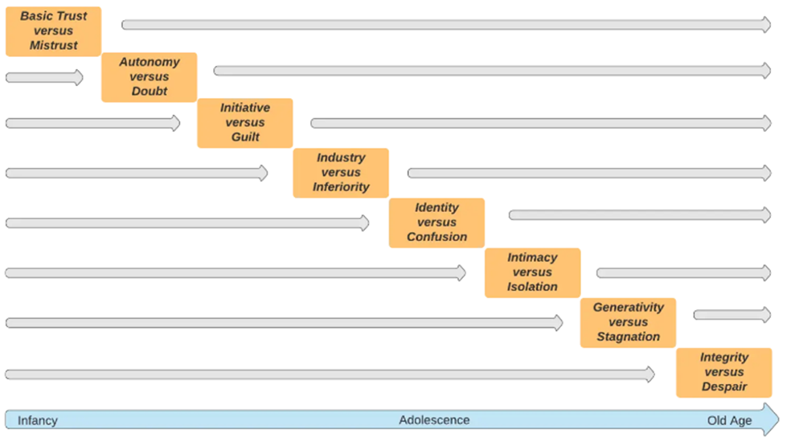
Figure 1: Eight stages of the psychosocial development theory
(Source: Sutton, 2023)
In the initial stage of the model, infancy (18 months) is pivotal to the psychosocial development and the individual is completely dependent on the care provider for nurturing, warmth and love. In case, if the care is unreliable and inconsistent, then the trust of the infant will fail, this in turn will generate development of mistrust, fear and anxiety (Orenstein and Lewis, 2021).
The second stage emphases the early childhood (18 months to 3 years) when an individual starts to acquire independence and perception of control over their physical skills. During this time, caregivers provide children with some degree of choices, to perform actions on their own. Accomplishing success over bodily functions leads to a sense of personal power and autonomy. Over criticism and restricted control results in lack of esteem and the children may feel shame and doubt his or her ability (Sutton, 2023).
The third stage of the model usually takes place between the ages of three to five years. When conflict takes place between guilt and initiative, children learn to emphasise them and instigate direct play and social interaction. By completing the task of stage 3, children learn to feel secure, capable and able to utilise their initiative. In case, if parents or caregivers restrict such exploration, children can develop a sense of guilt (Khairani and Maemonah, 2021).
Stage four deals with children between the ages of 5 to 12 years, immersed in the field of education. Social interaction and peer groups are relevant for the development of self-esteem and feeling of pride on completing a task successfully. If failure, development leads to a sense of inferiority, however, success can result in development of competence(Sutton, 2023).
The fifth stage entails the teenage phase of individuals (12 to 18 years) offers an in-depth and valuable exploration of goals, and beliefs while seeking for personal identity. According to Orenstein and Lewis (2021), the fifth stage exists between the morality acquired by the child and the ethics to be developed by the adult. However, inability to develop a sense of identity leads to confusion.
The sixth stage emphasises individuals of age 18 to 40 years (young adulthood), exploring personal relationships and desire to establish intimate association. A positive outcome generate happy and healthy relationships, developing the asset of love, however, failure results in avoidance of intimacy and creates a sense of isolation (Sutton, 2023).
The seventh stage of the model takes place between 40 to 65 years of age (middle adulthood). Success is illustrated by the asset of care such as accomplishing something or contributing to the society, develops a sense of generativity, whereas failure makes the individual feel disconnected and unproductive, developing a sense of stagnation (Maree, 2021).
The final stage occurs from the age of 65 years to death (maturity) and represented by reflection to the entire life. Success is reflected in terms of achievement of the objectives and happiness, developing a feeling of integrity. Failure can be experienced as regret and despair over the unaccomplished things and mistakes made in life (Sutton, 2023).

Comprehensive discussion on a psychological framework
A psychological framework is essential in health and social care as it incorporates numerous strands of psychological research, which are relevant for support and decision-making in emergency circumstances in the healthcare environment (Padilla et al., 2018). The cognitive framework will be explored and discussed as it will aid me to better understand the behaviour and mental condition of patients in the healthcare settings.

Cognitive framework
The concept of the cognitive framework is primarily based on the principles suggested by Jean Piaget in 1974 (Bryant and Frazier, 2019). Cognition comprises the processes and structures of knowledge: its storage, acquisition, manipulation, retrieval and utilisation by humans. According to the framework, cognitive operations entail perception and sensation, attention, thinking, attitude, imagery, memory, problem-solving, learning and reasoning. Piaget recognised four elements, which persuade the development of cognitive processes – biological development, physical interaction, social interaction, and integration of past and new experiences (Padmanabha, 2018). Development of cognition encompasses a persistent effort to accustom to the environment in terms of the approaches of accommodation and assimilation. A cognition error refers to the distortion of the cognitive patterns of individuals, which results in misinterpretation of events and responds incorrectly (Domingo et al., 2021). Appropriate understanding of an individual’s cognition pattern can impact my study and future career prospects in a positive manner in terms of identifying the cause of mental disorder in an efficient manner.

Reflection of the learnt perspective on current and future career settings
As a health and social care professional, the theory of psychosocial development helped me to understand the different stages of development, which can assist me in dealing with the patients effectively by understanding their behaviour and mental perception. By acquiring knowledge through the Erickson’s model and cognitive framework, I learned that understanding the impact of external factors such as physical and social interaction is important for identifying the cognition error in a patient in a healthcare setting. I also learned that in the initial phase of life of patients psychosocial theory can promote holistic development among children and adolescents, which includes emotional, social and physical development (Bryant and Frazier, 2019). I also understand that appropriate attainment of knowledge and in-depth understanding of the human cognition regarding the relationships between cognitive functions, disease processes and disabilities can enhance the quality of interventions in the future healthcare settings.

Conclusion
This study sheds lights on the significance of psychological theories and framework essential for the health and social healthcare professionals The psychosocial development theory discussed the impact of the social experiences across the entire lifespan in terms of eight stages - trust versus mistrust, doubt versus autonomy, guilt versus initiative, inferiority versus industry, confusion versus identity, isolation versus intimacy, stagnation versus generativity, and despair versus integrity. Furthermore, the cognitive framework can promote appropriate knowledge and understanding about the various cognitions and its impact on the disorder, which can aid healthcare professionals such as nurses to accurately identify the cause of illness and offer required interventions.

References
Bryant, C. and Frazier, A.D., (2019). Developing visual-spatial thinking in youth using sensorimotor experiences: Approaches from a Piagetian cognitive framework. Journal of Pedagogical Research, 3(3).
Domingo, J.G., Ibañez, E.D., Subia, G., Pentang, J., Pascual, L.E., Mina, J.C., Tomas, A.V. and Liangco, M.M., (2021). Cognitive skills achievement in mathematics of the elementary pre-service teachers using Piaget’s seven logical operations.
Haslam, C., Jetten, J., Cruwys, T., Dingle, G. and Haslam, S.A., (2018). The new psychology of health: Unlocking the social cure. Routledge.
Khairani, K. and Maemonah, M., (2021). THE NATURE OF PSYCHOSOCIAL DEVELOPMENT IN EARLY CHILDHOOD ACCORDING TO ERIK ERIKSON'S VIEW. Jurnal Kajian Gender dan Anak, 5(2), pp.151-161.
Maree, J.G., (2021). The psychosocial development theory of Erik Erikson: critical overview. Early Child Development and Care, 191(7-8), pp.1107-1121.
McGilton, K.S., Vellani, S., Yeung, L., Chishtie, J., Commisso, E., Ploeg, J., Andrew, M.K., Ayala, A.P., Gray, M., Morgan, D. and Chow, A.F., (2018). Identifying and understanding the health and social care needs of older adults with multiple chronic conditions and their caregivers: a scoping review. BMC geriatrics, 18, pp.1-33.
Orenstein, G.A. and Lewis, L., (2021). Eriksons stages of psychosocial development. In StatPearls [Internet]. StatPearls Publishing.
Padilla, L.M., Creem-Regehr, S.H., Hegarty, M. and Stefanucci, J.K., (2018). Decision making with visualizations: a cognitive framework across disciplines. Cognitive research: principles and implications, 3(1), pp.1-25.
Padmanabha, C.H., (2018). Critical Thinking: Conceptual Framework. Journal on Educational Psychology, 11(4), pp.45-53.
Sekowski, M., (2022). Attitude toward death from the perspective of Erik Erikson’s theory of psychosocial ego development: An unused potential. OMEGA-Journal of Death and Dying, 84(3), pp.935-957.
Sutton, J. (2023) Erik Erikson's stages of Psychosocial Development explained, PositivePsychology.com. Available at: https://positivepsychology.com/erikson-stages/#:~:text=Erik%20Erikson's%20(1958%2C%201963),from%20infancy%20to%20old%20age.

