Project Planning for Construction
Assignment 2 – Management and Quality Management in Construction

Lecturer: Dr Deborah Hughes
Student: Cai Gibbons
Student Number: 1907914
Course: Civil Engineering



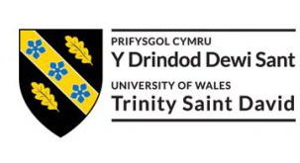

Contents
- - Introduction (Page 3)

- – Main Body (Page 3-11)

  - - Leadership on Site (Page 3)
  - - The Traditional Procurement Method (Page 3-5)
  - - Quality Management (Page 5)
  - - Quality Management Systems (Page 5)
  - - ISO 9000 (Page 5-6)
  - - ISO 9000 Accreditation (Page 6)
  - - Leadership (Page 7)
  - - Planning (Page 7)
  - - Support (Page 7)
  - - Operations (Page 7)
  - - Performance Evaluation (Page 7)
  - - Improvement (Page 7)
  - - The Benefits of Accreditation (Page 7)
  - - Case Study (Page 8)
  - - Process map (Page 9)
  - - Quality Assurance (Page 9)
  - - How to Implement Quality Assurance (Page 10)
  - - Aftercare Support (Page 10-11)

- - Conclusion (Page 12)
- - Reference List (Page 13)
4.1 - Image References (Page 14)
- - Bibliography (Page 15)

1.0 Introduction
In this piece, one has been employed by a local construction company to tender for a planned project in SA1, which involves the construction of student accommodation. Due to concerns over quality management/assurance, one must produce a flow chart detailing the traditional procurement method approach for a construction project. Furthermore, an improved quality management system will be explained, with a focus on client satisfaction, process mapping, improving quality standards and an after-sales procedure.
2.0 Main Body
2.1 Leadership on Site
A site manager must have a close relationship with all parties on site. The easiest way for all to communicate is electronically, with all parties being able to contact the site manager via telephone or email. In addition to this, regular meetings with parties or party representatives should take place. Given the scope of the project, these could be weekly or monthly meetings. As a site manager, one must demonstrate a multitude of skills, including teamwork, communicational and the ability to solve any disputes. In order to maintain a happy workforce, the site manager must display these skills at all necessary times, as well as maintain a working relationship with all parties involved on site.
2.2 The Traditional Procurement Method
In the construction industry, the most commonly used procurement route is the traditional approach, which involves a tripartite agreement between the client, contractor and consultants. This approach separates the design process from the construction. A team of consultants design the project in depth to ensure cost control and inspect construction works. Contractors are invited to submit tenders for the project on a competitive, single-stage basis. Due to the client’s contractual relationship with all parties, they have close control over the project, but also multiple points of responsibility. This procurement method has many positives, including high quality work due to the client’s control over the project, as well as the traditional approach being viewed as the easiest approach to adopt. On the flip side, the traditional method usually results in longer project completion times, due to the need for the design tendering to be completed before the construction tendering begins (Anon 2020).
Responsibilities regarding workmanship, work undertaken, and materials lie with the suppliers and subcontractors. Designing responsibilities fall on the architect and consultant team. A lump sum contract is usually undertaken, with a single sum being calculated and agreed before any works begin. Stage payments are then made as the work proceeds, which is suited to this style of procurement as significant changes to designs are unlikely after this stage. The diagram below outlines the traditional procurement approach (Fig 1) with the supporting image highlighting the contractual relationship between parties (Fig 2). A table outlining key information is also displayed.
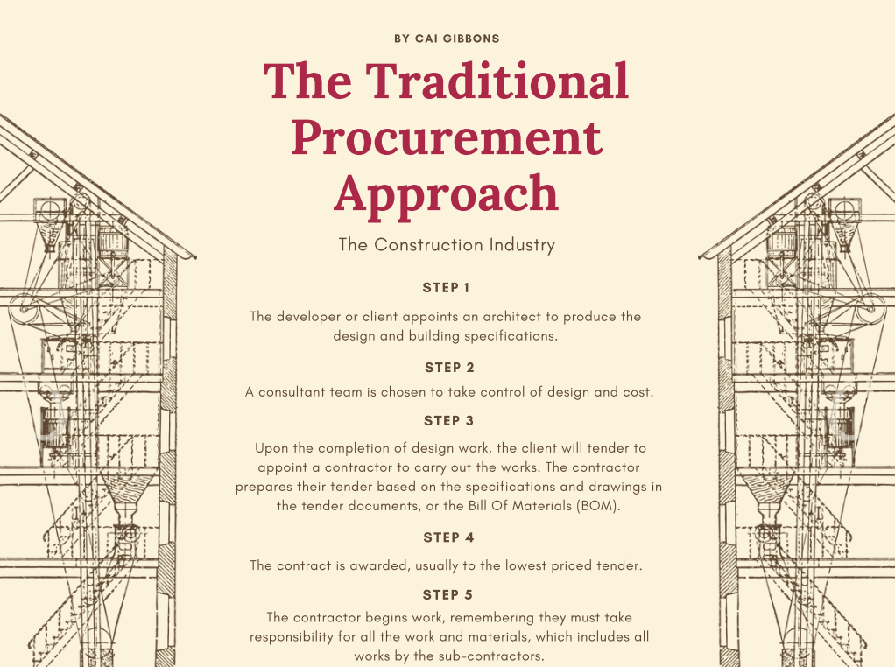

Fig 1 - The Traditional Procurement Approach

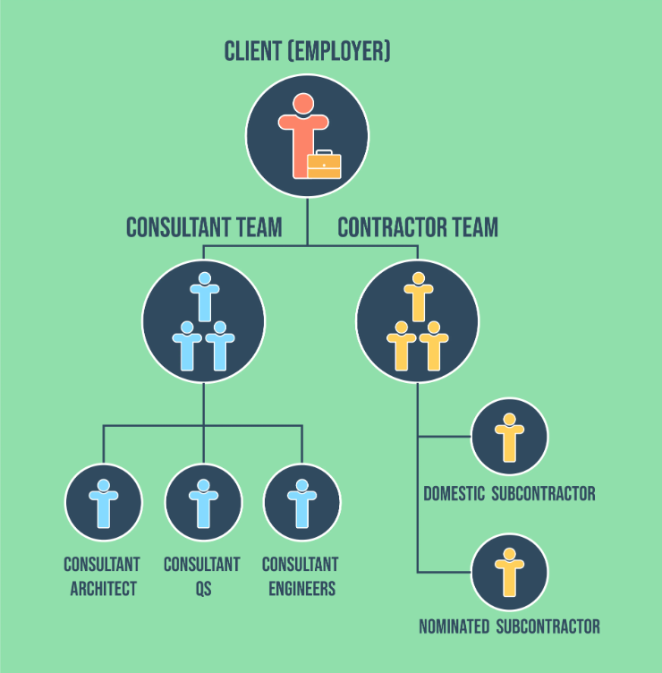
Fig 2 - Contractual Relationship

Key Information Surrounding the Traditional Procurement Method
Consultants retain control over design and quality. This may result in a higher standard than some other procurement routes. | Consultants are responsible for valuations and agreeing payments. | Contractors may submit claims if they do not receive the necessary timely instructions and information, or if changes are made.
There must be adequate time before tenders are invited to allow to produce a complete set of drawings and other documents. This means the traditional procurement route may be slower than some other routes. | The contractor generally has no design duties, but if this is necessary for say, some aspect of a project, the contract should include clear wording to this effect. | The traditional method – or adaptations of it – can be used with approximate quantities, provisional sums, or cost reimbursements where the nature or quantity of work cannot be accurately defined.
Designingbuildings (2020)
2.3 Quality Management
Quality management in construction is defined as “the policies, processes and procedures put in place (typically by management) to improve an organisation's ability to deliver quality to its customers - whether those customers are clients/owners, contractors or subcontractors - on a consistent and constantly improving basis”.(Hodgson 2020). Quality management is a key pillar of overall construction project management and is often the difference between a company's success and failure. All construction projects strive to deliver quality work on time and on budget. Establishing the internal and external principles which result in quality are detrimental to achieving this. The main objectives of quality management are;
- To minimise the defects on asset handover and delivery.
- To identify defects and solve issues before customers do.
- Safeguard the reputation of a company.
- Increase the amount of work the company receives.
2.4 Quality Management Systems
A quality management system is an organisation-wide approach to coordinating, controlling, and directing quality. The previously mentioned quality management takes more of a preventative approach, whereas a quality management system identifies risks and mitigates them. A working quality management system aids in measuring and reviewing the effectiveness and efficiency of processes, with the aim of informed improvement. Interestingly, a common misconception is that adopting a QMS demands a large amount of paperwork. Although certain documents are required, the modern QMS can be lean and agile, and should be developed to suit a business in terms of size, complexity and risk (Anon 2020). For each process involved in the quality management system, a methodology known as Plan, Do, Check, Act (PDCA) can be implemented. This entails;
- Plan: Establish the objectives and processes necessary to deliver results in line with customer service requirements and company policies.
- Do: Implement the process.
- Check: Monitor and measure processes necessary to deliver the results.
- Act: Take action and continually improve performance.
2.5 ISO 9000
In order to strive for client satisfaction and continuous improvement, a quality management system that satisfies these needs is the ISO 9000 family. “For organizations asking how to improve the quality of their products and services and consistently meet their customers’ expectations, ISO has an answer. Addressing various aspects of quality management and containing some of ISO’s best-known standards, there’s the ISO 9000 family.” (ISO 2021).
ISO 9001 lists the criteria for a quality management system with principles that include a customer focus, implication of top management, a process-based approach and continual improvement. Moreover, it can be adopted by any company, regardless of the size or field. Put simply, ISO 9001 ensures consistency in services and high-quality products, which brings along business benefits. For these reasons, one recommends the implementation of ISO 9001 as a way of combatting the problems facing the company currently.
2.6 ISO 9000 Accreditation
Adopting ISO 9000 results in the need to become accredited by the British Assessment Bureau. This process takes around 3-6 months and has multiple requirements. Firstly, someone with experience in implementing quality management systems is needed internally or externally as part of the company. Upon the completion of the ISO 9001 Quality Manual, the stage one audit can begin. After the assessment of the quality manual, stage two of the audit commences. This requires documentation that defines;
- Organisation structure
- Who should record information and what information is recorded.
- Responsibilities of employees.
- Lines of communication throughout the company.
- How continuity will be maintained as staff change.
ISO 9001 Accreditation
Requirement | Explanation
Management of Documentation | You will need to communicate to all of your staff, the importance of keeping records and using the correct documentation. You will need to identify which records are to be kept to comply with the requirements of your ISO 9001 system and what you need to successfully run the business.
System Definition | Define who your customers are for each department, for example:  - For the IT department it will be internal departments.  Document the activities in each area.  Identify any problem areas and rectify them.
Corrective and Preventive Measures | You should keep a record of any actions you have taken to rectify a problem. Where possible you should identify potential problem areas and set up a system to prevent or minimise their effect before it happens.
On-going support and training | Staff should be suitably trained to ensure they can carry out their job function. You must keep records of experience, education, and training to identify their capabilities. Future training requirements can then be implemented together with any new skills that may be needed as the business evolves.
Regular Internal Quality Auditing | Regular Internal Quality Auditing of your own system is required.  The Internal Auditor will check that procedures in the Quality Manual are being followed and will identify any areas of concern to be rectified. You must have a procedure for how audits are to be planned, conducted and recorded.
The British Assessment Bureau (2021)
2.7 Leadership
Senior management must demonstrate that they are driving an organisation’s quality policy. This includes;
- Standards for the performance of subcontractors and suppliers
- Identification of customer needs
- A focus on prevention (rather than detection)
- Performance measurement and review
- Allocation of responsibilities
- Customer satisfaction measurement
2.8 Planning
In terms of customer requirement and commercial context, the “who, what, how and when” is to be established by the quality management system. This aids in addressing opportunities, as well as risks and aims to avoid undesirable outcomes.
2.9 Support
The resources outlined in the quality policy and objectives throughout the organisation, as well as the supply chain are required to be collated. This includes the clear communication of the job roles within the organisation.
2.10 Operations
The planning, control and implementation of internal and outsourced processes is to be documented, in order to design and deliver a quality service.
2.11 Performance Evaluation
A system for monitoring, measuring, analysing and evaluating must be established within the quality management system. This aids in ensuring the system is adequate and also effective. Inputs to achieve this can include audits, schedules, complaints, metrics, and non-conformities.
2.12 Improvement
Documenting instances of undesirable results helps in identifying ways to prevent their future occurrence. Considering changes in internal and external environment can add to this, influencing how future risks and opportunities are to be addressed.
2.13 The Benefits of Accreditation
Certification can open a new market in instances where certification is a customer requirement, which it is amongst many public and private sector organisations. Becoming certified means only one audit is required, reducing the costs of auditing, and providing a universally recognised certificate. Certification allows an independent view of a companies’ quality management system, highlighting their capabilities in the terms of consistency and meeting customer requirements. Certification provides a level of confidence within an organisation’s supply chain, to always meet its requirements. In addition to this, the Chartered Quality Institute promotes “accredited certification” which essentially means that the accreditation can be recognised by customers internationally, which expands the market for the company involved. (Anon 2020).

2.14 Case Study
A study by Dr. J. R. Patil and Mrs. J. P. Pati published in ‘Advances and Research in Civil Engineering and Technology - Construction Management’, titled ‘Quality Management System at Construction Projects’ offers interesting findings upon implementing an eight question feedback based system on a construction project. These questions assessed the quality of work on the site, as well as offering a question’s regarding the hierarchy of importance for certain processes within the project.
Questionnaire Relating to the use of a Quality Management System
Question | Finding
What is the most important quality tool used at the construction site? | - Flow Chart  - Pareto Analysis  - Check Sheets
What is the most important quality control measure used on site? | - Quality of Workmanship  - Quality Control Laboratory on Site  - Maintaining the Sequence of Construction
What are important aspects of quality management during the planning and designing phase? | - Observe regular scheduling  - Review Meetings  - Coordination with all activities
What is the importance of quality management system at construction projects? | - Customer Satisfaction  - Stakeholder satisfaction

Findings
The study found that the quality management system in place at the company is sufficient and noted that suitable quality control was in place, as well as overall quality improving due to the implementation of a quality management system. What can be derived from this study is the fact that quality management systems do have a detrimental effect on a company and one would recommend the consideration of the factors assessed in the above table and their implementation into the quality management system that is to be introduced to the planned project in SA1.

2.15 Process Map
The diagram below outlines the correct format to be followed when a construction process takes place, in order to satisfy a successful quality management system.
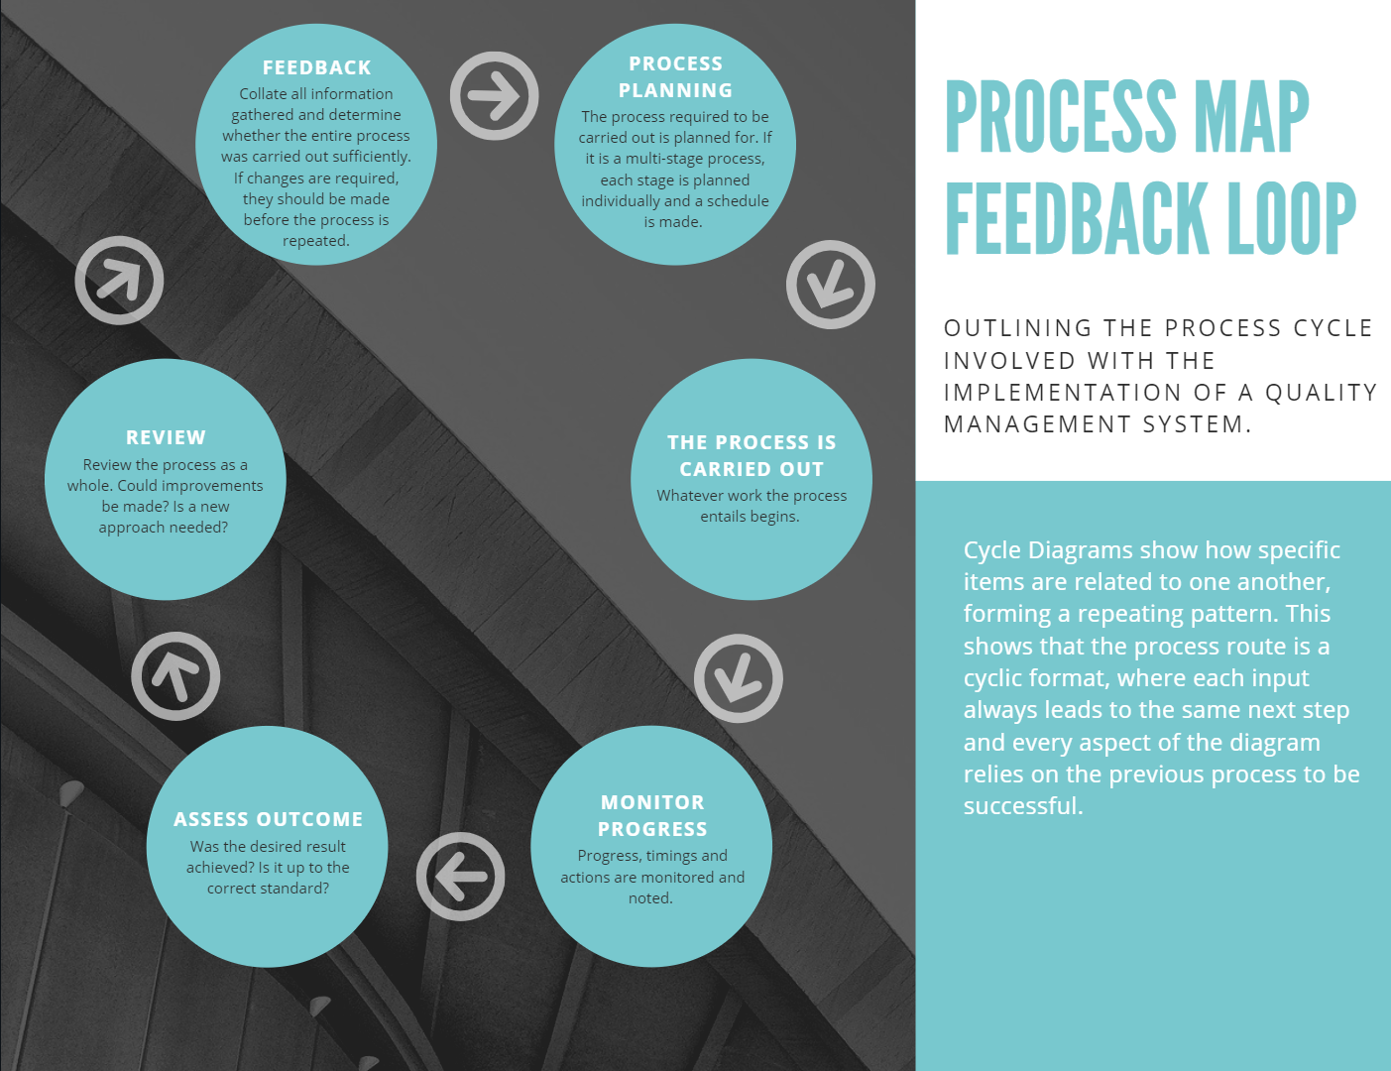
Fig 3 - Process Map
2.16 Quality Assurance
Quality assurance is defined as a set of procedures designed to ensure that quality standards and processes are adhered to, and that the final product meets or exceeds the required technical and performance requirements. (Anon 2017). Despite all the wealth of site experience throughout the past years, one out of ten building contracts still leads to client’s dissatisfaction and complaints against contractors. Research made by the BRE (Building Researches Establishment) in the United Kingdom indicate that 40% of building defects occurs during the construction phase (BRE 2012). In order to combat this, quality assurance should become a company focus. Quality assurance provides client assurance regarding the standard of workmanship, ensuring it is to a high level of quality and all work completed by the contractor reaches a certain level of specification. Furthermore, it should also ensure that company personnel, suppliers and subcontractors are aware of customer requirements. This is in relation with the previously mentioned Quality Manual, which should be encouraged to be used by all members of staff within the company in order to continually improve quality and customer satisfaction.

2.17 How to Implement Quality Assurance
- Project managers form a team or group dedicated to quality assurance. The team must value and evaluate every aspect of the company. This team reports to senior management and keeps all documents in organised files.
- The team should define tasks and assign them to the correct persons. Responsibilities include reviewing tools, services, standards, and guidelines. The outcome of the evaluation is to be reported.
- The quality assurance process plan is then defined by the team. This plan is to include quality objectives, testing activities, evaluation processes, budgeting, training, and funding for quality control.
- Checklists are to be generated related to the activities, which explain the way quality assurance is performed in step 5.
- Perform according to plan. Evaluation can begin upon project completion. Non-conformances are noted and reported to the correct department. Problems are corrected and re-tested. Testing and correcting goes on, till the project is proven to be in conformance with the standard.
- Identify training requirements for team members, to evaluate the processes detailed in the quality control plan.
- Team performance should be monitored regularly, with checking against plans, schedule, and budget. Corrective measures are to take place if required.
- Senior management reviews activities and results, with stakeholders encouraged to assess the review. Any unsolved issues are resolved by senior management.
- Review information is collected from multiple sources, improvements are accepted and implemented in future sessions.
- The team gives a defined structure for the entire process by reviewing and refining. This structure is then re-used and the process repeats.
There are multiple benefits regarding the introduction of quality assurance, but mainly the flow of work improves within a company, therefore improving overall efficiency. Moreover, the need for correct employee training and analysis of employee performance sets a high standard of workmanship that improves overall construction quality. One would recommend that a quality assurance approach such as the approach detailed above is implemented to the planned project in SA1.
2.18 Aftercare Support
Upon the completion of construction, an aftercare system is put in place. This maintains customer satisfaction as the contractor is still associated with the customer after handover. This means that any issues can be reported back to the contractor and relevant remedies will take place. An aftercare team is to be appointed, which is to deal with any defects the build is subject to. It is the decision of this team as to how defects are remedied, but there is to be no single defect left without remedy. Below is an aftercare support process that has been personally constructed, using the practices of multiple other construction companies’ aftercare procedures. This diagram strives to increase customer satisfaction by giving multiple ways for any issues to be solved. There should also be a post-occupancy evaluation after a year of living in the new accommodation completed by all occupants. This provides extensive data that is detrimental in distinguishing whether the project was a success or not. (BREEAM (2021)

Fig 4 - Aftercare Support

3.0 Conclusion
The traditional procurement method has been visually explained, allowing the process to be fully understood and implemented if applicable. A quality management system with a heavy influence from ISO 9000 has been recommended, alongside a step-by-step procedure of how a quality assurance system can become integrated within the project. Moreover, an aftercare procedure has been recommended. All recommendations were made with client satisfaction in mind and supported with relevant literature and the findings from a case study. With these recommendations implemented, the company should expect an increase in client satisfaction, more detailed process mapping, improvements in quality standards and a successful aftercare system.

4.0 Reference List

Aftercare Support
Author - BREEAM (2021)
Source - www.breeam.com

Building Defects
Author - The BRE (Building Research Establishment)
Source - www.bregroup.com

ISO 9000 Family - Quality Management
Author - ISO
Source - www.iso.org

Key Information Surrounding the Traditional Procurement Method
Author - Anonymous (2021)
Source - https://www.designingbuildings.co.uk/wiki/Traditional_procurement_method

Quality Management Systems
Author - Anonymous (2020)
Source - https://www.designingbuildings.co.uk/wiki/Quality_Management_System

Quality Assurance in Construction
Author - Anonymous (2017)
Source - www.ukessays.com

Quality Management System at Construction
Author - Pravin P. Mane, Dr. Jalindar R. Patil (2015)
Source - Advances and Research in Civil Engineering and Technology - Construction Management

Quality Management in Construction
Author - Peter Hodgson (2020)
Source - sitemate.com

Traditional Procurement
Author - Coventry University (2020)
Source - Contract Management and Procurement: An Introduction - Coventry University

4.1 Image References

Fig 1 - The Traditional Procurement Approach
Author - Cai Gibbons
Source - Personally produced

Fig 2 - Contractual Relationship
Author - Coventry University (2020)
Source - www.futurelearn.com

Fig 3 - Process Map
Author - Cai Gibbons
Source - Personally produced

Fig 4 - Aftercare Support
Author - Cai Gibbons
Source - Personally Produced

All tables are personally produced, with any information included that is not personal work being referenced below the table and then included in my reference list.

5.0 Bibliography

ISO 9001 - What is ISO 9001, quality management systems
Very helpful, outlines multiple ISO that are required to become ISO 9001 accredited, all of which can be mentioned in terms of quality assurance.
Accessed - 21/12/2020

Traditional procurement (futurelearn.com)
Outline of traditional procurement approach. Offers a useful diagram but not huge detail.
Accessed - 2/1/2020

Traditional procurement method - Designing Buildings Wiki
Helpful additional information on the traditional procurement approach. A number of Key criteria that can be listed after the flowchart has been completed.
Accessed - 4/1/2020

Traditional/Conventional – The Joint Contracts Tribunal (jctltd.co.uk)
Helpful information. Side panel offers outlines of Design and Build + case studies that could be used. Website is made by a service that “sets the standard for construction projects”.
Accessed - 5/1/2020

Traditional Procurement vs Design & Build: Which One is Better? (urbanistarchitecture.co.uk)
Compares traditional route to design build and others. Offers pro’s and con’s of multiple approaches. Very Useful.
Accessed - 10/1/2020

Quality management in construction: Here's what you need to know (sitemate.com)
Quality management in Construction. Lots of information, offers pointers to talk off.
Accessed - 12/1/2020

(PDF) Quality Management System at construction projects (researchgate.net)
Could be used to boost references. Contents table outlines some processes that one may need to touch on. Possible table outlining factors?
Accessed - 13/1/2020

Quality Management System - Designing Buildings Wiki
Heavily explains what ISO 9001 9=is and how to achieve accreditation. Very helpful, detrimental to use.
Accessed - 15/1/2020

After Sales and Maintenance - Malcolm Reed Construction (mr-construction.co.uk)
Examples of after sale (After care) procedure used at Malcolm Reed Construction. Possibly make my own? Questionnaire?
Accessed - 18/1/2020

After Sales Service / Customer Service (managementstudyguide.com)
Additional examples of aftercare processes.
Accessed - 18/1/2020

Applicable Word Count = 2186
Total Word Count = 3549

