Program - Certificate in Higher Education Skills for the Workplace

Module - Professional and Career development

Module code - BMSW 4005

Assignment – reflective portfolio

Word count – 2000 +/-

Student id – 2017461

Student name – Zeba Arif

Tutor - Vasilios Tavlaridis

Table of content -

Introduction page 3

Swot analysis Page 3

PDP Page 4

Skills required to be an “effective” manager in the care industry Page 4

What I have learned from this module Page 5

Conclusion Page 9

References Page 10

Introduction -

Why is reflection important? “Reflection helps you develop and review your skills and their effectiveness, its about questioning your skills and deciding how you can be better and more efficiently use them in the future.” (university, 2021) I will be writing a reflection report on what I have learnt during this module on improving my skills and the skills I currently have which will help me at finding the right career and guide me in improving on my weakness. In this portfolio I will also conduct a SWOT analysis and complete a personal development plan which will help me identify my skills. Following on from this analysis I will also do an analysis on the skills I will require to be an “effective manager” in my chosen field of work.

What is a SWOT analysis and why we use it -? “A SWOT analysis is a framework used to evaluate and assess internal and external factors as well as identify the strengths, weakness, opportunities and threats. Which when all assessed allow you to come to an informed and fact-based analysis” (Kenton, 2021)

Below is a SWOT analysis I have conducted on my self –

Strengths –  - Caring  - Compassionate  - Good team player  - Good at multitasking  - Able to work under pressure  - Punctual | Weaknesses –  - Emotionally sensitive  - Easily persuaded  - Very soft  - Overly caring
Opportunities –  - NHS as I have experience and have always been in the health care profession  - Increasing my skills as an HCA to increase my capabilities in what I can do | Threats –  - Overqualified and more experience  - Others having more knowledge of the job  - Barriers also include my health being fragile

What is a PDP, and why do we use it -? “This is an action plan which helps you identify individual goals, your strengths and weaknesses, areas you need to improve and develop, and what you need to do to achieve your goal.” (what is a personal development plan ? , 2021). There are 5 main stages to a PDP which are identify, plan, action, record, and review.

Below is a PDP on my self -

Identify goal | Plan on how to achieve | Action required to achieve goal | How long will you take to achieve goal | Date goal was achieved
Improve anxiety levels in public place | Attend more events, socialise more | Attend uncle’s birthday party were all family and friends will be present | Party on the 15th november 2021 | 15.11.2021
Train to be a phlebotomist | Search online for local course | Select the most suited course with the right price up to £300 | Aim to complete in 6 months | 6 months from 08.11.2021
Look for more GP practice as a receptionist and apply as you have the experience | Search online for vacancies | Apply to a minimum of 2 vacancies daily | Check responses after a week if non then increase minimum to 4 | To be reviewed weekly

The skills required to be a “effective” manager in the health industry-

What is effective management? “This is when the manager improves their own efficiency while building a team of productive team players to achieve a goal” (Software, 2021) . an effective management equals to effective team. To be an effective manager you need to have the essential skills like a great team player, organised and good leadership skills

working in the health care industry has its own challenges and management would need to hold these extra skills to be effective and successful. According to Dragon Sutevski “there are 7 skills required to become an efficient health care manager” (Sutevski, 2021).

Each skill and why it’s important? -

Sufficient knowledge about the industry-
this is important if you’re going to manage a team of health care professions you need to have an idea and knowledge about what and how the staff should react. For example, a question regarding a medication that was administered or a procurer that’s due to take place.

Transparency and accountability-
This is an important skill to have as you will be interacting whit many patients and other health care providers you need to be transparent to be able to provide the best health care. Accountability is also important as management you are responsible for your and your teams’ actions and in this profession all actions and all staff are accountable for their actions.

Quick thinking and easy adaptability-
As this is a quick and fast past job you need to have the skill of quick thinking and be able to adapt to different situations. Being in the health care industry every day is a new day you never know what you will see or deal with and sometimes you will have to make spontaneous decision to save a life.

Team management skills-
Team management skills are very important for managing a team in the health care industry. You are responsible for people’s health and wellbeing you need to maintain good management to be able to run a team in a busy and fast pacing environment.

Passion for the job -
This is a job where passion is very important. Having to deal with different people and different health conditions you need to have a passion to be able to complete your job. There are many obstacles, you will need to provide care and comfort to people who are unwell, and to be able to do this you need to love your job and what you do.

Excellent problem-solving skills –
Problem solving skills are vital in any job as you as a manager are always going to be paced with complications and problems ad having the skill to deal with these is important especially in a health care environment where you are responsible for the health and wellbeing of others.

Good understanding of legal requirements-
Being in the health care environment having knowledge of the legal requirements is very important as even the smallest mistake caused by you or a member of your team could be a lawsuit against you all, and this is not something you want. Having enough knowledge to be able to handle a misunderstanding before its escalated is important especially for management.

What have I learnt from this module? –

This module has been very interesting and educational. I learnt alot about myself which I did not know before. I learned my learning style, how to self-reflect, bout the different skills I have and much more. Among the many things we learned one was setting goals and working to achieve our goals. We learnt about a method called SMART goals.

SMART Goals –

S- specific – make it specific to what you want to achieve this will give you a better understanding of what you need to do.

M- measurable – how will you monitor your progress? You need to know how you will check how much progress you have made

- Achievable – set a reasonable goal which could be achieved in a reasonable time frame, and which would be a step forward to achieving more

R- relevant – will achieving this goal help you achieve your bigger target? will this be a step forward. You need to make sure your goal is relevant to what your overall aspiration is.

T- time – what is the time frame for you to achieve this goal? Can you achieve your target in this time frame? you need a realistic time frame to achieve your goal, this will give you motivation.

As stated by the indeed team “SMART is an acronym, and each element of this framework works together to make a goal that is tailored and planned to you and your needs” (team, 2021).

In this module I have also learned about the UK Employment laws.

UK Employment laws -

There are many laws in place to help protect the employee and to insure they are treated fairly when they apply for a job. According to the UK rules website “all employees have employment rights, the employment laws give you a list of your entitlements” (Rules, 2021).

Some of the employment laws include-

Data protection law – “the Data protection act 1998 section c29 has 8 principles which protect personal data which is stored on paper or on computers” (Rules, 2021). This law is in place to protect all personal data.

Equality act 2010- this law is in place to grant equal opportunities to people. This law allows there to be no discrimination due to a person’s age, sex, religion and so forth.

Health and safety act 1974 – this is a law which is in place to ensure the health and safety of employees and employers in the workplace.

Recruitment legislation- this is a law in place to ensure all new employees are recruited fairly and there is no discrimination.

Equal pay act 1970- this is a law in place to ensure that men and women receive equality in the workplace.

Work time regulations 1993- this is a law which is put in place to ensure that employees are not over worked unless they wish to. This law is in place to ensure that the staff can work the maximum number of hours unless otherwise stated.

Learning theories –

While learning about self-awareness we also learned that there are different types of learning styles and there are several theories which help you identify which learning style best describes you.

Kolb learning theory – according to David Kolb “experience is crucial in the development of knowledge construction, He stated knowledge is created threw experience” (Kurt, 2020).

Image below of Kolb’s learning style theory (Kurt, 2020)

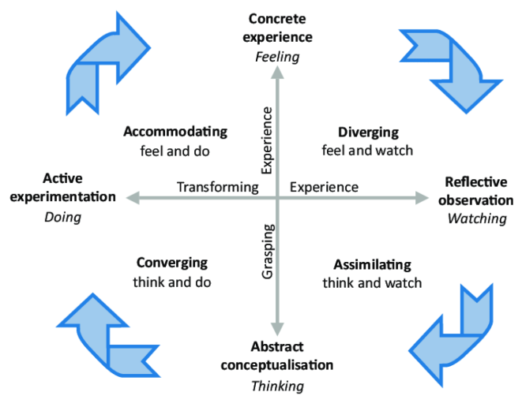
Diverging- someone who is more hands on and likes to explore. (Kurt, 2020)

Assimilating – someone who is independent. (Kurt, 2020)

Converging – someone who enjoys Computer-based tasks and interactive activities. (Kurt, 2020)

Accommodating – someone who likes to actively participate in activities, explores instructions with questions. (Kurt, 2020)

Honey & Mumford learning theory – “this is a theory that identifies four distinct styles that people use while learning, it was said most people only use one or two of these styles and different activities suite different styles” (Rosewell, 2021).

Below is an image of Honey and Mumford learning style (management, 2021)

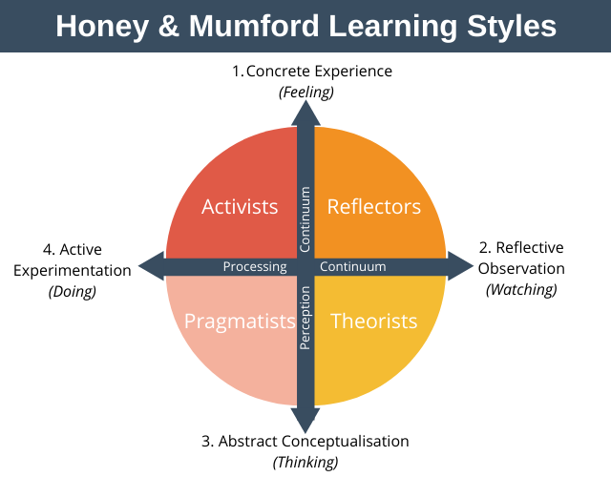
Activist – “these are people who learn by doing things, they like experiencing new things they normally act before thinking about the consequences.” (management, 2021)

Theorist- “these people like to understand the theory behind the action, they need concepts and facts to learn.” (management, 2021)

Pragmatist- “these people are keen on trying things out, they look for new ideas that can be applied to the problem.” (management, 2021)

Reflector – “these are people who learn by observing and thinking about what will happen, they like to consider all angels and implications before having an opinion.” (management, 2021)

Neil Fleming learning theory – this theory is also known as VARK. “The

The Neil Fleming / VARK mode of learning suggests that there are 4 main types of learners visual, auditory, reading/ writing and kinesthetic.” (Cherry, 2019)

Visual- “this kind of learner learns best by seeing things like illustrations, diagrams, videos and handouts.” (Cherry, 2019)

Auditory- “these learners learn best by hearing information and understand a lot from lectures, they are also good at remembering things.” (Cherry, 2019)

Reading and writing- “these learners take information and display it in words.” (Cherry, 2019)
Kinesthetic- “this learning style learners learn best by touching and doing they are hands on.” (Cherry, 2019)

We also discuss self-awareness method which were Helpful in identifying our inner selfs and making us self-aware.

A method we used was the jo hari window. “The Johari window is a tool used to identify self-awareness and mutual understanding between individuals and a group. It was made by 2 American psychologists Joseph Luft and Harry Ingham in 1955” (BusinessBalls, 2021)

This diagram has 4 window each window reflecting different information.

- open area -this is the information that is known by you and others. This area helps you and your team create an understanding of what you both know and understand about you

- Blind area- this information is known by others but not your-self. This area is completed by team members or someone that knows you, this helps you to have a better understanding of what people see in you.

- Hidden area – this is information you know about yourself, but others don’t. it’s information you know about yourself that you don’t want to disclose to others.

- Unknown area – this is information unknown by you and others. This is an area worth understanding as this is information you don’t know about your self and nor do others.

This is an image of the Johari framework (BusinessBalls, 2021)
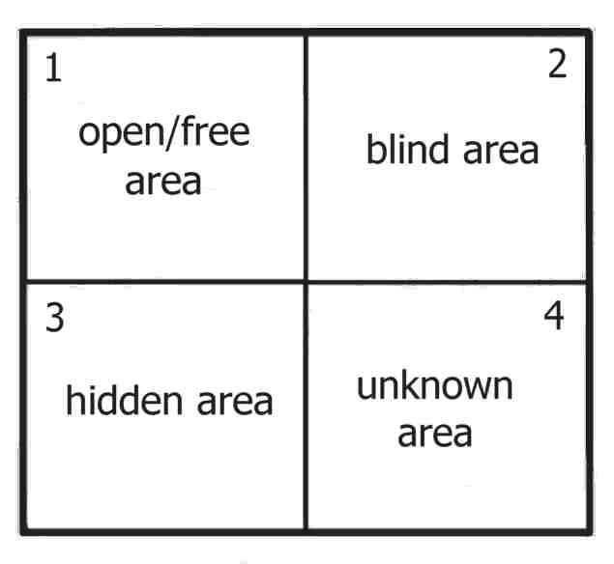

We also completed a learning styles quiz and a personality test. I really enjoyed completing these tests I was fascinated with how accurate the results were. And they made me look back at myself and question myself

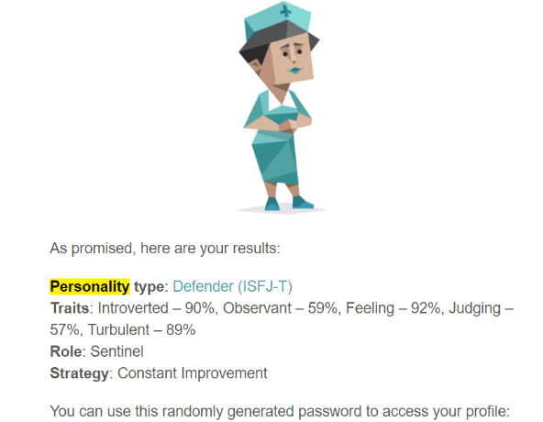

My personality test results. Picture taken as a screen shot from my email.

To conclude I found this module very educational and very interesting. We completed many quizzes and assessment each were great learning kerbs. Having a great tutor always helps. I enjoyed getting better understanding of myself and learning about how I could improve myself, my skills and how the career world works. I also learned about the laws and legislations that are there from the recruitment process all the way threw employment. Learning about how to conduct an interview for our dream job and receiving feedback really helped me to understand how I can improve in a real interview.

References

BusinessBalls. (2021, 02 16). Johari Window Model and Free Diagrams. Retrieved from businessballs: https://www.businessballs.com/self-awareness/johari-window-model-and-free-diagrams/
Cherry, K. (2019, 11 27). Overview of VARK Learning Styles. Retrieved from very well mind : https://www.verywellmind.com/vark-learning-styles-2795156
Kenton, W. (2021, 03 29). strength, weakness, opportunity, and threats ( SWOT ) Analysis. Retrieved from investopedia: https://www.investopedia.com/terms/s/swot.asp
Kurt, D. S. (2020, 12 28). Kolb’s Experiential Learning Theory & Learning Styles. Retrieved from educationaltechnology: https://educationaltechnology.net/kolbs-experiential-learning-theory-learning-styles/
management, E. p. (2021, 11 24). Honey and Mumford learning styles. Retrieved from expert program management : https://expertprogrammanagement.com/2020/10/honey-and-mumford/
Rosewell, J. (2021, 11 24). Learning styles. Retrieved from the open university : https://www.open.edu/openlearn/ocw/pluginfile.php/629607/mod_resource/content/1/t175_4_3.pdf
Rules, T. U. (2021, 11 16). Main Features of Current Employment Legislation. Retrieved from The UK Rules : https://www.theukrules.co.uk/rules/employment/laws-list.html
Software, P. (2021, 11 15). Five tips for effective business management in the hybrid workplace. Retrieved from phocas software: https://www.phocassoftware.com/business-intelligence-blog/five-keys-to-effective-business-management
Sutevski, D. (2021, 11 15). Top 7 Skills Needed to Become A Healthcare Manager. Retrieved from entrepreneurshipinabox.com: https://www.entrepreneurshipinabox.com/17939/top-7-skills-needed-to-become-a-healthcare-manager/
Team, I. E. (2021, 05 27). 8 Team Management Skills Every Leader Should Know. Retrieved from indeed: https://www.indeed.com/career-advice/career-development/team-management-skills
team, i. e. (2021, 11 02). SMART Goals : definition and examples. Retrieved from indeed: https://www.indeed.com/career-advice/career-development/smart-goals
university, T. o. (2021, 11 08). what is self reflection ? . Retrieved from The open university : https://www.open.ac.uk/choose/unison/develop/my-skills/self-reflection
what is a personal development plan ? . (2021, 06 01). Retrieved from CPD Online college: https://cpdonline.co.uk/knowledge-base/business/what-are-personal-development-plans/

