11/25/2020
Gavin Clarkson (1809104)
BEng mechanical and maunfacturing engineering
Theories of Elastic Failure
M6X00420
Advanced Stress and FEA

Table of Contents
Introduction 2
Complex stress Situations 3
Theories of Elastic Failure 4
Von Mises (Maximum Distortion Energy Theory) 4
Tresca (Maximum Shear Stress Theory) 5
Rankine (Maximum Principal Stress) 5
Comparing Von Mises and Tresca 6
Analysis of Tie-Rod used in TATA Steel Trostre 7
Failure Analysis of Crane Hook 8
Conclusions 12
References 13
Appendices 15
Appendix 1 15

Introduction
The study of mechanics of materials is described by Hibbeler (2013) as the “effects of stress and strain in a solid body that is subjected to an external force”. With the primary goal of obtaining all stresses, strains and displacement acting on an object, once these are known it should be possible to avoiding structural failure in a component. The most common way to predict material failure is by using a tensile test, this test applies tension in a uniaxial, or opposing, direction until failure occurs. It uses a standard circular bar and gradually increase the tensile load until yielding occurs (Dowling, 2013) (Hearn, 1997) (Hibbeler, 2013) (Gere, 2001). However, this method does not predict failure in a multiaxial or complex stress situation. As the stress needed to produce yielding in complex stress situations is affected by the magnitude of other stresses (C F Braun & Co, 1969) (The Efficient Engineer, 2020) (Hearn, 1997) (Hibbeler, 2013) (Dowling, 2013).


Figure 2 - The Efficient Engineer (2020)
Figure 1 - The Efficient Engineer (2020)

Complex stress Situations
When looking at a complex stress situation, both the total strain energy and shear strain energy need to be considered. Fig 3 (a) shows the stresses acting on a cube, it shows that the 3 primary stresses can be observed as σ_{a,} σ_{b} and σ_{c}. Each of these stresses are acting perpendicular to each other. The corresponding principles strains are given as ε_{a}, ε_{b} and ε_{c} which means that the total stain energy, U_{t}, is:
$$U_{t}= \frac{1}{2} σ_{a}ϵ_{a}+ \frac{1}{2}σ_{b}ϵ_{b}+ \frac{1}{2}σ_{c}ϵ_{c}$$
(Hearn, 1997) (Gere, 2001) (Beer, et al., 2015) (Hibbeler, 2013).
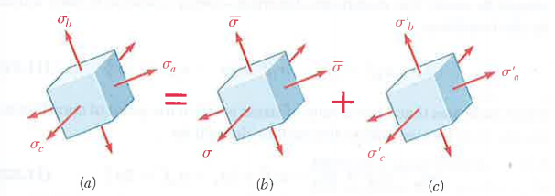
The stress state shown in Fig 3 (a) is made up of Fig 3 (b &c). The state shown in Fig 3 (b) are stresses that change the volume but not the shape of an element. Whereas Fig 3 (c) shows the state that changes the shape of an element but not the volume. The stresses in this state can be tensile and compressive. These two states can be called Hydrostatic and Deviatoric stresses, respectively. The hydrostatic stress is characterised as the Volumetric strain energy, U_{v}, and is shown as:
Figure 3 - Beer, et al (2015)
$$U_{v}= \frac{1-2v}{6E}\left[{\left(σ_{a}+σ_{b}+σ_{c}\right)}^{2}\right]$$
Total shear strain energy = shear strain energy + volumetric strain energy
$$U_{t}= U_{s}+ U_{v}$$
Therefore,
$$U_{s}= U_{t}- U_{v} \\ U_{s}= \frac{1}{2E}\left(σ_{a}^{2}+σ_{b}^{2}+σ_{c}^{2}-2v\left(σ_{a}σ_{b}+σ_{b}σ_{c}+σ_{a}σ_{c}\right)\right)-\frac{1-2v}{6E}\left({\left(σ_{a}+σ_{b}+σ_{c}\right)}^{2}\right)$$
Simplified down by using,
$$\frac{E}{2G}=1+v$$
$$U_{s}= \frac{1}{12G}\left[{\left(σ_{a}-σ_{b}\right)}^{2}+{\left(σ_{b}-σ_{c}\right)}^{2}+{\left(σ_{a}-σ_{c}\right)}^{2}\right]$$
(Hearn, 1997) (Beer, et al., 2015) (Jones, 2009).

Theories of Elastic Failure
There are many different theories on predicting multiaxial stress failure, all of them have the same objective. To reliably predict failure in materials or structures (Baltic, et al., 2020). Out of these theories, there is not one specific theory that is suitable for all materials as materials can behave different depending on the loading conditions, temperature or the way they are shaped (Hibbeler, 2013) (The Efficient Engineer, 2020). These theories use the materials tensile test results to predict when failure occurs under any stress conditions. The most prominent theories are:
- Maximum Distortion Energy Theory (Maxwell – Huber – Hencky – Von Mises)
- Maximum Principal Stress Theory (Rankine)
- Maximum Shear Stress Theory (Tesca)
- Mohr’s’ Modified Shear Stress Theory
(Hearn, 1997) (The Efficient Engineer, 2020) (C F Braun & Co, 1969).
The different theories are more suitable for use with ductile or for brittle materials. Brittle materials tend to fail at fracture. Have larger compressive strengths as opposed to tension strength. Ductile materials tend to fail at the point of plastic deformation (The Efficient Engineer, 2020) (Hearn, 1997) (Jones, 2009) (Hibbeler, 2013).

Von Mises (Maximum Distortion Energy Theory)
It is stated by Hearn, (1997) that in the Von Mises theory “failure occurs when the maximum shear strain energy.…Is equal to the yield point in the tensile test” (Hearn, 1997). This theory deals with changes in shape of a material as opposed to changes in volume. It is given that the structural properties of a material are safe as long the maximum distortional energy is less than the yielding point when performed in a tensile test (Beer, et al., 2015). The maximum shear strain energy can also be known as the maximum distortional energy, this strain energy relates to the effect of deviatoric stresses. Since we know that during a tensile test the maximum principal stress is equal to the yield strength of the material and the other two stresses are equal to zero, the distortion energy can be calculated by inputting these values into U_{s} equation above. Which gives:
$$U_{s,y}=\frac{1+v}{3E}σ_{y}^{2} \\ U_{s,y}= \frac{σ_{y}^{2}}{6G}$$
By using this equation, and re-arranging we get:
$$\frac{1}{12G}\left[{\left(σ_{a}-σ_{b}\right)}^{2}+{\left(σ_{b}-σ_{c}\right)}^{2}+{\left(σ_{a}-σ_{c}\right)}^{2}\right]= \frac{σ_{y}^{2}}{6G} \\ \sqrt{\frac{1}{2}\left[{\left(σ_{a}-σ_{b}\right)}^{2}+{\left(σ_{b}-σ_{c}\right)}^{2}+{\left(σ_{a}-σ_{c}\right)}^{2}\right]}= σ_{y}$$
This equation shows that if the left hand side of the equation is greater than the yield strength then yielding is expected to have occurred (Hearn, 1997)$CITATION The20 \backslash l 2057 (The Efficient Engineer, 2020)$ (Hibbeler, 2013)$CITATION Rob09 \backslash l 2057 (Jones, 2009)$$CITATION CFB69 \backslash l 2057 (C F Braun \& Co, 1969)$$.$
The Von Mises theory is said to have better agreement with experimental data and suited for use with ductile materials (Hearn, 1997) (The Efficient Engineer, 2020) (C F Braun & Co, 1969) (Beer, et al., 2015) (Hibbeler, 2013). It is also used in solidworks as part of the failure criteria in simulation (Solidworks Help, 2020).

Tresca (Maximum Shear Stress Theory)
The Tresca theory shows that failure occurs when the maximum shear stress, in a complex stress situation, is equal to the shear stress at yielding in a uniaxial tensile test. By using Mohr’s Circle, it can be shown that the maximum shear stress is equal to half the difference between the maximum and minimum principal stress (fig 4) and that for yielding in a tensile test the maximum principal stress is equal to the yield strength of the material (fig 5). This means that the shear stress is half the yield strength. This gives the following formula:
$$τ_{max}= τ_{yielding} \\ \frac{σ_{1}-σ_{3}}{2}= \frac{σ_{y}}{2} \\ σ_{1}- σ_{3}= σ_{y}$$
(Hearn, 1997) (C F Braun & Co, 1969) (Jones, 2009) (The Efficient Engineer, 2020) (Beer, et al., 2015) (Hibbeler, 2013) (Jones, 2009).
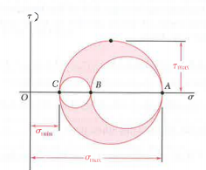
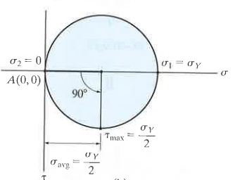
This theory is generally considered to be good with experimental data but is known to be conservative (Hearn, 1997) (C F Braun & Co, 1969). As the Von Mises theory, the Tresca theory is more suited to use with ductile materials (Hearn, 1997) (Beer, et al., 2015) (Hibbeler, 2013) and can be easier to use (C F Braun & Co, 1969) (The Efficient Engineer, 2020).
Figure 4 - Beer, et al (2015)
Figure 5 - Hibbeler (2013)

Rankine (Maximum Principal Stress)
The maximum principal stress theory states that failure in a complex stress situation will occur under two conditions. The first is when the maximum principal stress surpasses the tensile yield stress in a uniaxial system and the second is when the minimum principal stress becomes as small as the yield stress in compression (Hearn, 1997) (Hibbeler, 2013) (Jones, 2009) (C F Braun & Co, 1969) (Beer, et al., 2015).
This theory is reported to not be suitable for ductile materials and should only be used on brittle materials (Hearn, 1997) (C F Braun & Co, 1969) (Hibbeler, 2013) (Jones, 2009) (The Efficient Engineer, 2020). This is due to the failure of ductile materials not solely being caused by the direct stresses (Hearn, 1997) (The Efficient Engineer, 2020).

Comparing Von Mises and Tresca
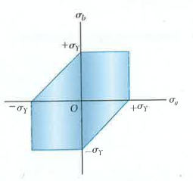
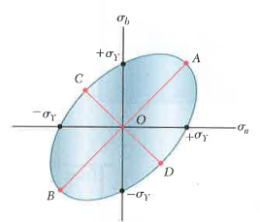
The relationship of each theory can be represented graphically, as shown in fig 6 and fig 7 Von Mises is plotted to be an ellipse while Tresca is plotted to be a hexagon. At any material state, the stress is represented by σ_{a} and σ_{b} these can be shown as co-ordinates and are the principal stresses. If the co-ordinates are within the highlighted ellipse or hexagon then the material is deemed to be safe. Alternatively, if they fall outside the material is at risk of failure (Beer, et al., 2015) (The Efficient Engineer, 2020).
Figure 6 - Beer, et al (2015)
Figure 7 - Beer, et al (2015)
When these are overlayed as a comparison (fig 8), it can be seen that the Tresca yield surface lies completely inside Von Mises yield surface. This shows that Tresca is more conservative in its approach. The comparison also shows that failure in a torsion test occurs in the Tresca model at $σ_{a}= {}_{-}^{+}{{0.5σ}_{y}}$ and in Von Mises at $σ_{a}= {}_{-}^{+}{{0.577σ}_{y}}$ (Beer, et al., 2015) (The Efficient Engineer, 2020). Beer, et al (2015) goes on to state that the Von Mises theory appears to be more accurate than Tresca as the ratio between τ_{y} and σ_{y} for ductile materials range from 0.55 to 0.6 where Von Mises lies within these number. This is also backed by Hearn, (1997) who states that Von Mises is considered to be the best theory of the four mentioned above as well as being the most reliable.

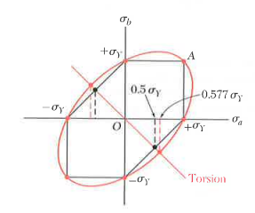
Figure 8 - Beer, et al (2015)

Analysis of Tie-Rod used in TATA Steel Trostre
As part of the operation in TATA Steel Trostre tie-rods are used to connect gates together which open and close depending on line conditions, the layout of these gates is shown in appendix 1. The tie rods, fig 9, are manufactured out of material 43A which, according to Matmatch, (2020) and West Yorkshire Steel, (2020), is a low carbon steel grade. Low carbon steel, also known as mild steel, tend to have a carbon content of between 0.1% and 2.5% this mean they are a general-purpose steel as the hardness and tensile strength are low. They are known be very ductile (Bolton, 1998) (Higgins, 1994).
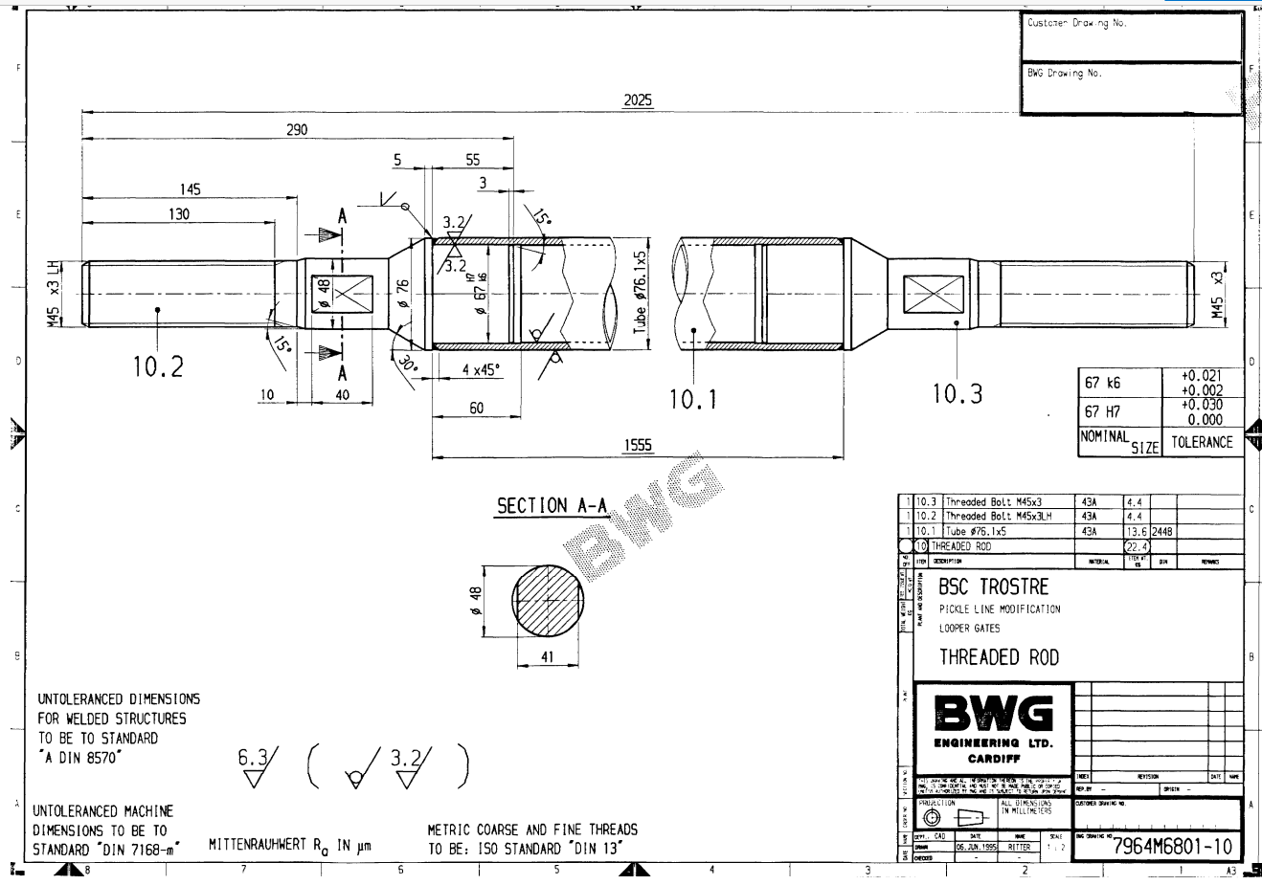
Figure 9 - Tie-rod
As the material is known to be ductile, using Rankine’s Theory to determine the failure point during development would not be suitable, as it is more suitable for use with brittle materials. Therefore, either Von-Mises or Tresca’s Theory would be suitable to use in development as both of these theories are for use with ductile materials (Hearn, 1997) (The Efficient Engineer, 2020) (Hibbeler, 2013) (Beer, et al., 2015). It is shown in several studies regarding tie-rod failure that Von-Mises has been used in FEA models (Duan & Joshi, 2013) (Bošnjak, et al., 2020) (Winklberger, et al., 2018).In the study Duan & Joshi, (2013), the material and conditions are similar to the tie-rod previously mentioned. Although, this study focused more on the stress load applied on the threads as opposed to the whole rod. These tie-rods have failed several times, each time in the same area, as shown in fig 10. It is the point where there is a change in diameter next to the thread part at the bar. This potentially points to weak point on these rods.
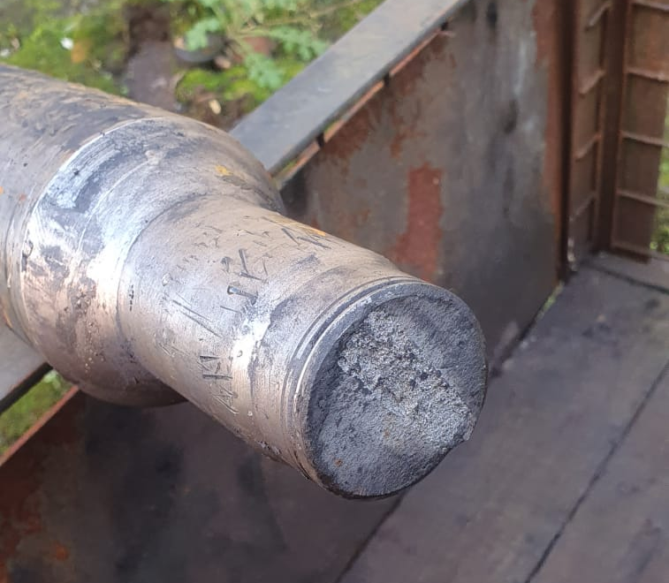
Figure 10 - Sheared Tie-rod

Failure Analysis of Crane Hook
An article was published in the journal of Engineering Failure Analysis in September 2020. The article relates to a failure of hook used in an overhead crane in a TATA Steel site in India and is written by (Kishore, et al., 2020). The crane and hook were used to transport cold rolled coils around the mill department. It was initially installed in 2001 and failure occurred at the end of 2019. The hook was used to carry 110 coils per day weighing 24T.
Kishore, et al (2020) start by summarising different literature about crane hook failure. They show that several different approaches have been used in studying failure, including metallurgical analysis, finite element analysis (FEA) and photo elasticity. But never used in conjunction with each other. These studies are said to not show detailed explanations for why hooks fail in a certain place or what effect a small defect has on the stress intensification. This study looks to present “detailed failure analysis using both metallurgical and engineering design approach to address aforementioned gaps”.
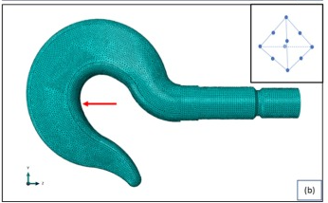
The hook that failed and a spare were inspected to pinpoint the location of failure, operation parameters was taken, dimensions compared to drawings and fractography, chemical and microstructural analysis was taken. The hook was then modelled and exported into Abaqus, which is a FEA modeler which is able to perform both linear and non-linear analysis (Simuleon, 2014), as shown below (fig 11).
Figure 11 - Kishore, et al (2020)

A mesh size of 6mm was used for the normal locations and 1mm for areas with changes in geometry. Having a small mesh size is important in FEA as the smaller the mesh the higher the accuracy and if the size of the mesh is too big then the component has a higher complexity (Dutt, 2015).
The dimensions of the hook were found to be the same as the specified drawing. Failure is shown to have occurred around the thread area (fig 12) where there is a change of cross-sectional area, near this area deep tool marks can be observed (fig 13) which can heighten the stress concentration. It is also stated that the surface finish on the failed component does not match the drawing specification. Suhr (2015) cited by Kishore, et al (2020) suggests that a good surface finish can help to improve the fatigue strength.

This area of failure is in the same region as the tie-rod spoke about above. The drawing of the load hook states that the area around the change in diameter should be polished (Kishore, et al., 2020) however, the drawing for the tie-rod does not state any change in surface finish.
Figure 12 - Kishore, et al (2020)
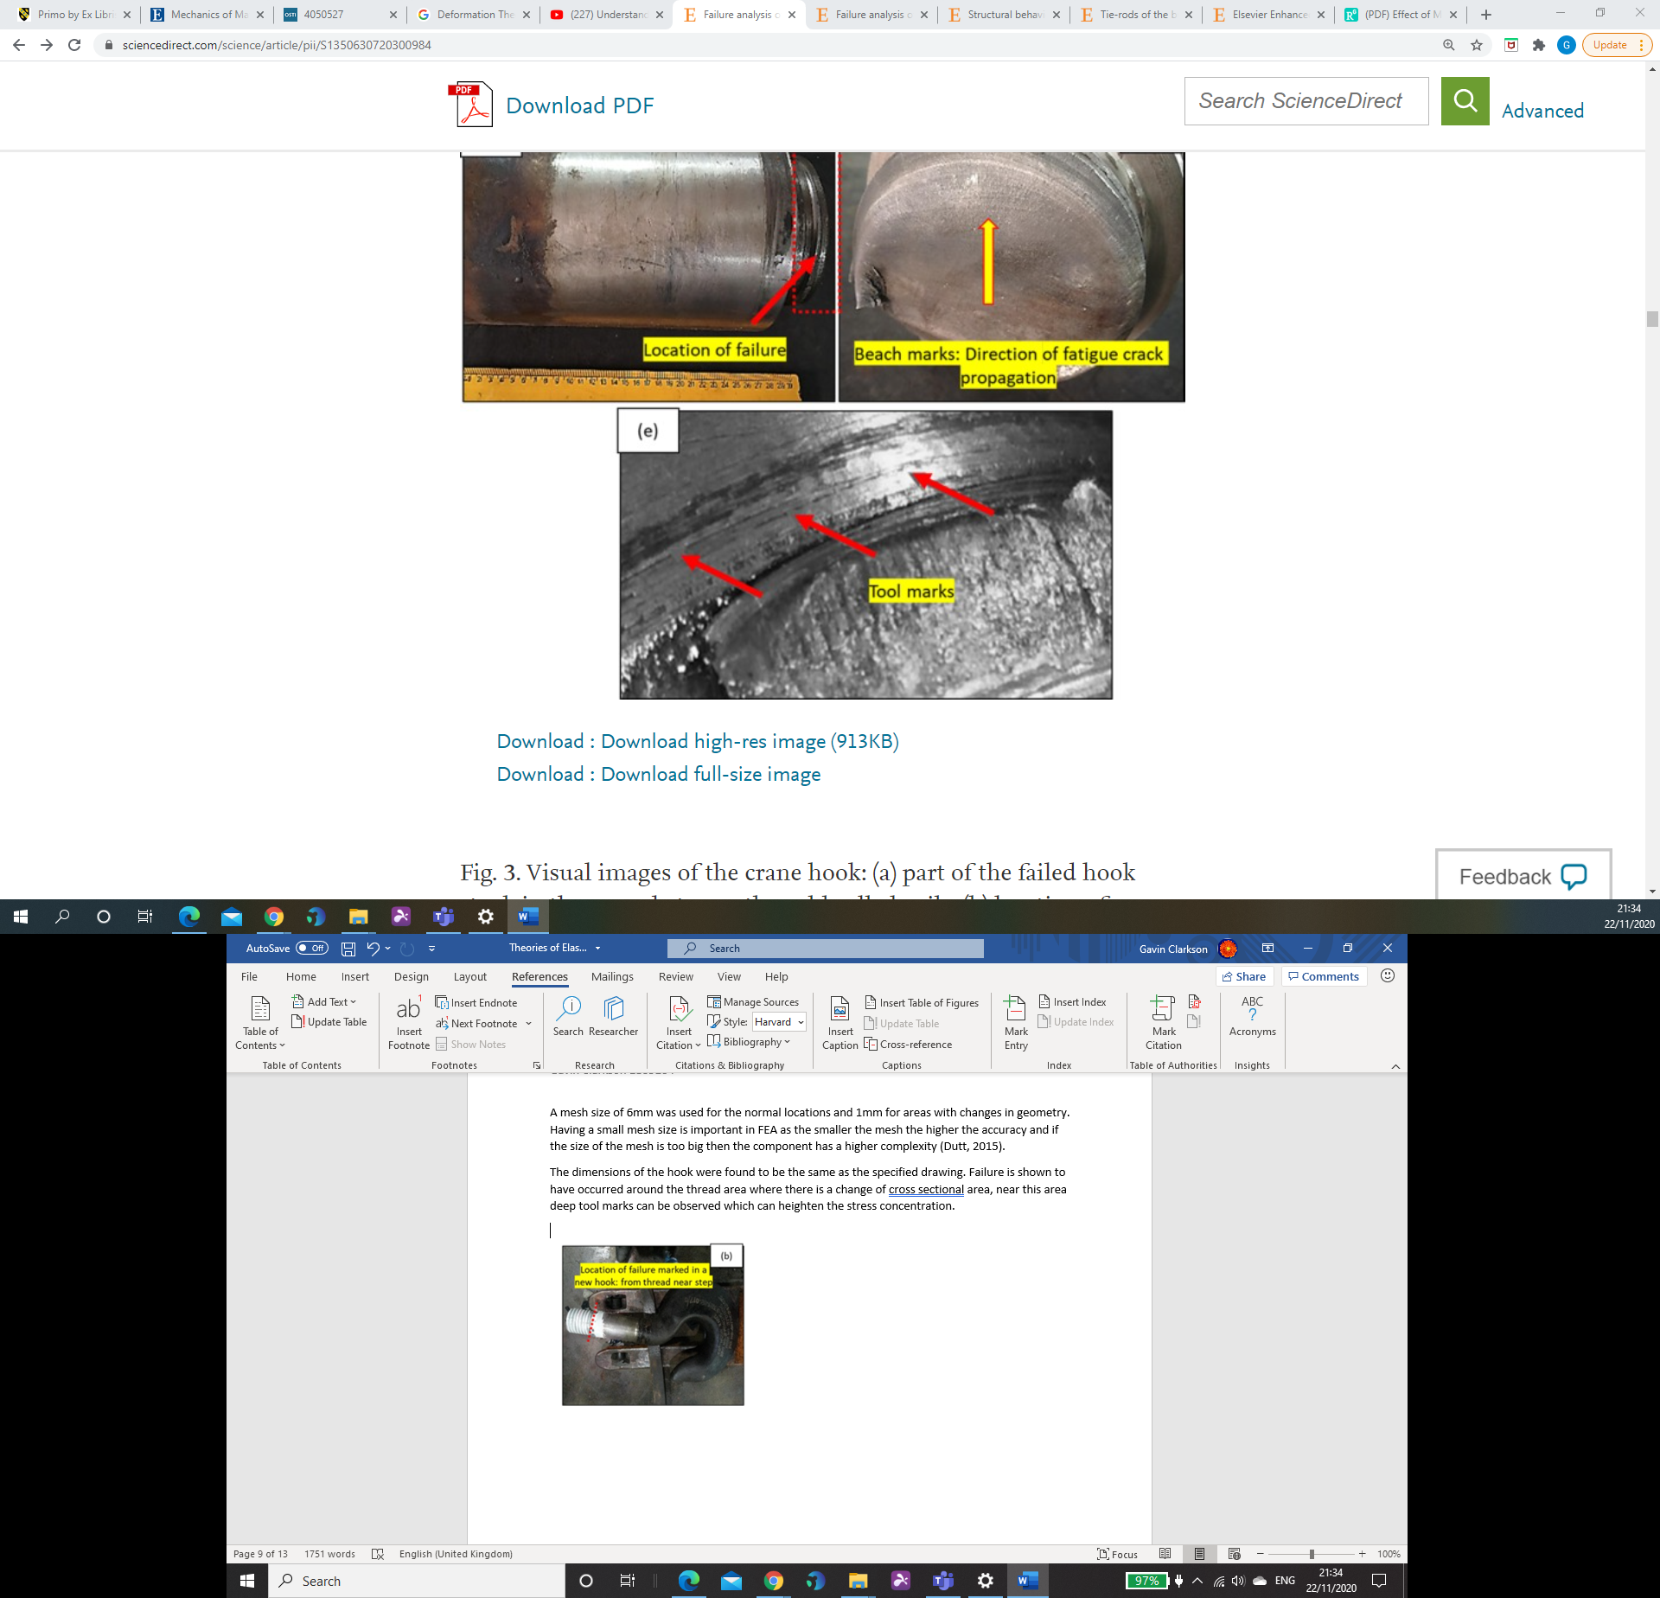
Figure 13 - Kishore, et al (2020)

The load hook was analysed using both fractography and microstructural analysis. These showed that the stress that led to failure was caused by a high cycle count with a low stress amplitude and tool marks were witnessed around the failure area which assisted in raising the stress concentration.
Again, this high cycle count is similar to the conditions of that tie-rods are in, with the gates being opened and closed several times an hour. The stress condition on the tie-rods is currently unknown.
The stress was calculated at different sections of the load hook, these were at the inner fibre of the hook, outer fibre of the hook and at failure location. The results are as follows:
- Stress at inner fibre = 48.68MPa
- Stress at outer fibre = -14.69MPa
- Stress at failure location = 61.9MPa
These results show that failure around the stepped shaft location was more likely than in other locations. It is important to note that 61.9MPa is below the endurance limit of the material, which is 210MPa, this as suggested by Kishore, et al (2020) means that there were other factors that assisted in the failure.
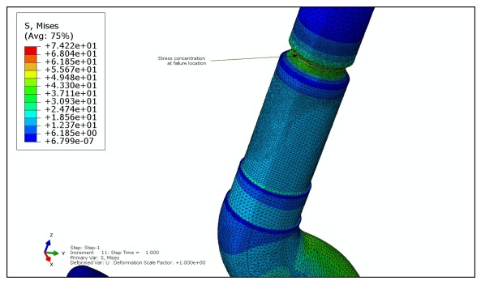
FEA on the load hook using Von Mises stress calculations can be shown in fig 14, this shows the hook in perfect conditions with no irregularities on the material surface. It shows that the location of maximum stress corresponds with the failure area. The maximum stress value given using Von-Mises is 74MPa which close to the calculated stress.
Figure 14 - Kishore, et al (2020)

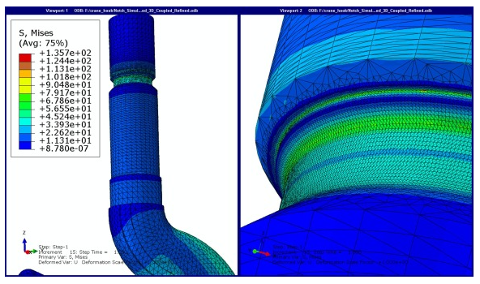
Further FEA was taken with notch or tool marks on the hook surface, this is because deep tool marks were observed. The stress with these notch marks were taken at 1mm, 1.5mm, 2mm, 2.5mm and 3mm depths. Fig 15 and 16 show examples of these results. Fig 17. shows the Von Mises stress at different depth. With the 2mm notch size there is the highest stress value which as stated by Kishore, et al (2020) increases the stress concentration.
Figure 15 - Kishore, et al (2020). 1.5mm Depth.

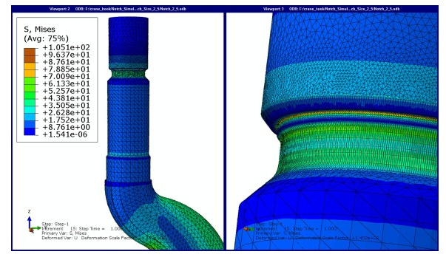
Figure 16 - Kishore, et al (2020). 2.5mm Depth.
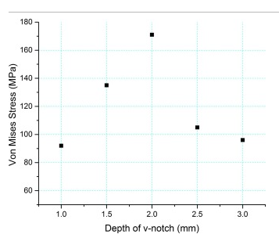
Kishore, et al (2020) concluded that:
Figure 17 - Kishore, et al (2020)
- The crane hook failed under a high cycle, low stress condition.
- That failure occurred at the point identified using FEA and analytical approach.
- FEA calculations compared well to the analytical calculation.
- Because deep tool marks were observed, the stress concentration was increased.
Recommendations from this study stated that crane hooks which show deep tool marks should not be allowed to operate, ultrasonic testing should be carried out to detect fatigue and the manufacture should investigate its secondary steel making process.

Conclusions
In conclusion, the study of the theories of elastic failure is vital importance to ensure that structures or components are manufactured to withstand the loads being generated on them. It can be assumed that out of the theories mentioned above, that the Von-Mises or the maximum distortion energy theory is the more accurate theory to use when working with ductile materials and when working with brittle materials the Rankine theory or the maximum principal stress theory should be used. The Von-Mises theory seems to be the most popular theory for predicting failure, as it is used in the studies by Kishore, et al (2020), Duan & Joshi (2013), Bošnjak, et al (2020) and Winklberger, et al (2018) who all used this theory as part of their FEA.
When developing a component that has a change in diameter and/or a threaded section, such as the crane load hook or tie rod mentioned above, special attention should be given to this area. The surface finish is of particular importance with Kishore, et al (2020) believing that deep tool marks of notches on the surface of the material can lead to an increase in the stress concentration.

References
Baltic, S. et al., 2020. Coupled Damage Variable Based on Fracture Locus: Prediction of Ductilefailure in a Complex Structure. International Journal of Solids and Structures, Volume 207, pp. 132 - 144.
Beer, F., Johnston, E. R., DeWolf, J. & Mazurek, D., 2015. Mechanics of Materials. 7th ed. New York: McGraw-Hill Education.
Bolton, W., 1998. Engineering Material Technology. 3rd ed. Oxford: Butterworth-Heinemann.
Bošnjak, S. M. et al., 2020. Tie-Rods of the Bucket Wheel Excavator Slewing Superstructure: A Study of the Eye Plate Stress State. Engineering Structures, Volume 207, p. 110233.
C F Braun & Co, 1969. A Study of Failure Theoriesas Related to LMFBR Piping Systems, Alhambra: C F Braun & Co.
Dowling, N. E., 2013. Mechanical Behaviour of Materials. 4th ed. Harlow: Pearson Eductaion Limited.
Duan, W. & Joshi, S., 2013. Structural Behavior of Large-Scale Triangular and Trapezoidalthreaded Steel Tie Rods in Assembly using Finite Element Analysis. Engineering Failure Analysis, Volume 34, pp. 150 - 165.
Dutt, A., 2015. Effect of Mesh Size on Finite Element Analysis of Beam. SSRG International Journal of Mechanical Engineering, 2(12), pp. 8 - 10.
Gere, J. M., 2001. Mechanics of Materials. 5th ed. Cheltenham: Nelson Thornes LTD.
Hearn, E. J., 1997. Mechanics of Materials Volume 1 : An Introduction to the Mechanics of Elastic and Plastic Deformation of Solids and Structural Materials. 3rd ed. Boston: Butterworth-Heinemann.
Hibbeler, R. C., 2013. Mechanics of Materials. 9th ed. Singapore: Pearson Education.
Higgins, R. A., 1994. Properties of Engineering Materials. 2nd ed. London: Edward Arnold.
Jones, R. M., 2009. Deformation Theory of Plasticity. Blacksburg: Bull Ridge.
Kishore, K. et al., 2020. Failure Analysis of a 24 T Crane hook using Multi-Disciplinary Approach. Engineering Failure Analysis, Volume 115.
Matmatch, 2020. BS 4360 Grade 43A Hot Rolled. [Online]
Available at: https://matmatch.com/materials/minfm21427-bs-4360-grade-43a-hot-rolled
[Accessed 25 11 2020].
Simuleon, 2014. SIMULIA Abaqus. [Online]
Available at: https://www.simuleon.com/simulia-abaqus/
[Accessed 22 11 2020].
Solidworks Help, 2020. Failure Criteria. [Online]
Available at: https://help.solidworks.com/2020/english/SolidWorks/cworks/Failure_Criteria.htm?verRedirect=1
[Accessed 10 11 2020].
Suhr, R., 2013. The Effect of Surface Finish on High-Cycle Fatigue of a Low Alloy Steel. EFG1.
The Efficient Engineer, 2020. Understanding Failure Theories (Tresca, von Mises etc...). [Online]
Available at: https://www.youtube.com/watch?v=xkbQnBAOFEg
West Yorkshire Steel, 2020. S275 S275JR Steel. [Online]
Available at: https://www.westyorkssteel.com/carbon-steel/s275/
[Accessed 25 11 2020].
Winklberger, M., Heftberger, P., Sattlecker, M. & Schagerl, M., 2018. Fatigue Strength and Weight Optimization of Threaded Connections in Tie-Rods for Aircraft Structures. Procedia Engeering, Volume 213, pp. 374 - 382.

Appendices

Appendix 1
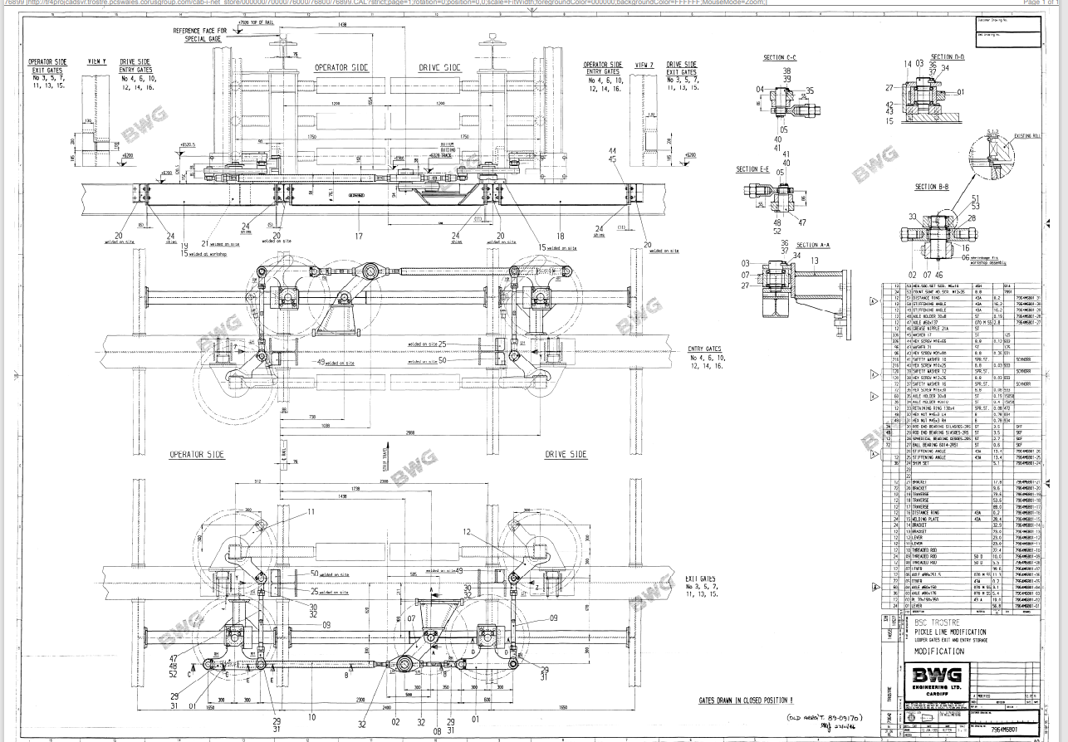
Layout of gate showing tie-rod position.

