4/28/2026
University of Wales Trinity Saint David
London campus
Code Link:
https://github.com/Alina78-78/Assessment-Project.git
Module Name: Scripting and Programming Concepts
Module Code: ACCA 5036
Student Name: Alina Mariana Daraban
Student ID: 2413829

Lecturer’s Name: Koushik Modak

SPC Assignment 1
Student Equipment Booking System

Table of Contents
Introduction 2
Main Body 2
1.Analysis 2
2.Software Design and Development 4
Design: 5
Implementation Decisions: 1
Source Code 3
3.Testing and Debugging Report 6
4. Evaluation 11
Conclusion 13
References 14

Introduction
Modern educational environment increasingly relies on equipment such as laptops projectors and other digital resources to support learning activities. In many cases, the management of these resources is still handled manually or through basic systems, which can lead to inefficiencies such as double booking, lost records and difficulty in tracking availability. As the number of users and equipment items grows, these issues become more frequent and harder to manage.
The scenario addressed in this project focuses on the need for a simple and reliable computer-based solution that allows staff to manage equipment booking more effectively. The system must support everyday administrative tasks, including adding new equipment, assigning items to students and reviewing booking records. In addition, it should provide basic search functionality and alert staff when equipment usage is low helping improve resource utilisation [3].
To address this need, this project develops a console-based Python application designed to manage equipment booking in a structured and user-friendly way. The solution applies fundamental programming concepts such as data structure, control flow and input validation to ensure that the system operates reliably and handles user interactions effectively. The design also considers future scalability, allowing the system to be expanded with additional features if required.
Overall, the aim of this project is to demonstrate how a simple scripting solution can improve the organisation and accessibility of booking information, while reducing common errors associated with manual processes [3].

Main Body
- Analysis
• Requirements Analysis
The development of the equipment booking system begins with a clear understanding of the functional and non-functional requirements that define how the system should operate. These requirements are essential in ensuring that the final solution meets the needs of staff while remaining reliable, efficient and easy to use.

Functional Requirements
The system must provide several core functionalities to support the management of equipment bookings. Firstly, staff should be able to add new equipment items to the system. This allows the system to remain up to date as new resources become available. The implemented solution enables users to input an equipment name, which is then stored within a structured data collection.
Secondly, the system must allow staff to record booking. This functionality enables a piece of equipment to be assigned to a specific student for a chosen date. The system validates the input to ensure that booking is recorded correctly and prevents duplicate booking for the same equipment on the same date, reducing scheduling conflicts.
Another key requirement is the ability to view booking records. Staff should be able to display all equipment along with their associated booking. This provides visibility over equipment usage and helps staff quickly determine availability.
In addition, the system includes a simple search function. Users can enter either a student name or an equipment name to retrieve relevant booking information. This improves efficiency by allowing staff to locate specific records without manually scanning through all data.
The system also incorporates a low-booking alert feature. This function identifies equipment items with minimal or no bookings, helping staff recognise underutilised resources and make better allocation decisions.
Finally, the system is designed with usability in mind. A menu-driven interface ensures that staff can interact with the system easily, even without advanced technical knowledge. The structure of the program also allows for future expansion, supporting scalability as requirements grow [6].

Non-Functional Requirements
In addition to functional capabilities, the system must satisfy several quality-related requirements to ensure overall effectiveness.
Reliability is a key requirement, as the system must consistently store and display accurate booking information. Input validation and structured data storage help minimise errors and maintain data integrity.
Performance is also important, particularly when retrieving or recording booking. The system is designed to respond quickly to user input, ensuring a smooth user experience without delays.
Security considerations are addressed by controlling how data is entered and stored. While the system is simple, validation checks prevent invalid or incomplete data from being recorded, reducing the risk of data inconsistencies.
Accessibility is another important factor, especially in a hybrid working environment. The system is designed to be simple and intuitive, allowing staff with varying levels of technical experience to use it effectively without requiring additional training [6].

- Software Design and Development
The development of the equipment booking system followed a structured approach, beginning with the design of the program logic and continuing through implementation decisions that support functionality, usability and reliability. This section outlines the design representation of the solution, along with key technical decisions made during development.
Design of the Proposed Solution
The proposed software solution will be a simple equipment booking system designed for staff who need to manage shared equipment efficiently. The main purpose of the system is to make it easier to record, track and search booking for items such as laptops, projectors and tablets. Since the users may not be highly technical, the design should be clear, straightforward and easy to use.
The system will follow a simple structure where staff can choose options from a menu. For example, they will be able to add new equipment, create a booking, view all booking records and search for a specific student or equipment item. This menu-driven approach is suitable because it is easy to understand and reduces the chance of user errors.
To store the information, the program can use lists and dictionaries. Equipment items can be saved with their names and availability status, while booking can include details such as the student’s name, equipment name and booking date. This allows the program to organise data clearly and retrieve it when needed.
The design should also include validation to make sure the user enters correct information. For instance, the system should not allow a booking for equipment that does not exist and it should not accept empty names or invalid dates. This improves reliability and helps maintain accurate records.
Another important part of the design is searching for functionality. Staff should be able to quickly find which student booked a certain piece of equipment or check whether an item is already booked on a certain day. This makes system more practical and efficient in a real educational environment. Overall, the design focuses on simplicity, usability and accuracy. By creating a structured and use-friendly program, the solution will help staff manage equipment booking more effectively than a manual paper-based method.

Design: Represent the algorithm of your solutions as follows:
    - Flowcharts: The system follows a menu-driven structure, where users interact with the application by selecting options from a list of available actions. The flow of the program begins with displaying the main menu, followed be user input and then executing the corresponding function based on the selected option.
FLOWCHART
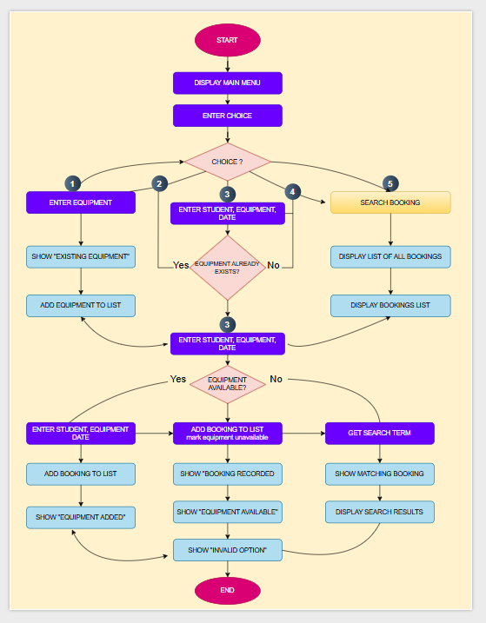

    - Pseudo-code:

START

DECLARE equipment_list
DECLARE bookings_list
SET equipment_list = empty
SET bookings_list = empty

REPEAT

DISPLAY "MAIN MENU"
DISPLAY "1. Enter Equipment"
DISPLAY "2. Enter Student, Equipment, Date"
DISPLAY "3. View Bookings"
DISPLAY "4. Search Booking"
DISPLAY "5. End"

INPUT choice

IF choice = 1 THEN
INPUT equipment_name

IF equipment_name EXISTS IN equipment_list THEN
DISPLAY "Existing equipment"
ELSE
ADD equipment_name TO equipment_list
DISPLAY "Equipment added"
ENDIF

ELSE IF choice = 2 THEN
INPUT student_name
INPUT equipment_name
INPUT booking_date

IF equipment_name EXISTS IN equipment_list THEN

SET available = TRUE

FOR each booking IN bookings_list
IF booking.equipment = equipment_name AND booking.date = booking_date THEN
SET available = FALSE
ENDIF
ENDFOR

IF available = TRUE THEN
ADD student_name, equipment_name, booking_date TO bookings_list
DISPLAY "Booking recorded"
DISPLAY "Equipment available"
ELSE
DISPLAY "Equipment not available"
ENDIF

ELSE
DISPLAY "Equipment does not exist"
ENDIF

ELSE IF choice = 3 THEN
DISPLAY "List of all bookings"

FOR each booking IN bookings_list
DISPLAY booking.student_name
DISPLAY booking.equipment_name
DISPLAY booking.booking_date
ENDFOR

ELSE IF choice = 4 THEN
INPUT search_term
SET found = FALSE

FOR each booking IN bookings_list
IF booking.student_name = search_term OR booking.equipment_name = search_term THEN
DISPLAY "Matching booking"
DISPLAY booking.student_name
DISPLAY booking.equipment_name
DISPLAY booking.booking_date
SET found = TRUE
ENDIF
ENDFOR

IF found = FALSE THEN
DISPLAY "No search results found"
ENDIF

ELSE IF choice = 5 THEN
DISPLAY "End"

ELSE
DISPLAY "Invalid option"
ENDIF

UNTIL choice = 5

END

Main Program Logic:

Implementation Decisions:
- The program starts by displaying the main menu with available options.
- The user is prompted to enter a choice.
- If the user selects Add Equipment, the system asks for the equipment name.
- The program checks whether the equipment already exists.
- If it exists, an appropriate message is displayed.
- Otherwise, the equipment is added to the system.
- If the user selects Record Booking, the system requests the student’s name, equipment name and booking date.
- The program first checks whether the equipment exists in the system.
- If the equipment does not exist, an error message is displayed.
- If it exists, the system checks whether the equipment is available for the selected date.
- If available, the booking is recorded.
- If not available, a message is displayed to inform the user.
- If the user selects View Booking, all stored booking records are displayed.
- If the user selects Search Booking, the user enters a search term (student name or equipment name).
- The system searches through the booking records.
- Matching results are displayed it found otherwise, a message is shown.
- If the user selects Exit, the program terminates.
- If the user enters an invalid option, the system displays an error message and returns to the main menu.
- The program runs continuously using a loop until the user chooses to exit.

- Data Structures:
The program uses lists and dictionaries as the main data structures because they are simple, efficient and suitable for storing booking information in a small-scale system.
An “equipment_list” is used to store the names of all available equipment items. A list was chosen because it allows new equipment to be added easily and makes it possible to check whether an item already exists in the system.
A “booking_list” is also used to store all booking records. Each booking is saved as a dictionary containing related information such as the student’s name, equipment name and booking date. A dictionary was selected because it groups different values together using meaningful keys, which makes the data easier to organise, read and access in the program.
Several variables are used throughout the solution. For example, “choice” stores the menu option selected by the user, “equipment_name” stores the name of the equipment entered, “student_name” stores the student’s name, and “booking_date” stores the selected booking date. In the search function, “search_term” is used to hold the text entered by the user. A variable such as “found” is used to check whether a piece of equipment is free on a chosen date. These variables help control the flow of the program and support decision-making.
The choice of list and dictionaries was also influenced by their flexibility. Lists allow dynamic resizing, meaning new equipment and booking can be added without predefined limits. Dictionaries improve data organisation by linking related values together, which makes retrieval and comparison more efficient.
From a programming perspective, combining iteration and selection structures allows the system to perform complex checks in a simple way. For example, looping through booking records while applying conditional checks ensures that equipment availability is verified accurately. This combination demonstrates how fundamental programming constructs can be used to build practical solutions [1].

- Programming Constructs:
A range of programming constructs were used in this project to ensure the system operates correctly and efficiently.
Selection statements such as “if”, “elif” and “else” were used to control decision-making in the program. These statements are essential because the system must respond differently depending on the user’s menu choice. They are also used to check important conditions, such as whether equipment already exists, whether equipment is available and whether a valid option has been entered.
Interation was implemented using loops. A while loop keeps the main menu running continuously until the user chooses to exit the program. This is important because the system needs to allow repeated use without restarting the script each time. A “for” loop is used to go through booking records when checking availability, displaying all bookings, and searching for matching records.
Functions may also be used to improve the organisation of the program. For example, separate functions could be created for adding equipment, recording bookings, viewing records and searching. This makes the code easier to read, test and maintain. Even if the current version is written mainly in one main block, the logic still follows functional separation based on menu choices.
Error handling and validation were included through conditional checks. For example, the program prevents duplicate equipment from being added, stops booking from being recorded for equipment that does not exist and display an error message when the user enters an invalid menu option. This improves reliability and reduces the chance of incorrect data being stored [5].

- Python Modules and Libraries:
The program was implemented as a Python script and executed using the Thonny IDE. All core functionalities were tested and performed successfully, demonstrating that the system operates as intended. The menu-driven structure allowed continuous interaction and features such as equipment validation, booking management, search functionality and low-booking alerts were verified through multiple test scenarios [4].

Source Code

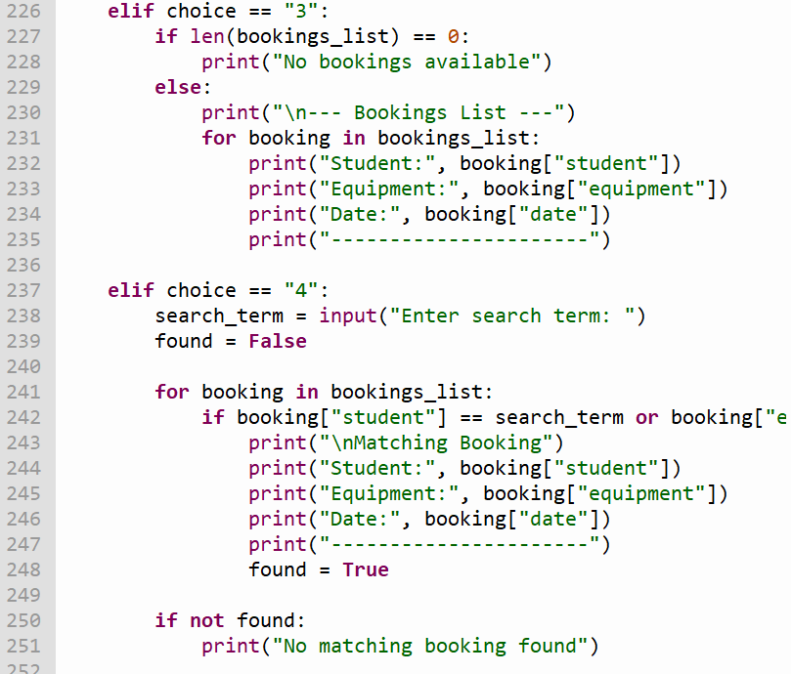Fig. 1
Fig.1: This section shows the main program loop and menu structure. The “while True” loop ensures continuous execution until the user input determines which function is called.

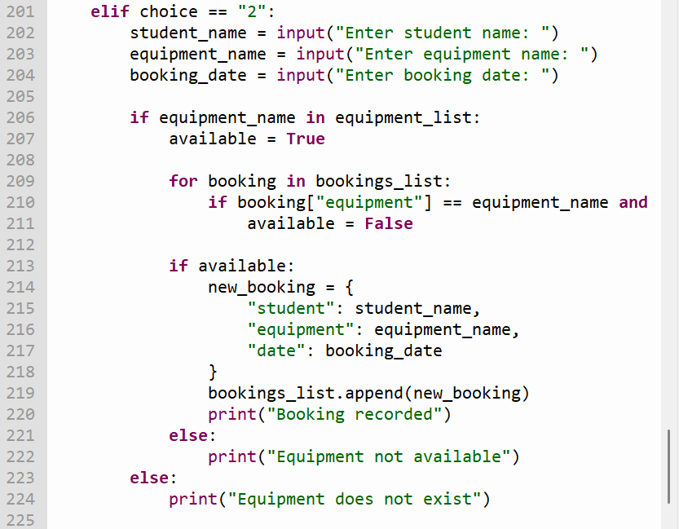Fig. 2
Fig.2: This function allows users to add new equipment while preventing empty to duplicate entries, improving data integrity.

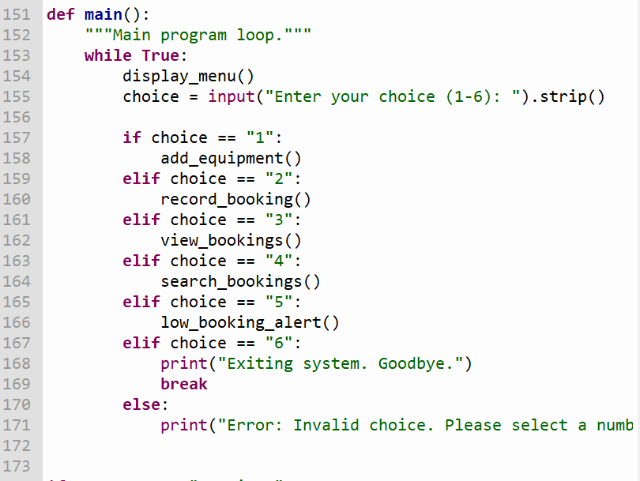Fig. 3
Fig.3: This section records booking and includes validation such as checking if equipment exists and ensuring correct date format using exception handling.

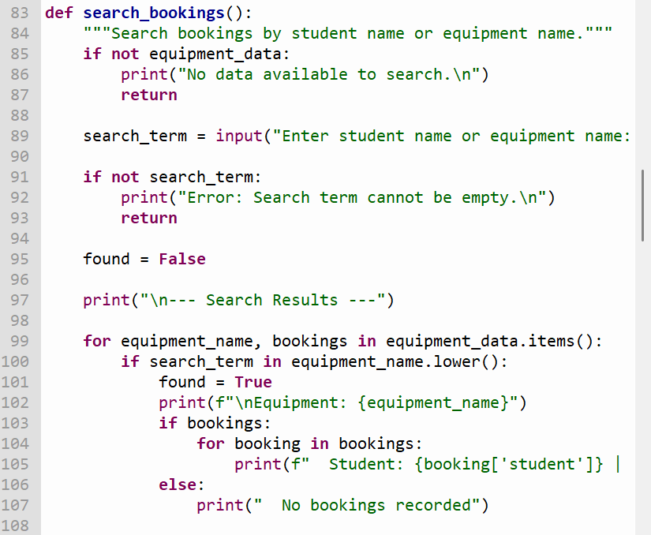Fig. 4
Fig.4: This part of the program searches for bookings by student or equipment name using internation and conditional checks.

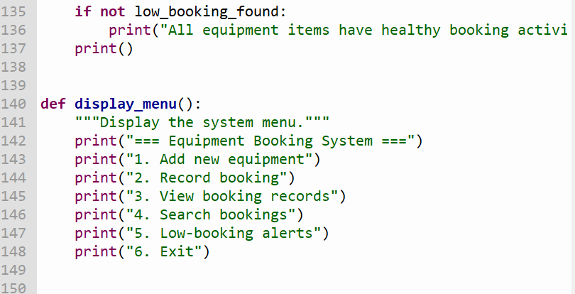Fig.5
Fig.5: This feature identifies equipment with low booking activity, providing additional insights beyond the basic requirements.

Testing and Debugging Report

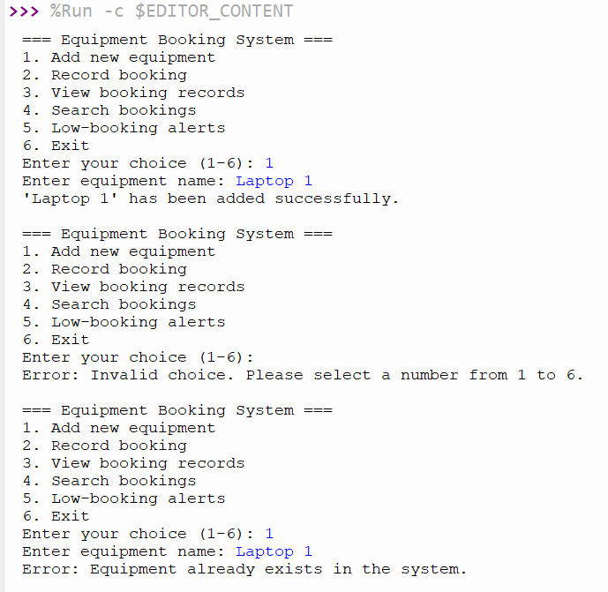Fig. 1

Fig.1: Adding equipment, invalid menu input and duplicate equipment detection
This screenshot shows how the system adds a new equipment item successfully. It also shows how the program reacts when the user enters an invalid option and when trying to add the same equipment again. In both cases, the system correctly displays an error message, which shows that validation is working.

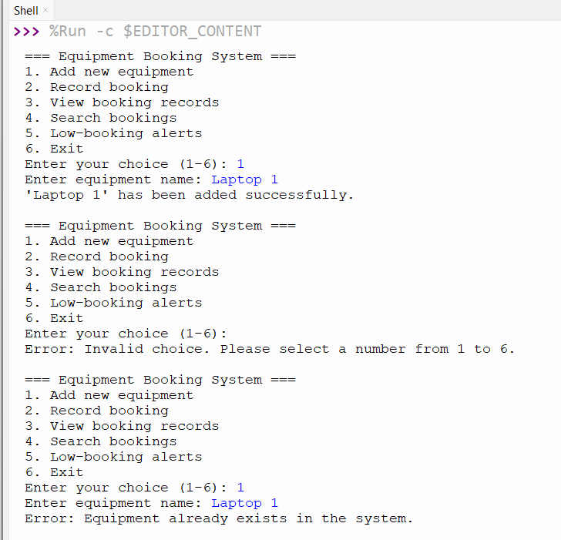Fig.2
Fig. 2: Recording a booking successfully
This screenshot shows a correct booking process. The user enters the equipment name, student name and a correct formatted date. The system accepts the input and confirms that the booking has been recorded, which proves that this feature works properly.

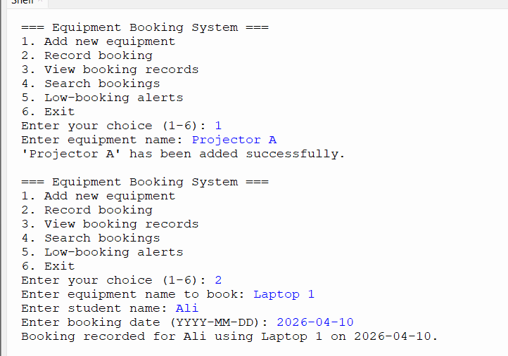Fig.3
Fig.3: Same as Fig.2

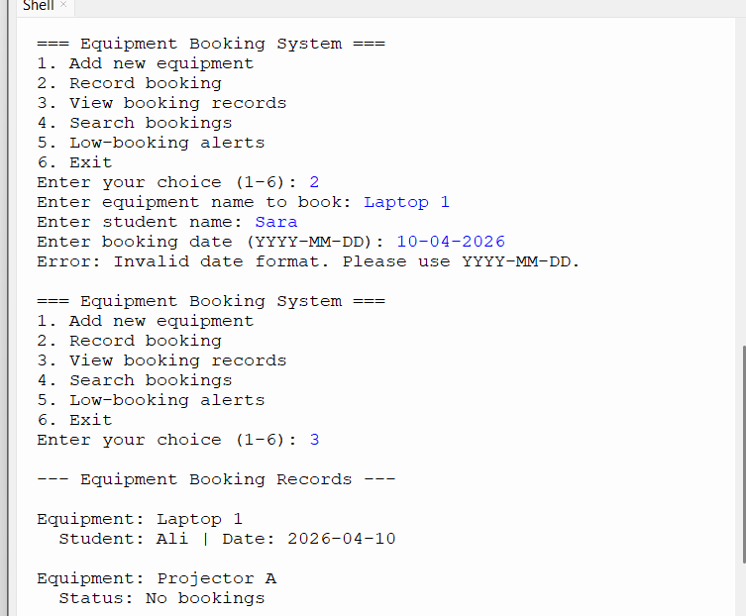Fig.4

Fig.4: Invalid date format and viewing booking records
This screenshot, the user enters a date in the wrong format. The program detects the mistake and displays a message asking for the correct format. It also shows the booking records, including equipment with and without bookings, which confirms that the display function works correctly.
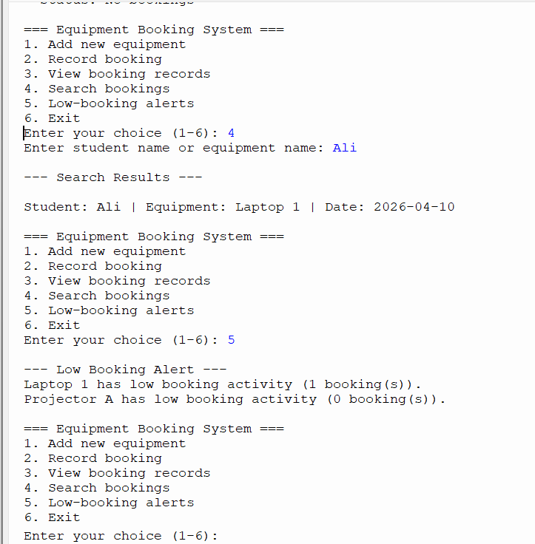Fig.5

Fig.5: Search function and low-booking alert
This screenshot shows two important features. The search function successfully finds a booking based on the name entered. It also shows the low-booking alert, which identifies equipment with little or no activity. This demonstrates that the system can provide additional useful information beyond basic functions.

The testing results show that the system works reliable in different situations. It handles both correct and incorrect inputs properly, which confirms that the validation and overall program logic are effective.

- Importance of Program Testing in Software Development
Testing is a key part of developing any program because it helps make sure the system actually works the way it is supposed to. Without testing, it is very easy for errors to go unnoticed, which can lead to incorrect results or a poor user experience.
In this project, testing was important because the system has multiple features, such as adding equipment, making booking, searching records and showing alerts. Each of these needed to be checked carefully to make sure they behaved correctly. Testing also helped confirm that the program handles incorrect input properly, for example when the user enters a valid option, a duplicate item, or a wrongly formatted date.
Overall, testing improves the reliability of the program and makes it more trustworthy for users [2].

- Types of Errors in Programming and how to Fix
There are different types of errors that can appear in a program and understanding them helps in fixing issues more effectively.
A syntax error happens when the code is written incorrectly and does not follow Python rules. For example, missing brackets, wrong indentation, or forgetting a colon can stop the program from running. These errors are usually easy to fix because Python highlights them, so the programmer just need to correct the structure.
A logical error is more difficult to notice because the program runs, but the output is wrong. For example, if the system allowed two bookings for the same equipment on the same date, this would be a logic problem. These errors are fixed by carefully testing different situation and adjusting the conditions in the code.
A runtime error happens while the program is running. This can occur when the user enters unexpected input. In this system, an example is entering a date in the wrong format. This issue was handled by adding validation and using error handling, so the program does not crash and instead shows a clear message.
By testing regularly and checking different cases, these types of errors can be identified and corrected [2].

- Test Cases and Validation Evidence
The system was tested in Thonny using a variety of inputs to make sure it works correctly in both normal and error situations. The aim was to check that all features behave as expected and that validation prevent incorrect data from being entered.
Testing was carried out using a structured approach to ensure that all features of the system were working correctly. Both normal and edge cases were considered in order to fully evaluate the behaviour of the program. Positive testing was used to confirm that the system produces correct outputs when valid data is entered, while negative testing was used to verify that the program can handle incorrect inputs without failing.
Special attention was given to validation process, such as preventing duplicate entries, ensuring correct date formats and handling invalid menu selections [2]. By testing a variety of scenario, it was possible to identify potential weaknesses and confirm that the implemented solutions were effective.

Test Case | Input | Expected Outcome | Status
Add equipment | Laptop 1 | Equipment should be added | Passed
Add duplicate  equipment | Laptop 1  again | Program should reject it | Passed
Invalid menu input | e.g.blank/incorrect  input | Error message shown | Passed
Valid booking | Laptop 1, Ali, 2026-04-10 | Booking should  be recorded | Passed
Invalid date format | Laptop 1, Sara, 10-04-2026 | System should reject format | Passed
View booking  records | Option 3 | Booking list should display | Passed
Search booking | Option 4, Ali | Matching booking shown | Passed
Low booking alert | Option 5 | Low activity items shown | Passed

4. Evaluation
Challenges Faced
While working on this project, I ran into a few difficulties, mainly around making the system behave correctly in all situations. One of the biggest challenges was controlling the booking process so that the same piece of equipment could not be reserved more than once for the same date. In the beginning, my condition was too simple, so the system didn’t always block duplicate bookings. I fixed this by adjusting the logic to compare both the equipment and the date together inside loop.
Another issue I had to deal with was use input. People can type things in many ways, especially when it comes to dates. This caused problems when the program tried to process incorrect formats. To solve this, I added validation using error handling, so instead of crashing, the program now shows a clear message when the input is wrong.
Structuring the code was also a challenge at first. Breaking the program into separate functions felt confusing initially, but once I organised it properly, it made the code much cleaner and easier to follow.

Future Improvements
Even though the program is working well, there are still several areas that could be improved. One major improvement would be adding permanent data storage. Now, all the information disappears when the program is closed, so saving data to file or database would make the system more practical.
Another useful upgrade would be creating a graphical interface instead of using only text. A visual interface would make the system more user-friendly and easier to interact with.
The search feature could also be made more flexible bey allowing partial matches instead of requiring exact input. On top of that, more advanced features could be added, such as tracking which equipment is used the most or generating simple reports. Input validation could be expanded further to make the system even more reliable, especially when dealing with unexpected use input.

Self-Reflection
This project helped me understand what it takes to build a program from the ground up. I learned how to take an idea, plan it using a flowchart and pseudocode and then turn it into working code step by step.
I became more confident using Python, especially with concept like loops, conditions and data structures. I also improved my ability to think through problems logically and fix mistakes when things didn’t work as expected.
Using Thonny made a big difference as well, because it allowed me to run the program and test different scenarios easily. This helped me see how the code behaves in real time and understand where changes were needed. One of the most valuable things I learned was how important testing is. Trying both correct and incorrect inputs showed me where the program could fail and how to improve it.
Another important aspect of this project was learning how small mistakes in logic can significantly affect the outcome of a program. This experience highlighted the importance of careful planning before implementation. It also showed that debugging is not just about fixing errors, but also about understanding why they occur.
Additionally, the project improved my ability to organise code in a structured way. By separating functionality into different parts and using clear naming conventions, the program became easier to read and maintain.
Overall, this experience helped me grow as a developer and I now feel more comfortable creating similar systems in the future.

Conclusion
To conclude, this project resulted in a working equipment booking system that meets its main purpose. The program allows users to add equipment, record booking, view existing records, search for specific entries and identify items with low usage. All core features were tested and shown to function correctly, including handling incorrect inputs.
The process of building this system helped bring together different stages of development, from planning and designing to coding and testing. Each step contributed to making the final program more structured and reliable.
This project also demonstrates how relatively simple programming concepts can be combined to create a useful and practical application. It highlights the importance of planning, testing and continuous improvement throughout the development process
Overall, the outcome is a functional and practical solution that demonstrates key programming skills. The system could be improved further in the future but is its current form, it successfully achieves the intended goals and reflects the work put into developing and refining it.

References
References
[1] M. T. Goodrich, R. Tamassia and M. H. Goldwasser,Data structures and algorithms in Python, John Wiley & Sons Ltd, 2013.
[2] G. J. Myers, The art of software testing, John Wiley & Sons, 2006.
[3] I. Sommerville, "Software engineering tenth edition," 2016,
[4] M. Lutz, Learning python: Powerful object-oriented programming, " O'Reilly Media, Inc.", 2025.
[5] D. Allen, Think Python: How to think like a computer scientist, Green Tea Press, 2015.
[6] V. Hyppönen, "A Comparative Analysis of Migration Tools for Python 3 in Medical Device Software," 2025,

