Student name: Nikita Morley
P Number: 1802253
Programme of Study: Film and TV
Module: ADAD4010

This assignment will discuss the ideas for curating an Exhibition based on the theme of water. The proposed venue will be The Mission Gallery and the reasons for selecting this location will be discussed further in this essay. The works of Damien Hirst, the BBC’s Blue Planet, Nick Drake, The water Hole by Graeme Base and the Bible will be used as a source of inspiration for the proposed exhibition.
The Mission Gallery is the perfect location for my exhibition. The Gallery is a good size, I have five piece of art that will be shown during the exhibition and the size of the space will perfectly fit all the art pieces in while not having a lot of space between each piece but also not feeling too cramped in the space. The layout of the pieces will go in the order shown in the image below. I have decided on this order because I feel it goes in an order that fits well and tells a story.
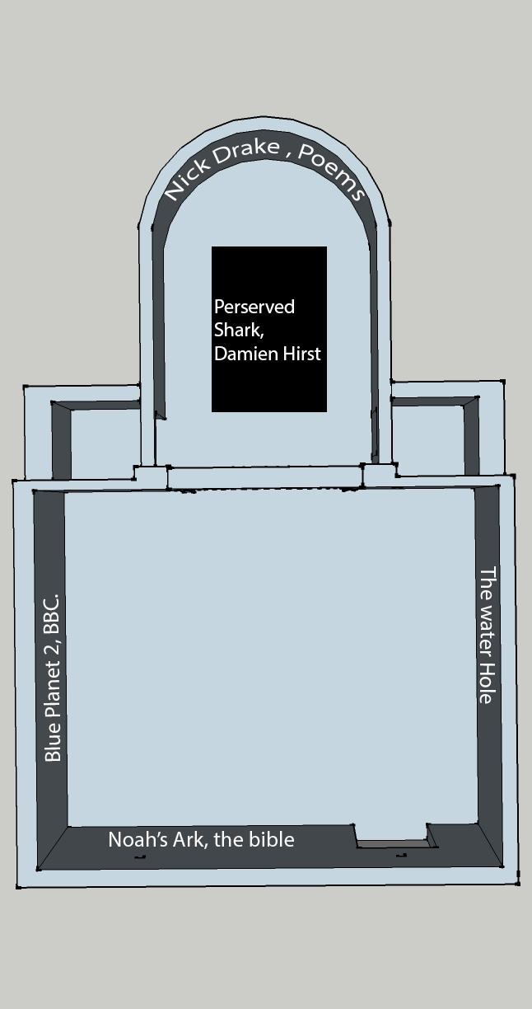

Water is one of the most important of the natural elements on earth. Around 71%of the earth’s surface is covered in water. The earth’s atmosphere is a closed system meaning that not much is able to leave or enter the earth’s atmosphere, which means that water that was present billions of years ago is still here today. Even though more than half of the earth’s surface is covered by water, only about 0.3% of it is attainable by humans (Mullen, n.d.) .Water is used by plants, animals and humans and all need to have water to survive, if there was no water on earth, there would be no life, and everything would die. (Anon., 2010). Water in its frozen form creates ice. Ice caps are very important to the earth’s natural way of life and are important to the marine life, as well as helping regulate sea levels and global temperature (Friedl, 2012).
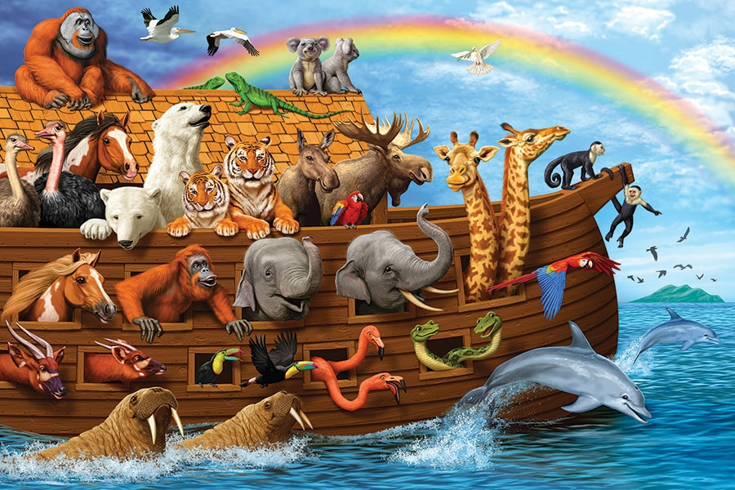
There have been accounts of how powerful water can be dating back to early biblical stories, with the story of Noah’s Ark. God began to see how bad and horrible the people he had created were acting and decided that he was going to release a great wave of water over the world, destroying everyone and everything on earth. However, he wanted to keep the animals he had created alive, and set a task for Noah to complete. The task was to build an Ark big enough to carry a pair of each animal of both gender that he had created. Noah and his family were also able to live on the ark to care for the animals that they would be saving. People stood by and watched him build the ark and they just made fun of him, telling him that he was just making up stories and continued to be bad. It took Noah many years to build the ark as it was very large (Bible, n.d.) .There was approximately 7,000 animals on the ark that Noah and his family cared for, this number excludes non land creatures, for example fish and sea creatures.
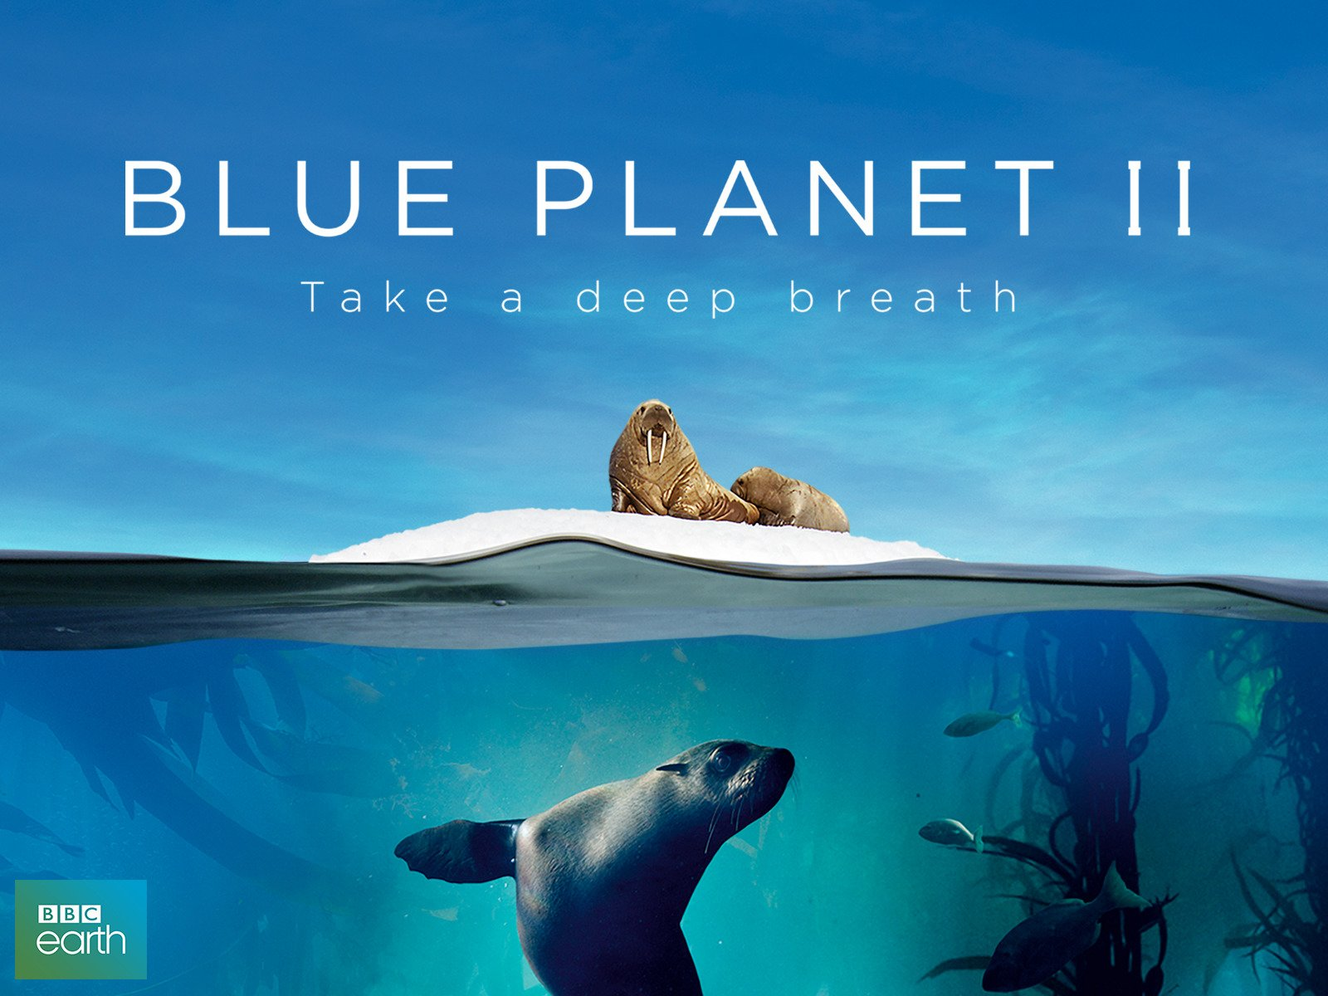
Blue Planet 2, which was narrated by David Attenborough. The programme concentrates on the ocean and what secrets it holds. Throughout the BBC series the team went on 125 expeditions, visited 39 countries, and filmed on every continent and across every ocean (Keene, 2018). One of the main things that shocked viewers watching the series is the major impact humans have on the ocean. The final episode shows multiple species within the ocean being affected by the damage that humans have created, for example Albatross parents feeding their young bits of plastic and Dolphin parent’s involuntarily feeding their calves contaminated milk (Allen, n.d.).The effect that Blue Planet 2 has had on the world has been very positive. Research has shown that around 88% of people who have watched Blue Planet 2 have changed their way of living. More than 60% of people now use reusable bottles and cups then they did in 2017. People are also now purchasing unpackaged fruit and veg using paper bags or bringing their own containers (Calderwood, 2018).

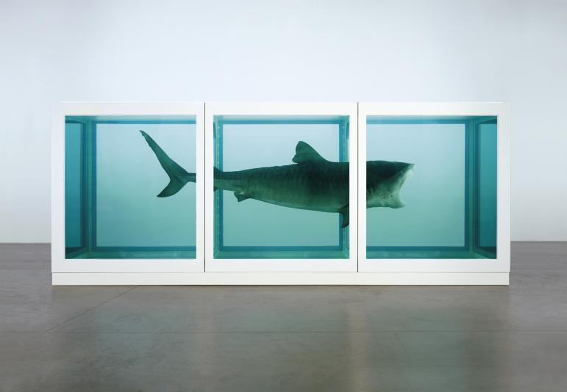In the 1990’s Damien Hirst created an art piece in which he preserved a tiger shark in a tank. The shark was caught by a fisherman in Harvey Bay in Australia, who was informed that it had to be big enough to eat a person. In 1991, Hirst created an art piece titled “The Physical Impossibility of Death in the Mind of Someone Living,” which is the Tiger shark preserved in Formaldehyde. However, the shark was not preserved correctly and began to decompose. In 1993 the gallery the shark was kept in decided to gut the shark and stretch its skin over a fibreglass mould. Conversely, people complained that the shark now looked fake and no longer frightened its audience. Hirst sent out another expedition to preserve another shark, which was also caught in Queensland, this was much better preserved where they injected the body with formaldehyde, as well as soaking the body in 7% formalin solution for 2 weeks and they used the same 1991 tank the first shark was housed in. The reason as to why the shark was preserved in the first place was because for a lot of people, they will never come into contact with a shark. This is an exhilarating experience for anyone who comes into contact with the art piece, as they are face to face with a real shark. This also means that viewers of the shark now have a new way of thinking about this animal, due to it being out of its own habitat making it less threatening. Viewers are also seeing the animal with their own eyes and not through what the media makes them out to be so they are able to free think their opinion of the animal (Stanska, 2017).
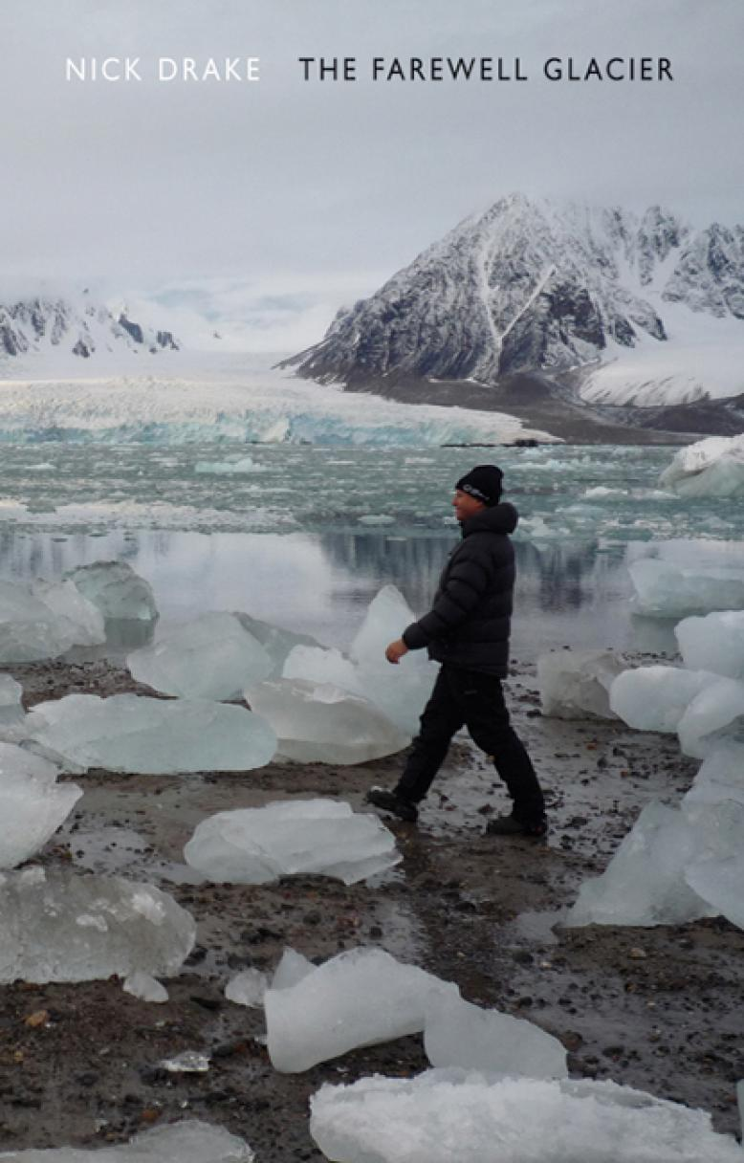
In 2010 Nick Drake went on a 3 week trip to the artic to study climate change, he says that it was an incredibly exciting but daunting experience in which he was able to learn a lot. He tries to give a voice to the artic itself and the animals who live there. He believes by 2100 the artic will cease to exist. (Books, n.d.) During his trip he documented how climate change is affecting the ice caps and wrote several poems around this topic. From his trip Nick Drake created a book of poetry called The Farewell Glacier, which is a collection of poetry he himself has written based around the ice caps and how climate change is affecting them. Drake focuses on how the consequences of climate change is affecting the sea level and how climate change is affecting species causing some to become extinct.

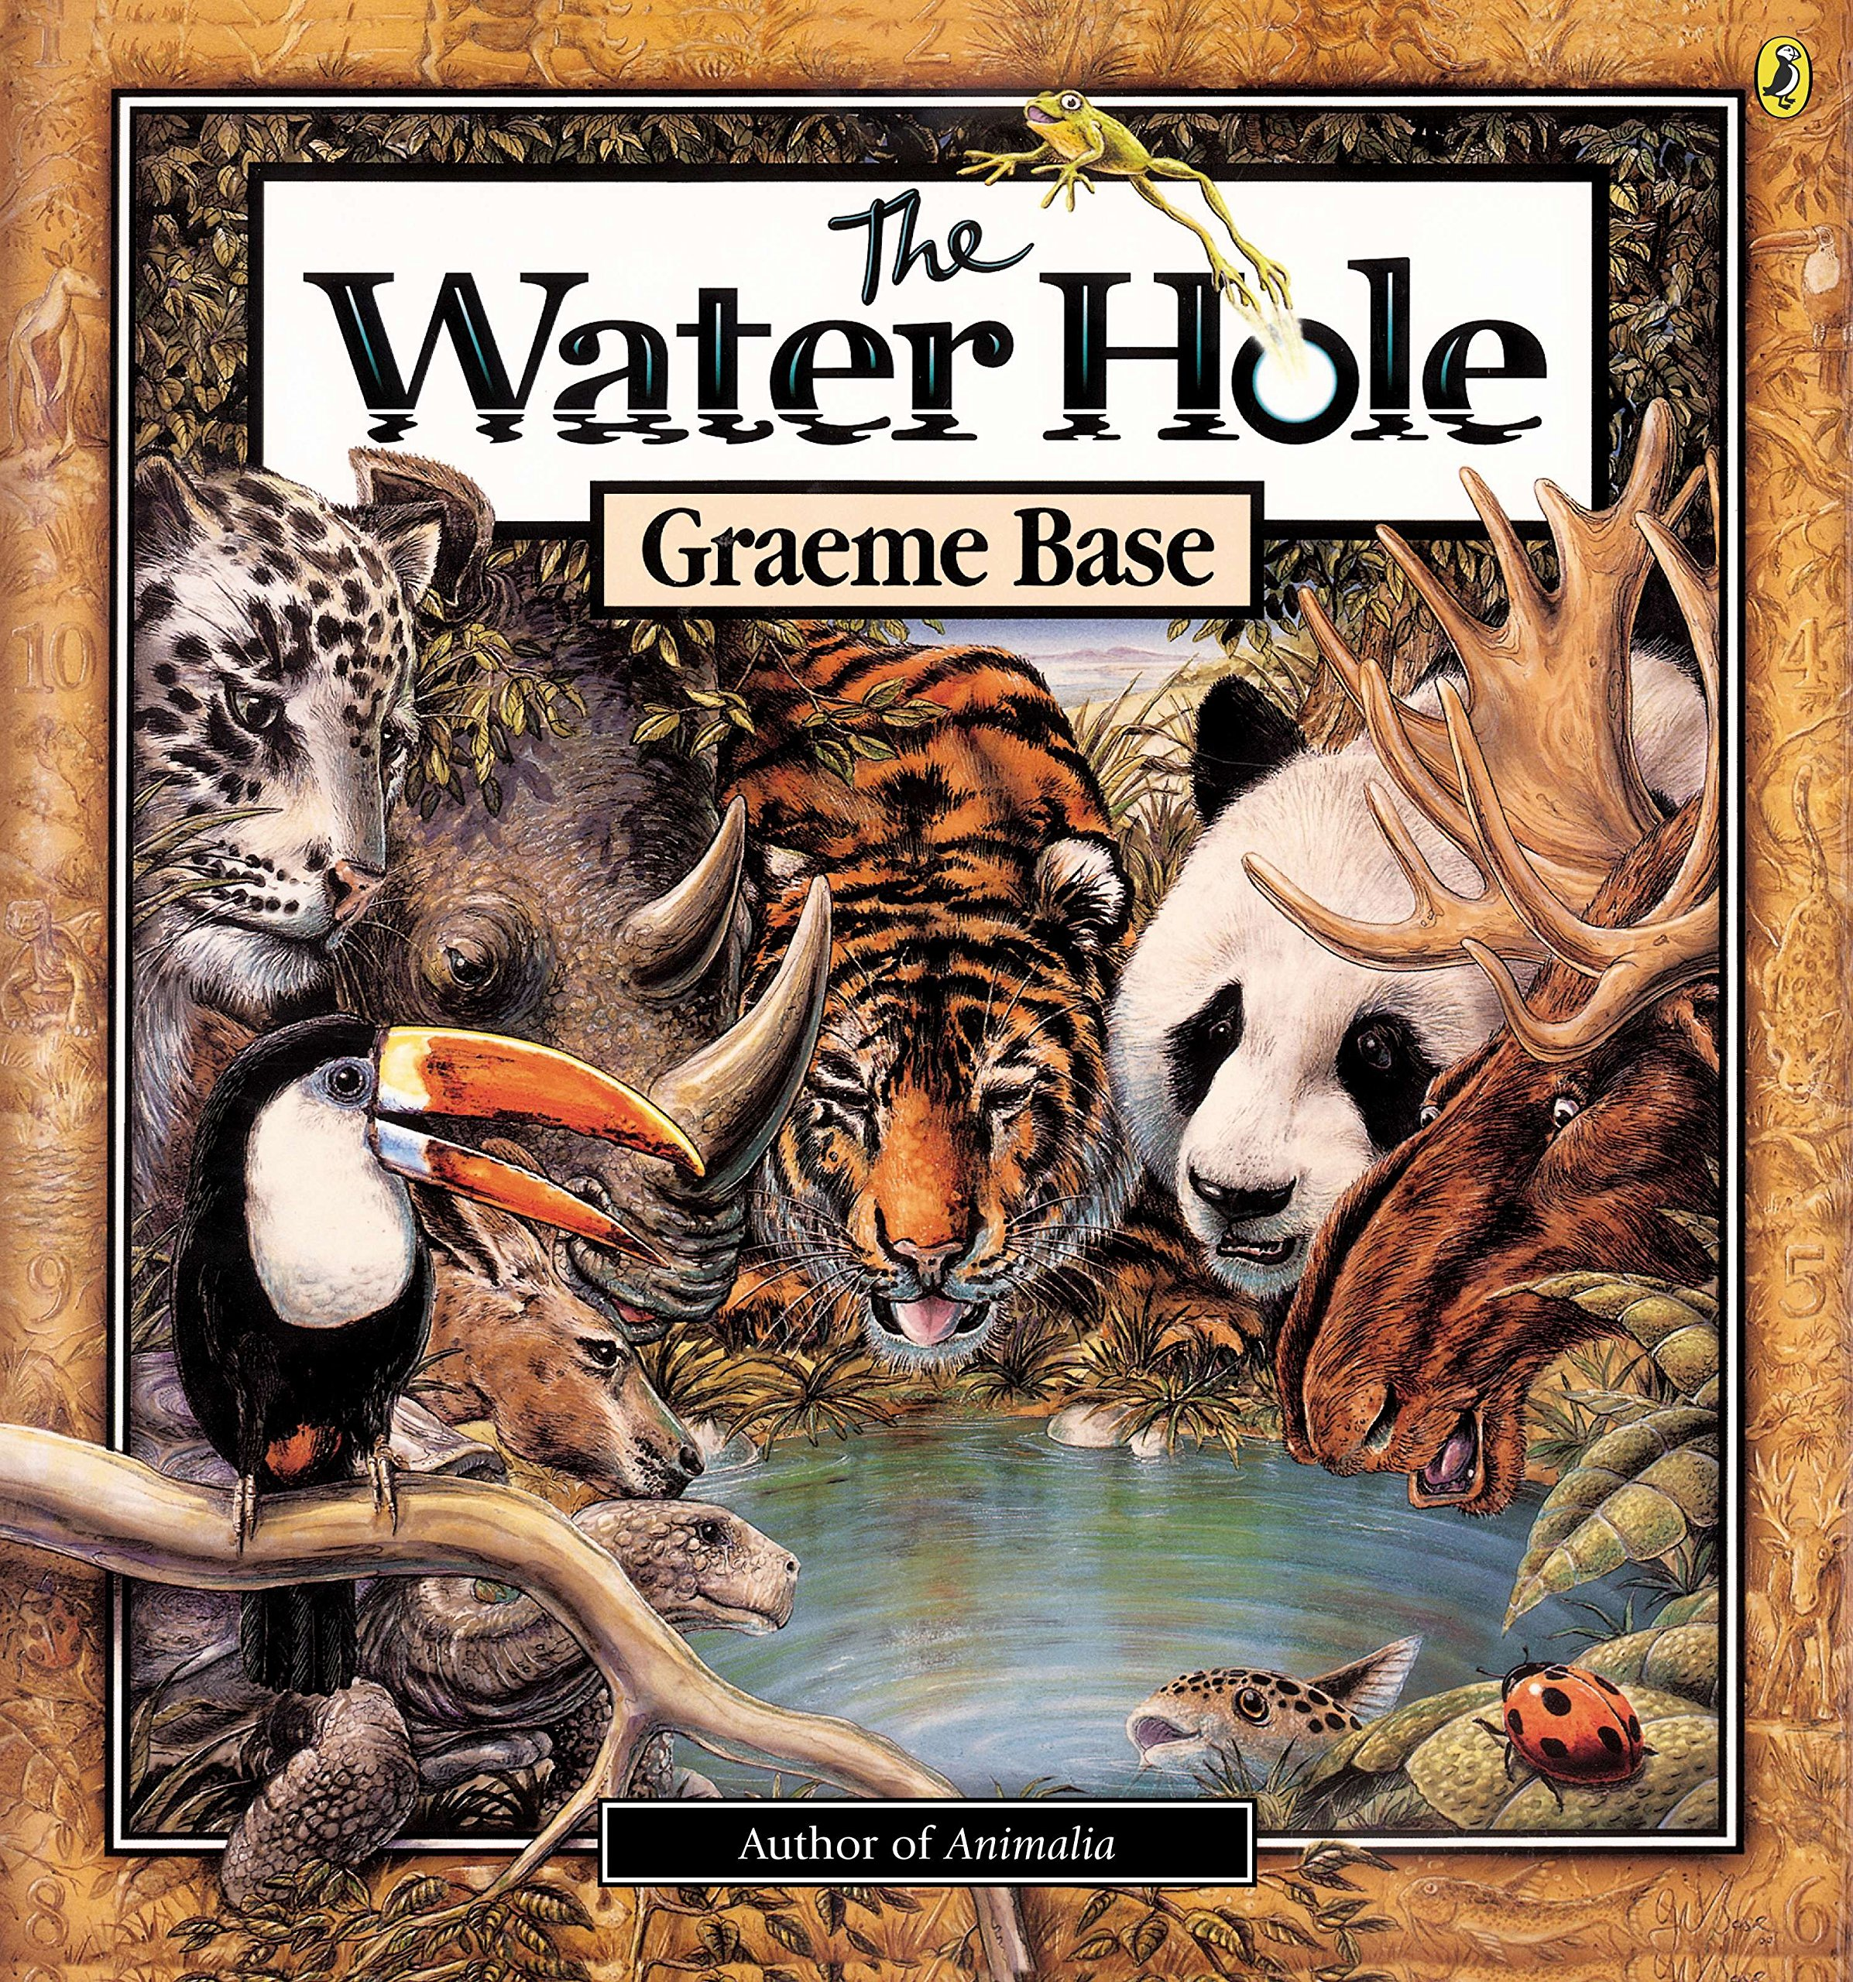The water hole is a widely known children’s book. The story about multiple animals going to a watering hole to drink water. However as the story goes on the watering hole gets smaller and smaller which meant that less and less animals came to drink making readers wonder what was happening to them. The watering hole eventually becomes non-existent and leaves the forest dead and dry, this can be show young children the effect of climate change and the lack of water can do to the earth and natural wildlife. This is an important topic that needs to be taught to young children so they are able to learn and understand what climate change is doing to the earth. Without rain the world will become dry and lifeless which teaches young kids that water is an important factor of life.
Water is a key aspect in our everyday life as shown in multiple art pieces, films and book that I’ve referred to during this essay. Climate change is a major problem that effecting earth every day, causing the ice caps to melt which is causing many species to go extinct. The lack of rain is causing different parts of the world to dry up and affect the natural habitat of many animals. Water affects everything on earth, without it we would cease to exist.

